

**Software Requirements Specification**

**for**

**Luci di Lusso Diamond Shop**

**Version 1.0 approved**

**Prepared by Group 7**

**July 23, 2024**

**Table of contents**

**I Project introduction……………………………………………………………………02** 1.1 Overview**……………………………………………………………………….02**  
 1.1.1 Project information**……………………………………………………02**  
 1.1.2 Project team**…………………………………………………………...02**  
 1.2 Project Background**…………………………………………………………….02**  
 1.2.1 Issue**…………………………………………………………………...02**  
 1.2.2 Benefits**………………………………………………………………..02**  
 1.3 Vision statements**…………………………………………………………...….03**  
**II Overall Description…………………………………………………………………...04** 2.1 User classes and characteristics**…………………………………………...….02**  
 2.4 User context diagram**……………………………………………………...….02**  
**III** **Functional Requirements………………………………………………………...….06** 3.1 Screen Flow Diagram**……………………..………………………..……...….02** 3.2 Entity Relationship Diagram**………………………………………..……...….02** 3.3 Data dictionary**……………………………………………...…..…..……...….02** 3.1 Use cases diagram**………………………………………………………….….02**  
 3.2 Use case specification**……………………………………………………...….02**  
 3.2.1 Use case 01: Order Jewelry**……………………………………….….02**  
 3.2.2 Use case 02: Create a Weekly Report**……………………………..….02**   
 3.2.3 Use case 03: View Cart**……………………………………………….02**  
 3.2.4 Use case 04: Manage Transport**……………………………………....02**  
 3.3 Sequence Diagram**…………………………………………………………….02**  
 3.4 State Machine**………………………………………………………………....02**  
 3.5 Swimlane Diagram**…………………………………………………………....02**  
 3.6 Class Diagram**……………………………………………………………..….02**  
**IV Non-functional Requirements………………………………………………….…….34** 4.1 Usability**……………………………………………………………………….02**  
 4.2 Reliability**……………………………………………………………………...02**  
 4.3 Performance**…………………………………………………………………...02**  
 4.4 Security**………………………………………………………...……………...02  
V Supporting Information……………………………………………………………….37**

**I. INTRODUCTION**

# **1.1 Overview**

## **1.1.1 Project information**

Project name: Luci di Lusso Diamond Shop System

Class: SE1840

Technology in use: Backend: SpringBoot

Frontend: Angular

Database: SQL Server (Deployed on Azure)

## **1.1.2 Project team**

| **Full name** | **Role** | **Email** |
| --- | --- | --- |
| Vo Nguyen Minh Nhat | Leader | @fpt.edu.vn |
| Nguyen Phuc Trong | Member | @fpt.edu.vn |
| Nguyen Trung Viet Anh | Member | anhntvse182398@fpt.edu.vn |

# **1.2** **Project background**

## **1.2.1 Issues**

Manual Order Management: Handling orders manually through paper documentation can lead to mistakes, information loss, and difficulty in retrieving necessary data.

Ineffective Product Management: Keeping track of inventory, product information, and related data also poses challenges.In the diamond business industry, efficiently managing sales transactions and related processes is crucial.

## **1.2.2 Benefits**

Customer: Minimize geographical difficulties and help customers easily access diamond and jewelry information and compare prices between products. Furthermore, payment for high-value diamond and jewelry products will be quick and safe.

Management: Minimize difficulties and time spent training sales staff. Manage and update product information quickly and accurately. Make automatic and accurate revenue reports

# **1.3 Vision Statement**

*Vision statements for a diamond shop system outlines the long-term aspirations and goals of the business :*

- **As Sales Staff** who want to be the single most desirable brand for fine jewelry and service, making customers look and feel their very best. To become the world's most recognized jewelry brand, the system has to update. The system should be passionate for excellence, customer-centricity, and constant innovation.

- **As a Store** **Manager** who needs to know vision is crucial for business success. It inspires employees and impacts your business positively. Consider your shop's unique qualities and create a vision that reflects your aspirations. Need a panel which can see every information of the system that is easy to access and use. So it can avoid unexpected problems like lost information or wrong information ….

- **As a Delivery Staff**

- **As Customers** that the end-users purchase our products. We aspire to provide an unparalleled shopping experience where every customer feels valued and special. Our vision is to offer a user-friendly platform that ensures a smooth browsing and purchasing process, backed by exceptional customer support and personalized services.

**II. OVERALL DESCRIPTION**

# **2.1 User Classes and Characteristics**

| **User class** | **Characteristics** |
| --- | --- |
| Customer | Customers are the main people who use the website to search, view and buy jewelry. They need a user-friendly and easy-to-use interface, as well as features like advanced search, product reviews, and secure payments. |
| Store Manager | Store management will use the website to manage products, orders and customer information. They need features like customizing diamonds and jewelries, revenue management, order management . |
| Sales Staff | Sales staff can use the website to help customers search for products, provide consultation and process orders. They need features like searching for products, viewing product information, and processing orders. |
| Delivery Staff |  |

# **2.2 User Context Diagram**

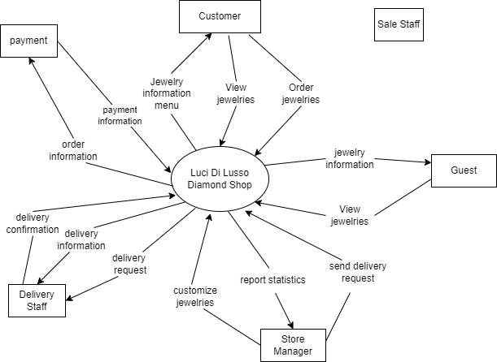

*Figure 2.2.1 User context diagram*

**III. FUNCTIONAL REQUIREMENTS**

# **3.1 Screens Flow**

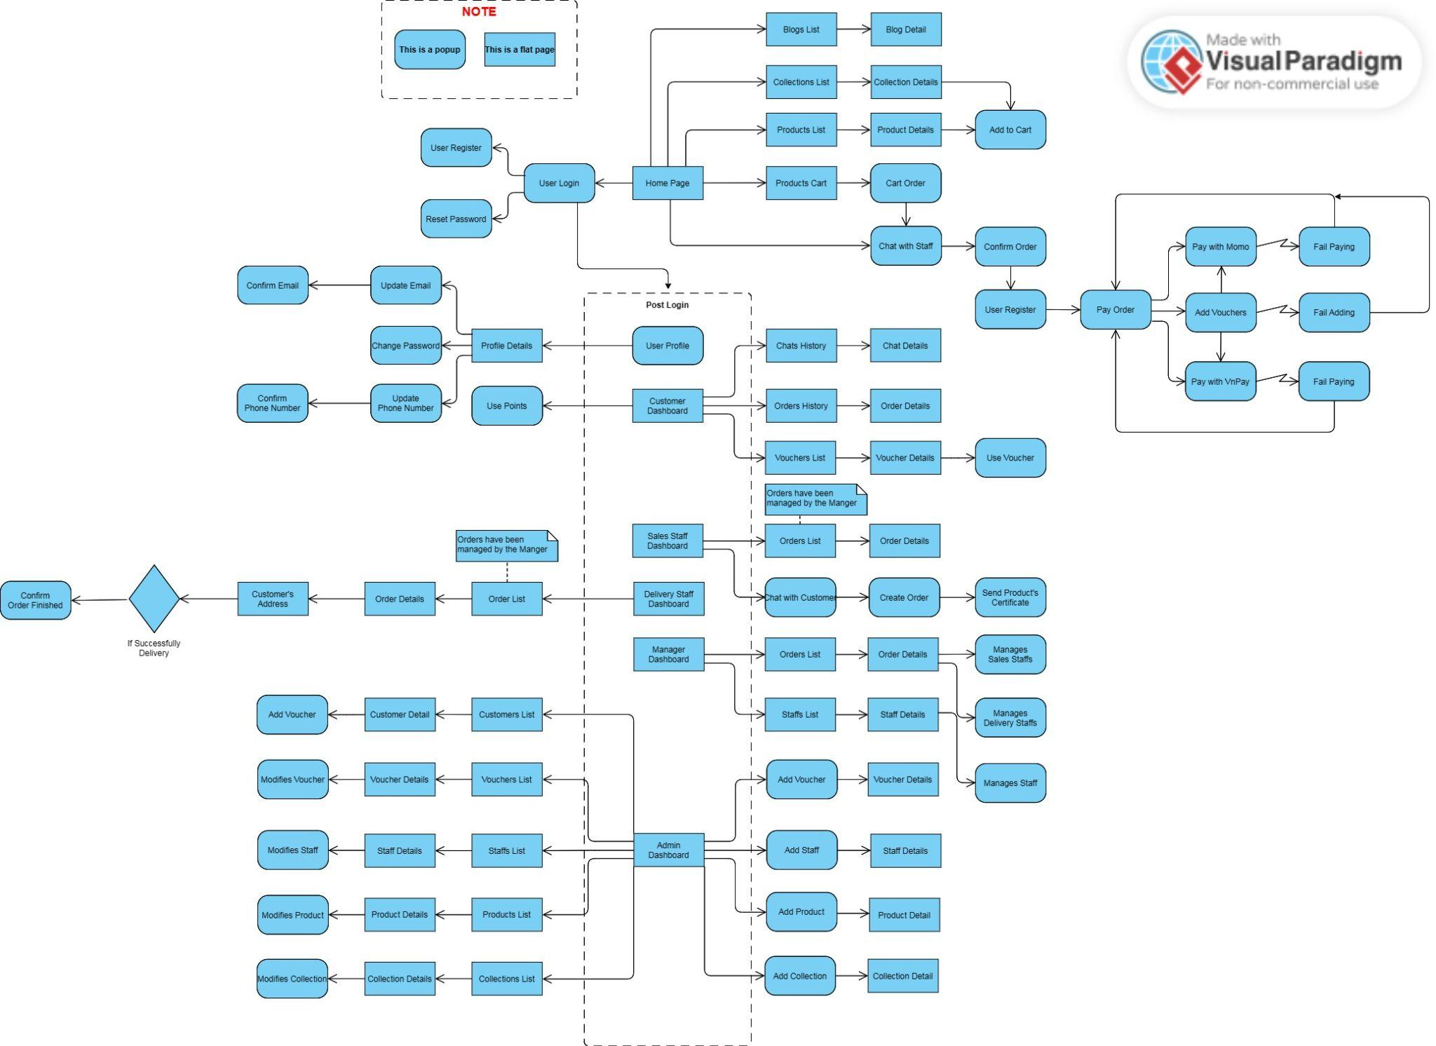

*Figure 3.1. Screen Flow Diagram*

# 

# 

# 

# 

# **3.2 Entity Relationship Diagram**

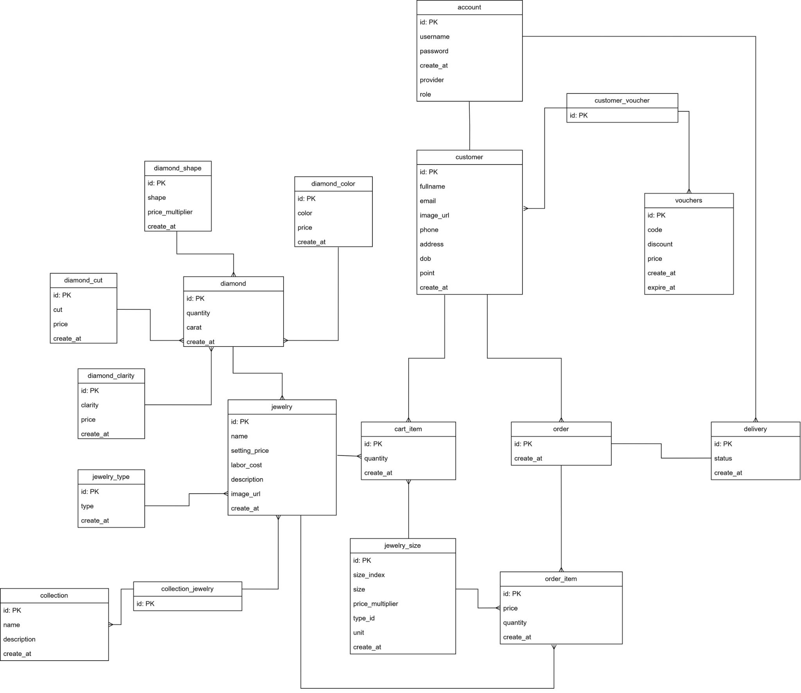

*Figure 3.2. Entity relationship diagram*

# 

# 

# 

# **3.3 Data Dictionary**

| Data Element | Description | Composition or Data Type | Length | Values |
| --- | --- | --- | --- | --- |
| account_id | Provides an identity id for user who logged in | Long |  | Not null |
| role_id | Provides an id to specify each role user has | Long | 10 | Not null |
| role | Provides a role name to direct user who logged in to correct page | String | 20 | Not null |
| role_description | A detailed description of the role. | String | 1000 |  |
| create_at | Collects date & time create new data | Date |  |  |
| update_at | Collects date & time update new data | Date |  |  |
| username | Using email user registered to log in | String | 20 | Not null |
| password | Using characters user registered in create password to log in | String | 100 | Not null |
| dateOfBirth | User’s birthday | Date |  |  |
| name | User’s name | String | 255 |  |
| address | User’s address | String | 1000 |  |
| phone | User’s phone number | String | 10 |  |
| email | User’s email | String | 20 |  |
| payment | Customer’s payment method | String | 20 |  |
| salary | User’s salary (except customer) | Long |  |  |
| jewelry_id | Provides an id to specify each jewelry. | Long |  | Not null |
| jewelry_name | Provides a name to specify each jewelry. | String | 50 |  |
| jewelry_description | A description for jewelry | String | 1000 |  |
| jewelry_quantity | Provides quantity of jewelry available | Integer | 10000 |  |
| jewelry_img | An image for each jewelry | Byte |  |  |
| jewelry_price | A price of jewelry | Long |  |  |
| jewelry_types | Types of jewelry | String | 50 |  |
| diamond_id | Provides an id to specify each diamond. | Long |  | Not null |
| diamond_name | Provides a name to specify each diamond. | String | 50 |  |
| diamond_carat | Specify diamond’s carat | Double | 10 |  |
| diamond_cut | Specify diamond’s cut | String | 20 |  |
| diamond_color | Specify diamond’s color | String | 20 |  |
| diamond_clarity | Specify diamond’s clarity | String | 20 |  |
| diamond_description | Specify diamond’s description | String | 20 |  |
| diamond_shape | Specify diamond’s shape | 20 | 20 |  |
| diamond_price | A price of diamond | Long |  |  |
| diamond_image | An image for each diamond | Byte |  |  |
| cart_id | Provides an id to specify each cart item. | Long |  |  |
| cart_total_amount | Calculate total amount of each item | Integer | 100 |  |
| order_id | Provides an id to specify each order. | Long |  |  |
| order_name | Provides an order’s name | String | 50 |  |
| order_date | Provides a date when order is created | Date |  |  |
| order_status | Show order status is purchased or not | Bit |  |  |
| order_total_amount | Calculate total amount cart items | Integer | 1000 |  |
| order_total_price | Calculate total price of order | Long |  |  |
| f_id | Provides an feedback id | Long |  |  |
| f_title | Provide issue to feedback | String | 100 |  |
| f_description | Give a description about issue | String | 10000 |  |
| v_id | Provides a voucher id | Long |  |  |
| v_name | Provide a voucher name | String | 100 |  |
| v_value | Provide a voucher value | Long |  |  |
| v_description | A voucher description | String | 10000 |  |
| v_expiration | Voucher expiration date | Date |  |  |

# 

# **3.4 Use Case Diagram**

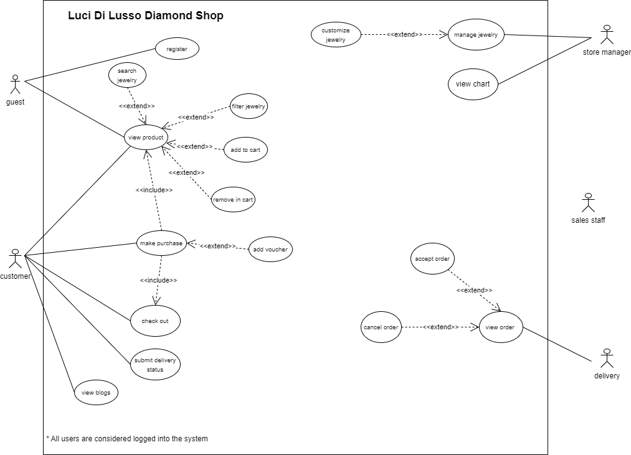

*Figure 3.4. Use case diagram*

# **3.5 Use Case Specification**

## **3.5.1 Use Case 01: Order Jewelry**

| **ID and Name** | UC01 - Order Jewelry | | |
| --- | --- | --- | --- |
| **Date created** | 27/05/2024 | | |
| **Primary Actor** | Customer | Secondary Actors | Storage manager, sales staff, diamond system |
| **Description** | A Guest/ Customer accesses the Diamond shop to view the menu of jewelry , search and select items he wants to buy, then choose delivery methods, use discounts and choose payment methods. | | |
| **Trigger** | A Guest/ Customer wants to buy jewelry online | | |
| **Preconditions** | PRE - A guest must login/register into diamond shop system | | |
| **Postconditions** | POST - 1 Jewelry orders stored in system with a status of “Accepted”  POST - 2 Storage of available jewelry items with 4C Standard  POST - 3 Ensuring safe delivery to customers | | |
| **Normal Flow** | 1.0 Order a Single Jewelry  1. Customers ask to view menu and jewelry’s price change  2. Customers menu of available Jewelry items and the daily price.  3. Customers select one or more Jewelry items from the menu.  4. Customers indicate that the Jewelry order is complete.  5. System displays ordered menu items, individual prices, and total price, including taxes and delivery charge.  6. System will send customers a product quality inspection certificate according to 4c standards  7. System displays available delivery times for the delivery date  8. Customers selects a delivery time and specifies the delivery location  9. Customers specify payment methods.  10. System confirms acceptance of the order. 11. System sends Patron an email message confirming order details, price, and delivery instructions. 12. System stores order, sends Jewelry items information to Cafeteria Inventory System, and updates available delivery times. | | |
| **Alternative Flows** | 1.1 Order multiple identical Jewelries 1. Customers require a diamond inspection certificate and safe delivery  1.2 Order multiple Jewelries  1. Customers ask to exchange or return Jewelries. | | |
| **Exceptions** | 1.0.E1 Requested date is today and current time is after today’s order cutoff time  1. System informs Customer that it’s too late to place an order for today. 2a. If Customer cancels the jewelry ordering process, then System terminates the use case. 2b. Else if Customers requests another date, then System restarts use case.  1.0.E2 No delivery times left 1. System informs Customer that no delivery times are available for the jewelry date. 2a. If Customer cancels the meal ordering process, then System terminates the use case. 2b. Else if Customer requests to pick the order up at the diamond shop, then continue with normal flow, but skip steps 7 and 8.  1.1.E1 Insufficient inventory to fulfill multiple Jewelry order  1. System informs Patron of the maximum number of identical meals he can order, based on current available inventory. 2a. If Customer modifies the number of Jewelry ordered, then Return to step 4 of normal flow. 2b. Else if Customer cancels the meal ordering process, then System terminates use case | | |
| **Priority** | High | | |
| **Frequency of Use** | About 1000 users, on average 1-2 users buy jewelry. Because jewelry is expensive, users just access the website to see the jewelry. | | |
| **Business Rules** | BR-1: Receiving purchase requests from after 8:00 AM to 9:00 PM from Monday to Sunday. BR-2: Receiving invoices with a maximum quantity of 10 items/invoice. In case the invoice has more than 10 items or contains loose stone products, the sales staff must assist the customer BR-3: In case a customer orders the same item on multiple invoices and uses cash payment upon receipt, the sales staff is responsible for contacting the customer about the purpose of the order within 24 hours. after the order is recorded on the system. BR-4: In case an order for an individual does not have contact information on the system or is placed as a gift, the person placing the order must provide full and correct information about full name, address and contact information. BR-5: In case a customer has problems ordering diamonds or diamond-encrusted jewelry, sales staff or store managers must receive support within 15 minutes at most from the time the customer requests support. BR-6: Customers paying in cash must transfer a deposit in advance equal to 10% of the value of the order invoice and must receive an electronic deposit receipt via the system or Zalo to confirm with the delivery person. BR-7: Customers who pay by bank transfer after successful transfer must receive a receipt and related documents no later than 30 minutes from the successful transaction. BR-8: In case of domestic delivery, to customers' addresses close to the warehouse, the slowest delivery time is 5 days to 1 week in case of stock. For addresses far from the warehouse, it will take at least 2 weeks in case of stock, depending on shipping conditions. In the above delivery cases, all relevant documents and invoices must be provided to the customer after confirmation from the sales staff. BR-9: Domestic return policy is 48 hours from successful delivery and each product in the invoice can only be exchanged once within 48 hours in cases of damage caused by the manufacturer. , damage during transportation or goods that do not match the specifications, appearance, or quantity as ordered by the customer.  BR-10: In case the customer has applied for a voucher with a value of less than 500,000 VND, the return policy will still apply but will only refund based on item BR-7 and will not refund the voucher. | | |
| **Other Information** | 1. Customers shall be able to cancel the jewelry ordering process before deposit time. If they cancel after deposit time they will lose deposit cost. 2. Customers can check the product quality after receiving the goods, and can investigate if they do not comply with the requirements when placing the order. | | |

## 

## **3.5.2 Use Case 02: Add a jewelry**

| **ID and Name** | UC02 - Add a jewelry | | |
| --- | --- | --- | --- |
| **Date created:** | 27/05/2024 | | |
| **Primary Actor** | Store Manager | **Secondary Actors:** | Store manager |
| **Description** | A store manager adds new jewelry into the system. | | |
| **Trigger** | A sales staff logs into the systems and interacts with the create function. | | |
| **Preconditions** | PRE-1. Sales staff members must login to the system and | | |
| **Postconditions** | POST-1. A weekly sales report is generated.  POST-2. The report is available for review by the store manager. | | |
| **Normal Flow** | Generate a Weekly Report   1. Sales staff members select the ‘Generate Weekly Report’ option in Generate Report Feature (GRF) . 2. GRF prompts to confirm or edit date range for reporting period. 3. Sales staff member confirms date range. 4. GRF retrieves all relevant sales data for a specified period. 5. GRF compiles data into a predefined report format including total sales, top products sold, weekly revenue, etc. 6. GRF displays a draft of a weekly report on screen for review. 7. Sales staff members review and approve drafts or make necessary edits. 8. Approved final version of the weekly report is saved in the system or exported into excel files if needed and notification sent to the store manager. | | |
| **Alternative Flows** | A1: If there are discrepancies in data  1. System flags discrepancies for review by sales staff members.  2. Staff corrects any errors before finalizing the report. | | |
| **Exceptions** | E1. The day range in the report includes a holiday  1. The system displays an error message and prompts the user to correct the input**.** 2a. If sales staff cancels the process, then Generate Report Feature terminates use cases.  2b. Else if sales staff request another day range, then GRF restarts use case.  E2. Weekly Report is already generated  1.The system informs sales staff that the weekly report is already generated for this week and asks sales staff if they want to update this report or not.  2a.If sales staff cancels the process, then the notification disappear  2b.Else if sales staff requests to update weekly report, then continue with step 4 | | |
| **Priority** | Medium | | |
| **Frequency of Use** | Every Monday. Peak usage load for this use case is 8:00 AM in local time | | |
| **Business Rules** | BR-1: The system should automatically remind sales staff to generate the weekly report every Monday at 8:00 AM  BR-2: 1 sales staff can only create 1 weekly report a week.  BR-3: The report must be filled in the previous day or within the limit is 2 days after the week's report in case of a sales staff absence on Monday.  BR-4: The weekly report must include total sales revenue, number of transactions, and average transaction value. BR-5: The report must detail the number of new customers, returning customers, and total customer visits. BR-6: The weekly report must include current inventory levels, restocked items, and items low in stock. BR-7: The report must analyze the effectiveness of ongoing promotions and discounts, including total discount given and sales uplift. BR-8: The report must include individual sales staff performance metrics, such as total sales, number of transactions handled, refund offer and customer feedback ratings. BR-9: The report must include comparisons with previous weeks' data to identify trends and patterns.  BR-10: In case of sales staff reports more than 2 days late from the date of annual reporting or not reporting more than 2 weeks will be fined on salary based on weekly penalties.  BR-11: In case the Staff quits his/ her job, the store manager must generate the employee's weekly report from the data from the date of the data collection to the end date. | | |
| **Other**  **Info** | None | | |

## **3.5.3 Use Case 03: View Cart**

| **ID and Name** | UC03 - View Cart | | |
| --- | --- | --- | --- |
| **Date created:** | 27/05/2024 | | |
| **Primary Actor** | Customer | **Secondary Actors:** | Support system(Product, Inventory,....) |
| **Description** | Allows customers to check and manage products added to the cart before making payment. When the customer selects "View cart", the system will display a list of added products including detailed information about each product such as product name, image, price, quantity. Customers can perform operations such as updating product quantities, removing products from the cart and applying discount codes if available. | | |
| **Trigger** | * Select cart icon: Customers click the cart icon on the website or mobile app to view added products. * Select the "View Cart" link or button: The customer clicks the "View Cart" link or button from the menu or product page. * Complete adding products to cart: After adding products to cart, some systems will automatically display the cart or provide the option for customers to view the cart immediately. | | |
| **Preconditions** | **PRE-1** Customer is logged in (if necessary): If the system requires the customer to log in to view or manage their shopping cart, the customer must be logged in to their account.  **PRE-2** There is at least one product in the cart: The customer has added at least one product to the cart. If the cart is empty, the system will not be able to display the product list and may notify the customer that the cart is currently empty.  **PRE-3** System functioning properly: Essential system services such as product management, warehouse management, and other related services are operating normally to provide detailed information and cart updates.  **PRE-4** Stable network connection: Customers have a stable network connection to interact with the system and receive shopping cart updates. | | |
| **Postconditions** | **POST-1** Shopping cart updated and stored: Any changes made by the customer, such as updating product quantities or deleting products, are saved by the system and the shopping cart is updated in real time .  **POST-2** Total order value information is displayed accurately: The total value of the shopping cart, including product price, taxes, and shipping fees (if any), is calculated and displayed accurately to customers.  **POST-3** Discount code applied (if any): If the customer has entered a discount code, the system will check the validity of the code and apply the discount to the total order value.  **POST-4** Customers can proceed to checkout or save the shopping cart: After viewing and managing the shopping cart, customers can select "Checkout" to begin the payment process or save the shopping cart to continue shopping later.  **POST-5** Notify customers about cart status: If any problems occur, such as the product is no longer in stock, the system will notify the customer so they can adjust their cart. | | |
| **Normal Flow** | 1. Customer selects "View Cart": Customer clicks the cart icon or "View Cart" link/button from any page on the website or app. 2. Cart display system: The system retrieves customer cart information and displays a list of products added to the cart, including: Product name, Product image, Quantity, Price of each product products, Total price of each product, Total cart value (excluding taxes and shipping fees) 3. Customer checks cart: Customer reviews the products in the cart to make sure everything is as expected. 4. Customer updates cart: Customer can take the following actions:   +Update quantity: Customers can increase or decrease the quantity of each product.  +Delete products: Customers can remove unwanted products from the shopping cart.   1. Cart update system: The system updates the cart according to customer changes and displays the total cart value again. 2. Customers apply discount code (optional):   +Customers can enter the discount code in the corresponding box and press the apply button.  +The system checks the validity of the discount code and updates the total cart value if the code is valid.   1. The system calculates the total value of the cart: The system displays the total value of the cart including discounts, taxes and shipping fees (if any). 2. The customer decides on the next action:   +Select "Checkout": If the customer is satisfied with their shopping cart, they can select the "Checkout" button to proceed to the checkout process.  +Continue shopping: Customers can choose to continue shopping and add other products to the cart.  +Save cart (optional): Customers can choose to save the cart to continue managing or paying later. | | |
| **Alternative Flows** | 1. Shopping cart is empty   + The system confirms that the customer's shopping cart does not contain any products.  +Display notification: The system displays a notification to the customer that the shopping cart is empty, with suggestions to continue shopping and add products to the shopping cart.  +Redirection: The system can provide links or buttons for customers to return to the home page or product category page to continue shopping.   1. The product is out of stock   + Check warehouse status: The system checks warehouse status when customers update product quantities.  + Out of stock notification: If the product is no longer in stock or does not have the required quantity, the system displays an error message to the customer, informing that the product is out of stock or has insufficient quantity.  + Update cart: The system keeps the current quantity of products in the cart (if any) and requires the customer to adjust the quantity.   1. Invalid discount code   + Check discount code: The system checks the discount code when the customer presses the apply button.  + Invalid code notification: If the discount code is invalid or expired, the system displays an error message to the customer, explaining why the code is not accepted.  + Request to re-enter code: The system allows customers to re-enter another discount code or continue without a discount code. | | |
| **Exceptions** | 1. Lost network connection   + Connection loss detection: The system detects that the network connection is interrupted when the customer interacts with the shopping cart.  + Display error message: The system displays an error message to the customer, requesting to check the network connection.  + Retry: The system provides the option for customers to try again after the network connection is restored.   1. System error   + System error detection: The system detects that a system error occurred while the customer interacted with the shopping cart.  + Display error message: The system displays a general error message to the customer, apologizing for the problem and asking to try again later.  + Error recording: The system records errors in the log and sends a notification to the technical department to check and fix the problem. | | |
| **Priority** | High | | |
| **Frequency of Use** | Daily frequency: Most users will use the "View Cart" function every time they visit an e-commerce website or application to shop online. They often review their shopping carts to check and manage products before proceeding to checkout. | | |
| **Business Rules** | **BR-1** Maximum number of products in cart: Limit the number of products to 10 that a customer can add to the cart to ensure flexibility and the best shopping experience.  **BR-2** Cart retention time: Determines the time a cart is stored on the system before being deleted. This could be related to customer waiting times or business policies.  **BR-3** Shipping Rules: Defines the shipping rules that apply to the shopping cart, including shipping rates, available shipping methods, and delivery zones.  **BR-4** Promotion Rules:Rules and conditions apply to the use of discount codes or other offers related to the shopping cart.  **BR-5** Total order value calculation rules: Define how the total value of the cart is calculated, including product price, taxes, shipping charges, and applicable discounts.  **BR-6** Out-of-stock product check rule: The system must check before adding a product to the cart to ensure that the product is still in stock and has sufficient quantity.  **BR-7** Product quantity update rule: Defines how the product quantity is updated in the shopping cart when the customer changes the product quantity.  **BR-8** Login rule: Require customers to log in to their account to view and manage shopping carts (optional).  **BR-9** Save cart feature rule: Determines whether to allow customers to save their cart for future reuse, and how long the cart is stored. | | |
| **Other Information** | 1. Integration with "Save for Later" function: The system can provide a "Save for Later" feature to allow customers to save products they do not want to buy immediately into a separate list, helping to create a more flexible shopping experience. 2. Integration with the "Recommendations" function: The system can integrate the "Suggestions" function to suggest similar or suitable products to customers during the cart viewing process, increasing purchase opportunities.. 3. Integration with Analytics system: Data on the use of the "View Cart" function can be collected and analyzed to understand customer shopping behavior, thereby optimizing user experience and sales strategy row. | | |

## **3.2.4 Use Case 04: Manage Transport**

| **ID and Name** | UC04 - Manage Transport | | |
| --- | --- | --- | --- |
| **Date created:** | 30/05/2024 | | |
| **Primary Actor** | Transporter  Customer | **Secondary Actors:** | Storage Manager |
| **Description** | This use case describes how the Storage Manager and Transporterinteract with the Diamond Shop System to manage the transport from store to customer. | | |
| **Trigger** | Customers create a bill when choose to buy something available in the store | | |
| **Preconditions** | PRE-1.The system is up and running.  PRE-2.The Customer must have valid login.  PRE-3.The Customer must buy diamond available in the store  PRE-4.Storage Manager received order from customer | | |
| **Postconditions** | POST-1.The Transporter receive diamond from Storage Manager  POST-2.The Transporter coutinue update status when leave the store until successful delivery. | | |
| **Normal Flow** | 1.The customers log into the system.  2.The customers buy diamonds and the system creates orders.  3.The Storage Manager received orders from the system.  4.The Storage Manager identifies and prepares orders.  5.The Transporter received diamonds from the Storage Manager.  6. The Transporter starts shipping and keeps updating status from when leaving the store until successful delivery. | | |
| **Alternative Flows** | If the diamonds are not available in the inventory, therefore we can not ship away and have to ask customers to choose the order of diamonds. | | |
| **Exceptions** | 1.If during delivery, the Transporter is unable to update the status   * There is a emergency phone number in case a problem occurs for the Transporter keep report until the system is fixed and operates normally again   2.After successful delivery, if the Transporter is unable to report success   * There is a emergency phone number for the Transporter in case a problem occurs, call and report | | |
| **Priority** | High | | |
| **Frequency of Use** | Daily, as the customer needs to buy anything. | | |
| **Business Rules** | BR-1: The Transporters only ship when the Storage Manager confirms the order.  BR-2: The diamonds which customers buy must be available.  BR-3: The Transporters must take the picture or video package's original condition when receiving the diamond and show it to the customer.  BR-4: The package's original condition must be the same of the picture or video which the Transporters show to the customers  BR-5: For inner-city orders in The Transporter must deliver the same day.  BR-6: For inter-provincial orders The Transporter must deliver at max at one week  BR-7: For international orders The Transporter must deliver at max at one month | | |
| **Other Information** | The system should be user-friendly and secure.  The system should have a backup and recovery mechanism in case of data loss. | | |

# **3.6 Sequence Diagram**

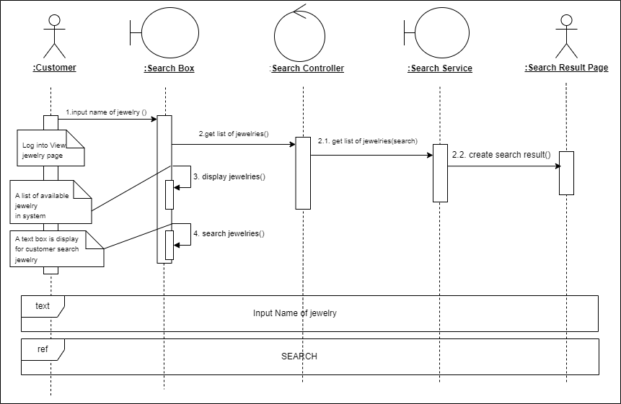  
*Figure 3.6.1. Sequence diagram - Search jewelry*

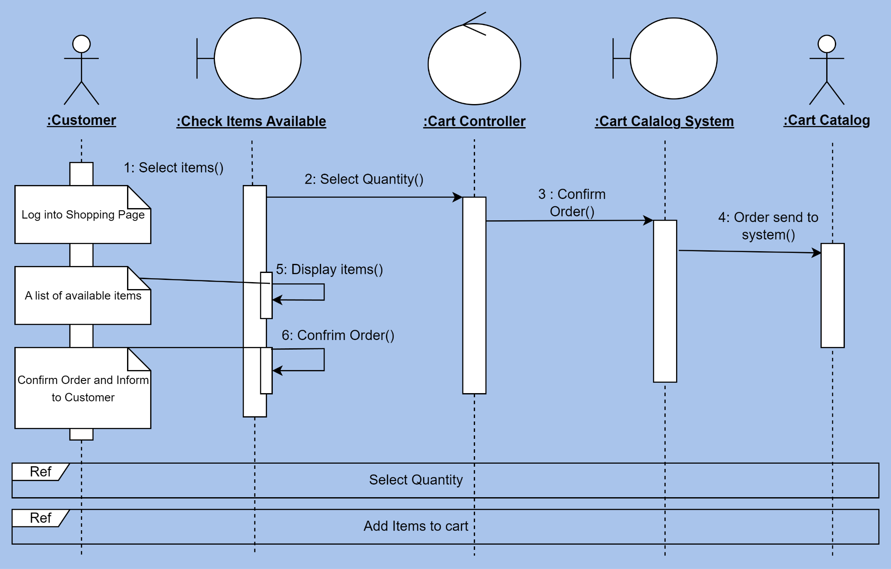

*Figure 3.6.2. Sequence diagram - Add to cart*

# **3.7 State Machine**

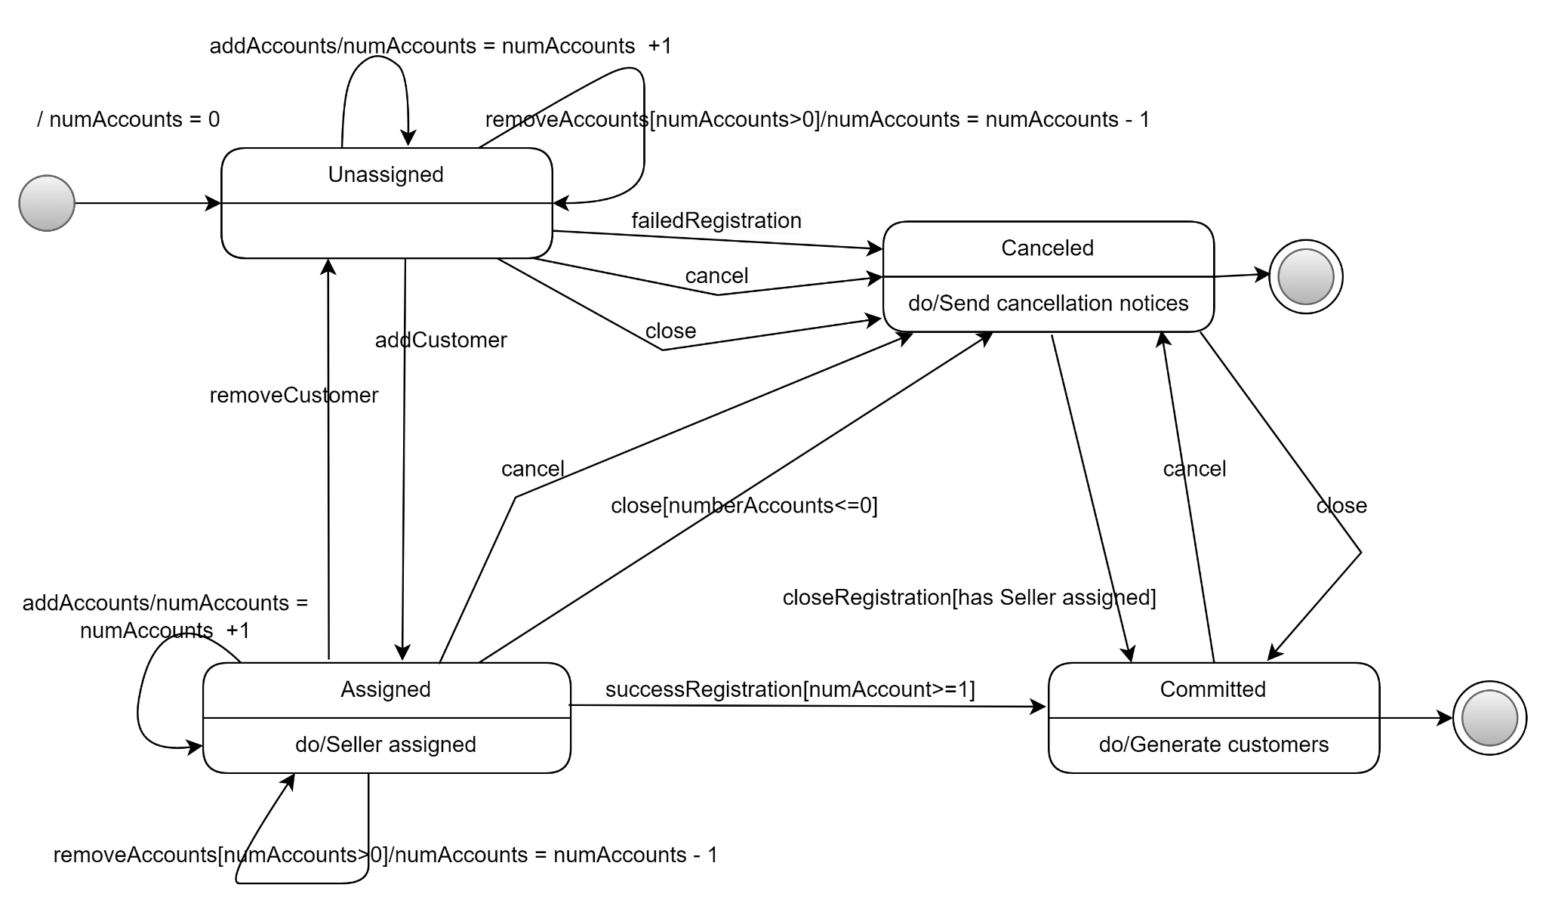

*Figure 3.7.1. State machine - Customer account registration*

*Figure 3.7.2. State machine - Add to cart*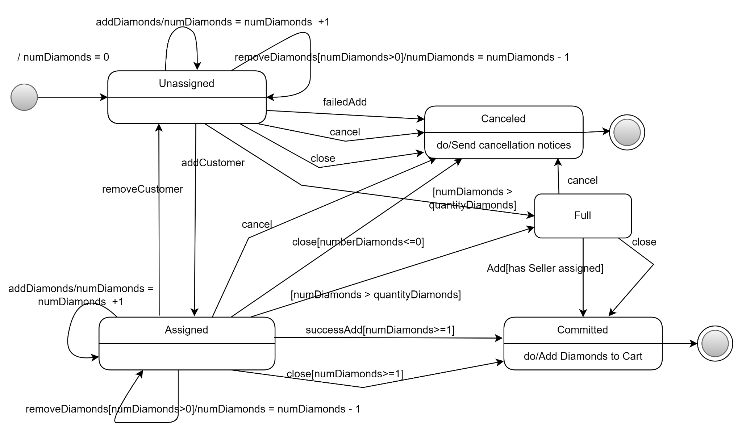

# **3.8 Swimlane Diagram**

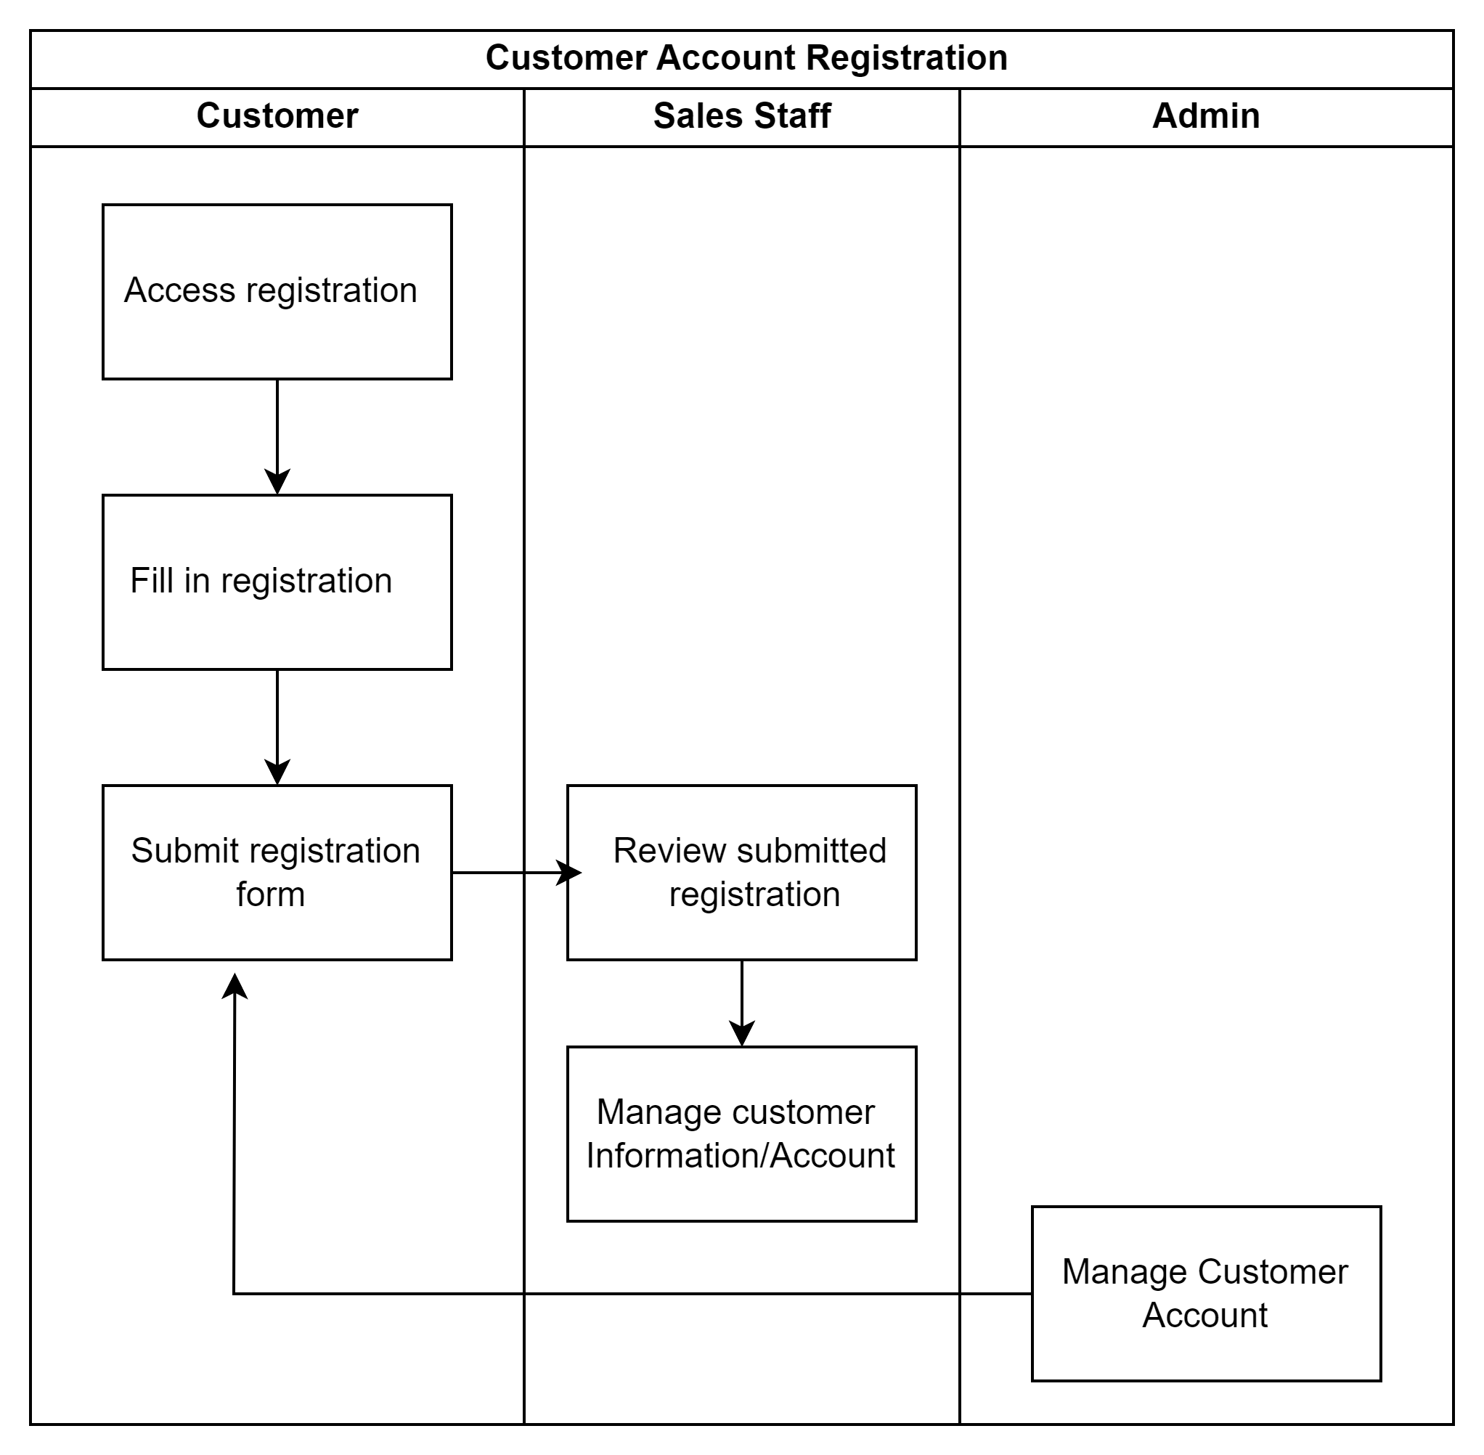

*Figure 3.8.1. Swimlane diagram - Customer account registration*

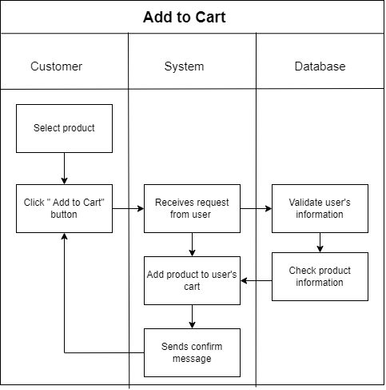

*Figure 3.8.2. Swimlane diagram - Add to cart*

# **3.9 Class Diagram**

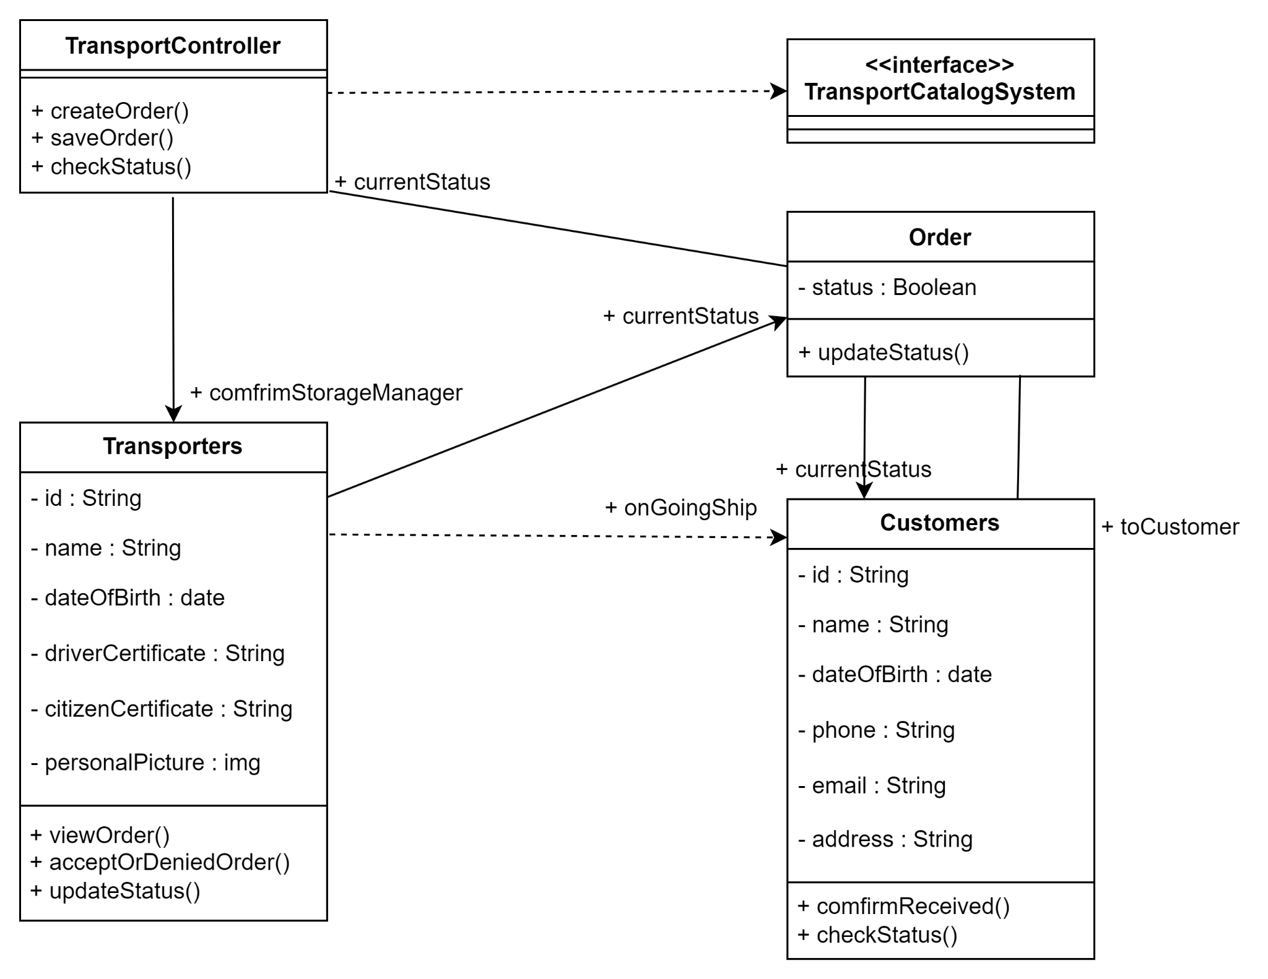

*Figure 3.9.1 Class diagram - Manage transport*

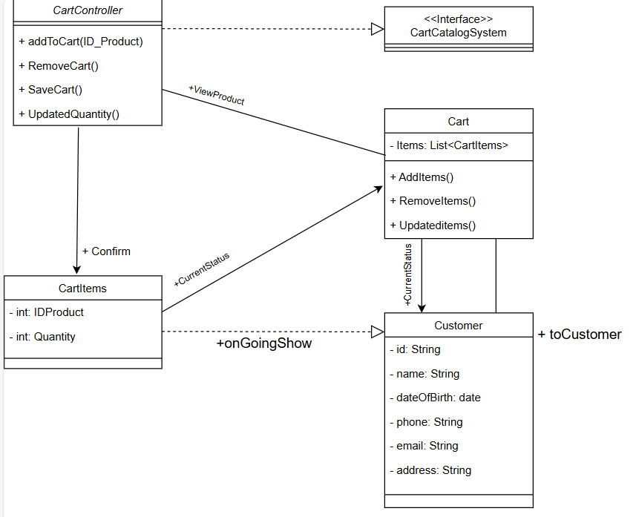

*Figure 3.9.2 Class diagram - View cart*

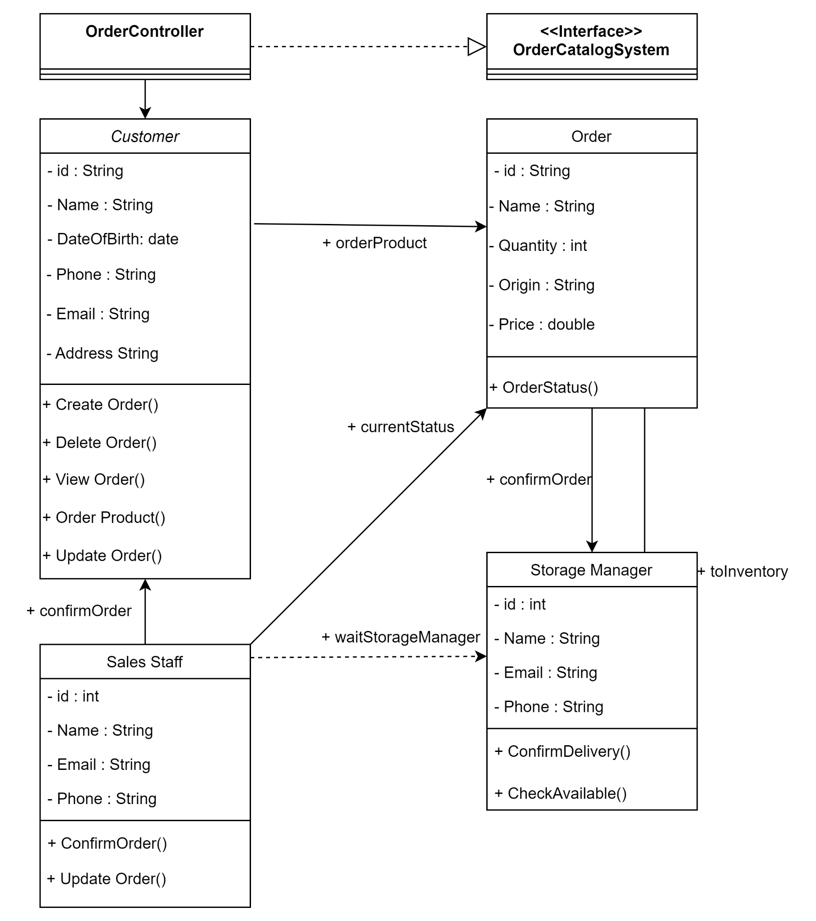

*Figure 3.9.3 Class diagram - Order products*

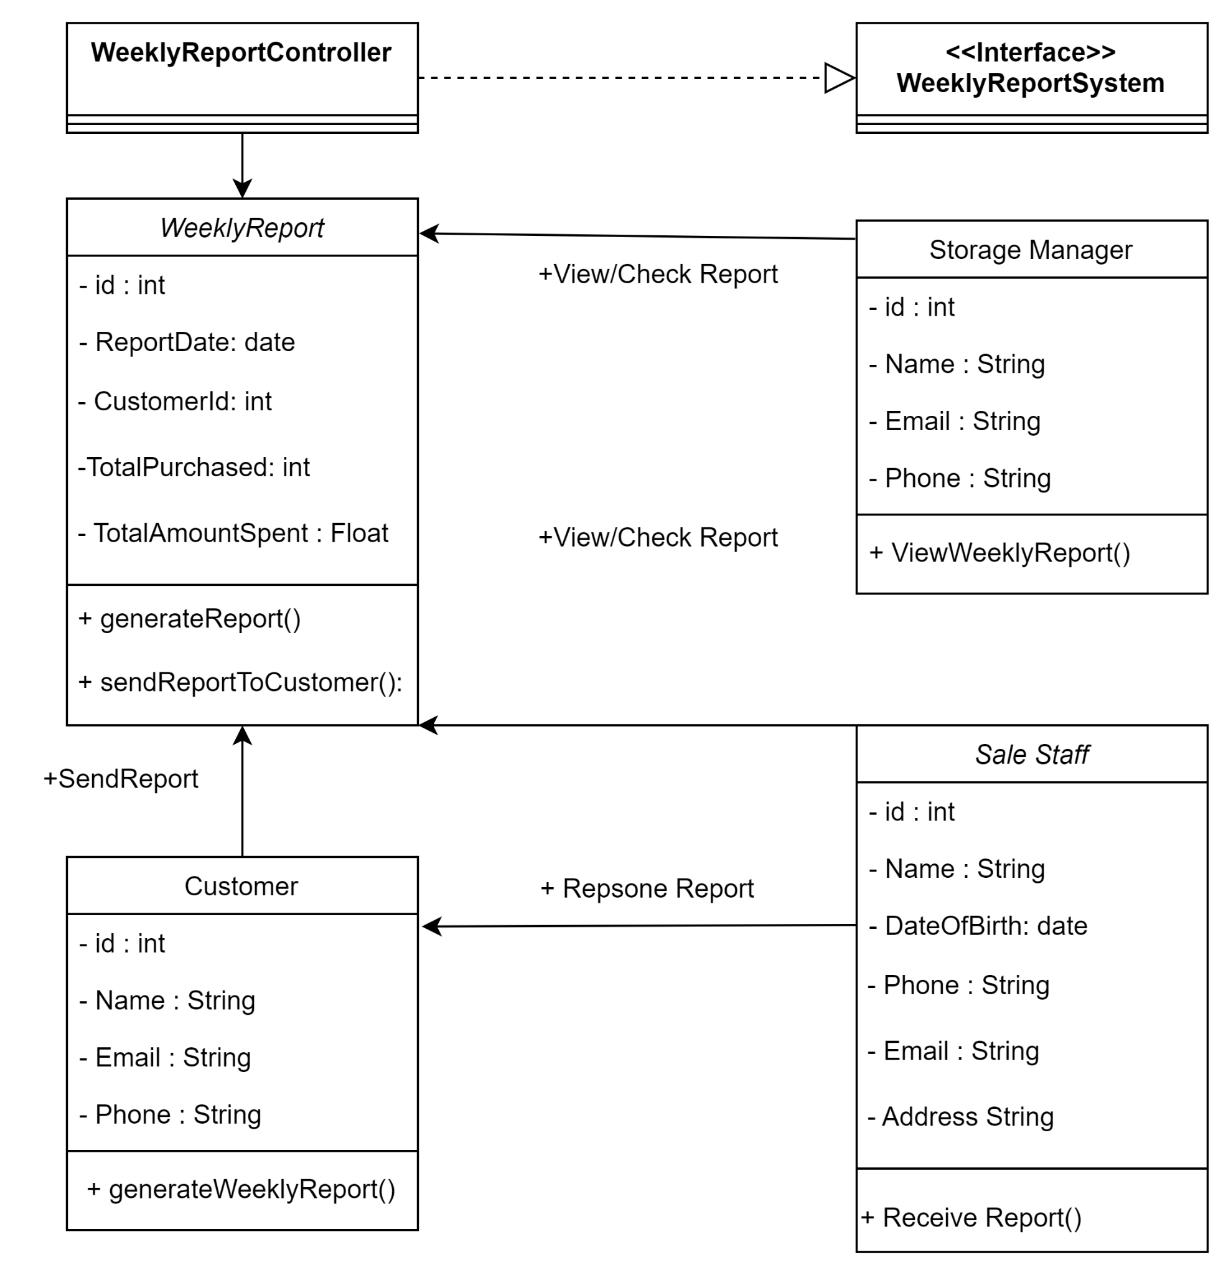

*Figure 3.9.4. Class diagram - Sales weekly report*

**VI. NON-FUNCTIONAL REQUIREMENTS**

# **4.1 Usability**

1. User Interface (UI) Design:

- Clarity: Use clear and concise language. Avoid jargon and provide explanations for technical terms related to diamonds.

- Feedback: Provide immediate feedback for user actions, such as button clicks, form submissions, and interactions with product images.

2. Navigation:

- Intuitive Navigation: Design an easy-to-use navigation menu that categorizes products logically (e.g., by type, cut, price range).  
- Search Functionality: Include a robust search feature with filters for attributes like carat, cut, clarity, and price.

3. User Support:

- Live Chat: Offer live chat support to assist users in real-time.  
- FAQs: Provide a comprehensive FAQ section addressing common questions about diamond purchasing, shipping, and returns.  
- Guides and Resources: Include educational resources such as guides on choosing diamonds, understanding the 4Cs (cut, carat, color, clarity), and diamond certification.

4. Personalization:

- Recommendations: Use algorithms to recommend products based on user behavior and preferences.  
- Saved Searches: Allow users to save their search criteria and favorite items for easy access later.

# **4.2 Reliability**

1. Availability:

Uptime: Ensure the website is available at least 99.9% of the time. Implement robust hosting solutions to minimize downtime.

Redundancy: Use redundant servers and data centers to prevent single points of failure. This includes load balancing and failover mechanisms.

Maintenance Scheduling: Perform regular maintenance during off-peak hours and inform users in advance of any planned downtime.

2. Disaster Recovery:

Disaster Recovery Plan: Develop and maintain a disaster recovery plan outlining procedures to restore services in case of a major failure or disaster.

Recovery Point Objective (RPO) and Recovery Time Objective (RTO): Define and achieve RPO and RTO targets to minimize data loss and downtime in disaster scenarios.

Regular Drills: Conduct regular disaster recovery drills to ensure the plan’s effectiveness and team preparedness.

# **4.3 Performance**

1. Response Time:  
- Page Load Time: Ensure the homepage and key product pages load within 2-3 seconds on average.  
- User Interactions: All user interactions, such as clicks, form submissions, and image loads, should have a response time of less than 100 milliseconds.

2. Scalability:  
- Horizontal Scaling: The architecture should support horizontal scaling to accommodate increased load by adding more servers.  
- Auto-Scaling: Implement auto-scaling to automatically adjust resources based on real-time traffic and load.

3. Load Balancing:  
- Distribution of Traffic: Implement load balancing to evenly distribute incoming traffic across multiple servers.  
- Failover: Ensure failover mechanisms are in place so that if one server fails, traffic is automatically rerouted to other active servers without user disruption.

4. Database Optimization:  
- Indexing: Use appropriate indexing on database tables to speed up query performance.

- Read/Write Separation: Implement read/write separation using primary and replica databases to distribute the load.

5. Performance Testing:  
- Stress Testing: Perform stress testing to determine the breaking point of the system and ensure it degrades gracefully.  
- Latency Testing: Test the system under various network conditions to ensure acceptable performance for users with different internet speeds.

# **4.4 Security**

1: Web Security Protocols

The website shall use industry-standard web security protocols (such as HTTPS, SSL/TLS) to protect all data transmissions between the server and clients. This ensures that sensitive information such as customer data and payment details are encrypted and securely transmitted.

2: Data Encryption

All stored data, including customer information, transaction records, and inventory details, shall be encrypted using strong encryption algorithms (e.g., AES-256) to prevent unauthorized access in case of a data breach.

3: User Authentication

The system shall implement a robust user authentication mechanism requiring strong passwords, multi-factor authentication (MFA), and account lockout policies after a defined number of failed login attempts to prevent unauthorized access.

4: Access Control

Access to the system shall be role-based, ensuring that only authorized personnel (e.g., sales staff, managers, admins) have access to specific functionalities and data. Each role should have clearly defined permissions to minimize the risk of unauthorized access.

5: Data Integrity

The system shall ensure data integrity by using checksums or hash functions to detect any unauthorized modifications to data. Regular integrity checks should be performed on critical data.

**V. SUPPORTING INFORMATION**  
 - Return and refund policy:

<https://www.pnj.com.vn/chinh-sach-bao-hanh-va-thu-doi.html>

<https://izzi.asia/vi-vn/bai-viet/chinh-sach-doi-tra-va-huy-san-pham>