PROJECT DOCUMENTATION
Incident Lifecycle Automation in ServiceNow
End-to-End Incident Management, Knowledge, SLA, Escalation and Change Integration

Platform | ServiceNow – Service Operations Workspace
Project | Incident Lifecycle Automation
Prepared by | Uppugandla Manjeera
Primary scenario | INC00100004 – Unable to connect to Corporate VPN from home office
Document type | Implementation and validation report

Table of Contents
1. Executive Summary
2. Problem Statement
3. Business Objectives
4. Functional Scope
5. Stakeholder Mapping
6. Execution Roadmap
7. Implementation Phases
8. Testing & Deployment
9. Results and Evidence
10. Conclusion
11. Skills Demonstrated

1. Executive Summary
This project demonstrates a complete Incident Management lifecycle automation in ServiceNow. The solution uses Service Operations Workspace and related ServiceNow capabilities to standardize incident creation, classification, assignment, knowledge integration, escalation, child-incident management, SLA tracking, emergency change integration, and resolution documentation.
The primary scenario is a Corporate VPN connectivity issue. The workflow demonstrates how a Service Desk can capture the incident, classify and assign it, use knowledge, escalate investigation, place the incident on hold while awaiting a change, resolve the parent and child incidents, and maintain a traceable activity history.

2. Problem Statement
IT incidents reported through email, phone calls, or informal channels can lead to poor tracking, inconsistent classification, delayed escalation, limited resolution visibility, SLA breaches, and weak corrective-action traceability. This project addresses those issues through a structured ServiceNow incident lifecycle.

3. Business Objectives
- Enable Service Desk agents to create and classify incidents.
- Integrate Knowledge Management for faster resolution.
- Allow reassignment to appropriate support groups and Level 2 technicians.
- Create emergency change requests from incidents when required.
- Allow child incident creation for related or recurring issues.
- Generate Knowledge Articles from resolved incidents.
- Improve SLA compliance, traceability, and service visibility.
- Document incident cause, workaround, and final resolution.

4. Functional Scope
Functional Area | ServiceNow Capability | Expected Outcome
Incident Record Creation | Service Operations Workspace | Structured incident record
Incident Classification | Category, Subcategory, Impact, Urgency, Service, CI | Accurate prioritization
Knowledge Integration | Agent Assist / Knowledge | Relevant troubleshooting guidance
Reassignment & Escalation | Assignment Group / Assigned To | Level 2 ownership
Emergency Change | Change Management | Controlled emergency change
Child Incident | Parent/child relationship | Tracking related issues
Resolution | Resolution code and notes | Complete closure documentation
Knowledge Creation | Create Knowledge | Reusable solution article
SLA Tracking | Task SLAs / Related Records | SLA visibility

5. Stakeholder Mapping
Stakeholder | Role | Needs / Expectations | Automation Impact
End Users | Report IT issues | Quick resolution and visibility | Faster resolution; transparent tracking
Service Desk Agents | First-level support | Easy logging and classification | Standardized intake; faster escalation
Level 2 Support | Diagnose and resolve | Complete incident data | Better diagnosis; clear ownership
Change Management Team | Handle emergency changes | Structured change requests | Integrated change control
ServiceNow Admin | Maintain configuration | Scalable, controlled solution | Governed and trackable process

6. Execution Roadmap
1. Requirement Analysis & Planning
2. Create New Service and Service Offering
3. Incident Record Creation
4. Incident Classification
5. Knowledge Integration
6. Reassignment & Escalation
7. Incident Tracking by Level 2
8. Emergency Change Request Creation
9. Incident Resolution
10. Knowledge Creation
11. SLA & Related Record Validation
12. Testing & Deployment
13. Conclusion

7. Implementation Phases

7.1 Phase 1 – Requirement Analysis & Planning
The planning phase defines the problem, business objectives, stakeholder responsibilities, functional scope, milestones, and required ServiceNow skills. The roadmap covers incident creation, classification, knowledge integration, escalation, emergency change, child incidents, resolution, knowledge creation, and SLA validation.

7.2 Phase 2 – Create New Service and Service Offering
The Corporate VPN service offering was configured under Remote Access. The offering is shown as a production, operational service with business criticality configured, establishing the service context used by VPN incidents.
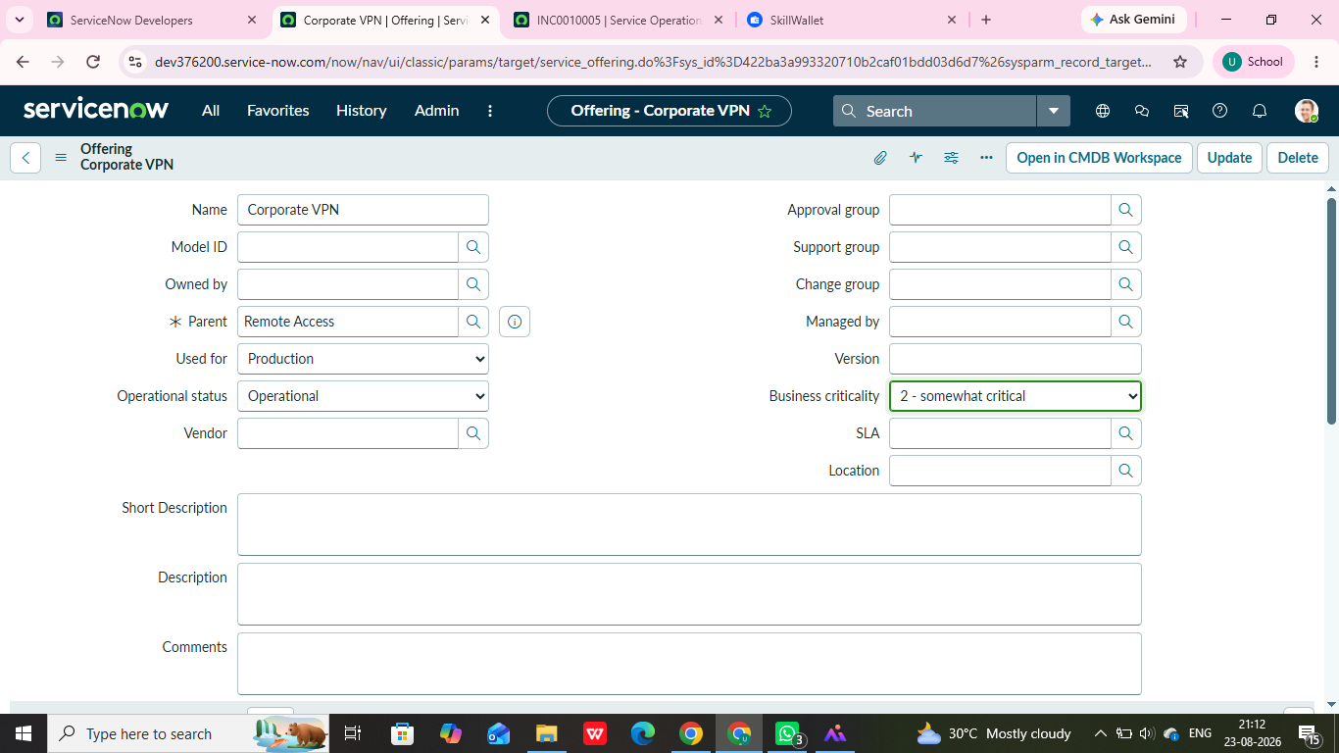
Corporate VPN service offering configuration.

7.3 Phase 3 – Incident Record Creation
A VPN incident was created for a user receiving an authentication failure while the Internet remained available. The record includes a short description, detailed description, caller, service context, assignment information, and SLA information.
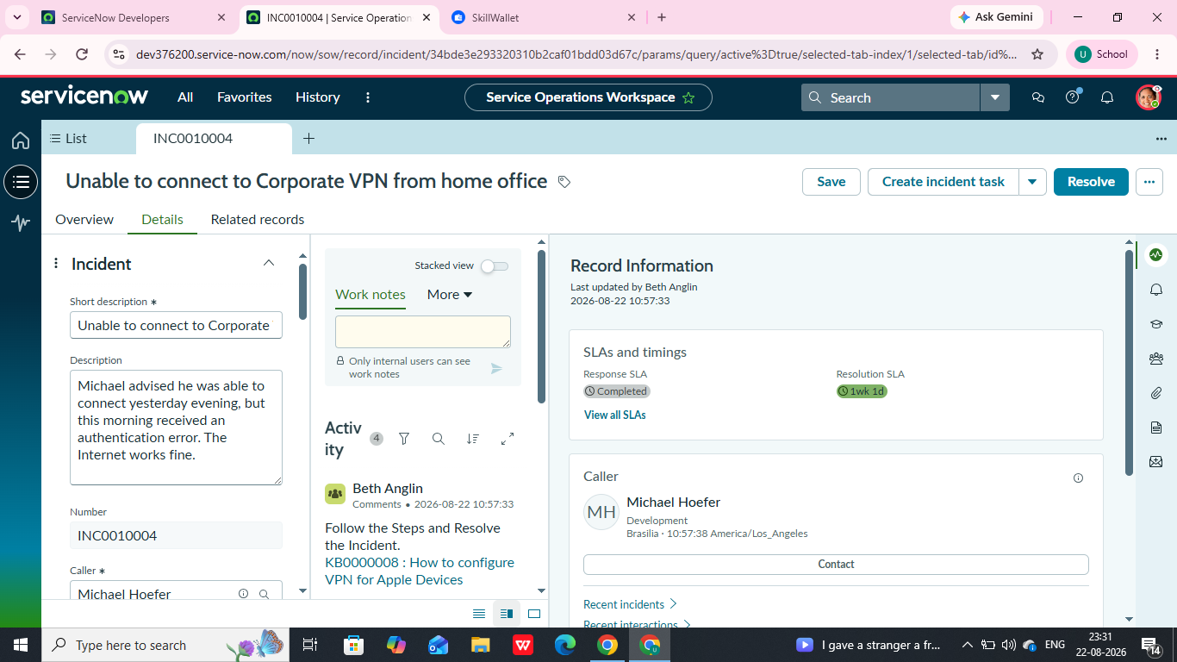
Incident description and activity showing VPN troubleshooting knowledge guidance.

7.4 Phase 4 – Incident Classification
The incident was classified using impact, urgency, priority, category, service, and configuration-item context. The activity stream records classification and assignment changes for traceability.
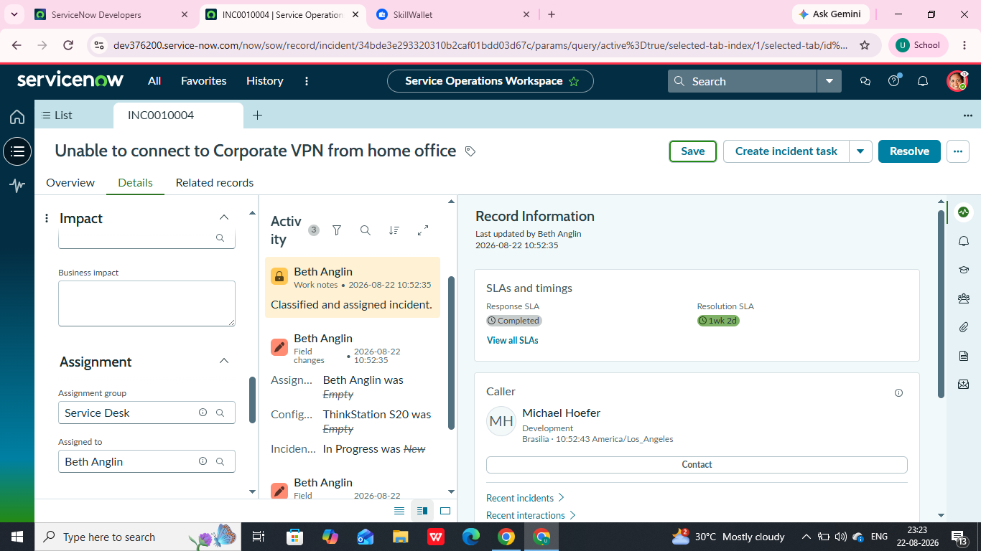
Incident INC00100004 showing assignment, activity history, and SLA information.

7.5 Phase 5 – Knowledge Integration
Knowledge integration connects incident handling with documented troubleshooting guidance. The VPN incident activity references a VPN configuration knowledge article. The project also includes creation and verification of a Knowledge Article from the incident.

Knowledge guidance referenced in the incident activity.

7.6 Phase 6 – Reassignment & Escalation
The incident lifecycle supports assignment to the Service Desk and escalation to appropriate support teams. Assignment Group, Assigned To, work notes, and activity history provide evidence of ownership and collaboration.
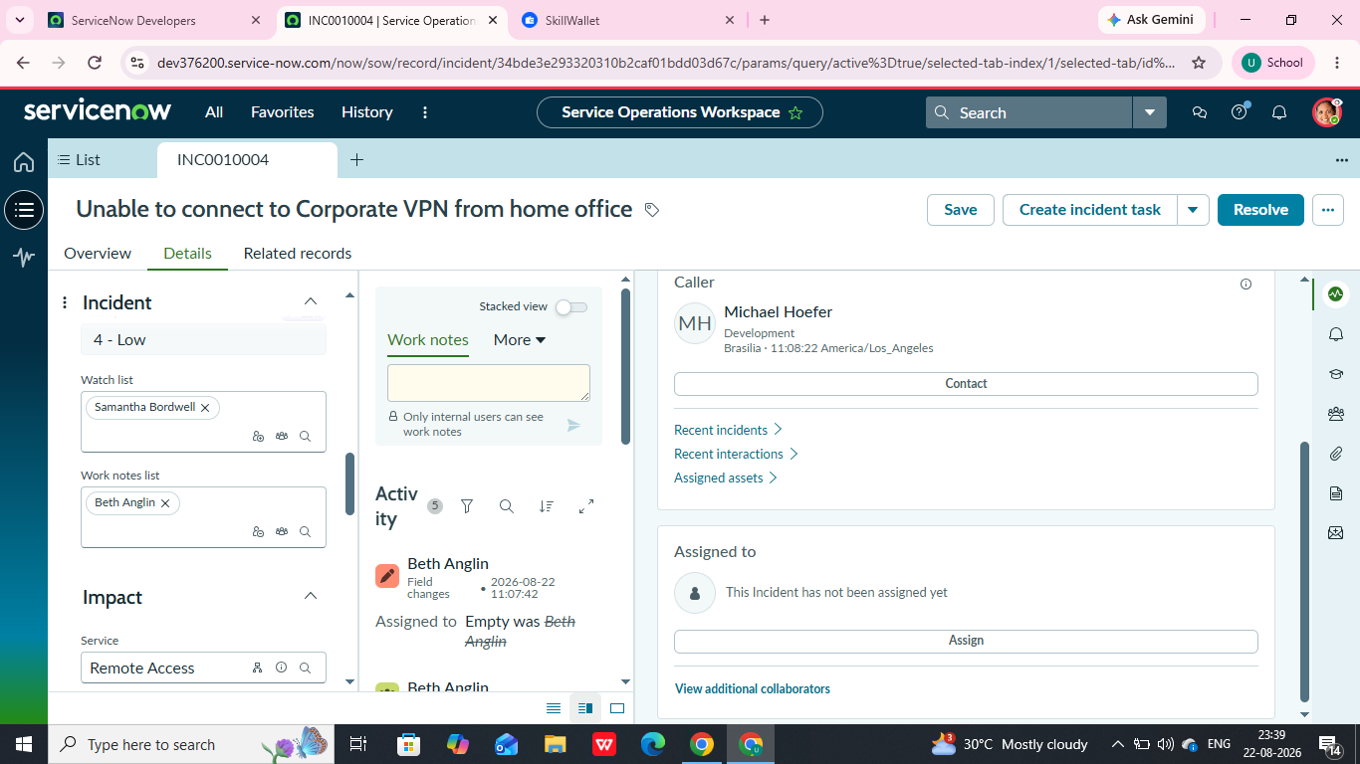
Incident assignment and collaboration fields.

7.7 Phase 7 – Incident Tracking by Level 2
Level 2 investigation is supported through assignment, activity history, configuration-item context, and related incident records. This provides the technical team with the information needed for investigation.
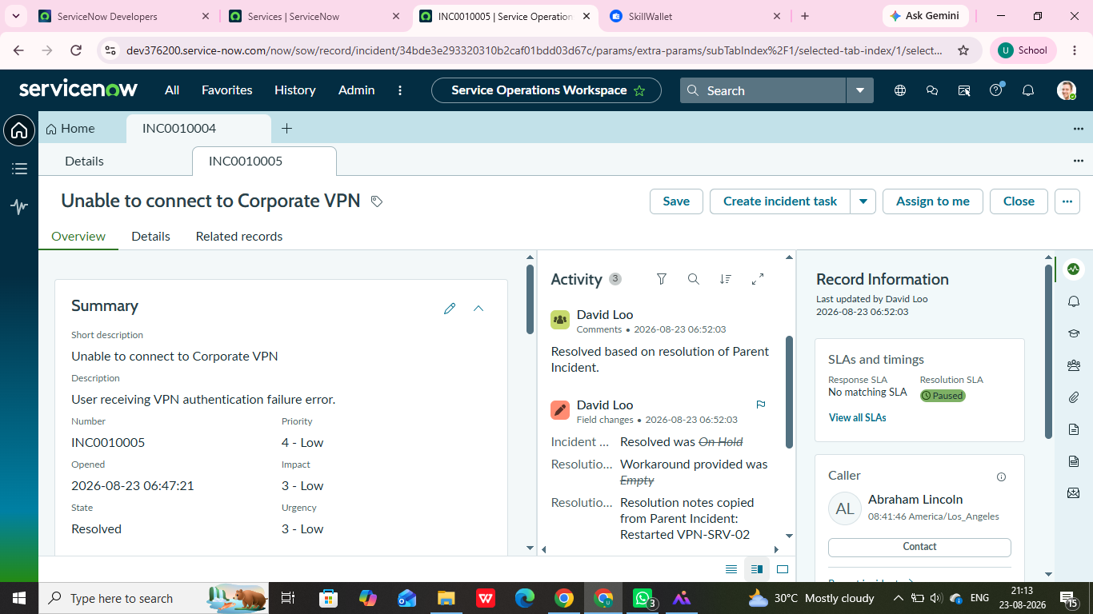
Child incident INC00100005 showing resolution based on the parent incident.

7.8 Phase 8 – Emergency Change Request Creation
When an incident requires an emergency change, the incident can be placed On Hold with the reason Awaiting Change while the change is processed. The resolution history then documents the corrective action performed under the emergency change.
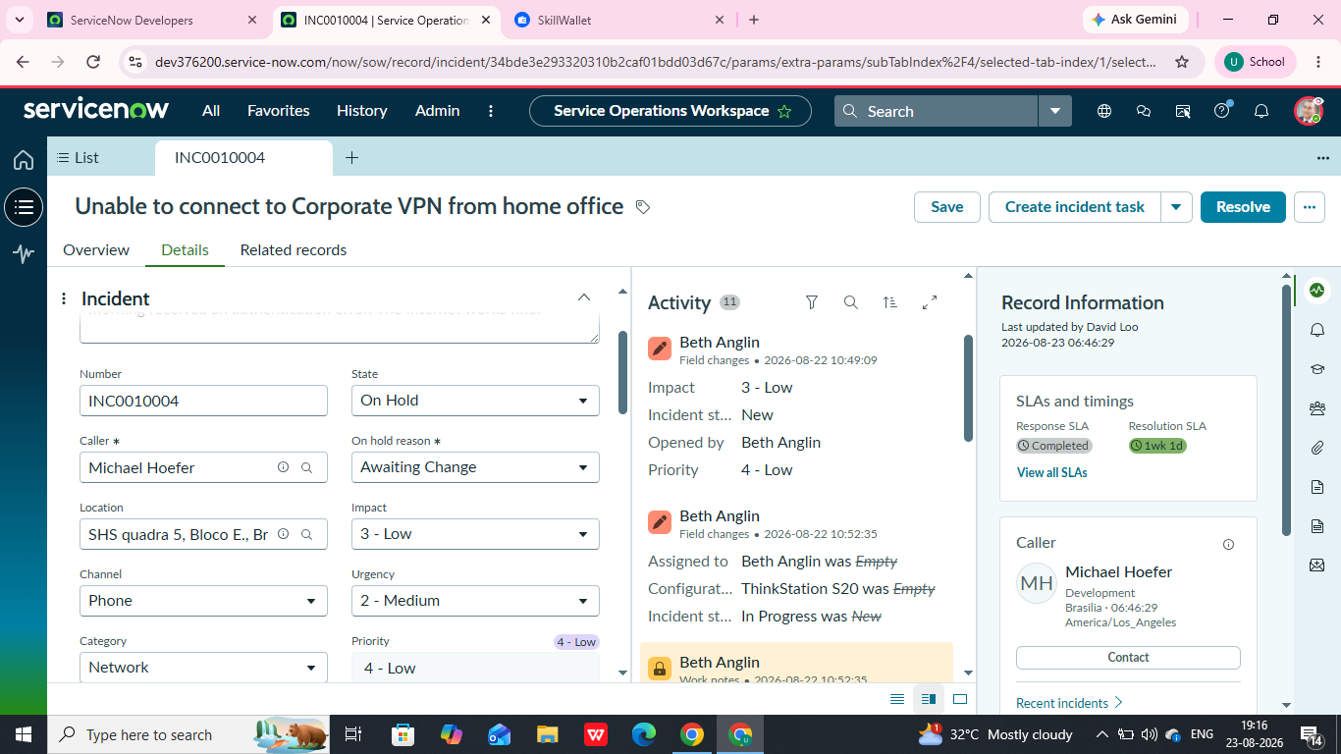
Incident INC00100004 placed On Hold with On Hold Reason set to Awaiting Change.
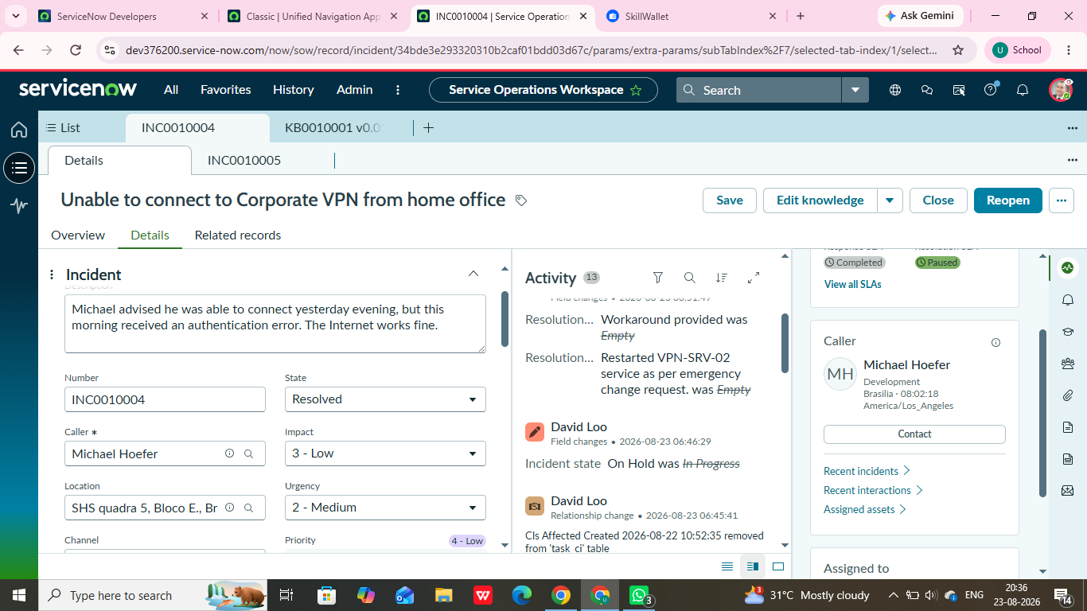
Resolved parent incident with resolution notes documenting the emergency change.
The supplied evidence shows the Awaiting Change state and later resolution notes stating that the VPN server service was restarted as per an emergency change request.

7.9 Child Incident Management and Resolution
The parent/child incident relationship supports tracking of related issues. The evidence shows a child incident, INC00100005, being resolved based on the resolution of the parent incident.
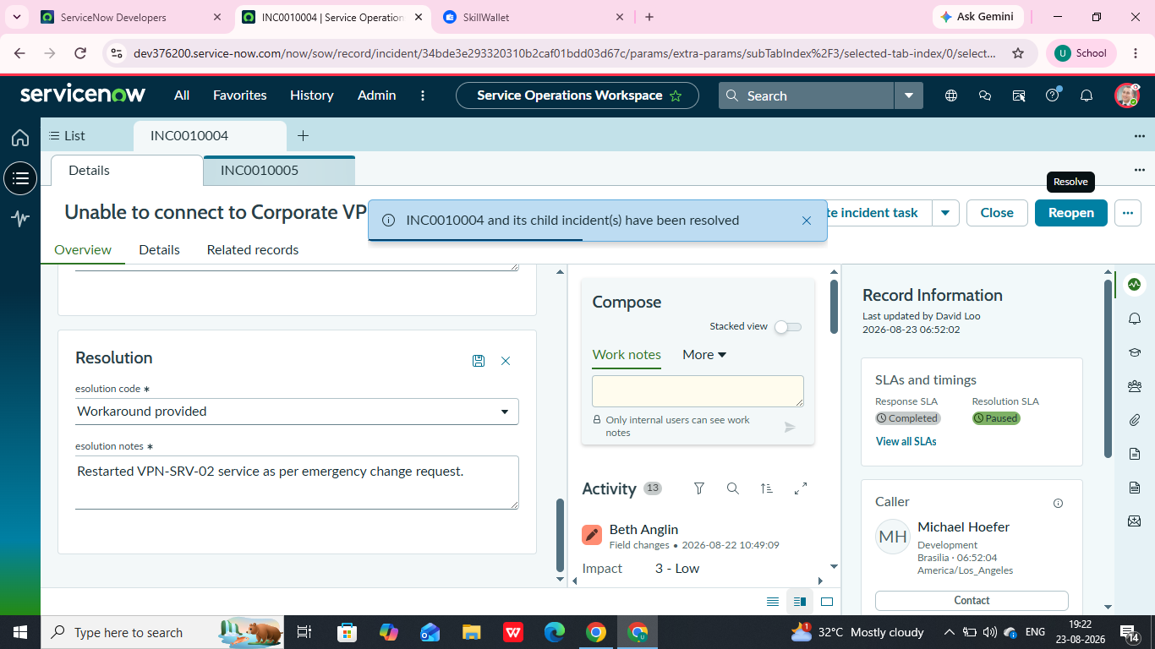
Resolution information and notification showing parent and child incidents were resolved.

Child incident INC00100005 showing resolution based on the parent incident.

7.10 Knowledge Creation and SLA Validation
The project creates a reusable Knowledge Article from the incident and verifies knowledge through Related Records. Task SLA records are also visible under Related Records, providing response and resolution tracking.
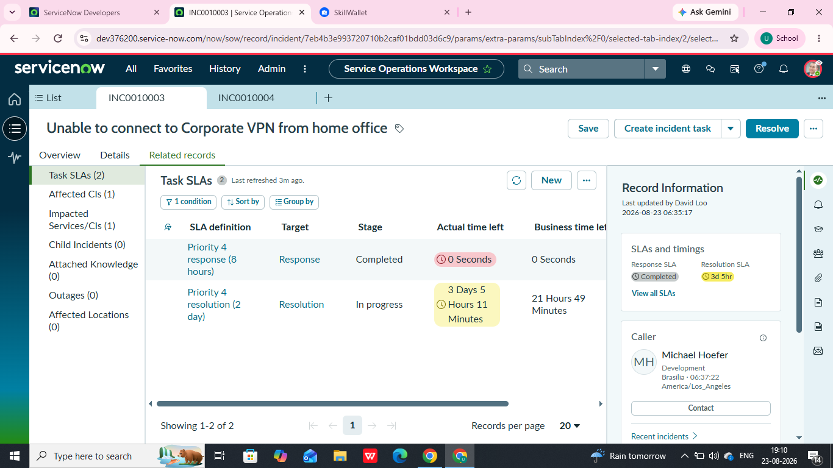
Related Records view showing Task SLAs.

8. Testing & Deployment
Testing & Deployment is the final verification stage. It validates that the configured Incident, Change, Knowledge, Child Incident, SLA, escalation, and multi-team workflows operate together end-to-end.
Test Area | Validation | Evidence
Incident lifecycle | State transitions and resolution | Incident state/activity history
Escalation | Ownership and support-team changes | Assignment and activity
Change integration | Emergency change related to incident | CHG/incident relationship
Knowledge creation | Article created and visible | Created/Attached Knowledge
Child incidents | Child linked and resolved | INC00100005
SLA tracking | Response/resolution SLAs visible | Task SLAs
Multi-team collaboration | Activities traceable across teams | Assignment/activity history

9. Results and Evidence
- Corporate VPN service offering is configured under Remote Access.
- VPN incident INC00100004 contains structured incident data and activity history.
- Incident classification and assignment changes are recorded.
- Knowledge guidance is referenced in the incident workflow.
- The incident can be placed On Hold with Awaiting Change.
- Resolution notes document the corrective action performed under an emergency change.
- Parent and child incident resolution behavior is demonstrated.
- Task SLA records are visible in Related Records.

10. Conclusion
The Incident Lifecycle Automation project demonstrates how ServiceNow can standardize and automate the complete incident-management journey. Service Desk agents can log and classify incidents, use knowledge for faster resolution, reassign work to Level 2 teams, manage child incidents, initiate emergency changes, track SLAs, and document final resolution.
The integration between Incident, Change, and Knowledge capabilities creates a structured and traceable process, improving service visibility, supporting SLA adherence, and providing better IT service delivery.

11. Skills Demonstrated
- ServiceNow Incident Management
- Service Operations Workspace
- Incident classification and prioritization
- Assignment and escalation
- Agent Assist / Knowledge integration
- Knowledge Article creation
- Change Management integration
- Child incident management
- Related Lists and task relationships
- SLA tracking and validation
- Incident resolution and activity auditing
- End-to-end workflow testing

