CAR SALES ANALYTICS
Project Documentation
Power BI Dashboard | Business Sales & Performance Analysis
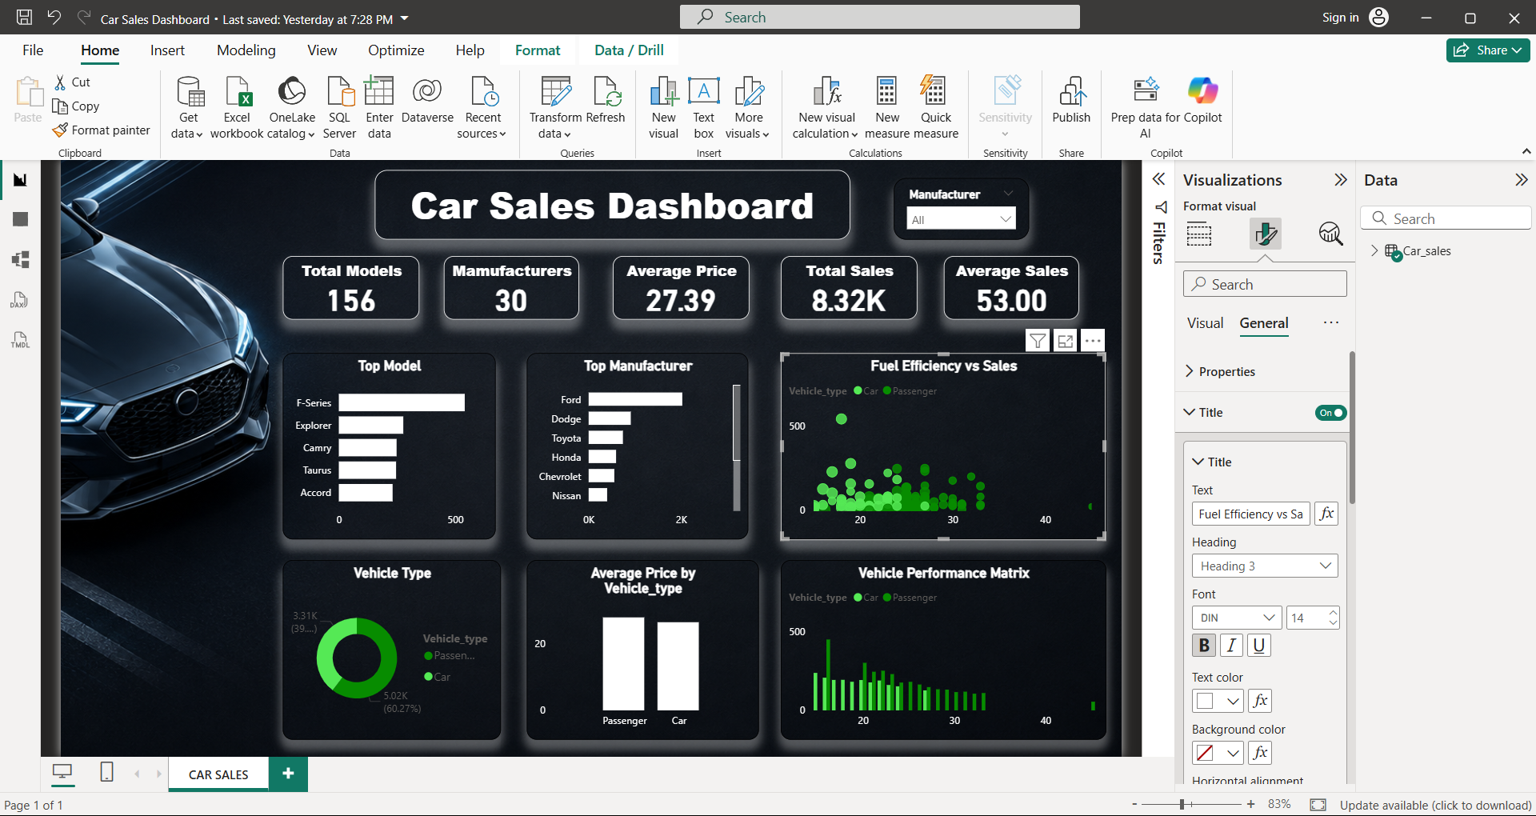
Prepared from the provided Car_sales(4).csv dataset

1. Executive Summary
This project analyzes vehicle sales, pricing, vehicle type, fuel efficiency, and performance characteristics using a 157-row car sales dataset. The final Power BI dashboard is designed as a compact management view that helps a viewer quickly understand market scale, manufacturer performance, model-level demand, and vehicle characteristics.
The dashboard combines five headline KPIs with six analytical visuals and a manufacturer slicer. The design emphasizes fast comparison, clear hierarchy, and business-oriented storytelling rather than displaying the full dataset.

Headline KPIs
Distinct Models | Manufacturers | Average Price | Total Sales | Average Sales
156 | 30 | 27.39K | 8.32K | 53.00K
Unit note: Sales_in_thousands is already expressed in thousands of vehicles. Therefore, 8.32K in the dashboard represents approximately 8.32 million vehicles when interpreted as individual units; the dataset itself reports the measure in thousands.

Key findings
- Ford is the leading manufacturer by total recorded sales at 2022.6 thousand units, materially ahead of the next manufacturer, Dodge (910.1 thousand).
- F-Series is the top-selling model at 540.6 thousand units, making it the strongest single model in the dataset.
- Passenger vehicles account for 74% of rows/models in the dataset, while Car accounts for about 26%.
- Average vehicle price is 27.39 thousand dollars, while the average recorded sales volume per model row is 53.00 thousand units.
- Sales are strongly concentrated in a small set of high-volume models and manufacturers, which makes ranking visuals particularly useful for management interpretation.

2. Project Objectives
The project was developed to turn raw car sales records into a decision-ready analytical dashboard. The objectives are to:
- Measure overall sales scale and model coverage.
- Compare manufacturers using total sales contribution.
- Identify the highest-selling vehicle models.
- Compare sales and pricing across vehicle types.
- Explore the relationship between fuel efficiency, vehicle characteristics, and sales.
- Provide an interactive management view using Power BI and a manufacturer filter.

Business Questions
- Which manufacturers generate the highest sales?
- Which models are the strongest volume drivers?
- How does vehicle type differ in model count, sales, and average price?
- Is higher fuel efficiency visibly associated with higher sales?
- How do price and performance characteristics vary across the market?

3. Dataset Profile
The supplied dataset contains 157 records and 16 fields. It combines categorical attributes (manufacturer, model, vehicle type), commercial measures (sales and price), technical specifications (engine size, horsepower, dimensions, fuel capacity, fuel efficiency), and a launch date field.

Field inventory
Field | Type | Description
Manufacturer | object | Vehicle manufacturer / brand
Model | object | Vehicle model name
Sales_in_thousands | float64 | Recorded sales volume, measured in thousands
__year_resale_value | float64 | Expected/observed resale value field with substantial missingness
Vehicle_type | object | Car or Passenger
Price_in_thousands | float64 | Vehicle price in thousand dollars
Engine_size | float64 | Engine displacement
Horsepower | float64 | Engine power
Wheelbase | float64 | Wheelbase measurement
Width | float64 | Vehicle width
Length | float64 | Vehicle length
Curb_weight | float64 | Curb weight
Fuel_capacity | float64 | Fuel tank capacity
Fuel_efficiency | float64 | Fuel efficiency in MPG
Latest_Launch | object | Latest model launch date
Power_perf_factor | float64 | Composite performance factor

4. Data Quality Review & Preparation
A structural review of the supplied CSV found no fully duplicated rows. There are, however, missing values in several numerical columns. These blanks are important to document because they affect averages and scatter plots.
Field | Missing | Share of 157 rows
__year_resale_value | 36 | 22.9%
Fuel_efficiency | 3 | 1.9%
Curb_weight | 2 | 1.3%
Price_in_thousands | 2 | 1.3%
Power_perf_factor | 2 | 1.3%
Wheelbase | 1 | 0.6%
Engine_size | 1 | 0.6%
Horsepower | 1 | 0.6%
Length | 1 | 0.6%
Width | 1 | 0.6%
Fuel_capacity | 1 | 0.6%
Dashboard handling note: standard Power BI aggregation functions such as AVERAGE ignore blank numeric cells rather than treating them as zero. This behavior is appropriate for descriptive averages, but it should be documented whenever results are interpreted.

Recommended preparation sequence
- Load the CSV into Power BI / Power Query.
- Confirm data types; convert Latest_Launch to Date.
- Check duplicate records and confirm Model uniqueness at the expected grain.
- Keep missing resale values as blanks unless a defensible imputation rule is required.
- Validate numeric ranges for price, sales, horsepower, fuel efficiency, and performance factor.
- Create measures for distinct model count, manufacturer count, total sales, average sales, and average price.

5. Dashboard Design
The dashboard is organized into three layers: top-level KPIs, comparison visuals, and diagnostic relationship visuals. A dark automotive theme provides strong contrast and visually separates the report from a traditional spreadsheet-style dashboard.

Figure 1. Final Power BI dashboard view supplied with the project.

Visual inventory
Visual | Purpose | Primary takeaway
Top Model | Rank models by sales | F-Series leads model-level volume
Top Manufacturer | Rank brands by sales | Ford is the leading manufacturer
Fuel Efficiency vs Sales | Show relationship / distribution | Sales are spread across a wide efficiency range
Vehicle Type | Show model mix | Passenger is the larger category
Average Price by Vehicle Type | Compare category pricing | Average prices are close but not identical
Vehicle Performance Matrix | Compare performance and sales distribution | Volume is concentrated in a smaller number of records

6. KPI Definitions & Power BI Measures
The following measures reproduce the logic represented by the dashboard KPIs. Replace Car_sales with the exact Power BI table name when creating them.
Measure | DAX | Meaning
Total Models | DISTINCTCOUNT(Car_sales[Model]) | Counts distinct vehicle models.
Manufacturers | DISTINCTCOUNT(Car_sales[Manufacturer]) | Counts distinct manufacturers.
Average Price | AVERAGE(Car_sales[Price_in_thousands]) | Average listed price in thousand dollars, excluding blanks.
Total Sales | SUM(Car_sales[Sales_in_thousands]) | Total recorded sales in thousands.
Average Sales | AVERAGE(Car_sales[Sales_in_thousands]) | Average recorded sales volume per row/model.
Formatting recommendation: display sales and price with compact units (K/M) where appropriate, while keeping the semantic unit explicit in tooltips and report notes.

7. Sales Performance Analysis
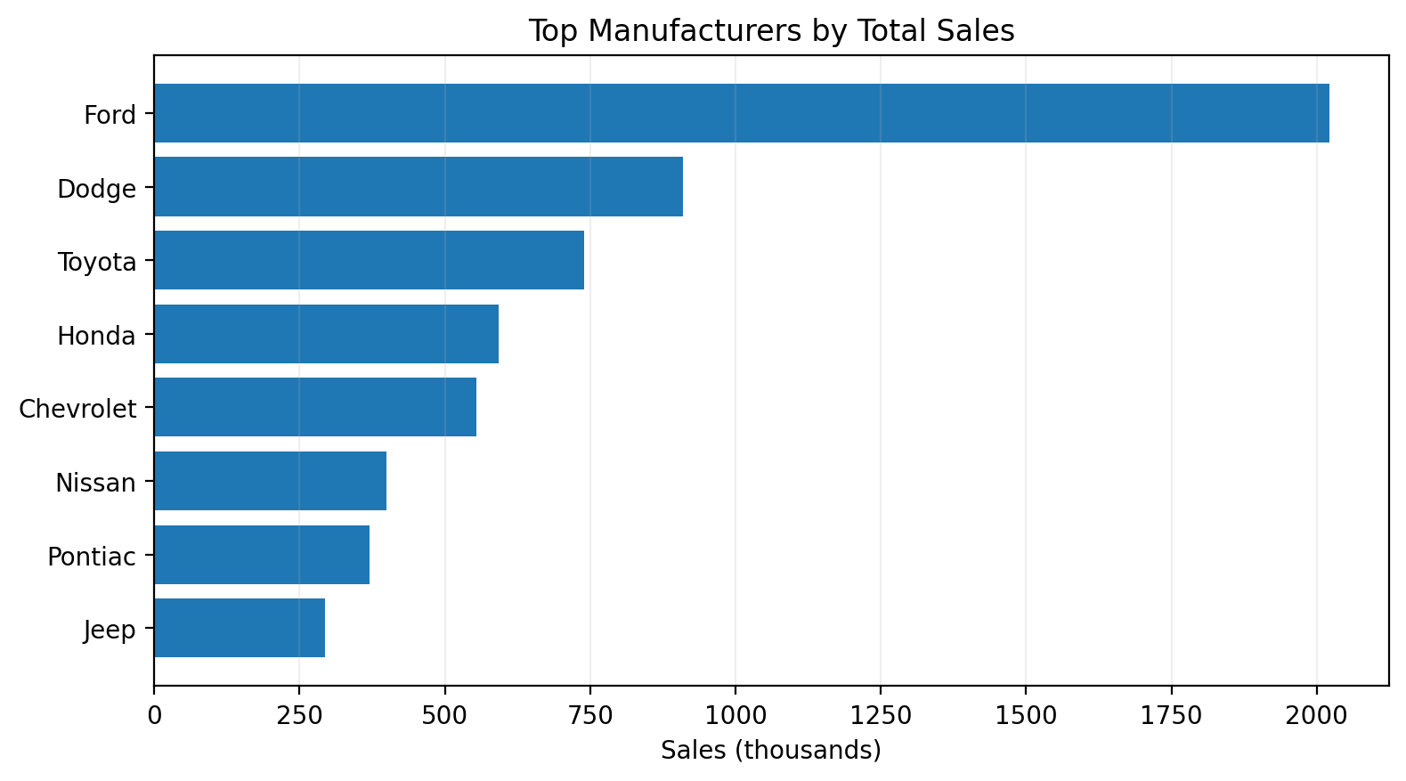
Figure 2. Leading manufacturers by total recorded sales.
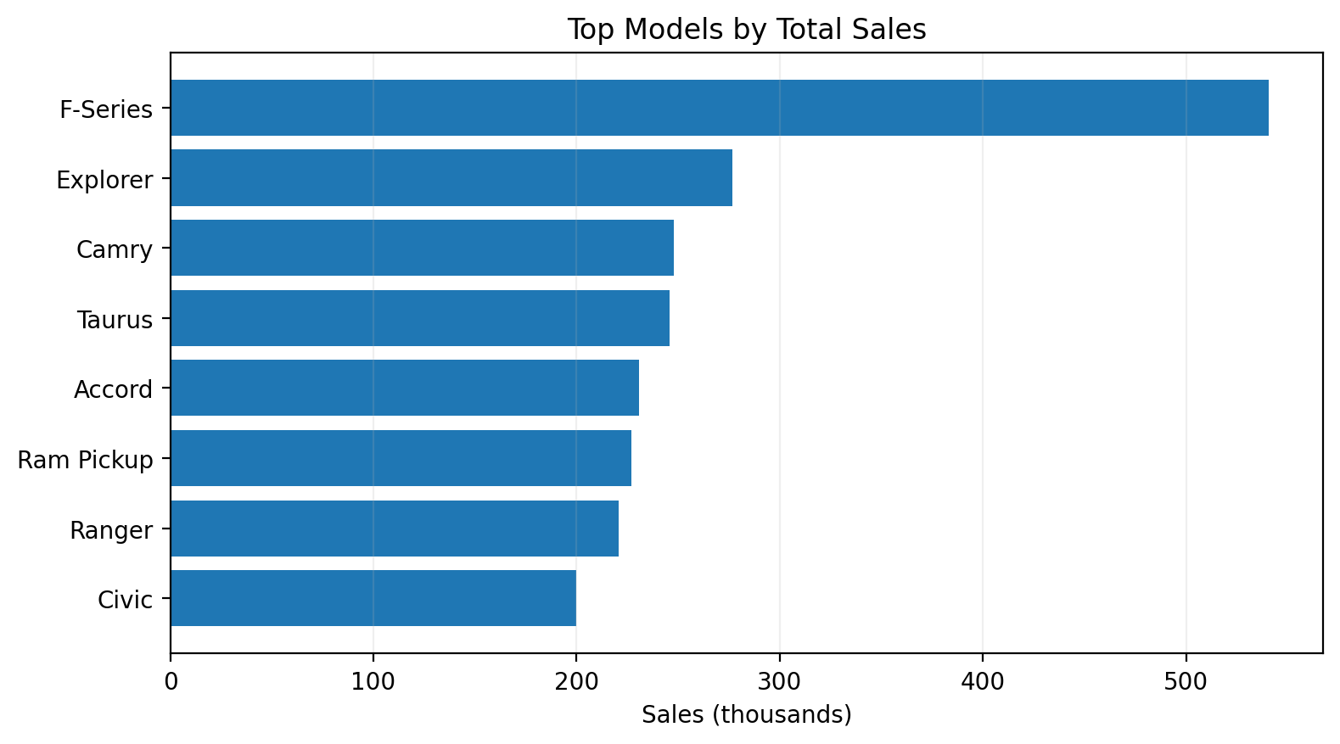
Figure 3. Leading models by total recorded sales.
Ford records approximately 2022.6 thousand units, more than twice Dodge at 910.1 thousand. At model level, F-Series records 540.6 thousand units, creating a clear concentration of demand in a single model. Explorer, Camry, Taurus, and Accord form the next tier of high-volume models.

8. Vehicle Type & Pricing Analysis
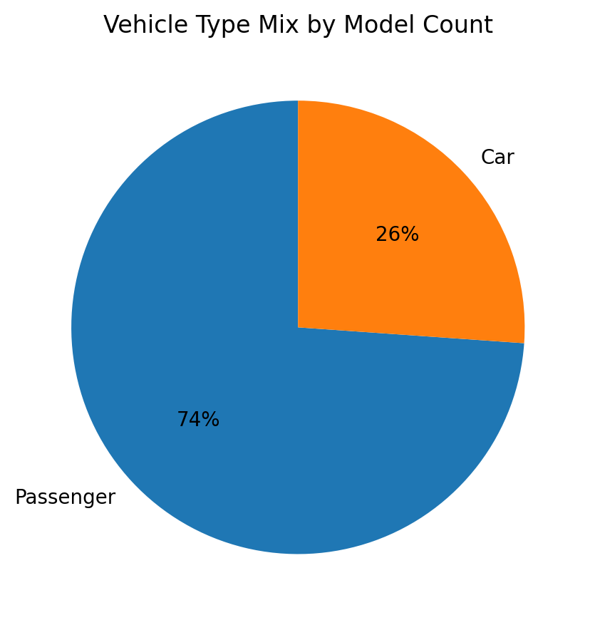
Figure 4. Vehicle type mix by model rows.
Vehicle Type | Model Rows | Total Sales (K) | Average Price (K)
Car | 41 | 3305.5 | 26.32
Passenger | 116 | 5015.2 | 27.76
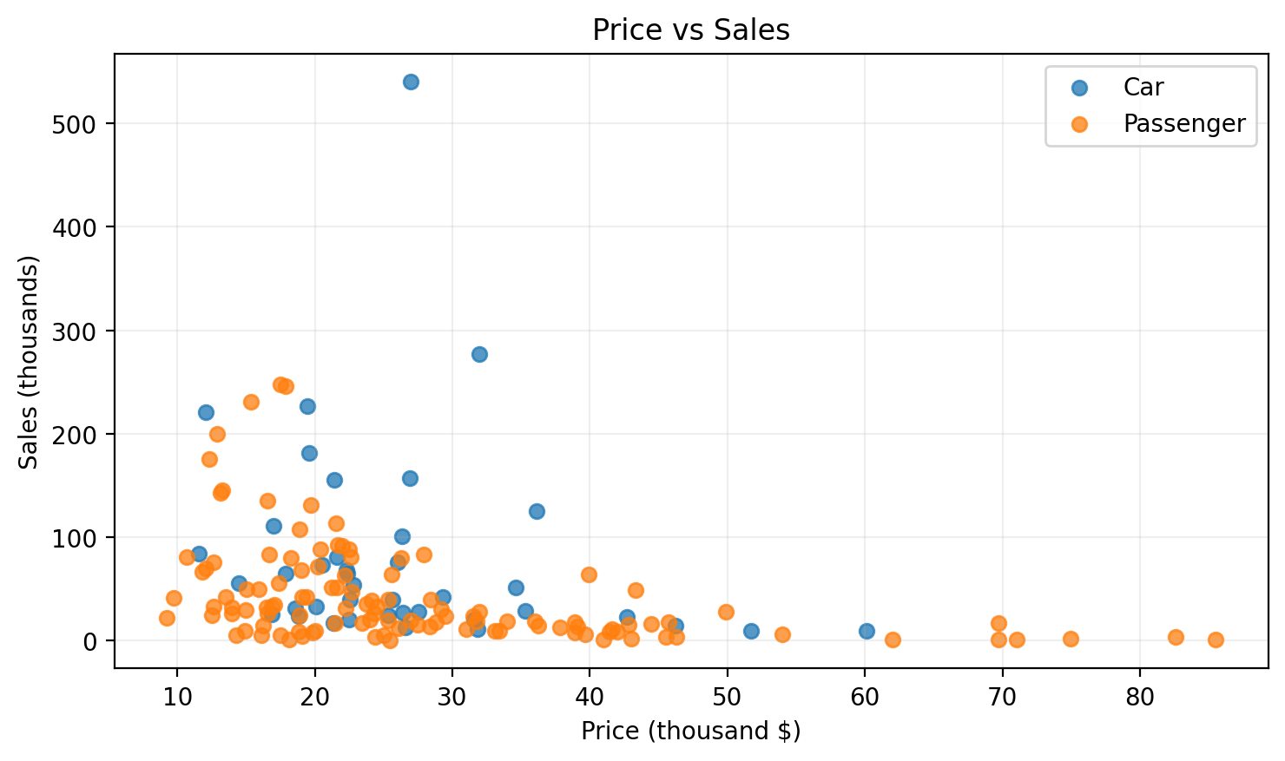
Figure 5. Price versus sales distribution.
Passenger vehicles are the larger group in the dataset by row count and also account for higher total sales. Average prices are close between the two categories, which suggests that vehicle type alone does not fully explain pricing differences in this sample.

9. Fuel Efficiency & Performance Analysis
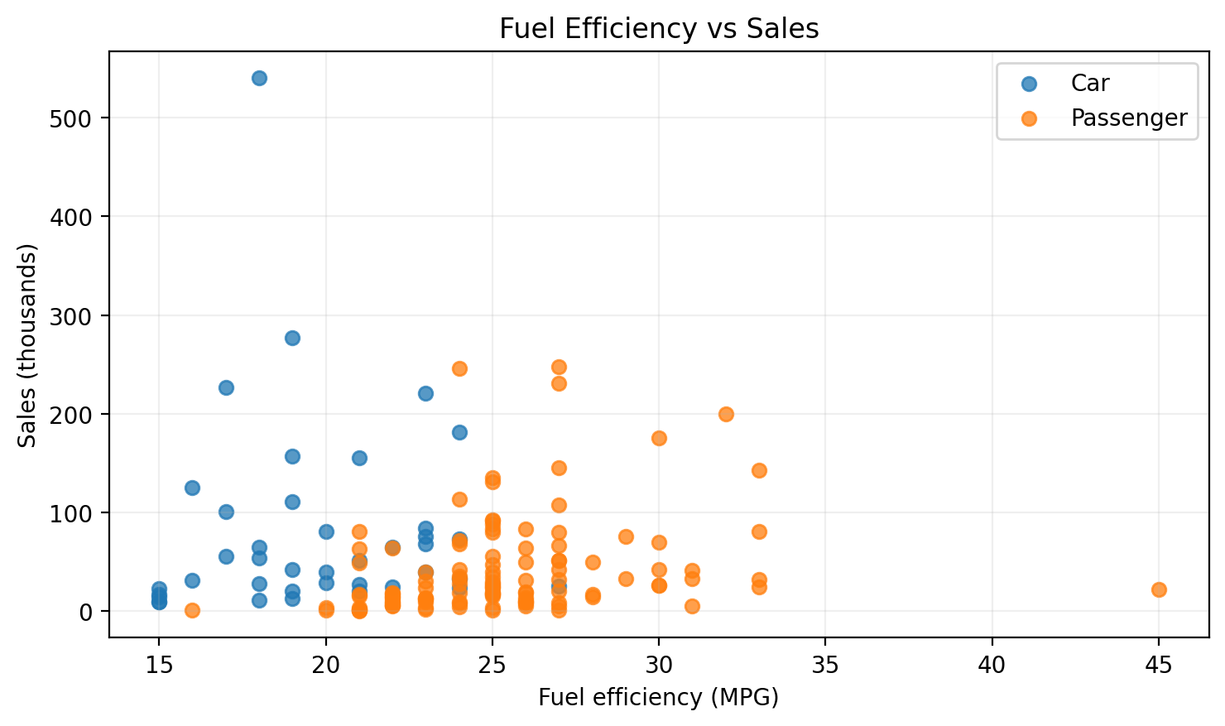
Figure 6. Fuel efficiency versus sales.
The dataset does not show a strong positive relationship between fuel efficiency and sales. The overall Pearson correlation between Fuel_efficiency and Sales_in_thousands is approximately -0.02, indicating an almost neutral linear association in this sample. By comparison, price has a moderately negative correlation with sales (about -0.30), suggesting that lower-priced vehicles tend to have higher recorded sales in this dataset, though correlation does not establish causation.
The performance-related fields also show wide dispersion. Horsepower ranges from 55 to 450, while Power_perf_factor ranges from roughly 23.28 to 188.14. The wide spread indicates a diverse mix of vehicle categories and performance levels.

10. Key Business Insights
Scale: The dataset covers 30 manufacturers and 156 distinct models across 157 records.
Concentration: Ford and its high-volume models drive a substantial share of the recorded sales.
Model leadership: F-Series is the strongest individual model and is a major volume driver.
Category mix: Passenger vehicles are more numerous in the dataset and also account for more total sales.
Pricing signal: Higher price is not associated with higher sales in a simple linear sense; the observed correlation is negative.
Efficiency signal: Fuel efficiency has almost no linear relationship with sales in this dataset, so it should not be treated as a primary demand predictor without more variables.

11. Recommendations
- Prioritize high-volume models in sales planning, inventory decisions, and promotional analysis.
- Use manufacturer and model rankings as a recurring management view to spot shifts in demand.
- Segment future analysis by vehicle type, price band, and performance level instead of relying on one variable alone.
- Add time-series sales data, geography, dealer information, discounts, and customer segments in a future version to improve business usefulness.
- Track KPI definitions carefully so that sales units (thousands) and price units (thousand dollars) are never confused with raw unit counts.

12. Technical Implementation

Technology stack
- Power BI Desktop for data modeling, measures, visuals, formatting, and dashboard assembly.
- Power Query for data import, data type validation, and transformation.
- CSV as the source data format.
- DAX for KPI calculations and analytical measures.

Suggested report structure
- Page 1: Car Sales Dashboard (executive view).
- Optional Page 2: Manufacturer & Model drill-down.
- Optional Page 3: Vehicle specification analysis.

Future enhancements
- Add year-over-year sales trends when a valid time series is available.
- Add decomposition tree / drill-through for manufacturer-to-model analysis.
- Introduce price bands and performance bands.
- Add geographic analysis if location fields become available.
- Use bookmarks for Executive / Product / Performance views.

13. Conclusion
The Car Sales Analytics project successfully converts a compact vehicle dataset into an executive-friendly Power BI dashboard. The dashboard communicates the most important measures first, then uses rankings and relationship visuals to explain where sales are concentrated and how vehicle characteristics relate to demand. The analysis indicates that manufacturer and model leadership are the clearest differentiators in this dataset, while fuel efficiency alone provides limited explanatory power for sales.
This project demonstrates practical skills in data profiling, Power Query preparation, DAX KPI creation, Power BI visualization, analytical interpretation, and dashboard storytelling.

