**INSTALLATION INSTRUCTIONS FOR PYTHON TOOLBOX WITH THE SCRIPT FOR THE FORMATION OF GROUP'S ADJACENT POLYGONS ACCORDING TO A CUMULATIVE MAGNITUDE**

The tool developed for the creation of the group’s adjacent polygons according to the cumulative magnitude of a specific attribute, fulfills the same conditions as the installation of Python Toolbox for ArcGIS Desktop.

The following are principal steps to complete the installation satisfactorily:

1. Download the file "Script_UPRA_grouping_polygons_ cumulative magnitude.zip".

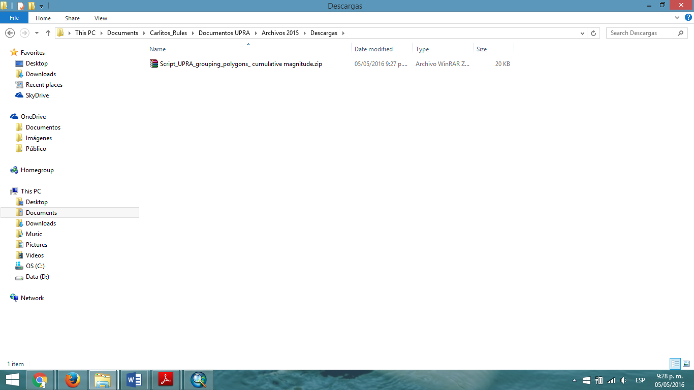

2. Unzip the file "Script_UPRA_grouping_polygons_ cumulative magnitude.zip" through a decompression file software. Note that in the folder generated after decompression there are the following files:

- "Toolbox_ UPRA_grouping_polygons_ cumulative magnitude. tbx "

- "Cod_ UPRA_grouping_polygons_ cumulative magnitude.py".

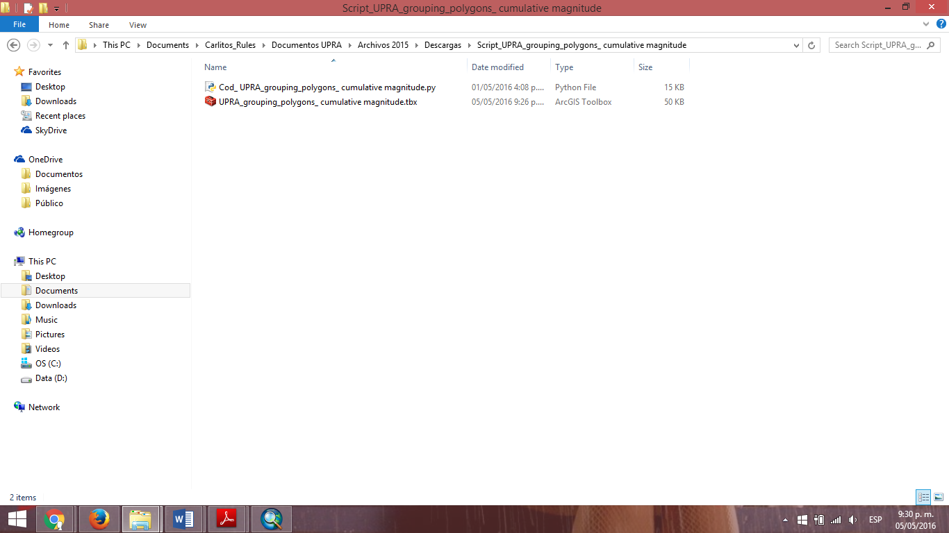

3. Once file is unzipped, open ArcGIS Desktop (10. 3 or higher) and locate the folder from the catalog. Important: The execution of the tool must be done with advanced license, because it invokes tools that only run in this type of licensing.

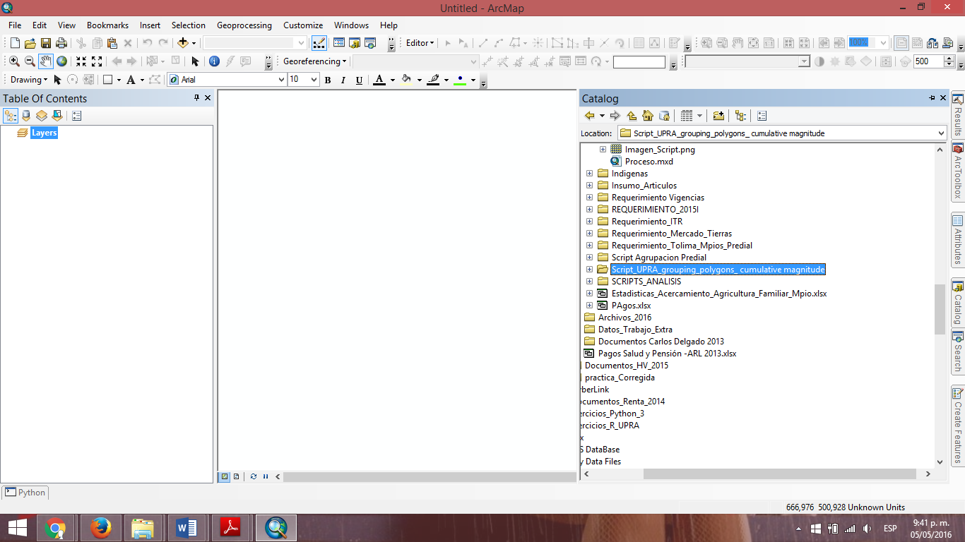

4. Expand the tree where the Toolbox is and locate the Pyhton script "Script_UPRA_grouping_polygons_cumulative magnitude".

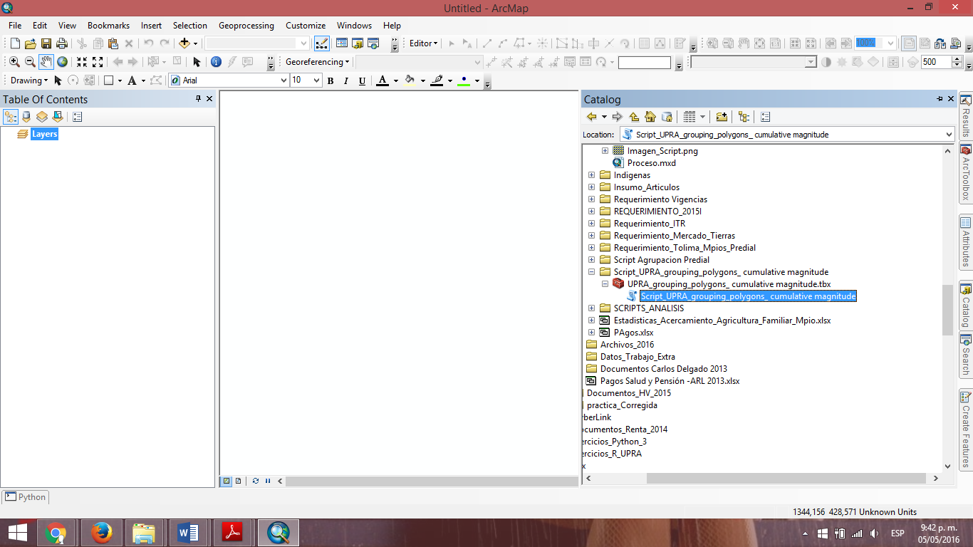

5. Double-click on the Script "Script_UPRA_grouping_polygons_cumulative magnitude" where one can observe the initial user interface for data entry by the user.

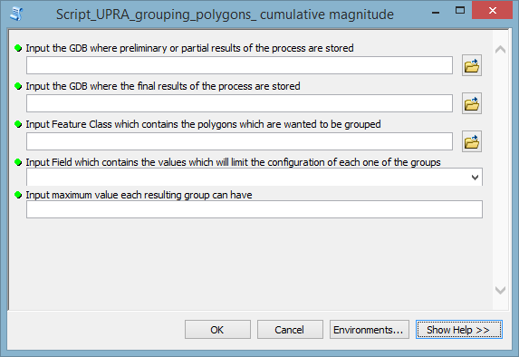

The tool is ready for use.

Warning:

If you move or change any file location of the unzipped folder it is preferable to move the entire folder or all files to the same location. Otherwise you may lose the script path Python code location "Cod_ UPRA_grouping_polygons_ cumulative magnitude.py" and generate an error. If this happens you should go to the properties of the Script and then to the "Source" tab, where you will place the new code file path "Cod_UPRA_grouping_polygons_cumulative magnitude.py".