**USER GUIDE FOR PYTHON TOOLBOX WITH THE SCRIPT FOR THE FORMATION OF GROUP'S ADJACENT POLYGONS ACCORDING TO A CUMULATIVE MAGNITUDE**

**Instructions to insert data in the Script:**

Before initiating the following steps remember that before one should have read and implemented the steps in the installation instruction manual.

1. Open ArcMap and ensure that in the options of Geoprocessing the option “Overwrite the outputs of geoprocessing operations” is checked.

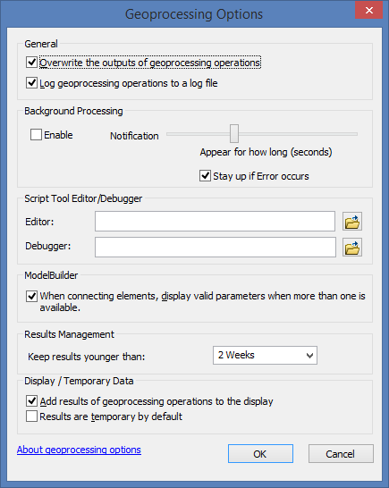

1. From the ArcMap Catalog find the Python Script, “Script_UPRA_grouping_polygons_ cumulative magnitude,” and then double click on the Python Script where a user window will appear in order to insert the input data necessary for the Script to work.

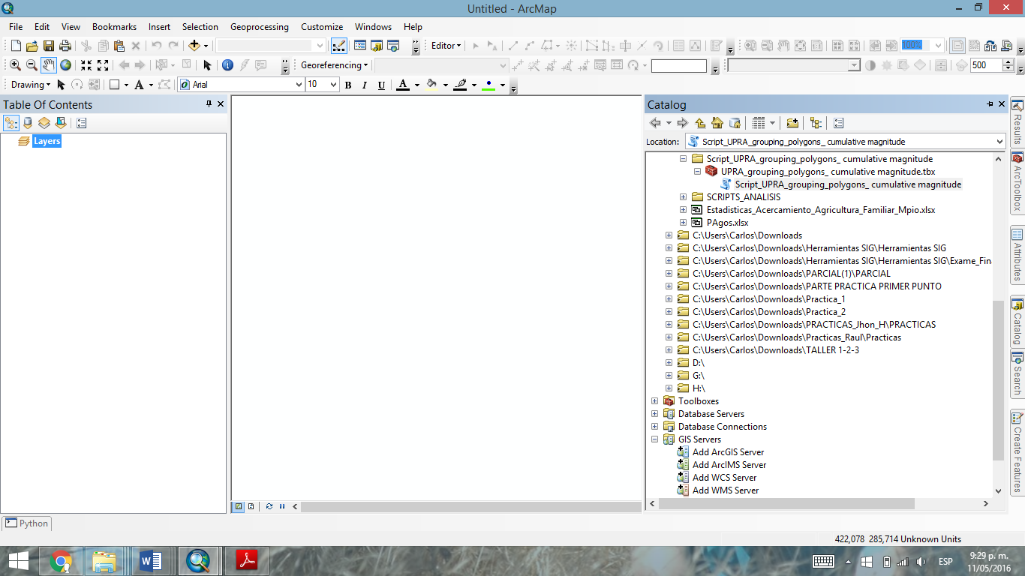

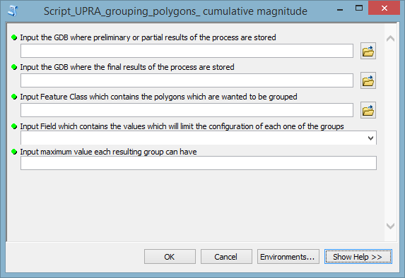

1. In the window shown, notice that the first parameter which the Script solicits is the location route of the GDB (Geodatabase) where preliminary or partial results of the process are stored. (If this GDB is not available, please create it).

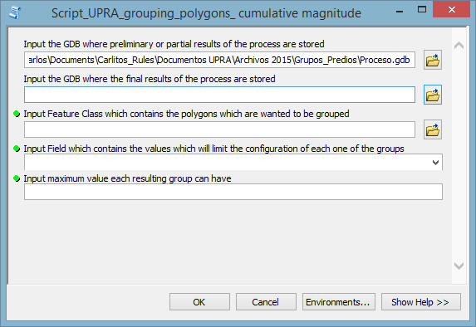

1. The second parameter asked for from the user is the location route of the GDB where the final results of the process are stored. In this GDB the Feature Class of the resulting groups of the algorithm are stored; with the Feature Class containing the merger of each one of the groups. This GDB should not be the same as the one in step 4. (If this GDB does not exist, please create it).

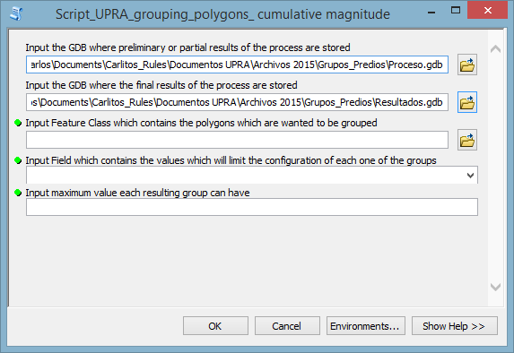

1. The third parameter asked for by the Script is the location of the Feature Class which contains the polygons which are wanted to be grouped (Properties, lots, blocks, zones, neighborhoods, etc.). Important: The Feature Class entered by the user must be as Single Part.

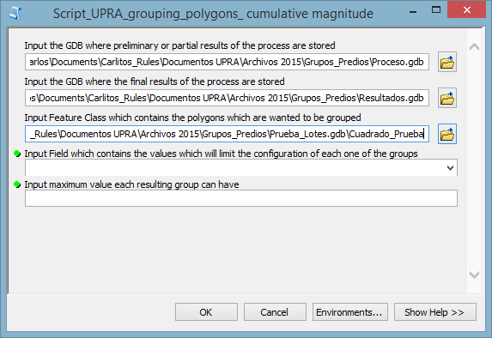

1. In the fourth parameter the user should select the numerical field which contains the values which will limit the configuration of each one of the groups while completing the sum total. (Field which contains values of area, prices, budgets, etc.)

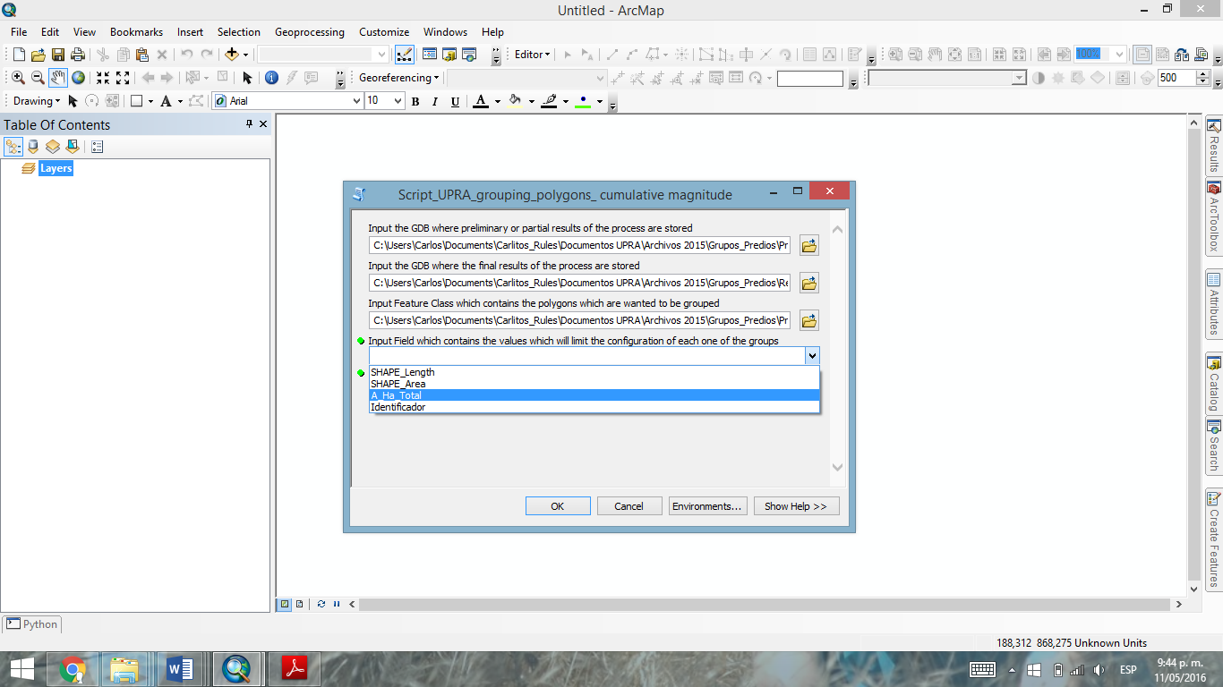

1. The last parameter which should be filled in by the user is the maximum value each resulting group can have. This value must be related logically to the field selected in step 6. Important: The maximum value submitted by the user should not be less than the maximum value of the field submitted by the user in step 6; this would create an error. Logically the maximum value submitted by the user too should not be less than the minimum value of the field submitted by the user in the before step.

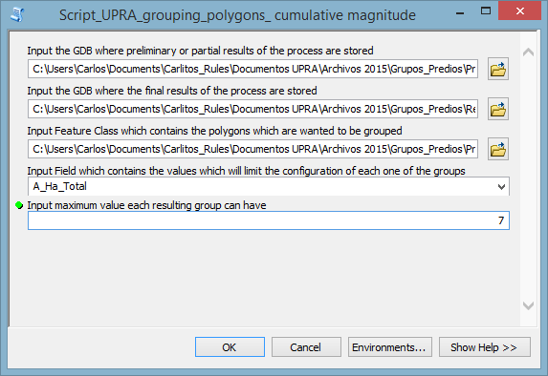

1. Once all of the data has been entered into the script, the user should proceed to click on the OK button and wait for the execution of the process.