**Overview**

OpenSea is a decentralized non-fungible token (NFT) marketplace for buying, selling, and trading NFTs. If you look at the OpenSea homepage, you can see that there are “Exclusive OpenSea drops” section.

In September of this year, someone was accused of using confidential information to snap up items in OpenSea’s front-page collections ahead of general release.

<https://www.theblockcrypto.com/post/117751/opensea-confirms-executive-used-insider-knowledge-when-buying-nfts>

This project aims to collect data that can be used to identify informed users such as the user above

**How to develop**

To get the target data, we developed this project in 3 steps.

Step 1: Get all dropped collections from OpenSea Marketplace.

Step 2: Get transaction information for each dropped collection.

Step 3: Get buyer information for the above transaction.

*Step 1*

In this step, we should get all the collections that have been dropped so far.

We can use “Wayback Machine” to view past OpenSea homepages.

We can get a list of all the captures with this URL:

<https://web.archive.org/cdx/search/cdx?url=opensea.io&collapse=digest&from=20210301&to=20210914&output=json>



From this, we can get captured date and should get past OpenSea homepages using this captured date.

We can retrieve

<https://web.archive.org/web/20210915044922/https://opensea.io/>

Then We need to find the dropped collection data on the homepage.

If you inspect homepage, you can see the following script element with id=” __NEXT_DATA__”.



This element contains all the collection information displayed on the homepage.

Parsing this json data will find the promotion field containing the dropped collection data.

The promoCardLink and promoHeader represent the collection link and name.

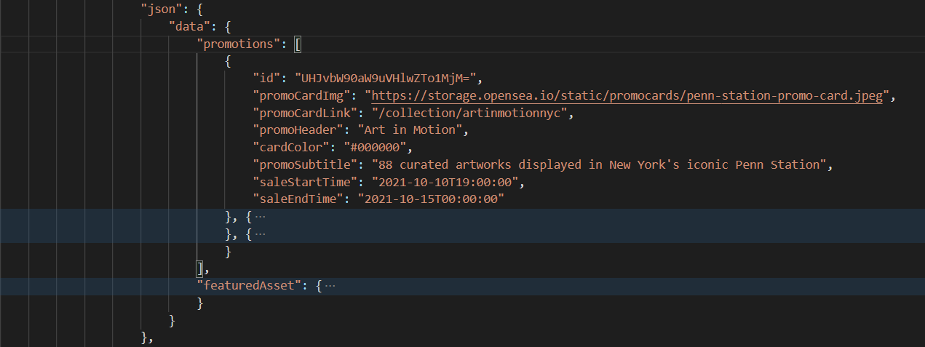

*Step 2*

In this step, we should find transactions history for the dropped collection in the days before it was displayed on the OpenSea homepage.

We can use the OpenSea API to find information about transactions that have occurred in OpenSea:

<https://docs.opensea.io/reference/retrieving-asset-events>

To find transaction information using this API, we need to set some parameter values.

* we need to set collection_slug to identify a specific collection.

A collection_slug is a key to identify a collection, so is bit different from collection name.

We can get collection_slug from collection link or OpenSea API:

<https://docs.opensea.io/reference/retrieving-a-single-asset>

* we need to set event_type to identify the sales transaction.

We need to set event_type value with ‘successful' to find only sales transactions.

* we need to set occurred_before to find only transactions listed before a specific date.

From this transaction information, we can get the collection name, NFT token name, trade price, seller, buyer, trade date, etc.

*Step 3*

In this step, we should find the buyers who bought a dropped collection before it was made a featured collection.

We can use the transaction history created in step 2.

We need to transform the transaction data based on the collection into the buyer data based on the buyer.

We then rank buyers based on how many they bought meeting that criteria.

**Installing**

We recommend switching to Python version 3.8.10 or later.

Then, install following modules.

python(py) -m pip install numpy

python(py) -m pip install requests

python(py) -m pip install bs4

python(py) -m pip install pandas

**Getting Started**

To get data, you need to following command.

python(py) main.py

If you implement above command, this program create collections_list.csv, trade_history.csv, buyer_list.csv files.

When you first implement this program, it takes time to create the csv files.

If created csv files already exists, it will only append the new data to the csv files.