Sri Lanka Institute of Information Technology



Assignment 1

G3 S1_04

On Road Vehicle Breakdown Assistance

**Internet and Web Technologies – IT1100**

B.Sc. (Hons) in Information Technology

**Group Details**

Group Number: 04

Project Title: On Road Vehicle Breakdown Assistance

|  |  |  |  |  |
| --- | --- | --- | --- | --- |
|  | Student ID | Student Name | Email | Contact Number |
| 1 | IT18107388 | Perera D.F.Y.D | dananjayaperera655@gmail.com | 077-3355142 |
| 2 | IT18106916 | Malagala D.S.K | saveen.kulanjith@gmail.com | 071-3948232 |
| 3 | IT18107210 | Seekkubadu D.P. | dileepapavel98@gmail.com | 071-4874053 |
| 4 | IT18107074 | Upulie H.D.I | ireshaupulie@gmail.com | 071-4978151 |
| 5 | IT18107524 | Thariq A.L.M | thariqlatheef@gmail.com | 077-4169614 |

# **Introduction**

In-order to achieve higher levels of profitability, efficiency and productivity as a business it’s sagacious to use information systems to perform better in any sector of work. In a world where convenience plays a bigger role than the value, owning a private automobile has become almost customary. The status, liberty and independence that comes along with owning a car, are always followed by the responsibilities and breakdowns that could occur alongside the road.

Although good vehicle maintenance could go a long way to avoiding breakdowns, it’s not a guarantee. Breakdowns could occur in an unfamiliar area and when a person least expects. This is when “On Road Vehicle Breakdown Assistance” could be beneficial.

With on road vehicle breakdown assistance services like roadside recovery, roadside rescue or on-demand gas delivery is simply at a person’s fingertips. Companies like AA, Breakdown Assist, Admiral, AXA, Emergency Assist Ltd, Allianz, NRMA are some of the reputable companies on this sector.

# 

Personas

**Owner**

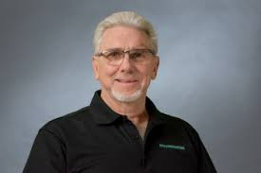

* Name: Dhammika Dissanayake
* Age: 45
* Gender: Male
* Motivation: To invest in a company and gain a higher profit.
* Goals: To build himself a brand name.

Hiring more experienced workers in the field.

**Administrator**



* Name: Isuri Rajapaksha
* Age: 27
* Gender: Female
* Motivation: To make every road journey safe and to build a trust between travelers and our company.
* Goals: To become one of the top companies in the country.

To make an efficient employee system within the company.

**Financial Executive Officer**



* Name: Chamal Perera
* Age: 29
* Gender: Male
* Motivation: To be a part of much larger group than myself and to build a reputation for myself.
* Goals: To build a high functional system within the company to handle the financials.

******Technician**

* Name: Naveen Jayasinghe
* Age: 42
* Gender: Male
* Motivation: To perform a better, faster, accurate service.
* Goal: To become a better working senior technician in 3 to 5 years.

Achieve a salary of Rs.60 000 so he can afford a better house.

**Customer**



* Name: Sawandi Balasooriya
* Age: 25
* Gender: Female
* Motivation: Fast and effective service from the company.
* Goals: Getting the problem solved as efficiently and quickly as possible.

User Journeys

**Customer - User Journey**

Is it a registered customer?

Go to Registration Page

(Sign Up)

No

Land on the site via online advertisements or prior knowledge

Yes

Add in details

Login to the site

(Sign In)

Confirm the payment method

Go to the Home Page

Choose the service?

Change account details

(user account page)

Search for support

(Services Page)

Search for details

(Go to the About Us Page/FAQ)

Contact Us Page/Feedback Page

Change payment methods

FAQs, Terms & Conditions

Contacts of branches

Contact 24 x 7 customer care

Financial Support

Breakdown Services

**Administrator - User Journey**

Visit the site to update or review details

Choose the service?

Responses for Feedbacks

Adding new content/details

Managing Technicians

Managing/Updating the website

Reply with appropriate messages and improve services

Generate monthly sales report

Updating services

New Technicians

Current Technicians

New Offers & Details

New Services

New Policies

**Owner - User Journey**

Visit the site to check new updates and review

Sign in to the owner’s profile using user credentials

Choose a service?

Check social media feedbacks from customers (marketing)

Check out monthly reports of the services (sales)

Check out handling of payroll of workers

Check any complaints

Check any complaints

**Technician - User Journey**

Visit the site to get details

Log In with the given user credentials

Choose the service?

Responses to personal Feedbacks

Reference to work procedures

Updating technician profile

Reply with appropriate messages and improve services

Safety Terms

Maintain

Troubleshoot & repair

**Financial Executive Officer - User Journey**

Visit the page for work purposes

Log in as the Financial Executive

Choose the service?

Payment records and analyzation reports

Adding new content/details

Managing online transactions

Managing employee payroll process

New Offers & Details

Issuing checks

Depositing cash

Wire Frames

**Home Page** 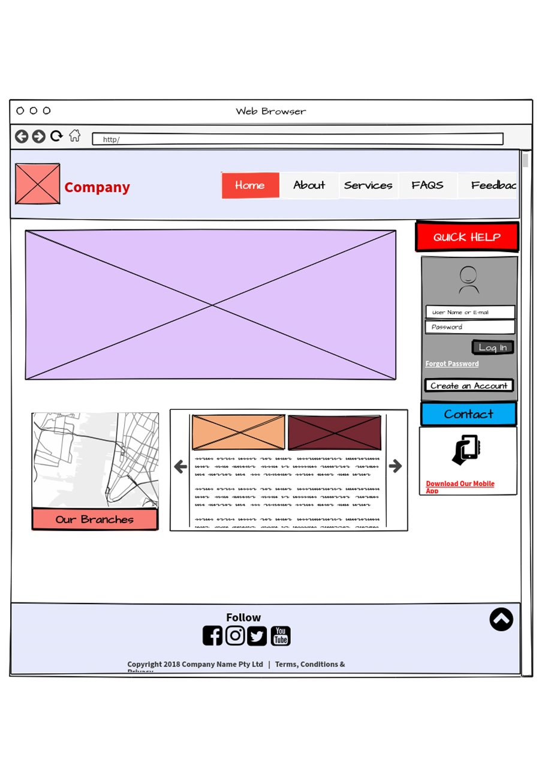

**Registration Page**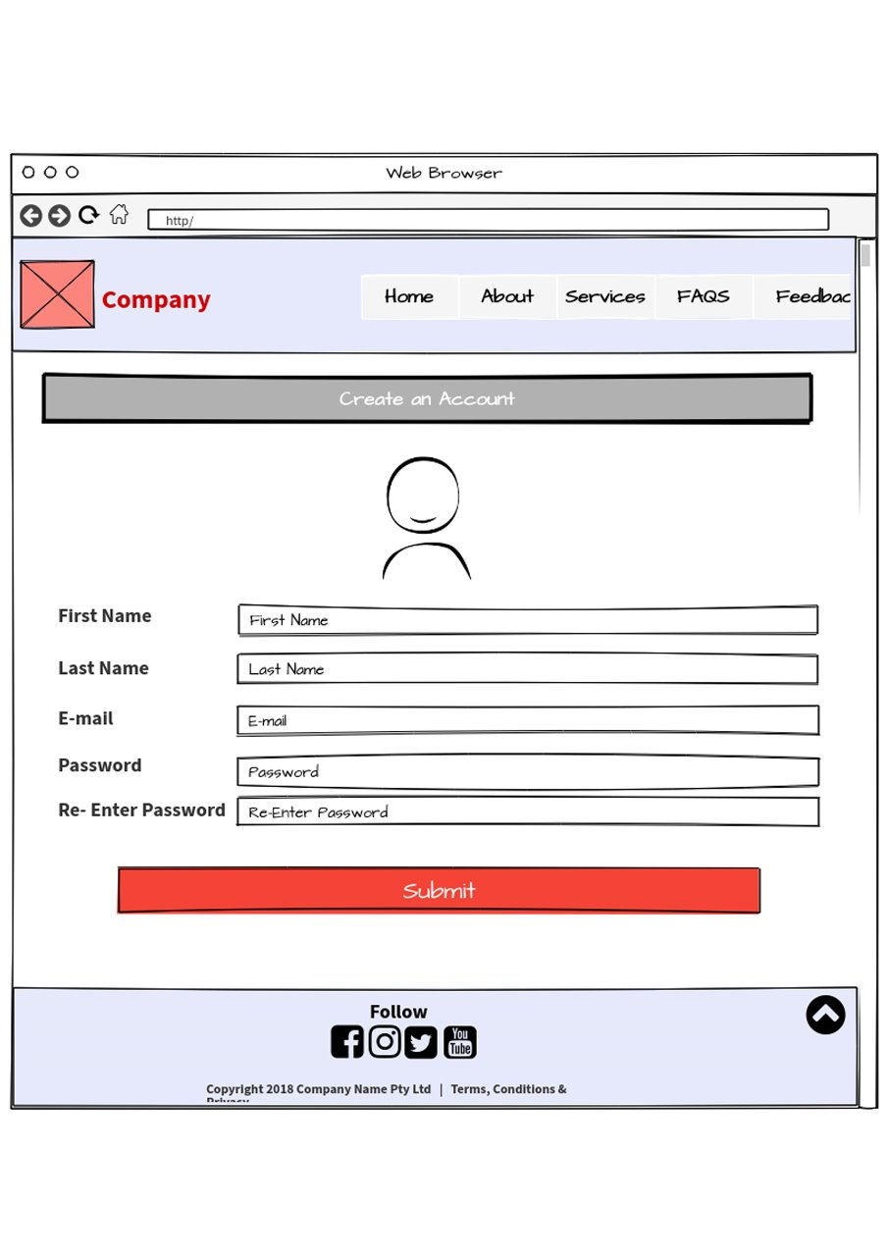

**Contact Us Page**

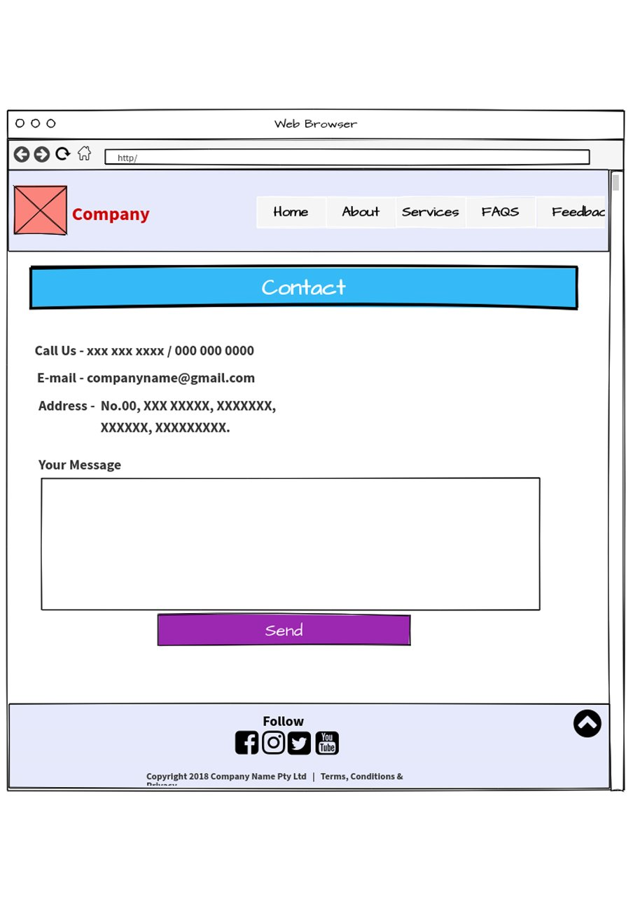

**User Account Page**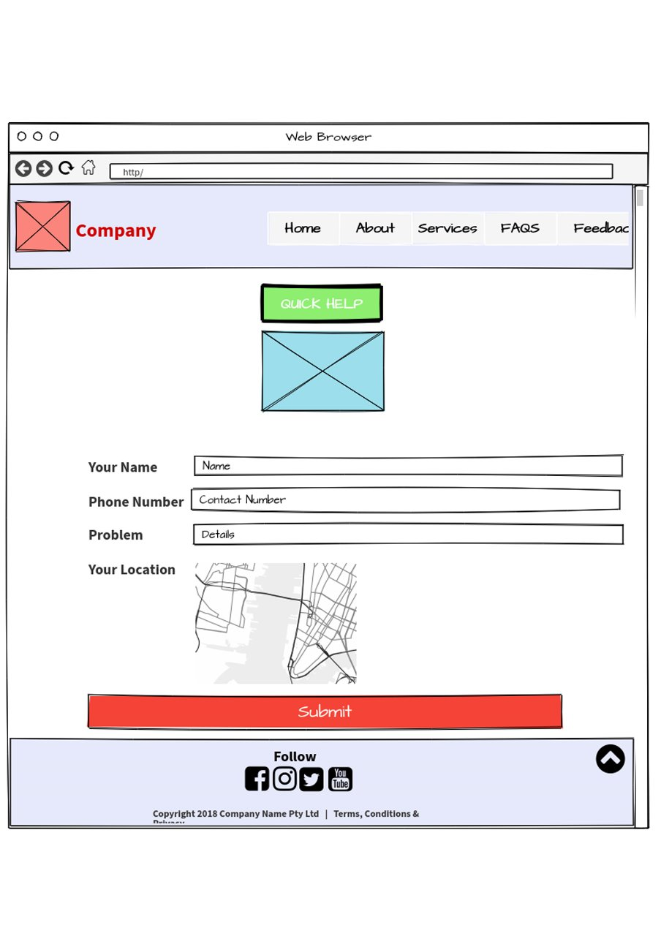

**About Us Page**

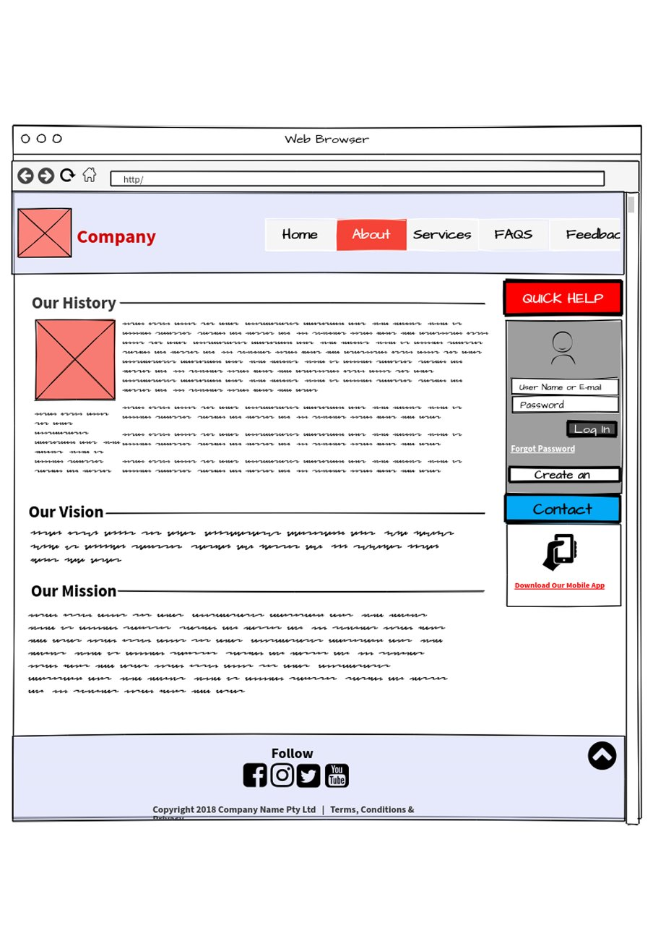

**Feedback Page**

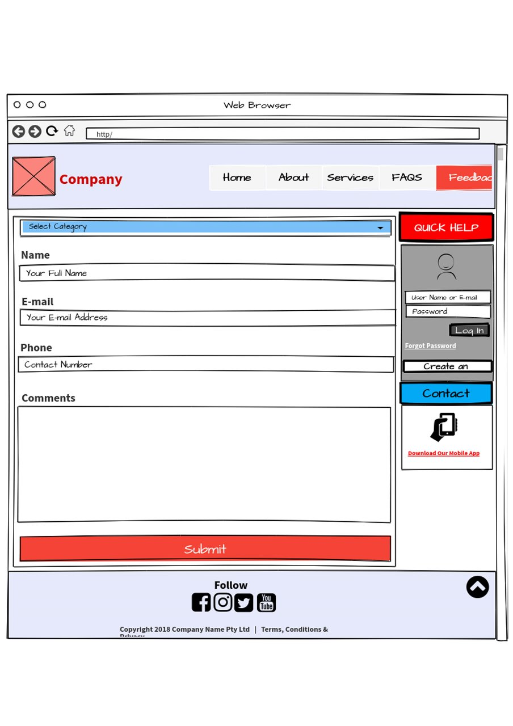

**Services Page**

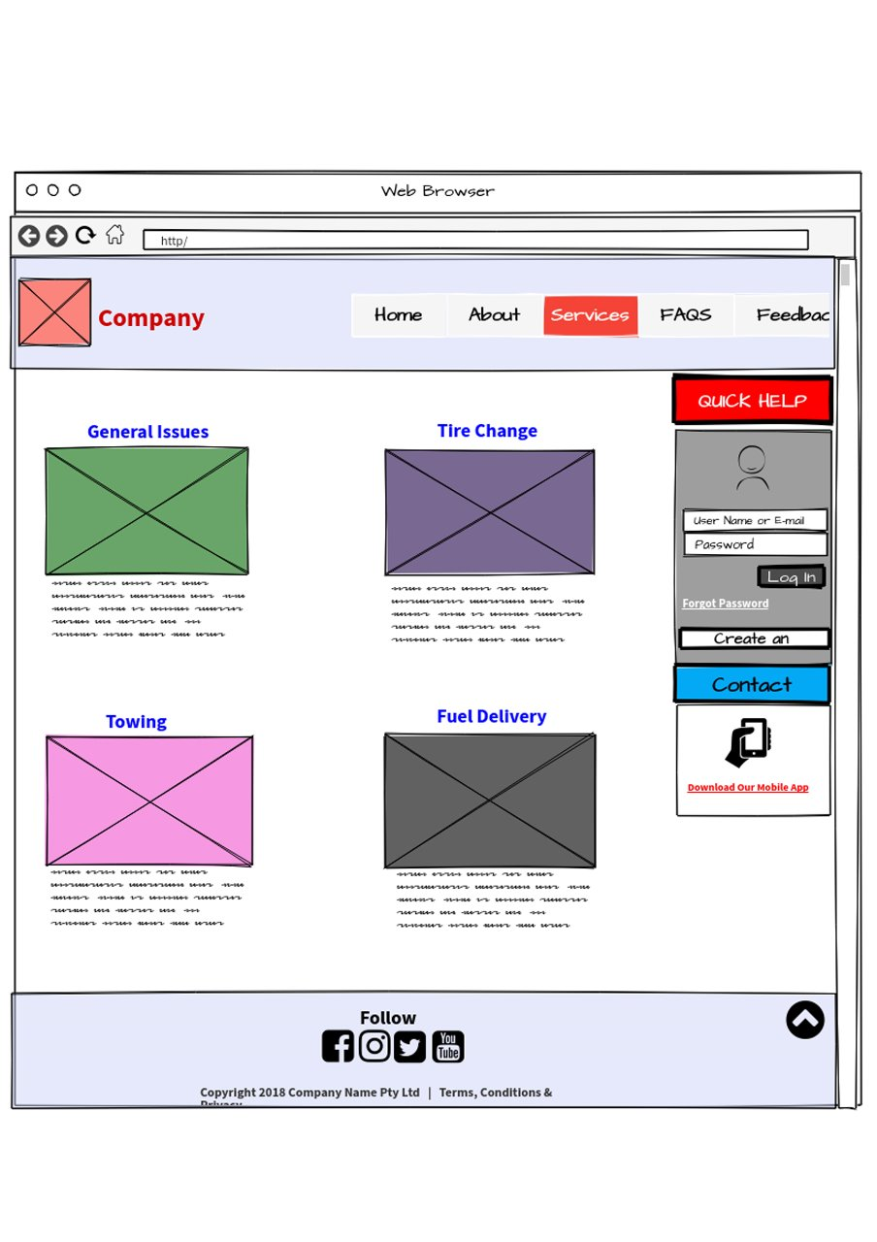

**FAQ Page**

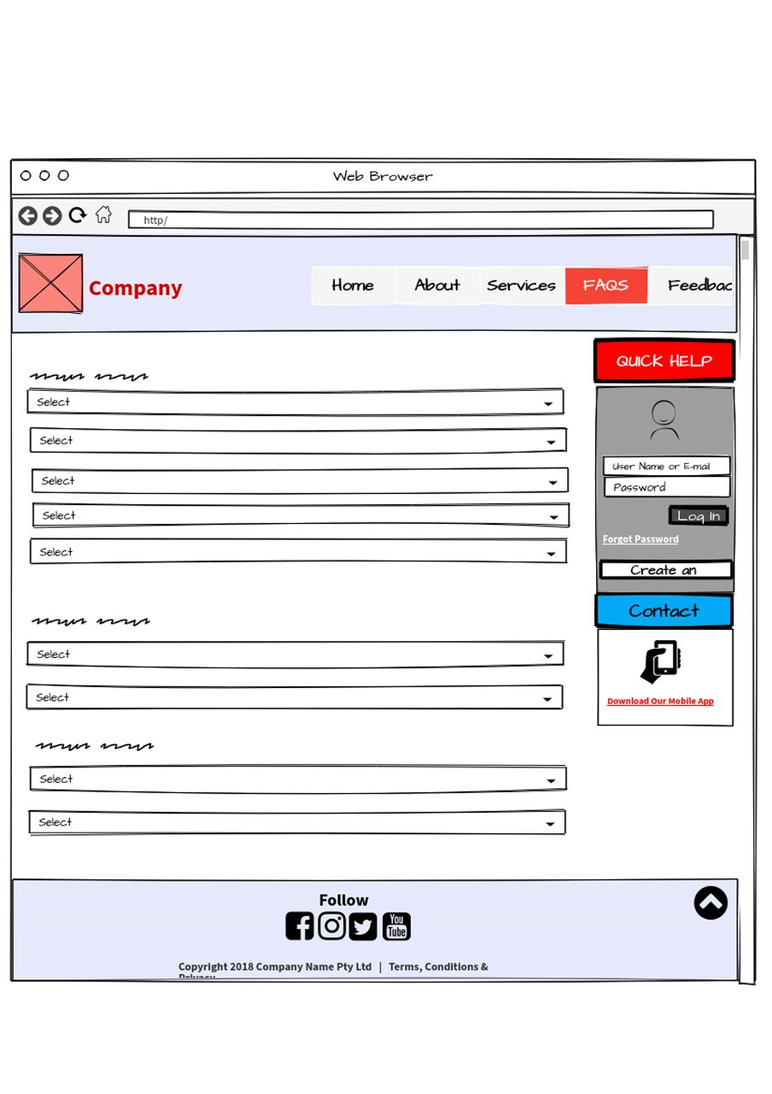

# **Individual Contribution**

|  |  |  |  |
| --- | --- | --- | --- |
|  | **Student ID** | **Student Name** | **Individual Contribution** |
| 1 | IT18107388 | Perera D.F.Y.D | * Persona: Owner * User Journey: Owner * Wireframe : Registration Page |
| 2 | IT18106916 | Malagala D.S.K | * Persona: Customer * User Journey: Customer * Wireframe: FAQ Page |
| 3 | IT18107210 | Seekkubadu D.P. | * Persona: Administrator * User Journey: Administrator * Wireframe: Contact Us Page |
| 4 | IT18107074 | Upulie H.D.I | * Introduction * Persona: Technician * User Journey: Technician * Wireframe: User Account Page |
| 5 | IT18107524 | Thariq A.L.M | * Persona: Financial Executive Officer * User Journey: Financial Executive Officer * Wireframe: Home Page, About Us Page, Feedback Page, Services Page, FAQ |

