* Wireless Standards
  + What are the Seven (7) IEEE WLAN standards in use today?
    - 802.11, 802.11a, 802.11b, 802.11g, 802.11n, 802.11ac, 802.11ax
  + What are the Wi-fi Alliance names associated to each IEE standard? When was each standard released?
    - 802.11b - Wi-Fi 1 (1999)
    - 802.11a - Wi-Fi 2 (1999)
    - 802.11g - Wi-Fi 3 (2003)
    - 802.11n - Wi-Fi 4 (2009)
    - 802.11ac - Wi-Fi 5 (2014)
    - 802.11ax - Wi-Fi 6 (2019)
  + Which standards are listed at 2.4 GHz, and which standards are listed at 5 GHz?
    - **2.4 GHz only: 802.11b, 802.11g**
    - **5 GHz only: 802.11a, 802.11ac**
    - **Both 2.4 GHz and 5 GHz: 802.11n, 802.11ax​**
  + What is the maximum theoretical speed that each standard can handle?
    - 802.11b: 11 Mbps
    - 802.11a: 54 Mbps
    - 802.11g: 54 Mbps
    - 802.11n: Up to 600 Mbps (with channel bonding)
    - 802.11ac: Up to 6.9 Gbps
    - 802.11ax: Up to 9.6 Gbps
  + How many channels are in the 2.4 GHz spectrum (USA standards)? What are the non-overlapping channels in the 2.4 GHz spectrum?
    - There are 11 Channels with three non-overlapping channels: 1, 6, and 11.
  + How does channel bonding work in the 5 GHz spectrum? Give one reason why you would use Channel Bonding.
    - Channel bonding combines multiple adjacent 20 MHz channels into a single 40, 80, or even 160 MHz channel to increase throughput, though it reduces the number of available channels. Channel bonding can provide faster speeds by increasing bandwidth. It is often used to support higher data rates in environments with sufficient available spectrum.
  + In the 2.4 GHz spectrum, which of the following channels would overlap with Channel 6? Choose all that apply.
    - Channel 1
    - Channel 2
    - Channel 3
    - Channel 4
    - Channel 5
  + Which Wifi standards support communication on 5 GHz frequencies? Choose all that apply.
    - 802.11b
    - 802.11a
    - 802.11g
    - 802.11n
    - 802.11ac
    - 802.11ax
  + Give a brief description of how CSMA/CA works. How does that differ from CSMA/CD?
    - **CSMA/CA (Collision Avoidance):** Used in Wi-Fi, it checks the channel for any ongoing transmissions and sends a "Request to Send" (RTS) to announce its intention to transmit. It proceeds if it receives "Clear to Send" (CTS); otherwise, it waits a randomized time.
    - **CSMA/CD (Collision Detection):** Used in Ethernet, it immediately sends data without pre-checking, detecting any collisions post-transmission and retransmitting if necessary​.
* Wireless Infrastructure
  + What is the Service Set Identifier (SSID)? Name four characteristics of an SSID.
    - The SSID is the wireless network's name, which is case-sensitive, up to 32 characters, and allows users to identify and connect to a network. Each WLAN has a unique SSID.
  + List three different Service Sets and list one characteristic that differentiates each Service Set.
    - **BSS (Basic Service Set):** A single access point (AP) connected to a wired network.
    - **ESS (Extended Service Set):** Multiple APs with the same SSID for broader coverage.
    - **IBSS (Independent Basic Service Set):** Peer-to-peer network without an AP, often for ad-hoc connections​
  + What is RSSI and what does it measure?
    - RSSI measures signal strength received by the client device, helpful in assessing Wi-Fi coverage quality.
  + Users report intermittent connectivity when connected in certain areas of your WIFI 6 deployment. What are the first three tasks that will help you better understand coverage issues?
    - Look at AP placement
    - Check AP association time: Ensures optimal signal coverage.
    - Evaluate Captive Portal settings
    - Do a Site Survey: Helps map out signal strength across the area.
    - Build a Heat map: Visualizes signal strength to identify weak spots.
  + Users in your WLAN are unable to roam between access points. What changes allow for seamless roaming? Choose two.
    - Configure the WLAN as an ESA(ESS)
    - Configure the WLAN as a BSA (BSS)
    - Configure the WLAN as an IBSA (IBSS)
    - Place Access Points in the same SSID
    - Place Access Points in different SSIDs
  + What could be affected to alter the coverage extended by a single access point when interference is not a concern? Choose all the apply.
    - Change the Antenna Power
    - Change the AP placement
    - Change the Channel
    - Change the Antenna
  + Your users are reporting poor performance. Upon investigating, you notice a new SSID from an adjacent business. Which variable is likely to assist in allowing your SSID to coexist with the new SSID?
    - MIMO
    - Channel Bonding
    - Channel Value
    - Match the SSID of the adjacent business
  + While investigating your WLAN, you discover that users who are close to an AP are more likely to connect to an AP across the floor, much farther away. What would you consider changing?
    - Change the polarization
    - Change the AP Placement
    - Change the Channel
    - Change the Antenna Power
* Wireless Security and Encryption Standards
  + List 4 WIFI Security standards used in Wireless Networks. List 2 characteristics for each cryptographic protocol.
    - WEP: Weak security, uses static 64-bit or 128-bit key with RC4 cipher
    - WPA: Uses TKIP for encryption, 48-bit IV, includes Message Integrity Check (MIC)
    - WPA2: Stronger security using AES with 128-bit encryption in CCMP
    - WPA3: Strongest, uses SAE for authentication and AES with 128 or 192-bit keys.
  + List 2 Authentication Methods and the major component/standard used for each Method.
    - Pre-Shared Key (PSK): Requires a shared password for all devices.
    - Enterprise Mode: Uses 802.1X authentication with a RADIUS server for centralized credential management.
  + What WiFi security standard uses AES as the primary encryption cipher?
    - WEP
    - WPA
    - WPA2
    - WPA3
  + You need an authentication protocol that encrypts passwords and uses digital certificates. What should you use?
    - AES
    - WPA2
    - TKIP
    - EAP-TLS
  + Describe a Dissociation Attack and what the result would be of this attack.
    - An attacker sends a dissociation frame to disconnect a client from the network, causing disruptions in connectivity and enabling potential interception of reconnect attempts​.

Updated Screenshots:

-2.0.7

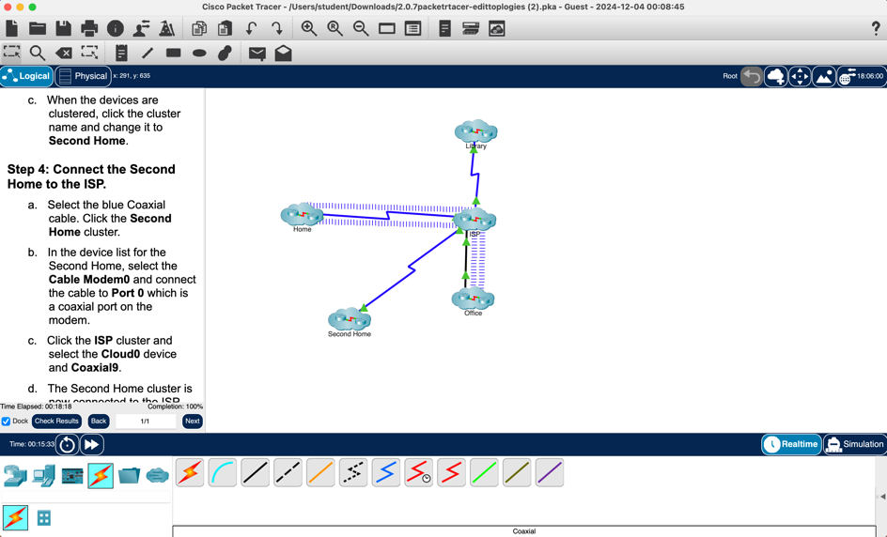

-2.1.3

-2.1.5

**-2.2.1**

