ASSIGNMENT-01

Create an account on aws and launching the instance

* Create your account on amzon aws using root or IAM user
* Open ec2 services and click on instances and select region (asia pecific Mumbai).
* Name your instance and click on window O.S and select it.
* Select instances types ( select t3.micro ).
* Now create your key pair name (key pair type should be RSA and and format .pem or .ppk as your recuirement).
* After creating your key it will be downloaded automatically.
* Allow SSH traffic from my ip address or 0.0.0.0/0 if you want to access it from anywhere on internet .
* Now click on launch instance.
* After launched your instances go to your instances and select your instance.
* click on connect then click on RDP client and download remote desktop file.
* Now click on get password and click on upload private key.
* And choose your pem or ppk file and upload it.
* Then click on decrypt password and copy your password .
* Open your remote desktop file and paste your password.
* And click on connect now your virtual window will be opened and you are ready to use.

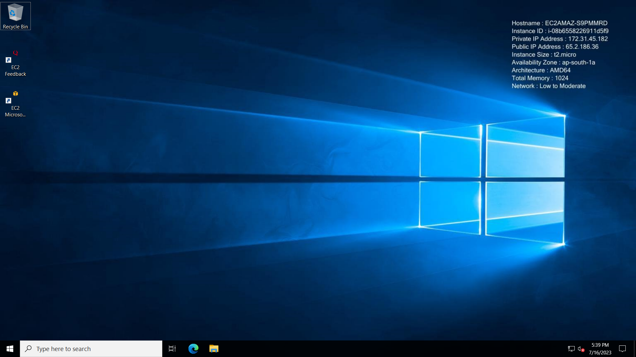

Installing Web server

* Now further to install Apache static web server to host static web page on internet you need to open the web browser.
* Now you just search for Apache web server and download your desired file from the options.
* Then go to file explorer and extract the file in c drive .
* After extracting the file open it and open the bin folder and copy the path now open administrators command prompt .
* Now type cd command which stands for change directory command.
* cd c:\Apache24\bin
* then hit httpd -k install
* the apache is live now
* if you want to check then open your web browser and press 127.0.0.1 url.
* If it is installed correctly then you will be able to see “it works!” web page on you browser locally.

