# C:\Users\fluo\AppData\Local\Microsoft\Windows\INetCache\Content.Word\Performance Education_DARK_RGB_510px.png

# Professional Year Program Australian Workplace Environment

**Australian Workplace Legislation**

This module addresses the following elements:

* Define legislation in the workplace and understand its importance
* Identify and navigate useful legislation websites
* Define the National Employment Standards
* Explain work rights, anti-discrimination and equal employment opportunity
* Understand the effects of workplace bullying and harassment
* Research key areas of Australian workplace legislation
* Participate in a workplace legislation revision activity

Activity 1.1: Wall Crawl – Definitions and Acronyms

1. What is the definition of **legislation**?

|  |
| --- |
|  |

1. **Why** is employment legislation important?

|  |
| --- |
|  |

1. What is the **Fair Work Act** and what does it cover?

|  |
| --- |
|  |

1. What is the meaning of **industrial relations**?

|  |
| --- |
|  |

1. What is a **trade union**?

|  |
| --- |
|  |

1. What is an **ombudsman**?

|  |
| --- |
|  |

1. What is the definition of **harassment**?

|  |
| --- |
|  |

1. What is the definition of **bullying**?

|  |
| --- |
|  |

1. What is **discrimination**?

|  |
| --- |
|  |

1. What is an **award wage**?

|  |
| --- |
|  |

1. What is **unfair dismissal**?

|  |
| --- |
|  |

1. What is **workers’ compensation**?

|  |
| --- |
|  |

1. What is **superannuation**?

|  |
| --- |
|  |

1. What does **EEO** stand for?

Australian accounting and ICT professionals, and especially team leaders and hiring managers require knowledge of a wide range of employment-related legislation. The federal [Fair Work Act 2009](http://www.austlii.edu.au/au/legis/cth/num_act/fwa2009114/) is most important because of its provision of minimum **NES** for all Australian workers, as well as its coverage of important issues such as termination of employment and industrial relations. However, state and territory legislation applies in areas such as **EEO** and discrimination, **WHS**, and workers’ compensation.

1. What does **NES** stand for?
2. What does **WHS** stand for?



Activity 1.2: Where to Find the Info You Need

1. Fill in the gaps according to the YouTube clip. There may be more than one word used. *“Industrial awards (called modern awards) set up the*\_\_\_\_\_\_\_\_\_\_\_\_\_\_\_\_\_ \_\_\_\_\_\_\_\_\_\_\_\_\_\_\_\_\_\_\_\_\_\_\_\_\_\_\_\_\_\_\_\_\_\_ *for a particular job and cover many employees. Some groups of workers negotiate their own pay and conditions with their employer. These are called* \_\_\_\_\_\_\_\_\_\_\_\_\_\_\_\_\_\_\_\_\_\_\_\_\_*“*
2. What is the role of the Fair Work Commission?

|  |
| --- |
|  |

1. What other key national organisation supports harmonious workplaces?

|  |
| --- |
|  |

1. The Fair Work Commission is established by which Act?

|  |
| --- |
|  |

1. Which organisation is responsible for the following? Write FWC (Fair Work Commission) or FWO (Fair Work Ombudsman).

|  |  |
| --- | --- |
| Independent umpire for disputes including unfair dismissals |  |
| Advise on awards, pay and leave |  |
| Resolve issues with pay and entitlements |  |
| Creates and changes modern awards |  |
| Sets minimum wages |  |
| Investigate serious non-compliance |  |

1. What organisation should you contact if you have questions about superannuation entitlements?

|  |
| --- |
|  |

1. If you have worries about safety in your workplace, which organisation can you contact?

|  |
| --- |
|  |

1. Individual employees can get help from the Fair Work Commission if they believe they have been affected in which areas?



1. \_\_\_\_\_\_\_\_\_\_\_\_\_\_\_\_\_\_\_\_\_\_\_\_\_\_\_\_
2. \_\_\_\_\_\_\_\_\_\_\_\_\_\_\_\_\_\_\_\_\_\_\_\_\_\_\_\_
3. \_\_\_\_\_\_\_\_\_\_\_\_\_\_\_\_\_\_\_\_\_\_\_\_\_\_\_\_\_\_

Activity 1.3: Navigating Important Websites

It is important to know where to look for information regarding your work rights and where to find the answers you need. The Fair Work Ombudsman and the Fair Work Commission are important websites to familiarise yourself with. Both of these websites include very useful information, which will help your preparation for the workplace. They also have links to other important websites.

In pairs, navigate each website and identify the navigation tabs to find the following information.

**Fair Work Ombudsman –** <http://www.fairwork.gov.au>

|  |  |
| --- | --- |
| **Where can I find out more about…** | **Navigation tabs** |
| 1. … maternity leave and parental leave? |  |
| 1. … free online training? |  |
| 1. … what to do if I experience bullying and harassment? |  |
| 1. … unfair dismissal? |  |
| 1. … penalty rates and allowances? |  |
| 1. … visa holders and migrant workers – workplace rights and entitlements? |  |
| 1. … employment contracts? |  |
| 1. … managing performance and warnings? |  |
| 1. … tax and superannuation? |  |

## Fair Work Commission – <https://www.fwc.gov.au>

|  |  |
| --- | --- |
| **Where can I find out more about…** | **Navigation tabs** |
| 1. … how to prevent or resolve disputes in my workplace? |  |
| 1. … legislation and regulations? |  |
| 1. … information related to major cases, significant decisions and orders made by the Commission and its predecessors? |  |
| 1. … industrial action? |  |
| 1. … the national workplace relations system? |  |
| 1. … minimum wages and conditions? |  |
| 1. … how to make a complaint against a registered organisation? |  |



Activity 1.4: National Employment Standards (NES)

**Q: What** are the NES and **why** are they important?

|  |
| --- |
|  |

**Q:** To **whom** do the NES apply?

|  |
| --- |
|  |

### The 10 minimum entitlements of the NES are:

* [Maximum weekly hours](http://www.fairwork.gov.au/Employee-entitlements/hours-of-work-breaks-and-rosters/Hours-of-work/default)
* [Requests for flexible working arrangements](http://www.fairwork.gov.au/Employee-entitlements/Flexibility-in-the-workplace/flexible-working-arrangements)
* [Parental leave and related entitlements](http://www.fairwork.gov.au/Leave/maternity-and-parental-leave/default)
* [Annual leave](http://www.fairwork.gov.au/leave/annual-leave/default)
* [Personal carers leave](http://www.fairwork.gov.au/leave/sick-and-carers-leave/default) and [compassionate   
  leave](http://www.fairwork.gov.au/leave/compassionate-leave)
* [Community service leave](http://www.fairwork.gov.au/leave/community-service-leave/default)
* [Long service leave](http://www.fairwork.gov.au/leave/long-service-leave/default)
* [Public holidays](http://www.fairwork.gov.au/Leave/Public-holidays/default)
* [Notice of termination](http://www.fairwork.gov.au/Ending-employment/notice-and-final-pay/default) and [redundancy pay](http://www.fairwork.gov.au/ending-employment/redundancy/default)
* [Fair Work Information Statement](http://www.fairwork.gov.au/Employee-entitlements/National-Employment-Standards/fair-work-information-statement)

### Casual employees and the NES

Casual employees only get NES entitlements relating to:

|  |  |
| --- | --- |
| * unpaid carer's leave * unpaid compassionate leave | * community service leave * the Fair Work Information Statement |

In some states and territories, **long serving casuals** are eligible for long service leave.

If a casual worker has been regularly and systematically employed for at least 12 months and their work is ongoing, they have extra entitlements from the NES.

These are:

* the right to request flexible working arrangements
* access to parental leave

Activity 1.5: Researching the NES

In pairs, research The National Employment Standards in Australia and complete the following information.

1. The **maximum weekly hours of work** is hours per week, plus reasonable additional hours.
2. **Requests for flexible working arrangements** – an entitlement allowing employees in certain circumstances as set out in the Fair Work Act 2009 to request a change in their working arrangements because of those circumstances.
3. **Parental leave and related entitlements** – up to months unpaid leave per employee, plus a right to request an additional 12 months unpaid leave, plus other forms of maternity, paternity and adoption related leave.
4. **Annual leave** – weeks paid leave per year, plus an additional week for certain shift workers.
5. **Personal/carer’s leave and compassionate leave** – days paid personal/carer’s leave, \_\_\_\_ days unpaid carer’s leave as required, and days compassionate leave (unpaid for casuals) as required.
6. **Community service leave** – leave for voluntary emergency activities and leave for jury service, with an entitlement to be paid for up to days for jury service.
7. **Long service leave** – a transitional entitlement for employees as outlined in an applicable pre‑modernised award, pending the development of a uniform national long service leave standard.
8. **Public holidays** – a day off on a public holiday, except where reasonably requested to work.
9. **Notice of termination and redundancy pay** – up to weeks’ notice of termination and up to \_\_\_\_\_\_ weeks’ severance pay on redundancy, both based on length of service.
10. **Provision of a Fair Work Information Statement** – must be provided by employers to \_\_\_\_\_\_\_\_\_\_\_\_\_\_\_\_\_\_\_\_\_\_\_\_\_\_\_\_\_\_\_, and contains information about the NES, modern awards, agreement-making, the right to freedom of association, termination of employment, individual flexibility arrangements, union rights of entry, transfer of business, and the respective roles of the Fair Work Commission and the Fair Work Ombudsman.

### What are the consequences if a company doesn’t comply with the Fair Work Act?

Employers should be familiar with the important concepts of workplace rights and adverse action, and be aware of their scope to reduce the risk of claims in this area. A breach of this provision of the Fair

### 

### I’m not an Australian citizen.

### Do I still have rights?

# Anti-Discrimination and EEO law

All employers, managers, supervisors and   
employees should know about equal   
employment opportunity (EEO). From a   
legal point of view, it is everyone’s   
responsibility to ensure that everyone   
in your company complies with them.



Activity 1.6: Defining Terminology

**Q:** What is **EEO?**

|  |
| --- |
|  |

**Q:** What is **unlawful discrimination?**

|  |
| --- |
|  |

## http://aseemrastogi2.files.wordpress.com/2014/02/discrimination-or-odd-one-out1.jpgWhat Does Australia Law Say About Discrimination in the Workplace?

EEO is also about ensuring that all new staff are *appointed on their merits*; and that *promotions* are *made on this basis.* It is against the law to treat any employee unfairly or less favourably because of a characteristic they possess which these laws cover to protect.

**No individual may be discriminated against on the basis of any of the following:**

|  |  |
| --- | --- |
| * gender * marital/domestic status * potential pregnancy * pregnancy * breastfeeding * disability * race, colour, national extraction, social origin, descent, ethnic, ethno-religious or national origin * age * compulsory retirement age * family responsibilities, family status, status as a parent or carer | * religious belief or activity * political belief or activity physical features * industrial activity * employer association activity * trade union activity * sexuality incl. homosexuality, transsexuality, transgender * profession, trade, occupation or calling * medical record * HIV/AIDS * criminal record |



Activity 1.7: Direct and Indirect Discrimination

There are two types of discrimination that are prohibited by  
 legislation, direct and indirect.

**Part A**

Q: What is **direct** discrimination?

|  |
| --- |
|  |

Q: What is **indirect discrimination?**

|  |
| --- |
|  |

Q: What is **genuine occupational requirement (GOR)?**

|  |
| --- |
|  |

**Part B**

Your trainer will show a series of slides. Decide whether each scenario is an example of direct discrimination, indirect discrimination, a genuine occupational requirement (GOR) or a justified action on the employer’s behalf (the employee is breaching a justified workplace policy).

**Part C**

Go to <http://www.myworkrights.com.au/> and complete the online quiz.

# https://www.papermasters.com/images/workplace-bullying-harassment.jpgBullying and Harassment

|  |
| --- |
| **Fact Sheet** |
| Bullying at work, as defined by the [Fair Work Act 2009](https://www.fwc.gov.au/about-us/legislation-regulations/fair-work-act-2009), occurs when: “A person or a group of people behaves unreasonably and repeatedly towards a worker or a group of workers while at work, and the behaviour creates a risk to health and safety.” |
| “A Safe Work Australia (SWA) report found bullying levels in Australian workplaces are substantially higher than international rates” - Know Bull! Facts and stats. |
| “Females report significantly higher levels of overall sexual harassment and bullying and experience bullying for significantly longer periods of time than men” - Safe Work Australia/AWB report (The Australian Workplace Barometer Report) |
| “The AWB results showed that females reported experiencing significantly more unwanted sexual advances, humiliation, and unfair treatment due to gender than men. Alternatively, men reported significantly higher rates of physical violence and being yelled at or sworn at than women” - Safe Work Australia/AWB report (The Australian Workplace Barometer Report) |





Activity 1.8: Examples of Bullying

**Q:** What are some **examples** of bullying?

|  |
| --- |
|  |



### What are the consequences of bullying?

## What Does the Law Say About Bullying and Harassment?

The consequences of bullying and harassment have serious consequences on the Australian economy and the health and wellbeing of its workers. These two terms are often used hand-in-hand.

Even though the definition of what constitutes bullying and harassment and their negative effects are vastly similar, there are some differences from a legislative perspective.

A single incident of unreasonable behaviour is not considered to be workplace bullying, however, it is important to understand that a one-off incident can constitute harassment.

Bullying could be classified as unlawful according to anti-discrimination legislation when it is linked to, or based on, one of the characteristics covered by various federal anti-discrimination legislation (age, sex, race, disability, etc.).





Activity 1.9: Harassment in the   
Workplace

The law also has specific provisions relating to sexual harassment, racial hatred and disability harassment.

### The Sex Discrimination Act 1984

* Prohibits harassment in the workplace by employers, co-workers and other “workplace participants”, such as partners, commission agents, volunteers and contract workers.
* Sexual harassment is broadly defined as unwelcome sexual conduct that offends, humiliates or intimidates the person harassed.

### The Disability Discrimination Act 1992

* Prohibits harassment in the workplace based on or linked to a person’s disability or the disability of an associate.

### The Racial Discrimination Act 1975

* Prohibits offensive behaviour based on racial hatred.
* Racial hatred is defined as something done in public that offends, insults or humiliates a person or group of people because of their race, colour or national or ethnic origin.

**Q:** In regards to the three Acts outlined above, **what type of behaviour** could be an example of harassment?

|  |
| --- |
|  |



### What can I do if I’m being bullied or I’ve been harassed?



**Safe Work Australia** provides a workers guide to *Dealing with Workplace Bullying*. <http://www.safeworkaustralia.gov.au/sites/SWA/about/Publications/Documents/828/Workers-Guide-workplace-bullying.pdf>

Activity 1.10: Case Studies on Bullying and Harassment

Read real life case studies on bullying and harassment that have taken place in Australia.

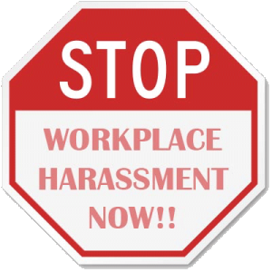

# http://jamiemcintyre.com/wp-content/uploads/2011/09/Aus-Cash.jpgFacts About Pay



Activity 1.11: What Do These Words Mean?

|  |  |  |  |  |
| --- | --- | --- | --- | --- |
| minimum wage | award wage | penalty rates | pay slips | tax |
| cash-in-hand | superannuation | ATO | overtime |  |

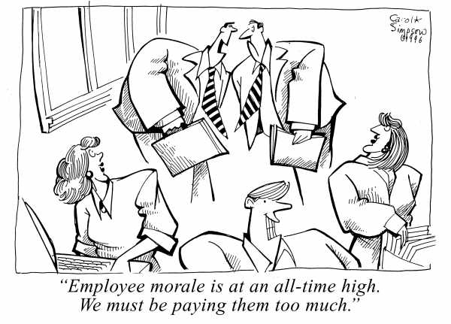

|  |
| --- |
| Notes |

# http://www.saracenssolicitors.co.uk/wp-content/uploads/2012/09/Unfair-Dismissal-Solicitors1.jpgUnfair Dismissal

Activity 1.12: Unfair Dismissal – What Does the Law Say?

Q: What is unfair dismissal and who can I contact if I feel I’ve been unfairly dismissed?

|  |
| --- |
|  |

Federal law prohibits dismissal of an employee in the following cases:

* temporary absence from work because of illness or injury
* union membership or legitimate union activities
* non-membership of a union
* seeking to be or acting as a representative of employees
* filing a complaint against an employer or being involved in legal actions against an employer
* prohibitions of discrimination – e.g. race, colour, gender, sexual preference, age, physical or mental disability, marital status, family responsibilities, pregnancy, religion, political opinion, nationality or social origin.
* absence from work during maternity or other parental leave
* if your dismissal was not a case of genuine redundancy



### What are the consequences if companiesdon’t comply?

Activity 1.13: Assessment Task – AWE: WLRP Workplace Legislation Research Project

In this activity, you’ll be assessed on your ability to take notes, research information and deliver your findings as a **verbal report to a manager.**

### Individual and team performance criteria



Your trainer will monitor your participation and contributions to   
your team in this assessment. To be found competent, you will   
each need to –

* Understand the manager’s instructions, including the   
  objective of the task for the organisation
* Take notes of the task instructions, deadlines and important information
* Check information using clarification skills
* Share the workload equally
* Analyse information for reliability and validity
* Familiarise self with EEO, harassment legislation and employment conditions
* Understand new terms and words with the use of dictionaries and online resources
* Understand how to provide information using a direct and linear approach
* Provide a structured verbal report of findings to the manager, providing the right amount of relevant detail

**Scenario**

Your group works for an international company based in Singapore. The company will soon be expanding into Australia and will be establishing a satellite office here.

Your manager is about to assign your group an important task to complete which will aid the expansion process.

You will need to listen carefully to your manager’s instructions and take notes of what is required.

Later on, you will need to deliver your research to your manager as a verbal report.

**Part 1 – The importance of note taking**

Part 1 – The Importance of Note Taking

### Q: When your manager assigns you with a task, why is it important to take notes?

|  |
| --- |
|  |

**Q:** During your Work Integrated Learning Placement, in which **situations** do you think it will be important to take notes?

|  |
| --- |
|  |

### “For every minute spent organising, is an hour earned.”

### Benjamin Franklin

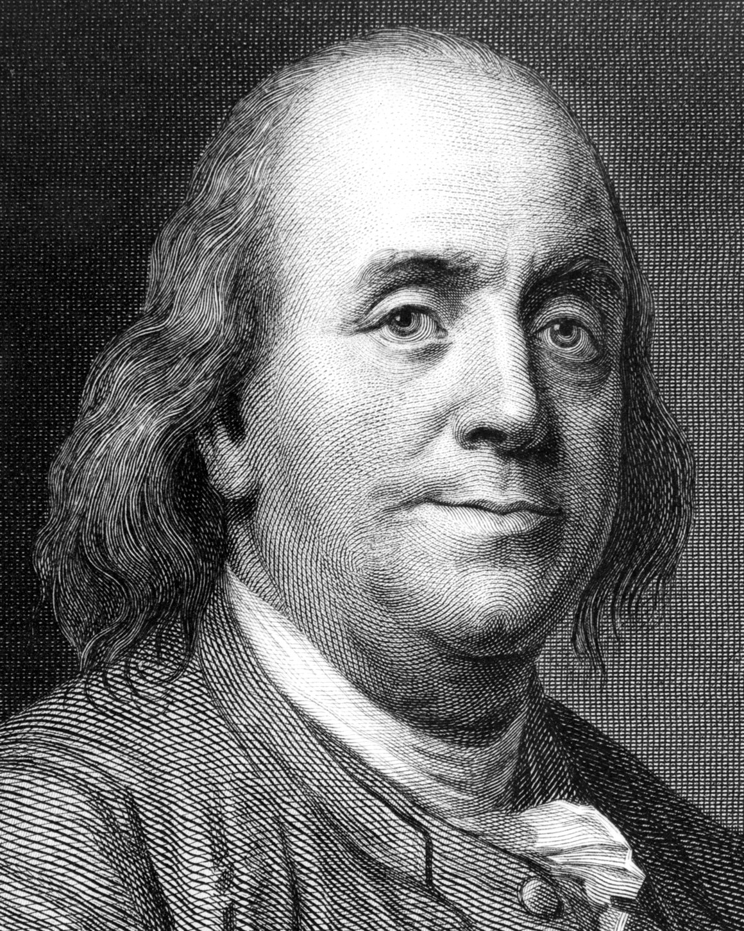

Part 2 – Understanding the Manager’s Instructions

Your trainer will now take on the role of your manager and will explain the task that you must complete. **Everyone must take notes individually**. Ensure that your notes are clear and systematic and capture the key information required.

|  |
| --- |
|  |

### Your team is tasked with:

* researching important information as instructed by your manager
* sharing the workload equally among team members
* deliver a structured verbal report to your manager (class), providing the right amount of relevant detail

### Your objective is to:

1. raise awareness related to the topic area assigned to your group
2. answer any questions the class may have regarding the area researched.

### Follow – up

Your trainer will provide you with blank paper and scissors. As a group, you are to create at least 15 question cards and answers, or multiple choice questions and answers, based on the information you’ll be presenting. These cards will later be used by others groups in a fun board game.

### Process

Part 3 – Researching, Planning and Creating

|  |
| --- |
| Notes |

Part 4 – Delivering verbal reports

Record key learnings from other teams’ verbal reports in the spaces below:



1. **Pay**

|  |
| --- |
|  |



1. **Leave**

|  |
| --- |
|  |

1. **Ending Employment**

|  |
| --- |
|  |



1. **Employee Entitlements**

|  |
| --- |
|  |



1. **Awards and Agreements**

|  |
| --- |
|  |



Part 5 – Revision

Write down three legislative areas of the Australian workplace which are most important to YOU and which perhaps you were not previously aware of. Why are they important?

|  |
| --- |
| 1. |
| 2. |
| 3. |

**Legislation Board Game**



**Who will be the winner?**

Activity 1.14: Legislation Board Game - Are You Ready to Play?

* In groups, your trainer will provide you with a set of cards prepared by another group, dice, and a board game.
* Instructions for playing are written on the board game.
* Good luck!

References

|  |  |
| --- | --- |
| Workplace rights  Workplace Info  Breaching FWA  Australian Workplace Safety  Workplace Discrimination  Direct and Indirect Discrimination  Workplace Bullying & harassment  Case Studies  Work Rights quiz  Google images | <https://www>.fwc.gov.au  <http://www>.fairwork.gov.au  <http://workplaceinfo.com.au>  http://www.mondaq.com/australia  www.safeworkaustralia.gov.au  <http://www.afei.org.au>  <https://www.adcq.qld.gov.au>  <http://www.know-bull.com/factsnstats.html>  www.safeworkaustralia.gov.au  <https://www.humanrights.gov.au/employers/good-practice-good-business-factsheets/>  http://www.comcare.gov.au/Forms\_and\_Publications  <http://www.smh.com.au/small-business/managing/workplace-bullying-case-worst-ever-seen-20100428-tshs.html>  <http://www.safetysolutions.net.au/content/business/article/a-case-of-workplace-bullying--632323172>  <http://www.myworkrights.com.au/> |

# Appendices

## Activity 1.13: Structure for a Verbal Report

### 1. What are verbal reports for?

In your work for an organisation, you will often have to speak in meetings and make either a short input or a verbal report on a particular issue. For example, you may give your view on an issue that is under discussion, report from a conference, or give input for a workshop on a particular issue you have researched.

### 2. Important things to know about inputs and verbal reports

* **Credibility:** people will listen to you if you sound as if you know what you are talking about
* **Facts:** prepare carefully and make sure that you have the correct facts at hand
* **Be strong and clear:** speak in a strong and logical way and avoid undermining yourself by saying things like "I’m not really sure, but I think…"
* **Keep it short and simple:** make your ideas seem simple, easy to implement and the most sensible solution.
* Always stress how the organisation will **benefit** so that people can see why it is worth supporting your proposal.

### 3. How to structure your report or input

* **Issue** – In your introduction, make it clear exactly what you will be talking about
* **Facts** - give the basic facts about the issue or describe the reasons for the problem so that your audience can also understand the situation
* **Options** – briefly tell people what could be done about this issue or problem. Here you can describe a number of alternatives, deal with costs, timeframes, benefits, etc.
* **Proposal** – clearly state what you believe is the right way to deal with the issue or problem and what should be done right now as well as in the long term. Always try to end on a positive note giving a clear way forward.

Keep all reports and inputs as short as possible.

*See example report on following pages.*

### Example: Three minute report by a local councilor

**(Issue)**  
This report deals with the proposals from the Community Policing Forum on what the council can do to combat crime in the area.

**(Facts)**  
Our town has one of the highest crime rates in the area with almost 200 murders reported last year. Housebreaking, theft and assaults have also increased dramatically and almost every family in our area has been affected in some way. The youth are organised into two strong and competing gangs that rule the township through terror. Unemployment is on the increase and most young people have little to occupy them or give them hope for the future. Crime is killing our town and the CPF has appealed to all stakeholders to unite in the battle against crime. Our three police stations are understaffed and have only five vehicles between them. The police alone cannot solve the problem. The business community has agreed to support the police by hiring private security for the CBD and sponsoring two extra police vans. The civic and youth organisations are recruiting volunteers to become police reservists so that the police can be freed from administrative duties. The churches have agreed to use their facilities to set up youth clubs especially over weekends. This is a small but important beginning and the council has been asked to support these initiatives in any way possible.

**(Options)**  
At present we have little additional funds available for any new work but I believe it is vital that we show our commitment and that we do what we can within the present budget. There are a number of options. We can support the development of youth facilities by making council venues available at a lower than normal rate, we can add to the vehicle fund. We can improve the street lighting around the taxi-rank. We can support the crime survivors counselling centre. We can supply direct support to the police by deploying council security staff to work in partnership with them. What is clear is that we cannot afford to do all of the above. We therefore have to choose options that are cost effective, have impact and show that the council cares.

**(Proposals)**  
I propose that we do two things immediately. Firstly, we should fix the soccer-field since we have already budgeted for it, and form a partnership with the churches to set up a proper soccer league in the area. Secondly, we should offer part of the old rent office next to the police station in town to Rape Crisis to use as a counselling facility. This would also enable the police to use the facility as a victim-friendly interview room for abuse cases. In the long-term our Exco has to take the issue of crime and employment as absolute priorities and put them high on next year’s budget.