Title: Impact of Structured Pediatric Nephrology Care on Clinical Outcomes in Children with Nephrotic Syndrome at a Developing Tertiary Care Centre in North India

Abstract
Objectives:
To evaluate the impact of introducing structured pediatric nephrology care on clinical outcomes of children with nephrotic syndrome at a developing tertiary care centre in North India.
Methods:
This Retrospective observational before-and-after study included children diagnosed with nephrotic syndrome during 2025. Patients managed from January–July formed the pre-intervention group, while those from August–December comprised the post-intervention group. The intervention included consistent implementation of Indian Society of Pediatric Nephrology (ISPN) steroid protocols, improved disease classification, structured parental training for home urine dipstick monitoring, and weekly WhatsApp-based remote monitoring. Outcomes were compared descriptively.
Results:
14 children were included (6 pre-intervention, 8 post-intervention). Mean hospital stay decreased from 8 to 5 days, and median time to remission reduced from 12 to 8 days. Remission rates improved from 66.7% to 87.5%, relapse rates declined from 50% to 25%, and loss to follow-up reduced from 33.3% to zero. Referrals to higher centres were eliminated. No mortality occurred.
Conclusion:
Structured pediatric nephrology care improved clinical outcomes and follow-up adherence. Standardised protocols, parental involvement, and low-cost digital monitoring can enhance care delivery in developing tertiary settings.

Introduction
Nephrotic syndrome is one of the most common glomerular disorders in children, characterised by heavy proteinuria, hypoalbuminemia, and/or concomitant edema, Its incidence ranges from 1.15 to 16.9 per 100,000 children and varies by ethnicity and region [1,2]. It contributes substantially to pediatric hospital admissions in India and other low- and middle-income countries [2]. The majority of affected children (ca. 85%) show complete remission of proteinuria within 4–6 weeks with daily prednisolone/prednisone (PDN) and have steroid-sensitive NS (SSNS). However, about 70–80% of patients will experience at least one relapse during follow-up. About 50% of patients have frequent relapses or are steroid-dependent, necessitating prolonged follow-up and immunosuppressive therapy [1,3-5]
In resource-limited settings, challenges such as lack of disease awareness, inadequate diagnostic support, inconsistent adherence to standard protocols, and limited pediatric nephrology expertise contribute to delayed remission and increased morbidity [5]. The establishment of structured pediatric nephrology services, the Indian Society of Pediatric Nephrology (ISPN) guidelines, and parent-led home urine monitoring can improve treatment standardisation and patient outcomes [6].
International study of kidney disease in children(ISKDC), International Pediatric Nephrology Association(IPNA) and recent Indian Society of Pediatric Nephrology(ISPN) guidelines all stresses upon use of standardised protocols for Nephrotic Syndrome treatment in adequate dose and duration to improves remission rates and reduces relapse frequency. [7-9]. However, data from newly established or developing centres—particularly in rural and semi-urban North India—remain sparse.
This study aimed to evaluate the impact of introducing structured pediatric nephrology care—including standardised ISPN steroid protocol, parent urine dipstick training, and remote WhatsApp-based monitoring—on children with nephrotic syndrome in a developing tertiary care centre in North India.
Methodology:
This retrospective observational study was conducted at a developing tertiary care centre in North India to evaluate the impact of introducing structured pediatric nephrology care on outcomes of children with nephrotic syndrome. The study included children managed between January 2025 and December 2025, and the study duration was divided into a pre-intervention period (January–July 2025) and a post-intervention period (August–December 2025). The post-intervention phase corresponded to the initiation of structured pediatric nephrology services at the institution. Ethical clearance was taken from the Institutional Ethical Committee Govt. medical college kathua Registered with DHR No: EC/NEW/INST/2023/3948 with number (IEC/GMCK/2025-26/223).
All children aged 1 to 18 years diagnosed with nephrotic syndrome during the study period were included. Nephrotic syndrome was defined according to ISPN definition ,by the presence of edema with urine protein ≥3+ on dipstick or nephrotic-range proteinuria, serum albumin <3 g/dL, with or without hyperlipidemia. Children with secondary nephrotic syndrome, incomplete medical records, or those already receiving long-term immunosuppressive therapy before presentation were excluded from the analysis.
During the post-intervention period, a structured pediatric nephrology care model was implemented. This included uniform adherence to the Indian Society of Pediatric Nephrology (ISPN) steroid treatment protocol, systematic classification of nephrotic syndrome into steroid-sensitive, steroid-dependent, or steroid-resistant categories, and standardized documentation. Parents were provided formal training for home urine protein monitoring using dipsticks, and follow-up was facilitated through a WhatsApp-based system, where caregivers shared weekly photographs of urine dipstick results or earlier during suspected relapse. Supportive care measures, including judicious use of albumin infusion for severe edema, were also standardised during this phase.
Data were collected retrospectively from inpatient case records, outpatient follow-up files, and hospital registers. Extracted variables included demographic details, type of nephrotic syndrome, duration of hospital stay, time to remission, remission and relapse rates, use of albumin infusion, complications, referrals to higher centres, and follow-up status. For the post-intervention group, additional data regarding parental training, protocol adherence, and telemonitoring practices were recorded.
Outcome measures included length of hospital stay, time to remission, remission rate, relapse rate, loss to follow-up, need for referral, and complications. Data were entered into Microsoft Excel and analysed using appropriate statistical methods. Continuous variables were expressed as mean with standard deviation or median with range, depending on data distribution. Categorical variables were presented as frequencies and percentages. Given the small sample size, the analysis was primarily descriptive in nature. Comparisons between the pre- and post-intervention groups were performed using appropriate non-parametric tests.A p-value of <0.05 was considered statistically significant. However, due to the limited number of participants, the study was not adequately powered to detect statistically significant differences, and findings were interpreted primarily in terms of clinical relevance rather than statistical significance.

Results:
A total of 17 children were diagnosed with nephrotic syndrome, out of which 14 were included in the study(n=3, excluded due to incomplete data), with 6 cases in the pre-intervention period (January–July 2025) and 8 cases in the post-intervention period (August–December 2025)(Figure 1 ). The mean age of presentation remained similar between the two groups (4.3 ± 2.8 years vs. 4.5 ± 2.8 years), with a slight shift from male predominance (66.7%) in the pre-intervention phase to a mild female preponderance (62.5%) post-intervention.
Before the introduction of structured pediatric nephrology services, all cases were recorded as “nephrotic syndrome (unclassified).” In the post-intervention period, detailed categorization was achieved — 6 steroid-sensitive nephrotic syndrome (SSNS), 1 steroid-dependent (SDNS), and 1 steroid-resistant nephrotic syndrome (SRNS) — reflecting improved documentation and diagnostic precision.
The mean duration of hospital stay reduced significantly from 8 days (range 5–12) to 5 days (range 3–9), representing a 38% reduction. Similarly, the median time to remission improved from 12 days (range 8–15) to 8 days (range 6–12), indicating a 33% faster response to therapy. The remission rate improved from 66.7% (4/6) in the pre-intervention period to 87.5% (7/8) in the post-intervention period.
Among patients with available follow-up, the relapse rate decreased from 50% (2/4) to 25% (2/8). Loss to follow-up also improved from 33.3% (2/6) to 0%, owing to better parental engagement and follow-up systems.
Albumin infusion, which was not used routinely earlier, was appropriately administered in 37.5% (3/8) of post-intervention cases for severe edema, indicating better supportive management. Referrals to higher centers decreased from 33.3% to 0%, demonstrating strengthened local management capacity (Table 1 ).
No mortality was recorded in either group. Complications were minimal and documented in three post-intervention cases hypertension, spontaneous bacterial peritonitis, and MMF-induced diarrhoea.
A key change in practice was the introduction of parent training for home urine dipstick monitoring, replacing prior reliance on urine routine reports. Additionally, weekly WhatsApp-based urine protein monitoring with shared photos was implemented, ensuring consistent remote supervision. Application of the standard ISPN steroid protocol became uniform post-intervention, contributing to more predictable outcomes and better follow-up adherence.
Overall, these findings indicate that structured pediatric nephrology services, standardized treatment protocols, and digital follow-up mechanisms substantially improved remission rates, shortened hospital stays, and reduced relapses among children with nephrotic syndrome in this developing tertiary care setting.

Discussion:

This study demonstrates that the introduction of structured pediatric nephrology care in a developing tertiary care centre significantly improved clinical outcomes among children with nephrotic syndrome. Following implementation of standardised treatment protocols, parental education, and telemonitoring strategies, we observed shorter hospital stays, faster remission, improved remission rates, reduced relapse frequency, elimination of loss to follow-up, and decreased referrals to higher centres.
One of the most notable findings was the reduction in mean hospital stay from 8 to 5 days and the decrease in median time to remission from 12 to 8 days, which was similar as seen in previous studies(10). Early remission is clinically important as prolonged proteinuria is associated with increased risk of infections, thrombosis, malnutrition, and hospitalisation burden(11). The improved remission rate (66.7% to 87.5%) in the post-intervention group likely reflects consistent adherence to the ISPN steroid protocol and better early monitoring of response. Standardised protocols reduce variability in dosing, duration, and tapering schedules, thereby improving predictability of response and minimising treatment delays. Different protocols has been used in previous studies with few studies showing prolonged period of prednisolone might reduce chances of subsequent relapses(12) and few recent studies showing A few recent, well-conducted trials showing that it may be safe to reduce the duration and thereby cumulative dose of corticosteroid therapy for the initial episode of nephrotic syndrome from 6 to 2 or 3 months, all these studies used pre-defined protocols for steroids duration ( 13-17)
Relapse frequency also declined from 50% to 25%, which may be attributed to structured parental training and early detection of proteinuria through home dipstick monitoring. In nephrotic syndrome, timely identification of relapse is crucial, as early steroid initiation often prevents full-blown edema and hospitalisation. The introduction of WhatsApp-based weekly monitoring allowed rapid communication between caregivers and treating physicians, bridging geographic and resource limitations. This low-cost digital follow-up system substantially improved adherence and eliminated loss to follow-up in the post-intervention phase.
Another important observation was the reduction in referrals to higher centres from 33.3% to zero. This reflects improved confidence and capacity in local management following structured pediatric nephrology service implementation. Appropriate use of albumin infusion in selected cases also indicates improved supportive care standardisation. Although minor complications such as hypertension, spontaneous bacterial peritonitis, and MMF-induced diarrhea were documented in the post-intervention phase, these were promptly identified and managed, demonstrating improved clinical vigilance and documentation.
The shift from unclassified nephrotic syndrome to proper categorisation (SSNS, SDNS, SRNS) further reflects strengthening of clinical documentation and disease stratification. Accurate classification is essential for prognosis, individualised therapy, and long-term planning.
This study highlights that even in resource-constrained settings, simple, structured interventions — including protocol adherence, caregiver education, systematic documentation, and telemedicine-based follow-up can produce measurable improvements in patient outcomes. Importantly, these improvements were achieved without advanced infrastructure or costly technological investments.
However, this study has certain limitations. The sample size was small, and the follow-up duration was relatively short. Being a single-centre retrospective analysis, the findings may not be generalizable to all settings. Inferential statistical testing was not performed due to limited numbers. Nevertheless, the study provides first of its kind, valuable real-world evidence from a developing tertiary care centre and demonstrates the feasibility and impact of structured pediatric nephrology services in improving outcomes of children with nephrotic syndrome.
In conclusion, the establishment of structured pediatric nephrology care, incorporating standardised treatment protocols, parental empowerment, and digital monitoring , significantly enhanced remission rates, reduced relapse frequency, shortened hospital stay, and improved follow-up adherence in children with nephrotic syndrome. These findings underscore the importance of strengthening pediatric nephrology services in emerging centres to improve renal health outcomes in children.

Parameter | Pre-Intervention Period(Jan–July 2025, n = 6) | Post-Intervention Period(Aug–Dec 2025, n = 8) | P-Value | Interpretation / Change
Mean age (years) | 4.3 ± 2.8 | 4.5 ± 2.84 | 0.89 | Similar age distribution
Sex ratio (M:F) | 4:2 (66.7% boys) | 3:5 (37.5% boys) | NA | Slight female preponderance post-intervention
Type of nephrotic syndrome | 6 NS(Unclassified) | 6 SSNS, 1 SDNS, 1 SRNS | NA | Improved Nephrotic syndrome classification and Documentation
Mean hospital stay (days) | 8 (range 5–12) | 5 (range 3–9) | 0.08 | ↓ 38% (shorter stay)
Median time to remission (days) | 12 (range 8–15) | 8 (range 6–12) | 0.07 | ↓ 33% (faster remission)
Remission achieved | 4 / 6 (66.7%) | 7 / 8 (87.5%) | 0.57 | Higher Remission rate
Relapse during follow-up | 2 / 4 (50%)* | 2 / 8 (25%) | 0.53 | Reduced Relapse frequency
Lost to follow-up | 2 / 6 (33.3%) | 0 / 8 (0%) | NA | Improved patient adherence
Received albumin infusion | 0 / 6 (66.7%)** | 3 / 8 (37.5%) | NA | Albumin transfusion started in severe edema
Referral to higher centre | 2 / 6 (33.3%) | 0 / 8 (0%) | NA | Improved local management
Complications | NA | 1 HTN, 1 SBP, 1 MMF-induced diarrhoea | NA | Complications Documented
Mortality | 0 | 0 | NA | Nil in both periods
Parent training for urine dipstick monitoring | Not practiced  (mostly Urine Routine based fup) | 100% trained | NA | Major intervention added
Standard ISPN steroid protocol applied | Inconsistent | Consistent |  | Protocol adherence improved
WhatsApp-based urine protein monitoring | Not done | Weekly (photo updates) |  | Enhanced remote monitoring

TABLE 1: Demographic details and outcome comparison in both groups

*lost to follow up
**2 patients referred to a higher centre in view of no remission

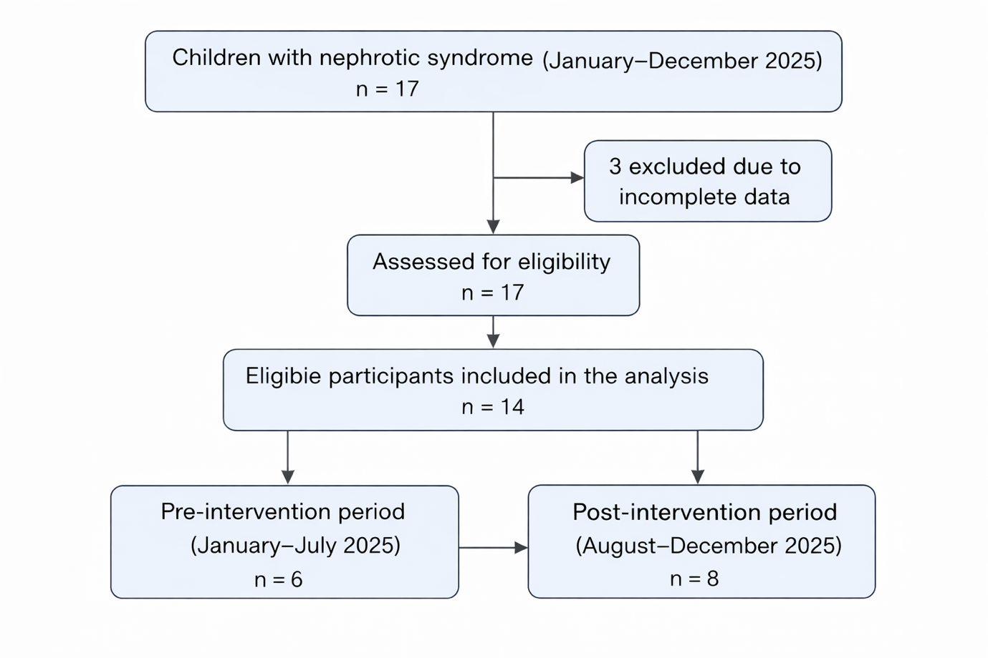

Figure 1: Study Flowchart

1.Noone DG, Iijima K, Parekh R (2018) Idiopathic nephrotic syndrome in children. Lancet 392:61–74
2. Tullus K, Webb H, Bagga A (2018) Management of steroidresistant nephrotic syndrome in children and adolescents. Lancet Child Adolesc Health 2:880–890
3. Tarshish P, Tobin JN, Bernstein J, Edelmann CM Jr (1997) Prognostic significance of the early course of minimal change nephrotic syndrome: report of the International Study of Kidney Disease in Children. J Am Soc Nephrol 8:769–776
4. Carter SA, Mistry S, Fitzpatrick J, Banh T, Hebert D, Langlois V, Pearl RJ, Chanchlani R, Licht CPB, Radhakrishnan S, Brooke J, Reddon M, Levin L, Aitken-Menezes K, Noone D, Parekh RS (2020) Prediction of short- and long-term outcomes in childhood nephrotic syndrome. Kidney Int Rep 5:426–434
5.McCulloch, M., Luyckx, V. A., Cullis, B., Davies, S. J., Finkelstein, F. O., Yap, H. K., Feehally, J., & Smoyer, W. E. (2021). Challenges of access to kidney care for children in low-resource settings. Nature Reviews. Nephrology, 17(1), 33–45. https://doi.org/10.1038/s41581-020-00338-7

6. Sinha A, Bagga A, Banerjee S, Mishra K, Mehta A, Agarwal I, Uthup S, Saha A, Mishra OP; Expert Group of Indian Society of Pediatric Nephrology. Steroid Sensitive Nephrotic Syndrome: Revised Guidelines. Indian Pediatr. 2021 May 15;58(5):461-481. doi: 10.1007/s13312-021-2217-3. Epub 2021 Mar 20. PMID: 33742610; PMCID: PMC8139225.
7. The primary nephrotic syndrome in children. Identification of patients with minimal change nephrotic syndrome from initial response to prednisolone. A report of the International Study of Kidney Disease in Children. J Pediatr. 1981;98:556-64.
8. Trautmann A, Boyer O, Hodson E, et al. IPNA clinical practice recommendations for the diagnosis and management of children with steroid-sensitive nephrotic syndrome. Pediatr Nephrol. 2023;38(3):877-919. doi:10.1007/s00467-022-05739
9. Sinha A, Bagga A, Banerjee S, et al. Steroid Sensitive Nephrotic Syndrome: Revised Guidelines. Indian Pediatr. 2021;58(5):461-481. doi:10.1007/s13312-021-2217-3
10. Baral R, Bhatta M, Khan SA, Yadav P, Yadav SP. Predictors of time to remission in children with steroid-sensitive nephrotic syndrome: a prospective observational study in Nepal. BMC Nephrol. 2025;27(1):77. Published 2025 Dec 25. doi:10.1186/s12882-025-04699-8
11. Cravedi P, Remuzzi G. Pathophysiology of proteinuria and its value as an outcome measure in chronic kidney disease. Br J Clin Pharmacol. 2013;76(4):516-523. doi:10.1111/bcp.12104
12. Hodson EM, Knight JF, Willis NS, et al. Corticosteroid therapy for nephrotic syndrome in children. Cochrane Database Sys Rev 2005.
13. Hoyer PF. New lessons from randomized trials in steroid-sensitive nephrotic syndrome: clear evidence against long steroid therapy. Kidney Int 2015;87:17–19. 10.1038/ki.2014.354
14. Hahn D, Hodson EM, Willis NS, et al. Corticosteroid therapy for nephrotic syndrome in children. Cochrane Database Syst Rev 2015:CD001533 10.1002/14651858.CD001533
15. Larkins N, Kim S, Craig J, et al. Steroid-sensitive nephrotic syndrome: an evidence-based update of immunosuppressive treatment in children. Arch Dis Child 2016;101:404–8. 10.1136
16. Yoshikawa N, Nakanishi K, Sako M, et al. A multicenter randomized trial indicates initial prednisolone treatment for childhood nephrotic syndrome for two months is not inferior to six-month treatment. Kidney Int 2015;87:225–32. 10.1038/ki.2014.260
17. Sinha A, Saha A, Kumar M, et al. Extending initial prednisolone treatment in a randomized control trial from 3 to 6 months did not significantly influence the course of illness in children with steroid-sensitive nephrotic syndrome. Kidney Int 2015;87:217–24. 10.1038/ki.2014.240

