Evaluating the Environmental and Energy Implications of Solar Panel Recycling in India: A Sustainability Assessment
¹Anjali ²Ajay
Assistant Professor
South Point Degree College Sonipat
E-mail id – anjalisingroha37@gmail.com
E-mail id – ajaykhatri02@gmail.com

Abstract:
Solar panel recycling is crucial for resource conservation, economic opportunities, and environmental impact reduction. Among different recycling methods, this study finds mechanical recycling to be most suitable for India, efficiently recovering valuable materials like silicon, silver, and cadmium/tellurium. Various recycling methods used globally were reviewed, however we specifically explore India’s context , where by 2030, solar panel waste is projected to reach 340,000 tons, highlighting the urgent need for effective recycling strategies.
Our study shows that mechanical recycling can recover 85% of silicon, 70% of silver, and 60% of cadmium/tellurium, with estimated costs of ₹22/kg for silicon, ₹90,000/kg for silver, and ₹150,000/kg for cadmium/tellurium. Embracing these methods could reduce imports, benefitting both the economy and the environment.
Keywords:
Solar panel, Recycling of solar panel, E-waste management India, Mechanical recycling, Energy efficient recycling.
Introduction:
The solar energy industry is expanding, emphasizing the importance of recycling solar panels to retrieve valuable materials, reduce the need for raw material mining, and create green employment opportunities [1]. Various recycling methods, such as thermal, mechanical, and chemical processes, including chemical dissolution, thermal decomposition, and electrostatic separation, are employed to recover materials like silicon, copper, and silver [1] Since all photovoltaic cells contain some amount of harmful material, this would make using PV panels as a source of energy less sustainable. The solar PV modules used in India are majorly composed of glass and aluminumand include crystalline silicon. Some of these ingredients, such as polymers and antimony found in glass, have the potential to be dangerous. Polyvinyl fluoride and Ethyl vinyl acetate are the polymers used to make backsheets and encapsulants. These polymers are usually burned because they cannot be recovered, although thermal processing can also safely evaporate them at 500 degrees Celsius. Glass exposed to sunlight or UV radiation runs the risk of leaking antimony if it is placed in damp conditions. As a result, the Ministry of New and Renewable Energy created a plan in March 2019 for the management, disposal and recycling of materials used in photovoltaic panels in an environmentally sustainable manner. India’s solar panel recycling industry faces a critical challenge: balancing energy-intensive processes with the need for responsible electronic waste management and resource conservation.
This paper delves into the physics behind these processes, analyzing the energy consumption of each stage. We'll explore how efficiently we can recover valuable materials while minimizing environmental impact, offering a scientific perspective on this crucial aspect of India's clean energy transition.New technologies and techniques, such as pyrolysis, airflow separation, and chemical etching, are proposed to further improve the recycling process [2]. The global solar panel recycling market is projected to grow significantly, with the recoverable raw materials' cumulative value estimated to reach $450 million by 2030 [1]. Monocrystalline and polycrystalline silicon solar cells, which are based on wafer-based technology, are widely used for solar energy systems. The recycling of solar panels holds an opportunity to reduce energy consumption and emissions associated with production-related materials, minimize waste, and manage emissions [32]. Mechanical recycling is highly efficient, capable of recovering up to 99% of raw materials at a rapid pace. It involves physically breaking down panels into their components such as glass, metal, copper wiring, and silicon solar modules, offering sustainable ways to reclaim valuable materials for reuse in various applications [3]. In India, efficient energy management through solar panel recycling is crucial. Researchers in Germany have demonstrated the potential for upcycling scrap modules by using recycled materials to produce new solar modules. Solar panel recycling can save energy costs by up to 90% compared to using virgin-grade materials and transition India’s solar industry toward a more self-reliant and independent economy through effective waste management practices [3].These insights underscore the significance of solar panel recycling to conserve resources, reduce the need for raw material mining, and create job opportunities, while also highlighting the potential economic and environmental benefits of recycling, especially in the context of energy management in India [1][2][3].
Literature Review
Although photovoltaic systems only contribute to approximately 3% of the global electricity supply, they consume a significant share of the world's resources, including 40% of tellurium, 15% of silver, substantial amounts of quartz for semiconductors, and smaller quantities of indium, zinc, tin, and gallium. A joint report by the International Energy Agency Photovoltaic Power Systems Programme (IEA-PVPS) and the International Renewable Energy Agency (IRENA) underscores the importance of recycling solar PV panels at the end of their roughly 30-year lifespan. This report estimates that by 2050, recycling could potentially release around 80 million tons of raw materials and valuable components globally. The recycling of solar panels is a crucial aspect of sustainable energy management, particularly in India where the installed solar capacity has generated significant amounts of waste. Mechanical recycling, which involves physically breaking down panels into their components, is a highly efficient method that can rapidly recover up to 99% of raw materials. This approach not only diminishes the environmental repercussions of waste disposal but also preserves crucial materials like silicon, copper, tellurium, and cadmium, pivotal for India's mineral security. The majority of traditional glass and metal recyclers worldwide employ mechanical procedures to separate the laminated structures of silicon dioxide modules. This involves the extraction of copper and aluminium from the junction box and module frame, respectively, either manually or automatically. Glass and polymer fractions are separated using crushers, screens, electro-magnetic devices and optical sorters. The metallic fraction was sent to metal recyclers for smelting. However, the glass fraction still contains contaminants, such as metals, polymers, and silicon fragments. Low-quality glass is utilized to make low-value glass fibers for the building sector, but it is unsuitable for use in the production of new modules. Glass needs to be purified using a combination of chemical and thermal procedures, which are typically not included in traditional glass recycling facilities. The polymer fraction primarily consisted of a blend of polymers with trace amounts of silicon, glass, and metals. This percentage is either disposed of in landfills or burned in nations where there are no regulations regarding the recycling or cremation of photovoltaic cells. This poses a severe risk to the environment because burning polymers releases toxic greenhouse gas emissions. Polymer burning in traditional incinerators is impossible as trash volumes increase because of halogen-based corrosive fumes.7. Utilizing specialized incinerators will probably result in a 10–15% increase in the overall cost of recycling. Seventy to eighty percent of the raw materials of a c-Si module can be recovered through conventional recycling. Glass makes up the majority of recovered and recycled material, with copper and aluminium coming in second and third. In standard recycling methods, a significant portion of valuable resources, such as silver and high-quality silicon, as well as elements that pose environmental risks, such as lead and various plastics, typically remain unclaimed. Advanced solar panel recycling techniques utilize a mix of mechanical, thermal, and chemical processes to recover various materials such as copper, lead, glass, aluminum, copper, silicon, and silver.


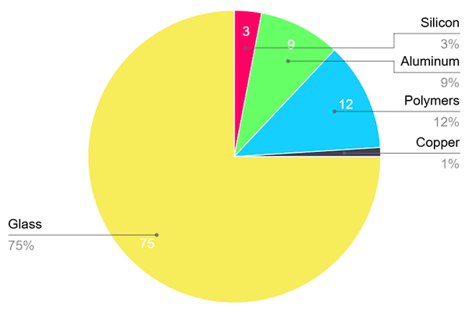
Figure-1


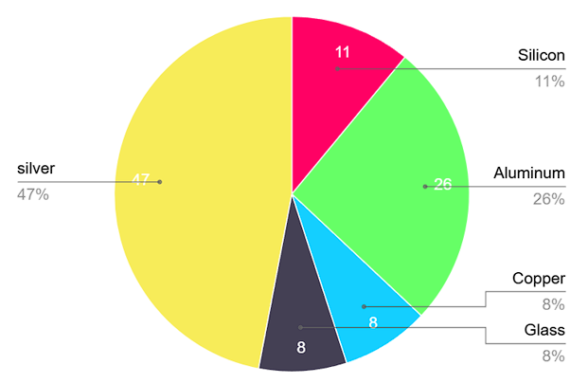
Figure-2

The results of solar cell emissions, Energy payback time EPBTand environmental load reduction highlights the importance of recycling in reducing the environmental impact of photovoltaic modules, particularly in terms of energy consumption and emissions.[4]The attention mechanism recycling proposed by Yeonghyeon Park et al. effectively improves the efficiency of defective solar panel detection by enhancing the spatial features of defects[5].Pretrained attention recycling technology reduces the need for manual inspections, saving time and effort while improving operational efficiency in solar plants[6]and the economic viability of recycling PV modules[7].End-of-life (EOL) recycling [8]Policy support from government agencies such as the Ministry of Environment, Forest, and Climate Change (MoEFCC) and the Ministry of New and Renewable Energy (MNRE) is essential for the implementation of efficient recycling methods. The inclusion of solar cells and modules under the E-Waste (Management) Rules and the prioritization of solar PV recycling under the Renewable Energy Research and Technology
Development (RE-RTD) Programme demonstrate the government's commitment to sustainable waste management practices. Through the utilization of both mechanical and chemical recycling techniques, backed by policy backing and technological progress, India's solar sector has the potential to shift from a linear to a circular economic model. This transition aims to optimize resource utilization, strengthen domestic supply networks, and stimulate innovation within the industry.
[9] The latest advancements in mechanical recycling technologies for solar panels involve the development of advanced mechanical separation techniques, leveraging robotics and automation to efficiently disassemble panels and recover materials such as glass, metals, and wafers of silicon. Conventional refineries have the opportunity to operate as waste refineries by co-feeding alternative feeds such as polyolefin plastics, waxes obtained from their fast pyrolysis, and tire pyrolysis oils together with current streams in fluid catalytic cracking (FCC) and hydro processing units [10] with recycling challenges [11][12] for processing and recycling solar panels [13]. This minimizes waste and facilitates the reuse and repurposing of components, along with the principles of the circular economy. Mechanical recycling technology involves shredding of spent solar modules, followed by physical separation of components using mechanical equipment such as vibrating screens and air separation. This procedure facilitates the retrieval of materials, such as silicon wafers, metal electrodes, and glass substrates, all of which can be reintegrated into the manufacturing of new solar cells. Recycling waste from crystalline silicon photovoltaic solar panels for the creation of adapted composite goods is also achievable. [14]and combined application of physical separation technologies [15] [16[17] With Techno-Economic analysis [18]as well as Solar cell model recycling method [19] smart and sustainable techniques [20] Economic and environmental impact of recycling of solar PV [21][22][23][24][25]and Solar Battery module [30]
Methodology:
Conventional methods of recycling:
Conventional Methods of Recycling Solar Panels in India.The conventional methods of recycling solar panels in India involve mechanical, thermal, and chemical processes to recover valuable materials like glass, metals, and semiconductors.
Mechanical Recycling
Mechanical recycling involves physically separating the different components of the solar panel, such as the glass, aluminum frame, and solar cells. This is typically done through crushing, shredding, and sieving the panels. The recovered materials can then be used in new products [33][34][35].
Thermal Recycling
Thermal recycling uses high temperatures to decompose the polymeric materials in the solar panels, allowing the recovery of the semiconductor materials and metals. This process can involve pyrolysis, incineration, or plasma treatment [33][34][35].
Chemical Recycling
Chemical recycling uses acids, solvents, or other reagents to dissolve and extract the valuable materials from the solar panels. This can include leaching processes to recover metals like silver, copper, and silicon [33][34][35].
Financials and Outputs
The financials and outputs of these conventional methods vary based on the specific process and facility. Here are some general estimates:
Mechanical Recycling
- Cost: ₹1.5 million to ₹3 million per ton of solar panels recycled.
- Output: While glass, aluminum, and copper are recovered, extracting valuable materials like silver and silicon is challenging.
Thermal Recycling
- Cost: ₹2 million to ₹5 million per ton of solar panels recycled.
- Output: Semiconductor materials and metals can be recovered; however, the process is energy-intensive and may not always be economically feasible.
Chemical Recycling
- Cost: ₹3 million to ₹6 million per ton of solar panels recycled.
- Output: This method allows the recovery of valuable materials such as silver, copper, and silicon, but it is complex and requires specialized facilities.

Setup Costs
The setup costs for these recycling methods differ depending on the specific process and facility. Below are general estimates:
- Mechanical Recycling Plant:
- Cost: ₹10 million to ₹50 million for a small-scale plant with an annual capacity of 1,000 tons.
- Thermal Recycling Plant:
- Cost: ₹20 million to ₹100 million for a small-scale plant with an annual capacity of 1,000 tons.
- Chemical Recycling Plant:
- Cost: ₹30 million to ₹150 million for a small-scale plant with an annual capacity of 1,000 tons.
These estimates are based on general industry trends and may vary depending on the specific requirements of the facility and the location in which it is set up.

Top Five States in India for Solar Panel Recycling Facilities

State | Cumulative Solar Installation (MW) | Expected Share of Solar Waste by  2030
Rajasthan | 16,353.07 | 24%
Gujarat | 8,747.42 | 16%
Karnataka | 8,018.60 | 12%
Tamil Nadu | 6,497.32 | 10%
Andhra Pradesh | 5,000 | 8%
Table -1
Additionally, these states are prominent in solar modulemanufacturing, contributing to 75% of the total manufacturing in India.

Graph 1
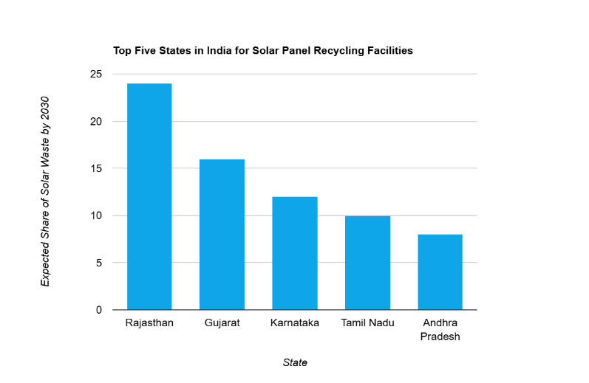

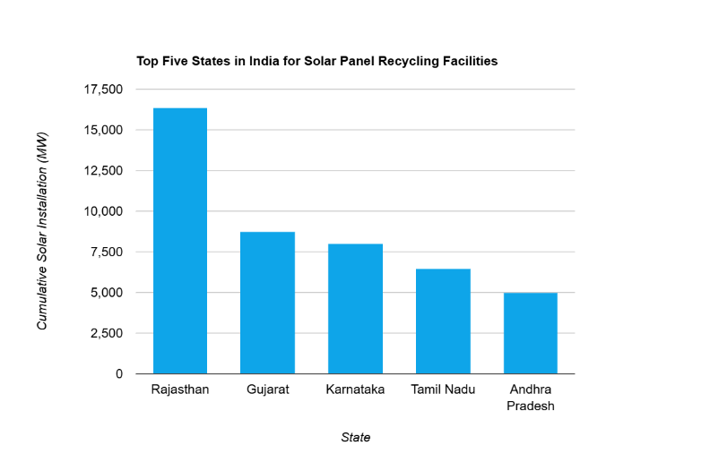
Graph-2

Estimated Recovery Rates and Costs for Mechanical Recycling of Solar Panels in India:
Material | Recovery Rate | Estimated Cost(₹/kg)
Silicon | 85% | ₹22
Silver | 70% | ₹90,000
Cadmium/Tellurium | 60% | ₹1,50,000

Table- 2
The Financial Challenges of Solar Panel Recycling in India is asignificant barrier to the growth of a sustainable recycling sector. Theprimary challenge lies in the economic imbalance between the value of the recovered materials and the cost of the recycling process. According to a study by the International Renewable Energy Agency(IRENA), merely 3% of the total weight of a solar panel represents around 60%
of its recycling value [1]. This disproportionate distribution of value withinthe panel makes it economically unattractive for recyclers to invest in thenecessary infrastructure and processes. The most valuable components of a solar panel are polysilicon, aluminum, silver, and copper [2]. However, the recovery of these materials can be costly and energy-intensive. For instance, the recycling of polysilicon requires a significant amount of energy, making it an expensive process [2]. Additionally, silver, which accounts for less than 1% of the panel's weight, represents more than 45% of its material value [2]. On the other hand, the bulk components of a silicon photovoltaic cell, such as glass and aluminum, make up around 80% of its mass but have a relatively low resale value [2]. This further exacerbates the economic imbalance, as the less valuable components account for two-thirds of the cell's total monetary value [2]. The current cost-to-revenue ratio of solar panel recycling is often unfavorable, with the process costing up to $25 per panel, while it only generates around $3 from the recovered materials [1]. This lack of profitability is a significant barrier to the widespread.

Graph 3
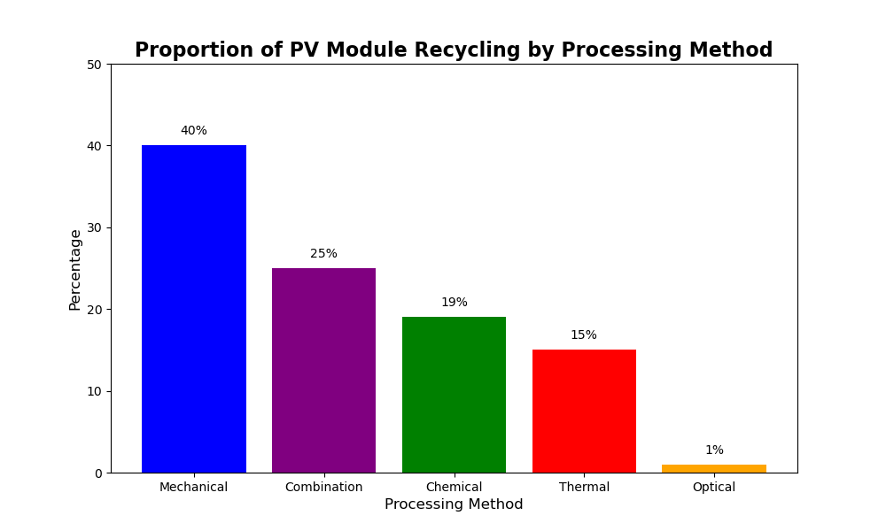

Step | Description
Disassembly | The solar panel parts are dismantled.
Separation | The cell modules are separated from the plastic covering.
Thermal Processing | Heating at 500°C removes the plastic covering, and the generated heat is reused.
Glass Recycling | 95% of the glass is recovered and recycled.
Metal Recycling | 100% of the metal is recovered and reused.
Silicon Processing | Silicon wafers are etched and the cell modules are separated. 85% of the silicon is recovered.
Module Reuse | 80% of the modules are reused.
Table 3
Conventional methods for recycling solar photovoltaic (PV) panels in India involve mechanical, thermal, and chemical processes to recover valuable materials. Table 3 shows different steps in order to recycle the solar panels. The graph above shows the amount of materials recycled by different methods of recycling.
Results and Discussion:
Our study shows that by 2030, mechanical recycling in India could recover approximately 28,900 tons of silicon, 23,800 kg of silver, and 40,800 kg of cadmium/tellurium, contributing significantly to resource conservation and reducing environmental impact. Despite the economic challenges—costing up to ₹635.8 million for silicon alone—the long-term benefits in reducing dependency on imports and mitigating environmental risks outweigh initial investment costs.
Data collection involved reviewing global and India-specific studies on solar panel recycling. Conventional methods such as mechanical shredding, thermal decomposition, and chemical dissolution were analyzed for their effectiveness in recovering silicon, silver, and cadmium/tellurium. Cost analysis indicated varying expenses: ₹22/kg for silicon, ₹90,000/kg for silver, and ₹150,000/kg for cadmium/tellurium, influencing the economic viability of recycling processes.
Conclusion:
The recycling of solar panels in India can be made more energy efficient by using a mechanical approach that recovers up to 99% of raw materials like silicon, copper, tellurium, and cadmium. This method involves physically breaking down panels into their components and can be enhanced through advancements in technology such as robotics and automation. Policy support, including the inclusion of solar cells and modules under the E-Waste (Management) Rules and prioritizing solar PV recycling under the Renewable Energy Research and Technology Development (RE-RTD) Programme, is crucial for the success of mechanical recycling. Additionally, a three-pronged approach is necessary to bridge the gap: government policies that incentivize recycling over landfilling, continued research and development (R&D) efforts to unlock more efficient and cost-effective recycling techniques, and transitioning towards a "circular economy" where materials recovered from decommissioned panels are directly used in the manufacturing of new ones. This closed-loop system minimizes waste, reduces reliance on virgin resources, and promotes environmental responsibility throughout the entire solar energy lifecycle, ultimately paving the way for a brighter and more sustainable future.

Recommendations
To overcome these challenges, India should consider the following actions:
Develop a comprehensive policy framework for solar panel recycling. Invest in research and development to enhance recycling technologies. Foster collaborative efforts among stakeholders, including manufacturers, policymakers, and environmental agencies.
Acknowledgment:
The authors wish to express their gratitude for the support provided by the Indian Ministry of New and Renewable Energy (MNRE), as well as the industry partners and academic institutions that participated in this research.
References:
1. Yayati, Shinde., Firdos, Khan. (2023). Recycling Methods for Crystalline Silicon Solar Panels. doi: 10.1109/ICACCS57279.2023.10112744
2. (2023). Recycling Methods for Crystalline Silicon Solar Panels. doi: 10.1109/icaccs57279.2023.10112744
3. Ramy, Khalid, Zakaria, El, Adli, Imam. (2022). Concept for Solar Panel Recycling based on High-Temperature Density Separation. Journal of Student Research, doi: 10.47611/jsrhs.v11i4.3763
4. Aleksandra, Ziemińska-Stolarska. (2023). Effect of Recycling on the Environmental Impact of a High-Efficiency Photovoltaic Module Combining Space-Grade Solar Cells and Optical Micro-Tracking. Energies, doi: 10.3390/en16083302
5. YeongHyeon, Park., Myung, Jin, Kim., U, Ju, Gim., Juneho, Yi. (2023). Boost-Up Efficiency of Defective Solar Panel Detection with Pre-Trained Attention Recycling. IEEE Transactions on Industry Applications, doi: 10.1109/TIA.2023.3255227
6. Boost-Up Efficiency of Defective Solar Panel Detection with Pre-Trained Attention Recycling. IEEE Transactions on Industry Applications, doi: 10.1109/tia.2023.3255227
7. Idiano, D׳Adamo., Francesco, Ferella., Massimo, Gastaldi., Nicolò, Maria, Ippolito., Paolo, Rosa. (2023). Circular solar: Evaluating the profitability of a photovoltaic panel recycling plant. HaikibutsuGakkaishi, doi: 10.1177/0734242X221149327
8. Jakob, Lauhoff. (2023). Photovoltaic Panels End-of-Life Recycling. doi: 10.1007/978-981-19-6223-3_109
9. Liana, Spytska. (2022). Recycling of Discarded Photovoltaic Solar Modules for Metal Recovery: A Review and Outlook for the Future. doi: 10.1021/acs.energyfuels.2c02847
10. Sultan, Büşra, Artaş., Emrullah, Kocaman., Hasan, Huseyin, Bilgic., Hakan, Tutumlu., Hüseyin, Yağli., Recep, Yumrutaş. (2023). Why PV panels must be recycled at the end of their economic life span? A case study on recycling together with the global situation. Chemical engineering research &design, doi: 10.1016/j.psep.2023.03.053
11. Mark, Peplow,special, to, C&EN. (2022). Solar panels face recycling challenge. doi: 10.1021/cen-10018-cover
12. Mark, Peplow. (2022). Solar Panels Face Recycling Challenge. ACS central science, doi: 10.1021/acscentsci.2c00214
13. Nataliia, Samoilenko., Vadym, Katenin., Antonina, Baranova. (2021). Processing and recycling of photovoltaic solar panels. doi: 10.20998/2413-4295.2021.02.17
14. S, Ram, Kokul., Shantanu, Bhowmik. (2021). Recycling of crystalline silicon photovoltaic solar panel waste to modified composite products. Progress in Rubber Plastics and Recycling Technology, doi: 10.1177/14777606211019416
15. Aya, Heiho., Izuru, Suwa., Yi, Dou., Soo-Jin, Lim., Takao, Namihira., T., Koita., Kazuhiro, Mochidzuki., Shinsuke, Murakami., Ichiro, Daigo., Chiharu, Tokoro., Yasunori, Kikuchi. (2023). Prospective life cycle assessment of recycling systems for spent photovoltaic panels by combined application of physical separation technologies. Resources Conservation and Recycling, doi: 10.1016/j.resconrec.2023.106922
16. Mariusz, Niekurzak., Wojciech, Lewicki., Hasan, Huseyin, Coban., Agnieszka, Brelik. (2023). Conceptual Design of a Semi-Automatic Process Line for Recycling Photovoltaic Panels as a Way to Ecological Sustainable Production. Sustainability, doi: 10.3390/su15032822
17. Sang-Ho, Cho., Kim, Hyon, Soo., Kim, Young, Kook. (2020). Solar panel recycling apparatus and method.
18. Antonio, Rubino., Giuseppe, Granata., Emanuela, Moscardini., Ludovica, Baldassari., Pietro, Altimari., Luigi, Toro., Francesca, Pagnanelli. (2020). Development and Techno-Economic Analysis of an Advanced Recycling Process for Photovoltaic Panels Enabling Polymer Separation and Recovery of Ag and Si. Energies, doi: 10.3390/EN13246690
19. Sakai, Noriyuki., Harada, Hideki. (2021). Solar cell module recycling method and recycling device.
20. S.L.K., Gopalamma, Aravelli., Srinu, Naik, Ramavathu. (2021). Smart and sustainable technologies for recycling photovoltaic panels. doi: 10.1016/J.ENVC.2020.100020
21. Meng, Tao., Vasilis, Fthenakis., Burçak, Ebin., Evelyn, Butler., Parikhit, Sinha., Richard, Corkish., Karsten, Wambach., Ethan, S., Simon. (2020). Major Challenges and Opportunities in Silicon Solar Panel Recycling. doi: 10.1109/PVSC45281.2020.9300650
22. Sampath, Kumar, Venkatachary., Ravi, Samikannu., Srinivasan, Murugesan., Narasimha, Rao, Dasari., Ragupathy, Uthandipalayam, Subramaniyam. (2020). Economics and impact of recycling solar waste materials on the environment and health care. Environmental Technology and Innovation, doi: 10.1016/J.ETI.2020.101130
23. Sudiksha, Srivastava. (2022). An Overview on Recycling of Photovoltaic Modules at the End of Life (EoL). Indian Scientific Journal Of Research In Engineering And Management, doi: 10.55041/ijsrem16386
24. Sun, Gang., Li, Shengchun., Liu, Kaihua. (2020). Solar cell recycling method.
25. Saurabh, Desai., S., M., Usman. (2020). Solar e waste recycling technology. Journal of emerging technologies and innovative research,
26. Ruan, Jujun., Huang, Zhe., Baojia, Qin., Qiu, Rongliang. (2018). Method for recycling metal and energy gas from waste solar panel.
27. York, R., Smith., Pamela, Bogust. (2018). Review of Solar Silicon Recycling. doi: 10.1007/978-3-319-72362-4_42
28. Ewa, Klugmann-Radziemska. (2016). Recycling of raw materials, silicon wafers and complete solar cells from photovoltaic modules. doi: 10.15377/2410-2199.2016.03.01.2
29. Kimura, Masanori. (2014). Solar cell module recycling method.
30. Tsushima, Takuya., Ogasawara, Shinobu., Kurihara, Koji., Ibarada, Naoki., Tsuboi, Nobuyuki. (2018). Solar battery module recycling method and solar battery module recycling device.
31. “Managing India’s PV Module Waste.” Available: https://bridgetoindia.com/backend/wp-content/uploads/2019/04/BRIDGE-TO-INDIA-Managing-Indias-Solar-PV-Waste-1.pdf
32. A. Ali, D. Saygin, S. Vinci, and N. Wagner, “End-of-Life Management: Solar Photovoltaic Panels,” Jun. 2016
33.https://indianexpress.com/article/explained/explained-sci-tech/india-solar-waste-new-study-9225154/
34.https://link.springer.com/article/10.1007/s13762-023-04953-2
35.https://www.ceew.in/sites/default/files/ceew-study-on-photovoltaic-solar-panel-waste-management-disposal-india.pdf
36.https://www.linkedin.com/pulse/solar-waste-india-challenges-remedies-servokonsystems
37.Down to Earth. (2022, September 19). Recycling solar panels needs boost from Indian policymakers. https://www.downtoearth.org.in/blog/energy/recycling-solar-panels-needs-boost-from-indian-policymakers-84999
38.The Financial Express. (2023, March 13). The Dilemma of India's Solar Waste. https://www.financialexpress.com/business/sustainability-the-dilemma-of-indias-solar-waste-3469915/
39.Renewable Watch. (2024, February 27). Solar PV Recycling: Emerging opportunities and the path to a circular economy. https://renewablewatch.in/2024/02/27/solar-pv-recycling-emerging-opportunities-and-the-path-to-a-circular-economy/

