Social Network Analysis
  - Lab 07 Test First Programming II
SE 314 Software Construction Fall 2026
Muhammad Adil Umer
CMS ID 501991 | BESE15 B
Lab date 23 October 2026 | Completed 26 October 2026

Purpose and result
This solution implements Problem 3 of the tweet toolbox: infer a directed following graph from mentions and rank users by distinct follower count. Tests were run first against method stubs, then rerun after implementation. Eclipse JUnit reports 18 of 18 tests passing with zero errors and zero failures.

Repository
https://github.com/UrCoderAdil/Lab07SoftwareConstruction

Task coverage
Task | Completed work
01 | guessFollowsGraph maps each author to the distinct users mentioned in their tweets.
02 | influencers returns all graph users sorted by decreasing follower count.
03 | 16 partition-based specification tests and 2 separate policy tests, with red-to-green Eclipse evidence.

Project scope
The Eclipse project isolates the two SocialNetwork methods requested in Lab 07. Tweet.java is unchanged from the supplied MIT starter. Main.java uses a fixed offline sample so the demonstration is reproducible; it does not contact Twitter. Extract and Filter belong to other problems in the original problem set.

Tools and deliverables
Eclipse IDE 2025 09 version 4.37, Java 21.0.8 and JUnit 4 were used for the captured runs. This report includes the test strategy, implementation explanation, actual Eclipse screenshots and complete Java source. The accompanying ZIP contains the importable Eclipse project and original screenshot files.

Specifications and implementation

Following graph
The representation is Map<String, Set<String>>. For each tweet, the method normalizes its author using Locale.ROOT, extracts valid @-mentions, removes self mentions, and inserts the remaining targets into a HashSet. Multiple tweets by the same author merge into one adjacency set. A repeated mention therefore contributes one edge.
The mention pattern accepts the assignment username alphabet: letters, digits, underscore and hyphen. Its left boundary rejects embedded email-like text such as x@invalid.edu. Every returned username comes from a tweet author or a valid mention. Authors without outgoing edges are omitted by this minimum mention-only implementation.

Influence ranking
The algorithm initializes each graph key with zero followers, then traverses all adjacency sets and increments the count of each target. This counts distinct followers because each author has one adjacency set with unique targets. It sorts the union of key and value users by descending count. Alphabetical ordering resolves ties reproducibly, although the specification permits any tie order.

Important specification interpretation
The handout suggests that a single user with no followers should yield no influencers. The starter method contract instead requires a list of all distinct usernames in followsGraph. Consequently, {alone: {}} returns [alone], with follower count zero. The test follows the method contract. An empty graph still returns an empty list.
guessFollowsGraph has an underdetermined postcondition: other evidence is permitted, usernames may use different casing, and a user with no outgoing edges may be absent or mapped to an empty set. Specification tests check required edges, valid user membership and representation invariants. They do not demand an exact graph or a particular tie order. Stronger mention-only checks are placed in MySocialNetworkTest.java.

Complexity and limits
Let L be the total tweet-text length, E the number of unique edges and V the number of graph users. Graph construction scans the tweet text and stores at most E edges, using expected O(L + E) time and O(V + E) space with hash collections. Ranking takes expected O(V + E + V log V) time and O(V) additional space. These methods infer relationships from mentions; they do not establish actual Twitter subscriptions or real-world influence.

Partition based test strategy
Each scenario is a separate @Test method. Fixtures use short artificial tweets with distinct IDs. Assertions compare usernames case insensitively, allow either tied ranking order, and verify nonincreasing follower counts without relying on map iteration order.
Required scenario | Expected property
Empty tweet list | No authors or mentions exist, so the graph is empty.
Tweets without mentions | No self edge; an absent author and an empty adjacency set are both accepted. A separate policy test checks omitted keys.
Single mention | ernie must follow bert after an @bert mention.
Multiple mentions | The author must have each required mention edge.
Multiple tweets from one user | Edges merge across tweets and repeated targets remain unique.
Empty influencer graph | The returned ranking is empty.
Single user without followers | The isolated user appears once, as required by the method contract.
Single influencer | The followed user ranks above the author with zero followers.
Multiple influencers | All users occur once and counts never increase along the ranking.
Tied influence | All tied users are retained; either tied order is accepted.

Additional partitions
The suite also checks mixed-case authors and mentions, case-insensitive follower accumulation, self-mention removal, underscore and hyphen usernames, email boundaries, multiple authors, and preservation of the input tweet list and graph. MySocialNetworkTest adds two exact-policy checks: no-mention tweets omit keys, and only distinct non-self mention edges are inferred.

Observed red to green cycle
The first Eclipse run executed the 16 specification tests against stubs that threw UnsupportedOperationException. JUnit displayed 16 errors and a red bar. The Failure Trace identified guessFollowsGraph at line 25 for singleMention. After implementing both methods, those same 16 tests passed. Running the whole project then passed all 18 tests. A separate command-line JUnit run also returned OK (18 tests).

Eclipse test first evidence
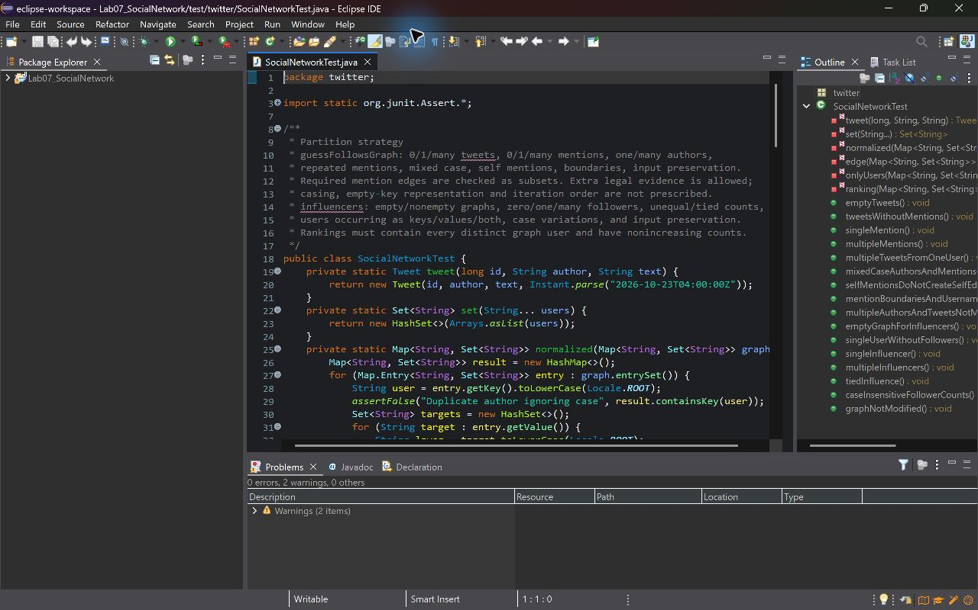
Figure 1 SocialNetworkTest.java in Eclipse documents the partition strategy before implementation.
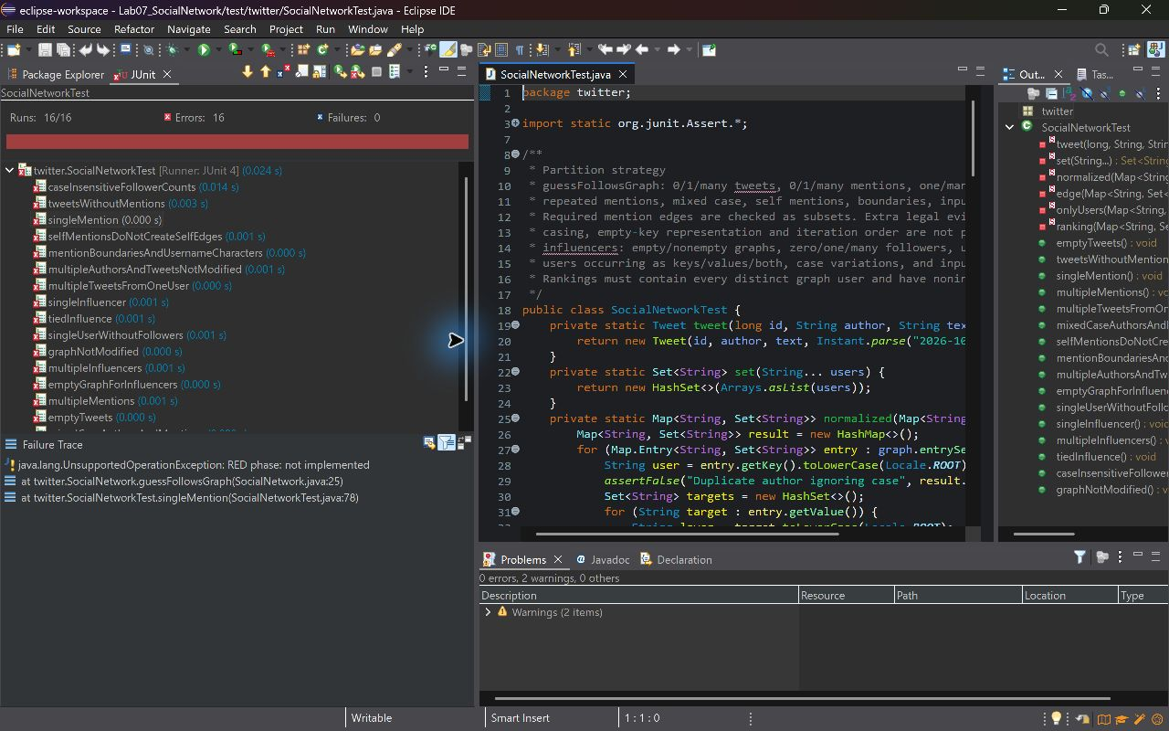
Figure 2 Red phase with 16 errors. The selected singleMention test shows the not-implemented exception and its Failure Trace.

Eclipse passing test evidence
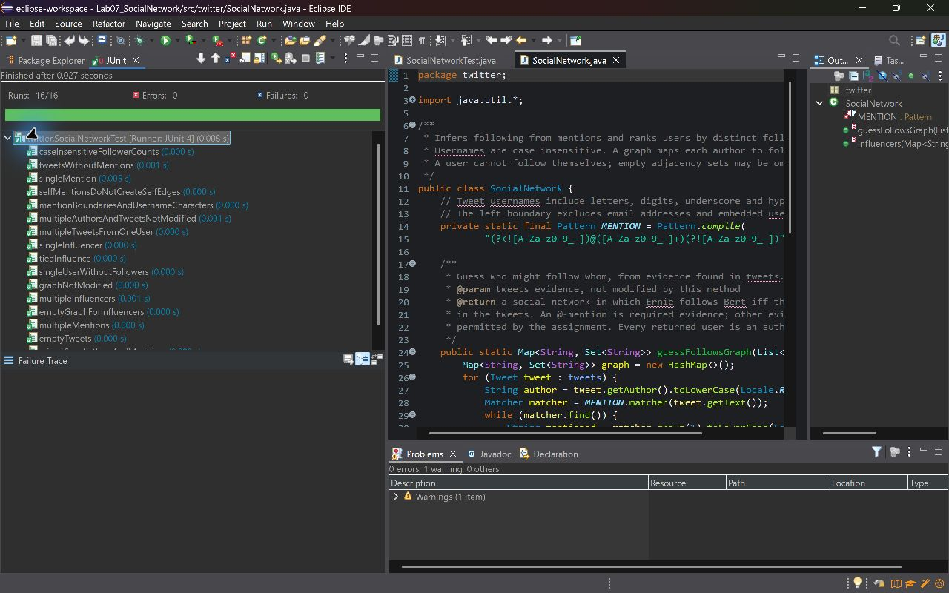
Figure 3 The unchanged specification suite passes 16 of 16 tests with zero errors and failures.
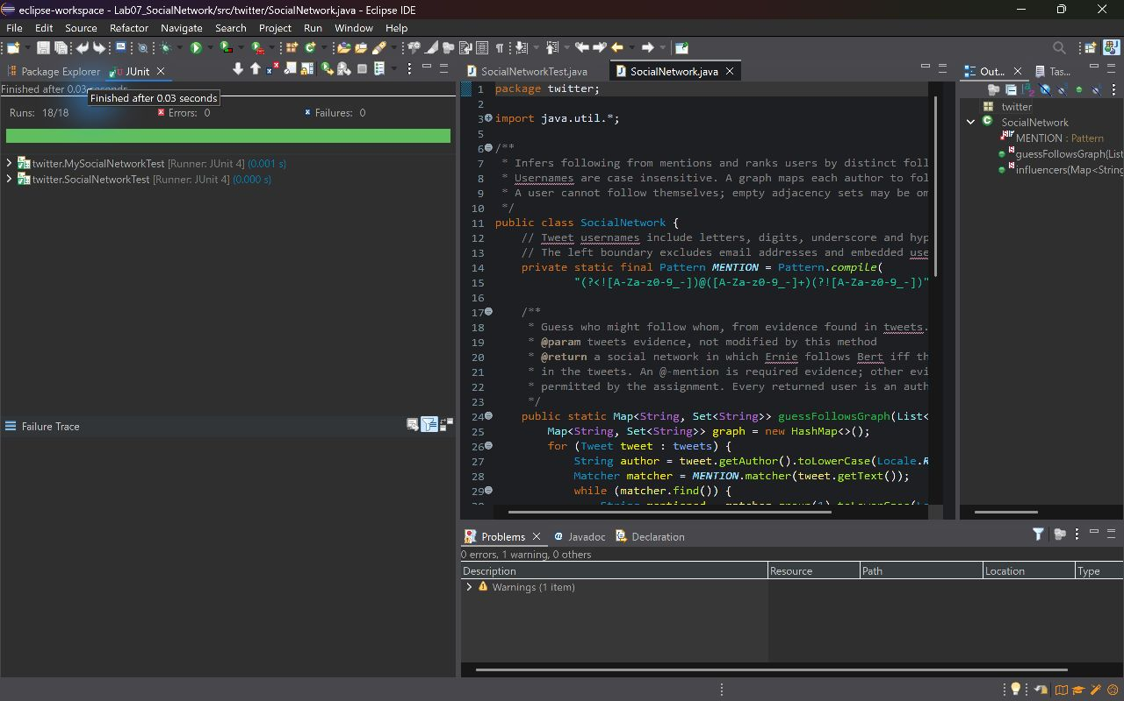
Figure 4 Project-wide JUnit run passes all 18 tests across SocialNetworkTest and MySocialNetworkTest.

Eclipse implementation evidence
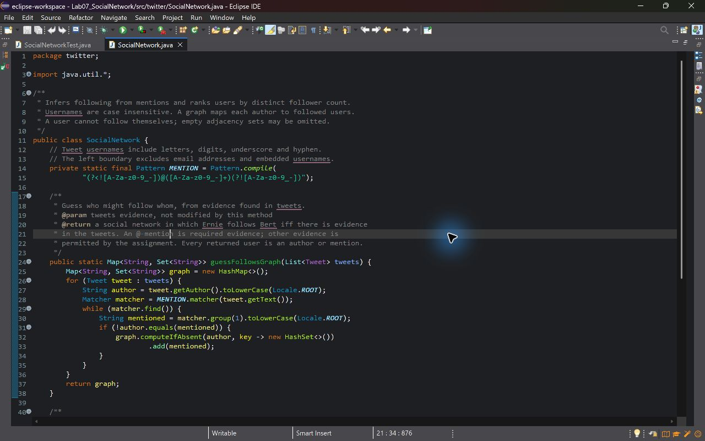
Figure 5 Mention extraction, case normalization, self filtering and edge deduplication in guessFollowsGraph.
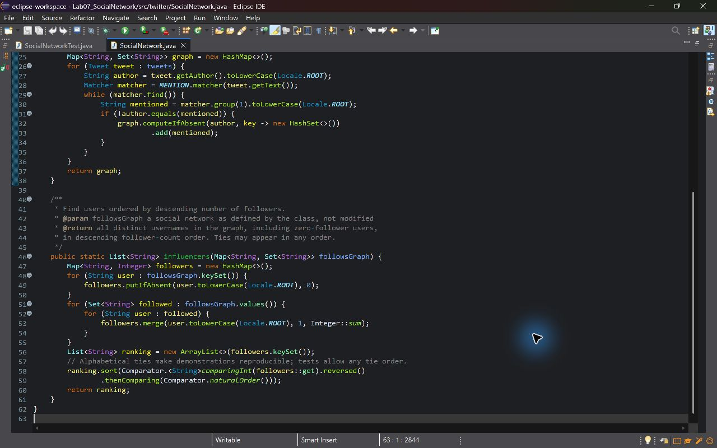
Figure 6 Follower counting includes key-only users and sorts every graph user by descending count.

Eclipse application output
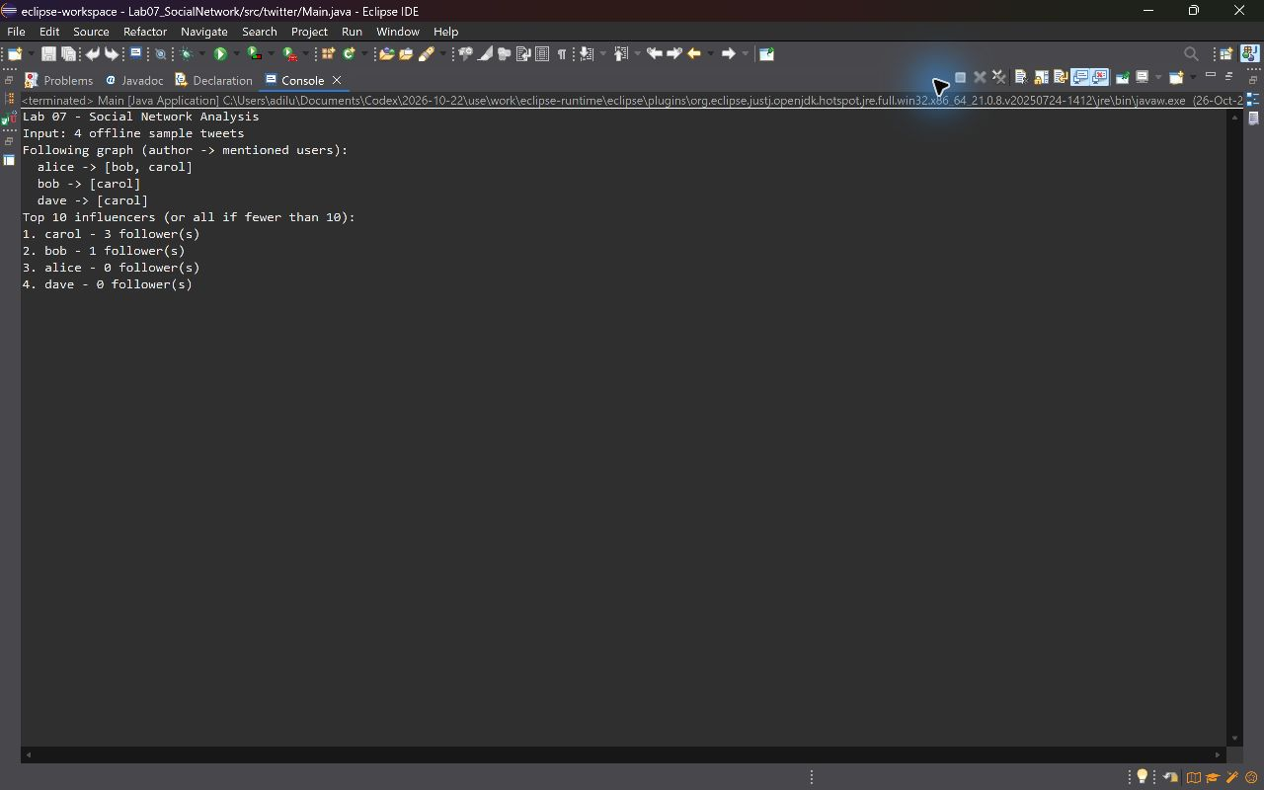
Figure 7 Main.java runs in Eclipse using four offline sample tweets and prints the graph and ranked users.

Interpreting the sample
Alice follows Bob and Carol. Bob and Dave each follow Carol. Alice mentions Bob again in the fourth tweet, which does not add another follower. Carol therefore has three distinct followers, Bob has one, and Alice and Dave each have zero. The program prints Carol, Bob, Alice, Dave; the last two have equal influence.

Run the submitted project
- Extract the source ZIP and keep the project folder intact.
- In Eclipse select File > Import > General > Existing Projects into Workspace, choose Lab07_SocialNetwork, and finish.
- Right-click the project and choose Run As > JUnit Test. The expected result is 18 tests, zero errors and zero failures.
- Open src/twitter/Main.java and choose Run As > Java Application to reproduce the console output.

Submission
The repository URL is listed at the start of this report. The Word report and project ZIP are the prepared deliverables. Upload the report to LMS and confirm that the submission succeeds.

SocialNetwork source
src/twitter/SocialNetwork.java
1 package twitter;
2
3 import java.util.*;
4 import java.util.regex.*;
5
6 /**
7 * Infers following from mentions and ranks users by distinct follower count.
8 * Usernames are case insensitive. A graph maps each author to followed users.
9 * A user cannot follow themselves; empty adjacency sets may be omitted.
10 */
11 public class SocialNetwork {
12 // Tweet usernames include letters, digits, underscore and hyphen.
13 // The left boundary excludes email addresses and embedded usernames.
14 private static final Pattern MENTION = Pattern.compile(
15 "(?<![A-Za-z0-9_-])@([A-Za-z0-9_-]+)(?![A-Za-z0-9_-])");
16
17 /**
18 * Guess who might follow whom, from evidence found in tweets.
19 * @param tweets evidence, not modified by this method
20 * @return a social network in which Ernie follows Bert iff there is evidence
21 * in the tweets. An @-mention is required evidence; other evidence is
22 * permitted by the assignment. Every returned user is an author or mention.
23 */
24 public static Map<String, Set<String>> guessFollowsGraph(List<Tweet> tweets) {
25 Map<String, Set<String>> graph = new HashMap<>();
26 for (Tweet tweet : tweets) {
27 String author = tweet.getAuthor().toLowerCase(Locale.ROOT);
28 Matcher matcher = MENTION.matcher(tweet.getText());
29 while (matcher.find()) {
30 String mentioned = matcher.group(1).toLowerCase(Locale.ROOT);
31 if (!author.equals(mentioned)) {
32 graph.computeIfAbsent(author, key -> new HashSet<>())
33 .add(mentioned);
34 }
35 }
36 }
37 return graph;
38 }
39
40 /**
41 * Find users ordered by descending number of followers.
42 * @param followsGraph a social network as defined by the class, not modified
43 * @return all distinct usernames in the graph, including zero-follower users,
44 * in descending follower-count order. Ties may appear in any order.
45 */
46 public static List<String> influencers(Map<String, Set<String>> followsGraph) {
47 Map<String, Integer> followers = new HashMap<>();
48 for (String user : followsGraph.keySet()) {
49 followers.putIfAbsent(user.toLowerCase(Locale.ROOT), 0);
50 }
51 for (Set<String> followed : followsGraph.values()) {
52 for (String user : followed) {
53 followers.merge(user.toLowerCase(Locale.ROOT), 1, Integer::sum);
54 }
55 }
56 List<String> ranking = new ArrayList<>(followers.keySet());
57 // Alphabetical ties make demonstrations reproducible; tests allow any tie order.
58 ranking.sort(Comparator.<String>comparingInt(followers::get).reversed()
59 .thenComparing(Comparator.naturalOrder()));
60 return ranking;
61 }
62 }

SocialNetworkTest source
test/twitter/SocialNetworkTest.java
1 package twitter;
2
3 import static org.junit.Assert.*;
4 import java.time.Instant;
5 import java.util.*;
6 import org.junit.Test;
7
8 /**
9 * Partition strategy
10 * guessFollowsGraph: 0/1/many tweets, 0/1/many mentions, one/many authors,
11 * repeated mentions, mixed case, self mentions, boundaries, input preservation.
12 * Required mention edges are checked as subsets. Extra legal evidence is allowed;
13 * casing, empty-key representation and iteration order are not prescribed.
14 * influencers: empty/nonempty graphs, zero/one/many followers, unequal/tied counts,
15 * users occurring as keys/values/both, case variations, and input preservation.
16 * Rankings must contain every distinct graph user and have nonincreasing counts.
17 */
18 public class SocialNetworkTest {
19 private static Tweet tweet(long id, String author, String text) {
20 return new Tweet(id, author, text, Instant.parse("2026-10-23T04:00:00Z"));
21 }
22 private static Set<String> set(String... users) {
23 return new HashSet<>(Arrays.asList(users));
24 }
25 private static Map<String, Set<String>> normalized(Map<String, Set<String>> graph) {
26 Map<String, Set<String>> result = new HashMap<>();
27 for (Map.Entry<String, Set<String>> entry : graph.entrySet()) {
28 String user = entry.getKey().toLowerCase(Locale.ROOT);
29 assertFalse("Duplicate author ignoring case", result.containsKey(user));
30 Set<String> targets = new HashSet<>();
31 for (String target : entry.getValue()) {
32 String lower = target.toLowerCase(Locale.ROOT);
33 assertNotEquals("No self following", user, lower);
34 assertTrue("No duplicate target ignoring case", targets.add(lower));
35 }
36 result.put(user, targets);
37 }
38 return result;
39 }
40 private static void edge(Map<String, Set<String>> graph, String from, String to) {
41 assertTrue("Missing required edge " + from + " -> " + to,
42 normalized(graph).getOrDefault(from, Collections.emptySet()).contains(to));
43 }
44 private static void onlyUsers(Map<String, Set<String>> graph, String... users) {
45 Set<String> allowed = set(users);
46 for (Map.Entry<String, Set<String>> entry : normalized(graph).entrySet()) {
47 assertTrue(allowed.contains(entry.getKey()));
48 assertTrue(allowed.containsAll(entry.getValue()));
49 }
50 }
51 private static void ranking(Map<String, Set<String>> graph) {
52 Map<String, Integer> counts = new HashMap<>();
53 for (Map.Entry<String, Set<String>> entry : normalized(graph).entrySet()) {
54 counts.putIfAbsent(entry.getKey(), 0);
55 for (String target : entry.getValue()) counts.merge(target, 1, Integer::sum);
56 }
57 List<String> actual = SocialNetwork.influencers(graph);
58 Set<String> seen = new HashSet<>();
59 int previous = Integer.MAX_VALUE;
60 for (String user : actual) {
61 String lower = user.toLowerCase(Locale.ROOT);
62 assertTrue("Unexpected or repeated user", counts.containsKey(lower) && seen.add(lower));
63 assertTrue("Counts must not increase", counts.get(lower) <= previous);
64 previous = counts.get(lower);
65 }

SocialNetworkTest source continued
test/twitter/SocialNetworkTest.java
66 assertEquals("All graph users must be ranked", counts.keySet(), seen);
67 }
68
69 @Test public void emptyTweets() {
70 assertTrue(SocialNetwork.guessFollowsGraph(Collections.emptyList()).isEmpty());
71 }
72 @Test public void tweetsWithoutMentions() {
73 Map<String, Set<String>> graph = SocialNetwork.guessFollowsGraph(
74 Arrays.asList(tweet(1, "alice", "Hello world")));
75 onlyUsers(graph, "alice"); // An omitted key and an empty adjacency set are both legal.
76 }
77 @Test public void singleMention() {
78 Map<String, Set<String>> graph = SocialNetwork.guessFollowsGraph(
79 Arrays.asList(tweet(1, "ernie", "Hello @bert")));
80 edge(graph, "ernie", "bert"); onlyUsers(graph, "ernie", "bert");
81 }
82 @Test public void multipleMentions() {
83 Map<String, Set<String>> graph = SocialNetwork.guessFollowsGraph(
84 Arrays.asList(tweet(1, "alice", "@bob and @carol")));
85 edge(graph, "alice", "bob"); edge(graph, "alice", "carol");
86 onlyUsers(graph, "alice", "bob", "carol");
87 }
88 @Test public void multipleTweetsFromOneUser() {
89 Map<String, Set<String>> graph = SocialNetwork.guessFollowsGraph(Arrays.asList(
90 tweet(1, "alice", "@bob @bob"), tweet(2, "alice", "@carol @bob")));
91 edge(graph, "alice", "bob"); edge(graph, "alice", "carol");
92 onlyUsers(graph, "alice", "bob", "carol");
93 }
94 @Test public void mixedCaseAuthorsAndMentions() {
95 Map<String, Set<String>> graph = SocialNetwork.guessFollowsGraph(Arrays.asList(
96 tweet(1, "ALIce", "@BOB"), tweet(2, "alice", "@bob @CAROL")));
97 edge(graph, "alice", "bob"); edge(graph, "alice", "carol");
98 onlyUsers(graph, "alice", "bob", "carol");
99 }
100 @Test public void selfMentionsDoNotCreateSelfEdges() {
101 Map<String, Set<String>> graph = SocialNetwork.guessFollowsGraph(
102 Arrays.asList(tweet(1, "alice", "@ALICE @bob")));
103 edge(graph, "alice", "bob"); onlyUsers(graph, "alice", "bob");
104 }
105 @Test public void mentionBoundariesAndUsernameCharacters() {
106 Map<String, Set<String>> graph = SocialNetwork.guessFollowsGraph(Arrays.asList(
107 tweet(1, "alice", "mail x@invalid.edu; (@user_1), @two-name!")));
108 edge(graph, "alice", "user_1"); edge(graph, "alice", "two-name");
109 onlyUsers(graph, "alice", "user_1", "two-name");
110 }
111 @Test public void multipleAuthorsAndTweetsNotModified() {
112 List<Tweet> tweets = new ArrayList<>(Arrays.asList(
113 tweet(1, "alice", "@bob"), tweet(2, "carol", "@bob")));
114 List<Tweet> before = new ArrayList<>(tweets);
115 Map<String, Set<String>> graph = SocialNetwork.guessFollowsGraph(tweets);
116 edge(graph, "alice", "bob"); edge(graph, "carol", "bob");
117 assertEquals(before, tweets);
118 }
119 @Test public void emptyGraphForInfluencers() {
120 assertTrue(SocialNetwork.influencers(Collections.emptyMap()).isEmpty());
121 }
122 @Test public void singleUserWithoutFollowers() {
123 Map<String, Set<String>> graph = new HashMap<>();
124 graph.put("alone", set());
125 ranking(graph); // The method spec includes zero-follower users.
126 }
127 @Test public void singleInfluencer() {
128 Map<String, Set<String>> graph = new HashMap<>();
129 graph.put("alice", set("bob")); ranking(graph);
130 assertEquals("bob", SocialNetwork.influencers(graph).get(0).toLowerCase(Locale.ROOT));

SocialNetworkTest source continued
test/twitter/SocialNetworkTest.java
131 }
132 @Test public void multipleInfluencers() {
133 Map<String, Set<String>> graph = new HashMap<>();
134 graph.put("alice", set("bob", "carol"));
135 graph.put("bob", set("carol")); graph.put("dave", set("carol"));
136 ranking(graph);
137 }
138 @Test public void tiedInfluence() {
139 Map<String, Set<String>> graph = new HashMap<>();
140 graph.put("alice", set("bob")); graph.put("bob", set("alice"));
141 ranking(graph); // Either tied order is legal.
142 }
143 @Test public void caseInsensitiveFollowerCounts() {
144 Map<String, Set<String>> graph = new HashMap<>();
145 graph.put("ALICE", set("BOB")); graph.put("carol", set("bob"));
146 graph.put("BoB", set("CAROL")); ranking(graph);
147 }
148 @Test public void graphNotModified() {
149 Map<String, Set<String>> graph = new HashMap<>();
150 graph.put("alice", set("bob"));
151 Map<String, Set<String>> before = new HashMap<>();
152 before.put("alice", set("bob"));
153 SocialNetwork.influencers(graph); assertEquals(before, graph);
154 }
155 }

MySocialNetworkTest source
test/twitter/MySocialNetworkTest.java
1 package twitter;
2
3 import static org.junit.Assert.*;
4 import java.time.Instant;
5 import java.util.*;
6 import org.junit.Test;
7
8 /** Stronger tests for this implementation's minimum mention-only policy. */
9 public class MySocialNetworkTest {
10 @Test public void noMentionsOmitKeys() {
11 Tweet tweet = new Tweet(1, "alice", "Hello", Instant.EPOCH);
12 assertTrue(SocialNetwork.guessFollowsGraph(Arrays.asList(tweet)).isEmpty());
13 }
14 @Test public void exactMentionOnlyEdges() {
15 List<Tweet> tweets = Arrays.asList(
16 new Tweet(1, "Alice", "@Bob @ALICE @bob", Instant.EPOCH),
17 new Tweet(2, "Carol", "Hello", Instant.EPOCH));
18 Map<String, Set<String>> expected = new HashMap<>();
19 expected.put("alice", new HashSet<>(Arrays.asList("bob")));
20 assertEquals(expected, SocialNetwork.guessFollowsGraph(tweets));
21 }
22 }

Main source
src/twitter/Main.java
1 package twitter;
2
3 import java.time.Instant;
4 import java.util.*;
5
6 /** Reproducible offline demonstration of the Lab 07 social network toolbox. */
7 public class Main {
8 public static void main(String[] args) {
9 List<Tweet> tweets = Arrays.asList(
10 new Tweet(1, "Alice", "Learning with @Bob and @Carol", Instant.EPOCH),
11 new Tweet(2, "Bob", "Thanks @Carol", Instant.EPOCH),
12 new Tweet(3, "Dave", "Hello @Carol", Instant.EPOCH),
13 new Tweet(4, "ALICE", "Again @BOB", Instant.EPOCH));
14 Map<String, Set<String>> graph = SocialNetwork.guessFollowsGraph(tweets);
15 System.out.println("Lab 07 - Social Network Analysis");
16 System.out.println("Input: 4 offline sample tweets");
17 System.out.println("Following graph (author -> mentioned users):");
18 for (String author : new TreeSet<>(graph.keySet())) {
19 System.out.println(" " + author + " -> " + new TreeSet<>(graph.get(author)));
20 }
21 System.out.println("Top 10 influencers (or all if fewer than 10):");
22 List<String> users = SocialNetwork.influencers(graph);
23 for (int i = 0; i < Math.min(10, users.size()); i++) {
24 String user = users.get(i);
25 long count = graph.values().stream().filter(set -> set.contains(user)).count();
26 System.out.printf("%d. %s - %d follower(s)%n", i + 1, user, count);
27 }
28 }
29 }

Tweet source
src/twitter/Tweet.java | Unchanged MIT starter class
1 /* Copyright (c) 2007-2016 MIT 6.005 course staff, all rights reserved.
2 * Redistribution of original or derived work requires permission of course staff.
3 */
4 package twitter;
5
6 import java.time.Instant;
7
8 /**
9 * This immutable datatype represents a tweet from Twitter.
10 *
11 * DO NOT CHANGE THIS CLASS.
12 */
13 public class Tweet {
14
15 private final long id;
16 private final String author;
17 private final String text;
18 private final Instant timestamp;
19 /* Rep invariant:
20 * author.length > 0
21 * all characters in author are drawn from {A..Z, a..z, 0..9, _, -}
22 * text.length <= 140
23 */
24
25 /**
26 * Make a Tweet with a known unique id.
27 *
28 * @param id
29 * unique identifier for the tweet, as assigned by Twitter.
30 * @param author
31 * Twitter username who wrote this tweet.
32 * Required to be a Twitter username as defined by getAuthor() below.
33 * @param text
34 * text of the tweet, at most 140 characters.
35 * @param timestamp
36 * date/time when the tweet was sent.
37 */
38 public Tweet(final long id, final String author, final String text, final Instant timestamp) {
39 this.id = id;
40 this.author = author;
41 this.text = text;
42 this.timestamp = timestamp;
43 }
44
45 /**
46 * @return unique identifier of this tweet
47 */
48 public long getId() {
49 return id;
50 }
51
52 /**
53 * @return Twitter username who wrote this tweet.
54 * A Twitter username is a nonempty sequence of letters (A-Z or
55 * a-z), digits, underscore ("_"), or hyphen ("-").
56 * Twitter usernames are case-insensitive, so "jbieber" and "JBieBer"
57 * are equivalent.
58 */
59 public String getAuthor() {
60 return author;
61 }
62
63 /**
64 * @return text of this tweet, at most 140 characters
65 */

Tweet source continued
src/twitter/Tweet.java | Unchanged MIT starter class
66 public String getText() {
67 return text;
68 }
69
70 /**
71 * @return date/time when this tweet was sent
72 */
73 public Instant getTimestamp() {
74 return timestamp;
75 }
76
77 /*
78 * @see Object.toString()
79 */
80 @Override public String toString() {
81 return "(" + this.getId()
82 + " " + this.getTimestamp().toString()
83 + " " + this.getAuthor()
84 + ") " + this.getText();
85 }
86
87 /*
88 * @see Object.equals()
89 */
90 @Override public boolean equals(Object thatObject) {
91 if (!(thatObject instanceof Tweet)) {
92 return false;
93 }
94
95 Tweet that = (Tweet) thatObject;
96 return this.id == that.id;
97 }
98
99 /*
100 * @see Object.hashCode()
101 */
102 @Override public int hashCode() {
103 final int bitsInInt = 32;
104 final int lower32bits = (int) id;
105 final int upper32bits = (int) (id >> bitsInInt);
106 return lower32bits ^ upper32bits;
107 }
108 }

Conclusion and references
The implementation meets the two SocialNetwork method contracts through case-insensitive mention inference and distinct follower counting. The test suite covers the ten required scenarios and additional boundary partitions. Eclipse evidence records a genuine red-to-green cycle, a complete 18-test passing run, readable source views and the application output.

References
Faculty of Computing. SE 314 Software Construction. Lab 07 Test First Programming II Social Network Analysis. Fall 2026 handout dated 23 October 2026.
MIT OpenCourseWare. 6.005 Software Construction, Spring 2016. Problem Set 1 Tweet Tweet, Problem 3 Inferring a social network. Method contracts and unchanged Tweet.java are from the downloadable starter archive.
https://ocw.mit.edu/ans7870/6/6.005/s16/psets/ps1/
Repository
https://github.com/UrCoderAdil/Lab07SoftwareConstruction

