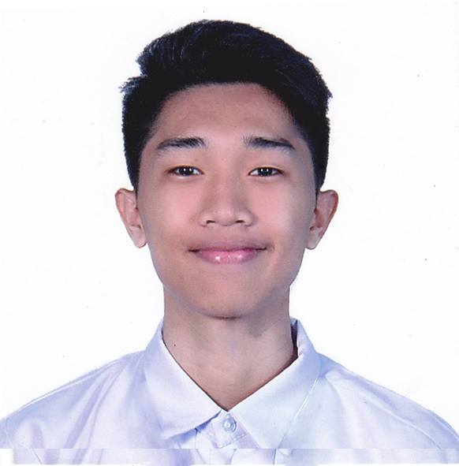Gelacio, Samuel Allen L.

Blk. 2 Lot 1 Ph2 De Lima Subd. Brgy Ibaba, CSRL

09972852993

bsitwanwan@gmail.com

**Personal Information**

Age: 20 Date of Birth: Dec. 12, 2000

Place of Birth: San Pedro, Laguna Civil Status: Single

Gender: Male Citizenship: Filipino

# Objective

* To showcase my communicating and coding skills in a professional work driven environment which will enable me to use my acquired skills and will aid me to continuously learn and gain valuable skills as a web developer.

# Education

***Tertiary***

* **PUP Sta. Rosa Campus** 2018 - 2020

Bachelor of Science in Information Technology (3rd year College)

***Senior High School***

* **Sta. Rosa Science and Technology HS** 2016 - 2018

STEM Strand

***Junior High School***

* **Sta. Rosa Science and Technology HS** 2012 – 2016

***Elementary***

* **JTEN**  2006 - 2012

# SKILLS

* HIGHLY SKILLED WITH COMPUTERS
* PROFESSIONAL WITH MICROSOFT OFFICE APPLICATIONS
* HAVE PROGRAMMING KNOWLEDGE
* HAVE EXCELLENT COMMUNICATING SKILLS

# Work Experience

* PROTEL March 2019 – January 12 2020

Appointment Settler

* DepEd Regional Office August – November 2018

Work Immersion

* SPES 2017

# Seminars attended

**IT/SOCIAL AND LEGAL ISSUES**

IT SEMINAR

**ZERO TO ONE: RECOGNIZING INNOVATION**

IT SEMINAR

# Character References

* ERNESTO BALDOZA TEACHER SCI-TECH
* ARWIN NUCUM TEACHER PUP STA. ROSA CAMPUS