**ARDHI UNIVERSITY**



**SCHOOL OF EARTH SCIENCEs, REAL ESTATES, BUSSINESS AND INFORMATICS (SERBI).**

**By**

**KAMALAMO, NOELA VEDASTUS.**

**REG NO: 25516/T.2020**

**ASSESSING AND MODELLING THE IMPACTS OF WEATHER VARIABILITY IN SUNFLOWER CULTIVATION**

**CASE STUDY MWANKOKO**

CERTIFICATION

The undersigned certify that they have supervised and proof read the dissertation and recommended for acceptance by the Ardhi University a dissertation document entitled “Assessing and modelling the impacts of weather variability in sunflower cultivation” In fulfilment of the requirements for the bachelor of science degree in Geographical Information’s System and Remote Sensing System.

………………….. ……………………….

Dr Guido Dr Ngereja

(Supervisor) (Supervisor)

Date…………….......... Date……………………

**DECLARATION AND COPYRIGHT**

I, Kamalamo Noela Vedastus, declare that the contents of this dissertation are the results of my own findings, obtained through leading and investigations. To the best of my knowledge, it has not been presented to any other university as a thesis for an award of Diploma, Degree or similar professional award.

**…………………………………**

**KAMALAMO NOELA VEDASTUS**

**25516/T.2020**

**Date**

**…………………………..**

.

**ABSTRACT**

Understand more about the direct impact of change in weather parameters how can affect the agricultural activities and see how the agricultural activities needs to adapt change of the weather parameters. It is important to understand the climatic patterns of a specific area so as farmers and others decision makers should be able to make decision and plans at what time they need to cultivate more than the other based on the trend of weather patterns. In this study the relationship between Mwankoko sunflower yields production and rainfall and temperature was examined using Multiple linear regression Model. From multiple linear regression the results show how change in temperature and rainfall cause an increase or decrease of sunflower yield production in Mwankoko wards.

Furthermore, the research employers modelling techniques to stimulate future weather scenario and assess their potential impacts on sunflower cultivation. Sunflower is a widely grown oilseed crop, and understanding the effects of weather fluctuations on its

Cultivation is essential for sustainable agricultural practices and food security. Using historical weather data including rainfall and temperature from 2010 to 2020 together with sunflower yields record of the farms found in Mwankoko ward. Statistical analysis techniques, such as regression analysis have performed to analyze and evaluate the relationship between weather variables and sunflower productivity. By identifying significant weather drivers, the study aims to quantify the specific impacts of weather variability on sunflower cultivation.

The result of this research contribute and understanding of how weather variability affects sunflower cultivation ,moreover the analysis provides the future climatic patterns over the study area and provides valuable information’s for policy makers ,farmers and stakeholders to develop adaptation strategies and policy for sustainable sunflower farming in the face of changing weather patterns .Overall this study emphasizes the need to consider weather and climate factors in agricultural planning to enhance the resilience of sunflower farming systems and ensure food security in a changing climate.

This study describe trend in sunflower yields against rainfall and temperature for the past 10 years from 2010 to 2020 and discovered that higher rainfall and low temperature cause an increase in production. This study also predicts the climate patterns for the future 10 years from 2020 to 2030, and finally this study conclude that temperature and rainfall have a direct impact to the yields production and therefore it’s important to understand the climatic patterns of Mwankoko ward.

TABLE OF CONTENTS

List of abbreviations 19

CHAPTER ONE 20

INTRODUCTION 20

1.1 Background of the problem 20

1.2 Statement of the problem 21

1.3 OBJECTIVES 22

1.3.1 Main objective 22

1.3.2 Specific objectives 22

1.4 Research questions 22

1.5 Significance of the research 22

1.6 Location of the study area 22

1.7 Research Scope and Limitation 22

1.8 Beneficiaries of the research 23

1.9 Structure of the dissertation 23

CHAPTER TWO 24

LITERATURE REVIEW 24

2.1 Overview 24

2.2 Weather and climate variability 24

2.3 Impacts of climate variability in sunflower cultivation 25

2.4 Modelling climate variability 25

2.5 Multiple linear regression 25

2.6 Correlation 26

2.7 Multicolinearity 26

2.8 Trend analysis of rainfall, temperature and sunflower yield 26

2.9 Climate variability impacts on crop productions 26

CHAPTER THREE 28

METHODOLOGY 28

3.1 Overview 28

3.2 Data used in this study and its functions 29

3.3 Software utilized 29

3.4 Data preparation 30

3.5 Method used 34

3.6 Data processing 34

3.7 Model Validation 36

3.8 Trend analysis of sunflower yield, precipitation and temperature 36

3.9 Predicting climate patterns 36

CHAPTER FOUR 37

RESULTS, ANALYSIS AND DISCUSSION 37

4.1 Overview 37

4.4 Validation 39

4.5 Prediction 39

4.6 A trend of average maxim temperature and its prediction 41

4.7 A graph show tends of average minimum temperature and its prediction 42

4.8 A graph shows a trend of annual rainfall and its prediction 42

4.9 Discussion 43

CHAPTER FIVE 44

CONCLUSION AND RECOMMENDATION 44

5.1 Overview 44

5.2 Conclusion 44

5.3 Recommendation 44

REFERENCES; 45

**List of Figures**

**List of Tables**

# 

# List of abbreviations

GIS - Geographical Information Systems

MLR - Multiple Linear Regression

# 

# CHAPTER ONE

# INTRODUCTION

## 1.1 Background of the problem

Agriculture is the most important economic sector in Tanzania as it provides the main source of food and employment among others (URT ,2012), More than 80% of population in Tanzania are farmers and they depend on rain fed crops as a source of livelihood but they fail to know the climatic patterns of a certain area that caused due to climate variability .Weather and Climate variability are environmental phenomena that can affect our daily lives, and then it is important to understand the relationship that exist between weather, climate and its effect in yields production. In Tanzania agriculture is characterized by high production risks due to its dependence on unpredictable and highly variable climatic patterns, low returns in investment resulting among others from low productivity, rudimentary technology and insufficient market system (URT, 2012). From the research done in East Africa (MPRA, 20 Nov 2021) tries to investigate whether the effects of weather variability in temperature and precipitation on agriculture output are short or long-run, and gives the concern about the impacts of climate variability on agricultural production per season.

Sunflower is native to North America but commercialization of the plant took place in Russia, Sunflower oil is the preferred oil in the most of Europe, Mexico and several South American countries (Kleingartner, 2007)The impacts of climate variability on agricultural production are well established in the scientific literature. From a research done in Uganda (CRAFT, 2019) show that the major factor for the expected increase in sunflower yields in the future will be due to increase in rainfall during the OND seasons these effect were and expected using the water requirement sartification index (WRSI) .Natural extremes and anomalies in weather conditions that results from climate variability are already reducing crop production at the global level. If no adaptation takes place, global yields are expected to decrease at a pace of 1.5% per decade (Lobell &Gourdgi, 2012). In 2013, the United Republic of Tanzania was ranked the tenth-largest global sunflower producing country in the world with a production share of 2.4 % and one of the largest sub-Saharan African producer countries of sunflower after South Africa. (R.Berguland, 2007) Between 2010 and 2013, Tanzania production of sunflower seeds increased by more than 300% enabling the sector to satisfy a larger share of national edible oil demand with a population of 49.3 million people. Sunflower yield is the most sensitive to moisture stress during the following period (R-2 to 5-9 reproductive stage)

Research by (Berglung, SEPTEMBER 2007) of NDSU has demonstrated the yield potential of sunflower growth and optimal moisture conditions and the effects of water stress at different growth stages. Also production of sunflower seeds reached close to 1million tons in 2013, (URT, 2016) according to the FAO, AND 3million tons according to official statistics from the ministry of agriculture, livestock and fisheries (MALF). Yields have increased dramatically over the last decade and are now seven times the level they were at a decade ago. (R.Berguland, 2007) Overall for sunflower products (seed oil and cake) the United Republic of Tanzania has experience a major surge in export, moving from US $1million to over US $ 70 million within a decade .India is its main export market and absorbs over 80% of its export .Despite the world market of sunflower products experience extraordinary growth of 15%over the last decade, the United Republic of Tanzania managed to outperform the world market by reaching 50% average annual growth, albeit from a low base.

Using Geographical Information Systems and Remote sensing techniques, GIS can model and identify the trends of the climatic pattern over the specific area and then analyzing the impacts that can be caused due to climatic variation. Whereby remote sensing used in downloading gridded data and by using geostatistical methods then it can be easily to use an equation of regression and analyses the existing relationship between climate variables and the yields production. This study takes consideration of two factors that are temperature and rainfall this is because these factors have highly contribution for support the growth and yields production for rain fed crops while other factors like pesticides, diseases and etc. there are different methods that implemented in order maximize yields production during harvesting. There are different support vector machines that can be used in different studies where by in this study multiple regression analysis is going to be performed to give a final output. (WEISBERG, 2005)By considering regression analysis is used to answer questions about the dependence of a response variables no one or more predictors, including the future prediction of future values of a response, predicting which predictors are important, and estimating the impact of changing a predictor or a treatment on the value of the response.

This research is going to model climatic patterns and then assessing its impacts to sunflower yields production by looking on how the change of one factor may affect the growth and harvesting of sunflower yields in MWANKOKO ward. Then finally farmers and decision makers should be able to understand climatic patterns of an area.

## 1.2 Statement of the problem

Currently, sunflower farmers depend entirely on rainfall for them to grow and expect good harvest of the crop. Weather variability has a direct impact to the growing and harvesting seasons of different crops including sunflowers. Farmers and decision makers are not aware/sure about weather patterns of the seasons, this results to lack of information about the impacts of weather variability and make most of farmers in a difficult situation during decision making. This being the case, it is more important for the farmers and decision makers to know how is varying over time and how it affects the growth and harvesting of sunflower so that to help them make informed in decision making on when to start preparations for growing the crop.

# 1.3 OBJECTIVES

## 1.3.1 Main objective

To assess and model the impacts of weather variability in sunflower cultivation using

GIS and remote sensing techniques.

## 1.3.2 Specific objectives s

1. To examine trends in weather variables (rainfall and temperature) over the study area for the past ten years.
2. Trend of sunflower yields production over the study area for the past ten years.
3. To examine the relationship between weather variables and yields production of sunflower in the study area for the past ten years.
4. Predict weather patterns for the next ten years.

## 1.4 Research questions

1. What are the weather patterns over the study area?
2. How yields production varies over the study area?
3. What is the relationship between temperature, rainfall and yields production in the study area?
4. How weather patterns affect sunflower growth and harvest yields?

## 1.5 Significance of the research

Finally, results will provide trend that show the impacts of weather variability in sunflower production so that farmers and other decision makers on agriculture sector should be able to understand the weather patterns and plan for the best strategies that can be used to minimize the effects in yields production.

## 1.6 Location of the study area

The research was conducted at the farms found in Mwankoko ward, Singida Urban district of the singida region of Tanzania. The area is located between latitudes 4’41” south, and longitudes 34’38” east. In Mwankoko ward there are different farms used for sunflower cultivation and all farms are showed in digitized map.

## 1.7 Research Scope and Limitation

This study will include the use of GIS and Remote Sensing techniques where by these techniques needs to be applying in processing data that acquired from the farmers, the rainfall and temperature data may not be accurately in a hundred percentage due to its deviation in different areas.

## 1.8 Beneficiaries of the research

1. Farmers at Mwankoko ward will be able to increase productivity of sunflower after informed the best growing season of the crop.
2. Policy makers and government organizations, as they could provide a better understanding of the potential impacts of weather variability in sunflower production.

## 1.9 Structure of the dissertation

The dissertation comprises of five chapters where chapter one consist of background, statement of the problem, study area, objectives of the study, significant of the study and beneficiaries of the study. Chapter two involves different existing ideas from other researchers works in this part includes ideas from different articles, papers and books. Chapter three consist of the methodology that was used to perform analysis in this study that meet the specific and main objectives. Chapter four include results, discussion and analysis. Finally, chapter five includes conclusion and recommendation.

# CHAPTER TWO

# LITERATURE REVIEW

## 2.1 Overview

This part provides information’s of existing studies and researches findings related to the impacts of weathers variability and focused on gathering relevant scientific articles, researches papers, reports, and other scholarly sources to understand the current state of knowledge in this field.

## 2.2 Weather and climate variability

Weather , This means the study of how atmospheric conditions affect the interpretation of satellite (Thomas lillesand, 2015) ,weather have a direct impact in growth and health a certain crop therefore it is important to understand weather patterns and their direct impact on crops is essential for farmers . (L, Agricultural meteorology, 2014).

Weather variability; This can be defined as the changes in weather patterns and conditions over a specific period of time, such as a day, weeks, months or years. Weather variability can be caused by natural factors such as change in atmospheric pressure, temperature and precipitation patterns.

Climate; Refers to a long-term average of weather patterns in a particular region or on a global scale. Climate is influenced by a variety of natural and human factors. (IPCC, 2007) also this is a long term average weather patterns observed over a significant period in a particular region or globally. (IPCC, 2013) It includes different factors, including temperature, precipitation, wind patterns, and atmospheric conditions. Where by

Temperature, this is the average measure of heat or coldness in a region, often recorded as mean annual temperature or seasonal variations.

Precipitation, this refers to the amount and distributions of rainfall, snowfall, and other forms of precipitation within a specific timeframe.

Climate Variability; Refers to the natural fluctuations and changes in the earth’s climate system over various time scales, ranging from short-term variations to long-term trends. (IPCC, 2014) Climate variability arises from internal and external factors example of internal factors are atmospheric circulation patterns, ocean currents, and interactions between different components of the climate system also there is external forcing such as solar radiation which influence the energy balance and climatic patterns. This defined as variations in statistics of the climate on all temporal and spatial scale’s, beyond individual weather events (FAO).

Vulnerability; Refers to the function of exposure to climate conditions, sensitivity to those conditions and the capacity to adopt the changes. (Cutter, 2016)Also can be defined as the state of being susceptible to harm, damage, or exploitation due to inherent weaknesses or exposure to external factors. It involves combination of individual, social and environmental factors that increase the likehood of negative outcomes.

## 2.3 Impacts of climate variability in sunflower cultivation

This means that in this part we want to understand how variation of climatic parameters can cause an increase or decrease of sunflower yields. (Lobell, 2012)This means that climate variability have a both negative and positive impacts on agricultural productivity, some keys impacts include crop yields where by precipitation patterns and temperature fluctuations can affect crop growth, leading to yields reduction or failures.

Assessing climate variability; This refers to the processing of understanding and analyzing climate variable using climatic parameters , (Smith, 2022)this is crucial for studying climate change ,prediction of future climate conditions, and implement effective adaptation and mitigation strategies ,this involve the use of historical records ,satellite observations and climate models. For example, using precipitation patterns this involves long-term records of rainfall and other form of precipitation where by the variation in precipitation levels and distribution can indicate climate variability such as change in seasonal rainfall patterns.

## 2.4 Modelling climate variability

This refers to the use of statistical models to analyze historical climate data to identify patterns and relationships between different variables. (Stocker, 2013)This mode can capture the statistical properties of climate variability and provide insight into likehood of future climate events. Also this is an essential aspect of understanding and predicting changes in the earth climate system , (Hurrell, 1995)by developing models that capture the complexity of the climate system ,scientists can scientists can simulate and analyze these variations and providing valuable insight into the future climatic conditions.

## 2.5 Multiple linear regression

Is a statistical technique used to model the relationship between a dependent variable and two or more independent variables , (Kytner, 2004)it extends the concept of multiple linear regression where by the goal of multiple linear regression is to estimate the coefficient of independent variables that the best to predict the dependent variable this is a method that show the relationship that exist between different climatic parameters in relation to the other parameters, this method has dependent variable and independents variables (Weisberg, 2005).

The multiple linear regression model can be represented as follows

Where by

Y Represents the dependent variable

X Represent independent variables

β0, β1, … βn Represent coefficient (also known as regression weight)

The coefficient in multiple linear regression model indicate the change in the dependent variable for a unit change in the corresponding independent variable, holding other variables constant.

## 2.6 Correlation

Correlation used to show the relationship exists between two or more variable where using correlation it show how independent variable affect the change of dependent variable. (Pearson, 1896)This refers to the statistical measure that quantifiers the degree of association or relationship between two variables, it indicate how change in one variable correspond to changes in another variable .The correlation coefficient, typically denoted by symbol r and it ranges from -1 to +1 ,where by a positive value indicate a positive correlation and a negative value indicate a negative correlation and the value close to zero suggest a weak or zero correlation.

## 2.7 Multicolinearity

Multicolinearity occurs when two or more predictors ignore regression model are highly correlated. Typically, this means that one predictor is a function of the other. That means in checking for multicollinearity we need to have two variables and we almost always have multicolineraity in the data. (Hair, 2014)Also this is a statistical phenomenon that occurs when there is high degree of correlation among independent variables in a regression analysis, multicolinearity arises from various factors including linear relationships, when two or more independent variables are highly correlated, it can lead to multicolineality.

## 2.8 Trend analysis of rainfall, temperature and sunflower yield

The cultivation of sunflower is highly depending on environmental conditions such as rainfall and temperature and it is important to understand the trends in rainfall and temperature and sunflower yields becomes crucial for sustainable agricultural practices, the trends used to analyze the potential impacts of climate variability to sunflower production.

Trend analysis of rainfall there are several studies that have examined the trends in rainfall patterns and their implications to sunflower production. For instance, found a decreasing trend in rainfall during critical growth stages, negatively affecting sunflower yields in certain regions of the United States. Also (Mendes, 2020) reported an increasing trend in rainfall in sunflower –growing regions of India, results to improve in yields production.

Trend analysis of temperature ,influence of temperature on sunflower yields has also been investigated .studies by (Johnson, 2017) indicates that higher temperature during the flowering stages reduced sunflower yields in the parts of Europe ,also demonstrated that extreme temperature have a negative impacts to sunflower yields in China.

## 2.9 Climate variability impacts on crop productions

Favorable temperature for sunflower growth are in the range of 20-25 degree (fernandez-Luqueno et al., 2014) so an increasing continentality of the climate contributes to the possibility of achieving optimal temperature conditions for sunflower growth. However, temperatures above 25 C and frosts at any stage of growth, which are also signs of the climate continentality, reduce the yields and oiliness of the seed. Most of the sunflower are cultivated under rain-fed conditions in Ukraine. (Gurkane et al, 2020)

Continentality reflect the most important climatic properties, such as the degree of variability of the annual temperature range. As the continentality increases, summer temperature rise and winter temperature fall (Driscoll and Fong, 1992).

# 

# CHAPTER THREE

# METHODOLOGY

## 3.1 Overview

This is the part that show what have done based on a specific study by presenting different methods used and different processes to achieve objectives of the study.

The area that used in this research (case study area) is found at Singida urban Mwankoko ward that is located in Singida urban district has a latitude of 4⁰54′ 0″S and longitude of 34⁰43′ 59″E. This area is used because is among the area where there is highly possibility of acquiring a lot of information about sunflower yields productions.

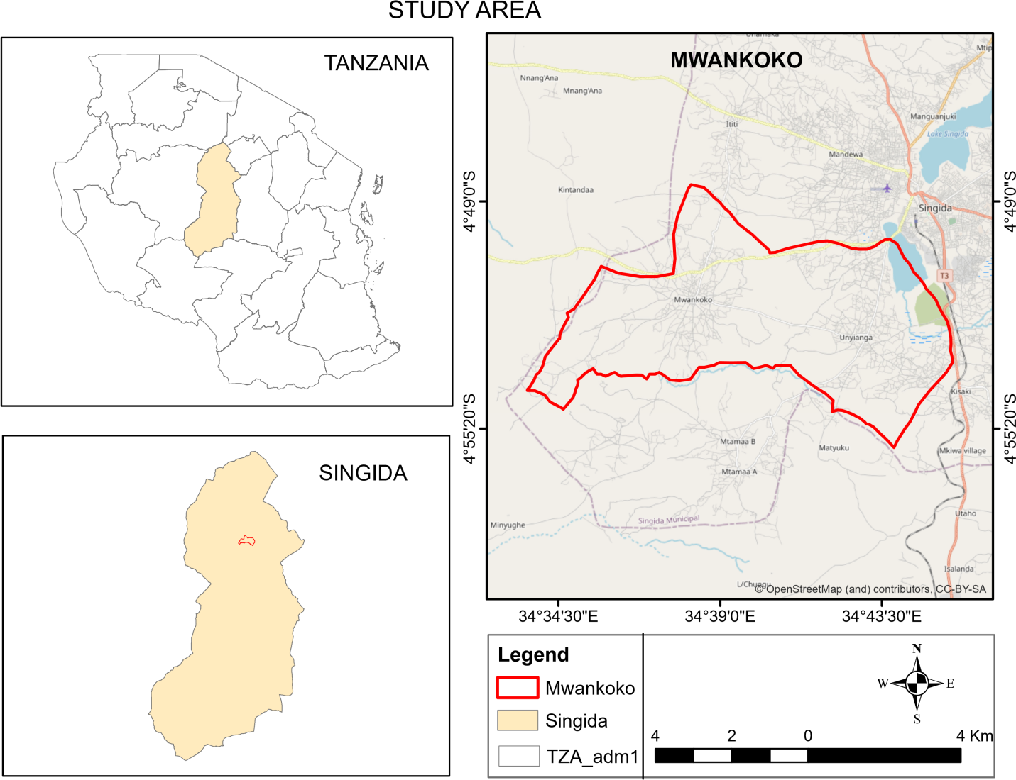

Figure 3.1Location map of Mwankoko Ward Figure

## 3.2 Data used in this study and its functions

### Table 3.1 Data used in the study

|  |  |  |  |  |
| --- | --- | --- | --- | --- |
| Type of data | Format | Data source | Epoch  (years) | Uses of the data |
| Rainfall | CSV | https;//www.climatologylab.org/terraclimate.html | 2010 – 2020 | Used to show rainfall patterns over the study area |
| Temperature | CSV | https;//www.climatologylab.org/terraclimate.html | 2010 – 2020 | Used to show temperature patterns over the study area |
| Mwankoko Sunflower yields data | CSV | Singida Ministry of agriculture | 2010 – 2020 | Used to analyze how productivity is affected during growing and harvesting |
| Gridded climate data | CSV | TMA | 2010 – 2020 | Used for validation |

## 3.3 Software utilized

The following are the software’s that can be used in this study

Data are downloaded from NASA

* Downloaded rainfall and temperature data.
* Performed statistical analysis and show trends

Arc GIS version 10.8

* Used in querying case study area using select by attributes
* Used in creating a map

In this study adapts multiple linear regression method (MLR) so as to achieve the main objective by using different parameters (rainfall and temperature) together with sunflower data so as to understand how rainfall and temperature can affect sunflower yields during growing and cultivation season.

## 3.4 Data preparation

This was done after downloading rainfall and temperature where by this performed by removing all unwanted information’s by selecting some columns and rows with unrequired data and remove then remained with required column only and rows.

By using rainfall and temperature data from 2010 to 2020 and then sunflower data that show production of sunflower yields at singida Mwankoko ward then we should be able to assess first the relationship between rainfall and temperature and then see how these two parameters can cause sunflower yields to increase or decrease in its production.

FLOWCHART DIAGRAM

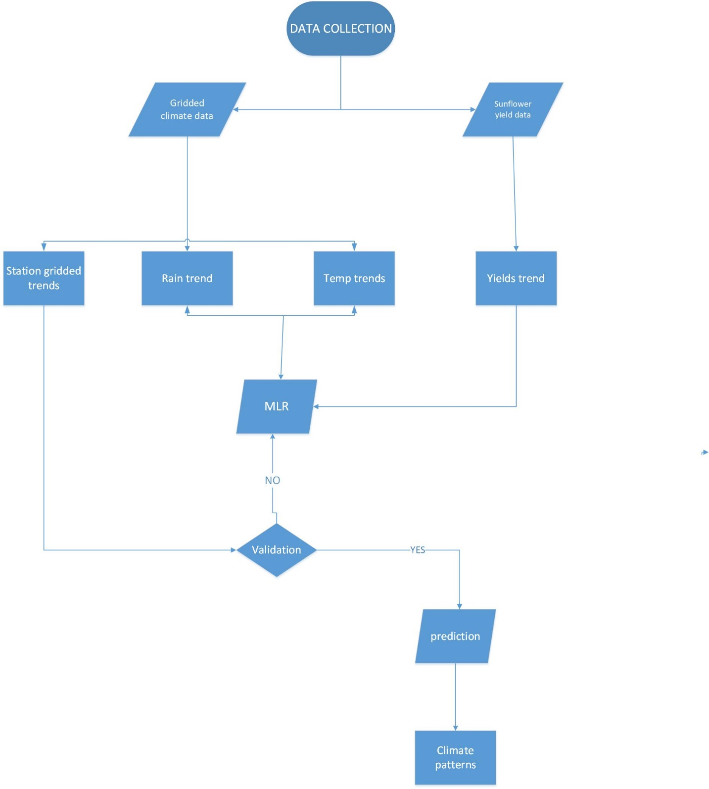

Figure 3. 2 Flowchart diagram

Where by

β0, β1, … βn are regression parameters

T.A this means trend analysis

MLR this means Multiple Linear Regression

Data type used

# This part shows the type of data that used in the study that includes sunflower yields data from 2010 to 2020 in tones per hectares, also there are temperature data and rainfall data that show weather patterns for the past ten years in degree C. Where y rainfall and temperature data were downloaded from NASA and sunflower yields data were obtained from the ministry of agriculture of singida -Mwankoko ward.

Table 3.2 Downloaded rainfall data in CSV

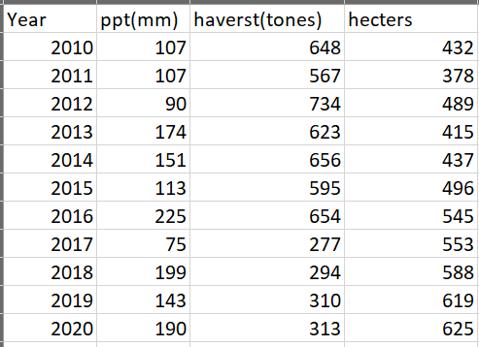

From the downloaded data show that rainfall ranges between 75mm to 190 mm where by the minimum rainfall is 75 mm and the highest is 190mm in Mwankoko ward.

Table 3.3 Downloaded temperature data in CSV format

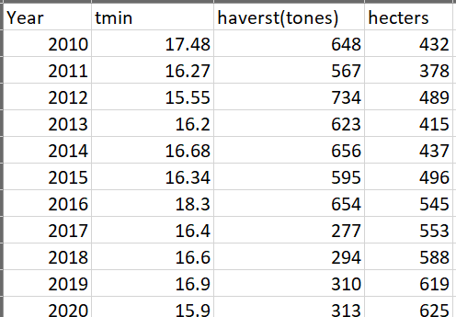

From the downloaded data show that average minimum temperature ranges between 15 to 18 degree centigrade

Table 3.4 Average maximum temperature in CSV format

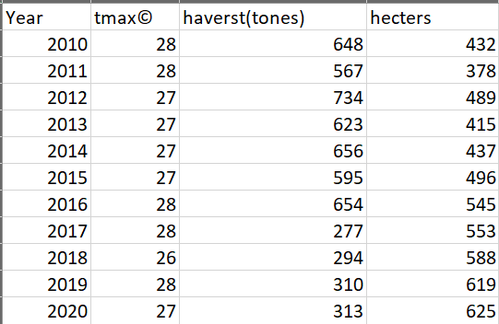

The average maximum temperature ranges between 26 to 28 degree centigrade in mwankoko ward

A diagram that show data for sunflower yields production

This is the table of data that show the trends of rainfall in Mwankoko ward, data that are recorded direct from the station and this data used for validation.

Table 3.5 Rainfall data provided from the station in CSV format

|  |  |
| --- | --- |
| YEAR | RAINFALL (mm) |
| 2010 | 741.5 |
| 2011 | 809.3 |
| 2012 | 590.4 |
| 2013 | 771.5 |
| 2014 | 674.1 |
| 2015 | 634.1 |
| 2016 | 672 |
| 2017 | 441.7 |
| 2018 | 925.6 |
| 2019 | 891.8 |
| 2020 | 1015 |

Table 3.6 Average Annual maximum temperature provided from the station in CSV format

|  |  |
| --- | --- |
| YEAR | ANN MAX TEMPERATURE |
| 2010 | 28.1 |
| 2011 | 27.9 |
| 2012 | 27.9 |
| 2013 | 27.6 |
| 2014 | 27.9 |
| 2015 | 27.9 |
| 2016 | 28.2 |
| 2017 | 28.8 |
| 2018 | 27.3 |
| 2019 | 28.1 |
| 2020 | 27 |

## 3.5 Method used

This study was done using a statistical method called Multiple Linear Regression (MLR), where by MLR is used to model the relationship that exist between dependent variable and independent variable and then use two or more independent variables to predict the outcome of a dependent variable. Also this are methods that can be used in determining relationship between climate parameters and yields production where by Tmax, Tmin have negative correlation while rainfall have positive correlation to rainfall crops. Then MLR after the relationship that exist between one variable and another is going to do the prediction

Multiple linear regression (MLR) is a statistical technique that uses several explanatory variables to predict the

Multiple linear regression equation

= β0 + β1 +… +βn

Where by β0, β1 … βn are regression parameters

Multiple linear regression, this used mathematical to be performed and then show the relationship between depend variable and independent variables. Where by in this study sunflower yields data are dependent variable and the rainfall and temperature this are independent variables.

## 3.6 Data processing

In this research the software used was Excel, where by there are different step that used in processing rainfall and temperature data and then to check for correlation between the two variables and then show the trend. Also sunflower yields data are estimated in excel and then tries to look how it is affected by weather patterns.

This was done by starting downloading an image of singida Urban and then in Qgis followed by adding Mwankoko shapefile and then starting digitizing all the farms found in mwankoko and then export digitized output. An image below shows digitization process that was performed to analyze the number if sunflower farms in Mwankoko ward and this process was performed in Qgis software.

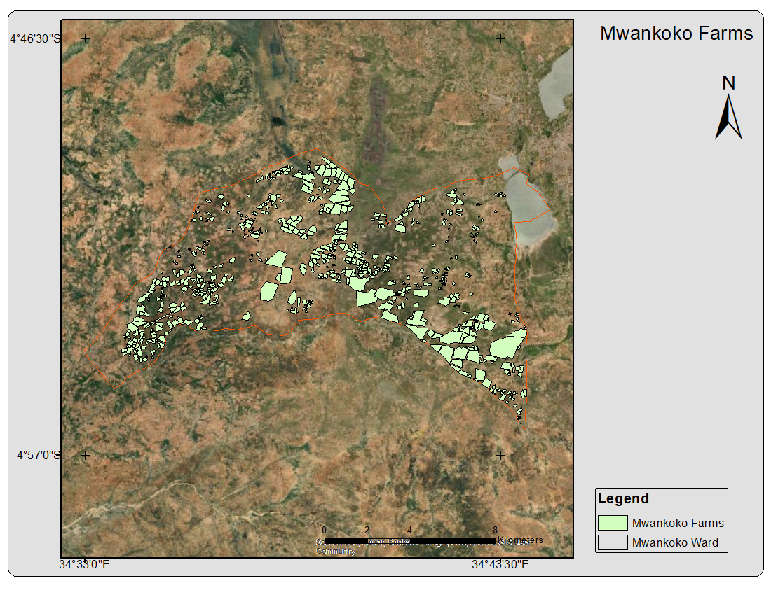

Figure 3. 3 Digitized farms

In this part the data arranged in CSV file were added in excel and then used to perform multiple linear regression method this was done by assigning independent variables that are rainfall and temperature variables and. Then the mode was formulated with the dependent variable of annual sunflower yield and independent variables as average annual precipitation and maximum and minimum temperature as their shown on the regression model.

The formulated model was done and provides a summary that gives the effect of the variables towards the prediction of new data

Regression report

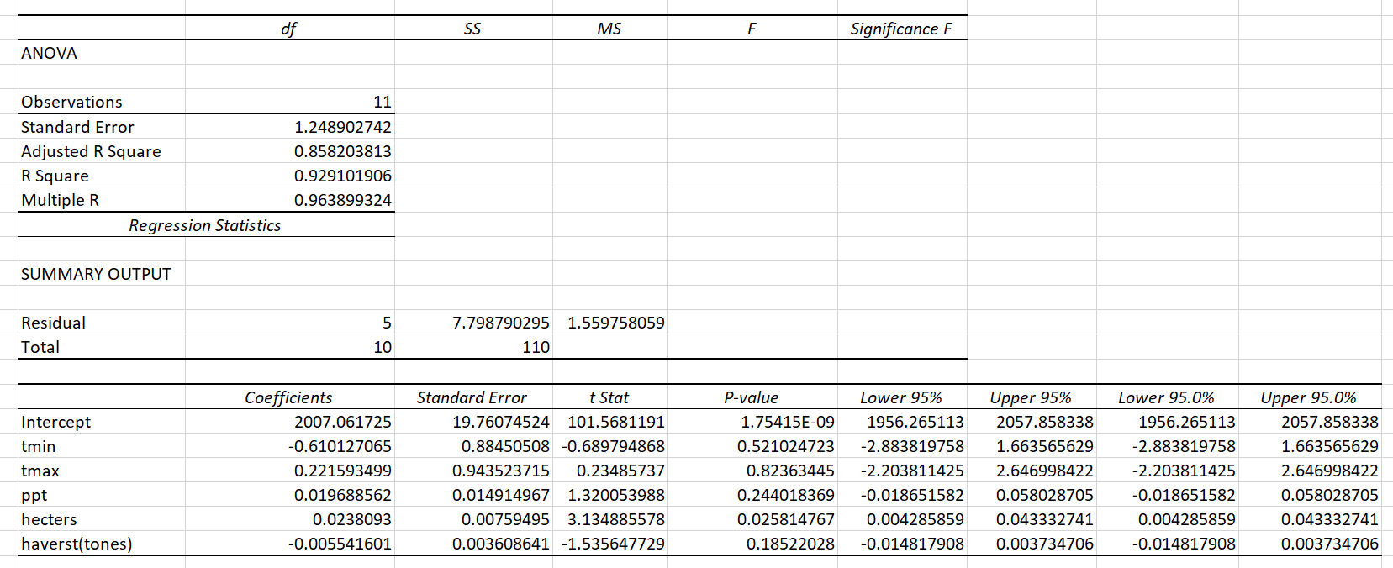

Figure 3. 4 Regression report

After performing regression process in an excel then provide a report that show a short summary of rainfall values, temperature and harvest in Mwankoko ward.

## 3.7 Model Validation

In the part of validation, the gridded climate data, means data that show trend of rainfall and temperature that was provided from the station together with downloaded gridded climate data was used. The adjusted coefficient of determination was used to check for the accuracy of the model

## 3.8 Trend analysis of sunflower yield, precipitation and temperature

The analysis of trends was done in Excel using Multiple linear regression by the function y on y-axis with m the trend line slope and the x-axis the years so as to detect the general patterns of relationship between variables and project the future direction of this pattern. The variables were plotted against time in years and the trend line showed the slope of direction of the pattern, for a negative slope trend it implied the decrease in the variable each year while the positive slope implied the increase in variable per each year.

## 3.9 Predicting climate patterns

The prediction was done by considering the trends of the climate patterns for the past years of 2010 to 2020 and then from the past trend it provides climate patterns of the future for the next 10 years

# CHAPTER FOUR

# RESULTS, ANALYSIS AND DISCUSSION

## 4.1 Overview

This chapter includes all results that obtained during data processing whereby there are different outputs that act as specific objectives and show how it meet with main objective. Then according to the methodology performed we need to discuss if it meets with the aim of the research that is to assess and model the impacts of weather variability in sunflower cultivation in the results there is graphs that show rainfall trend, both maximum and minimum temperature. Also this part shows outputs that obtained and provides the solutions to the objectives of the study and emphasize the need for adaptive strategies and technological interventions to mitigate the adverse effects of weather fluctuations on sunflower production.

**4.2 Effects of rainfall and temperature trends to sunflower production**

Figure 4. 0‑1Average minimum temperature vary together the sunflower yield production

**4.3 Maximum temperature trend with sunflower harvest**

Figure 4. 0‑2 An output that show how average maximum temperature vary with harvest

## 4.4 Validation

This step is done by using the downloaded rainfall data and temperature data of Mwankoko ward from 2010 to 2020 together with rainfall and temperature data that was given from the station and then check if this data its trend is it the same

## 4.5 Prediction

Table 4.1A table that show predicted rainfall in Mwankoko ward

|  |  |
| --- | --- |
| YEAR | RAINFALL (mm) |
| 2020 | 190 |
| 2021 | 183 |
| 2022 | 190 |
| 2023 | 197 |
| 2024 | 204 |
| 2025 | 211 |
| 2026 | 218 |
| 2027 | 225 |
| 2028 | 232 |
| 2029 | 239 |
| 2030 | 245 |

Table 4.2Table that show predicted average Maximum temperature in Mwankoko ward

|  |  |
| --- | --- |
| YEAR | Tmax predicted(degree C) |
| 2020 | 27 |
| 2021 | 27 |
| 2022 | 27 |
| 2023 | 27 |
| 2024 | 27 |
| 2025 | 27 |
| 2026 | 27 |
| 2027 | 27 |
| 2028 | 27 |
| 2029 | 27 |
| 2030 | 26 |

Table 4.3Table that show predicted average minimum temperature in Mwankoko ward

|  |  |
| --- | --- |
| YEAR | Tmin predicted(degree C) |
| 2020 | 15.9 |
| 2021 | 16.56 |
| 2022 | 16.56 |
| 2023 | 16.55 |
| 2024 | 16.54 |
| 2025 | 16.54 |
| 2026 | 16.54 |
| 2027 | 16.53 |
| 2028 | 16.53 |
| 2029 | 16.52 |
| 2030 | 16.52 |

## 4.6 A trend of average maxim temperature and its prediction

Figure 4. 0‑3 Predicted average maximum temperature

## 4.7 A graph show tends of average minimum temperature and its prediction

Figure 4. 0‑4 Predicted average minimum temperature

## 4.8 A graph shows a trend of annual rainfall and its prediction

Figure 4. 0‑5 A trend of annual rainfall and its prediction

Predicted precipitation trend in Mwankoko ward

Figure 4. 0‑6 Predicted precipitation

## 4.9 Discussion

This research based on the consideration of two factors that’s are precipitation and temperature in relation to sunflower yields production .The research found that sunflower yields increasing with an increase in rainfall this means that rainfall have a direct impact to the yields production where by temperature also has a direct impacts to sunflower yields ,for the minimum temperature have small impacts but maximum temperature affect productivity of sunflower and as the result of decrease in sunflower yields .

This study shows that in Mwankoko ward minimum temperature ranges between 15 to 18-degree C and the maximum temperature ranges between 26 to 29-degree C and for the rainfall data vary between 75 to 200 mm.

There are number of factors that affects the productivity of sunflower production that be shown by different authors that have negative impacts to the growth and productivity of sunflower such soil, fertilizer, pests and diseases therefore different studies needs to be conducted in order to increase productivity of sunflower.

# CHAPTER FIVE

# CONCLUSION AND RECOMMENDATION

## 5.1 Overview

This part shows the summary and reflection of the key findings, implications and future directions discussed throughout the research.

## 5.2 Conclusion

The research was successful carried out by using different variables such as maximum temperature and minimum temperature including rainfall/precipitation these variables play important part to the cultivation of sunflower. This study shows how the rainfall increases over the study area and then temperature decrease that cause high rate of sunflower need to be cultivated in Mwankoko ward based on the predicted climatic patterns.

## 5.3 Recommendation

Based on this research therefore further researches should be done by considering other factors that can also affect the productivity of sunflower and that have high possibility of affecting sunflower yields production over the study area.

# REFERENCES;

Berglung, D. R. (SEPTEMBER 2007). *SUNFLOWER PRODUCTION.*

CRAFT. (2019). Climate Change Risks an Opportunities. *Sunflower Ugnda*.

Cutter, S. (2016). Vulnerability to environmental hazards . *Progress in Human Geography ,20(4)*, 529-539.

FAO. (n.d.).

Hair, J. &. (2014). *Multivariate Data Analysis (7th ed).* Pearson Education Limited.

Hurrell, J. (1995). Decadal trends in the North Atlantic Oscillation :. *Regional temperature and precipitation.Science,269*, 676-679.

IPCC. (2013). *Climate Change ,The physical Science Basis .Contribution of Working Group I to the fifth Assessment Report of the Intergovernmental Panel on Climate Change.* Cambridge University Press.

IPCC. (2013). *Climate Change ,The physical Science Basis .Contribution of working Group I to the Fifth Assessment Report of the Intergovernmental Panel on the Climate Change.* Cambridge University Press.

IPCC. (2013). *Climate change 2013:The physical Science Basis.Contribution of working group I to the fifth assessment Reportof the governmental panell on climate chnge .* Cambridge University Press.

IPCC. (2014). *Climate change ,Impacts ,Adaptation,and Vulnerability.Contribution of Working Group II to the Fifth Assessment Report of the Intergovernmental Pannel on Climate Change.* Cambridge Univercity Press.

Johnson, S. &. (2017). Impact ofhigh temperature on sunflower productivity in Europe . *European Journal of Agronomy*, 32-41.

Kleingartner, J. S. (2007). *World Production.*

Kytner, M. N. (2004). *Applied linear statistical model(5th edition).* McGraw-Hill.

L, D. (2014). *Agricultural meteorology.*

L, D. (2014). *Agricultural meteororlogy.*

Lobell, D. &. (2012). The influence of climate change on global crop productivity . *Plant Physiology,160(4)*, 1686-1697.

Mendes, P. &. (2020). *Trends and sptial variability of sunflower yield and water use efficiency in Brazil.* Agricukture water management ,240,106272.

MPRA. (20 Nov 2021). *Climate variability impacts on agricultural output in East Africa.*

Pearson, K. (1896). Mathematical contribution to the theory of evolution on a form of spurious correlation which may arise when indices are used in the measurement of organs. *Proceeding of the Royal Society of London*, (359-367),(489-498).

R.Berguland, D. (2007). *SUNFLOER PRODUCTION.*

Smith, J. J. (2022). Assessing Climate Variability in the Western United using Treee Ring Proxies. *Journal of Climate Science*, 123-145.

Stocker, T. D.-K. (2013). *The physical science Basis.Contribution of working Group I to the Fifth Assessment Report of the Intergovenmental Panel on Climate Change.* Cambridge University Press,: United Kingdom and New York.

Thomas lillesand, R. k. (2015). *Remote sensing and interpretation.*

URT. (2016). *SUNFLOWER SECTOR DEVELOPMENT STRATEGY*.

WEISBERG, S. (2005). *APPLIED LINEAR.* John Willey & Sons ,Inc.,Hoboken,New Jersey.

weisberg, S. (2005). *Applied linear regression.*