**ARDHI UNIVERSITY**



**APPLICATION OF REMOTE SENSING IN ASSESSING THE INVASION OF LANTANA CAMARA**

**A Case Study of Serengeti National Park**

**JUDITH F. MAUKI**

**BSc** **Geographical Information Systems and Remote Sensing**

**Dissertation**

**Ardhi University, Dar es Salaam**

**July, 2023**

**APPLICATION OF REMOTE SENSING IN ASSESSING THE INVASION OF LANTANA CAMARA**

**A Case Study of Serengeti National Park**

**MAUKI, JUDITH F.**

A Dissertation Submitted to the Department of Geospatial Sciences and Technology in Partially Fulfilment of the Requirements for the Award of Science in Geographical Information Systems and Remote Sensing (BSc. GIS&RS) of Ardhi University

# CERTIFICATION

The undersigned certify that they have read and hereby recommend for acceptance by the Ardhi University dissertation titled **“Application of remote sensing in assessing the invasion of Lantana Camara, a case study of Serengeti National Park”** in partial fulfillment of the requirements for the award of degree of Bachelor of Science in Geomatics at Ardhi University.

…………………………………

**Mr. Joseph Maziku**

(Supervisor)

………………………

# DECLARATION AND COPYRIGHT

I, MAUKI, JUDITH F hereby declare that, the contents of this dissertation are the results of my own findings through my study and investigation, and to the best of my knowledge they have not been presented anywhere else as a dissertation for diploma, degree or any similar academic award in any institution of higher learning.

………………………………..

**MAUKI, JUDITH F**

25498/T.2020

Copyright ©1999 This dissertation is the copyright material presented under Berne convention, the copyright act of 1999 and other international and national enactments, in that belief, on intellectual property. It may not be reproduced by any means, in full or in part, except for short extracts in fair dealing; for research or private study, critical scholarly review or discourse with an acknowledgement, without the written permission of the directorate of undergraduate studies, on behalf of both the author and Ardhi University.

# ACKNOWLEDGEMENT

I would like to thank the Almighty God for granting me with knowledge and good health trough out the whole time of my dissertation and studies.

Limitless as it is worth appreciating to all that have contributed in the achievement of this field. Am deeply thankful to my supervisor Mr. Joseph, Maziku for his inestimable patience, encouragement, care and helpful criticism throughout the third year. My sincere gratitude to Mr. Michael Mavura and Dr. Atupelye Komba and all panelists for their criticism and structuring my Dissertation.

Besides, I would like to sincerely acknowledge my family particularly my father, Fortunatus Mauki, my mother, Constansia Njau, my lovely sister, Rhodasia Mauki and her husband Sostenes Kira, also special thanks to my brother Dr. Dickson Mauki, Mr. Laurian Materu and Dr. Zakaria Ngereja. My family plays an important and vital role your encouragement, prayers and support kept me going highly is greatly appreciated.

Again, special thanks are owed to my fellow students of Geographical Information System and Remote Sensing who in one way or another have taken part in the completion of my study. Truthfully, I have made this far with their companion. I would like extend my thanks to TANAPA Headquarter for their support in data collection process by directing the appropriate sources.

# ABSTRACT

Several alien plant species have expanded its range and subsequently became invasive in Serengeti National Park, Tanzania. The invasion of non-native plant species poses a significant threat to ecosystems worldwide, including protected areas such as Serengeti National Park. Lantana Camara, a highly invasive species, has been spreading rapidly in the park, impacting native biodiversity and ecosystem functioning. Remote sensing techniques have emerged as valuable tools for monitoring and assessing the extent and dynamics of invasive plant species. This study aims to investigate the application of remote sensing in assessing the invasion of Lantana Camara in Serengeti National Park. Moreover, abundance of Lantana Camara serve as baseline data for assessing its effect on landcover, cost of clearing and effect on livelihood. Discriminating Lantana Camara from other plants in Serengeti National Park evergreen forest is challenging even with remote sensing since seasonality cannot be utilized and presence of trees obstruct the sensors in detecting understory shrubs. Therefore, this study mapped the distribution of Lantana Camara using Sentinel 2A data with 10 m resolution using random forest classification. Lantana Camara was detected along the roads and forest edges with high abundance, while it was less abundant in bare lands and bare rocks. Among the negative impacts observed includes that it spread fast and weaken other species. Results also shows increase in the spread and invasion of Lantana Camara in Serengeti National Park. It is recommended that Lantana Camara should be managed while it is still not very dense and widely spread. The cost of managing will increase substantially with further invasion and mechanical means may not suffice.

TABLE OF CONTENTS

CERTIFICATION ii

DECLARATION AND COPYRIGHT iii

ACKNOWLEDGEMENT iv

ABSTRACT v

TABLE OF CONTENTS vi

LIST OF FIGURES ix

LIST OF TABLES x

ACRONYMS AND ABBREVIATIONS xi

CHAPTER ONE 1

INTRODUCTION 1

1.0 Background of the study 1

1.1 Problem Statement. 3

1.2 Research Objectives 3

1.2.1 Main Objective 3

1.2.2 Specific Objective 3

1.3 Research questions 4

1.4 Significance of the Research 4

1.5 Beneficiaries of the study 4

1.6 Scope and Limitations of the study 5

CHAPTER TWO 6

LITERATURE REVIEW 6

2.0 Overview 6

2.1 Remote sensing 6

2.1.1 Platforms and Remote sensors 6

2.1.2 Resolution. 6

2.2 Image pre- processing 7

2.2.1 Radiometric corrections 7

2.2.2 Geometric corrections 7

2.3 Ground truthing 8

2.4 Image classification 8

2.4.1 Principle of image classification 8

2.4.2 Classification scheme. 8

2.4.3 Levels of Anderson classification scheme 9

2.5 Classification Algorithms 9

2.5.1 Maximum Likelihood. 10

2.5.2 Support Vector Machine 10

2.5.3 Random Forest 10

2.6 General steps in classifying the satellite image 10

2.7 Classification methods 11

2.7.1 Supervised classifications 11

2.7.2 General stages in performing supervised classification 11

2.8 Accuracy assessment 12

2. 9 Lantana Camara as invasive specie 13

CHAPTER THREE 14

METHODOLOGY 14

3.0 Overview 14

3.1 Workflow 14

3.2 Study Area 16

3.3 Data Acquisition 18

3.3.1 Remote Sensing Data. 18

3.3.2 Ground truthing data 18

3.3.3 Lantana Camara data 18

3.4 Data pre-processing 19

3.5 Image processing 19

3.6 Image classification 19

3.7 Generating training samples 20

3.8 Separability analysis 20

3.9 Accuracy assessment 20

CHAPTER FOUR 22

RESULTS, ANALYSIS AND DISCUSSION 22

4.0 Overview 22

4.1 Mapping of Lantana Camara 22

4.2 Distribution of Lantana Camara specie in Serengeti National Park 25

4.3 Accuracy Assessment. 25

CHAPTER FIVE 28

5. CONCLUSION AND RECOMMENDATION 28

5.0 Overview 28

5.1 Conclusion 28

5.2 Recommendation 28

REFERENCES 29

# LIST OF FIGURES

Figure 1. 1 Lantana Camara specie……………………………………………………………1

Figure 3. 2 work Methodology flow………………………………………………………….15

Figure 3. 1 Location of the study Area……………………………………………………… 17

Figure 4. 1 Distribution map of Lantana Camara in Serengeti National Park year 2021…… 23

Figure 4. 2 Distribution map of Lantana Camara in Serengeti National Park year 2022…… 24

# LIST OF TABLES

Table 3. 1 Satellite data downloaded 18

Table 4. 1 Confusion Matrix for classified image of 2021……………………………………..26

Table 4. 2 Confusion Matrix for classified image of 2022……………………………………..27

# ACRONYMS AND ABBREVIATIONS

|  |  |  |  |
| --- | --- | --- | --- |
| GIS | Geographical Information System | | |
| GNSSS | Global Navigation Satellite System | | |
| GPS | Global Positioning System | | |
| IAP | Invasive Alien Species | | |
| IAPS | Invasive Alien Plants Species | |
| IAS | Invasive Alien Plants | |
| LC | | Lantana Camara | |
| QGIS | Quantum Geographic Information System | | |
| RF | Random Forest | | |
| RADAR | Radio Detection and Ranging | | |
| RS | Remoter Sensing | | |
| VHR | Very High Resolution | | |

# CHAPTER ONE

# INTRODUCTION

## 1.0 Background of the study

Lantana camara is a multi-stem shrub native to South America and a major weed in tropical and sub-tropical countries (Taylor et al., 2011). It is among the worst ten invaders in the world (Lowe et al., 2000). Invasive alien species such as lantana camara as it shown in Figure 1.1 are major threat to native biodiversity and ecosystem in many regions, this is the one of the most serious invasive plants species and have been seen spreading in Serengeti National Park which found within two regions Mara and Simiyu which affect the native vegetation and biodiversity. It is believed that Lantana camara was imported to Europe from America in mid-16th and 17th century where it underwent breeding which resulted into hundreds of hybrids. The species were then exported to India, Australia and Africa in mid-19th century. With time they escaped from their originally planted areas into unintended areas and became weeds (Goyal & Sharma, 2015)

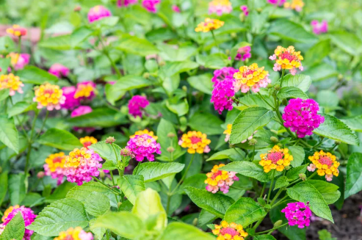

Figure 1. 1 Lantana Camara specie (Beaulieu, 2023).

Lantana camara is a multi-stem shrub native to South America and a major weed in tropical and sub-tropical countries (Taylor et al., 2011). It is among the worst ten invaders in the world (Lowe et al., 2000). It is believed that L. camara was imported to Europe from America in mid-16th and 17th century where it underwent breeding which resulted into hundreds of hybrids. The species were then exported to India, Australia and Africa in mid-19th century. With time they escaped from their originally planted areas into unintended areas and became weeds (Goyal & Sharma, 2015).

Understanding the costs and associated impacts caused by IAS requires both the intensive assessment (abundance) and extensive assessment (spread) of the invasion. Early detection of potentially IAS is crucial, because the expenses and effort required in halting and managing invasions increases considerably as the species spreads and becomes more abundant, until removal is impossible and control becomes very costly (Van Wilgen et al., 2008). FAO (2005) suggested that one of the important steps in prevention is identification of the possible susceptible sites in which the species would spread into and the pathways in which they can be introduced to those areas. This can be achieved through the use of remote sensing techniques. Remote sensing techniques utilize the information from satellite images in detection and mapping the distribution of invasive alien plants (Cho-ying Huang, 2009).

According to the World Conservation Union, invasive alien species are the second most significant threat to biodiversity, after habitat loss. In their new ecosystems, invasive alien species become predators, competitors, parasites, hybridizers, and diseases of our native and domesticated plants and animals.

It is spread by seedling growth especially along the edges of lantana patches. If left unchecked, lantana camara can alter the structure of wet sclerophyll and warm temperate rainforests to the detriment of these forests (Duggin & Gentle, 1998). It appears that lantana’s success is due to its reported ability to out-compete native species in frequently disturbed sites (Duggin & Gentle, 1998) and its shade tolerance. However, the level of this tolerance is not well known.

Lantana’s success may also be due to allelochemicals that inhibit both the germination and growth of other plants (Sharma et al., 2005). Many studies have highlighted these chemicals as an important component of lantana’s competitive strategy even though some studies have found that lantana camara-derived chemicals act negatively on many crops and plantation species (Swarbrick et al., 1995). (Webb et al., 1972) and (Lamb, 1991) both have shown that lantana thickets can withstand replacement by rainforest species and prevent the re-establishment of the rainforest.

Remote sensing using satellite images has been widely used as a tool for detecting and mapping invasive species. This study aims to use remote sensing techniques, specifically Sentinel 2 to assess the invasion of Lantana camara cover over a period of time, generate a map of Lantana camara distribution to aid in the identification of control priorities. This can be done using various remote sensing techniques such as satellite imagery to assess the invasion of Lantana Camara in vegetation cover such as the spread of Lantana camara in areas where it was not previously present. This study will provide valuable information to inform and evaluate control efforts aimed at minimizing the impact of Lantana camara on native biodiversity and ecosystem function in the region (Guo et al., 2009).

## 1.1 Problem Statement.

In spite that Tanzania developed different methods in protecting national parks such as application of laws that has been applied against that destroyed conserved areas and forests, it seems the existence of lantana camara species which are invasive in nature form dense thickets that smother and kill native vegetation. This is expected to become a serious problem for coming years. The spread of Lantana camara in Serengeti National Park poses a significant threat to native vegetation and biodiversity. However, there is a need of spatial information on the distribution and impacts of Lantana camara in these areas.

## 1.2 Research Objectives

### **1.2.1 Main Objective**

To assess the invasion of Lantana camara in Serengeti National Park using remote sensing techniques.

### **1.2.2 Specific Objective**

1. To produce a map showing distribution of Lantana camara in Serengeti National Park.
2. To assess changes of Lantana camara cover over a period of time using remote sensing imagery (2021 and 2022).

## 1.3 Research questions

1. What is the spatial distribution of Lantana camara within Serengeti National Park?
2. What is the extent of Lantana camara invasion in Serengeti National Park?

## 1.4 Significance of the Research

1. Improve the understanding of the extent and distribution of Lantana camara invasion in the natural forest which is important for identifying areas that are most affected and prioritizing control efforts.
2. Assessing changes in Lantana camara cover over a time which can help in evaluating the effectiveness of control efforts and adapting management strategies.
3. To aid in the identification of control priorities which can help to target control efforts more effectively.

## 1.5 Beneficiaries of the study

1. Conservation organizations and government agencies: These organizations can use the information obtained from remote sensing to develop effective management strategies for controlling the spread of Lantana camara and to prioritize areas for conservation efforts.
2. Forest managers: The information obtained from remote sensing can help forest managers to monitor the spread of Lantana camara, assess its impact on the forest, and evaluate the effectiveness of management strategies.
3. Scientists and researchers: The research can provide valuable information for scientists and researchers studying the ecology and biophysics of natural forests, and help to advance our understanding of the impact of invasive species on ecosystems.
4. Local communities: The information obtained from remote sensing can help local communities to understand the impact of Lantana camara invasion on their natural resources and to develop effective strategies for mitigating its impact.
5. Policy makers: The information obtained from remote sensing can inform policy makers about the extent and impact of Lantana camara invasion, helping to guide the development of policies and regulations to control the spread of this invasive species.

## 1.6 Scope and Limitations of the study

The study will explore on the use of remote sensing techniques to assess the invasion of Lantana Camara distribution of Lantana Camara and its extent over a period of time.

Limitation; this study will not evaluate the impact of Lantana Camara invasion on native vegetation and biodiversity. Also, this study will not consider other factors that lead to loss of biodiversity and destruction of natural ecosystem.

# CHAPTER TWO

# LITERATURE REVIEW

## 2.0 Overview

This is the important part of this research since it enables us to be familiar with different arguments and facts established by other authors. It gives a detailed explanation on different methods and techniques used in this research. It explains concepts in remote sensing and its applicability in assessing the invasion of Lantana Camara species in any geographical area.

## 2.1 Remote sensing

Remote sensing is the science of deriving information about an object from measurements made at a distance from the object, without actual coming in contact with it (Campbell & Wynne, 2011). It involves the use of sensors mounted either on an aircraft, space shuttle, space station or satellites to capture the energy reflected from the earth surface. These sensors are mostly mounted on moving platform like aircraft and satellites, occasionally static platforms can be used like when a spectrometer is mounted on a pole to measure the changing reflectance on a specific crop during a season (Tempfli et al., 2009).

### **2.1.1 Platforms and Remote sensors**

Platforms are referred as moving vehicles used to carry sensors for earth observation, the sensors mounted on the platforms are instruments used to record the magnitude of the energy flux reflected or omitted by objects on the earth surface (Mather, 2004).

### **2.1.2 Resolution.**

In general, the resolution is the minimum distance between two objects that can be distinguished in the image. Objects closer than the resolution appear as a single object in the image. However, in remote sensing the term resolution is used to represent the resolving power, which includes not only the capability to identify the presence of two objects, but also their properties. In qualitative terms resolution is the number of details that can be observed in an image (Hassan-Esfahani et al., 2015).

1. Spatial resolution

Spatial resolution is a measure of the area or size of the smallest dimension on the Earth’s surface over which an independent measurement can be made by the sensor. It is expressed by the size of the pixel on the ground in meters. Fig.1 shows the examples of a coarse resolution image and a fine resolution image.

1. Spectral resolution

This is the number and dimension of wavelength intervals in the electromagnetic spectrum to which a remote sensing instrument is sensitive (Hassan-Esfahani et al., 2015).

1. Temporal resolution

Temporal resolution of a remote sensing system refers to how often it records imagery of some area (Hassan-Esfahani et al., 2015).

### **2.2 Image pre- processing**

Preparation of data for subsequent analysis, correction of deficiencies and Removal of flaws which make the part of preprocessing important because it improves the quality of image as the basis for later analyses that will extract information from the image. Image pre-processing operations are also referred to as image restoration and rectification (Lillisand & Kiefer, 2000).

The pre-processing techniques are concerned with the removal of data errors and of un-wanted or distracting elements of the image. There are various pre-processing processes which are inspecting characteristics and quality of data by displaying, summarizing and presenting histograms and other statistical summaries, compensate for radiometric errors and geometric corrections (Lillisand & Kiefer, 2000).

### **2.2.1 Radiometric corrections**

Radiometric error is affecting the Digital Number (DN) stored in an image. Radiometric corrections involve improving the surface spectral reflectance, emittance, or backscattered measurements obtained using remote sensing system. They are caused by sensor Errors which are due to mechanical, electronic or communication failures of sensors and due to atmospheric errors, which are caused due to atmospheric constituents’ interaction with EMR. Radiometric errors affect the Digital Number (DN) stored in an image (Lillisand & Kiefer, 2000).

### **2.2.2 Geometric corrections**

The geometric correction process is normally implemented as a two-step procedure. First, those distortions that are systematic or predictable are considered. Second, those distortions that are essentially random or unpredictable are considered. Random distortions and residual unknown systematic distortions are corrected by analyzing well-distributed ground control points (GCPs) occurring in an image. Once the coefficients for these equations are determined, the distorted image coordinates for any map position can be precisely estimated (Lillisand & Kiefer, 2000).

## 2.3 Ground truthing

Ground truthing refers to the process of gathering or collecting information’s of locations for training and validating samples. A ground truth is the term used to refer to information on location provided by observation for training and validation samples. The sources of ground truth are field observations, in situ spectral measurements, descriptive reports, Aerial reconnaissance and photography, Maps and satellite data with various height (Rehna & Natya, 2016).

## 2.4 Image classification

Image classification is the process of assigning pixels to nominal, which results to the thematic classes. The principle of image classification is that a pixel is assigned to a class based on its feature vector by comparing it to the predefined clusters in the feature space where by doing so all image pixels results in a classified image. This is also a process in which the (human) operator instructs the computer to perform an interpretation according to certain conditions. Image classification is based on the different spectral characteristics of different materials on the earth’s surface. Spectral pattern is a set of radiance measurements from various wavelength bands for each pixel (Rehna & Natya, 2016).

### **2.4.1 Principle of image classification**

Pixel is assigned to a class based on its feature vector, by comparing it to predefined clusters in the feature space. Doing this for all image pixels results in a classified image. The crux of image classification in comparing it to predefined clusters, which require definition of clusters and methods of comparison. Definition of clusters is an interactive process and is carried out during the training process while comparison of individual pixels with the clusters takes place using classifier algorithms (Rehna & Natya, 2016).

### **2.4.2 Classification scheme.**

This shows how the classes will be chosen during the process of image classification. There are several classification schemes and one of them is Anderson’s classification scheme. This was developed for the use with remote sensing data both aircraft and satellite based.

The advantages of this are can be used for many applications by selecting the level of the detail desired and many of the classes are not separable over large areas using remote sensing observations (Rehna & Natya, 2016).

### **2.4.3 Levels of Anderson classification scheme**

Level One: At this level, the Anderson classification scheme categorizes the landscape into broad and distinct land cover categories. These categories provide a high-level overview of the major types of land use and land cover across the area being studied. The Level One category includes urban built-up areas, agriculture, rangeland, forest, water areas (Mather & Koch, 2011).

Level Two: At this level, the classification becomes more detailed by further dividing the Level One category into subcategories that provide additional information about the land cover. The Level Two categories includes residential, commercial, industrial and croplands pasture (Mather & Koch, 2011).

Level Three: At this level, the classification becomes even more detailed by focusing on specific types of land cover within the Level Two categories. The Level Three categories include single-family units and multifamily units (Mather & Koch, 2011).

The classes can be chosen based on pixel information as they are classified as pre-pixel classification, sub pixel classification, pre- field classification, contextual classification, knowledge-based classification and combination of multiple classifications. Based on training samples they are classified as supervised classification and unsupervised classification (Mather & Koch, 2011).

## 2.5 Classification Algorithms

This is the function that use input training data to predict the likelihood that a certain class will fall in to the predetermined categories. These algorithms are either Supervised or Unsupervised, and they typically use hard (crisp) classification logic to produce a classification map that consists of hard, discrete categories (Hassan-Esfahani et al., 2015).

### **2.5.1 Maximum Likelihood.**

Maximum likelihood this is a parametric Classification that is it assumes the observed measurement for each class is normally distributed. It calculates the probability of each pixel to belong to pre-defined class and assign the pixel to the class that has the highest probability (Hassan-Esfahani et al., 2015).

### **2.5.2 Support Vector Machine**

It uses training data set to find the optimal hyper plane which can be used to classify unknown data points. It tries to establish the hyper plane between the training samples to find the mostly similar examples between classes (Odindi et al., 2014).

### **2.5.3 Random Forest**

Random forest algorithm has been adopted from tree- based models. A tree-based model involves recursively partitioning of the given data set in to two groups based on a certain criterion until a predetermined stopping condition is met. This algorithm aggregates many decisions tree and each tree contribute a single vote for the assignment of the most frequent class to the input data, the assignment of a class to a pixel depend on the majority vote from all trees. This leads to better predictions than decision tree model (Odindi et al., 2014).

## 2.6 General steps in classifying the satellite image

The process of satellite image classifications involves selection and preparation of the image data depending on the cover types to be classified, the most appropriate sensor, the most appropriate dates of acquisition and the most appropriate wavelength bands should be selected. Definition of the clusters in the feature space where two approaches are used which is supervised and unsupervised classification. Selection of classification algorithms where the operators need to decide on how the pixels (based on their DN) are assigned to the classes. Running the actual classification which is done once the training data have been established and the classifier algorithm is selected. This means that based on its DN values, each pixel in the image is assigned to one of the predefined classes. Validation of the result which is done once the classified image has been produced its quality is assessed by comparing it to reference data (ground truth). This requires selection of sampling technique of a sampling technique, generation of an error matrix and the calculation of error parameters (Rehna & Natya, 2016).

## 2.7 Classification methods

Computer assisted classification is one among the classification methods, the other ones be manual and object-oriented method. Depending on the interaction between the analyst and the computer during the classification, there are two types of classification which are supervised classification and unsupervised classification (Tso & Mather, 2001).

### **2.7.1 Supervised classifications**

In supervised classification the operator defines the spectral characteristics of the classes by identifying sample areas (training areas). Supervised classification requires that the operator to be familiar with the area of interest. The operator needs to know where to find the classes of interest in the area covered by the image. This information can be derived from the general area knowledge of from dedicated fields’ observations (Rehna & Natya, 2016).

### **2.7.2 General stages in performing supervised classification**

Training stage, the analyst identifies representative training sites and develops a numerical description of the spectral attributes of each feature imaged (Rehna & Natya, 2016). The training effort is both an art and a science. It requires close interaction between the image analyst and the image data. It requires substantial reference data and a thorough knowledge of the geographic area represented by the data. The training stage is important as it determines the quality of the information generated through classification.

It helps to yield quality classification results; training data must be representative and complete but also to include all spectral classes and to include all information classes to be discriminated.

The selecting and identifying validation samples and training samples. The validation samples are the samples that are used to qualify the performance. The training samples are the samples used to create the model. Training samples are always 70% of all samples while the validation samples are 30% of all samples (Rehna & Natya, 2016).

Class separability, this is the statistical measure between two signatures and can be calculated by Euclidean distance, Divergence, Transform divergence and Jeffries (Rehna & Natya, 2016).

Classification stage, training sites are used to categorize each pixel in the image data into the land feature class it most closely resembles. A number of mathematical approaches exist for this purpose that is spectral pattern recognition. Select appropriate classification algorithm Example Minimum Distance to means classifier, Parallelepiped classifier, and Maximum Likelihood classifier. The actual classification is done here (Rehna & Natya, 2016).

Classifiers, computer program that implements a set of procedures for image classification. There are different methods/strategies to image classification (Lillisand & Kiefer, 2000). Example ML classification, composed of various sets of procedures. A proper selection of a classifier is required for good accurate results. The classifier selected was Maximum Likelihood Classifier. The operator provides class limits by means of class mean and covariance matrix (Rehna & Natya, 2016). It considers variability within a cluster but also considers the shape, the size and the orientation of clusters. Among the disadvantages of this is that it takes more time to compute.

Output stage, in this stage Presentation of the results of the categorization process. The output must effectively convey the interpreted information to its end user. The output might be in the form of Graphic files, Tabular data, Digital information file. It is in this place where Accuracy assessment is done (Rehna & Natya, 2016).

## 2.8 Accuracy assessment

This determines the correctness of a classified image based on pixel groupings. Example the categories of real-world features presented. The results of classification are assessed using a confusion matrix (Lillisand & Kiefer, 2000).

User accuracy, probability that a certain reference class has also been labeled as that class. In other words, it tells us the likelihood that pixel classified as a certain class actually represents that class (Rehna & Natya, 2016). User accuracy calculated by performing mathematical computations using Equation (2.1).

………………………………. (2.1)

Producer accuracy, probability that a sample point on a map is that particular class. It indicates how well the training pixels for that class have been classified (Rehna & Natya, 2016). Producer accuracy calculated by performing mathematical computations using Equation (2.2).

……………………. (2.2)

## 2. 9 Lantana Camara as invasive specie

Although Lantana camara is itself quite resistant to fire, it can change fire patterns in a forest [ecosystem](https://en.wikipedia.org/wiki/Ecosystem) by altering the fuel load, causing a buildup of forest fuel, which itself increases the risk of fires spreading to the [canopy](https://en.wikipedia.org/wiki/Canopy_(biology)). This can be particularly destructive in dry, arid areas where fire can spread quickly and lead to the loss of large areas of natural ecosystem.

Lantana Camara reduces the productivity in pasture through the formation of dense thickets, which reduce growth of crops as well as make harvesting more difficult. There are many reasons why Lantana Camara has been so successful as an invasive species; however, the primary factors which have allowed it to establish itself are:

Wide dispersal range made possible by birds and other animals that eat its drupes. Less prone to being eaten by animals due to toxicity. Tolerance of a wide range of environmental conditions. Increase in logging and habitat modification, which has been beneficial to Lantana Camara as it prefers disturbed habitats. Production of toxic chemicals which inhibit competing plant species. Extremely high seed production (12,000 seeds from each plant per year) (Petit et al., 2011).

Alien plant species become invasive when they escape from their original place of introduction to other areas and cause economic and environmental damage. For example, in crop, pasture and livestock production, or through reductions in biodiversity or access to water resources. Invasive alien plant species are known to establish particularly well in disturbed habitats and farming practices such as shifting cultivation may facilitate alien plant invasions (Petit et al., 2011)

# CHAPTER THREE

# METHODOLOGY

## 3.0 Overview

This chapter describes all methods and process to be used in the research study in order to get answers of research questions. It explains the method that used to map Lantana Camara distribution and cover within a period of two years 20021 and 2022.

## 3.1 Workflow

This research employed concepts on remote sensing to classify Lantana Camara cover and to determine the distribution of Lantana Camara in Serengeti National Park by mapping different period of time. Figure 3.1 summarizes the logical flows of methods together with the data set used in this research.

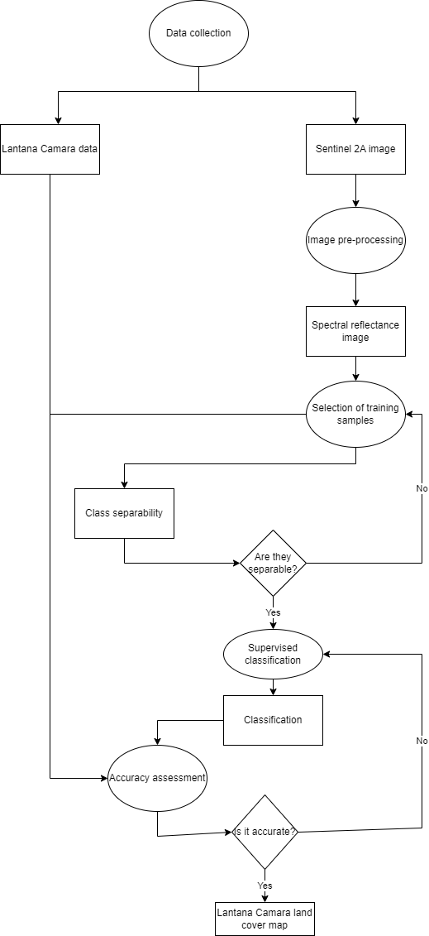

Figure 3. 1 Methodology work flow

## 3.2 Study Area

This study is based on Serengeti National Park which located in Mara and Simiyu regions. The Serengeti National Park is a large national park in Northern Tanzania that stretches over 14,763kilometer squares. The park located in eastern Mara region and northeastern Simiyu region with (597209, -224963), (669209, -224963), (597209, -425927) and (669209, -425927) coordinates and contains over 1,500,000 hectares (3,700,000 acres) of virgin savanna. Also, it is bordering Kenyan famous Masai Mara national Game Reserve and Ngorongoro Conservation Area in the South. Serengeti national park is the best wildlife game viewing destination not only in Africa but the whole world. Figure 3.2 shows the location of the chosen study area.

The park is divided in to three regions which are Serengeti plains, this is treeless grassland in the south that has kopjes, granite formations that serve as observation posts for predators. Western corridor this is the pair of rivers, Grumeti and Mbalageti which have big groups of river line forest and some small mountain ranges. Northern Serengeti, the land scape is dominated by open woodlands, pre dominantly Commiphora and hills, ranging from Seronera in the south of Mara River on the Kenyan border.

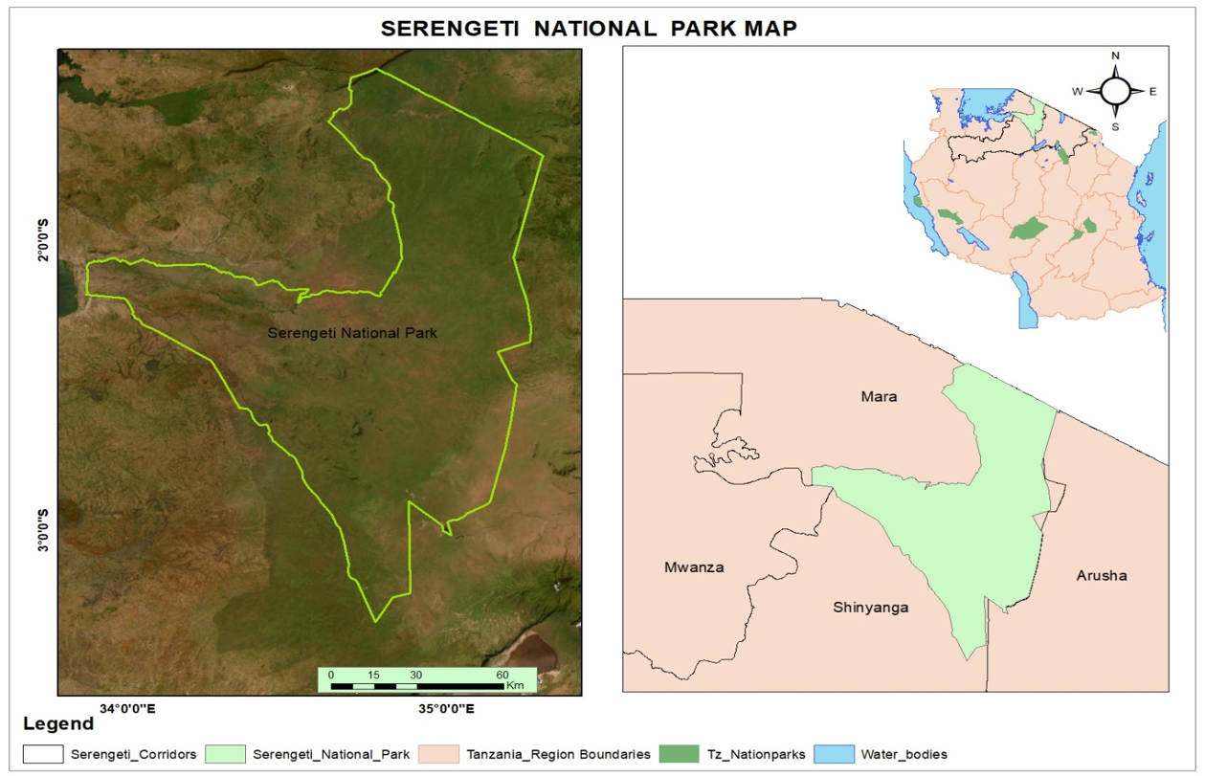

Figure 3. 2 Location of the study Area.

## 3.3 Data Acquisition

The data used in this study are Sentinel 2A data ground truthing data and administrative boundary data. Sentinel 2A data obtained from Copernicus Data hub (<https://scihub.copernicus.eu>) where these data used in image classification and analysis of Lantana Camara in Serengeti National Park.

### **3.3.1 Remote Sensing Data.**

This research used satellite imagery with 10m resolution acquired during the end of dry season for the year 2021 and 2022 (Table 3.1). The satellite imagery was the data that was classified to provide Lantana Camara cover maps of Serengeti National Park which were useful in assessing its invasion in the park.

Table 3. 1 Satellite data downloaded

|  |  |  |  |  |
| --- | --- | --- | --- | --- |
| S/No. | Satellite imagery | Spatial Resolution | Year of acquisition | Source |
| 4 | Sentinel2A | 10m | October, 2021 | https://scihub.copernicus.eu/ |
| 5 | Sentinel2A | 10m | October, 2022 | https://scihub.copernicus.eu/ |

### **3.3.2 Ground truthing data**

Ground truthing data were obtained from Google Earth Pro which provides high resolution of current and historical satellite images. These ground truthing data was used to collect training sample and validation process of the feature classes as existed on the ground.

### **3.3.3 Lantana Camara data**

These are data that obtained from Serengeti National Park via Tanzania National Park Headquarter, Arusha. Lantana Camara data of 2021 and 2022 was in form of points data that acquired by using GPS were by areas that covered by Lantana Camara species was generalized as one point. Through these data shape file layer of different years was created and used to validate classified images in order to show their distribution across Serengeti National Park.

## 3.4 Data pre-processing

This process involves the atmospheric correction of sentinel 2A images, it eliminates the influence of atmosphere on the measured signal. This involves changing of the digital number to surface reflectance so as to work with the characteristics of target rather than the function of radiometric resolution. This was done in Quantum GIS software using the Semi-Automatic Classification Plugin.

Area of interest was obtained through sub setting; it was done on the Sentinel 2A images to obtain the area of interest on the images by adding the shape file of Serengeti National Park. The extraction by mask tool was used to clip the area of interest from re-projected stacked images.

Also, another pre-processing process done was band stack in which four bands were used the blue band 2, green band 3, red band 4 and near infrared band 8 to create a multispectral image that was used throughout.

## 3.5 Image processing

This step involved all the basic processes needed to provide the outputs which are classified images for Lantana camara cover maps using field collected training points, the image was classified into five classes which are Lantana Camara, water, bare land, forest and grassland. Several machine learning classifiers have been used to classify remote sensed images; however, the Random Forest (RF) algorithm is one of the latest which has shown better accuracy results in classifying different land covers and plant species.

## 3.6 Image classification

In this step it involves assigning of land cover classes to pixels so as to get a classified image that shows the land cover basing on the four classes which are Lantana Camara class, water, bare land, forest and grassland classes. Several machine learning classifiers have been used to classify remote sensed images; however, the Random Forest (RF) algorithm is one of the latest which has shown better accuracy results in classifying different land covers and plant species (Berhane et al., 2018). Supervised classification method was used in which training samples were generated, and then separability analysis was performed followed by classification using the Random Forest machine algorithm and finally accuracy assessment.

## 3.7 Generating training samples

This procedure involved creation of training samples where at least 80 training samples for each class and 20 for classes that do not cover a large area, since it is suggested that you need at least *10**n* training sites per class where *n* is the number of features to be used in the analysis (Hassan-Esfahani et al., 2015). The training samples were collected basing on the knowledge of the area, google earth, the training samples based on homogeneity and variety of training sites so as to capture all the areas for a class. This was done in the ArcGIS software with the help of image classification extension to create the training samples.

## 3.8 Separability analysis

This analysis is done to the training samples so as to tell the expected errors that can happen in classification for those classes that overlap. It can be performed on the training data to estimate the expected error in the classification for various feature combination (Swain and Davis, 1978; Landgrebe, 2003). The method that was used was parametric transformed divergence separability measure were the statistics of the training samples used to plot bands against surface reflectance to show mean and standard deviation scatter plots that helped to determine the overlapping classes and in which band the classes were less overlapping.

## 3.9 Accuracy assessment

After performing classification validation should be done to check if the classification is accurate. Using error matrix that was generated in ArcGIS by using the ground truth data extracting values from the classified image to its shape file computing frequency and then creating the error matrix using pivot table. The table was exported to excel to calculate overall accuracy Equation (3.1), Error of omission, Equation (3.2), error of commission Equation (3.3), producer accuracy Equation (3.4) and consumer accuracy Equation (3.5) were computed (Duggin and Gentle, 1998). The following mathematical computation methods were used.

……………………………… (3.1)

……………… (3.2)

…………… (3.3)

……………………. (3.4)

……………………………………... (3.5)

# CHAPTER FOUR

# RESULTS, ANALYSIS AND DISCUSSION

# 4.0 Overview

This chapter presents all outputs that obtained in this research as the result of conducting the methodological frame work from Figure: 3.2 it shows Lantana Camara cover maps that obtained from classifying a combination of sentinel 2A bands, also it shows the distribution pattern of Lantana Camara in Serengeti National Park.

This part includes Lantana Camara cover maps of Serengeti National Park as shown on the Figure 4.1 for year 2021 and Figure 4.2 for year 2022. Lantana Camara cover map they also show the nature of the land and what cover the area in term of area coverage.

## 4.1 Mapping of Lantana Camara

In the process of classification of the images five classes were detected which are Lantana Camara, water, bare land, forest and grassland. The Lantana Camara cover map that is the output after image classification and accuracy assessment is done for the year 2021 and 2022. The maps are showing the land cover of Serengeti National Park in each year and how Lantana Camara it was distributed in the area. It is seen that Lantana Camara is much in the year 2022 as its invasion tend to increase as the time increase since Lantana camara has the ability to invade and penetrate in other vegetation. In the year 2022 Lantana Camara is very distributed in the area. Figure 4.1 and Figure 4.2 respectively show the distribution of Lantana Camara cover in Serengeti National Park.

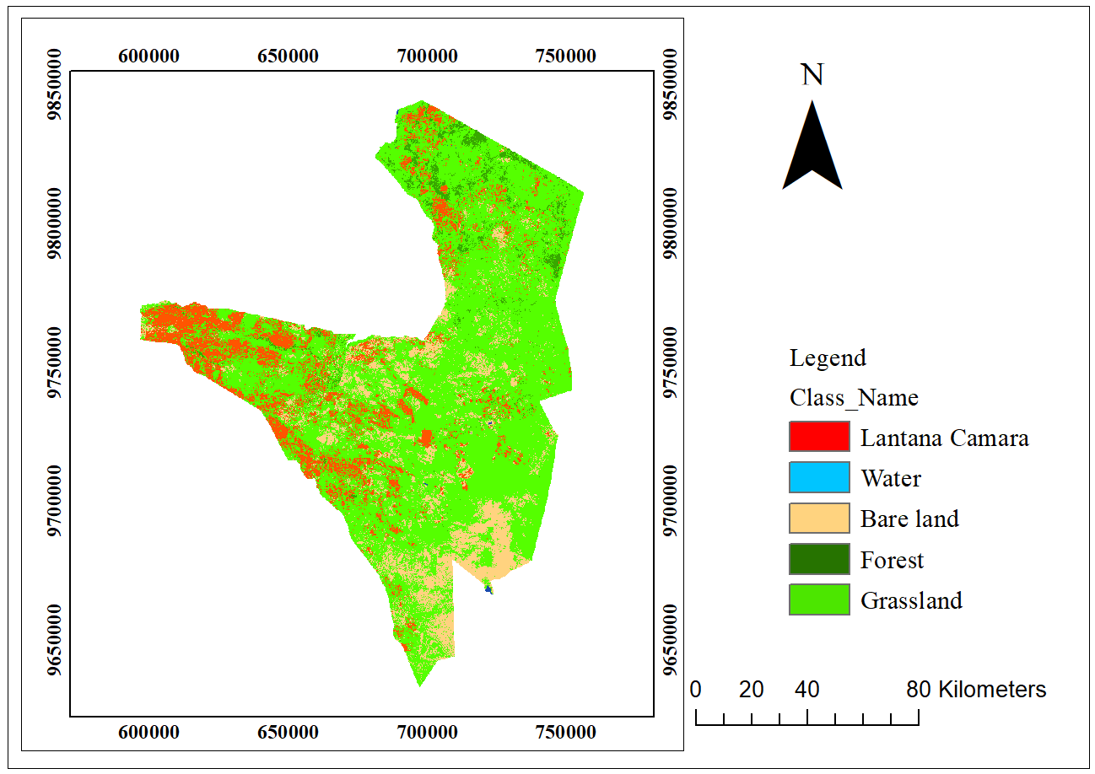

Figure 4. 3 Distribution map of Lantana Camara in Serengeti National Park year 2021

The invasion's ecological impact is a matter of concern. The invasive species has demonstrated a tendency to outcompete native vegetation, leading to potential biodiversity loss and alterations in ecosystem functioning. The spatial analysis highlighted concentrated infestations in Serengeti National Park where the invasion could disrupt native species interactions and possibly hinder wildlife movement.

The extent of habitat fragmentation due to Lantana camara invasion also emerged as a key issue. The invasion has led to fragmented habitats, potentially affecting species migration, genetic diversity, and ecosystem resilience. This fragmentation, along with the altered vegetation structure, may have implications for fire regimes and water availability.

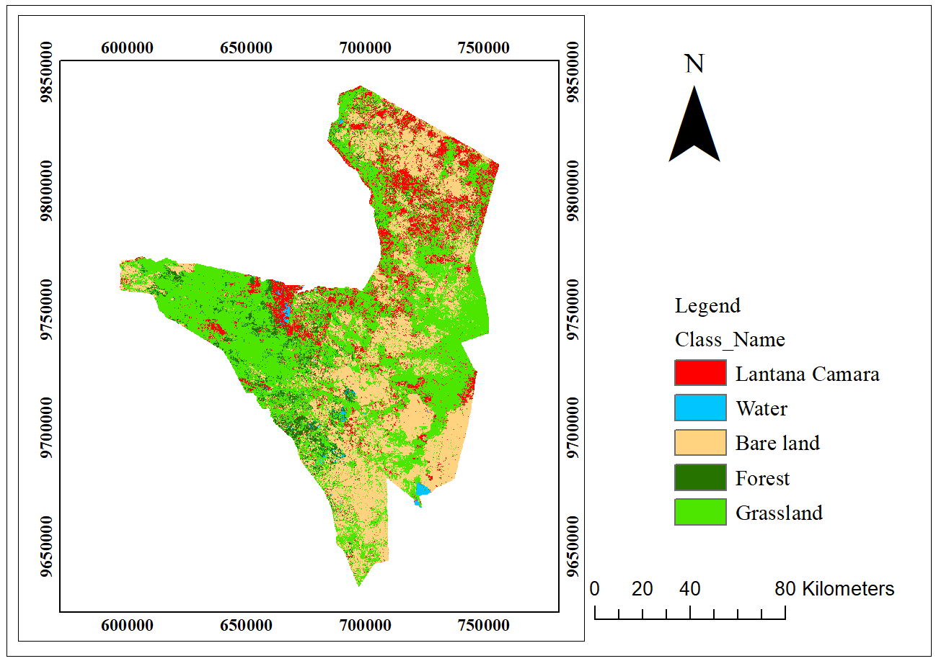

Figure 4. 4 Distribution map of Lantana Camara in Serengeti National Park year 2022

## 4.2 Distribution of Lantana Camara specie in Serengeti National Park

Figure 4.10 shows the distribution of Lantana Camara on land cover of Serengeti National Park, also it displays point data which indicates the actual location of Lantana Camara Species found during field survey. Distribution of Lantana Camara in 2021 is widely spread near roads, rough roads and in areas that are more interacted by human since the park involve tourism activities. As time increase it shows that the spread of these species widely in different areas from the center of the park to the north east of the park as shown in the year 2022.

The invasion of Lantana Camara in Serengeti National Park in some seasons favor the spread and reproduction since the area have no dense canopy and it dominated by grassland in season and small trees.

Since this study showed that Lantana Camara is widely distributed, therefore management strategies for Lantana Camara in Serengeti National Park should primarily focus on reducing the weed in invaded areas as well as prevention and Early Detection and Rapid Response for the non-invaded areas. Moreover, regional or national spatially explicit management strategy for this species should emphasize prevention alongside Early Detection and Rapid Response and control. Also, awareness of the negative impacts of woody IAPS should be raised among the general public and other stakeholders in regions that are still un invaded to avoid further invasions.

## 4.3 Accuracy Assessment.

These target accuracies often tend to be based upon the influential work of Anderson. Typically, the specified requirements take the form of a minimum level of overall accuracy, expressed numerically by some index such as the percentage of cases correctly allocated, and a desire for each class to be classified to comparable accuracy. For an overall accuracy should be greater than 70% to classification to be accurate. Additional features typically called for are the provision of more than one measure of classification accuracy (Odindi et al., 2014).

The accuracy assessment was performed by computations of confusion matrices. The accuracy assessment of Sentinel 2A of 2021 was 76% which is acceptable as it exceeds the minimum percentage (70%) of an overall accuracy of classified image. The Table 4.1 below represents confusion matrices for classified image and Overall accuracy for Sentinel 2A of 2021.

Table 4. 1 Confusion Matrix for classified image of 2021

|  |  |  |  |  |  |  |  |
| --- | --- | --- | --- | --- | --- | --- | --- |
|  | Class Value | Lantana Camara | Water | Bare land | Forest | Grassland | Total |
| 1 | Lantana Camara | 29 | 0 | 3 | 3 | 5 | 40 |
| 2 | Water | 0 | 19 | 0 | 1 | 1 | 21 |
| 3 | Bare land | 5 | 0 | 55 | 2 | 8 | 70 |
| 4 | Forest | 2 | 1 | 8 | 25 | 8 | 44 |
| 5 | Grassland | 5 | 1 | 8 | 2 | 69 | 85 |
|  | Total | 41 | 21 | 70 | 30 | 89 | 260 |

Overall Accuracy =76%.

The accuracy assessment of Sentinel 2A of 2022 was 83% which is acceptable as it exceeds the minimum percentage (70%) of an overall accuracy of classified image to be used and termed as good classified image. The Table 4.2 below represents confusion matrices for classified image and Overall accuracy for Sentinel 2A of 2022.

Table 4. 2 Confusion Matrix for classified image of 2022

|  |  |  |  |  |  |  |  |
| --- | --- | --- | --- | --- | --- | --- | --- |
|  | Class Value | Lantana Camara | Water | Bare land | Forest | Grassland | Total |
| 1 | Lantana Camara | 32 | 0 | 3 | 0 | 5 | 40 |
| 2 | Water | 0 | 20 | 0 | 1 | 0 | 21 |
| 3 | Bare land | 2 | 0 | 59 | 2 | 7 | 70 |
| 4 | Forest | 0 | 0 | 1 | 35 | 8 | 44 |
| 5 | Grassland | 8 | 0 | 2 | 5 | 70 | 85 |
|  | Total | 42 | 20 | 64 | 43 | 90 | 260 |

Overall Accuracy =83%.

# CHAPTER FIVE

# CONCLUSION AND RECOMMENDATION

## 5.0 Overview

This chapter is based on the finding from the results and discussion chapter, showing how the results answers the research objectives and questions where the explanation is summarized in the conclusion.

## 5.1 Conclusion

Lantana camara has been identified as one of the invasive species that spread Africa in different areas such as parks, game reserves, in settlement areas and in cultivation areas. This study managed to assess the invasion of Lantana camara in Serengeti National Park using remote sensing techniques through producing maps that shows distribution of Lantana camara in Serengeti National Park. Another objective was to assess changes of Lantana camara cover over a period of time using remote sensing imagery where by Sentinel 2A images of year 2021 and 2022 was used in accomplishment of the study.

The presence of Lantana Camara in any area has both positive and negative effects. One among the positive effects that seen in presence of Lantana Camara is edible fruits for human and birds, source of fuel wood, used as medicine, kill germs and insects, flowers attract pollinators and food for butterfly breeding. Also, Lantana Camara presence have the following negative effects it spread fast, widely and strenuous, difficult to remove, other plants cannot grow, hinder light, roots hardened the soil, hinder growth of crops, weaken other species, increase crop production cost, reduce productivity of cinnamon and that it is a killer of plants.

## 5.2 Recommendation

Lantana camara was found to have direct impact when growing with other vegetation hence it seems to have legacy effects. Therefore, removal of Lantana camara is sufficient to remediate its negative effects on ecosystem services and livelihood.

# REFERENCES

Beaulieu, D. (2023). How to Grow and Care for Lantana.

Berhane, T. M., Lane, C. R., Wu, Q., Autrey, B. C., Anenkhonov, O. A., Chepinoga, V. V., & Liu, H. (2018). Decision-tree, rule-based, and random forest classification of high-resolution multispectral imagery for wetland mapping and inventory. Remote sensing, 10(4), 580.

Cho-ying Huang, G. P. (2009). Applications of remote sensing to alien invasive plant.

Duggin, J. A., & Gentle, C. B. (1998). Experimental evidence on the importance of disturbance intensity for invasion of Lantana camara L. in dry rainforest–open forest ecotones in north-eastern NSW. Australia. Forest Ecology and Management, 109 279-292.

Goyal, N., & Sharma, G. P. (2015). Lantana camara L. (sensu lato): an enigmatic complex. NeoBiota, 25, 15-26.

Guo, B., Wang, Z., & Chen, Y. (2009). Applications of remote sensing to alien invasive plant studies. Sensors 9, 4869 4889.

Hassan-Esfahani, L., Torres-Rua, A., & Jensen, A. (2015). Assessment of surface soil moisture using high-resolution multi-spectral imagery and artificial neural networks. Remote Sensing.

Lillisand, T. M., & Kiefer, R. W. (2000). Remote Sensing and Image Interpretation. New York: John Wiley.

Lowe, S., Browne, M., Boudjelas, S., & de Poorter, M. (2000). 100 of the World’s Worst Invasive Alien Species: A Selection from the Global Invasive Species Database. Invasive Species Specialist Group, a Specialist Group of the Species Survival Commission of the World Conservation Union. Auckland, New Zealand, 12pp.

Mather, P., & Koch, M. (2011). Computer Processing of Remotely-Sensed Images. WileyBlackwell.

Odindi, J., Mutanga, O., & Adam, E. (2014). Land-use/cover classification in a heterogeneous coastal landscape using RapidEye imagery: evaluating the performance of random forest and support vector machines classifiers. Internartional Journal of Remote Sensing, 35(10).

Petit, s., Boursault, A., Le Guilloux, M., Munier-Jolain, N., & Reboud, X. (2011). Weeds in agricultural landscapes. A review Agronomy for Sustainable Development, 31 309-317.

Rehna , v., & Natya, J. (2016). Land cover classification schemes using Remote sensing images. .

Sharma, G. P., Raghubanshi, A. S., & Singh, J. S. (2005). Lantana invasion An Overview. Weed Biology and Management , 5 157 165.

Taylor, S., Kumar, L., & Reid, N. (2011). Comparison of broadband and hyperspectral sensors for lantana mapping in Proceeding 34th International Symposium on Remote Sensing of Environment. Sydney, Australia. International Society for Photogrammetry and Remote Sensing, 4pp.

Tso, B., & Mather, P. M. (2001). Classification Methods for Remotely Sensed Data.

Van Wilgen, B. W., Rayers, B., Le Maitre, D. C., Richardson, D. M., & Schonegevel, L. L. (2008). A biome-scale assessment of the impact of invasive alien plants on ecosystem services in South Africa. Journal of Environmental Management, 89 336-349.