DEFORMATION MONITORING OF THE SELANDER BRIDGE

JUMA JUMA. H

A Dissertation submitted to the Department of Geospatial Sciences and Technology in Partially Fulfillment of the Requirements for the Award of Science in Geometrics (BSc. GM) of Ardhi University.

**CERTIFICATION**

The undersigned certify that they have read and hereby recommend for acceptance by the Ardhi University dissertation titled, **“Deformation monitoring of the selander bridge”** in partial fulfillment of the requirements for the award of degree of Bachelor of Science in Geomatics at Ardhi University.

**….………....................................**

**Dr. Elifuraha Saria**

(Main Supervisor) Date…………………….

**DECLARATION AND COPYRIGHT**

I, JUMA JUMA H hereby declare that, the contents of this dissertation are the results of my own findings through my study and investigation, and to the best of my knowledge they have not been presented anywhere else as a dissertation for diploma, degree or any similar academic award in any institution of higher learning.

………………………………..

JUMA JUMA H

22795/T.2019

Copyright ©1999 This dissertation is copyright material protected under the Berne convention, the copyright act of 1999 and other international and national enactments, in that belief, on intellectual property. It may not be reproduced by any means, in full or in part, except for short extracts in fair dealing; for research or private study, critical scholarly review or discourse with an acknowledgement, without the written permission of the directorate of undergraduate Studies, on behalf of both the author and Ardhi University.

**ACKNOWLEDGEMENT**

This research would have not been possible without the assistance of many individuals who provided support in many ways. This summary will fall short of appreciating all of those who contributed information, time, advice, material and moral supports.

First and foremost, I would like to extend my heartfelt appreciation to my supervisor, Dr Elifuraha Saria for his unwavering support and guidance throughout the project. His expertise, insightful feedback, professional discussion and advice, patience, flexibility and availability have been very inspirational and instrumental in shaping the direction of my project. I feel privileged to have him as my supervisor

I am grateful to the ARDHI UNIVERSITY for providing the necessary resources, facilities, and access to relevant materials. Their support has been crucial in carrying out the research and analysis required for this project.

I would also like to acknowledge the assistance and cooperation of my colleagues and classmates, Peter Bugota, Jackson F, Songaraeli, Andrew W, Mafumbi and Beltillah B, Fuime who willingly shared their expertise, ideas, and perspectives. Their input and discussions have enriched my understanding and improved the overall quality of the project.

Lastly, I want to express my deepest appreciation to my family and friends for their unwavering support and understanding throughout this journey. Their love, encouragement, and belief in my abilities have been a constant source of motivation.

**DEDICATION**

I would like to express my deepest gratitude and thanks to Allah, the Most Merciful and the Most Gracious, for guiding me throughout this project. Your divine wisdom and blessings have been my source of strength and inspiration. I am humbled and honored to have been granted the opportunity to embark on this endeavor, and I acknowledge that without Your guidance, it would not have been possible. Your infinite knowledge has illuminated my path, and your unwavering support has fueled my determination.

I dedicate this work to my beloved parents Hamadi J, Shukia and Maimuna A, Mbatia, my lovely brother Ally H, Juma and my lovely sister Haitham H, Juma for their effort and support up to accomplishment

ABSTRACT

Deformation refers to the changes a body (natural or artificial objects) undergoes in its shape, dimension and position which may be caused by a variety of factors including changes in temperature, loading and natural disasters such as earthquakes, hurricanes or flood. In addition, human activities example mining and engineering activities may cause deformation to occur. This study concerned about deformation monitoring of Selander Bridge found at Oster Bay neighborhood in Dar es salaam city. Since its construction in 1929 only one epoch has been observed in 2020 which involved establishment of the monitoring network consisting of six object points, BR01, BR02, BR03, BR04, BR05 and BR06 and four reference points SLB01, SLB02, SLB03 and SLB04. Unfortunately one of the reference points SLB01 was not intervisible anymore with other network points due to construction activities continue around Selander Bridge. This study conduct vertical and horizontal observation of the object points by using precise leveling and tacheometry method based on the existing monitoring network. A leveling loop of the total length of 772m was conducted at SLB04 passing through the object points, SLB02, SLB3 and closing at SLB04 with misclosure of 0.9mm which was allowable. Tacheometry was based on SLB03 oriented to SLB04 and SLB02 oriented to SLB03 and the averages were calculated to determine the horizontal coordinate of the object points. The analysis was conducted by computing displacement between the two epoch and compared the displacement with the theoretical statistical values using hypothesis testing at 95 percent confidence interval. The result showed that four out of six of the object points installed on the bridge are stable horizontally while only one point is vertically stable. The maximum value of deformation in this period was 5.576mm in horizontal and 7.3mm in vertical direction

This study also involved establishment of one new reference point by using traverse method and precise leveling based on the three remained reference points. The new reference point was established in a safe place with less human and vehicular interference to ensure its long stability while considering its visibility to all other network points. The traverse was closed loop traverse consist of five stations including two new points TP and SLB05 and three control points, SLB02, SLB03 and SLB04, opening and closing at SLB03 and SLB04 with linear misclosure of 1:16091 and angular misclosure of one second. The elevation of the new point SLB05 from precise levelling was 4.3584m

**TABLE OF CONTENTS**

CHAPTER ONE 1

1.0 INTRODUCTION 1

1.1 Background of the study 1

1.2 Bridge failure around the world 2

1.3 Problem Statement 4

1.4 Research Objectives 4

1.4.1 Main Objective 4

1.4.2 Specific Objective 4

1.5 Significance of the Research 4

1.6 Beneficiaries 4

1.6 Location of the study area 5

1.7 Scope of the study 5

CHAPTER TWO 6

2.0 LITERATURE REVIEW 6

2.1 Selander Bridge 6

2.4 Deformation monitoring of the bridge 8

2.5 Type of deformation monitoring network 8

2.5.1 Absolute Network 8

2.5.2 Relative monitoring network 9

2.6 Deformation measurement technology 10

2.6.1 Geodetic technologies 10

2.6.5 Laser scanner 12

2.7 Previous deformation monitoring study 12

2.7.1 Deformation monitoring of highway bridge in Nigeria, 2015 12

2.7.2 Monitoring Bridge Deformation Using Auto-Correlation Adjustment Technique for Total Station Observations 13

2.7.3 Current research 15

CHAPTER THREE 16

3.0 METHODOLOGY 16

3.1 Reconnaissance 16

3.1.1 Office reconnaissance 16

3.1.2 Site visitation 16

3.2.1 The digital level 19

3.2.2 Total station 19

3.4 Pre analysis 20

3.4.1 Expected standard deviation in determining difference in elevation of leveling line 21

3.4.2 Expected standard deviation using Leica total station TS0 22

3.5 Traverse 23

3.5.1 Network design 23

3.5.2 Monumentation 23

3.6 Horizontal measurement 24

3.6.1 Data observation procedure 25

3.7 Vertical coordinate observation 25

3.7.1 Two Peg Test 26

3.7.2 Leveling procedure 27

4.0 RESULT, ANALYSIS AND DISCUSSION 30

4.1 Traverse result 30

4.2 Result of tachometry observation 31

4.3 Result from precise leveling observation 32

The leveling data were properly booked as shown in table 4.5 below 32

4.3.1 Closure tolerance check 33

4.3.2 Leveling adjustment 33

4.4 Comparison of result 36

4.5 Analysis of horizontal deformation 37

4.6 Analysis of vertical deformation 41

4.7 Visualization of displacement 45

4.8 Discussion of the result 45

CHAPTER FIVE 47

5.0 CONCLUSION AND RECOMMENDATION 47

5.1 Conclusion 47

5.2 Recommendations 47

REFERENCE 48

**LIST OF FIGURES**

Figure 1. 1: Seongsu Bridge, South Korea collapsed due to improper welding of the steel trusses . 2

Figure 1. 2: The locality sketch of the Area of interest 4

Figure 2. 3: Absolute and relative deformation monitoring network 8

Figure 2. 4: A deformation monitoring network of highway bridge in Nigeria 13

Figure 3. 2: Digital level 19

Figure 3. 3: Total station 20

Figure 3. 4: Traverse network design 23

Figure 3. 5: Monument 24

Figure 3. 6: Setup for levelling observation when the level is at the center 26

Figure 3. 7: Setup for levelling observation when the level shifted near point A 26

Figure 3. 8: A surveyor observing precise leveling……………………………………………28

Figure 4. 1: A graph showing horizontal displacement of each opoints 45

Figure 4. 2: A graph showing vertical displacement of each object points 45

**LIST OF TABLES**

Table 1. 1: A summary of few bridges’ failure occurred over past years and their causes and impacts (Wesley, 2020) 2

Table 3. 1: Control points near the site area obtained 16

Table 3. 2: List of network points staked during site reconnaissance 17

Table 3. 3: A list of instruments used during observation and their corresponding specification 18

Table 3. 4: Datum check between SLB2 and SLB3 25

Table 3. 5: Datum check between SLB3 and SLB4 25

Table 3. 6: Datum check between SLB 2 and SLB 4 25

Table 3. 7: Datum check for vertical coordinates 28

Table 4. 1: Traverse computations 30

Table 4. 2: Object points coordinated from SLB02 oriented to SLB0 3 31

Table 4. 3: Object points coordinated from SLB03 oriented to SLB04 31

Table 4. 4: Object points coordinated from SLB05 oriented to SLB03 31

Table 4. 5: Result from leveling observation 32

Table 4. 6: distance between points in the leveling lines 33

Table 4. 7: Adjusted height of the object points 35

Table 4. 8: Data from first epoch 2020 36

Table 4. 9 : Data from Second epoch 2023 37

Table 4. 10: comparison of data from the first epoch and the second epoch 37

Table 4. 11: Analysis of the object points horizontally and their corresponding velocity per year 41

Table 4. 12: analysis of object points vertical and their corresponding velocity per year 44

# CHAPTER ONE

# 1.0 INTRODUCTION

## Background of the study

Deformation refers to the changes of the geometrical shape, size and position of the structure over time which may be caused by natural phenomenon such as crustal loading, ground water level changes, tectonic plate, swelling and shrinkage of clay soils, landslides and tidal phenomena and artificial factors such as mining, quarrying’ engineering and excavation (Issaka et al., 2010)

Deformation monitoring involves the measurement and analysis of changes in a structure's shape, size, and position over time. It involves measuring the spatial displacement of the selected point both horizontal and vertically over a specified period of time. It is a hour to hour, day to day , month to month, year to year examining the change of the structure mainly to check whether the behavior of the monitoring object and the environment follows the predicted pattern so that any unpredicted deformation could be detected at an early stage and in the case of any abnormal behavior, to give an account of the actual deformation status which could be used for the determination of the causative factors which trigger the deformation (Anonym, 2002).

Deformation monitoring of the engineering structure has made progress in recent years. New development is driven to keep engineering structure in service beyond their expected lifetime, new advanced measurement techniques and technologies have been developed for deformation monitoring including the use of sensors, data acquisition systems, and remote sensing technologies that provide continuous, real-time monitoring of deformations (Hankungwe, 2010) . By monitoring these deformations, engineers and structure authorities can detect any deviations from the original design and assess the structural health of the structure. Early identification of deformations allows for prompt maintenance and repair interventions, preventing potential structural failures, improving public safety, and extending the service life of the structure (Ayan & Erol, 2003). The Selander Bridge is, a crucial transportation link, which serves as a vital artery for the movement of people and goods from North west side of Dar es salaam center to the South East of Oster Bay neighborhood. It was constructed in 1929 and named after John Einer Selander, Tanganyika first director of public work. As with any bridge structure, the Selander Bridge is subjected to various external forces and environmental conditions, which can cause deformations over time. Factors such as vehicular traffic, wind forces, temperature variations, and long-term wear and tear can contribute to structural changes and potential risks to the bridge's integrity. Therefore, continuous and accurate monitoring of the bridge's deformation is essential to ensure its safety, structural stability, and efficient functionality. This study involves revisiting the bridge and collecting up-to-date deformation data to assess its current condition and identify any emerging deformations or risks. This research aims to provide accurate, timely, and comprehensive data on its deformation patterns. The analysis of this data will enable engineers and bridge authorities to identify potential

## Bridge failure around the world

One example of a bridge collapse due to deformation that resulted in loss of life is the collapse of the I-35W Mississippi River Bridge in Minneapolis, Minnesota in 2007. The bridge carried more than 140,000 vehicles daily, the cause of the collapse was found to be a design flaw in the gusset plates, which were responsible for connecting the steel beams of the bridge. Overtime, the gusset plates had become fatigued due to the heavy load and traffic on the bridge, leading to their eventually failure. The failure of the gusset plates caused a critical section of the bridge to collapse, leading to the death of 13 people and injuring 145 others. Another example of bridge collapse due to deformation is the collapse of a bridge in Morogoro Tanzania in 2020 caused by heavy rainfall and flooding which caused the death of several and injured many others (Ballarini., Roberto. &Taichiro, O., 2009). The table 1.1 show the summary of other bridge failures over past years,

## Table 1. : A summary of few bridges’ failure occurred over past years and their causes and impacts (Wesley, 2020)

|  |  |  |  |
| --- | --- | --- | --- |
| Country | Date | Reason | Causalities |
| France | 18 Nov 2019 | Overweight | 2 dead, 5 injured |
| India | 31 March 2016 | Bolt failure | 27 killed,80 injured |
| Indonesia | 26 Nov 2011 | Human error | 20 killed, 40 injured and 33 missing |
| Nepal | 25 Dec 2007 | Overcrowded suspension bridge | 19 killed, 15 missing |
| China | 13 august 2007 | Local construction | 34 killed 22 injured |
| USA | 26 May 2002 | Barge struck one pier of the bridge | 14 killed |
| Portugal | 4 March 2001 | Overloaded | 59 killed |

These tragedies highlighted the importance of the regular inspection of the bridge to ensure their stability and safety. The Figure 1.1 show the Seongsu Bridge collapsed in 1984

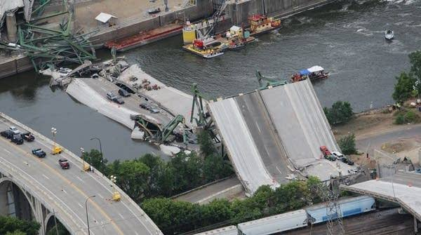

## Figure 1. : Seongsu Bridge, South Korea collapsed due to improper welding of the steel trusses (Wibeseoul, 1999).

## Problem Statement

Selander Bridge is an important transportation link in Dar es Salaam city that connect the North west side of Dar es Salaam city center to the South East of Oster Bay. It is a critical component of transportation infrastructure which undergone significant changes since its initial construction in 1929. Over time, external forces, environmental factors, and structural degradation can result in deformations and potential risks to the bridge's integrity. However, the existing deformation monitoring data for the Selander Bridge collected in 2020 is outdated and lacks information about its current condition. Therefore, there is a pressing need to conduct a second epoch deformation monitoring study to assess the bridge's current state and identify any emerging deformations or risks. This research aims to address this problem by implementing conventional measurement techniques to collect real-time and accurate data on the deformation patterns of the Selander Bridge in its current state. By conducting a comprehensive analysis of the second epoch deformation monitoring data, this research will contribute to the identification of potential structural vulnerabilities, facilitating timely maintenance and repair interventions to ensure the long-term safety and performance of the Selander Bridge.

## Research Objectives

### 1.4.1 Main Objective

The main objective of this research is to monitor deformation of Selander Bridge

### Specific Objective

1. To assess horizontal deformation of the bridge by observing 2D coordinate of the object point using tachometry method
2. To assess vertical deformation by observing 1D coordinate of the object point using precise leveling

## Significance of the Research

The outcome of this research is useful in ensuring structural safety and develops maintenance plans and schedules. The data collected can be used by engineers and decision makers to identify potential safety hazards and take corrective action before they become critical

## 1.6 Beneficiaries

The user of the bridge including all citizen that use that road for transportation activities,

Tanzania National Road Agency (TANROAD) and ARDHI UNIVERSITY students who will base on this research for monitoring other epochs.

## Location of the study area

The area of study of this research will be Selander Bridge located at Oyster Bay across msimbazi crack in Dar es Salaam city. The Figure 1.2 shows the locality sketch of Selander bridge

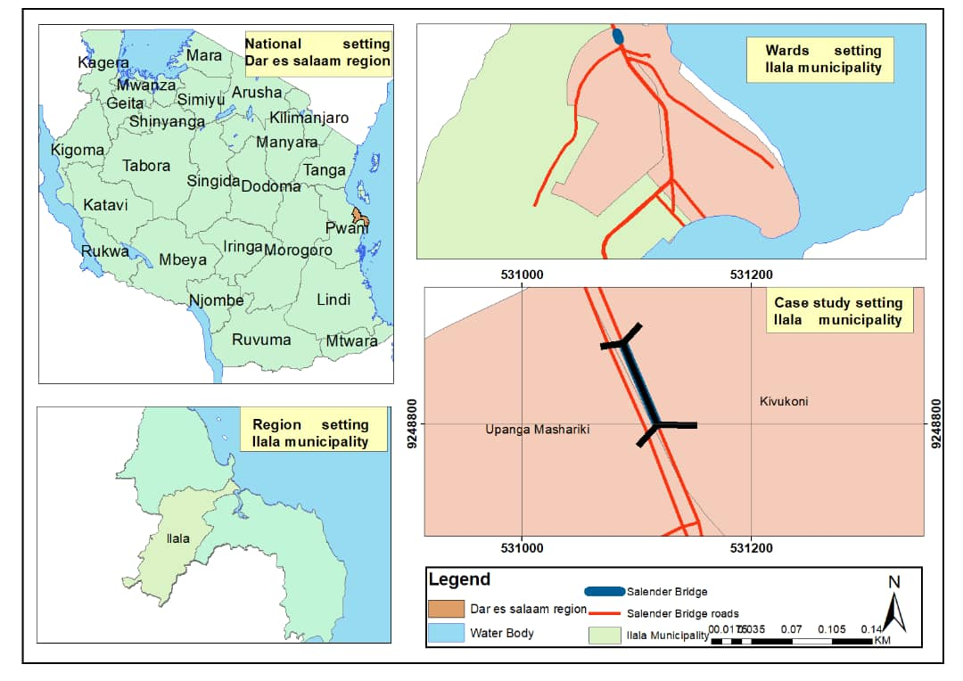

## Figure 1. : The locality sketch of the Area of interest

## Scope of the study

The study mainly concentrated on determination of the 3D coordinates for the object points selected on the selander bridge, comparison of data obtained with the data from the first epoch and statistical testing to determine if the displacement obtained have significant effects on the bridge or not.

# CHAPTER TWO

# 2.0 LITERATURE REVIEW

This chapter describes briefly a summary of deformation measurement and different published work about related studies

## 2.1 Selander Bridge

Selander bridge is one of bridge in Dar es Salaam city that link the North west side of Dar es salaam center to the South East of Oster Bay neighborhood, having total length of 85m and 4 lanes as dual carriageway. It was constructed 1n 1929 as two lane and later reconstructed in 1980s to four lanes due to increase traffic along Ali Hassan Mwinyi Road (Zacharia, 3D Geodetic Network Design For Monitoring Structural Deformation of Selander Bridge, 2020). The Figure 2.1 shows the top view of the Selander bridge

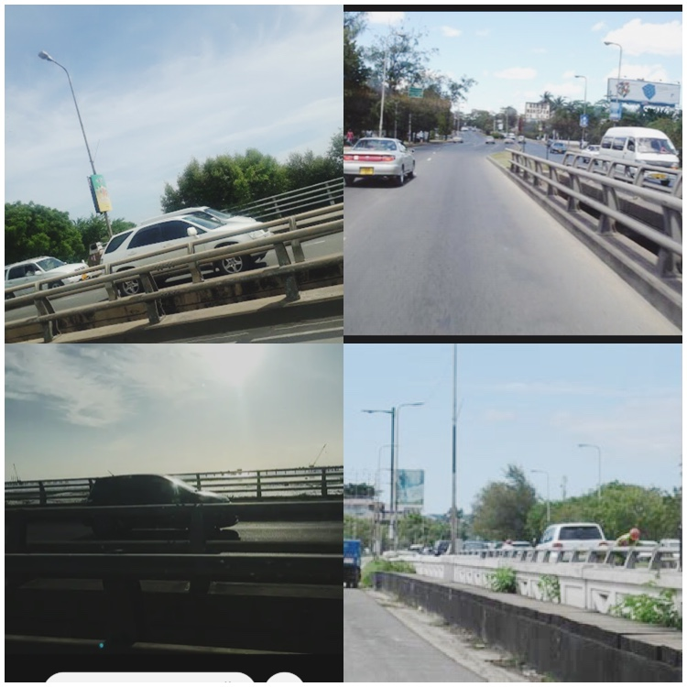

## Figure 2. : Top view of the Selander bridge

**2.2 Deformation analysis**

The deformation of the large structure is simply the variation of its position, size and shape with respect to its original state or its designed shape. Measuring the deformation is not only just the calculation of the exact position of the observed object but the variation of those positions with time (Wieser & Capra, 2017).

The general need for monitoring deformation of the large structure is to inspect whether or not movement in structure is taking place and also if the structure is stable and safe so as to ensure the structural and functional security of the structure (Sagamilwa, 2020).

Deformation analysis involve detection, localization and modeling of points movements in multiply measured networks; hence analysis provides valuable information about the deformation of physical and manufactured objects on the earth surface. In deformation studies geodetic observation are repeated at different epochs of time. The observation of each epoch is adjusted independently, then from the difference of coordinate from each epochs the parameter of the deformation is estimated and conclusions on the object deformations are drawn. Any object, natural or manufactured undergoes changes in space and time and since deformation surveys are directly relevant to the safety of human life and engineering surveying, recently deformation become more important (Kaplan, 2004).

During deformation studies, the used measurement and systems, which could be geodetic or non-geodetic, are determined considering the type of the structure of which deformations will be monitored, its environmental condition and expected accuracy from the measurements. Also, according to professions who use the deformation monitoring techniques, these techniques and instrumentation have traditionally been categorized into two groups; Geodetic surveys, which include conventional (terrestrial such as precise levelling measurements, angle and distance measurement etc.), photogrammetric (terrestrial, aerial and digital photogrammetry), satellite (such as GPS, INSAR), and some special techniques; geotechnical/structural measurement, using lasers, tilt meters, strain meters, joint-meters, plumb lines, micrometers (Ayan & Erol, 2003)2.3 2.3 Deformation monitoring schemes

Monitoring scheme, refer to the total plan of action, including choice of types and location of the observables, timing of measurement campaign, ensuring stability of the reference points, selecting monitoring techniques and suitable instrumentation, selecting type of monumentation and targeting and determining actual deformation. Designing of monitoring scheme depend on accuracy and reliability, temporal and spatial continuity dictating frequency of monitoring and adequacy of distribution of reference and object points, stability of refence points and monitoring technology (Ogundare, 2009)

The design should be based on a good understanding of the physical process which leads to deformation. The investigated deformable object should be treated as a mechanical system, which undergoes deformation according to the laws of continuum mechanics (Massiera et al, 2005). This requires the causative factors (loads) of the process and the characteristics of the object under investigation to be included in the analysis leading to the design. This is achieved by using deterministic modeling of the load-deformation relationship. Thus, the design process requires an interdisciplinary cooperation between specialists in various fields of geoscience and engineering, including structural, rock mechanics, and geodetic engineering, depending on the type of the investigated object (Adam, 2007).

## **2.4 Deformation monitoring of the bridge**

Deformation monitoring is an important aspect of bridge engineering that involve the continuous measurement and analysis of the deformation of the bridge’s components over time. Deformation of the bridge may occur as the result of seismic activity, traffic load and environmental elements such as temperature or wind (Yan, 2019). Inspection during the service life of the bridge include an initial inventory inspection after construction is complete, periodic routine inspection, special inspection to evaluate damage or deterioration and other special inspection (Kapovic, 2005) .

## 2.5 Type of deformation monitoring network

### 2.5.1 Absolute Network

This network consists of object points established in deformable body and reference points established in a stable part outside the deformable body. This mainly used on small scale deformation monitoring, for example for the small structure like dams, bridges and buildings. The most disadvantage of this type of network is that the movement of reference point will directly affect the deformable points on the structure to be monitored and its difficulty to confirm the stability of those reference points (Githumbi, 2008)

### 2.5.2 Relative monitoring network

In this network all points are considered moving or deforming, both reference and object points are located in a deformable body. This is best network as there is no need to check against stability and there is no need to worry about any movement of individual point and mostly used in a large-scale deformation monitoring example in tectonic movement (Bugalika, 2020). The Figure 2.2 show Absolute and relative monitoring network. The red points are reference points installed outside the deforming structure while the black points are the reference points located in a deformable body

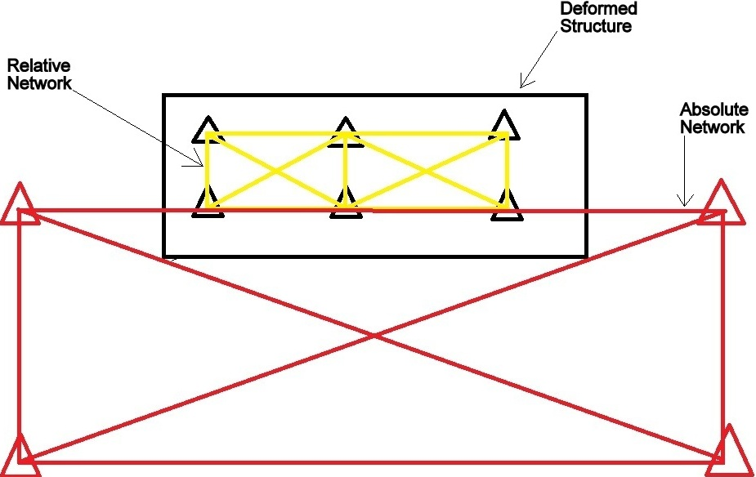

## Figure 2. : Absolute and relative deformation monitoring network

## 2.6 Deformation measurement technology

This include measurement technologies which can be applied in monitoring deformation of the structure considering the economy and budget available, required accuracy, amount of movement and inter visibility between points (Erol et al., 2008). The sensors used in monitoring measurements are generally grouped into two categories, geodetic techniques and non-geodetic techniques

### 2.6.1 Geodetic technologies

This method includes terrestrial geodetic methods, photogrammetric methods and space techniques. Geodetic methods supply information on the absolute and relative displacements (changes in coordinates) from which displacement and strain fields for the monitored object may be derived. Thus, geodetic surveys supply global information on the behavior of the investigated object (Massiera et al, 2005). The followings are the different geodetic techniques that used in deformation monitoring

#### 2.6.2 Conventional method

This employs tradition method of surveying techniques and equipment to measure changes in position and elevation of specific points on a structure or land. It involves measurement of distance, angle and difference in elevation to determine coordinate or difference in elevation. This method has been used for many years and remains a popular method for monitoring deformation due to its accuracy and reliability (Caspary, 2000). In conventional method survey method, survey instruments such as total station, levels and theodolite are used to measure the position and elevation of specific points on the structure or land at different times and then compared to determine whether deformation has been occurring or not. The conventional method of monitoring deformation is often used in civil engineering and constructions projects where it’s important to ensure that the structure or land is safe and stable, it’s also commonly used in mining to monitor stability of the surrounding rocks and the movement of the mining infrastructure. One of the main advantages of the conventional method its accuracy; the instruments used in the conventional method are highly precise and can is measuring changes in position and elevation with great accuracy. Also it is economic effective as it provide high accuracy at low price. This makes it possible to detect even smaller amount of deformation however its time consuming and labor intensive (Beshr, 2015).

#### 2.6.3 Photogrammetry

This involves the use of the photographs to measure the position and elevation of objects or surfaces. It’s widely used in deformation monitoring of civil engineering, geology and mining application. Photogrammetry can be used to measure the deformation of the structure such as buildings and bridges as well as the movement of land and rock masses. Photogrammetry involves taking multiple photographs of an objects or surface from different angles and then using software to calculate the position and elevation of specific points on the objects. The software can also be used to create 3D model of the object or surface, which can be used to visualize the deformation (ASPRS, 2005). In deformation monitoring photogrammetry can be used to measure changes in the position on a structure or land. For example, if the building is being monitored for deformation, photographs of the building would be taken at regular intervals from different angle of the camera or drone. The photographs would then processed using photogrammetry software to calculate the position and the elevation of the specific point on the building. The measurement would be compared to previous measurements to determine if there has been any movement or deformation. Aerial photogrammetry has been extensively used in determining ground movements in ground subsidence studies in mining areas, and terrestrial photogrammetry has been used in monitoring of engineering structures. The advantages of photogrammetry for deformation monitoring include its high accuracy, ability to cover large areas and non-intrusive nature using. It also allows for remote monitoring which can be useful for monitoring hard-to-access or dangerous areas however it requires skilled personnel and the processing of the photographs can be time consuming (Anonym, 2002).

#### 2.6.4 Global Position system (GPS)

This is satellite-based navigation system that can be used for deformation monitoring in various application including civil engineering, geology and mining. GPS technology provides accurate and precise positioning information, which can be used to monitor the movement and deformation of the structures, land and rock masse. In deformation monitoring GPS can be used to measure the position and elevation of the specific’s points on a structure or land. GPS receivers can be placed on the ground or on the structure being monitored and measurement can be taken at regular intervals to track any changes in position or elevation (Hemmati, 2008). Global Positioning System offers advantages over conventional terrestrial methods as the Inter-visibility between stations is not strictly necessary hence allow greater flexibility in the selection of station locations than for terrestrial geodetic surveys. Measurements can be carried out during night or day, under varying weather conditions, which makes GPS measurements economical, especially when multiple receivers can be deployed on the structure during the survey, however there are handicaps about vertical positioning using this technique. Because, the height component is the least accurately determined GPS coordinate, predominantly due to inherent geometric weakness and atmospheric errors (Featherstone, 1998). Therefore, using GPS measurement technique in deformation measurements with millimeter level accuracy requires some special precautions that increase the measurement accuracy in GPS observables via eliminating or reducing some error sources such as using forced centering equipment, applying special measuring techniques like rapid static method for short baselines or designing special equipment for precise antenna height readings (Ayan & Erol, 2003).

### 2.6.5 Laser scanner

Laser scanning also known as LIDAR (Light Detection and Ranging), is the technology that uses lasers to measure distance and create 3D models of the structures, land, and other structure. Laser scanning involves emitting laser pulses from a scanner and measuring time it takes for the pulses to bounces back after hitting an objector surface (Chandler & Paul L., 2005).

These, measurements can be used to create 3D point cloud, which can be visualize and measure deformation. Laser scanner also can be used with the combination with other techniques such as GPS and photogrammetry to provide more accurate and comprehensive deformation monitoring for example GPS can be used to provide additional visual data. The advantage of laser scanner for deformation monitoring includes its high accuracy and precision, ability to cover large areas and ability to capture detailed 3D images of structure and land. Laser scanning also allows rapid, remote measurement of millions of points, thus providing an unprecedented amount of spatial information. This in turn permits more accurate prediction of the forces acting on a structure (Githumbi, 2008)

## 2.7 Previous deformation monitoring study

### 2.7.1 Deformation monitoring of highway bridge in Nigeria, 2015

One of the previous monitoring works was conducted in Nigeria (Beshr, 2015) the research title is Structural Deformation Monitoring and Analysis of Highway Bridge Using Accurate Geodetic Technique. The equipment used was two GPS dual frequency receiver (sokkia), two total stations Geo Max accessories which have the accuracy of measuring angles equals to 1 but the accuracy of measuring distance was 2mm ± 2ppm for reflector measuring and 3mm ± 3ppm for reflector-less measuring, four tripods, two plumb bobs, sheet prism, two survey umbrella and two-foot plates. The monitoring points on the bridge were observed from the four occupied stations (CP3, CP4, CP5 and CP6). Four epochs of observation for studying the structural deformation of studied bridge were performed at December 2011, May 2012, December 2012 and June 2013 in which after statistical test, the difference in monitoring points coordinates exceed the expected surveying error at several points on the bridge and this is likely due to actually movement of these points. It’s deduced that there are some monitoring points were moved between the periods from December 2011 to May 2012. The maximum value of deformation in this period was 8.3cm in horizontal component and 4.7cm in vertical direction (Githumbi, 2008). The Figure 2.3 show the monitoring network established

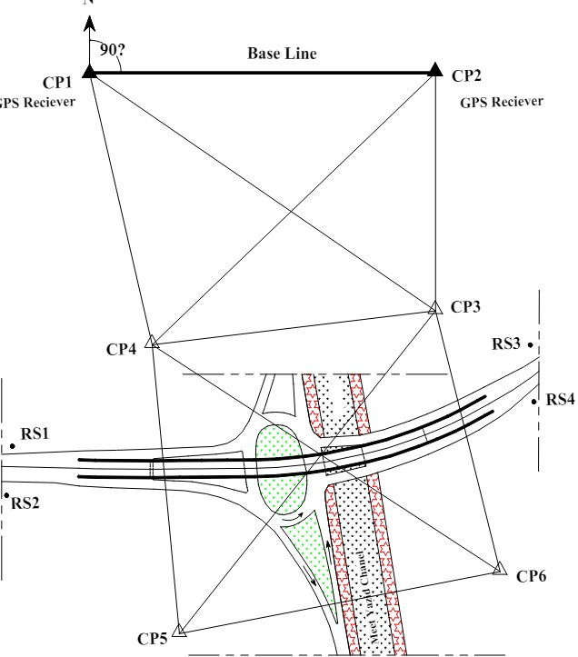

## Figure 2. : deformation monitoring network of highway bridge in Nigeria, 2015 (Githumbi, 2008)

### 2.7.2 Monitoring Bridge Deformation Using Auto-Correlation Adjustment Technique for Total Station Observations

This paper investigates an integrated monitoring system for the estimation of the deformation (i.e., static, quasi-static) behavior of bridges from total station observations and studies the effect of autocorrelation technique on the accuracy of the estimated parameters and variances. The proposed monitoring network consisted of eleven monitoring surveying points which are well distributed to completely cover the bridge. There are two-bench marks outside the bridge (BM1 and BM2) which were used to observe all monitoring points in the network by using two total station techniques. All monitoring points are surveyed by using sheet prism of diameter 1 cm fixed on the superstructure of the bridge and two total station (Nikon DTM 850 and Sokiaa SET300, The manufacturer quotes a standard deviation 0.5’’ to 1’’ for angle measurements and ±(2 + 2 ppm × D) mm for EDM measurements with prisms) fixed at points A and B for two cases of loading (empty and loading cases). The correlation coefficients between adjusted observations from regression analysis have to be taken into consideration to form the cofactor matrix (Q). With application of autocorrelation technique, the standard deviations for the first case (empty bridge) are varied from 0.26 mm to 1.09 mm in the horizontal components, and from 4.3 mm to 44.4 mm in vertical component. While in the second case (load bridge), the corresponding values are varied from 0.26 mm to 1.2 mm in horizontal components and from 6.5 mm to 60.3 mm in vertical component. Practically, the overall analysis has shown that the autocorrelation technique improved the accuracy of horizontal components (X and Y directions) but did not improve the vertical component. The results have shown that autocorrelation technique is reduced the standard deviation of X and Y-direction about 6.7% to 29.4% and 6.5% to 15.5% of the original value, respectively, but the situation was differed in Z direction; the standard deviation in vertical component Z was increased. The figure 2.4 show the observation process

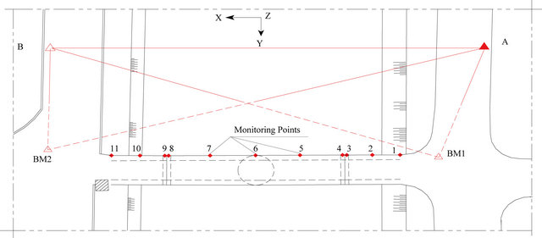

## Figure 2. : A deformation monitoring network of the bridge, established by using two total stations (Ashraf, 2015)

### 2.7.3 Current research

This research concern about deformation monitoring of Selander Bridge found at Oster Bay neighborhood in Dar es Salaam city by using conventional method. It involved vertical and horizontal observation to determine reference data for the second epoch. Precise leveling was conducted to ensure better measurement results of vertical coordination and tachometry observation for the horizontal coordination of the object points installed on the bridge basing on the monitoring network established in 2020. The data obtained in this research were compared with the data from the first epoch and the statistic test was carried out to find out if the object points deform from their original position or not. The existed monitoring network consists of six object points and four reference points. The reference points were established by GNSS method and precise leveling while object points were established by traverse and precise leveling

# CHAPTER THREE

# 3.0 METHODOLOGY

This chapter explain necessary methods and procedures carried out to accomplish this study including, reconnaissance, network design, data collection and processing of data to the final output. According to the research set up the study on deformation at Selander Bridge is divided into three parts. The first part is to check if the reference points of the established monitoring network are still in-situ by using distance method for the horizontal coordinates and precise leveling for vertical coordinate. The second part involve second epoch observation for both horizontal and vertical coordinates of the object points and the lastly is to compare the first and second epoch coordinate of the object points to determine if deformation occur or not. The following section explains all steps in details

## 3.1 Reconnaissance

This is the initially planning stage which enable surveyor to gather the information and data which are meaningfully for the study. It involves office and site visitation checking the condition and information of the reference and object points of the established monitoring network at Selander Bridge.

### 3.1.1 Office reconnaissance

Data from previous monitoring were acquired so that to be compared with the new observed data. Also, the data for the near control point near the site was obtained. The table 3.1 shows the existing control point near Selander bridge in UTM (WGS84)

## Table 3. : Control points near the site area obtained

|  |  |  |
| --- | --- | --- |
| Point ID | EASTING(m) | NORTHING(m) |
| UGS 18 | 529801.020 | 9239698.383 |
| OSTABAY | 529776.685 | 9239691.637 |

### 3.1.2 Site visitation

This involves physical visitation of site, checking for existing control point and collect information about the condition of the existing network points. Started by staking out network points by using RTK method, setting base at TO8D and initialize RTK mode by connecting base and rover using data logger then staking out four reference points SLB1, SLB2, SLB3 and SLB4 and six object points BR1, BR2, BR3, BR4, BR5 and BR6. Unfortunately, it was found that there is no inter- visibility between SLB1 and other network points due to construction activities continue around the Selander Bridge. The table 3.2 show list of network point staked during reconnaissance in UTM (WGS84)

## Table 3. : List of network points staked during site reconnaissance

|  |  |  |
| --- | --- | --- |
| STN POINT ID | EASTING(m) | NORTHING(m) |
| SLB1 | 530922.277 | 9249334.169 |
| SLB2 | 531034.743 | 9248912.920 |
| SLB3 | 531034.743 | 9248622.116 |
| SLB4 | 531187.012 | 9248533.655 |
| BR1 | 531097.981 | 9248788.528 |
| BR2 | 531104.662 | 9248775.202 |
| BR3 | 531114.036 | 9248751.89 |
| BR4 | 531070.281 | 9248791.761 |
| BR5 | 531081.649 | 9248765.643 |
| BR6 | 531093.428 | 9248737.083 |

3.2 Instrumentation

In this study different instruments were used depending on observation required for deformation monitoring of Selander Bridge. The table 3.3 show the instruments used and their specification for this study

## Table 3. : A list of instruments used during observation and their corresponding specification

|  |  |  |
| --- | --- | --- |
| S/NO | INSTRUMENTS | SPECIFICATION |
| 1 | Digital level(dna03) | Centering accuracy=0.3̋ |
| 2 | Foot plate | N/A |
| 3 | Leica total station (TS015) | Angle measurement accuracy α =1̋  Distance measurement with reflector ± (1.5mm + 2ppm) |
| 4 | Leica GPS receiver | Horizontal 3mm+0.1ppm  Vertical 3.5mm+0.4ppm |
| 5 | Bar code staff | Standard reading accuracy =1.0mm/km |
| 6 | Tripod | N/A |
| 7 | Driller | N/A |
| 8 | Machete | N/A |
| 9 | Iron pin/ bolts | N/A |
| 10 | Reflectors | N/A |
| 11 | GPS pole | N/A |

### 3.2.1 The digital level

This is the instrument that uses electronic image processing to evaluate the staff readings. The observer is in effect replaced by a detector which derives a signal pattern from a bar-code type leveling staff. A correlation procedure within the instrument translates the pattern into the vertical staff reading and the horizontal distance from the staff, staffs reading errors by the observer are thus eliminated. The basic fields are automatically stored by the instrument thus further eliminating booking error (Schofield & Breach, 2007). The Figure 3.2 below show a Leica DNA03 digital level

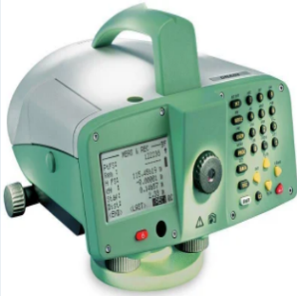

## Figure 3. : Leica DNA03 digital level

### 3.2.2 Total station

This is the instrument that combines the angle measurement that could be obtained with traditional theodolite with electronic distance measurements. Taping distance, with all associated problems has been rendered obsolete for all baseline measurement. This result in much greater control of scale error. Furthermore, it enables deformation monitoring to sub-millimeter accuracies using high precision EDM. This instrument has a range of 8km and accuracy of ±0.2mm/km of the distance measured ignoring unimodal refraction effect (Schofield & Breach, 2007). In this research, Leica TS09 was used to obtain the 2D position of the object points by tacheometry method. The Figure 3.3 show a Leica TS09 total station

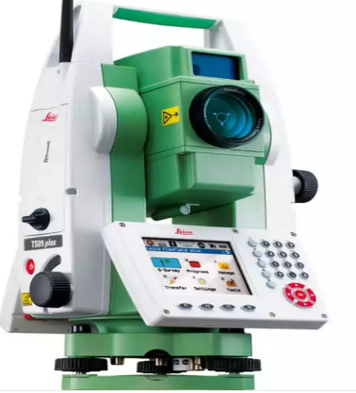

## Figure 3. : Leica TS09 total station

3.2.3 The bar-coded leveling staffs

The staff is usually made from a synthetic material which has small coefficient of expansion. On one side of the staff is a binary bar code for electronic measurement and on the side, there are often conventional graduation in meters. The black and white binary code comprises many elements over the staff length. The scale is absolute in that it does not repeat along the staff. As a correlation method is used to evaluate the image, the elements are arranged in a pseudo-random code. The code pattern is such that the correlation procedure can be used over the whole working range of the staff and instrument. Each manufacturer uses a different code on their staff; therefore, an instrument will only work with a staff from the same manufacturer (Schofield & Breach., 2007)

## 3.4 Pre analysis

Pre analysis refers to the analysis of the component measurement of a survey project before it is undertaken. Pre analysis helps overall design of the project, and to provide basics evaluation of accuracy of survey measurement, it facilitates selection of suitable instruments, selection of suitable procedure and provides basics for evaluation of accuracy of survey measurement. It involves determination of the expected standard deviation in determining horizontal position using total station TS015 and vertical position using digital level DNA03 instrument. All those instruments were examined in order to understand the maximum tolerance that is expected when using them in deformation analysis.

### 3.4.1 Expected standard deviation in determining difference in elevation of leveling line

There are several sources of errors which have effects on accuracy of digital level such as effect of sun which may be caused by working for a long time in the field also the inclined angle of reflecting surface. From digital level DNA03 instrument specifications, the accuracy in determining difference in elevation of a leveling line(route) is 1mm for a loop of 1km. standard deviation of digital level based on specifications from the manufacture.

Referring from instrumental manual

Centering accuracy α=0.3̋

With standard staff δß=1.0mm per km

For the first loop

Total distance of the level line S=771.646m

Maximum leg distance = 30.02m

From

(Abdullahi & Yelwa, 2016)

Where, expected standard deviation in determining different in elevation

S= total loop distance

D= distance of the longest loop

Centering error

α=

=1.4544

δ ß=

=0.000001

Therefore

σ

σm

Therefore, expected standard deviation in determining difference in elevation of a leveling line is m

### 3.4.2 Expected standard deviation using Leica total station TS0

From the instrument specification, σ α=0. 3‶ and =1.5*mm* + 2*ppm*

From

σ = (Abdullahi & Yelwa, 2016)

where,

σ=expected standard deviation in determining position using TS015

standard deviation in determining angle using TS015

standard deviation in determining distance using TS015

therefore,

σ

σ

Therefore, the expected standard deviation in determining 2D position is 1.5mm.

## 3.5 Traverse

Traverse is a surveying technique for establishing control networks which involve determination of the bearing and horizontal distances by measuring horizontal angles between stations. The main purpose of this traverse was to establish new SLB1 which distorted from the existing network basing on the remained three reference points SLB2, SLB3, and SLB4. The traverse was closed loop traverse consist of five station points opening and closing at SLB3 and SLB 4

### 3.5.1 Network design

The network was designed with good geometry considering the intervisibility between consecutive stations and length of the legs. A network consists of five station points, including three control points, SLB2, SLB3 and SLB4 and two new stations TP and SLB05. Basing on the formal monitoring network, SLB05 was located on the stable ground with less human and vehicular interference to ensure its long stability while considering its visibility to all other network points. The Figure 3.4 show the designed traverse network

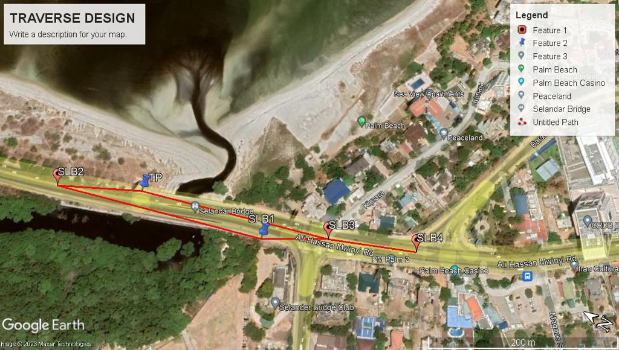

## Figure 3. : Traverse network design

### 3.5.2 Monumentation

The double beacon monumentation technique was applied to the new SLB1 in order to ensure long stability and security. It involves setting two or more secondary markers in close proximity to the primary control point, providing redundancy and additional reference points for future monitoring activities. These secondary markers serve as witness marks or backups in case the primary control point is disturbed or lost. A hole of 90cm was dug and an iron pin of about 40cm was inserted in the ground up to 20cm, the center point of the pin was maintained by using optical plummet mounted on the tripod stand and the concrete was used to hold still the pin. The second pin was then guided using an optical plummet to maintain the center of the built in pin and the built in concrete. The Figure 3.5 show the monument of SLB05

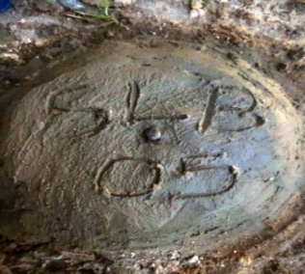

## Figure 3. : Monument

**3.5.3 Observation procedure**

It involved the measurement of horizontal angle and horizontal distance between station. Traverse began by setting total station at the opening control point SLB3 oriented at SLB4 measuring the angle clockwise to the SLB1, then total station shifted to SLB1 repeating the same procedure passing through SLB2 and TP and closing at SLB3. To eliminate collimation error both face left and face right observation were taken. In all set up it was assured that all circular bubbles were well leveled in both total station and reflector and all angle and distance were properly booked.

## 3.6 Horizontal measurement

This was conducted by using tachometry method which involved the use of electronic tachometer to coordinate the object points. Basing on the reference points SLB01, SLB02, SLB03 and SLB04 it was possible to determine 2D position of the object points inserted on the bridge.

### 3.6.1 Data observation procedure

A total station was first set at SLB03 oriented to SLB04 and performs a datum check, then all object were coordinated. Also, procedure was repeated to SLB02 and SLB03 and SLB01 and SLB02. In all setup it was assured that all circular bubbles were well leveled in both target and total station. The table 3.4, table 3.5 and table 3.6 show datum checks between reference points in UTM (WGS84)

## Table 3. : Datum check between SLB2 and SLB3

|  |  |  |  |  |  |  |  |
| --- | --- | --- | --- | --- | --- | --- | --- |
| Station | X(m) | Y(m) |  | º | ‘ | ‶ |  |
| SLB2 | 9248912.920 | 531034.743 | Brg | 158 | 50 | 36 |  |
| SLB3 | 9248622.120 | 531147.284 | S(c) | 311.8174 |  | MS |  |
| DX, DY | -290.8 | 112.541 | S(m) | 311.817 |  | Diff | 0.0004 |

## Table 3. : Datum check between SLB3 and SLB4

|  |  |  |  |  |  |  |  |
| --- | --- | --- | --- | --- | --- | --- | --- |
| Station | X(m) | Y(m) |  | º | ‘ | ‶ |  |
| SLB03 | 9248622.120 | 531147.284 | Brg | 155 | 48 | 54 |  |
| SLB04 | 9248533.660 | 531187.012 | S(c) | 96.9724 |  | MS |  |
| DX, DY | -88.461 | 39.728 | S(m) | 96.971 |  | Diff | 0.0015 |

## Table 3. : Datum check between SLB 2 and SLB 4

|  |  |  |  |  |  |  |  |
| --- | --- | --- | --- | --- | --- | --- | --- |
| Station | X(m) | Y(m) |  | º | ‘ | ‶ |  |
| SLB02 | 9248912.920 | 531034.743 | Brg | 155 | 48 | 54 |  |
| SLB04 | 9248533.660 | 531187.012 | S(c) | 408.6856 |  | MS |  |
| DX, DY | -379.26 | 152.269 | S(m) | 408.687 |  | Diff | -0.0014 |

## 3.7 Vertical coordinate observation

This was conducted to obtain better measurement result of 1D framework. It enabled to transfer reduced elevation from reference points to the object points on the bridge structure. Before vertical observation was conducted, the leveling instrument was tested for collimation error by two peg test method.

### 3.7.1 Two Peg Test

The purpose of two pegs is to test if the line of sight through the level line is horizontal. To perform the two-peg test, two pegs were placed on a flat ground at a distance of 60m apart. The digital level was set up midway between the two points and the staff readings were taken at both points. The Figure 3.6 illustrate the leveling set up

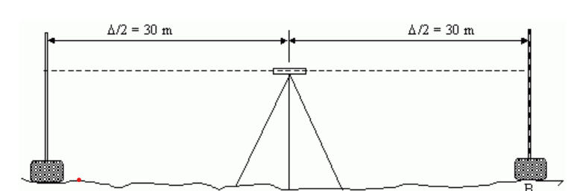

## Figure 3. : Setup for leveling observation when the level is at the center

If the line of sight through the level is not horizontal, the error in staff readings at both points A and B are identical because the level is half way between the points. The error is identical so the calculated difference in elevation between points A and B is the true difference in elevation. Figure 3.7 illustrate the leveling set up

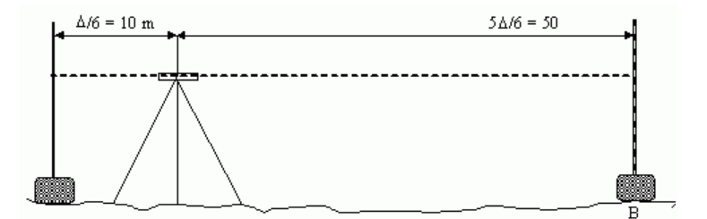

## Figure 3. : Setup for leveling observation when the level shifted near point A

Since distance from A to the level is very small then any staff reading error introduced using this very short sight is relative insignificant

∆*h*1= (*A1* + *e*) – (*B1* + *e*) = *A1* – *B1*

Where, ∆*h*1= change in elevation between point A and B when level is at the center

A1= reading at A when level is at the center

B1 = reading at B when level is at the center

e= staff reading error

∆*h*2= *A*2 – (B2+ *e*) = *A*2 – *B*2 + *e*

Where, ∆*h*2= change in elevation between point A and B when level is shifted near point A

A2= reading at A when level shifted near point A

B2= reading at B when level shifted near point A

∆*h*1 = ∆*h*2

Thus, *A1* – *B1* = *A*2 – *B*2 + *e*

*e* = (*A1* – *A*2) + (B2 – *B1*)

*e* = (1.32185 – 1.45018) + (1.52215 – 1.39371)

*e* = 0.000011m

### 3.7.2 Leveling procedure

The work of leveling commenced after testing collimation error and the following procedure were involved

1. The level machine was set up between the benchmark SLB04 and the first changing point P1 and the staff reading for back sight and fore sight were recorded
2. This proceeded for whole route through points P01 to SLB03, P03, P04, BR03, BR02, BR01, P08, P09 to SLB02 for vertical datum check
3. Then leveling was conducted between benchmark SLB04 to SLB02 passing through object point BRO3, BR02, BRO1 to SLB02, SLB01 passing through BRO4, BR05, BR06
4. Back sight and fore sight distance were maintained nearly equal so that to cancel the effect of collimation error
5. In all set up it was assured that all circular bubbles were well leveled in both staff and level machine
6. Intermediate sight was avoided, since in precise leveling the intermediate sight always reference the last back sight
7. Staff was always sighted higher than 0.5m above the ground due to the variable refraction effect near the ground
8. Leveling was carried out only during the favorable condition of light and temperature and not during high wind and rain

The table 3.7 show vertical datum check of the reference points and the Figure 3.6 show a surveyor observing precise leveling

## Table 3. : Datum check for vertical coordinates

|  |  |  |  |  |  |  |
| --- | --- | --- | --- | --- | --- | --- |
| STN | BS(m) | FS(m) | ∆h(m) | H(m) | CHECK(m) | ERROR(m) |
| SLB04 | 0.8746 |  |  | 6.123 |  |  |
| P01 | 0.916 | 1.7169 | -0.8423 | 5.2807 |  |  |
| SLB03 | 1.2303 | 1.6443 | -0.7283 | 4.5524 | 4.553 | -.0.0006 |
| P03 | 1.6294 | 1.4099 | -0.1796 | 4.3728 |  |  |
| P04 | 1.678 | 1.2001 | 0.4293 | 4.8021 |  |  |
| BR03 | 1.6078 | 1.2596 | 0.4184 | 5.2205 |  |  |
| BR02 | 1.5212 | 1.4976 | 0.1102 | 5.3307 |  |  |
| BR01 | 1.2424 | 1.5313 | -0.0101 | 5.3206 |  |  |
| P08 | 1.2671 | 1.6143 | -0.3719 | 4.9487 |  |  |
| P09 | 1.5066 | 1.6637 | -0.3966 | 4.5521 |  |  |
| SLB02 | 1.2452 | 1.5771 | -0.0705 | 4.4816 | 4.482 | -0.0004 |
| P011 | 1.5792 | 1.5816 | 0.0661 | 4.4245 |  |  |
| P015 | 1.5301 | 1.5219 | -0.2877 | 4.0639 |  |  |
| P017 | 1.8699 | 1.0092 | 0.514 | 5.0663 |  |  |
| SLB04 |  | 0.8141 | 1.0558 | 6.1221 | 6.123 | 0.0009 |

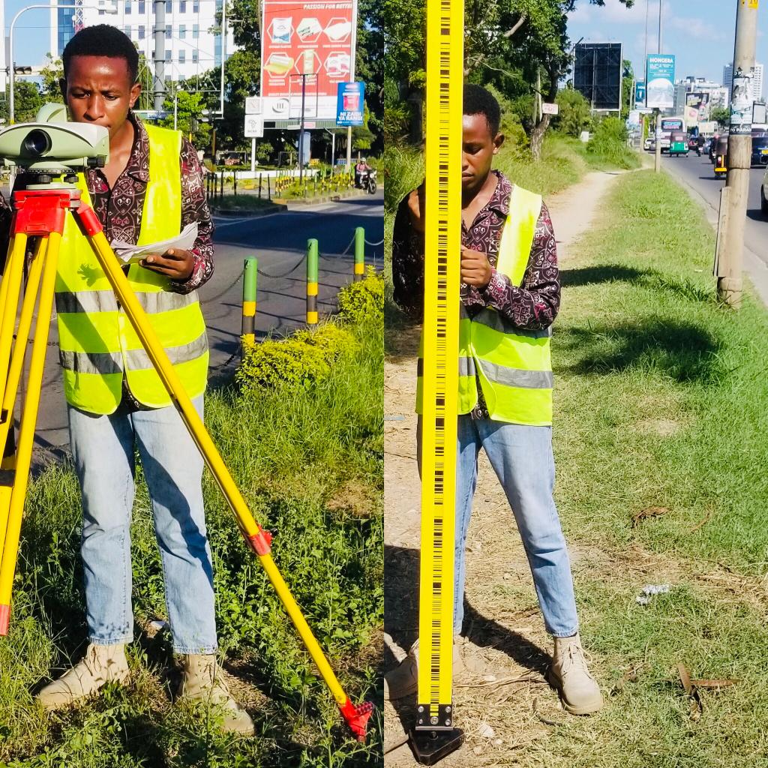

## Figure 3.8: A surveyor observing precise leveling

CHAPTER FOUR

# 4.0 RESULT, ANALYSIS AND DISCUSSION

This chapter presents the analysis and discussion of the result obtained from leveling and tachometry observation. It involves processing, refinements of raw data, reduction, misclosure check and adjustment of the data to obtain the final product which will be analyzed with the data from the first epoch. The deformation analysis was determined by analyzing the reference points and the structure point to determine the changes in the structure.

## 4.1 Traverse result

Traverse data were processed by using CADpro software and the coordinate of the new points established were found as show in table 4.1 below

## Table 4. : Traverse computations

|  |  |  |  |  |  |  |  |
| --- | --- | --- | --- | --- | --- | --- | --- |
| Station | Northing | Corr | Easting | corr |  |  | Station |
|  | M | m | m | m | X(m) | Y(m) |  |
|  |  |  |  |  |  |  |  |
| SLB4 |  |  |  |  | 9248533.655 | 531187.012 | SLB4 |
|  |  |  |  |  |  |  |  |
| SLB3 |  |  |  |  | 9248622.116 | 531034.743 | SLB3 |
|  | 28.305 | 0.004 | -68.956 | -0.003 |  |  |  |
| SLB5 |  |  |  |  | 9248650.425 | 530965.784 | SLB5 |
|  | 142.359 | 0.012 | -192.01 | -0.009 |  |  |  |
| SLB2 |  |  |  |  | 9248792.795 | 530773.756 | SLB2 |
|  | -42.009 | 0.005 | 86.294 | -0.004 |  |  |  |
| TP |  |  |  |  | 9248750.791 | 530860.047 | TP |
|  | -128.686 | 0.011 | 174.704 | -0.008 |  |  |  |
| SLB3 |  |  |  |  | 9248622.116 | 531034.743 | SLB3 |
|  | -0.031 | 0.031 | 0.024 | -0.024 | 0.000 | 0.000 |  |
| SLB4 | 0.000 | 0.000 | 0.000 | 0.000 | 9248533.655 | 531187.012 | SLB4 |
| Stns no=5 | x miscl= | 0.031 | y miscl | -0.024 | Accuracy=1: | 16091 |  |
| Ang.cor=0 |  |  |  |  | 9248622.116 | 531034.743 | SLB3 |

## 4.2 Result of tachometry observation

Object points were coordinated in UTM (WGS84) based on reference points. Total station was first set at SLB3 oriented to SLB04 and all object points were coordinated. The same procedures were repeated on SLB02 oriented to SLB03 as shown in table 4.2, table 4.3 and table 4.4

## Table 4. : Object points coordinated from SLB02 oriented to SLB0 3

|  |  |  |
| --- | --- | --- |
| DESCRIPTION | EASTING(m) | NORTHING(m) |
| BR01 | 531097.9849 | 9248788.5346 |
| BR02 | 531104.6632 | 9248775.1996 |
| BR03 | 531114.0418 | 9248752.8920 |
| BR04 | 531070.2794 | 9248791.7639 |
| BR05 | 531081.6459 | 9248765.6456 |
| BR06 | 531093.4262 | 9248737.0861 |

## Table 4. : Object points coordinated from SLB03 oriented to SLB04

|  |  |  |
| --- | --- | --- |
| DESCRIPTION | EASTING(m) | NORTHING(m) |
| BR01 | 531097.9843 | 9248788.5248 |
| BR02 | 531104.6651 | 9248775.2024 |
| BR03 | 531114.0398 | 9248751.8899 |
| BR04 | 531070.2792 | 9248791.7634 |
| BR05 | 531081.6438 | 9248765.6474 |
| BR06 | 531093.4251 | 9248737.0883 |

## Table 4. : Object points coordinated from SLB05 oriented to SLB03

|  |  |  |
| --- | --- | --- |
| DESCRIPTION | EASTING(m) | NORTHING(m) |
| BR01 | 531097.9842 | 9248788.5249 |
| BR02 | 531104.6653 | 9248775.2025 |
| BR03 | 531114.0396 | 9248751.8897 |
| BR04 | 531070.2791 | 9248791.7636 |
| BR05 | 531081.6436 | 9248765.6475 |
| BR06 | 531093.4253 | 9248737.0882 |

## 4.3 Result from precise leveling observation

## The leveling data were properly booked as shown in table 4.5 below

## Table 4. : Result from leveling observation

|  |  |  |  |  |
| --- | --- | --- | --- | --- |
| STN | BS(m) | FS(m) | ∆h(m) | H(m) |
| SLB04 | 0.8746 |  |  | 6.123 |
| P01 | 0.916 | 1.7169 | -0.8423 | 5.2807 |
| SLB03 | 1.2303 | 1.6443 | -0.7283 | 4.5524 |
| P03 | 1.6294 | 1.4099 | -0.1796 | 4.3728 |
| P04 | 1.678 | 1.2001 | 0.4293 | 4.8021 |
| BR03 | 1.6078 | 1.2596 | 0.4184 | 5.2205 |
| BR02 | 1.5212 | 1.4976 | 0.1102 | 5.3307 |
| BR01 | 1.2424 | 1.5313 | -0.0101 | 5.3206 |
| P08 | 1.2671 | 1.6143 | -0.3719 | 4.9487 |
| P09 | 1.5066 | 1.6637 | -0.3966 | 4.5521 |
| SLB02 | 1.2452 | 1.5771 | -0.0705 | 4.4816 |
| SLB01 | 1.6477 | 1.3684 | -0.1232 | 4.3584 |
| P011 | 1.5792 | 1.5816 | 0.0661 | 4.4245 |
| BR04 | 1.3368 | 1.6728 | -0.0936 | 4.3309 |
| BR05 | 1.4013 | 1.2473 | 0.0895 | 4.4204 |
| BR06 | 1.2342 | 1.4701 | -0.0688 | 4.3516 |
| P015 | 1.5301 | 1.5219 | -0.2877 | 4.0639 |
| SLB03 | 1.5232 | 1.0417 | 0.4884 | 4.5523 |
| P017 | 1.8699 | 1.0092 | 0.514 | 5.0663 |
| SLB04 |  | 0.8141 | 1.0558 | 6.1221 |

### 4.3.1 Closure tolerance check

The tolerance check has been performed so as to analyze the misclosure of data collected was acceptable or not for further analysis. The amount of misclosure in leveling can only be assessed by either connecting the leveling back to the BM from which it started or connecting into another of known and proved value. Alternatively, the permissible criteria may be used on the distance leveled or the number of setups involved. A common criterion used to assess the misclosure is: E =m where K is the leveled distance in Km and m is the constant with unit of millimeter which vary depending on order of leveling and its application. For this study, the total distance was 0.772km and the value of m is 3mm, therefore the allowable misclosure is 2.636mm. From observation the misclosure for the leveling loop is 2.317mm

### 4.3.2 Leveling adjustment

Least squares adjustment technique was used to adjust the network to obtain vertical position of reference and object point and its accuracy. The table 4.6 shows the observed height difference and the distance between leveling points

## Table 4. : distance between points in the leveling lines

|  |  |  |  |
| --- | --- | --- | --- |
| Line | From-To | Observed h(m) | Length of line (Km) |
| 1 | SLB04-SLB03 | -1.5706 | 0.0973 |
| 2 | SLB03-BR03 | 0.6681 | 0.1366 |
| 3 | BR03-BR02 | 0.1102 | 0.0252 |
| 4 | BR02-BR01 | -0.0101 | 0.0149 |
| 5 | BR01-SLB02 | -0.8390 | 0.1408 |
| 6 | SLB02-SLB01 | -0.4576 | 0.0403 |
| 7 | SLB01-BR04 | -0.0275 | 0.0879 |
| 8 | BR04-BR05 | 0.0895 | 0.0299 |
| 9 | BR05-BR06 | -0.0688 | 0.0317 |
| 10 | BR06-SLB03 | 0.2007 | 0.0960 |

From the table above the following parametric equations were made

∆h1= HBR03

∆h2= HBR02 HBR03   
∆h3= HBR01 HBR02

∆h4=HSLB02 HBR01

∆h5=HBR04 HSLB01

∆h6= HBR05 HBR04

∆h7=HBR06 HBR05

∆h8=HSLB03 HBR06

From the parametric equation the following matrix were obtained

First design matrix

A=

X

F(X˳)

Misclosure matrix (w)= F(X˳)

W

Weight matrix

P

Corrections to the approximate elevations:

δ = − Pw

Adjusted parameters:

x = x + δ

by using the MATLAB software, the adjusted elevations were obtained as shown in table 4.7 below

## Table 4. : Adjusted height of the object points

|  |  |  |
| --- | --- | --- |
| POINT ID | H(m) | Residual(m) |
| BR1 | 5.320111 | -0.000489 |
| BR2 | 5.330202 | -0.000498 |
| BR3 | 5.219986 | -0.000514 |
| BR4 | 4.3302 | -0.0007 |
| BR5 | 4.4197 | -0.0007 |
| BR6 | 4.3509 | -0.0007 |
| SLB1 | 4.3577 | -0.0007 |

## 4.4 Comparison of result

Deformation assessment requires at least two epochs of observation at specific time interval in which displacement can be computed. The magnitude of displacement is given by subtracting the position of the recently epoch from that of the previous epoch. Table 4.8 and table 4.9 show data from first and second epoch respectively and table 4.10 show the comparison between data

This mathematical can be given as

Displacement

Were,

## Table 4. : Data from first epoch 2020

|  |  |  |  |
| --- | --- | --- | --- |
| POINT ID | EASTING | NOTHING | ELEVATION |
| BR01 | 531097.982 | 9248788.531 | 5.321 |
| BR02 | 531104.662 | 9248775.203 | 5.330 |
| BR03 | 531114.037 | 9248751.892 | 5.223 |
| BR04 | 531070.284 | 9248791.764 | 4.332 |
| BR05 | 531081.647 | 9248765.645 | 4.427 |
| BR06 | 531093.429 | 9248737.084 | 4.353 |

## Table 4. : Data from Second epoch 2023

|  |  |  |  |
| --- | --- | --- | --- |
| POINT ID | EASTING | NOTHING | ELEVATION |
| BR01 | 531097.9846 | 9248788.5297 | 5.320111 |
| BR02 | 531104.6652 | 9248775.2001 | 5.330202 |
| BR03 | 531114.0408 | 9248751.8910 | 5.219986 |
| BR04 | 531070.2793 | 9248791.7637 | 4.3302 |
| BR05 | 531081.6449 | 9248765.6465 | 4.4197 |
| BR06 | 531093.4259 | 9248737.0865 | 4.3509 |

## Table 4. : comparison of data from the first epoch and the second epoch

|  |  |  |  |
| --- | --- | --- | --- |
| POINT ID | (m) | (m) | H(m) |
| BR01 | 0.0026 | -0.0013 | -0.0009 |
| BR02 | 0.0032 | -0.0029 | 0.0002 |
| BR03 | 0.0038 | -0.0010 | -0.003014 |
| BR04 | -0.0047 | -0.0030 | -0.0018 |
| BR05 | -0.0021 | 0.0015 | -0.0073 |
| BR06 | -0.0031 | 0.0025 | -0.0021 |

## 4.5 Analysis of horizontal deformation

For analyzing horizontal deformation, the magnitude of displacement is given by

dn were,

∆N is the difference in Northing of deforming point from the observation of two epochs and ∆E is the difference in Easting of deforming point from observation of two epochs. Usually, displacement at any rate does not mean the structure is deforming. There are many factors to be considered. Sometimes displacement can be result from blunder, systematic error not well modeled, random error, monument instability or inaccurate instruments, so before accepting the obtained displacement value surveyor need to ask how confident are we that these displacements represent deformation. Table 4.11 show horizontal analysis of object points and their corresponding velocity

The relation dn∠ *en* is used to assess deformation, where dn is the magnitude of horizontal displacement of the point and *en* is the maximum dimension of combined 95confidence elipse

For point n, en = Cp (Abdullahi & Yelwa, 2016)

For 95 Cp= 1.9599 and from pre-analysis σ=1.5mm for both Northing and Easting

Hence, en= 1.9599

en= 4.1576mm

Therefore, the standard error en= 4.1576mm

Interpretation Null hypothesis (Ho): Point assumed to be stable

Alternative hypothesis (Ha): point assumed to be stable

Ho: *dn* and

Ha:

Therefore

*dn*the point is not deforming.

, the point is deforming.

***For BR01***

2.6mm

= -1.3mm

dn=

*dn*

dn= 2.9069mm

This results show that the horizontal displacement does not exceeds the expected survey error

bound, therefore BRO1 is not horizontal moving

***For BR02***

=3.2mm

2.9mm

dn=

dn= 4.3186mm

Rate of deformation per year = 4.3186/ 3year

Rate of deformation per year= 1.4395mm/ year

The result show that the horizontal displacement exceeds the expected survey error bound, hence BR02 is horizontal deforming at the rate of 1.4395mm per year

***For BR03***

dn=

dn = 3.9294mm

*dn*

The result show that the horizontal displacement does not exceeds the expected survey error bound; therefore BR03 is not horizontal deforming

***For BR04***

dn=

dn= 5.5758mm

Rate of deformation per year= 5.5758/3year

Rate of deformation per year= 1.8586mm/year

The result show that the horizontal displacement exceeds the expected survey error bound, hence BR04 is horizontal deforming at the rate of 1.8586mm per year

***For BR05***

dn=

dn= 2.5807mm

Thus,

*dn*

the result show that the horizontal displacement does not exceeds the expected survey error bound, therefore BR03 is not horizontal deforming

***For BR06***

dn=

dn= 3.9825mm

*dn*

The result show that the horizontal displacement does not exceeds the expected survey error bound, therefore BR03 is not horizontal deforming.

## Table 4. : Analysis of the object points horizontally and their corresponding velocity per year

|  |  |  |  |  |
| --- | --- | --- | --- | --- |
| STATION ID | DISPLACEMENT  dn(mm) | PERCENTAGE ERROR en(mm) | VELOCITY (mm/year) | REMARK |
| BR01 | 2.9069 | 4.1576 | 0.969 | STABLE |
| sBR02 | 4.3186 | 4.1576 | 1.440 | UNSTABLE |
| BR03 | 3.9294 | 4.1576 | 1.310 | STABLE |
| BR04 | 5.5758 | 4.1576 | 1.589 | UNSTABLE |
| BR05 | 2.5807 | 4.1576 | 0.860 | STABLE |
| BR06 | 3.9825 | 4.1576 | 1.328 | STABLE |

## 4.6 Analysis of vertical deformation

This involve statistical test to determine if the displacement computed indicate movement or is likely due to survey error so as to conclude whether the bridge deform vertically or not.

For analyzing vertical deformation, the magnitude of displacement is given by *dn*=

The relation dn∠ *en* is used to assess deformation, where dn is the magnitude of vertical displacement of the point and *en* is the maximum dimension of combined 95confidence ellipse. Table 4.12 show vertical analysis of the object points and their corresponding velocity

For point n, en = Cp (Abdullahi & Yelwa, 2016)

Cp=1.9599 and from pre-analysis in section 3.3.1 m

en= 2.686

en= 0.000526m

Therefore, the standard error is 0.526mm

Given the value of displacement shown in the table……

Null hypothesis (Ho): point assumed to be stable

Alternative hypothesis (Ha): point assumed to be unstable

Ho: dn

Ha: dn

***For BR1***

H=-0.9mm

Magnitude of vertical displacement dn=

dn= 0.9mm

dn

Rate of deformation per year= 0.9/3year

Rate of deformation per year= 0.3mm/ year

The result show that the vertical displacement exceeds the expected survey error bound, therefore BR01 is vertically deforming at the rate of 0.3mm per year

***For BR02***

H=0.2mm

Magnitude of vertical displacement dn=

dn= 0.2mm

The result show that the vertical displacement does not exceeds the expected survey error bound, therefore BR02 is not vertically deforming.

For BR03

H=-3.014mm

Magnitude of vertical displacement dn=

dn= 3.014mm

dn

Rate of deformation per year= 3.014/3year

Rate of deformation per year= 1.005mm/ year

The result show that the vertical displacement exceeds the expected survey error bound, therefore BR03 is vertically deforming at the rate of 1.005mm per year

***For BR04***

H=-3.014mm

Magnitude of vertical displacement dn=

dn= 1.8mm

dn

Rate of deformation per year= 1.8/3year

Rate of deformation per year= 0.6mm/ year

The result show that the vertical displacement exceeds the expected survey error bound, therefore BR04 is vertically deforming at the rate of 0.6mm per year

*For BR05*

H=-7.3mm

Magnitude of vertical displacement dn=

dn= 7.3mm

dn

Rate of deformation per year= 7.3/3year

Rate of deformation per year= 2.43mm/ year

The result show that the vertical displacement exceeds the expected survey error bound, therefore BR05 is vertically deforming at the rate of 2.43mm per year

***For BR06***

H=-2.1mm

Magnitude of vertical displacement dn=

dn= 2.1mm

dn

Rate of deformation per year= 2.1/3year

Rate of deformation per year= 0.7mm/ year

The result show that the vertical displacement exceeds the expected survey error bound, therefore BR06 is vertically deforming at the rate of 0.7mm per year

## Table 4. : analysis of object points vertical and their corresponding velocity per year

|  |  |  |  |  |
| --- | --- | --- | --- | --- |
| STN ID | DISPLACEMENT  dn(mm) | PERCENTAGE ERROR en(mm) | VELOCITY (mm/year) | REMARK |
| BR01 | 0.9 | 0.526 | 0.3 | UNSTABLE |
| BR02 | 0.2 | 0.526 | 0.067 | STABLE |
| BR03 | 3.014 | 0.526 | 1.005 | UNSTABLE |
| BR04 | 1.8 | 0.526 | 0.6 | UNSTABLE |
| BR05 | 7.3 | 0.526 | 2.43 | UNSTABLE |
| BR06 | 2.1 | 0.526 | 0.7 | UNSTABLE |

## 4.7 Visualization of displacement

Figure 4.1 and figure 4.2 shows the graph of displacement of each object point horizontally and vertically  Figure 4. 1: A graph showing horizontal displacement of each object points

## Figure 4. : A graph showing vertical displacement of each object points

## 4.8 Discussion of the result

Horizontally, only two points BR02 and BR04 are unstable which may be due to expansion or contraction of bridge materials due to temperature changes or other lateral load such as wind.

Vertically, the graph show that the minimum height change was in BR02 while a maximum height change was in BR05. BR02 is located at the pier (support of the bridge) which mostly are designed to distribute the loads from the bridge superstructure to the ground while BR05 is located at the midspan of a bridge, the central section between the supports which is likely to experience high levels of stress due to the bridge's self-weight and live loads, such as vehicles or pedestrians crossing the bridge. That can be the reason that BR05 deform much compared to BR02. Similarly, to BR01 and BR06 established at the support of the bridge while BR03 and BR04 established on the midspan. Also, all deformed points are moving downward which indicate that the bridge deform vertically downward which may be due to excessive vertical loads such as heavy vehicles or overloaded trucks or bridge support may experience settlement or consolidation.

# CHAPTER FIVE

# 5.0 CONCLUSION AND RECOMMENDATION

## 5.1 Conclusion

The objective of this research was to carry out the second epoch of deformation monitoring of the Selander Bridge. This research involved precise leveling for vertical deformation on the established control and tachometry observations on the object points established within the bridge. Also, research involved establishment of the one reference point which distorted from the established network by using traverse method and precise leveling. The data collected in this research serve as the reference data which compared with the previous data collected in 2020. Observed data and previous data were statistically tested within the survey tolerance of 95 confidence level and the analysis show that some of the object points are stable while some deform from their original position. The analysis of horizontal deformation showed that four out of six of the object points installed on the bridge are stable while analysis on vertical deformation showed only one is vertically stable

Hence the outcome of this research can be used in decision making process to facilitate the formulation of proactive maintenance strategies to ensure the continued safe use of the Selander Bridge.

## 5.2 Recommendations

Recommendations to the analysis is as follows

For security and safety of Selander Bridge, deformation monitoring should be done regularly over time to ensure long safety and good performance

Further studies should be carried out on the selander bridge in order asses other type of deformation that are bounded to occur such as shear deformation, creep and fatigue, torsional deformation etc.

# REFERENCE

Abdullahi & Yelwa. (2016). Structural Deformation Monitoring Surveys of New Administrative Building of Federal School of Surveying. Sokoto-Nigeria: UsmanuDanfodiyo University, Department of Geology.

Adam. (2007). Deformation Monitoring Survey.

Anonym. (2002). Structural Deformation Survey. Washngton DC.

Ashraf. (2015). Monitoring Bridge Deformation Using Auto-Correlation Adjustment Technique for Total Station Observations.

ASPRS. (2005). Photogrammetric Engineering and Remote Sensing.

Ayan & Erol. (2003). An Investigation on Deformation Measurements of Engineering Structures With GPS And Levelling Data. Sofia, Bulgaria.

Balasubramanian, A. (2017). digital elevation model (dem) in gis. mysore: university of mysore.

Ballarini., Roberto. &Taichiro, O. (2009). The Infamous Gusset Plates. Minneapolis. University of Minnesota.

Beshr. (2015). structural Deformation Monitoring and Analysis of Highway bridge using Accurate Geodetic Technique.

Bird, B. (2009). Analysis of Survey Point Displacements Using Total Station Measurements. columbia: British Columbia Institute of Technology.

Bugalika, J. S. (2020). 3D Deformation Monitoring of Tiper Petroleum Storage Tank Foundation at Kigamboni. Dar es salaam.

Caspary, W. (2000). Concepts of Network and Deformation Analysis. Kensington.

Chandler & Paul L. (2005). Laser Scanning for the Environmental Sciences.

Ehiorobo, J. O. and. Ehigiator, R. I. ( 2011). Monitoring for Horizontal Movement in an Earth Dam Using Differential GPS. Journal of Emerging Trends in Engineering and Applied Sciences (JETEAS), 908-913.

Erol et al. (2008). A General Review of the Deformation Monitoring Techiniques. Istanbul, Turkey: Geodesy Division.

Essau, Z. (2020). 3D Geodetic Network Design for Monitoring Structural Deformation of Selander Bridge. Dar Es Salaam.

F.spiewak, A. (2021, february 6). spiewak consulting. Retrieved from andrew spiewak land surveyor, inc: www.landsurveyors.pro

Featherstone. (1998). Strategies for the Accurate Determination of Orthometric Heights from GPS.

Githumbi, W. (2008). Deformation Monitoring of Oil Tank by Using Geoditic Method. Nairobi.

Gorana N & Rinaldo P. (2005). Deformation Monitoring of the Bridge Using Conventional Method and GPS. University of Zagreb Faculty of Geodesy.

Hankungwe, B. (2010). A study of Deformation Monitoring System for Mtera.

Hemmati, H. (2008). Geodesy for Geomatics and GIS Proffesional.

Issaka et al. (2010). Monitoring Levels of Deformation within Tarkwa Community. Kumasi, Ghana.

jackson. (2023). kitabu. darse.

Jenkins, N. A. (2015). AN APPLICATION OF AERIAL DRONES IN ZONING AND URBAN LAND USE PLANNING IN CANADA . Toronto, Ontario, Canada: University of Guelph.

Kaplan. (2004). The Effect of Geodetic Configuration of the Network in Deformation Analyisis.

Kapovic, Z. (2005). Deformation Monitoring of the Bridge by Conventional an Gps Methods. University of Zagreb.

Leonard, S. (2018). Geodetic network establishment for monitoring Tanga tide gauge platform. Dar es salaam: Ardhi University.

Massiera et al. (2005). Use of Geodetic Monitoring Measurements in Solving Geomechanical Problems in Engineering and Geosciences.

Ogundare. (2009). Deformation Monitoring and Analysis: Geodetic Techniques .

Ogundare, J. O. (2019). Understanding Least Squares Estimation and Geomatics Data Analysis. Hoboken,USA: John Wiley & Sons, Inc.

Ono, M. N., Eteje, S. O. (June. 2018). Comparative Analysis of DGPS and Total Station Accuracies for Static Deformation Monitoring Of Engineering Structures. Journal of Environmental Science, Toxicology and Food Technology, 19-29.

Sagamilwa, P. N. (2020). 3D-Geodetic Network Design For Deformation Monitoring of Overhead Bridge. Dar es Salaam.

Schofield & Breach. (2007). Engineering Surveying(Sixth Edition). London.

Schofield, W. (2007). Engineering Surveying( Sixth EAdition ed.). London.

Schofield, W., & Breach, M. (2007). Engineering Surveying (Sixth Edition ed.). London: Elsevier Ltd, Linacre House, Jordan Hill, Oxford OX2 8DP, UK.

T. Schone, J. Illigner, P. Manurung,C. Subarya and Khafid. (2011). GPS-controlled tide gauges in Indonesia – a German contribution to Indonesia’s Tsunami Early Warning System. Natural Hazards and earth System Sciences, 731–740.

Tasci, L. (2012). Dam Deformation Measurement with GPS.

Tilo Schöne, Nana Schön, Daniela Thaller. (2009). IGS Tide Gauge Benchmark Monitoring Pilot Project (TIGA). journal of geodesy 83(3), 249-261.

UNESCO. (1994). Manual On Sea Level Measurement And Interpretation . Manual On Sea Level.

Wesley. (2020). Bridge Failure Rates, Consequences, and Predictive Trends.

Wibeseoul. (1999, january 1). About Us:steemit. Retrieved from A steemit: https://en.wikipedia.org/wiki/Seongsu_Bridge

Wieser & Capra. (2017). Special Issue.

Yan, J. (2019). Bridge Deformation Monitoring. Journal of Bridge Engineering.

Yogesh Bajpai,Atul Pandey. (2019). A Study to the Geometric Design of Road Project Using Civil 3D. International Journal of Technical Innovation in Modern Engineering & Science, 82-87.

Yunus Kalkan, Reha M. Alkan & Serdar BILGI. (2010). Deformation Monitoring Studies at Atatürk Dam. . Turkey.

Zacharia, E. (2020). 3D Geodetic Network Design for Monitoring Structural Deformation of Selander Bridge. Dar es Salaam.

APPENDIX A

LEVELLING DATA

|  |  |  |  |  |  |
| --- | --- | --- | --- | --- | --- |
| STATION  ID | IS | BS | FS | ∆h | RL |
| SLB04 |  | 0.8746 |  |  | 6.123 |
| P01 |  | 0.916 | 1.7169 | -0.8423 | 5.2807 |
| SLB03 |  | 1.2303 | 1.6443 | -0.7283 | 4.5524 |
| P03 |  | 1.6294 | 1.4099 | -0.1796 | 4.3728 |
| P04 |  | 1.678 | 1.2001 | 0.4293 | 4.8021 |
| BR03 |  | 1.6078 | 1.2596 | 0.4184 | 5.2205 |
| BR02 |  | 1.5212 | 1.4976 | 0.1102 | 5.3307 |
| BR01 |  | 1.2424 | 1.5313 | -0.0101 | 5.3206 |
| P08 |  | 1.2671 | 1.6143 | -0.3719 | 4.9487 |
| P09 |  | 1.5066 | 1.6637 | -0.3966 | 4.5521 |
| SLB02 |  | 1.2452 | 1.5771 | -0.0705 | 4.4816 |
| SLB01 |  | 1.6477 | 1.3684 | -0.1232 | 4.3584 |
| P011 |  | 1.5792 | 1.5816 | 0.0661 | 4.4245 |
| BR04 |  | 1.3368 | 1.6728 | -0.0936 | 4.3309 |
| BR05 |  | 1.4013 | 1.2473 | 0.0895 | 4.4204 |
| BR06 |  | 1.2342 | 1.4701 | -0.0688 | 4.3516 |
| P015 |  | 1.5301 | 1.5219 | -0.2877 | 4.0639 |
| SLB03 |  | 1.5232 | 1.0417 | 0.4884 | 4.5523 |
| P017 |  | 1.8699 | 1.0092 | 0.514 | 5.0663 |
| SLB04 |  |  | 0.8141 | 1.0558 | 6.1221 |

APPENDIX B

TRAVERSE DATA

|  |  |  |  |  |  |  |  |  |  |  |  |
| --- | --- | --- | --- | --- | --- | --- | --- | --- | --- | --- | --- |
| STATION | Face Left | | | Face right | | Mean | |  | | | Remark |
| At SLB03 | ° | ' | " | ' | " | ' | " | ° | ' | " |  |
| SLB04 | 00 | 00 | 20 | 00 | 15 |  |  |  |  |  |  |
| SLB05 | 172 | 10 | 05 | 10 | 00 | 09 | 45 | 172 | 09 | 45 |  |
|  | 60 | 00 | 20 | 00 | 23 |  |  |  |  |  |  |
|  | 232 | 10 | 05 | 10 | 07 | 09 | 44 | 172 | 09 | 44 |  |
|  | 120 | 00 | 19 | 00 | 22 |  |  |  |  |  |  |
|  | 292 | 10 | 05 | 01 | 08 | 09 | 46 | 172 | 09 | 46 | 172 ° 09 ' 45 " |
| At SLB05 |  |  |  |  |  |  |  |  |  |  |  |
| SLB03 | 00 | 00 | 15 | 00 | 18 |  |  |  |  |  |  |
| SLB02 | 194 | 14 | 21 | 14 | 24 | 14 | 06 | 194 | 14 | 06 |  |
|  | 60 | 00 | 15 | 00 | 18 |  |  |  |  |  |  |
|  | 254 | 14 | 23 | 14 | 26 | 14 | 07 | 194 | 14 | 07 |  |
|  | 120 | 00 | 15 | 00 | 10 |  |  |  |  |  |  |
|  | 314 | 14 | 23 | 14 | 17 | 14 | 07 | 194 | 14 | 07 | 194 °14 ' 07 " |
| At SLB02 |  |  |  |  |  |  |  |  |  |  |  |
| SLB05 | 00 | 00 | 10 | 00 | 15 |  |  |  |  |  |  |
| TP | 349 | 24 | 27 | 24 | 21 | 24 | 07 |  |  |  |  |
|  | 60 | 00 | 15 | 00 | 14 |  |  |  |  |  |  |
|  | 49 | 24 | 21 | 24 | 21 | 24 | 07 |  |  |  |  |
|  | 120 | 00 | 20 | 00 | 15 |  |  |  |  |  |  |
|  | 109 | 24 | 28 | 24 | 23 | 24 | 08 | 349 | 24 | 07 | 349°24'07 " |
| At TP |  |  |  |  |  |  |  |  |  |  |  |
| SLB02 | 00 | 00 | 15 |  |  |  |  |  |  |  |  |
| SLB03 | 190 | 25 | 19 | 25 | 04 |  |  |  |  |  |  |
|  | 60 | 00 | 12 |  |  |  |  |  |  |  |  |
|  | 250 | 25 | 16 | 25 | 04 |  |  |  |  |  |  |
|  | 120 | 00 | 10 |  |  |  |  |  |  |  |  |
|  | 310 | 25 | 15 | 25 | 05 | 25 | 04 | 190 | 25 | 04 | 190 °25 ' 04 " |
| At SLB03 |  |  |  |  |  |  |  |  |  |  |  |
| TP | 00 | 00 | 16 | 00 | 20 |  |  |  |  |  |  |
| SLB04 | 173 | 47 | 02 | 01 | 06 | 46 | 46 |  |  |  |  |
|  | 60 | 00 | 15 | 00 | 14 |  |  |  |  |  |  |
|  | 233 | 47 | 01 | 47 | 00 | 46 | 46 |  |  |  |  |
|  | 120 | 00 | 05 | 00 | 15 |  |  | 173 | 46 | 46 | 173°46'46" |

APPENDIX C

TACHEOMETRY DATA

SLB01,530922.2770,9249334.1690,5.7700

SLB02,531034.7430,9248912.9200,4.4820

SLB03,531147.2840,9248622.1160,4.5530

SLB05,5309650.4250,9248650.4250,4.3577

BR01CORD,531097.9849,9248788.5346,5.4238

BR02CORD,531104.6632,9248775.1996,5.4357

BR03CORD,531114.0418,9248751.8920,5.3271

BR04CORD,531070.2794,9248791.7639,4.6463

BR05CORD,531081.6459,9248765.6456,4.5106

BR06CORD,531093.4262,9248737.0861,4.4733

BR01CORD2,531097.9843,9248788.5248,5.4229

BR02CORD2,531104.6651,9248775.2024,5.4344

BR03CORD2,531114.0398,9248751.8899,5.2245

BR04CORD2,531070.2792,9248791.7634,4.7161

BR05CORD2,531081.6438,9248765.6474,4.5204

BR06CORD2,531093.4251,9248737.0883,4.3762

BR01CORD3,531097.9842,9248788.5249,5.3455

BR02CORD3,531104.6653,9248775.2025,5.4212

BR03CORD3,531114.0396,9248751.8897,5.2451

BR04CORD3,531070.2791,9248791.7636,4.3243

BR05CORD3,531081.6436,9248765.6475,4.5217

BR06CORD3,531093.4253,9248737.0882,4.4733