**ARDHI UNIVERSITY**



**ASSESSING THE IMPACTS OF URBANIZATION ON URBAN GREEN SPACE DYNAMICS USING REMOTE SENSING**

**A Case Study of Kayanga ward, Karagwe district**

**BRUNO MTAGOBWA**

**BSc Geographical Information Systems and Remote Sensing**

**Dissertation**

**Ardhi University, Dar es Salaam**

**July, 2023**

ASSESSING THE IMPACTS OF URBANIZATION ON URBAN GREEN SPACE DYNAMICS USING REMOTE SENSING

A Case Study of Kayanga ward, Karagwe district

BRUNO MTAGOBWA

A Dissertation Submitted to the Department of Geospatial Sciences and Technology in Partially Fulfilment of the Requirements for the Award of Science in Geographical Information Systems and Remote Sensing (BSc. GIS & RS) of Ardhi University

# CERTIFICATION

The undersigned certify that they have read and hereby recommend for acceptance by the Ardhi University dissertation titled “**Assessing the impacts of urbanization on urban green space dynamics using remote sensing. A case of Kayanga ward, Karagwe district**” in partial fulfillment of the requirements for the award of degree of Bachelor of Science in Geographical Information Systems and Remote Sensing at Ardhi University.

..………………………….

**Dr**. Hayola, Joseph

Supervisor

Date ………………………

# DECLARATION AND COPYRIGHT

I, Bruno Mtagobwa hereby declare that, the contents of this dissertation are the results of my own findings through my study and investigation, and to the best of my knowledge they have not been presented anywhere else as a dissertation for diploma, degree or any similar academic award in any institution of higher learning.

………………………………..

**BRUNO MTAGOBWA**

**25462/T.2020**

Copyright ©1999 This dissertation is the copyright material presented under Berne convention, the copyright act of 1999 and other international and national enactments, in that belief, on intellectual property. It may not be reproduced by any means, in full or in part, except for short extracts in fair dealing; for research or private study, critical scholarly review or discourse with an acknowledgement, without the written permission of the directorate of undergraduate studies, on behalf of both the author and Ardhi University.

# DEDICATION

*I dedicate this dissertation to my beloved family; Mr. & Mrs. Bernord Kalabamu. I highly acknowledge their day-to-day prayers and support to me. My dedication goes far to all people for their inspiration, encouragement and prayers during my studies.*

*May God bless you.*

# ACKNOWLEDGEMENT

All thanks reserved to The Almighty God, the author of knowledge and wisdom for divine intervention in accomplishment of my dissertation.

I would like to express my great honors and appreciations to my supervisor Dr. Hayola Josephand for his valuable guidance and encouragement to me. I would also like to express my deepest appreciation to my parents for supporting me for everything even giving me courage when I face challenges, last appreciations go to my fellow students for their support when working in all activities in the accomplishment of this dissertation.

Finally, I would like to extend my special thanks to the rest of Department of Geospatial Sciences and Technology (DGST) staff together with the entire Ardhi University administration for ensuring this dissertation is accomplished.

# ABSTRACT

The unprecedented rate of urban growth in developing countries causes various problems such as deficiency in public infrastructure services, lack of green spaces and inadequate service provisions. Urban Green Spaces (UGS) are essential constituents of the urban structure that enhance residents’ quality of life and behavior. The quality of a city’s environment manifested in its Urban Green Spaces (UGS) reflects in many ways the quality of life and societal behavior found in it.

This study applied GIS tools and remote sensing techniques to assess the effects of urban development on urban green space in Kayanga ward. Spatial and non-spatial datasets were collected from different organizations and processed using GIS tools and remote sensing techniques for land use/ land cover classification and analysis.

The supervised classification approach using Sentinel 2A images was adopted for LULC, the results showed the rapidly change in vegetation from 18.32% to 16.15% while built-up areas changed from 10.73% to 19.98%, these result indicated that the built-up areas increased from 2015 to 2023 while the vegetation cover increased from 2015 to 2019 due to bi-modal rainfall over the area and decreased in 2019 to 2023 due to increase of built-up areas, thus leading to the transformations of the vegetation cover to cropland.

Based on the findings of the assessment, recommendations can be made for managing and planning urban green spaces. This may include strategies for conserving and enhancing existing green spaces, promoting sustainable urban development practices, and integrating green infrastructure into urban planning processes.

# TABLE OF CONTENTS

CERTIFICATION ii

DECLARATION AND COPYRIGHT iii

DEDICATION iv

ACKNOWLEDGEMENT v

ABSTRACT vi

TABLE OF CONTENTS vii

LIST OF FIGURES x

LIST OF TABLES xi

LIST OF ABBREVIATION xii

CHAPTER ONE 1

INTRODUCTION 1

1.1 Background. 1

1.2 Statement of the research problem. 2

1.3 Research objectives. 2

1.3.1 Main objective. 2

1.3.2 Specific Objectives. 2

1.4 Scope and Limitations of the Research. 3

1.5 Significance of the research. 3

1.6 Beneficiaries. 3

1.7 Time schedule. 4

CHAPTER TWO 5

LITERATURE REVIEW 5

2.0 Overview. 5

2.1 Remote sensing 5

2.2 Image Pre- processing. 5

2.3 Image classification. 6

2.3.1 Ground trothing. 6

2.3.2 Class separability. 8

2.3.3 Principle of image classification scheme. 9

2.3.4 Classification scheme. 9

2.3.5 General steps for classifying the satellite image. 10

2.3.6 Validation of the result. 10

2.4 Accuracy assessment. 11

2.5 Change detection. 11

2.5.1 Techniques used for change detection. 11

2.5.2 Procedures for performing change detection. 11

2.6 Land cover. 12

2.7 Land use. 12

2.8 Public perceptions of urban green space. 12

2.9 Connection between urban green spaces and urbanization. 12

2.10 Normalized difference vegetation index. 13

CHAPTER THREE 15

METHODOLOGY 15

3.0 Overview. 15

3.1 Description of the study area. 15

3.2 Reconnaissance and data acquisition. 18

3.3 Image Pre-Processing. 18

3.3.1 Clipping. 18

3.4 Image classification. 18

3.5 Accuracy assessment. 20

3.6 Normalized Difference Vegetation Index (NDVI) generation. 20

3.7 Change detection. 21

CHAPTER FOUR 22

RESULT, ANALYSIS AND DISCUSSION 22

4.0 Overview. 22

4.1 Image classification results. 22

4.2 Land cover map. 23

4.3 Graphical representation of the land cover types from classified images. 25

4.4 Normalized difference vegetation index maps. 27

4.5 Change detection map. 29

CHAPTER FIVE 33

CONCLUSION AND RECOMMENDATION 33

5.1 Conclusion. 33

5.2 Recommendation. 33

REFERENCES 34

# LIST OF FIGURES

Figure 3. 1: Location map 16

Figure 3. 2: Methodology flowchart 17

Figure 4. 1: Kayanga land cover map of 2015, 2019 and 2023 24

Figure 4. 2: Histogram representation of the 2015 land cover types 26

Figure 4. 3: Histogram representation of the 2019 land cover types 26

Figure 4. 4: Histogram representation of the 2023 land cover types 26

Figure 4. 5: Kayanga urban green-space map 28

Figure 4. 6: A land cover change map from 2015 to 2023 30

Figure 4. 7: A land cover change map from 2015 to 2019 31

Figure 4. 8: A land cover change map from 2019 to 2023 32

# LIST OF TABLES

Table 1. 1: Schedule of activities 4

Table 3. 1: Description of LULC classification scheme 19

Table 4. 1: Confusion Matrix for Classified Image of 2015 22

Table 4. 2: Confusion Matrix for Classified Image of 2019 22

Table 4. 3: Confusion Matrix for Classified Image of 2023 23

Table 4. 4: Areas computed from 2015 classified image 25

Table 4. 5: Areas computed from 2019 classified image 25

Table 4. 6: Areas computed from 2023 classified image 25

Table 4. 7: NDVI value 27

Table 4. 8: LULC transformation processes between 2015, 2019 and 2023 29

# LIST OF ABBREVIATION

|  |  |
| --- | --- |
| DEM | Digital Elevation Model |
| GIS | Geographic Information System |
| LST | Land Surface Temperature |
| LULC | Land Use Land Cover |
| NDVI | Normalized Difference Vegetation Index |
| USGS | United States Geological Survey |

# CHAPTER ONE

# INTRODUCTION

## 1.1 Background.

Urban green space refers to all urban land covered by vegetation of any kind, e.g., parks, forests, farmland, and gardens (Haaland & van Den Bosch, 2015). Urban Green Spaces (UGS) are essential constituents of the urban structure that enhance residents’ quality of life and behavior. The quality of a city’s environment manifested in its Urban Green Spaces (UGS) reflects in many ways the quality of life and societal behavior found in it. It contains a variety of benefits including physical health benefits, psychological health benefits, socioeconomic benefits, and environmental benefits (Lee et al., 2011). For instance, the increasing area of urban green space is highly correlated with the reduction in urban heat islands (UHIs) (Meng et al., 2018). Moreover, there is a strong correlation between urban green space quantity and gross domestic product (Chen, et al., 2017). The understanding of urban green-space patterns in response to urban land-use changes in these cities is valuable for guiding small cities to improve their urban green-space system.

In developing countries where the population growth and rural-urban migration are highest in the world, municipal intervention where it exists oftenly limits to street planning. It practically never provides for future green space, thus most new Third World urban areas are commonly treeless (Olembo and Rham, 1987). Although cities cover less than 5 per cent of the earth’s land space, substantial amount of the world’s resources can be found in them (Zitkovic, 2008). Among these resources are green spaces. The ambience of urban planning does not only cover matters of the built environment such as housing and transportation network but also the integration of green spaces into the physical urban landscape (Baycan-Levent et al., 2009).

These urban green spaces literally cover all public and private open spaces in urban areas mostly covered by vegetation which are directly (e.g., active or passive recreation) or indirectly (e.g., positive influence on the urban environment) available for use (URGE Team, 2004). They include parks, gardens, allotments, wetlands, and urban trees. Planning concepts such as garden city, green belt, green fingers and greenways highlight the need to preserve the natural environment of urban areas by incorporating many green spaces into the design of cities. This is because these spaces offer immense benefits to cities. Socially, green spaces have been found to create land uses that provide avenues for recreation, support the development of children, and also promote social interaction and cohesion (Jim & Chen, 2006).

The role of remote sensing in assessing the impacts of urbanization on urban green space dynamics is applied in acquisition of satellite imagery and sensors, provides a comprehensive and synoptic view of urban areas, allowing for the detection of changes in land use, vegetation cover and urban infrastructure. Also through GIS and remote sensing the process of quantifying alterations in urban green space extent, fragmentation and quality in Kayanga. Population explosion in urban areas is continuously threatening the land available for urban green spaces. Urbanization both in population and spatial extent transforms the landscape from the natural cover types to impervious urban lands (Xian et al., 2006). The pressure for additional housing and business demands in towns and urban areas alters existing urban green spaces even more in the route to development (The World Resources Institute, 1996).

## 1.2 Statement of the research problem.

People are changing their permanent settlement from rural areas to urban areas searching for social services found in urban areas. The problem is expected to worsen in the coming years due to the massive construction of houses, buildings and roads and the less attention given to green spaces. Besides, the city does not have up-to-date information that can give an impression about the physical changes in general and the amount of green space in particular. These highlight the need for analyzing the rate change particularly urban green space using remote sensing and GIS technologies. This phenomenon is one of the most important factors that changes land surface leading to modification of receiving environments which are usually composed to natural cover.

## 1.3 Research objectives.

### 1.3.1 Main objective.

The main objective of this study is to assess urban green spaces dynamics in the Kayanga ward in relation to urbanization.

### 1.3.2 Specific Objectives.

In order to assess the changes of urban green spaces with urbanization, the following are the specific objectives;

* To map and quantify the changes in land cover/land use in an urban area over time
* To perform green-space analysis
* To assess the changes in urban green-space patterns with urban land cover/land use changes 2015 to 2023
* To validate the urban land cover/land use map

## 1.4 Scope and Limitations of the Research.

The research will aim at utilizing remote sensing technology in studying the green space change in relation to urbanization in a specific urban area, also the comparison of the study area with similar urban areas to understand the potential impact of land use changes on green space availability. The study may cover a specific period of time, making it difficult to understand long-term trends in green space change also availability of data for historical periods may be limited. However, urban green-space patterns cannot be detected directly by any remote sensing method but may be interpretable and inferable from different analysis relating to changes between urban land cover/land use and urban green space.

## 1.5 Significance of the research.

The discussion of this research will provide clear answers to planners on what exact parameters or patterns on the landscape have changed after a certain period in relation to urban green-space and urbanization, also understanding the impact of land cover/land use changes on the availability and distribution of green spaces in urban areas. However, planners and decision makers may reveal the potential loss of valuable green spaces due to development, urbanization and the impact of such loss on the environment and community well-being. Moreover, the result of this study may also help to inform decision-making and urban planning policies that aim to preserve and enhance green spaces in urban areas. Furthermore, it will provide the relationship between urbanization and the benefits that green spaces provide such as air, water quality, and biodiversity, mental and physical health.

## 1.6 Beneficiaries.

Expected users of this research results will include;

1. Urban planners and policy maker.

The planners and decision makers can use the findings to inform decision-making and urban planning policies that aim to preserve and enhance green space in urban areas.

1. Environmental scientists and conservationists.

These scientists can use the study to understand the impact of land cover changes on green spaces and biodiversity in urban areas and community well-beings.

1. Real estate developers and investors.

These developers can use the study to understand the potential impact of land cover changes on property values and development opportunities.

1. Researchers.

The findings obtained from this research will enable the future researcher to use this research as their starting point and hence improves the methodology or better techniques for obtaining better results of their research.

1. Non-governmental organizations (NGOs) and community groups who advocate for the preservation and enhancement of urban green spaces.

## 1.7 Time schedule.

The project involved series of activities from the start of the project up to the ending of it. Activities carried out at a specified period as follows. Table 1.1 shows the schedule of activities followed

|  |  |  |  |  |  |  |  |  |  |  |  |  |  |  |  |  |  |
| --- | --- | --- | --- | --- | --- | --- | --- | --- | --- | --- | --- | --- | --- | --- | --- | --- | --- |
| WEEK/ACTIVITIES | 1 | 2 | 3 | 4 | 5 | 6 | 7 | 8 | 9 | 10 | 11 | 12 | 13 | 14 | 15 | 16 | 17 |
| Literature review |  |  |  |  |  |  |  |  |  |  |  |  |  |  |  |  |  |
| Data acquisition |  |  |  |  |  |  |  |  |  |  |  |  |  |  |  |  |  |
| Data pre processing |  |  |  |  |  |  |  |  |  |  |  |  |  |  |  |  |  |
| Data processing |  |  |  |  |  |  |  |  |  |  |  |  |  |  |  |  |  |
| Spatial analysis |  |  |  |  |  |  |  |  |  |  |  |  |  |  |  |  |  |
| Thematic mapping |  |  |  |  |  |  |  |  |  |  |  |  |  |  |  |  |  |
| Report writing and consultation |  |  |  |  |  |  |  |  |  |  |  |  |  |  |  |  |  |
| Final presentation |  |  |  |  |  |  |  |  |  |  |  |  |  |  |  |  |  |

Table 1. 1: Schedule of activities

# CHAPTER TWO

# LITERATURE REVIEW

## 2.0 Overview.

This section will provide the sources cited throughout the report. It will offer information on the range of other studies cited and referenced to, it can be just a summary of the source of particular information and it usually has an organizational pattern. In addition, literature review discusses the published information on a subject area within a certain period.

## 2.1 Remote sensing.

Remote sensing (RS) refers to the use of sensors to collect data about an object or area from a distance, typically from aircraft or satellites. This technology is widely used in various fields, including agriculture, land use, and water resources (As-syakur, 2021). Remote sensing is particularly useful for monitoring and assessing changes in land cover, vegetation, water resources, and other environmental factors (Jain, 2021). It can provide valuable information for planning and management of natural resources, including water resources (Yilmaz, 2021). Remote sensing is the process of detecting and monitoring the physical characteristics of an area by measuring its reflected and emitted radiation at a distance (typically from satellite or aircraft). It collects information about an area process, object or phenomenon without being in physical contact with it. One of the key advantages of RS is that it allows for the collection of data over a wide area, including remote and inaccessible regions (As-syakur, 2021)

## 2.2 Image Pre- processing.

Preparation of data for subsequent analysis, correction of deficiencies and Removal of flaws which make the part of preprocessing is important because it improves the quality of image as the basis for later analyses that will extract information from the image. Image pre-processing operations are also referred to as image restoration and rectification (Lillisand,, Kiefer, & Chipman, , 2007). The pre-processing techniques are concerned with the removal of data errors and of un-wanted or distracting elements of the image. There are various pre-processing processes which are;

* Inspecting characteristics and quality of data by displaying, summarizing and presenting histograms and other statistical summaries
* Compensate for radiometric errors.
* Geometric corrections.

1. Radiometric correction

Radiometric error is affecting the Digital Number (DN) stored in an image. Radiometric corrections involve improving the surface spectral reflectance, emittance, or backscattered measurements obtained using remote sensing system. They are caused by sensor Errors which are due to mechanical, electronic or communication failures of sensors and due to atmospheric errors, which are caused due to atmospheric constituents’ interaction with EMR. Radiometric errors affect the Digital Number (DN) stored in an image.

1. Geometric correction

The geometric correction process is normally implemented as a two-step procedure. First, those distortions that are systematic or predictable are considered. Second, those distortions that are essentially random or unpredictable are considered. Random distortions and residual unknown systematic distortions are corrected by analyzing well-distributed ground control points (GCPs) occurring in an image. Once the coefficients for these equations are determined, the distorted image coordinates for any map position can be precisely estimated (Placeholder2).

## 2.3 Image classification.

Image classification is the process of assigning pixels to nominal, which results to the thematic classes (Mather & Koch, 2011). The principle of image classification is that a pixel is assigned to a class based on its feature vector by comparing it to the predefined clusters in the feature space where by doing so all image pixels results in a classified image (Dimitrov et al, 2018). This is also a process in which the (human) operator instructs the computer to perform an interpretation according to certain conditions. Image classification is based on the different spectral characteristics of different materials on the earth’s surface.

### 2.3.1 Ground trothing.

Ground truthing refers to the process of gathering or collection of information of locations for training and validation samples (Rehna & Natya, 2016). A ground truth is the term used to refer to information on location provided by observation for training and validation samples. The sources of ground truth are field observations, in situ spectral measurements, descriptive reports, Aerial reconnaissance and photography, Maps and satellite data with various height.

**Spectral pattern** is a set of radiance measurements from various wavelength bands for each pixel. Classification procedures can be based on Spectral pattern (spectral pattern recognition), Spatial patterns (spatial pattern recognition), Temporal patterns (temporal pattern recognition). Spectral pattern recognition uses pixel-by-pixel spectral information as a basis for automated classification. (Rehna & Natya, 2016)

Computer assisted classification is one among the classification methods, the other ones be manual and object-oriented method (Rehna & Natya, 2016) Depending on the interaction between the analyst and the computer during the classification, there are two types of classification which are supervised classification and unsupervised classification.

1. Supervised classification

In supervised classification the operator defines the spectral characteristics of the classes by identifying sample areas (training areas). Supervised classification requires that the operator to be familiar with the area of interest. The operator needs to know where to find the classes of interest in the area covered by the image. This information can be derived from the general area knowledge of from dedicated fields of observations.

* Stages for performing supervised classification.

The analyst identifies representative training sites and develops a numerical description of the spectral attributes of each feature imaged (Rehna & Natya, 2016) The training effort is both an art and a science. It requires close interaction between the image analyst and the image data. It requires substantial reference data and a thorough knowledge of the geographic area represented by the data. The training stage is important as it determines the quality of the information generated through classification. It helps to yield quality classification results; training data must be representative and complete but also to includeall spectral classes and to include all information classes to be discriminated. In the training stage is where the;

* The number of classes are identified
* The Training sample per each class
* The selecting and identifying validation samples and training samples. The validation samples are the samples that are used to qualify the performance. The training samples are the samples used to create the model. Training samples are always 70% of all samples while the validation samples are 30% of all samples.

### 2.3.2 Class separability.

This is the statistical measure between two signatures and can be calculated by Euclidean distance, Divergence, Transform divergence and Jeffries. (Rehna & Natya, 2016)

1. Classification stage.

Training sites are used to categorize each pixel in the image data into the land feature class it most closely resembles. A number of mathematical approaches exist for this purpose i.e. spectral pattern recognition. Select appropriate classification algorithm Example Minimum Distance to means classifier, Parallelepiped classifier, Random Forest classification, Maximum Likelihood classifier. The actual classification is done here. 16 Classifiers. A computer program that implements a set of procedures for image classification. There are different methods/strategies to image classification. Example ML classification, composed of various sets of procedures. A proper selection of a classifier is required for good accurate results. The classifier selected was; **Random Forest Classification**. This performs both regression and classification task and handle large dataset efficiently also, provides a higher level of accuracy in predicting outcomes over the decision tree algorithm (Rehna & Natya, 2016). It can handle binary features, categorical features and numerical features. There is little pre-processing that needs to be done also, the data does not need to be transformed or rescaled. Among the disadvantage is that large number of trees can make the algorithm too slow and ineffective for real-time prediction and works on tabular data.

1. Output stage.

In this stage Presentation of the results of the categorization process. The output must effectively convey the interpreted information to its end user. The output might be in the form of Graphic files, Tabular data, and Digital information file. It is in this place where Accuracy assessment is done. Accuracy assessment determines the correctness of a classified image based on pixel groupings. Example the categories of real world features presented. The results of classification are assessed using a confusion matrix.

**User accuracy** Probability that a certain reference class has also been labelled as that class. In other words, it tells us the likelihood that pixel classified as a certain class actually represents that class.

**Producer accuracy**. Probability that a sample point on a map is that particular class. It indicates how well the training pixels for that class have been classified (Rehna & Natya, 2016)

### 2.3.3 Principle of image classification scheme.

Pixel is assigned to a class based on its feature vector, by comparing it to predefined clusters in the feature space. Doing this for all image pixels results in a classified image. The crux of image classification in comparing it to predefined clusters, which require definition of clusters and methods of comparison Definition of clusters is an interactive process and is carried out during the training process. Comparison of individual pixels with the clusters take place using classifier algorithms (Rehna & Natya, 2016)

### 2.3.4 Classification scheme.

This shows how the classes will be chosen during the process of image classification. There are several classification schemes and one of them is Anderson’s classification scheme. This was developed for the use with remote sensing data both aircraft and satellite based. The advantages of this are can be used for many applications by selecting the level of the detail desired and many of the classes are not separable over large areas using remote sensing observations. (Rehna & Natya, 2016)

Levels of Anderson classification scheme are;

1. **Level one** Urban built up areas, Agriculture, Rangeland, forest, water areas
2. **Level Two** Residential commercial, industrial, croplands, and pasture.
3. **Level three** Single-family units and multifamily units.

Classes chosen during the process of image classification. The classes can be chosen;

1. Based on pixel information.

Based on pixel information and are classified as pre-pixel classification, sub pixel classification, pre-field classification, contextual classification, knowledge-based classification and combination of multiple classifications.

1. Based on training samples.

Based on use of training samples and are classified as supervised classification and unsupervised classification. Supervised classification methods require input from an analyst. The input from analyst is known as training set.

All the supervised classifications usually have a sequence of operations that must be followed

* Defining of the Training Sites.
* Extraction of Signatures.
* Classification of the Image

### 2.3.5 General steps for classifying the satellite image.

The process of satellite image classifications typically involves five steps which are.

1. Selection and preparation of the image data depending on the cover types to be classified, the most appropriate sensor, the most appropriate dates of acquisition and the most appropriate wavelength bands should be selected.
2. Definition of the clusters in the feature space where two approaches are used which is supervised and unsupervised classification.
3. Selection of classification algorithms where the operators needs to decide on how the pixels (based on their DN) are assigned to the classes.
4. Running the actual classification which is done once the training data have been established and the classifier algorithm is selected. This means that based on its DN values, each pixel in the image is assigned to one of the predefined classes.

### 2.3.6 Validation of the result.

This process is done once the classified image has been produced its quality is assessed by comparing it to reference data (ground truth). This requires selection of sampling technique of a sampling technique, generation of an error matrix and the calculation of error parameters. (Rehna & Natya, 2016)

1. Unsupervised classification

Unsupervised classification is the most basic technique. Because you don’t need samples for unsupervised classification, it’s an easy way to segment and understand an image. In unsupervised classification, it first groups pixels into “clusters” based on their properties. Then, you classify each cluster with a land cover class. The two basic steps for unsupervised classification are:

• Generate clusters

• Assign class

The algorithm of unsupervised classification;

• Iso Data classification

• K -Means classification

## 2.4 Accuracy assessment.

These target accuracies often tend to be based upon the influential work of Anderson. Typically, the specified requirements take the form of a minimum level of overall accuracy, expressed numerically by some index such as the percentage of cases correctly allocated, and a desire for each class to be classified to comparable accuracy. For an overall accuracy should be greater than 70% to classification to be accurate. Additional features typically called for are the provision of more than one measure of classification accuracy (Mausel et al, 2003).

## 2.5 Change detection.

Change detection is the process of identifying differences in the state of an object or phenomenon by observing it at different times (Mausel et al, 2003)Some typical change detection includes land use land cover change, Forest or vegetation change, landscape change, urban change and environmental change. The output of change detection should provide information about.

* Area change and change rate.
* Spatial distribution of changed types.
* Change trajectories of land-cover types.
* Accuracy assessment of change detection results.

### 2.5.1 Techniques used for change detection.

* Image algebra methods which use a reference/threshold to detect change and involve some techniques such as image differencing, image regression, image rationing and vegetation index differencing.
* Classification methods which based on the classified images and some of the techniques used are post-classification comparison and artificial neural networks.
* Advanced models which convert image reflectance values into physically based parameters or fractions which are easy to interpret and some of the techniques used is the spectral mixture analysis YYJK, T6.
* Transformations method which reduce data redundancy and some of the techniques used are Principal component analysis (PCA) and tasseled cap transformation

### 2.5.2 Procedures for performing change detection.

* Image selection.
* Image registration
* Radiometric corrections
* Multi temporal analysis

## 2.6 Land cover.

Land cover refers to the surface cover on the ground, whether vegetation, urban infrastructure, water, bare soil or other; it does not describe the use of land, and the use of land may be different for lands with the same cover type. For instance, a land cover type of forest may be used for timber production, wildlife management or recreation; it might be private land, a protected watershed or a popular state park. Land cover is commonly defined as the vegetation (natural or planted) or man-made constructions (buildings, etc.) which occur on the earth surface. Water, ice, bare rock, sand and similar surfaces also count as land cover (Ryan C,, 2013).

## 2.7 Land use.

Land use refers to the purpose the land serves, for example, recreation, wildlife habitat or agriculture, residence; it does not describe the surface cover the ground. For example, a recreational land use could occur in a forest, shrub land, grasslands or on manicured lawns. Land use is commonly defined as a series of operations on land, carried out by humans, with the intention to obtain products and/or benefits through using land resources (Ryan C., 2013).

## 2.8 Public perceptions of urban green space.

Urban green space, such as parks, gardens, vegetated areas have been found to have a positive impact on public health and wellbeing as well as the environment.

* Green spaces are vital component of urban infrastructure, providing ecosystem services that support human wellbeing, such as regulating air quality, reducing urban heat island effects and enhancing biodiversity (United Nations, 2016)
* Access to green space has been linked to reduced stress and improved cognitive function as well as increased physical activity and social interactions (Bratman et al., 2015)
* Urban green spaces are valued by the public as important places for recreation, relaxation and connection with nature (URGE Team, 2004)
* The provision of urban green spaces has been shown to have significant benefits for public health, including improved mental health, physical activity and social cohesion (Maas et al., 2006)

## 2.9 Connection between urban green spaces and urbanization.

Urban green spaces and urbanization are closely linked, with green spaces often seen as the key for managing the challenges associated with urbanization.

* Urbanization has led to a reduction in natural habitats, which has negative impacts on biodiversity and ecosystem services. Urban green spaces can help to mitigate these impacts by providing habitats for wildlife and supporting ecosystem services such as air and water purification (Hunhammar, 1999)
* As urbanization continues to accelerate, urban green spaces are becoming increasingly important for promoting public health and wellbeing, and providing opportunities for recreation and relaxation (Maas et al., 2006)
* Urban green spaces are important for mitigating the urban heat island effect, which is a common problem in densely populated urban areas. Trees and vegetation in green spaces can provide shade and cooling, reducing the need for energy-intensive air conditioning (Berardi et al., 2014)

## 2.10 Normalized difference vegetation index.

The Multi Spectral Remote Sensing images are very efficient for obtaining a better understanding of the earth environment. It is the Science and Art of acquiring information and extracting the features in form of Spectral, Spatial and Temporal about some objects, area or phenomenon, such as vegetation, land cover classification, urban area, agriculture land and water resources without coming into physical contact of these objects. The NDVI technique is used for extracting the various features presented in the 3-band Satellite image of Dodoma Urban district. Vegetation Cover is the one of most important part of land cover, which can be estimated using vegetation indices derived from the Satellite images (Karaburum & Bhandari, 2010). Vegetation indices allow us to delineate the distribution of vegetation and soil based on the characteristic reflectance patterns of green vegetation (Xie, Zhao, Li, & Wang). The NDVI is a simple numerical indicator that can be used to analyze the remote sensing measurements, from a remote platform and assess whether the target or object being observed contains live green vegetation or not. From the equation below, NDVI is calculated as;

RNDVI= where RED is visible red reflectance, and NIR is near infrared reflectance

In other words, on a pixel by pixel basis subtracts the value of red band from the value of NIR band and divides by their sum. Very low value of NDVI (0.1 and below) correspond to barren areas of rock or sand. Moderate values represent shrub and grassland (0.2 to 0.3), while high value indicates temperate and tropical rainforests (0.6 to 0.8). Bare soil is represented with NDVI values, which are closest to 0 and water bodies are represented with negative NDVI values. The degree of greenness is equal to the chlorophyll concentration. NDVI values vary with the absorption of red light by plant chlorophyll and the reflection of infrared radiation by water-filled leaf cells. All visible ranges are captured by the Satellite camera in form of bands through which features can be extracted after applying the NDVI method for different characteristics. The bands are expressed in terms of wavelengths.

**CHAPTER THREE**

**METHODOLOGY**

**3.0 Overview.**

In this part, the whole procedures and methods followed during the research will be discussed and analyzed. The type of methodology used is the mixed type of methodology that combines both qualitative and quantitative methodologies. This involves the description of the study area, body of methods, rules, techniques employed, tools and materials used in a project, also how data was processed and analyzed.

## 3.1 Description of the study area.

Kayanga Ward is located in the Karagwe District of Tanzania. Karagwe is a district in the Kagera Region, situated in the northwestern part of the country. Kayanga Ward is one of the administrative units within Karagwe District. Kayanga Ward is primarily a rural area with a diverse population that consists of various ethnic groups, including the Haya, Zinza, and Nyambo. The ward is characterized by its picturesque landscape, surrounded by rolling hills and green vegetation. Agriculture is the main economic activity in the ward, with farming being the primary source of livelihood for the local community. During the census held in 2012, the ward had about 18,968 residents living there. The figure 3.1 below is the location map of the study area.

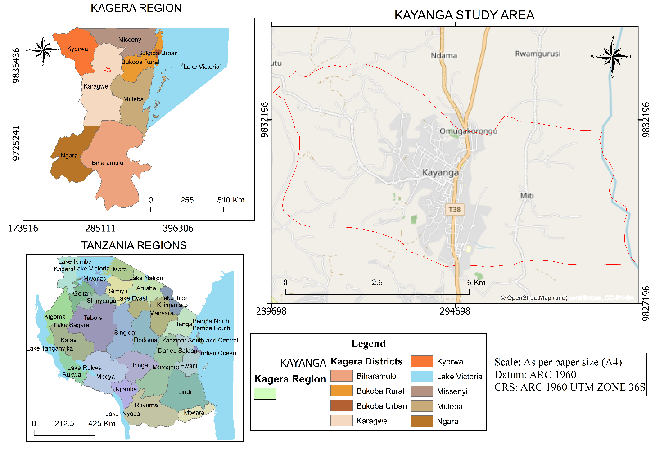

Figure 3. 1: Location map

The post classification comparison method was used to detect area changes and rate changes whereby land cover map of 2019 was compared by land cover map of 2021 and land cover map of 2021 was compared by land cover map of 2023. The following figure 3.2 shows the workflow for this change detection map of urban green space dynamics;

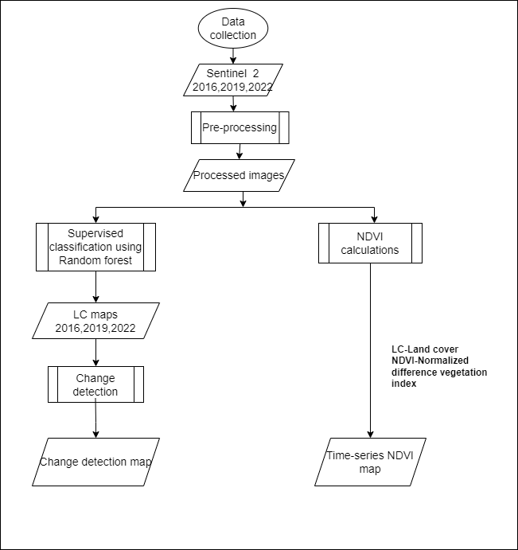

Figure 3. 2: Methodology flowchart

## 3.2 Reconnaissance and data acquisition.

Three (3) Sentinel 2A images with the spatial resolution of 10m were downloaded from The Copernicus Open Access Hub and ([www.](http://www.usgs.gov) earthengine.com) with two (4) epochs of interval of four years that were Sentinel 2A of 2015 to Sentinel 2A of 2019 and Sentinel 2A of 2019 to Sentinel 2A of 2023 of Kayanga ward with the following specifications as shown in table 3.1 below.

## 3.3 Image Pre-Processing.

Preprocessing Sentinel-2A data in Google Earth Engine (GEE) involves several steps to prepare the imagery for further analysis. The following are the typical preprocessing activities for Sentinel-2A data in GEE;

1. Image loading: Sentinel-2A images collection were loaded into GEE using the appropriate dataset identifier available in the data package. The collection was organized into different bands, each representing a specific wavelength range or spectral information.
2. Cloud masking: Sentinel-2A images often contain clouds, which can interfere with the intended spatial analysis. Cloud masking techniques were applied to remove or minimize cloud cover from the imagery. One common method is to use the Sentinel-2 cloud probability band and set a threshold to mask out cloudy pixels.

### 3.3.1 Clipping.

All data was then clipped to the respective study areas through ancillary vector data. Clipping extents were either defined by the spatial extent of the scenes or by administrative boundaries.

## 3.4 Image classification.

The method of supervised classification was employed as a technique of image classification where feature classes were assigned into pixels, and the algorithm used was Random Forest where it performs both regression and classification task and it can handle large dataset efficiently. Each pixel is assigned to the class that has the highest probability. Its accurate classifier (take most variable into consideration and also takes variability of classes into accounts by covariance matrices). It was involved in the selection of classification scheme, selection of training sample, generation of signature files, evaluation of signature files and performing the supervised classification. The classification processed can be summarized in the following steps;

1. Selection of Classes

Anderson level I classification scheme was used during selection of land cover classes which was based on the available ground truth data and resolution of the image used. Due to the nature

of project area four classes were used to represent features as follows;

• Barren

• Vegetation

• Built up area

• Crop land

Table 3. 1: Description of LULC classification scheme

|  |  |
| --- | --- |
| **LULC types** | **Description** |
| **Barren** | Are parts of the land surface which is mainly covered by bare soil. |
| **Vegetation** | All areas covered with natural grass and small shrubs dominated by grass. |
| **Built-up** | Areas allotted for residential, commercial and government and private institution. |
| **Crop land** | Areas of land prepared for growing agricultural crops. This category includes areas currently under crop and land under preparation. |

1. Selection of Training Sample

The training samples were collected by using rectangular polygon icon tool which were used to select small part of the class that was identified and positioned by using the ground truthing data that were collected basing on the selected classes of ground features for Sentinel 2A image of 2023. For other Sentinel 2A images of 2015 and 2019 the spectral reflectance was used to facilitate selection of training samples based on different band combination. The number of pixels based on number of bands were used to select training sample.

1. Generation of Signature Files

After selection of training samples from each class, in addition each class were merged and renamed accordingly. Signature files tend to describe classes and their respective feature’s locations and value determining the general class value used in the classification processes.

1. Selection of Classification Algorithm

After spectral classed being defined in the feature space the Random forest classification algorithm was used to decide how the pixels are assigned to the classes and then performing the classification.

## 3.5 Accuracy assessment.

The accuracy of the classified image of 2023 was assessed by confusion matrix which uses validation data from ground truth as reference, the classified images of 2015 and 2019 were assessed by confusion matrix which uses random points from the google earth as the reference.

## 3.6 Normalized Difference Vegetation Index (NDVI) generation.

After downloading Sentinel images for year 2015, 2019 and 2023.The 8th and 4th bands from sentinel image were useful in calculating NDVI. All this was done by geo-processing tool in ArcMap known as Map Algebra (Raster Calculation).

NDVI was calculated from 8th and 4th bands of sentinel 2A by using the formula from raster calculator in ArcMap which measure the difference near infrared and red light. Near infrared and red light were used because vegetation reflects strongly near infrared and absorb large amount of red light, NDVI is used to estimate density of green in an area of interest. The NDVI was then prepared for three years 2015, 2019 and 2023 and the following was the formula for calculating NDVI



Where:

RED= 4th band

NIR= 8th band

After obtaining NDVI, Kayanga ward shape file was then added as the boundary for the area of interest of the project and then by using spatial analyst tool called mask NDVI of study area was extracted then mapped to produce Kayanga ward map showing NDVI of 2015, 2019 and 2023.

## 3.7 Change detection.

The post classification comparison method was used to detect area changes and rate changes whereby land cover map of 2015 was compared by land cover map of 2019 and land cover map of 2019 was compared by land cover map of 2023.

# CHAPTER FOUR

# RESULT, ANALYSIS AND DISCUSSION

## 4.0 Overview.

This chapter involves data presentation, analysis and interpretation of the project results and products. Aimed at narrating the findings and also to provide the direction on the discussion section of the project.

## 4.1 Image classification results.

The process of classification was done completely based on the classification scheme, selecting of training sample, generation of signature files. The different number of pixels were assigned to the high probability specific class in order to determine the accuracy of the process as shown in table 4.1, 4.2 and 4.3

Table 4. 1: Confusion Matrix for Classified Image of 2015

|  |  |  |  |  |  |  |
| --- | --- | --- | --- | --- | --- | --- |
|  | **Reference class** | | | | | |
| **Classification** | **Land cover** | Vegetation | Crop land | Built up | Barren | TOTAL |
| Vegetation | 17 | 1 | 7 | 1 | 23 |
| Crop land | 13 | 19 | 4 | 1 | 37 |
| Built up | 7 | 2 | 13 | 3 | 25 |
| Barren | 10 | 1 | 0 | 44 | 55 |
| TOTAL | 47 | 23 | 24 | 49 | 140 |
| Overall accuracy % | | | 87.70 | | | |
| Kappa statistics | | | 0.877 | | | |

Table 4. 2: Confusion Matrix for Classified Image of 2019

|  |  |  |  |  |  |  |
| --- | --- | --- | --- | --- | --- | --- |
|  | **Reference class** | | | | | |
| **Classification** | **Land cover** | Vegetation | Crop land | Built up | Barren | TOTAL |
| Vegetation | 24 | 4 | 9 | 2 | 39 |
| Crop land | 5 | 22 | 6 | 1 | 34 |
| Built up | 2 | 0 | 15 | 3 | 20 |
| Barren | 9 | 2 | 0 | 39 | 50 |
| TOTAL | 40 | 28 | 30 | 45 | 143 |
| Overall accuracy % | | | 78.51 | | | |
| Kappa statistics | | | 0.7851 | | | |

Table 4. 3: Confusion Matrix for Classified Image of 2023

|  |  |  |  |  |  |  |
| --- | --- | --- | --- | --- | --- | --- |
|  | **Reference class** | | | | | |
| **Classification** | **Land cover** | Vegetation | Crop land | Built up | Barren | TOTAL |
| Vegetation | 19 | 1 | 9 | 3 | 32 |
| Crop land | 3 | 21 | 6 | 4 | 34 |
| Built up | 4 | 0 | 17 | 7 | 28 |
| Barren | 5 | 2 | 6 | 40 | 53 |
| TOTAL | 31 | 24 | 38 | 54 | 147 |
| Overall accuracy % | | | 77.63 | | | |
| Kappa statistics | | | 0.7763 | | | |

The classification accuracy of the land cover maps was assessed by comparing the trained samples (reference data) that were generated. Table 4.1, 4.2 and 4.3 shows the accuracy report of Kayanga land cover types of year 2015, 2019 and 2023 at the rate of 87.70%, 78.51%, and 77.63% respectively.

## 4.2 Land cover map.

During the classification of the images four land cover were detected and classified which were Barren land, Built up, Vegetation and Crop land and the different land cover maps of different years. Land cover maps of 2015, 2019 and 2023 as shown in figure 4.1.

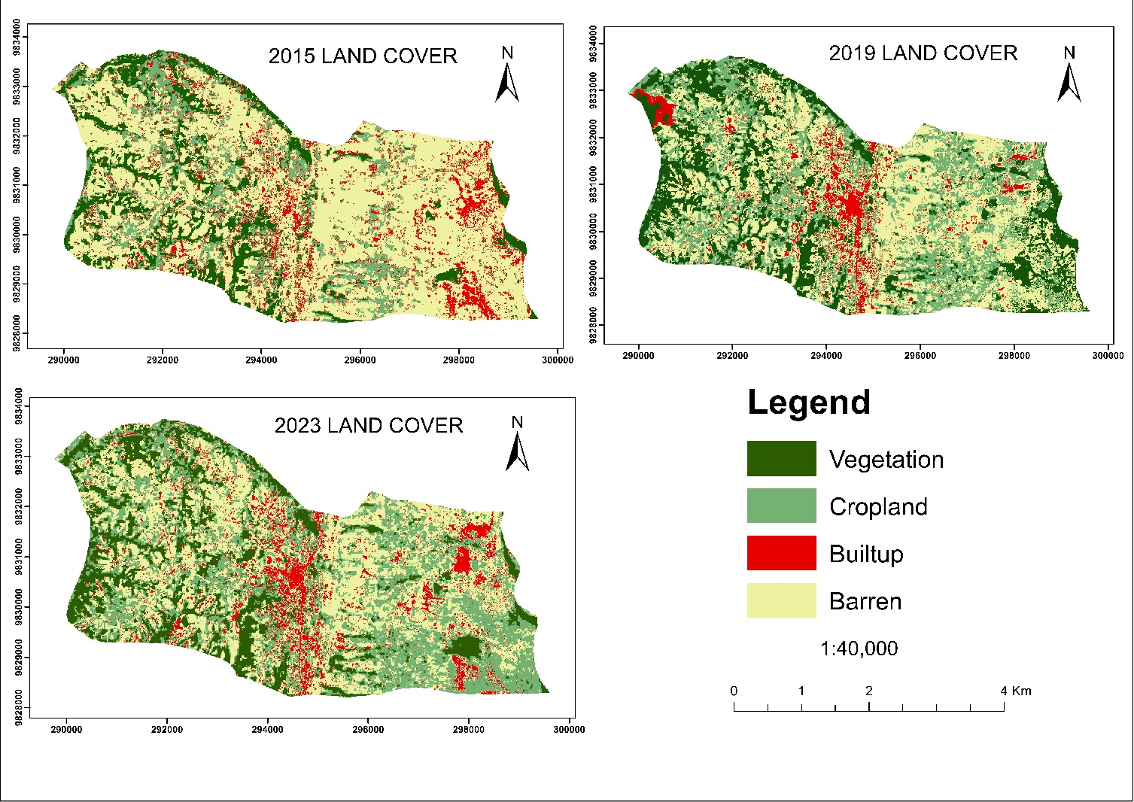

Figure 4. 1: Kayanga land cover map of 2015, 2019 and 2023

The results demonstrated that the changes in urban land-use patterns are affected by urban land-use changes and not only urbanization in Kayanga ward as shown in figure 4.1. From the classified images people establish their settlements at the center of Kayanga ward compared to neighboring areas hence alter the green spaces that supports their living, as the increase of settlements within the center of Kayanga ward is rapid. In the figure below the built-up are increasing from the year 2015 to 2023

## 4.3 Graphical representation of the land cover types from classified images.

The below bar graphs with class area coverages in terms of percent show the graphical representation of the land cover types in the years 2015, 2016 and 2023 respectively as shown in figure (4.4, 4.5 and 4.6) also in table (4.4, 4.5 and 4.6) the percentage compositions of each class out of total land cover for each respective year as shown below. From figures and tables below barren and Cropland are predominant covering the large area ,but the built-up areas are increasing in both years at the rate of (10.73%, 15.27%, and 19.98%) and due to its increase the area covered by vegetation also decrease.

*Table 4. 4: Areas computed from 2015 classified image*

|  |  |  |
| --- | --- | --- |
| **Class** | **Coverage (%)** | **Area (sq km)** |
| **Vegetation** | 14.41 | 5.13 |
| **Cropland** | 15.56 | 5.53 |
| **Built-up** | 10.73 | 3.81 |
| **Barren** | 59.30 | 21.09 |

Table 4. 5: Areas computed from 2019 classified image

|  |  |  |
| --- | --- | --- |
| **Class** | **Coverage (%)** | **Area (sq km)** |
| **Vegetation** | 18.32 | 6.51 |
| **Cropland** | 30.11 | 10.78 |
| **Built-up** | 15.27 | 4.30 |
| **Barren** | 36.30 | 13.97 |

Table 4. 6: Areas computed from 2023 classified image

|  |  |  |
| --- | --- | --- |
| **Class** | **Coverage (%)** | **Area (sq km)** |
| **Vegetation** | 16.15 | 4.23 |
| **Cropland** | 24.55 | 9.80 |
| **Built-up** | 19.98 | 6.48 |
| **Barren** | 39.32 | 15.05 |

Figure 4. 2: Histogram representation of the 2015 land cover types

Figure 4. 3: Histogram representation of the 2019 land cover types

Figure 4. 4: Histogram representation of the 2023 land cover types

## 4.4 Normalized difference vegetation index maps.

These maps were obtained through a band ratio of the Red and Near Infrared Bands to which we obtained the NDVI values which are used to indicate the health of the vegetation, the values vary from -1 to 1. Hence the values obtained showed the variation of the vegetation cover in different years from 2015 to 2023.

Table 4. 7: NDVI value

|  |  |
| --- | --- |
| **Images year** | **NDVI value range** |
| **2015** | 0.012 - 0.772 |
| **2019** | -0.049 - 0.896 |
| **2023** | -0.051 – 0.649 |

The NDVI analysis was employed in order to show the vegetation cover transition. In 2015, the NDVI value was ranging from 0.012 to 0.772 witnessing a high vegetation cover whereas in 2019 and 2023 the value declined from -0.049–0.896 and -0.051–0.649 respectively (Table 4.7).

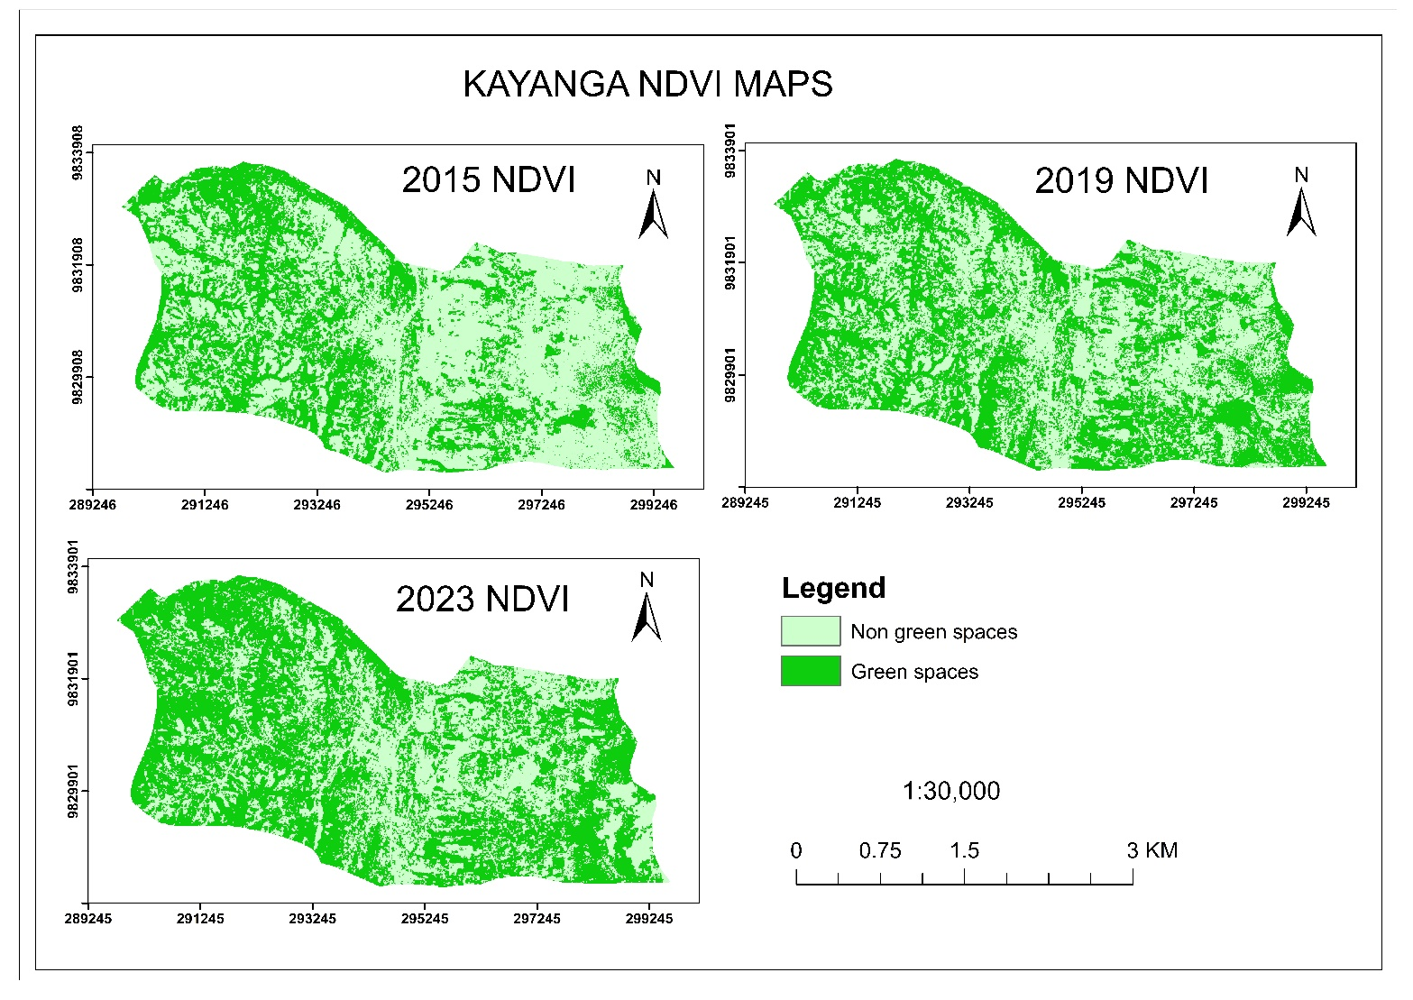

Figure 4. 5: Kayanga urban green-space map

From the results of NDVI obtained the legend indicates that the area with non-vegetation no green spaces due to some factors like low amount of rainfall and increased settlements due to urbanization, but for the case of vegetation the green spaces are secured. Figure 4.5, shows the Normalized Difference Vegetation indices of three consecutive years of 2015, 2019 and 2023. Therefore, vegetation covers have been transformed to other LULC unit such as built-up, cropland and barren land.

## 4.5 Change detection map.

The changes that have occurred in a series of 8 years were analyzed. Various pixel values of defined classes had changed, where some increased, decreased while some remained the same as they were initially. Based on the LULC classification, the major part of the area was covered by barren land in 2015 later shifted to built-up area. In 2015, vegetation, cropland, and built-up were covered 14.41%, 15.56%, and 10.73% of the total area respectively. In 2019, barren land, cropland, built-up and vegetation covered 36.30%, 30.11%, 15.27% and 18.32% of the total area respectively. The built-up area was occupied by (19.98%) and the remaining 80.2% were covered by other LULC classes in 2023. To some extent in the classification, the vegetation LULC type was decreasing from 2019 to 2023, but as evident in the field observation, vegetation is highly diminished due to urbanization and increase of cultivated land. The built-up cover has been increasing since the year 2015 in the order of 10.73% for 2015, 15.27% for 2019 and 19.98% for 2023. The change detection results for 2015 to 2023 were represented on the land cover change image as shown in (figure 4.6, 4.7 and 4.8) and table 4.8 below.

Table 4. 8: LULC transformation processes between 2015, 2019 and 2023

|  |  |  |  |  |  |  |  |  |  |  |  |  |
| --- | --- | --- | --- | --- | --- | --- | --- | --- | --- | --- | --- | --- |
| **LULC CLASS** | **2015** | | **2019** | | **2023** | | **Change 2015-2019** | | **Change 2019-2013** | | **Change 2015-2023** | |
| **sq. km** | **%** | **sq. km** | **%** | **sq. km** | **%** | **sq. km** | **%** | **sq. km** | **%** | **sq. km** | **%** |
| **Vegetation** | 5.13 | 14.41 | 6.51 | 18.32 | 4.23 | 16.15 | 1.38 | 3.90 | -2.28 | -2.17 | -0.90 | 1.74 |
| **Crop land** | 5.53 | 15.56 | 10.78 | 30.11 | 9.80 | 24.55 | 5.25 | 17.56 | -0.98 | -5.56 | 4.27 | 8.99 |
| **Built up** | 3.81 | 10.73 | 4.30 | 15.27 | 6.48 | 19.98 | 0.49 | 4.54 | 2.18 | 4.71 | 2.67 | 9.23 |
| **Barren** | 21.09 | 59.30 | 13.97 | 36.30 | 15.05 | 39.32 | -7.12 | -20.00 | 1.08 | 3.02 | -6.04 | -19.98 |
| **Total** | 35.56 | 100.00 | 35.56 | 100.00 | 35.56 | 100.00 |  |  |  |  |  |  |

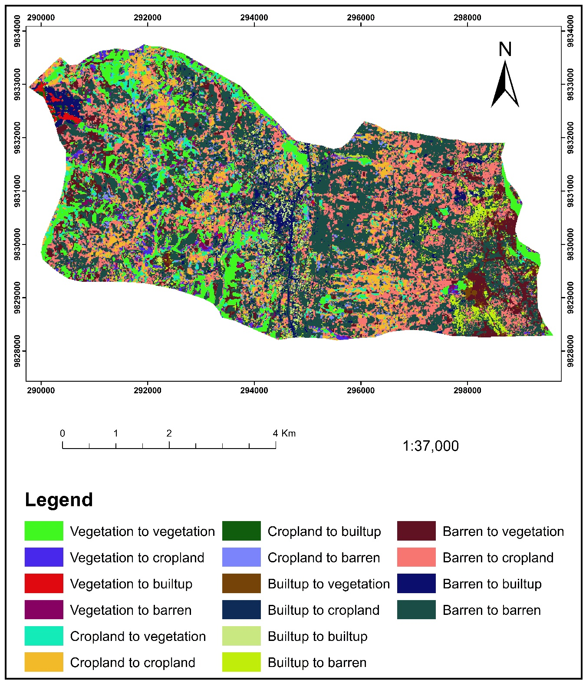

*Figure 4. 6: A land cover change map from 2015 to 2023*

By this period detected changes were as follows, vegetation decreased by 1.74% followed by cropland that decreased by 8.99% but the built-up increased by the rate of 9.23%. This increase of settlements caused green spaces to decrease. Hence the overall increase of settlements in Kayanga ward led to the decrease of green spaces.

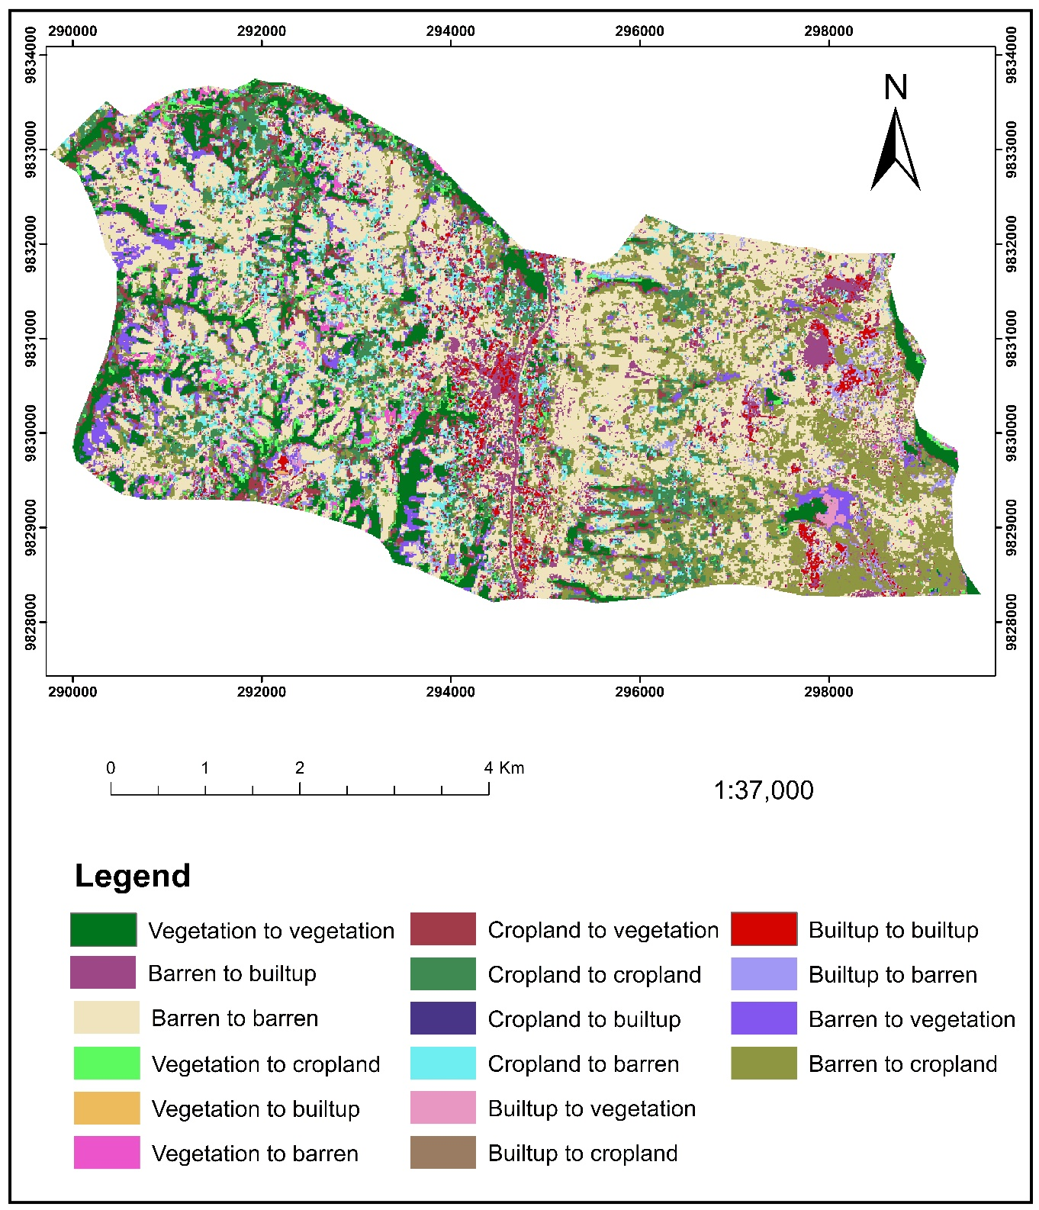

*Figure 4. 7: A land cover change map from 2015 to 2019*

By this period detected changes were as follows, vegetation increased by 3.90% followed by cropland that increased by 17.56% and built-up increased by the rate of 4.54%, for this case the barren land decreased and other experienced positive changes.

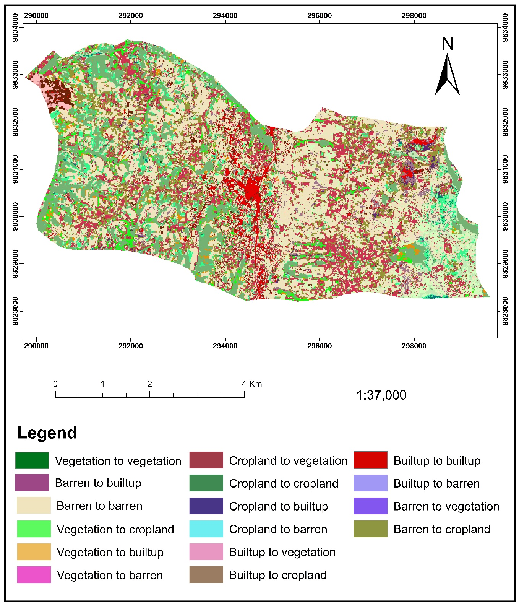

*Figure 4. 8: A land cover change map from 2019 to 2023*

By this period detected changes were as follows, vegetation decreased by -2.17% followed by cropland that decreased by -5.56% and built-up increased by the rate of 4.71%, for this case settlements increased at this period thus reducing the green spaces.

# CHAPTER FIVE

# CONCLUSION AND RECOMMENDATION

## 5.1 Conclusion.

Decline in vegetation cover, there is a significant decline in vegetation cover over the years, and built-up area increasing from 10.73% in 2015 to 19.98% in 2023. This indicates ongoing urbanization at Kayanga Township. At present the green spaces of Kayanga are almost transformed to urban habitats. Unsustainable use of land, climatic conditions, uncoordinated urban development and insecure land tenure system might be the source of these prime problems. Added to these, lack of public awareness, low level of community participation, poor implementation of government policies, lack of budget, lack of skilled manpower, shortage of land, illegal settlement, problem of regular follow-up, problem of pollution from different sources and lack of cooperation among different stakeholders have contributed to the shrinking of green spaces in Kayanga ward. The study also witnessed the power of remote sensing and GIS technologies in capturing and analyzing land use/ land cover changes and dynamics of urban green spaces with urbanization.

## 5.2 Recommendation.

For the research to provide more accurate results the socio-economic factors that influence urbanization changes should be considered. These factors includes incorporate demographic data, economic indicators and infrastructure development information to gain a holistic understanding of the drivers and impacts of urbanization. Also, the research should integrate spatial analytics techniques to extract valuable information from urban space dynamics, the tools include hotspots of urban growth and areas of concern for better urban planning and management.

# REFERENCES

As-syakur, A. R. (2021). *Remote sensing applications in agriculture, land use, and water resources*: A comprehensive review. Journal of Remote Sensing and GIS, 9(3), 100032.

Baycan-Levent and Nijjkamp. *Planning and Management of Urban Green Spaces in Europe*: *Comparative Analysis*, March 2009 [*Journal of Urban Planning and Development*](https://www.researchgate.net/journal/Journal-of-Urban-Planning-and-Development-0733-9488) 135(1)

Cao, X., & Chen, L. (2019). *Assessing urban green space pattern dynamics using remote sensing and landscape metrics*: a case study in Wuhan, China. International Journal of Environmental Research and Public Health, 16(3), 446.

Chen, T.; Huang, Q.; Liu, M.; Li, M.; Qu, L.A.; Deng, S.; Chen, D*. Decreasing Net Primary Productivity in Response to Urbanization in Liaoning Province, China*. *Sustainability* 2017, 9, 162

Dimitrov, S.; Georgiev, G.; Georgieva, M.; Gluschkova, M.; Chepisheva, V.; Mirchev, P.; Zhiyanski, M. *Integrated assessment of urban green infrastructure condition in karlovo urban area by in-situ observations and remote sensing*. One Ecosyst. 2018.

Haaland, C.; van Den Bosch, C.K. Challenges and strategies for urban green-space planning in cities undergoing densification: A review. *Urban For. Urban Green*. 2015, 14, 760–771.

Howison, R.A.; Piersma, T.; Kentie, R.; Hooijmeijer, J.C.; Olff, H. *Quantifying landscape-level land-use intensity patterns through radar-based remote sensing*. J. *Appl. Ecol*. 2018, 55, 1276–1287

Huang, J., Lu, X., Liu, J., & Ma, X. (2019). *Hotspot analysis of green space changes and their driving factors in the urbanization process*. Science of the Total Environment, 670, 746-754.

Jain, M. K. (2021). *Remote sensing for monitoring and assessing changes in land cover, vegetation, and water resources:* A comprehensive review. Journal of Environmental Monitoring and Assessment, 193(2), 1-23.

Jim, C.Y. and Chen, W. (2006) *Recreation-Amenity Use and Contingent Valuation of Urban Green Spaces in Guangzhou, China*. Landscape and Urban Planning, 75, 81-96

Lee, A.C.; Maheswaran, R. The health benefits of urban green spaces: A review of the evidence. J. *Public Health* 2011, 33, 212–222

Li, L., Wu, X., Xie, H., & Wu, C. (2019). *Monitoring urban green space change and landscape connectivity in a compact urban area.* Landscape and Urban Planning, 184, 100-110.

Li, W., & Zhou, W. (2018). *Urban green space change and its impacts on air quality and human health in urban areas of Shanghai*, *China*. Journal of Environmental Management, 206, 676-684.

Lillisand,, T., Kiefer, R., & Chipman, , J. (2007). *Remote sensing and Image interpretation. .* John Wiley & Sons.

Liu, X., Yin, S., Zhang, Z., & Yin, Z. (2017). *Analyzing the change of green space pattern and its driving forces in urban areas:* A case study of Guangzhou, China. Sustainability, 9(6), 1034.

LO, C.P. *Applied Remote Sensing*. Longman: New York, NY, USA, 1986

Longley, P. A., Goodchild, M. F., & Smith, M. (2011). *Geospatial Analysis - a comprehensive guide, 3rd edition.* Leicester: Troubador Publishing Ltd.

Mather, P., & Koch, M. (2011). *Computer Processing of Remotely-Sensed Images.* WileyBlackwell.

Meng, Q.; Zhang, L.; Sun, Z.; Meng, F.; Wang, L.; Sun, Y. *Characterizing spatial and temporal trends of surface urban heat island effect in an urban main built-up area*: A 12-year case study in Beijing, China. *Remote Sens. Environ*. 2018, 204, 826–837

Olembo, R. J., Rhan, P. (1987). *Urban forestry; cities, trees and people*. *Unasylva*, 155

Rehna , v., & Natya, J. (2016). *Land cover classification schemes using Remote sensing images.*

URGE-Team (2004) *Making Greener Cities – A Practical Guide*. UFZ-Bericht, 8(37) (Stadtökologische Forschungen)

Wang, R., Li, X., Zhang, Y., & Lu, J. (2019). *Mapping urban green space patterns and assessing their changes in Shanghai, China, from 1990 to 2015*. Urban Forestry & Urban Greening, 44, 126411.

Wu, C., Peng, J., & Zhang, Y. (2019). *Exploring spatial patterns of urban green space fragmentation using high-resolution remote sensing data and landscape metrics*. Urban Forestry & Urban Greening, 42, 41-51.

Xian, G., and Crane, M. (2006). *An Analysis of Urban Thermal Characteristics and Associated Land Cover in Tampa Bay and Las Vegas Using Landsat Satellite Data*. *Remote Sensing Environ*. 104 (2), 147-156.

Xiao, Y., Zhang, J., & Zhang, L. (2020). *Analyzing the spatial-temporal change of urban green space pattern and its driving factors using GIS and landscape metrics*. Journal of Cleaner Production, 256, 120418.

Yang, W., Li, X., Zheng, H., & Zheng, Z. (2020). *Analyzing the spatial pattern of urban green spaces and their determinants using geographically weighted regression*:

Yang, Y., Xiao, R., Li, X., & Li, Y. (2020). *Exploring the spatiotemporal patterns of urban green space*: A case study in Wuhan, China. ISPRS International Journal of Geo-Information, 9(9), 560.

Zhang, H., Zhang, P., & Wang, S. (2018). *Analysis of the spatial pattern and temporal change of urban green space in Beijing, China.* Sustainability, 10(9), 3214.

Zhang, X., Tian, X., & Huang, C. (2019). *Quantitative analysis of urban green space patterns and landscape connectivity in Beijing, China*. Urban Forestry & Urban Greening, 39, 71-79.

Zhou, Y., & Weng, Q. (2018). *Evaluating the effect of urbanization on green space pattern and landscape connectivity using multi-temporal remote sensing data*. Landscape and Urban Planning, 175, 98-108.

Zhou, Y., Zhang, Y., & Zhou, Y. (2017). *Evaluation of urban green space pattern change in Hangzhou city, China*. Ecological Indicators, 83, 238-248.