**ARDHI UNIVERSITY**



**ENHANCING ACCESS TO THE NHC HOUSES THROUGH WEB GIS DECISION SUPPORT SYSTEM.**

**A Case Study of Dar es Salaam**

**GADIEL SIMON MVAMBA**

**BSc Geoinformatics**

**Dissertation**

**Ardhi University, Dar es Salaam**

**July, 2023**

ENHANCING ACCESS TO THE NHC HOUSES THROUGH WEB GIS DECISION SUPPORT SYSTEM

A Case Study of Dar es Salaam

BY

GADIEL SIMON MVAMBA

A Dissertation Submitted to the Department of Geospatial Sciences and Technology in Partially Fulfilment of the Requirements for the Award of Science in Geoinformatics (BSc. GI) of Ardhi University

**CERTIFICATION**

The undersigned certify that they have read and hereby recommend for acceptance by the Ardhi University dissertation titled **“Enhancing Access to the NHC Houses through Web GIS Decision Support System.”** in partial fulfillment of the requirements for the award of degree of Bachelor of Science in Geoinformatics at Ardhi University.

………………………………… ……………………………..

**Dr. Zakaria Ngereja .** **Mr. Michael Mavura.**

Date ……………………… Date ………………………

**DECLARATION AND COPYRIGHT**

I, GADIEL SIMON MVAMBA declare that this dissertation is my own original work and that to the best of my knowledge, it has not been presented to any other University for a similar or any other degree award except where due acknowledgements have been made in the text.

………………………………..

**GADIEL SIMON MVAMBA**

22716/T.2019

Copyright ©1999 This dissertation is the copyright material presented under Berne convention, the copyright act of 1999 and other international and national enactments, in that belief, on intellectual property. It may not be reproduced by any means, in full or in part, except for short extracts in fair dealing; for research or private study, critical scholarly review or discourse with an acknowledgement, without the written permission of the directorate of undergraduate studies, on behalf of both the author and Ardhi University.

**ACKNOWLEDGEMENT**

I begin by expressing my heartfelt gratitude to the Almighty God for bestowing upon me the strength, wisdom, and perseverance to undertake and complete this dissertation. Without divine guidance and blessings, this journey would not have been possible.

I am deeply indebted to my supervisor, DR. ZAKARIA ROBERT NGEREJA and MR MICHAEL MAVURA, whose unwavering support, expertise, and mentorship have been indispensable throughout the entire process. Their guidance has shaped my research and sharpened my academic abilities, and for that, I am profoundly grateful.

I would like to extend this appreciation to the staff members of Geospatial Science and Technology Department for their moral and academic support. I am truly grateful for all your help.

I wouldn’t be grateful if I didn’t thank my friends Hilguard Mawondo, Yusuph H Hasani, Gulamali Said, Laura Mboya and all my classmates for their assistance, encouragement and support in my academic journey and in completion of this dissertation.

To all those mentioned above and anyone else who has contributed to this dissertation, whether directly or indirectly, I offer my sincerest thanks. Your unwavering support, guidance, and encouragement have made an indelible impact on this work, and I am profoundly grateful for your contributions.

May God add where you have sacrificed for my sake.

I would like to thank myself for my hard work and dedication on this project. I am grateful for my own perseverance and determination. I am also thankful for my own willingness to learn and grow. I am proud of the work that I have done, and I am confident that it will make a positive contribution to the field.

**DEDICATION**

*I dedicate this dissertation to my beloved family Mr & Mrs. Mvamba, Peter and Navone who have been my unwavering source of love, support, and inspiration. Throughout this arduous journey, you have stood by me with unwavering belief in my abilities, providing the encouragement and understanding needed to overcome challenges. This achievement would not have been possible without your love, guidance, and unwavering support. This dissertation is a testament to the strength and unity of our family, and I dedicate it to you with deepest gratitude and love.*

# ABSTRACT

This dissertation aims to enhance access to Tanzania National Housing Cooperation houses through the development of a web GIS decision support system. The current system for accessing national housing lacks features that allow potential renters to explore and understand properties based on factors such as location, size, proximity to essential facilities, and transportation networks which make it time-consuming and frustrating for renter. The scope of the study focuses on the development of a web GIS platform that utilizes spatial components to map and visualize the distribution of national housing across the country. Users will have the ability to view the locations of available properties in relation to their workplace, place of worship, schools, hospitals, parks, and shopping centers. The system aims to facilitate informed decision-making by providing renters with comprehensive information about the properties and their surroundings. The waterfall methodology used guides the development of a web GIS with OpenLayers and GeoServer through a step-by-step process. It starts with gathering user requirements, followed by designing the system's architecture and user interface. The development of the geographical user interface (GUI) involved setting up the backend infrastructure with GeoServer and PostgreSQL/PostGIS for spatial and non-spatial data storage and management. The frontend GUI was designed using languages HTML, CSS and Java script library OpenLayers, allowing for map display and customization functionality. According to user requirements interactions to system is abled and spatial data querying is implemented using GeoServer's services.

In conclusion, web GIS decision support system has the potential to greatly improve access to TNHC houses by empowering users with the ability to explore, compare, and make informed decisions about their housing options. It contributes to data management, spatial analysis, and enhanced accessibility to national housing information, ultimately facilitating a more efficient and effective housing search process.

**TABLE OF CONTENTS**

CERTIFICATION ii

DECLARATION AND COPYRIGHT ii

ACKNOWLEDGMENTS iv

DEDICATION v

ABSTRACT vi

LIST OF FIGURES xi

LIST OF TABLES xii

ACRONYMS AND ABBREVIATIONS xiii

CHAPTER ONE 1

1. INTRODUCTION 1

1.1 Background of the study 1

1.2 Problem Statement 2

1.3 Research Objectives 3

1.3.1 Main Objective 3

1.3.2 Specific Objective 3

1.4 Research questions. 3

1.5 Scope and Limitations 3

1.6 Significance of the Research 3

1.7 Beneficiaries 4

1.8 Case study 4

1.9 Dissertation organization 5

CHAPTER TWO 6

2. LITERATURE REVIEW 6

2.1 Overview 6

2.2 Web-GIS, House Accessibility, Decision Support System and Location Based Services are Related 6

2.2.1Web-GIS 6

2.2.2 House Accessibility 6

2.2.3 Decision Support System 7

2.2.4 Location Based Services 7

2.2.5 How Web-GIS, House Accessibility, Decision Support System and Location Based Services are Related? 7

2.3 Advances in GIS 8

2.3.1 Desktop GIS (Stand-alone GIS) 8

2.3.2 Server GIS (Client-server GIS) 9

2.3.3 Web GIS 9

2.3.4 Distributed GIS 9

2.3.5 Trends in GIS 9

2.3.6 GIS in the cloud 9

2.3.7 Real-time GIS 9

2.3.8 Image/raster analytics 9

2.3.9 Spatial analysis & data science 10

2.3.10 GIS in the field 10

2.4 Web GIS system design 10

2.4.1 Defining the requirements: 10

2.4.2 Choosing a platform: 11

2.4.3 Designing the database 11

2.4.4. Creating the user interface 12

2.4.5. Developing the back-end and fore end of web GIS: 13

2.4.6. Testing and deploying: 14

2.5 How Web GIS operate. 14

2.6 Web GIS for access to rental houses 16

2.6.1 Ways that Web GIS DSS can be used to enhance access to housing: 16

CHAPTER THREE 18

3. METHODOLOGY 18

3.1 Overview 18

3.2 Identifying user requirements 19

3.3 System designing 19

3.4 Data collection and software selection. 20

3.5 Data processing 21

3.6 Geodatabase development 21

3.6.1 PostgreSQL and PostGIS installation 21

3.6.2 Loading Shapefiles into the PostgreSQL Database 21

3.7 Web development 22

3.8 Development of the geographical user interface 24

3.9 System testing 25

CHAPTER FOUR 26

4.RESULTS AND ANALYSIS 26

4.1 Overview 26

4.2 User requirements 26

4.3 Design and structure of the system 27

4.4 Geodatabase 27

4.5 Web GIS system and prototype validation 28

4.5.1 Zoom in and out/panning/switching on and off the layers 28

4.5.2 Measurements of distance, area and location coordinates 29

4.5.3 Pop ups of attribute data of spatial features 29

4.5.4 Finding the location of national house 30

4.5.5 Add WMS available layer. 31

4.5.6 link to google map 31

4.6 Discussion 32

CHAPTER FIVE 33

5.CONCLUSION AND RECOMMENDATION 33

5.1 Conclusion 33

5.2 Recommendation 33

REFERENCES. 34

# LIST OF FIGURES

Figure 1.1 Location map of the study area 5

Figure 2.1 Advances in GIS 8

Figure 2.2 How Web-GIS work 15

Figure 2.3 GIS data from a web GIS system 16

Figure 3.1 Workflow of the research 18

Figure 3.2 illustrates the design and structure of the system 19

Figure 3.3 PostGIS connect PostgreSQL and shapefiles view in the database 22

Figure 3.4 GeoServer running in Apache Tomcat Server 23

Figure 3.5 Published layers in Geoserver 23

Figure 3.6 Code workplace 25

Figure 3.7 Structure of web-based GIS 27

Figure 3.8 View of non-spatial data geodatabase 28

Figure 3.9 Switching on and off layers and zoom in and out functionalities 29

Figure 3.10 Distance and area measurement functionalities in the system. 29

Figure 3.11 Attribute pop ups functionalities in the system. 30

Figure 3.12 Place search and user location identification functionalities. 30

Figure 3.13 View, adding, updating WMS available layer 31

Figure 3.14 link to google map. 31

# LIST OF TABLES

Table 1 software package needed for Web GIS system development 20

Table 2 data needed for Web GIS system development 21

Table 3 User requirements 26

# ACRONYMS AND ABBREVIATIONS

|  |  |
| --- | --- |
| TNHC | Tanzania National Housing Cooperation |
| HTTP | Hypertext Transfer Protocol |
| PHP | Hypertext Preprocessor |
| CSV | Comma-Separated values |
| GIS | Geographical information system |
| GUI | Geographical User Interface |
| DSS | Decision Support System |
| LBS | Location Based System |
| GPS | Geographical Position System |
| CSS | Cascading Style Sheet |
| URL | Universal Resource Locator |

# CHAPTER ONE

# INTRODUCTION

## 1.1 Background of the study

Tanzania has a population of 61.7 million people in 2022(NBS, 2022). With a growth rate of over 3 percent a year, Tanzania as fastest rate of population growth in the world, by 2030 the number of people in Tanzania is projected to increase to over 80 million and by 2050 it could exceed 130 million people. Tanzania had 12.3 million households in 2018 of which 8.2 million (66 percent) are in rural areas and 4.2 million (34 percent) are in urban areas. Over the next five years, the number of households in rural areas will increase by 255,000 a year and urban households by 130,000 per year. This rapid urbanization, coupled with a reducing average household size, will require consistently larger numbers of smaller, more affordable housing units to satisfy urban housing demand from rural-urban migrants and newly- formed families in urban areas (Gardner et al., 2019).

Tanzania’s housing demand will be met through following processes, most likely in the following order of scale. First, through the rapid expansion of informal rental accommodation, mostly in the form of Chumba accommodation in slum areas. Second, existing built-up areas will face increased population densities through greater co-living arrangements. Third, existing accommodation will be extended to accommodate larger or multiple households. Fourth, households able to access land will build their houses incrementally; and finally, through formal accommodation development, sale and rental (national housing)(Gardner et al., 2019) .A formal accommodation development in Tanzania that works in collaboration with the private sector to develop new housing projects and manages a portfolio of properties, including rental homes and commercial properties is Tanzania national house cooperation (TNHC).

The advent of the web has transformed everything around us and GIS is no exception. Web-GIS is the pattern or architectural approach for implementing the modern GIS. It enables the distribution of maps and processing tools without time and location restriction to users(Liu et al., 2021). Web-GIS allows visual interaction with the geospatial data on the web (either on our mobile phones, desktop software, tablets or practically anywhere with a web browser) (Tek & Emmanuel, 2021). Progress made in information technology has greatly opened up the number of opportunities supporting data analyses and communications in the recent years. A Geographic Information System allows one to create and manage spatially referenced data which is useful for any field or situation that utilizes spatial information(Aydinoglu & Bovkir, 2020).GIS enables spatial analysis and the location of geographically scattered facilities in the distribution network of a buildings.

Access to suitable and affordable housing plays a vital role in ensuring a high quality of life for individuals and families. However, the current system of national housing accessibility presents significant challenges for individuals seeking to rent NHC houses. The available system falls short in providing comprehensive information and tools for users to explore and understand properties effectively. As a result, potential renters or buyers struggle to make informed decisions about housing options due to the lack of consideration for crucial factors such as property location, size, and proximity to essential amenities(Liu et al., 2021)

To address these limitations and improve access to NHC houses, this research aims to develop a web GIS decision support system. By integrating spatial components and advanced mapping techniques, this system will enable users to explore, compare, and select NHC houses based on their specific requirements and preferences. The system will provide a user-friendly and interactive platform that visualizes the locations of available properties in relation to workplaces, schools, hospitals, parks, shopping centers, and other essential places. This comprehensive approach to housing accessibility aims to empower individuals in making well-informed decisions about their living arrangements

## 1.2 Problem Statement

The existing national housing accessibility system is time-consuming and frustrating for renters to filter and find properties that meet their specific criteria such as property location, size, proximity to main roads, and visual representation of nearby amenities such as schools, hospitals, parks, and shopping centers. Consequently, there is a lack of comprehensive information and visualization tools for users to explore and evaluate housing options. This research aims to address these limitations by developing a web-based spatial decision support system that enhances the search and selection process for Tanzania National Housing Cooperation houses.

## 1.3 Research Objectives

### 1.3.1 Main Objective

To create a web-based GIS for spatial decision support system to improve search and selection TNHC houses.

### 1.3.2 Specific Objective

1. To examine the existing national housing management system and identify user requirements.
2. To design a web system that contains national houses Geodatabase.
3. To develop a one stop Geodatabase for both national houses and spatial surrounding for NHC houses.

## 1.4 Research questions.

In this study, the following questions are answered,

1. What is the existing national housing management system? What are the needs of the users?
2. Is the infrastructure of the existing databases effective? Is it possible to create one stop Geodatabase for national houses and spatial data?
3. Can national house’s locations and spatial data be displayed and manipulated in one web interactive interface?

## 1.5 Scope and Limitations

This study will base on developing Web GIS for national housing cooperation using spatial components for mapping in order to explore the distribution of national housing across the country. Also, will enable renters to visualize the locations of available properties in relation to their workplace, place of worship and other important places such as nearby schools, hospitals, parks, and shopping centers, this information’s help renters to make informed decisions about where to live. Although, other information’s such as lease terms, cost for rent or price of the property, additional fees for security, water and electricity supply will not be included.

## 1.6 Significance of the Research

The significance of this study lies in the development of a web GIS (Geographic Information System) for the national housing cooperation, which provides advanced mapping and analysis capabilities to improve data management and accessibility to national housing information. The web GIS platform enables customers to access detailed and comprehensive information about specific rental or sales properties, facilitating informed decision-making. Moreover, by visualizing the locations of available properties in relation to workplaces, places of worship, schools, hospitals, parks, and shopping centers, the system empowers renters to make informed decisions about their living arrangements. This research contributes to enhancing the housing search process by integrating spatial components, promoting efficient and informed decision-making, and improving overall accessibility to national housing resources.

## 1.7 Beneficiaries

Potential beneficiaries, of a web-based Geographical Information System (GIS) for enhancing national housing accessibility can be grouped into several categories:

1. Governments: National, regional, and local governments are able to use the GIS system to make informed decisions about housing policies and programs.
2. Housing organizations: Non-profit organizations, housing authorities, and other groups involved in providing housing services benefit from having access to accurate and up-to-date information about housing.
3. Private sector organizations: Private sector organizations such as real estate developers, property managers, and lenders can benefit from having access to comprehensive data about housing and accessibility.
4. Individuals: The general public are able to use the GIS system to find information about housing, accessibility, and affordability in their local area, allowing them to make informed decisions about where to live.

## 1.8 Case study

Study area will be Dar es salaam region, located at 6°48' S, 39°17' E of Tanzania on a natural harbor on the coast of East Africa. Dar es salaam is among of 31 regions of Tanzania with a population of 5,383,728 people which is 8.7 percentage of Tanzania population according to census 2022. More than three-quarters of the city's population live in informal settlements. The city has 5.6% average annual growth rate which is the highest in the country. Therefore, population of Dar es salaam is expected to be high as 13.4 million by 2035. NHC has total 164 houses of which 42 percentage is in Dar es salaam this large number of national houses is associated with increase in demand due to factors such as rural-urban migrants and newly- formed families in urban areas.

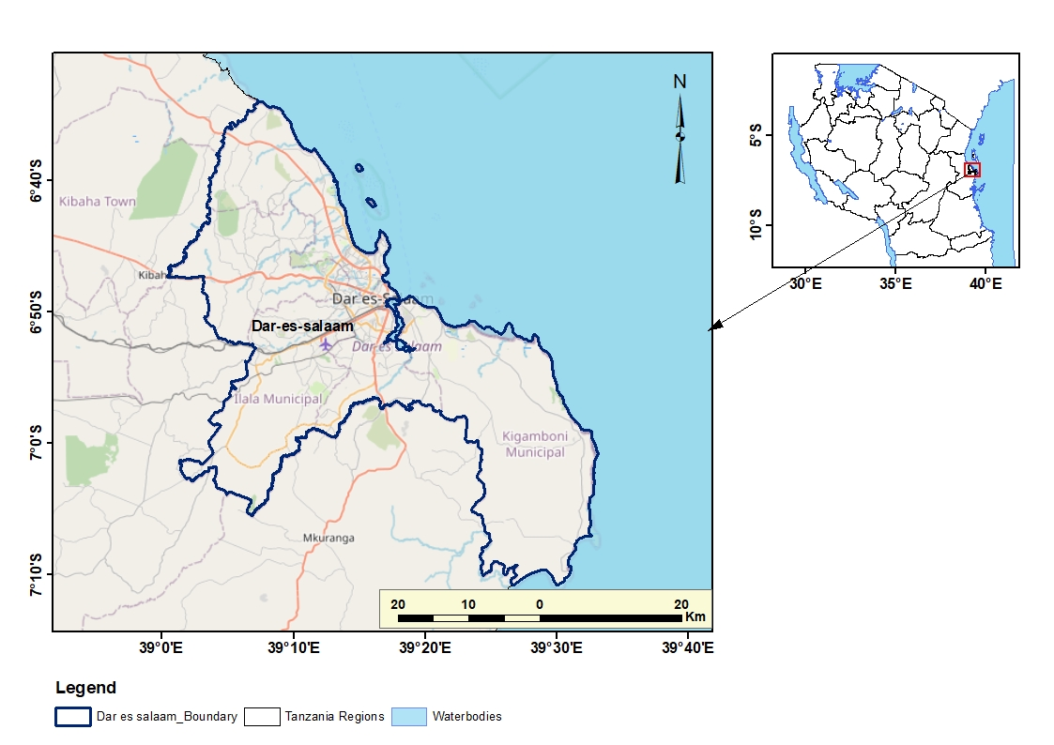

Figure 1.1 Location map of the study area

## 1.9 Dissertation organization

This dissertation consists of five chapters, explaining in detail all the methods, principles, procedures and the results obtained in developing Web-based GIS system for supporting decision making in selecting national house.

Chapter 1 explains the background of the study, which gave rise to the problem. The objectives, research questions, significance and beneficiaries of the research, together with the description of the study area.

Chapter 2 gives the review of the study. It explains all literatures and studies done in relation to developing a web-based GIS system. This chapter shows also how other authority system in developed countries work.

Chapter 3 covers all the methods and techniques involved in the study.

Chapter 4 provides the analysis and discussion of the results. It shows the results obtained in this study and the results obtained by previous studies.

Chapter 5 provides conclusion and recommendation of the study.

# CHAPTER TWO

# LITERATURE REVIEW

## 2.1 Overview

Studies in this chapter provides a literature review on the understanding of the study through Previous. It sets the course of the study through applying techniques used in previous researches and establish the gap. This chapter provides a review of literatures related to Web-GIS, house accessibility, and Location based services. How other researchers think about the advantage of accessibility to houses and support in decision making through web based GIS will be discussed also in this chapter.

Web GIS Decision Support System (DSS) aimed at enhancing access to houses. The system leverages Geographic Information System (GIS) technology and web-based platforms to provide users with efficient tools and data to support decision-making related to accessing residential properties. The DSS integrates spatial data, such as road networks, property locations, transportation options, and socio-economic factors, to provide users with valuable insights and analysis capabilities. This chapter discusses the key components of the Web GIS DSS, including data collection and integration, user interface design, and decision support functionalities

## 2.2 Web-GIS, House Accessibility, Decision Support System and Location Based Services are Related

### 2.2.1Web-GIS

Web-GIS is a geographic information system (GIS) that is accessible through the web. This means that users can access and interact with GIS data and maps through a web browser. Web-GIS has a number of advantages over traditional GIS, including:

* Increased accessibility: Web-GIS can be accessed from anywhere with an internet connection, making it more accessible to a wider range of users.
* Reduced cost: Web-GIS can be hosted on a server, which can reduce the cost of hardware and software.
* Improved collaboration: Web-GIS can be used to collaborate with others on projects, which can lead to better decision-making.

### 2.2.2 House Accessibility

House accessibility is the ability of people to access and use houses. This can be affected by a number of factors, including:

* The physical layout of the house
* The presence of accessibility features
* The distance to amenities

### 2.2.3 Decision Support System

A decision support system (DSS) is a computer-based system that helps users make decisions. DSSs typically use data, models, and analytical tools to help users identify and evaluate alternatives. DSSs can be used in a wide variety of settings, including business, government, and healthcare(Coetzee et al., 2021).

### 2.2.4 Location Based Services

Location based services (LBS) are a type of mobile service that provides information based on the user's location. LBSs typically use GPS or cellular data to determine the user's location. LBSs can be used for a variety of purposes, including:

* Finding directions
* Finding businesses
* Getting weather information
* Checking traffic conditions

### 2.2.5 How Web-GIS, House Accessibility, Decision Support System and Location Based Services are Related?

Web-GIS, house accessibility, decision support system and location based services are all related in a number of ways. Web-GIS can be used to collect, store, and analyze data about house accessibility. This data can then be used to develop decision support systems that can help people make informed decisions about housing. Location based services can be used to provide information about house accessibility to people who are on the go for renting.(Sadeghi-Niaraki et al., 2020). The combination of these technologies can help to improve house accessibility for people of all abilities. This can lead to a more inclusive and equitable society.

Here are some examples of how Web-GIS, house accessibility, decision support system and location-based services are being used to improve house accessibility:

* A Web-GIS is being used to collect data about the accessibility of public housing in a city. This data is being used to develop a decision support system that will help people with disabilities find accessible housing.
* A location-based service is being used to provide information about the accessibility of restaurants in a city. This information is being used to help people with disabilities find restaurants that they can easily access.
* A decision support system is being used to help people with disabilities find accessible housing in a city. The decision support system uses data about the accessibility of housing, as well as the needs of the individual, to make recommendations about housing.

## 2.3 Advances in GIS

Over the decades following the invention of GIS, programmers and researchers expanded the boundaries of geospatial data collection and problem-solving. Advances in digital tools for gathering, visualizing and analyzing spatial information opened new possibilities for organizations in both the public and private sectors. GIS has been advancing from Desktop GIS, Server GIS, Web GIS and Distributed GIS. (Agrawal & Gupta, 2017). Figure 2.1 illustrates the advances in GIS from the beginning to current era.

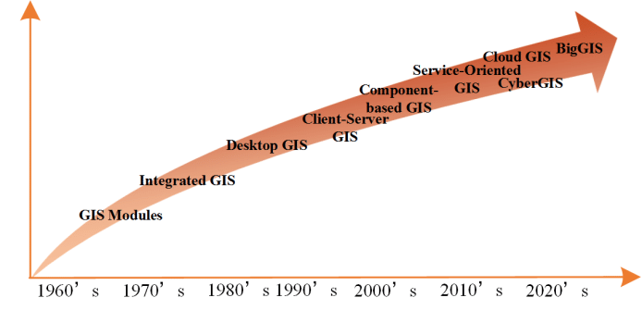

Figure 2.1 Advances in GIS

Source: <https://www.esri.com/en-us/search/?q=advances%20in%20gis>

### 2.3.1 Desktop GIS (Stand-alone GIS)

This is the form of GIS that uses the tradition desktop supporting GIS application software that is used by one user at a time. It is an immensely powerful computer mapping system. It is the tool for managing information of any kind according to where it is located ( Liu et, al, 2011). Desktop GIS involve applications like ArcMap and Q GIS which are widely currently used by web GIS developers for mapping purposes.

### 2.3.2 Server GIS (Client-server GIS)

This the software that makes your geographical information available to others in your organization and optionally anyone with internet connection. This is accomplished through web services, which allow a powerful server computer to receive and process request for information sent by other devices(Zhang et al., 2019).

### 2.3.3 Web GIS

Web GIS is a Geographic Information System distributed across a networked computer environment to integrate, disseminate, and communicate geographic information visually on the World Wide Web over the Internet(Goodchild, 2018). The system that will be developed will use this type of GIS. It will involve TNHC Web GIS that will have all essentials needed for Web GIS to be formed.

### 2.3.4 Distributed GIS

A system where components of a GIS are distributed amongst computers on a LAN or the internet. Users should be able to access services provided by a distributed GIS without an interruption of the internal workflow of the host/owner of the distributed GIS(Liu et al., 2021) Later in the future TNHC can use this type of GIS since is more advanced more than Web-GIS.

### 2.3.5 Trends in GIS

The recent trends in GIS include Internet GIS, Spatial decision supportive systems, Distributed.GIS and spatial data warehouse and mining (Song & Wu, 2021).

### 2.3.6 GIS in the cloud

With this development, we can massively scale out problems. It also means, for planners, who are often not necessarily IT literate, we can actually use an outsourced environment more cheaply and use the resources of the cloud in various ways (Aydinoglu & Bovkir, 2020).

### 2.3.7 Real-time GIS

Think of this as maps that have things that move around on them. As we wire up the city for this digital transformation, and especially with the Internet of Things, basically everything that moves and changes will be fed into these GIS systems(Zhang et al., 2019)

### 2.3.8 Image/raster analytics

"Imagery from remote sensing, drones, aircraft, and even spacecraft is becoming more and more available, and GIS is providing the framework to manage all these images and also apply them in near-real time for various kinds of applications. This means that our challenges for gathering new data will become less and less." (Henderson & Linton, 2009)

### 2.3.9 Spatial analysis & data science

"GIS analytics and spatial data science continue to advance with literally hundreds and hundreds of new tools. On the forefront, for example, is the ability to take all the data for an entire city, put it into a cloud-based data warehouse, and begin to do analytics of relationships and patterns and see things that we have never seen before. But more practically, we can do things like time series forecasting, GeoAI, machine learning, and statistical reporting this is all about creating a better understanding of the city" (Goodchild, 2008).

### 2.3.10 GIS in the field

This means being able to connect with every field worker in a city. People doing inspections, censuses, and tree counts. We can also use this for housing or building inspections or observations of social conflict." Bringing this information together and monitoring it on dashboards allows us to “better manage everybody in the field and better react to things like disasters or emergencies"(Li et al., 2015) .

## 2.4 Web GIS system design

Web GIS system design is the process of planning and implementing a web-based GIS system. It involves a number of steps, including:

### 2.4.1 Defining the requirements:

The first step is to define the requirements for the web GIS system. This includes identifying the users of the system, their needs, and the types of data that will be used.

User requirements are the needs and expectations of the users of a system. They are used to define the scope and functionality of the system. User requirements are typically gathered through interviews, surveys, and focus groups.

There are a number of different types of user requirements, including:

* Functional requirements: Functional requirements define what the system should do. They are typically expressed in terms of features and capabilities.
* Non-functional requirements: Non-functional requirements define how the system should work. They include requirements for performance, security, and usability.

User requirements are important for a number of reasons. They help to ensure that the system meets the needs of the users. They also help to communicate the requirements of the system to the developers.

There are a number of different techniques that can be used to define user requirements. The most appropriate technique will depend on the size and complexity of the system, the resources available, and the preferences of the users.

### 2.4.2 Choosing a platform:

The next step is to choose a platform for the web GIS system. There are a number of commercial and open-source platforms available, each with its own strengths and weaknesses.

GeoServer is a platform. It is an open-source web map server that allows you to share geospatial data. GeoServer can be used to publish a variety of geospatial data formats, including shapefiles, GeoTIFFs, and PostGIS layers. GeoServer can also be used to create WMS and WFS services, which can be used by other applications to access and display geospatial data.

GeoServer is a powerful tool that can be used to share geospatial data with a wide range of users. It is a good choice for organizations that need to share geospatial data with others, but do not have the resources to develop their own web map server (kim, Spafford, & Kerievsky, 2019).

Here are some of the features of GeoServer:

* Open source: GeoServer is an open-source project, which means that it is free to use and modify.
* Web-based: GeoServer is a web-based application, which means that it can be accessed from any web browser.
* Scalable: GeoServer can be scaled to handle a large number of users and requests.
* Secure: GeoServer can be configured to use a variety of security mechanisms, including HTTPS and user authentication.
* Extensible: GeoServer can be extended with a variety of plugins, which add new features and functionality.

### 2.4.3 Designing the database

The next step is to design the database for the web GIS system. This involves creating tables to store the spatial and non-spatial data that will be used by the system.

PostGIS is a spatial database extension for PostgreSQL, a popular open-source relational database management system (RDBMS). PostGIS adds support for storing and querying spatial data, such as points, lines, and polygons (warmerdam & muller, 2015).

PostGIS has a number of features that make it a powerful spatial database. These features include:

* Support for a wide range of spatial data types, including points, lines, polygons, and raster.
* Support for a wide range of spatial operations, such as spatial joins, spatial queries, and spatial analysis.
* Integration with PostgreSQL, a popular open-source RDBMS.

2.4.4. Creating the user interface:

The next step is to create the user interface for the web GIS system. This involves designing the maps, forms, and other elements that users will use to interact with the system.

Creating a web GIS (Geographic Information System) user interface involves designing and developing the visual and interactive elements that allow users to interact with GIS data and tools through a web application. Here's a short summary of key considerations for creating a web GIS user interface:

* Map Visualization: The core of a web GIS interface is the map visualization. Design an interactive map that displays spatial data, layers, and symbology in a clear and visually appealing manner. Consider the use of appropriate base maps, zooming and panning functionality, and thematic mapping techniques to effectively communicate spatial information.
* Data Interaction: Enable users to interact with GIS data through the interface. Provide tools for querying, searching, and selecting features on the map. Support data exploration through attribute information, pop-ups, and tooltips. Allow users to filter and visualize data based on their preferences and criteria.
* Spatial Analysis Tools**:** Incorporate spatial analysis tools and functionalities into the interface. Provide tools for measuring distances, calculating areas, performing buffer operations, and other common spatial analyses. Make these tools intuitive and accessible, ensuring that users can perform analysis tasks easily.
* User-Friendly Controls: Design intuitive and user-friendly controls for navigating and interacting with the web GIS application. Use familiar interface elements such as buttons, dropdowns, sliders, and checkboxes to provide users with clear options and actions. Consider the layout and organization of controls to ensure a seamless user experience.
* Customization and Personalization: Allow users to customize the interface according to their preferences. Provide options to personalize the appearance, map layers, and toolsets. Allow users to save and load their custom settings or create user profiles for a personalized experience.
* Collaboration and Sharing: Incorporate collaboration and sharing features into the web GIS interface. Enable users to share maps, data, and analysis results with others. Provide options for collaboration, such as sharing maps with specific users or groups, and allowing users to annotate and comment on shared maps.
* Responsive Design: Ensure that the web GIS interface is responsive and optimized for various screen sizes and devices. Design a layout that adapts to different screen resolutions, including desktops, tablets, and smartphones. Consider touch-based interactions for mobile devices to enhance the user experience.

### 2.4.5. Developing the back-end and fore end of web GIS:

1. To develop the back-end for the web GIS system.

This involves writing the code that will process data, generate maps, and perform other tasks. There are several programming languages and frameworks that can be used to develop the back end of a web GIS application(Tejera-Martínez et al., 2020). The choice of technology depends on factors such as the specific requirements of the project

* Python: Python is a popular programming language for web development and has a rich ecosystem of GIS libraries and frameworks such as Django, Flask, and GeoDjango. These frameworks provide robust tools for building scalable and feature-rich web GIS applications.
* JavaScript: JavaScript is widely used for front-end development, but it can also be used for back-end development with frameworks like Node.js. Node.js allows you to build scalable and efficient server-side applications, making it suitable for developing the back end of a web GIS.
* PHP: PHP is a server-side scripting language that is widely used for web development. It has frameworks like Laravel and Symfony that offer features and tools for building web GIS applications. PHP is known for its simplicity and ease of integration with databases.

1. To develop the front end of a web GIS application.

Primarily use HTML, CSS, and JavaScript. These three technologies work together to create the user interface and interactivity of the application. Additionally, you can utilize various libraries and frameworks specifically designed for web mapping(Tejera-Martínez et al., 2020). Here are some commonly used tools and frameworks for front-end web GIS development:

* HTML: HyperText Markup Language (HTML) is the standard markup language used for structuring the content of web pages. It provides the basic structure and elements for creating the user interface of a web GIS application.
* CSS: Cascading Style Sheets (CSS) is used to define the visual appearance and layout of HTML elements. CSS allows you to customize the styling, such as colors, fonts, spacing, and positioning, to create an attractive and responsive user interface.
* JavaScript: JavaScript is a programming language that adds interactivity and dynamic functionality to web pages. With JavaScript, you can implement map interactions, handle user events, perform client-side validations, and communicate with the back-end server.
* Leaflet: Leaflet is a lightweight JavaScript library for interactive maps. It provides a simple and versatile platform for displaying and interacting with geographic data. Leaflet offers various built-in functionalities like markers, pop-ups, overlays, and tile layers.
* OpenLayers: OpenLayers is a powerful JavaScript library for displaying maps and overlaying data. It offers a wide range of features, including support for multiple map projections, vector layers, advanced controls, and interaction capabilities.

### 2.4.6. Testing and deploying:

The final step is to test and deploy the web GIS system. This involves testing the system to ensure that it meets the requirements and deploying it to a web server so that users can access it.

## 2.5 How Web GIS operate.

A web GIS server has a URL so that users can find it online. Requests made to the server by the client are sent using HTTP standards. After completing the requested GIS operations, the server provides HTTP responses to the client. Numerous formats, including HTML, binary images, XML, and JSON (JavaScript Object Notation), can be used for the answer that is given to the client(Kong, 2017) Figure 2.2 Illustrate the operation of the web-GIS

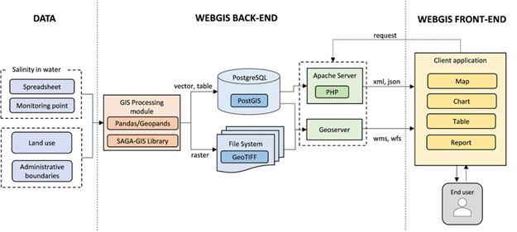Figure 2.2: How Web-GIS work

A web GIS system is a type of GIS that uses the World Wide Web to store, visualize, analyze, and distribute spatial information. It allows users to access and interact with GIS data from any web-enabled device, such as a computer, tablet, or smartphone.

A web GIS system consists of three main components:

1. The web server: The web server is a computer that hosts the web GIS software and data. It is responsible for serving web pages to users and responding to requests for GIS data.
2. The web GIS software: The web GIS software is a collection of programs that allow users to create, manage, and use GIS data. It includes a web browser client, a web server, and a database server.
3. The GIS data: The GIS data is the spatial information that is stored in the database server. It can include vector data, such as points, lines, and polygons, or raster data, such as satellite images or aerial photographs.

When a user requests a map or other GIS data from a web GIS system, the following steps occur:

* 1. The user's web browser sends a request to the web server.
  2. The web server retrieves the requested data from the database server.
  3. The web server sends the data back to the user's web browser.
  4. The user's web browser displays the data on the user's screen.

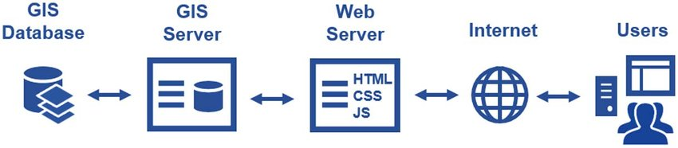

Figure 2.3 GIS data from a web GIS system

## 2.6 Web GIS for access to rental houses

Web GIS decision support systems (DSS) can be used to enhance access to housing by providing decision-makers with a comprehensive view of the housing market. By integrating data on housing prices, availability, and affordability, Web GIS DSS can help decision-makers identify areas where housing is in short supply or where prices are out of reach for low- and middle-income households(Dawidowicz et al., 2018). This information can then be used to develop policies and programs to increase the supply of affordable housing or to make housing more affordable for low- and middle-income households.

### 2.6.1 Ways that Web GIS DSS can be used to enhance access to housing:

1. Identify areas with a shortage of housing.

* Web GIS DSS can be used to identify areas where the demand for housing exceeds the supply. This information can be used to target areas for new housing development or to provide financial assistance to developers who are willing to build affordable housing in these areas (Barton et al., 2005)..

1. Location and Proximity:

* Distance to amenities: Consider the proximity to essential amenities such as schools, hospitals, shopping centers, parks, and public transportation.
* Commute time: Evaluate the commuting distance and time to your workplace or other frequently visited locations.

1. Accessibility and Transportation:

* Road network: Assess the accessibility of the area by examining the road infrastructure, including major highways, arterial roads, and public transportation options.
* Transportation modes: Consider the availability and convenience of public transportation, such as bus routes, subway lines, or train stations, depending on your preferences and needs.

1. Surrounding Environment:

* Land use and zoning: Understand the land use regulations and zoning restrictions in the area to determine if they align with your desired lifestyle and future development plans.
* Natural hazards: Check for potential risks like flood zones, seismic activity, or other natural hazards that may impact the safety and long-term suitability of the location.

1. Property-specific Factors:

* Size and layout: Evaluate the size and layout of the house to ensure it meets your current and future needs, including the number of bedrooms, bathrooms, and overall floor area.
* Property condition: Consider the age, maintenance, and overall condition of the property, including any renovations or repairs required.
* Outdoor space: Assess the availability of a yard, garden, or outdoor amenities if they are important to you.

1. Demographic and Socio-economic Factors:

* Local demographics: Research the demographics of the area, including population composition, age distribution, and socio-economic indicators, to understand the community and potential social dynamics.
* Property values: Analyze the historical and current property values in the neighborhood to assess the investment potential and future market trends.

# CHAPTER THREE

# METHODOLOGY

## 3.1 Overview

In this chapter, methods implemented, techniques applied and data inputs used throughout this study are explained. This chapter describes overall methods ranging from data collection, System design and development, and finally getting the expected Web-GIS system. This study involved development of Web-based GIS system that NHC house’s location and proximity services. The whole process from identifying user requirements, designing and development of the system step by step is summarized in figure 3.1

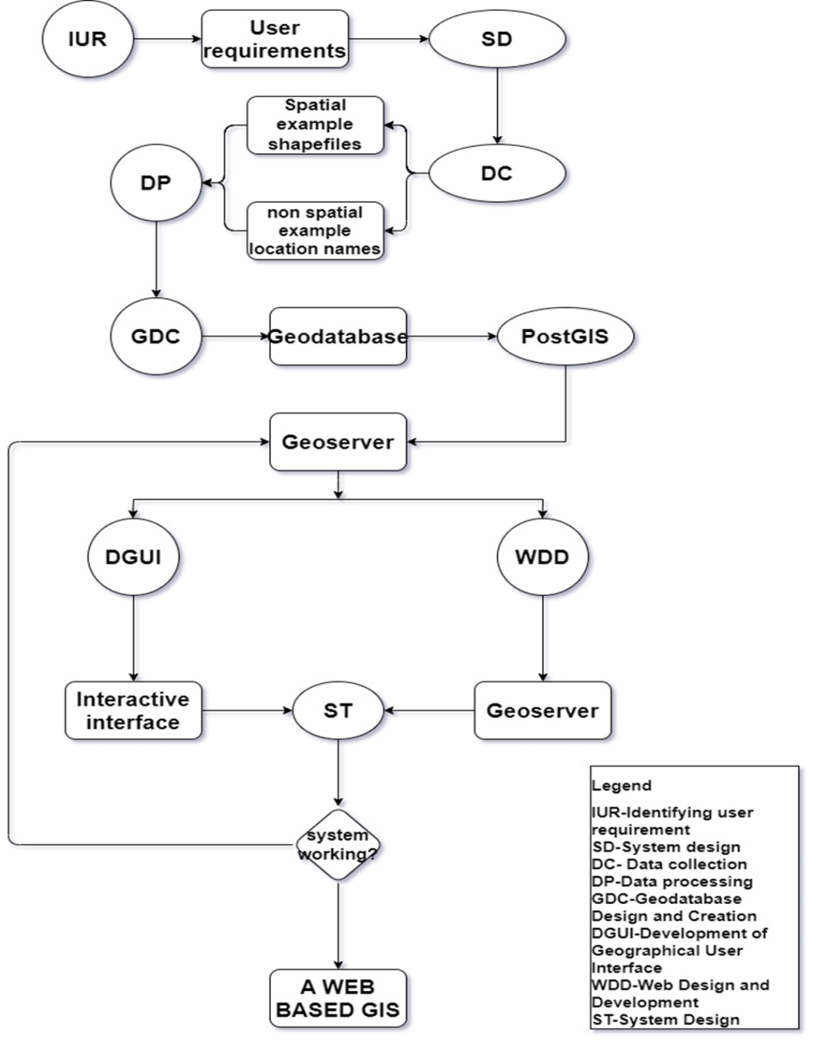

Figure 3.1 Workflow of the research

## 3.2 Identifying user requirements

Online questionnaires were created to gather the predicted Web-GIS System requirements of the users while making sure that the data collected are related mostly to spatial components.

By observing and asking questions to employees and national houses users of their preference requirements based on both spatial and non-spatial components which can support the user to make decision on houses to live according to their preferences.

## 3.3 System designing

The framework for the system that needed to be created was planned. The system was created in a way that it satisfies user needs and serves as a guide for reaching the study's goals.

The system required data to be prepared and processed using GIS processing modules to obtain required formats that could be used in PostgreSQL database and Geoserver. Data in back-end platforms could be accessed by the user by sending requests to the Apache Tomcat server which is the web application manager. This server receives request, interprets it, processes it and sends back required feedback to the client as requested. Figure 3.2 illustrates the design and structure of the system that was developed.

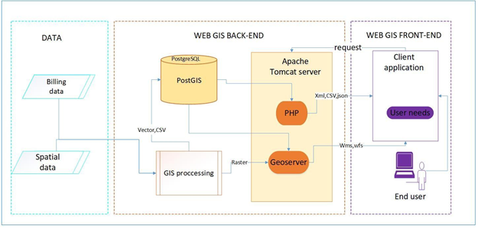

Figure 3.2 illustrates the design and structure of the system

When a user requests a map or other GIS data from a web GIS system, the following steps occur:

1. The user's web browser (front end) sends a request to the web server (back end).

2. The web server retrieves the requested data from the database server.

3. The web server sends the data back to the user's web browser.

4. The user's web browser displays the data on the user's screen.

## 3.4 Data collection and software selection.

Data used for developing the system was collected from Tanzania national house corporation (TNHC). Data included were spatial data and non-spatial data which shows information about national houses. Software’s that were used for system developing are selected by looking at their availability and their required licenses. Table 1 and table 2 below show software package needed for Web GIS system development and Summary of data used respectively.

|  |  |  |
| --- | --- | --- |
| **SN** | **SOFTWARE/TOOLS** | **FUNCTION** |
| 1 | Quantum GIS | Spatial data creation |
| 2 | PostgreSQL | Geo-database creation |
| 3 | PostGIS | Data conversation |
| 4 | Geoserver | Data visualization |
| 5 | Leaflet | Development of geographical user interface |
| 6 | Apache /Tomcat | Web Application manager |
| 7 | Visual Studio Code/GitHub | Code editor and management |

Table 1 software package needed for Web GIS system development

Table 2 data needed for Web GIS system development

|  |  |  |  |
| --- | --- | --- | --- |
| DATA | FORMAT | SOURCE | USE |
| National houses | Shapefiles | NHC | For mapping component in the system |
| NHC houses | csv | NHC | For mapping and choice components |
| Public services | Shapefiles | OSM | For Mapping component |

## 3.5 Data processing

This involved processing spatial and non-spatial data components of Tanzania national houses corporation such as creating shapefile for national houses which is to be used for visualization on open layers of the web GIS, the operation was conducted using QGIS software. Houses data and its availability data were prepared in Microsoft excel and exported to CSV format for further insert in the database. The location coordinates of the houses and other spatial data were projected to WGS84 spatial reference which is required by Geoserver that functions as the middleware server in web application.

## 3.6 Geodatabase development

Geodatabase was developed by following these steps below;

### 3.6.1 PostgreSQL and PostGIS installation

PostgreSQL software was downloaded and installed from [http://www.enterprisedb.com/products-](http://www.enterprisedb.com/products-services-training/) [services-training/. P](http://www.enterprisedb.com/products-services-training/)ort number for running the software was 5432 while installing. Then PostGIS extension was downloaded using stack builder by checking “Spatial Extension” option during the installation of PostgreSQL.

### 3.6.2 Loading Shapefiles into the PostgreSQL Database

Before importing the shapefiles to the database, PostGIS extension was added in the database. In pgAdmin4 v6, Database server in object explorer was connected. Then by right clicking the extension tab and later new extension to select PostGIS. Using SQL Editor, the following command was run “CREATE EXTENSION PostGIS” and then extension was created.

PostGIS Shape file Import/Export Manager was used to establish a connection by clicking on view connection details and connection parameters like Host, Port, Username, Password, Database and Server were filled as it seen in figure 3.3. Connection was successfully made and Then NHC_TANZANIA shapefiles were added using Add File and import buttons found in this manager.

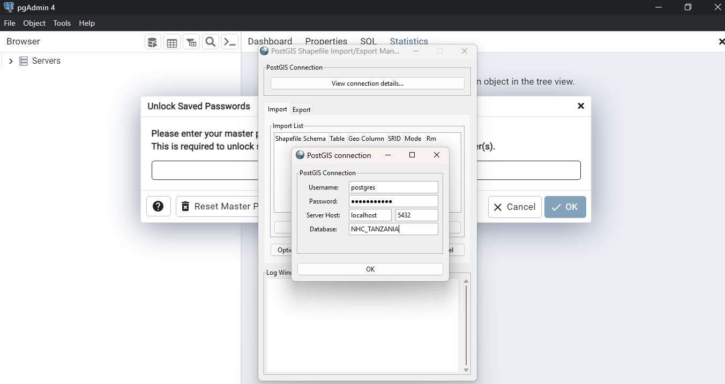

Figure 3.3 PostGIS connect PostgreSQL and shapefiles view in the database

## 3.7 Web development

Development of web server-side environment was done by performing the following procedures; Firstly, Java Development Kit (JDK) was downloaded from [http://www.oracle.com/ .](http://www.oracle.com/)JDK was as necessary Kit since it runs and develops java application on the computer system. Java runs Geoserver and other related type of servers.

Then, Apache Tomcat Server which acts as the web application manager was installed. GeoServer package was downloaded from [http://geoserver.org/release/stable/ .](http://geoserver.org/release/stable/%20.)Geoserver package was copied and pasted in Apache Tomcat folder in war format (geoserver.war) so that can be managed by Apache Tomcat server.

By opening Chrome and typing [http://localhost/8080/ Ap](http://localhost/8080/)ache tomcat server was opened to check the status of the software run by this server. GeoServer was started and Apache Tomcat agreed to manage the application. Figure 3.4 show the status of Geoserver in Apache Tomcat after being started.

Figure 3.4 GeoServer running in Apache Tomcat Server

Logging in to the GeoServer using the address [http://localhost:8080/geoserver/web/ (](http://localhost:8080/geoserver/web/)Default username was “admin” and password was “geoserver”) was done. The new workspace was added by using the link in the left panel and it was named NHC_TANZANIA.

In the Workspace created, the new PostGIS store was added in the GeoServer using the link in the left panel and by adding basic store information and connection parameters.

Opening the PostGIS store publish tab, the layers that were needed to be published selected. All layers that were found in the PostGIS extension were published using the same layer projection system “Declared SRS” and acquired styles from Q GIS (sld format). Then these layers were previewed in the layer preview option of Geoserver. Figure 3.5 show published layers in GeoServer.

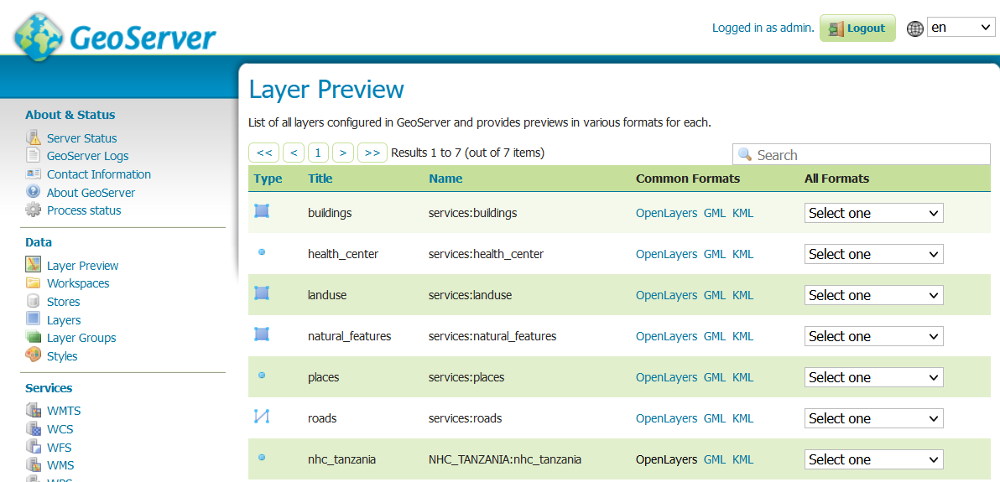

Figure 3.5 Published layers in Geoserver

## 3.8 Development of the geographical user interface

Geographical user interface was developed by performing the following steps;

Firstly,the developed geographical user interface (GUI) for a web GIS application using OpenLayers, GeoServer, and PostgreSQL/PostGIS, started by setting up the backend infrastructure. To Install and configure GeoServer, which will acted as the map server, allowing us to publish and serve spatial data. Additionally,I settled up a PostgreSQL/PostGIS database to store and manage geographic data efficiently. Once the backend was ready, proceed to prepare spatial data by importing it into the PostGIS database and ensuring it is in the appropriate projection and schema for application’s requirements.

Secondly, moving on to the frontend GUI, created an HTML file and include the OpenLayers library by linking the necessary scripts. Designed GUI by creating a container <div> that will hold the map interface. HTML file was Connect to GeoServer by using OpenLayers to create a map instance and define the initial view, specifying the extent and zoom level. Configure the map to consume the map tiles or image data served by GeoServer by setting up a TileLayer or ImageLayer in OpenLayers.

Customized GUI to enhance its functionality and aesthetics, Utilized OpenLayers' vector layer functionality to add overlays, markers, controls and interactions to provide zooming, panning, and measurement capabilities. CSS styles and layout techniques used to create an appealing and user-friendly interface.

Handle user interactions by listening for events on the map, such as clicks or queries, provides various methods and functionalities. For querying spatial data, you can use OpenLayers' capabilities to send requests to GeoServer's Web Map Service (WMS) or Web Feature Service (WFS) endpoints, retrieving specific data based on the user's query. Figure 3.6 illustrates code workplace.

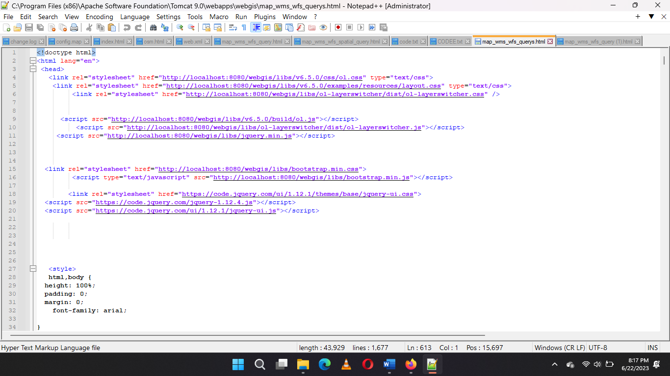

Figure 3.6: Code workplace

## 3.9 System testing

After performing the mentioned above steps and combining the system. The system was tested if it functions per localhost computer network. Testing involved assessing the functionality of Apache tomcat which manages Geoserver for spatial data which makes the back end of the system.

The functionality of the interactive interface was tested by checking if shapefiles can be added to the PostgreSQL database directly from an interface. Functionalities like zooming in and out, panning, measuring distance and area, searching location, switching on and off the layers and pop ups of attribute data of spatial layers were tested also.

Finally, The Web system link for accessing the system per localhost was tested by checking if it opens the Web-based GIS system. Below is the link for the system made and when you click it takes you directly to the system. localhost:8080/webgis/NHC_TANZANIA.html

# CHAPTER FOUR

# RESULTS AND ANALYSIS

## 4.1 Overview

In this chapter, the results of this study indicated that the developed web GIS decision support system successfully improved access to NHC houses. Through the integration of spatial components and advanced mapping techniques, users were able to visualize the distribution of national housing across the country and assess its proximity to important amenities.

## 4.2 User requirements

Table 3 illustrates are important features that users wanted implemented in the System after identifying their requirements.

Table 3 User requirements

|  |  |  |
| --- | --- | --- |
| **SN** | **DESIRED FUNCTIONS** | **PEOPLE WHO NEED ITS IMPLEMENTATION** |
| 1. | NHC house’s location in user interactive interface web GIS and accessible to the internet | Both TNHC workers and their customers |
| 2. | Adding and updating houses information’s such as its current status and property type | Both TNHC workers and their customers |
| 3. | Measuring distance and showing routes from one location to another | TNHC Customers |
| 4. | Ability to explore surroundings of the houses such to know nearby schools, hospital, markets etc. | TNHC Customers |
| 5. | Assessing NHC houses through different methods of query | TNHC Customers |
| 6. | Connecting spatial data and non-spatial data. | Both TNHC workers and their customers |

## 4.3 Design and structure of the system

Structure of the system was designed in order to meet the user requirements and the objective of this study. Figure 3.7 illustrates structure of Web based GIS system;

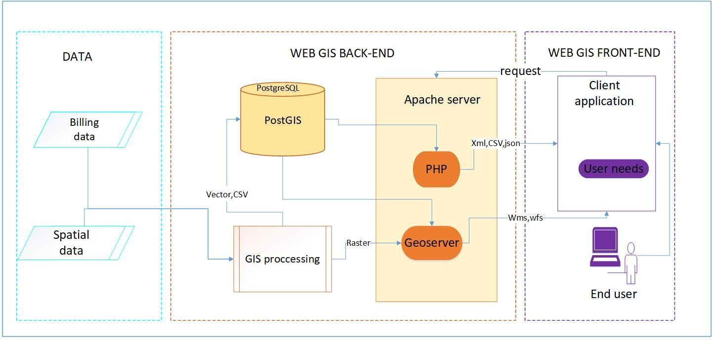

Figure 3.7: Structure of web-based GIS

The system structure designed had three main parts which are data, web GIS back-end and web GIS front end. The end user can send request to the server and server receives requests and interprets it.

If the request from the client could be spatial data, then Geoserver which has published data will receive request and send back the published layers with their attributes that will pop up when selected in the client-side interface. Web map services and feature services are being received and sent back to the client using Geoserver.

## 4**.4 Geodatabase**

One stop Geodatabase that has spatial data and non-spatial data was developed. Spatial data was stored in the database as tables where you can only see the attribute table of published layers but when you want to view the whole layer then you may use the Geoserver open layer since the PostgreSQL database is connected with Geoserver with PostGIS extension. Non spaatial data like property type, its availability, costs and other information can be viewed directly from the Geodatabase as you can view in figure 3.8

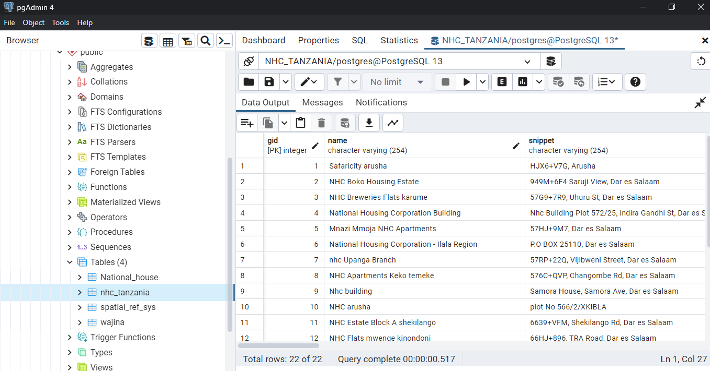

Figure 3.8: View of non-spatial data geodatabase

## 4.5 Web GIS system and prototype validation

Web GIS system that combines house’s locations and non-spatial data about houses were successfully made. The user interface had the following functionalities;

### 4.5.1 Zoom in and out/panning/switching on and off the layers

The user will be able to zoom in, zoom out, and pan the map the way he or she may need to view. But also, the system allows the user to switch on and off the layers at any time and concentrate with one layer. Figure 3.9 show zooming, switching on and off layers and panning functionalities on the web system

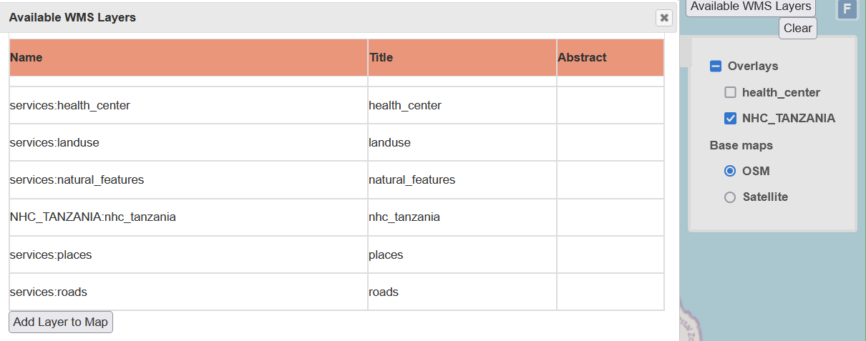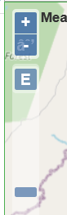

Figure 3.9: Switching on and off layers and zoom in and out functionalities

### 4.5.2 Measurements of distance, area and location coordinates

The system created enables the user to measure distance from one location to another, measure the coordinates of the specific location and calculate the area of different polygon. National houses renter will use this system to measure distance from one place to another and areas of different polygons. Figure 3.10 illustrates these functionalities

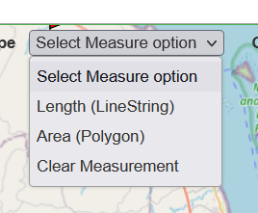

Figure 3.10: Distance and area measurement functionalities in the system.

### 4.5.3 Pop ups of attribute data of spatial features

The user will be able to pop up the attribute data of all spatial features found in the system. This will help national house renter to see the characteristics of each house just while located at any place. This will help to make decision on selection of houses to rent. Figure 3.11 illustrates these functionalities

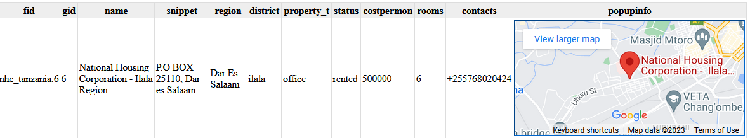

Figure 3.11: Attribute pop ups functionalities in the system.

### 4.5.4 Finding the location of national house

The system enables the user to find location of specific national house using different attributes such as name of the house, region, district, property type, status, number of rooms and cost. this will easily help customers to find houses based on their requirements. Figure 3.12 illustrates these functionalities.

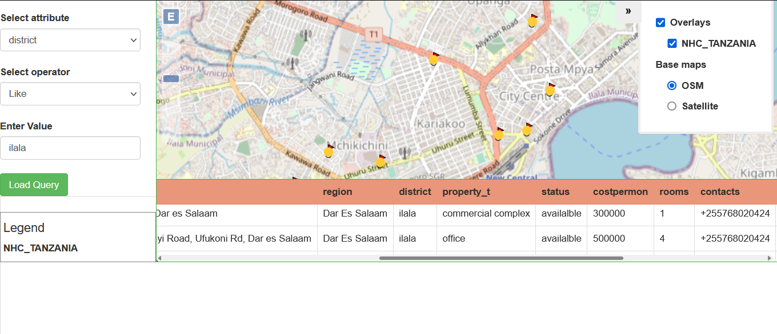

Figure 3.12: Place search and user location identification functionalities.

### 4.5.5 Add WMS available layer.

System enables the user to add new WMS layers showing services and land use surrounding the national houses.



Figure 3.13: View, adding, updating WMS available layer

### 4.5.6 link to google map

Google Maps offers a range of capabilities and libraries to enhance geospatial applications. The Maps JavaScript API enables embedding interactive maps with custom features. The Directions API calculates routes and provides travel information. The Geocoding API converts addresses to coordinates and vice versa. The Places API accesses a database of points of interest. The Street View API offers immersive street-level imagery. The Static Maps API generates static map images.

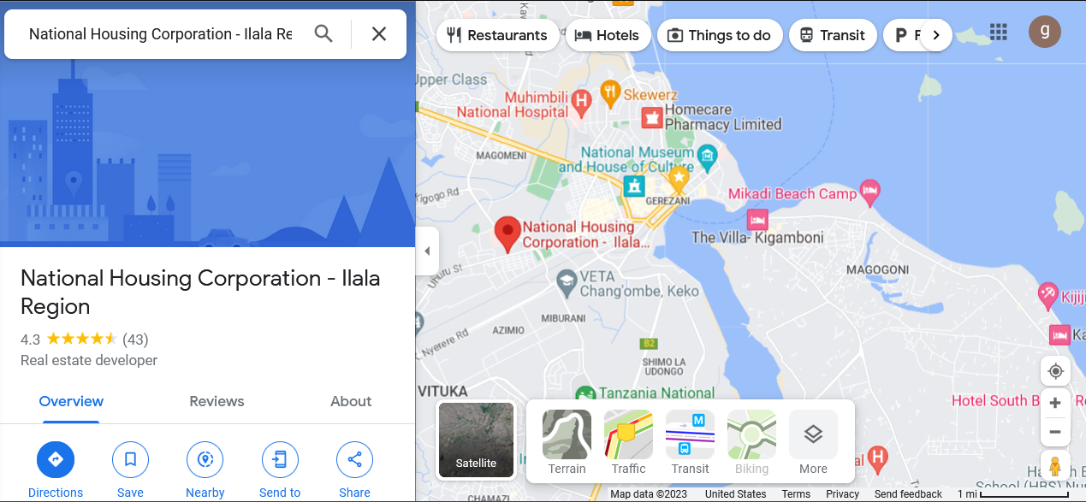

Figure 3.14: link to google map.

## 4.6 Discussion

This Web based GIS system that has been developed increases interaction between Tanzania National house corporation and their customers, since they have been brought together in one system that enables surveying and support the renter to make decision on where to live. Management of national houses has been simplified since all locations of houses and their attributes information are managed in one system. This system can be accessed using this link

localhost:8080/webgis/NHC_TANZANIA.html

# CHAPTER FIVE

# CONCLUSION AND RECOMMENDATION

## 5.1 Conclusion

In conclusion, this study has successfully developed a web GIS decision support system for the national housing cooperation, addressing the limitations of the existing system and providing enhanced accessibility to housing information. The integration of advanced mapping and analysis capabilities, along with comprehensive property details, empowers customers to make informed decisions about renting properties. By visualizing property locations in relation to key amenities and facilitating efficient search and selection processes, the web GIS system significantly improves the housing search experience.

## 5.2 Recommendation

To provide a more comprehensive and informative housing search experience, it is recommended to expand the integration of data sources. This includes incorporating additional datasets such as real-time transportation information, crime statistics, and demographic data to provide users with a more holistic understanding of the areas surrounding the available properties.

# REFERENCES.

Agrawal, S., & Gupta, R. D. (2017). Web GIS and its architecture: a review. *Arabian Journal of Geosciences*, *10*(23), 1–13. https://doi.org/10.1007/S12517-017-3296-2/metrics

Aydinoglu, A. C., & Bovkir, R. (2020). *Developing A Mobile Application For Smart Real Estate Information*. https://doi.org/10.5194/isprs-archives-xliv-4-w3-2020-89-2020

Barton, J., Plume, J., & Parolin, B. (2005). Public participation in a spatial decision support system for public housing. *Computers, Environment and Urban Systems*, *29*(6), 630–652. https://doi.org/10.1016/j.compenvurbsys.2005.03.002

Coetzee, S., Griffin, A. L., Köbben, B., Kubicek, P., Harvey, F., Varanka, D. E., Camboim, S. P., Behr, F.-J., Plews, R., Moellering, H., & Midtbø, T. (2021). Mapping in words: Standardizing cartographic terminology. *Abstracts of the ICA*, *3*. https://doi.org/10.5194/ica-abs-3-54-2021

Dawidowicz, A., Muczyński, A., & Pacholczyk, M. E. (2018). The Use Of GIS Tools For Sustainable Management Of Municipal Housing Stock In Poland. *Https://Doi.Org/10.1080/00396265.2018.1474694*, *51*(368), 431–441. https://doi.org/10.1080/00396265.2018.1474694

Gardner, D., Lockwood, K., & Pienaar, J. (2019). *Assessing Rwanda’s Affordable Housing Sector Housing And The Economy*.

Goodchild, M. F. (2018). Reimagining the history of GIS. *Annals of GIS*, *24*(1), 1–8. https://doi.org/10.1080/19475683.2018.1424737

Kong, N. (2017). Getting to Know Web GIS. *The Cartographic Journal*, *54*(2). https://doi.org/10.1080/00087041.2017.1307041

Li, Z., Yang, C., Jin, B., Yu, M., Liu, K., Sun, M., & Zhan, M. (2015). Enabling big geoscience data analytics with a cloud-based, mapreduce-enabled and service-oriented workflow framework. *plos one*, *10*(3). https://doi.org/10.1371/journal.pone.0116781

Liu, J., Ma, X., Zhu, Y., Li, J., He, Z., & Ye, S. (2021). Generating and Visualizing Spatially Disaggregated Synthetic Population Using a Web-Based Geospatial Service. *Sustainability 2021, Vol. 13, Page 1587*, *13*(3), 1587. https://doi.org/10.3390/SU13031587

NBS. (2022). Matokeo ya Mwanzo ya Sensa ya Watu na Makazi ya Mwaka 2022. In *Matokeo ya Mwanzo ya Sensa ya Watu na Makazi ya Mwaka 2022*.

Sadeghi-Niaraki, A., Jelokhani-Niaraki, M., & Choi, S. M. (2020). A Volunteered Geographic Information-Based Environmental Decision Support System for Waste Management and Decision Making. *Sustainability 2020, Vol. 12, Page 6012*, *12*(15), 6012. https://doi.org/10.3390/SU12156012

Song, W., & Wu, C. (2021). Introduction to advancements of GIS in the new IT era. *Https://Doi.Org/10.1080/19475683.2021.1890920*, *27*(1), 1–4. https://doi.org/10.1080/19475683.2021.1890920

Tejera-Martínez, F., Aguilera, D., & Vílchez-González, J. M. (2020). Programming Languages and Development of Key Competences. Systematic Review. *Revista Electronica de Investigacion Educativa*, *22*. https://doi.org/10.24320/redie.2020.22.e27.2869

Zhang, T., Wang, J., Cui, C., Li, Y., He, W., Lu, Y., & Qiao, Q. (2019). Integrating Geovisual Analytics With Machine Learning For Human Mobility Pattern Discovery. *ISPRS International Journal of Geo-Information*, *8*(10). https://doi.org/10.3390/IJGI8100434