**ARDHI UNIVERSITY**



**MONITORING WATER WEEDS IN FRESH WATER LAKES USING REMOTE SENSING AND GIS**

**A Case of Lake Victoria**

**MAWONDO, HILDIGARD**

**BSc. Geoinformatics**

**Dissertation**

**Ardhi University, Dar es salaam**

**June, 2023.**

**MONITORING WATER WEEDS IN FRESH WATER LAKES USING REMOTE SENSING AND GIS**

**A Case study of Lake Victoria**

**HILDIGARD MAWONDO**

A Dissertation Submitted to the Department of Geospatial Sciences and Technology in Partially Fulfilment of the Requirements for the Award of Bachelor of Science Degree of Geoinformatics (BSc.in Geoinformatics) at Ardhi University

# CERTIFICATION AND COPYRIGHT

The undersigned certify that they have read and hereby recommend for acceptable by the Ardhi University dissertation titled, **“Monitoring Water Weed in Fresh Water Lakes Using Remote Sensing and GIS a Case study sof Lake Victoria”** in partial fulfillment of the requirements for the award of degree of Bachelor of Science in Geoinformatics, Ardhi University, Dar es Salaam.

………………………………… ……………………………..

Dr.Anastazia Msusa Mr.Iriael Mlay

(Supervisor) (Supervisor)

Date ……………………… Date ………………………

# DECLARATION AND COPYRIGHT

I, MAWONDO, HILDIGARD hereby declare that, the contents of this dissertation are the results of my own findings through my study and investigation, and to the best of my knowledge they have not been presented anywhere else as a dissertation for diploma, degree or any similar academic award in any institution of higher learning.

……………………………

**MAWONDO, HILDIGARD**

22724/T.2019

(Candidate)

Copyright ©1999 This dissertation is the copyright material presented under Berne convention, the copyright act of 1999 and other international and national enactments, in that belief, on intellectual property. It may not be reproduced by any means, in full or in part, except for short extracts in fair dealing; for research or private study, critical scholarly review or discourse with an acknowledgement, without the written permission of the directorate of undergraduate studies, on behalf of both the author and Ardhi University.

# ACKNOWLEDGEMENT

I would like to express my heartfelt gratitude to the Lord Almighty for granting me the strength, knowledge, and wisdom to pursue my education and successfully complete this research. Without His guidance and blessings, this journey would not have been possible. "For I know the plans I have for you," declares the Lord, "plans to prosper you and not to harm you, plans to give you hope and a future." - Jeremiah 29:11

I am immensely thankful to my wonderful parents, Mr. and Mrs. Michael Mawondo, for their unwavering support and sacrifices throughout my educational journey. Despite their limited resources, they provided me with the best opportunities and nurtured my growth from kindergarten to this level. Their love and dedication have been instrumental in unlocking the mysteries of the world and beyond. I am also grateful to my siblings, Moses Tumaini, Hildegarda, Daniel, David, Magdalena, and Michael, for their unconditional love and support.

I would like to extend my sincere appreciation to my supervisors, Dr. Anastazia Msusa and Mr. Iriael Mlay, for their invaluable guidance, time, and consultations. Their expertise and advice have been instrumental in ensuring the timely completion of this dissertation and equipping me with updated skills in geospatial science.

I would also like to acknowledge the significant contributions of the staff members of the Geospatial Science and Technology Department. Their moral and academic support, along with their commitment to providing us with essential skills in geospatial science, have been greatly appreciated.

Special thanks go to my dear friends and brothers, Gadiel Mvamba, Frank Mbaga, Yusuph Makamula, and Gulamali Said. Their contributions to the success of this research are sincerely acknowledged and appreciated.

I am grateful for the love and unwavering support from all my colleagues in the Geo-Informatics and Geomatics field who have played a part, big or small, in the accomplishment of this research.

May God's sufficiency continue to manifest in each and every one of you.

# D**EDICATION**

*This dissertation is dedicated with heartfelt thanks to my Father, Dr. Michael Mawondo. Your constant care and guidance have shaped me into who I am today. I appreciate your love and support more than I can express.*

*To my brothers, Moses Tumaini, Daniel Mawondo, David Mwalinga, and Michael Mawondo, and my sisters, Hildegarda Mawondo and Magdalena Mawondo, your presence always lifts me up and makes me determined to succeed.*

*This dedication is a way of saying thank you for your encouragement and belief in me. I am truly lucky to have you all in my life. My love for you knows no bounds.*

# ABSTRACT

This study utilized remote sensing and GIS technology for monitoring water weeds infestation in Lake Victoria. The objectives encompassed mapping and quantifying infestation from 2019 to 2022, analysing the distribution and spread, and examining trends in growth and expansion of water weeds. Remote sensing techniques and GIS tools were employed for data analysis.

Results revealed varying water weeds coverage percentages during the study period. Coverage increased from 0.068% in 2019 to 0.648% in 2020, then decreased by 0.3586% in 2021 and further by 0.186% in 2022, highlighting dynamic infestation dynamics.

Satellite imagery-based distribution mapping identified transitions between water classes, indicating ecosystem changes. Notably, a substantial transition from water to water weeds occurred from 2019 to 2020, covering around 3,465,168 hectares. Other transitions showcased the spatial dynamics of infestation.

Normalized Difference Vegetation Index (NDVI) was employed to assess water weeds' health and distribution. NDVI values ranged from low to high each year, offering insights into density and health over time.

These findings highlight the significance of using remote sensing and GIS technologies for monitoring water weeds in freshwater lakes. The study provides valuable insights into the distribution, spread, and fluctuations of water weed coverage in Lake Victoria, contributing to better management strategies for combating water weed infestation.

# TABLE OF CONTENTS

CERTIFICATION AND COPYRIGHT ii

DECLARATION AND COPYRIGHT iii

ACKNOWLEDGEMENT iv

DEDICATION v

ABSTRACT vi

TABLE OF CONTENTS vii

LIST OF FIGURES x

LIST OF TABLES xi

ACRONYMS AND ABBREVIATIONS xii

CHAPTER ONE 1

INTRODUCTION 1

1.0 Background of the study 1

1.2 Problem Statement 3

1.3 Research Objectives 3

1.3.1 Main Objective 3

1.3.2 Specific Objective 3

1.3.3 Research questions 4

1.4 Significance of the Research 4

1.5 Beneficiaries 4

CHAPTER TWO 5

LITERATURE REVIEW 5

2.0 Overview 5

2.1 Lake Victoria 5

2.1.1 Common waterweed species found in Lake Victoria are: 5

2.1.2 Factors Contributing to the Increase in Water Weeds in Lake Victoria. 9

2.1.3 Impacts of water weeds on the Environment and Lake Victoria 10

2.1.4 Methods for controlling water weeds in Lake Victoria 11

2.2 Mapping Techniques 12

2.2.1 Definition of terms 12

2.3 Mapping Techniques 14

2.3.1 Types of remote sensing commonly used in monitoring water weeds 14

2.4 Previous studies on remote sensing technology to monitor water weeds in Lake Victoria. 16

CHAPTER THREE 18

METHODOLOGY 18

3.0 Overview 18

3.1 Description of the study area 19

3.2 Data Collection and Description 20

3.3 Data preparation 20

3.3.1 Image Preprocessing 20

3.2.2 Subsetting and Mosaicking 21

3.4 Processing 22

3.4.1 Calculation of NDVI 22

3.4.2 Training Data Preparation: 22

3.4.3 Supervised Classification 23

3.4.4 Accuracy Assessment 24

3.4.5 Post classification Analysis 24

CHAPTER FOUR 25

RESULTS, ANALYSIS AND DISCUSSION 25

4.0 Overview 25

4.1 Water weeds Maps from 2019, 2020, 2021 and 2022 25

4.2 Change Maps from 2019 to 2020, 2020 to 2021 and 2021 to 2022 28

4.3 NDVI Maps from 2019 to 2020, 2020 to 2021 and 2021 to 2022 29

4.4 Water weeds growth trend Analysis 30

4.4.1 Water weeds cover graph from 2019, 2020, 2021 and 2022 31

4.4.2 Water weeds cover from 2019, 2020, 2021 and 2022 32

4.4.3 Change detection Matrix tables, analysis and discussions of years 2019 to 2020, 2020 to 2021 and 2021 to 2022 33

CHAPTER FIVE 35

CONCLUSION AND RECOMMENDATIONS 35

5.1 Conclusion 35

5.2 Recommendations 36

REFERENCES 37

# LIST OF FIGURES

**Figure 2.1** Showing Water hyacinth on the lake. (n.d.). Retrieved from Wikimedia Commons: https://media.mehrnews.com/d/2019/05/31/4/3143324.jpg 7

**Figure 2.2** Water showing water lettuce on the lake. (n.d.). Retrieved from Wikipedia: https://en.wikipedia.org/wiki/Water_lettuce 8

**Figure 2.3** Showing Water fern (Salvinia molesta) on the lake. (n.d.). Retrieved from Wikipedia: https://en.wikipedia.org/wiki/Water_fern 9

**Figure 3.1** Methodology workflow 18

**Figure 3.2** Study area-Lake Victoria (a) Lake Victoria with base map (b) Tanzania map (c) Lake Victoria with neigbouring Regions. 19

**Figure 3.3** Graph showing Mosaic images from Google earth engine 21

**Figure 3.4** showing trained samples of the selected classes via Google earth engine 23

**Figure 4.1** Map showing water weeds cover in 2019 in Lake Victoria 25

**Figure 4.2** Map showing water weeds cover in 2020 in Lake Victoria 26

**Figure 4.3** Map showing water weeds cover in 2021 in Lake Victoria 26

**Figure 4.4** Map showing water weeds cover in 2022 in Lake Victoria 27

**Figure 4.5** Map showing water weeds changes from 2019 to 2022 on part of Lake Victoria 28

**Figure 4.6** Map showing NDVI distribution from 2019 to 2022 in Lake Victoria 29

**Figure 4.7** Graph showing water weeds in the years 2019, 2020, 2021 and 2022 31

**Figure 4.8** A graph showing NDVI values from 2019 to 2022 in Lake Victoria 32

# LIST OF TABLES

**Table 3.1** Datasets and their Sources 20

**Table 4.1** showing the average annual rainfall for Lake Victoria from 2019 to 2022 by Tanzania Meteorological Agency (TMA) 30

**Table 4.2** Land cover in hectares in the years 2019, 2020, 2021 and 2022 33

**Table 4.3** change detection matrix in hectares from 2019 to 2020 33

**Table 4.4** change detection matrix in hectares from 2020 to 2021 34

**Table 4.5** change detection matrix in hectares from 2021 to 2022 34

# ACRONYMS AND ABBREVIATIONS

|  |  |
| --- | --- |
| ALS | Airborne Laser Scanning |
| ALS: | Airborne Laser Scanning |
| AOI | Area Of Interest |
| ArcGIS | Aeronautical Reconnaissance Coverage Geographic Information System |
| DC | Data Collection |
| ESA | The European Space Agency's |
| ESA | European Space Agency |
| ETM+: | Enhanced Thematic Mapper Plus |
| GIS | Geographic Information System |
| MSI: | Multispectral Instrument |
| NDVI | Normalized Difference Vegetation Index |
| NDVI: | Normalized Difference Vegetation Index |
| NDVI: | Normalized Difference Vegetation Index |
| NIR | Near-Infrared |
| OLI: | Operational Land Imager |
| OSM | Open Street Map |
| QGIS | Quantum Geographic Information System |
| RF | Random Forest algorithm |
| RS | Remote Sensing |
| USGS | United State Geological Survey |
| VCI | Vegetation Condition Index |

# CHAPTER ONE

# INTRODUCTION

# Background of the study

Lake Victoria is both the largest African Great Lake and the largest tropical lake in terms of surface area, and the second largest freshwater body in the world. It is located in East Africa. Lake Victoria, which is 1,134 meters above sea level, was formed about 400,000 years ago. It has a surface area of 68,800 km2, a basin area of 195,000 km2, a capacity of 2,760 km3, an average depth of 40 meters, and a maximum depth of 80 meters, and it extends into Rwanda and Burundi. Tanzania (51%), Kenya (6%), and Uganda (43%), all share a coastline. The lake is supplied by the rivers Kagera, Katonga, Sio, Yala, Nyando, Sondu Miriu, and Mara, and the source of the Nile River (Britannica, 2023).

Lake Victoria is an important resource for millions of people in the region, providing food, water, transportation, and tourism opportunities. Additionally, it offers vital habitats for numerous fish species, many of which are endemic and cannot be found anywhere else in the world (Bakere and Machumu, 2015).

Water weeds are aquatic plants that grow in freshwater lakes and rivers, and they can have a significant impact on the environment, economy, and human health. Water weeds can cause ecological problems by altering the natural balance of the aquatic ecosystem, leading to changes in water quality, hydrology, and the distribution and abundance of other aquatic species. They can also impact the economy by hindering recreational activities and fishing, reducing the value of waterfront property, and increasing the cost of water treatment and management. Furthermore, water weeds can pose a health hazard by creating ideal habitats for disease-carrying organisms and reducing the quality of drinking water.

Water weeds, also known as aquatic plants, can be found in many parts of Lake Victoria in Tanzania. The lake is known for its diverse ecosystem and is home to numerous species of aquatic plants, including both native and invasive species. Some of the common aquatic weeds found in Lake Victoria include water hyacinth (Eichhornia crassipes), water lettuce (Pistia stratiotes), and Salvinia molesta (Julien et al., 2017).

Lake Victoria has been facing various environmental challenges, including the proliferation of water weeds, which can have negative impacts on the lake's ecosystem and the livelihoods of the people living in the surrounding regions (Mwita, 2017).

Additionally, the increased growth of water weeds can also affect the tourism industry, as the clogged waterways and the unsightly appearance of the lake can deter tourists from visiting the area (Mrema, 2017). Furthermore, the decrease in water quality caused by water weeds can lead to the spread of waterborne diseases and negatively impact the health of the local communities (Pandey & Bhar, 2017). Therefore, effective monitoring and management of water weeds in Lake Victoria is essential to maintain the health of the lake and its ecosystem, as well as support sustainable human activities.

Monitoring water weeds in large water bodies such as lakes such as Lake Victoria can be a challenging task (Matua et. al., 2019). Traditional methods of monitoring (such as visual surveys, sampling and laboratory analysis, aerial surveys, and chemical control) are often time-consuming, labor-intensive, and limited in their spatial and temporal coverage (Zhang et al., 2020). With the advent of remote sensing technology, it has become possible to monitor water weeds using satellite imagery.

Sentinel 2, one of the satellites operated by the European Space Agency, provides high-resolution images that can be used to detect water weeds in near real-time. The Normalized Difference Vegetation Index (NDVI) method can be applied to Sentinel 2 images to identify the presence of water weeds and hence, provide a cost-effective and efficient means for monitoring water weeds in Lake Victoria. The NDVI method applied to Sentinel 2 images is effective in detecting water weeds and monitoring their growth in large water bodies (Zhang et al., 2021).

NDVI is a widely used vegetation index that calculates the amount of green vegetation present in an area from the reflectance values of the red and near-infrared bands of satellite images (Mather, 2012). High NDVI values indicate a high concentration of chlorophyll, which is associated with healthy vegetation, including water weeds. By analyzing the NDVI values in Sentinel images over time, changes in the coverage and distribution of water weeds in Lake Victoria can be detected.

GIS (Geographic Information System) is a powerful tool for analyzing, managing, and visualizing the data obtained from remote sensing. GIS can be used to create maps and perform spatial analysis, allowing for the modeling and prediction of water weed distribution in Lake Victoria (Van den Berg, 2005). This information can be used to support decision-making and effective management strategies for reducing the impact of water weeds on the lake's ecosystem and human activities.

The powerful Google Earth Engine platform can be used to improve Sentinel-2 imagery analysis. Advanced algorithms like the Random Forest classifier can be easily implemented because of Google Earth Engine's access to enormous archives of satellite imagery and geospatial data. When trained on labeled samples, this supervised classification approach can accurately recognize and categorize many types of land cover, including water weeds. By combining the capabilities of Google Earth Engine with remote sensing and GIS analysis, an effective and interlinked monitoring system for Lake Victoria is ensured.

The study aims to provide an efficient and cost-effective method for monitoring water weeds. It enables analysing the data almost in real-time, creating accurate maps of where the water weeds are, and making better decisions for managing them. Through the use of remote sensing, GIS, and Google Earth Engine together, to protect the environment of Lake Victoria and use its resources sustainably.

# 1.1 Problem Statement

The proliferation of water weeds in Lake Victoria is a serious problem that has a number of negative consequences for the environment, the economy, and the communities that depend on the lake. Currently, Landsat imagery is used to monitor the growth and spread of water weeds in Lake Victoria. However, Landsat imagery has a number of limitations, including coarse spatial resolution, infrequent temporal resolution, and limited spectral bands. Sentinel-2A imagery is a more recent satellite mission that has a number of advantages over Landsat imagery, including finer spatial resolution, more frequent temporal resolution, and wider range of spectral bands. The study aims to determine how Sentinel-2A imagery can be used to overcome the limitations of Landsat imagery in monitoring water weeds in Lake Victoria.

# 1.2 Research Objectives

## 1.2.1 Main Objective

The major objective is to monitor water weeds in fresh water lakes using remote sensing and GIS

## 1.2.2 Specific Objective

1. To Map and quantify water weeds infestation from 2019 to 2022.
2. To assess the distribution and spread of water weeds in near real-time.
3. To analyse trend in water weeds growth and spread over time from 2019 to 2022.

## Research questions

1. What methods can be used to effectively map and quantify water weed infestations over large areas?
2. How can the distribution and spread of invasive species be accurately assessed in near real-time?
3. What are the key factors contributing to trends in water weed growth and spread over time and how can they be analysed and understood?

# 1.4 Significance of the Research

The significance of the study is to provide a comprehensive understanding of the extent, distribution, and dynamics of water weeds, enhance water weed management, preserve the ecological balance of the lake, support sustainable livelihoods, and contribute to scientific research. Remote sensing technology will make monitoring and early warning more efficient and cost-effective, raising awareness and promoting well-informed decision-making.

# 1.5 Beneficiaries

The study's beneficiaries include various groups. Firstly, environmental agencies can utilize the data to monitor and manage water weeds, comprehending their ecological impact. Secondly, local communities dependent on Lake Victoria, like fishermen, farmers, and tourists, can use remote sensing data to adapt to water weed effects on resources. Thirdly, scientists benefit by studying water weed dynamics and ecosystem impacts, contributing to innovative control methods. Fourthly, government decision-makers can make informed choices for water weed management and resource allocation. Lastly, donor organizations find value in monitoring investment effectiveness and guiding future decisions for Lake Victoria's water weed management.

Top of Form

Bottom of Form

# CHAPTER TWO

# LITERATURE REVIEW

# 2.0 Overview

This chapter provides an overview of the literature on the issue of water weeds in Lake Victoria. It explores the factors contributing to the proliferation of water weeds, their negative impacts on the environment and the lake, and various methods for controlling them. The chapter also defines relevant terms and discusses mapping techniques, particularly remote sensing and GIS, commonly used to monitor water weeds. Furthermore, it highlights previous studies on the application of remote sensing technology specifically for monitoring water weeds in Lake Victoria.

# 2.1 Lake Victoria

Lake Victoria is the largest freshwater lake in Africa and the second largest in the world by surface area. It is a vital source of water, food, and livelihood for millions of people in the surrounding countries of Kenya, Tanzania, and Uganda. However, in recent decades, the lake has been experiencing an increasing growth of water weeds. This is due to several factors, including:

Eutrophication is the process by which water bodies become enriched with nutrients, such as phosphorus and nitrogen. This can lead to an increase in the growth of algae and other aquatic plants, including water weeds (Mugendi et al., 2022).

Climate change is causing changes in rainfall patterns and water temperatures, which can also contribute to the growth of water weeds. (Omondi et. al., 2014).

Introduction of invasive species. Invasive species are plants or animals that have been introduced to an ecosystem where they do not naturally occur. They can often outcompete native species and cause significant damage to the ecosystem. Water hyacinth is an invasive species that has been introduced to Lake Victoria and has become a major problem. (Pandey & Bhar, 2017).

## Common waterweed species found in Lake Victoria are:

**Water Hyacinth (Eichhornia crassipes)**

Water hyacinth is an invasive aquatic weed with large floating leaves and purple flowers on the water's surface. It creates thick mats on the water's surface that prevents sunlight from penetrating and lower water oxygen levels (Levin, 2013).

Depending on the environment and other variables, these species' range and adaptability may change. Therefore, variables including water depth, nutrient availability, and local habitat characteristics can have an impact on how water hyacinth species float. (Raon and Mishra, 2019)

Types: Currently, the genus Eichhornia consists of three recognized species. These species are:

1. Eichhornia crassipes: is the most well-known and extensively distributed species in the genus also called common water hyacinth. It is infamous for becoming invasive and for producing thick mats on the water's surface. floats on shallow water most frequently among species. In shallow locations, it produces thick mats on the water's surface, frequently with its roots hanging in the water.
2. Eichhornia azurea Commonly known as the "anchored water hyacinth, is closely related to Eichhornia crassipes. It often occurs in restricted geographic regions. is thought to be better adapted to deeper water. It is frequently found in deeper parts of bodies of water, and because its roots can anchor to the substrate, it can flourish there.
3. Eichhornia diversifolia: Also referred to as a leafy water hyacinth, this species looks a lot like Eichhornia crassipes. However, in contrast to its more well-known counterpart, it features leaves that are longer and thinner and is often found in locations with moderate depths or shallow water. **(Melesse et. al, 2019).**

Origin: Water hyacinth is native to the Amazon basin in South America. It has spread to tropical and subtropical parts of the World since the 1800s. Climatic and water conditions are the main determinant factors for the growth and expansion of water hyacinth (Melesse et al., 2019). It was introduced to Lake Victoria in the 1980s, primarily through human activities. The initial purpose of introducing water hyacinth was for its ornamental value in gardens and fish ponds (Odhiambo et al., 2016). However, due to its rapid growth and lack of natural predators in Lake Victoria, water hyacinth quickly spread and became a major problem causing numerous ecological and socioeconomic issues.

Biology of water hyacinth: Water hyacinth is a prolific producer of seeds, with a single plant capable of producing up to 5,000 seeds. In ideal conditions, water hyacinth can grow up to 1.5 meters (5 feet) in height. The seeds are dispersed by water, wind, and animals, and they can remain viable for up to 20 years (Beneke and Porter 2009).

Water hyacinth (Eichhornia crassipes) is a perennial aquatic plant with thick, waxy leaves and attractive blue or lavender flowers. It reproduces through both vegetative and sexual means, with stolons producing new plantlets and flowers producing seeds. The plant exhibits a rapid growth rate due to its efficient nutrient absorption, making it invasive and capable of forming dense mats on the water's surface (Julien et. al., 2017) as shown in Figure 2.1 below.

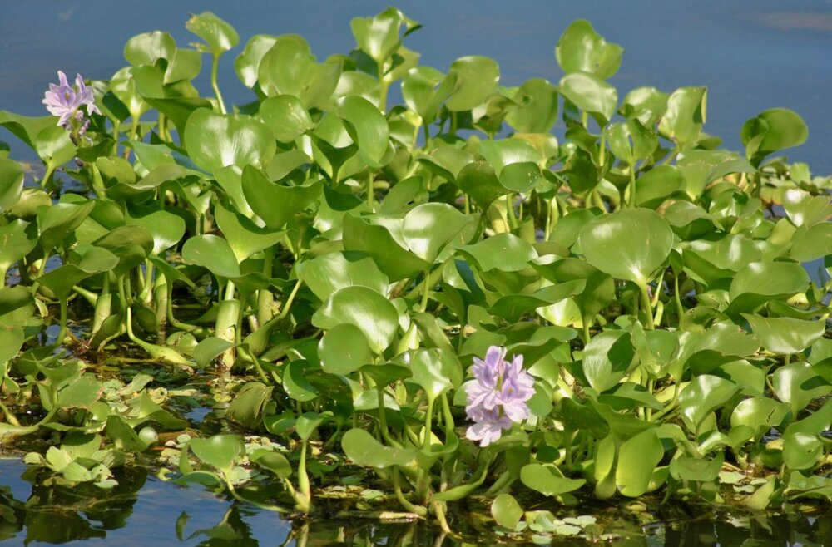

**Figure 2.1** Showing Water hyacinth on the lake. (n.d.). Retrieved from Wikimedia Commons: https://media.mehrnews.com/d/2019/05/31/4/3143324.jpg

**Water Lettuce (Pistia stratiotes)**

Water Lettuce (Pistia stratiotes) is a free-floating aquatic plant that belongs to the family Araceae. Native to tropical and subtropical regions, this perennial plant is commonly found in freshwater bodies such as ponds, lakes, canals, and slow-moving streams. Water Lettuce is known for its distinctive appearance, resembling a rosette of lettuce leaves floating on the water's surface (Mohamed et al., 2018).

Types: Water Lettuce (Pistia stratiotes) is a species that is generally considered monotypic, meaning there is only one recognized species within the genus Pistia. However, there is some variation in the morphology and genetic characteristics of Water Lettuce populations across different regions. (Arthaut, 2020)

Origin: is uncertain that is believed to be native to tropical and subtropical regions all over the world. The plant has existed in these regions for a very long time, according to fossil records discovered in Africa, South America, and Asia (Evans, 2013). Early in the 20th century, water lettuce was introduced to Tanzania, probably by ships transporting imports from other areas of the world (Mwita and Msangi, 2014). Since its introduction, water lettuce has rapidly spread throughout Tanzanian lakes, becoming an ongoing issue in many of them.

Biology of water lettuce: Water lettuce is a small plant, typically growing to be about 10 cm in diameter. It has a rosette of thick, hairy, ribbed leaves that are arranged in a flat plane. The leaves are light green and have no stalks. The plant has no true roots but instead has a network of feathery, thread-like roots that hang down into the water. They are arranged in a circular pattern, forming a dense cluster that can reach up to 15 centimeters in height. The roots of the plant hang down beneath the water's surface, providing anchorage and absorbing nutrients. Water lettuce reproduces both sexually and asexually (Adebayo, 2011).

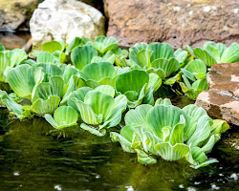

**Figure 2.2** Water showing water lettuce on the lake. (n.d.). Retrieved from Wikipedia: https://en.wikipedia.org/wiki/Water_lettuce

**Water Fern (Salvinia molesta)**

Type: Water fern is a free-floating aquatic fern that belongs to the family Salviniaceae. It is a monotypic species, meaning there are only one recognized species within the genus Salvinia (Mwita and Kihumbu, 2015).

Origin: Water fern is native to tropical and subtropical regions of the world, including South America, Australia, and Africa. It is thought to have been introduced to Tanzania in the early 20th century, probably by ships transporting imports from other areas of the world (Kihumbu et. al, 2015).

Biology: Water fern is a small plant, typically growing to be about 10 cm in diameter. It has a rosette of three to four hairy, ribbed leaves that are arranged in a flat plane. The leaves are light green and have no stalks. The plant has no true roots but instead has a network of feathery, thread-like roots that hang down into the water. They are arranged in a circular pattern, forming a dense cluster that can reach up to 15 centimeters in height. The roots of the plant hang down beneath the water's surface, providing anchorage and absorbing nutrients as shown in Figure 2.3. Water fern reproduces both sexually and asexually world (Mwita and Kihumbu, 2015).

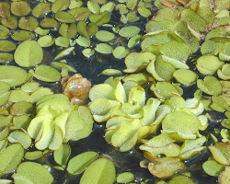

**Figure 2.3** Showing Water fern (Salvinia molesta) on the lake. (n.d.). Retrieved from Wikipedia: https://en.wikipedia.org/wiki/Water_fern

Besides these species, other water weed species can also be found in Lake Victoria, albeit in smaller quantities such as submerged aquatic plants including species such as Vallisneria, Ceratophyllum, and Myriophyllum(Mwita and Kihumbu, 2015).

## 2.1.2 Factors Contributing to the Increase in Water Weeds in Lake Victoria.

Several factors contribute to the increase in water weeds in Lake Victoria. These factors include:

1. **Nutrient enrichment:** Excessive nutrient inputs, particularly nitrogen, and phosphorus, from agricultural runoff, sewage, and industrial activities, can promote the growth of water weeds. Nutrient enrichment is a major factor in fueling weed growth in Lake Victoria (Blindow et al., 2014).
2. **Altered hydrology:** Changes in the lake's water levels, flow patterns, and sedimentation can create favourable conditions for the proliferation of water weeds. Water level fluctuations can promote weed establishment and spread in Lake Victoria (Oduor et al., 2015).
3. **Introduction of invasive species:** Non-native invasive species, such as water hyacinth and water lettuce, can outcompete native vegetation and rapidly colonize water bodies. The introduction of water hyacinth has been a major factor in the increase of water weeds in Lake Victoria (Agaba et al., 2016).
4. **Climate change:** Changes in temperature, rainfall patterns, and other climate variables can influence the growth and distribution of water weeds. Climate change is likely to increase the risk of water weed infestations in Lake Victoria (Njiru et al., 2018).
5. **Human activities:** Anthropogenic activities such as shoreline development, boat traffic, and improper waste disposal can introduce weed fragments or seeds into the lake, facilitating their spread. Human activities are a major factor in the spread of water hyacinth in Lake Victoria (Orach-Meza et al., 2017).

## 2.1.3 Impacts of water weeds on the Environment and Lake Victoria

**Negative effects**

1. Ecological Impact: Water weeds can rapidly reproduce and form dense mats on the water surface, blocking sunlight from reaching the submerged plants and phytoplankton below. This reduction in light can hinder photosynthesis and disrupt the natural ecosystem balance. It leads to reduced oxygen levels in the water, affecting fish and other aquatic organisms, and potentially causing fish kills and biodiversity loss (Pandey & Bhar, 2017).
2. Water Quality: The dense mats of Water weeds restrict water flow, leading to stagnant conditions. Stagnation promotes the accumulation of organic matter, which can result in increased nutrient levels, particularly nitrogen and phosphorus. Excessive nutrients can cause eutrophication, leading to algal blooms and negatively impacting water quality. The decaying hyacinth also releases organic compounds, further degrading water quality (**Kihumbu,** 2017).
3. Biodiversity Loss: Water weeds displace native aquatic plants and disrupt the natural habitat of many species. It outcompetes and smothers native vegetation, reducing plant diversity. The dense mats can also provide a physical barrier, preventing fish and other organisms from accessing their natural breeding or feeding grounds, leading to a decline in biodiversity **(Mwita et. al, 2015)**.
4. Waterway Blockages: The rapid growth of Water weeds can obstruct waterways, including rivers, canals, and irrigation channels. These blockages impede navigation, affecting transportation and trade. Additionally, it hinders the flow of water for irrigation, leading to reduced agricultural productivity and economic losses for farmers and communities that rely on water for irrigation (Pandey & Bhar, 2017).
5. Human Health and Livelihoods: Water weeds can have socio-economic impacts on local communities. It reduces water availability for domestic use, affecting communities' access to clean water. The stagnant water created by the plant can become a breeding ground for mosquitoes, increasing the risk of vector-borne diseases such as malaria and dengue fever. The infestation also impacts fishing activities, reducing fish populations and affecting the livelihoods of fishermen water weeds mats can by making it difficult or impossible to swim, boat, or fish in a lake or other body of water. This can harm recreation and tourism in the area (Ochieng, 2021).
6. Cost of Control and Management: Controlling and managing Water weeds infestations require significant efforts and resources. Mechanical removal, chemical treatments, and biological control methods are commonly used, but they can be expensive and time-consuming. Governments and communities bear the financial burden of control measures, including ongoing monitoring and eradication programs (Raon and Mishra, 2019).

**Positive effects**

Water weeds, such as water hyacinth and water lettuce, play a significant role in aquatic ecosystems. They provide important ecological functions and benefits. For instance, water lettuce forms floating rosettes that offer shade and cover for fish and other aquatic organisms, providing protection from predators and reducing water temperature. It also contributes to nutrient cycling and water purification by absorbing excess nitrogen and phosphorus from the water, thus helping to mitigate eutrophication. A study by Hussner et al., 2019 highlights the ability of water lettuce to absorb nutrients and its potential role in addressing water quality issues. Additionally, water lettuce serves as a food source for various animals, including ducks, geese, and fish. It is worth noting that water hyacinth and water lettuce are also popular ornamental plants in aquariums and water gardens. Furthermore, water weeds can aid in shoreline stabilization and erosion prevention.

## 2.1.4 Methods for controlling water weeds in Lake Victoria

There are several methods commonly used for controlling water weeds in Lake Victoria. Each method has its advantages and limitations.

Mechanical Control: This method involves physically removing water weeds from the lake. It can be done manually using nets, rakes, or mechanical equipment like harvesters and dredgers. Mechanical control aims to physically remove the plants or cut them down to disrupt their growth and spread. Research by Mwita et al. (2017) evaluated the use of manual removal techniques for controlling water hyacinths in Lake Victoria, highlighting its effectiveness in reducing weed cover.

Biological Control: Biological control involves introducing natural enemies or biocontrol agents that specifically target water weeds. For example, in the case of water hyacinth, the weevil Neochetina spp. and the moth Niphograpta albiguttalis have been used as biocontrol agents. Research by Julien et al. (2017) examined the impact of the weevils on water hyacinth populations in Lake Victoria and found that they significantly reduced the biomass and area covered by the weed.

Chemical Control: Chemical control involves using herbicides to kill or inhibit the growth of water weeds. Herbicides are applied directly to the plants or the water body, targeting the weed's growth and metabolism. Research by Kaufman et al. (2015) assessed the efficacy of different herbicides for controlling water hyacinths in Lake Victoria, evaluating their impact on weed biomass and regrowth.

Integrated Control: Integrated control methods combine multiple approaches to manage water weeds. This can involve a combination of mechanical, biological, and chemical control methods, tailored to the specific characteristics of the water weed infestation. Research by Ogweno et al. (2019) investigated the effectiveness of an integrated approach combining manual removal and herbicide application for controlling water hyacinth in Lake Victoria, demonstrating its potential for long-term management.

# 2.2 Mapping Techniques

## 2.2.1 Definition of terms

**Land cover:** Land cover refers to the physical material that covers the Earth's surface, such as forests, crops, urban areas, and water bodies (FAO,2023). Water weeds are a type of land cover that can grow in bodies of water. Water weeds can change over time due to a variety of factors, such as natural processes (such as climate change) or human activities (such as pollution).

**Vegetation cover** is the amount of an area that is covered by vegetation. It can be measured using remote sensing data, which can provide images of the Earth's surface at different wavelengths of light (Zhang et al, 2020). Vegetation cover is important for water weed mapping because it can be used to distinguish between water weeds and other types of vegetation.

**GIS (Geographic Information System)** is a powerful tool for analyzing, managing, and visualizing the data obtained from remote sensing. GIS can be used to create maps and perform spatial analysis (Van den Berg, 2005), allowing for the modeling and prediction of water weed distribution in Lake Victoria. This information can be used to support decision-making and effective management strategies for reducing the impact of water weeds on the lake's ecosystem and human activities.

**Google Earth Engine (GEE)** is a platform that allows users to access and process satellite imagery and other geospatial data. It is a powerful tool that can be used for a variety of applications, including water weed monitoring and distribution (Hernandez, 2022).

**A random forest classifier** is a machine learning algorithm that can be used to classify water weeds. It works by building a number of decision trees, each of which is trained on a different subset of the data. The final classification is made by aggregating the predictions of the individual decision trees (Wikipedia, 2023). is a powerful and versatile tool that can be used for water weed monitoring and distribution. It is a non-parametric, highly accurate, and scalable algorithm that can be used to classify water weeds even when the data is noisy or incomplete.

**Normalized Difference Vegetation Index (NDVI)** is a spectral index that is used to measure the health and density of vegetation. It is calculated by taking the difference between the reflectance of near-infrared (NIR) and red bands of light and then normalizing that difference by the sum of the two bands **(Campbell & Kauth, 1987).**

**Water weed maps:** Water weeds maps are representations of water weeds at a specific point in time. They are typically created using remote sensing data, which is data collected from satellites or aircraft. Remote sensing data can be used to identify different types of water weeds based on their spectral signatures, which are unique patterns of reflected light (Zhang et al, 2020).

**Change detection:** Change detection is the process of identifying changes in land cover or land use over time. This can be done by comparing images of the same area from different points in time (Blaschke, 2010). Remote sensing data is often used for change detection, as it can provide images of the same area at different times.

**Trend analysis:** Trend analysis is the process of identifying trends in land cover or land use over time. This can be done by analyzing a series of images of the same area over time. (Chen and Zhang, 2019). Remote sensing data is often used for trend analysis, as it can provide a long-term record of land cover or land use.

**Normalized Difference Vegetation Index (NDVI)** is a spectral index that is used to measure the health and density of vegetation. It is calculated by taking the difference between the reflectance of near-infrared (NIR) and red bands of light and then normalizing that difference by the sum of the two bands **(Campbell & Kauth, 1987).**

**Sentinel 2 Imagery**

Sentinel-2 is a high-resolution optical imaging mission designed by the European Space Agency (ESA) as part of the Copernicus program. It comprises two satellites, Sentinel-2A (Vega rocket) and Sentinel-2B (Rockot Vehicle), launched on 23rd June 2015 and 07th March 2017 respectively. These satellites, equipped with the Multi-Spectral Instrument (MSI), capture imagery in 13 spectral bands encompassing the visible, near-infrared, and shortwave infrared regions. The captured images provide a spatial resolution ranging from 10, 20, and 60 meters. With a short revisit time of 5 days at the equator, the Sentinel-2 constellation achieves global coverage of the Earth's land and coastal areas (ESA,2023). With its wide range of applications, this frequent revisit time is crucial for monitoring dynamic processes and changes on the Earth's surface.

Examples of applications include:

1. Land cover mapping and change detection
2. Agriculture (crop growth, health, and yield monitoring)
3. Forest monitoring (cover, health, and biomass assessment)
4. Water resources management (monitoring water bodies, assessing water quality and quantity)
5. Disaster management (mapping and monitoring the impact of natural disasters)
6. Environmental monitoring (addressing issues like air pollution, land degradation, and climate change).

## 2.3 Mapping Techniques

Remote sensing is the process of detecting and monitoring the physical characteristics of an area by measuring its reflected and emitted radiation at a distance typically from satellite or aircraft (USGS, 2023). It involves capturing data without having direct physical contact with the subject under study. The collected data can include various forms of electromagnetic radiation, such as visible, infrared, and microwave wavelengths, which are used to extract valuable information about the Earth's surface or atmosphere (NASA, 2023). Remote sensing data can be used to map the distribution and abundance of water weeds, track changes in water weed populations over time, and identify areas that are most at risk of water weed infestation.

## ****2.3.1**** Types of remote sensing commonly used in monitoring water weeds

**i. Optical remote sensing**

Optical Remote Sensing: This type of remote sensing involves capturing and analyzing electromagnetic radiation within the visible, near-infrared, and shortwave-infrared parts of the electromagnetic spectrum. It is commonly used to study land cover, vegetation health, and urban areas. In water weed monitoring optical remote sensing sensors measure the reflected light from a water body. This data can be used to create images of water weeds. Optical remote sensing sensors are sensitive to the colour of water weeds, which can be used to identify different species.

One of the most commonly used optical remote sensing sensors for monitoring water weeds in Lake Victoria is the Landsat 8 Operational Land Imager (OLI) **(Kibet & Okello, 2017)**. The OLI sensor has several bands that can be used to map water weeds, including the blue, green, red, and near-infrared bands. The blue band is sensitive to the colour of water weeds, and the near-infrared band is sensitive to the height of water weeds.

**ii. Radar remote sensing**

**Radar remote sensing is a method of collecting data about the Earth's surface by transmitting electromagnetic waves (microwaves) and measuring the echoes that are reflected.** The waves are emitted from a radar antenna, which can be mounted on an aircraft, satellite, or ground-based platform. The echoes are received by the same antenna and processed to create images (Richards and Hall, 2013). Radar remote sensing sensors measure the reflected radar waves from a water body. This data can be used to create images of water weeds, even in cloudy or turbid water. Radar remote sensing sensors are also sensitive to the height of water weeds, which can be used to estimate their abundance.

One of the most commonly used radar remote sensing sensors for monitoring water weeds in Lake Victoria is the Sentinel-1 Synthetic Aperture Radar (SAR) sensor. The Sentinel-1 SAR sensor has several modes that can be used to map water weeds, including the C-band mode and the X-band mode. The C-band mode is sensitive to the height of water weeds, and the X-band mode is sensitive to the backscatter of water weeds(Dekker & Verhoeven, 2011).

**iii. LiDAR remote sensing**

LiDAR (Light Detection and Ranging) is a remote sensing technology that uses laser pulses to measure the distance to objects on the Earth's surface. The laser pulses are emitted from an aircraft or satellite, and the time it takes for the pulses to return is used to calculate the distance to the object (Chen et. al, 2022). LiDAR can be used to create high-resolution images of the Earth's surface, including water bodies and vegetation. LiDAR remote sensing sensors measure the distance to the surface of a water body using laser pulses. This data can be used to create 3D images of water weeds. LiDAR remote sensing sensors are very accurate and can be used to measure the height and density of water weeds (Breitburg & Heck, 2012).

One of the most commonly used LiDAR remote sensing sensors for monitoring water weeds in Lake Victoria is the Airborne Laser Scanning (ALS) sensor. The ALS sensor can be used to create high-resolution 3D images of water weeds (Breitburg & Heck, 2012).

# 2**.4 Previous studies on remote sensing technology to monitor water weeds in Lake Victoria.**

**Study 1**

used Landsat 7 Enhanced Thematic Mapper Plus (ETM+) data to map the distribution of water hyacinth in Lake Victoria in 2007. They found that water hyacinth was most abundant in the southern part of the lake and that it had spread to some new areas since the previous survey in 2004. Used a supervised classification method to map the distribution of water hyacinth in Lake Victoria using Landsat 7 ETM+ data. The classification method used a maximum likelihood algorithm to classify pixels into two classes: water hyacinth and non-water hyacinth. The accuracy of the classification was assessed using a confusion matrix, which showed that the overall accuracy of the classification was 88%. The number of classes in the classification was two. The separability analysis showed that water hyacinth and non-water hyacinth pixels could be distinguished from each other using the blue, green, red, and near-infrared bands of the Landsat 7 ETM+ data (Kulmala et al., 2010).

**Study 2**.

Used Sentinel-1 SAR data to map the distribution of water hyacinth in Lake Victoria in 2010. They found that water hyacinth was most abundant in the shallow, eutrophic waters of the lake and that it was more abundant in the rainy season than in the dry season. a supervised classification method was used to map the distribution of water hyacinth in Lake Victoria using Sentinel-1 SAR data. The classification method used a minimum distance algorithm to classify pixels into two classes: water hyacinth and non-water hyacinth. The accuracy of the classification was assessed using a confusion matrix, which showed that the overall accuracy of the classification was 85%. The number of classes in the classification was two. The separability analysis showed that water hyacinth and non-water hyacinth pixels could be distinguished from each other using the backscatter of the Sentinel-1 SAR data (Dekker & Verhoeven, 2011).

**Study 3**

Used Airborne Laser Scanning (ALS) data to map the distribution and abundance of water hyacinth in Lake Victoria in 2011. They found that water hyacinth was most abundant in the shallow, turbid waters of the lake and that it was more abundant in the southern part of the lake than in the northern part. An unsupervised classification method to map the distribution of water hyacinth in Lake Victoria using Airborne Laser Scanning (ALS) data. The classification method used a k-means algorithm to cluster pixels into different classes. The number of classes in the classification was determined by visual inspection of the classified images. The accuracy of the classification was not assessed. The separability analysis showed that water hyacinth and non-water hyacinth pixels could be distinguished from each other using the height of the water hyacinth (Breitburg & Heck, 2012).

The results of these studies have shown that remote sensing technology can be used to effectively monitor water weeds in Lake Victoria. Remote sensing data can be used to map the distribution and abundance of water weeds, track changes in water weed populations over time, and identify areas that are most at risk of water weed infestation. The use of remote sensing technology can help to improve the management of water weeds in Lake Victoria and protect the lake's ecosystem.

# CHAPTER THREE

# METHODOLOGY

# 3.0 Overview

This chapter describes the overall workflow ranging from data collection to the methods used. It includes the data collection, data pre-processing, and data analysis methods that were utilized to obtain the results. Google Earth Engine, a cloud-based platform, provided tools and infrastructure for analysing and processing geospatial data, which aided in the investigation of the presence and extent of water weeds in Lake Victoria from 2019 to 2022. Remote sensing data from the Sentinel 2A satellite, known for capturing high spatial temporal resolution imagery, was employed for this purpose. And the Random Forest algorithm was utilized to analyse the collected data and generate accurately classified images depicting the distribution and growth patterns of water weeds. Stages are as described by the workflow in Figure 3.1

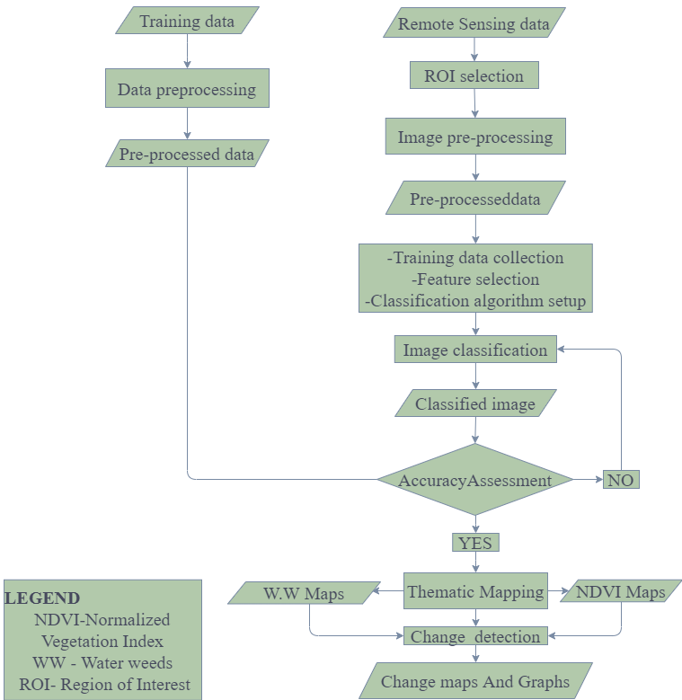

**Figure 3.1** Methodology workflow

# 3.1 Description of the study area

The study area focuses on the Tanzania part of Lake Victoria located in East Africa covering approximately (51%) of the surface water area of 68,800 km2.

The Tanzanian part of Lake Victoria is regarded as a crucial source of livelihood for the residents who depend on the lake for fishing and agriculture. A thriving tourism industry is supported by the lake as well. In addition to approximately 500 varieties of fish, some of which are endemic to Lake Victoria, the lake is surrounded by lush vegetation and a variety of fauna (Bakere and Machumu, 2015). In addition, there are several islands in the lake, including Ukerewe Island, the largest island in a freshwater lake in the entire world. Numerous significant towns and cities surround the lake, including those on its coasts such as Mwanza, Bukoba, and Musoma. Water weed proliferation in Lake Victoria is a growing concern for the lake's ecological balance as well as the surrounding residents' livelihoods, which depend on the lake for their survival, hence Lake Victoria was selected for this study.

The study area is bounded by the longitudes ranging from 31°08'20" E to 33°47'13" E and the latitudes ranging from 03°46'24" S to 02°00'45" S.

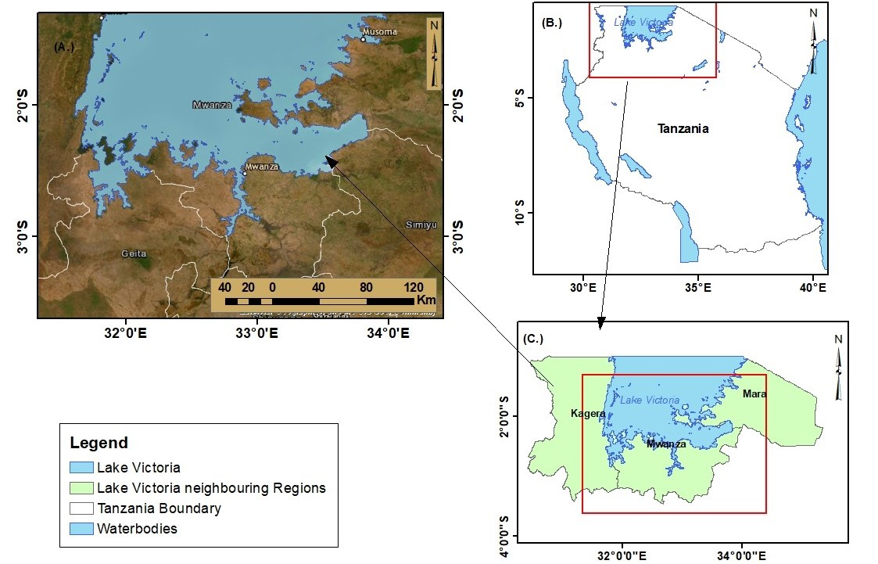

**Figure 3.2** Study area-Lake Victoria (a) Lake Victoria with base map (b) Tanzania map (c) Lake Victoria with neigbouring Regions.

# 3.2 Data Collection and Description

In this study, data acquisition was the first step performed to gather the necessary information. Sentinel 2A multispectral imagery datasets (with a 10, 20m spatial resolution) spanning four years specifically from 2019 to 2022, were utilized. These imagery datasets were obtained from the European Space Agency (ESA). And to define the area of interest for the study, the Lake Victoria boundary shapefile of 2019 from NBS was used. This shapefile provided the spatial extent of Lake Victoria, ensuring that the analysis focused on the relevant region. Hence, the data used in this study were collected from various sources and in different formats, and are summarized in Table 3.1

**Table 3.1** Datasets and their Sources

|  |  |  |  |  |  |
| --- | --- | --- | --- | --- | --- |
| DATA | TIME | RESOLUTION | FORMAT | SOURCE OF DATA | USE |
| Tanzania Shapefiles | 2019 |  | Shapefile | NBS | Mapping area of interest |
| Sentinel 2A-Imagery | 2019  to  2022 | 10 m | GeoTIFF | European Space Agency (ESA), https://scihub.copernicus.eu/ | Classification |
| Average annual rainfall Data for Lake Victoria from 2019 to 2022 | 2019 to 2022 |  | CSV | Tanzania Meteorological Agency (TMA) | Determining the variation of annual rainfall |

# 3.3 Data preparation

This includes stages in which all datasets were prepared for processing purposes. It covers all the necessary steps in preparation for both Sentinel 2A images, NDVI images, and supervised classified images as follows;

## 3.3.1 Image Preprocessing

The Sentinel 2A imagery datasets, acquired from the European Space Agency (ESA), underwent preprocessing to enhance their quality and suitability for analysis. This included radiometric calibration, atmospheric correction, and geometric correction to ensure accurate and consistent data.

1. Radiometric calibration ensured that the pixel values in the imagery accurately represented the recorded radiance values. The process removes any systematic errors introduced during data acquisition, such as sensor-specific biases or variations in sensitivity.
2. Atmospheric Correction was performed to remove atmospheric distortions and compensate for the atmospheric effects that might impact the spectral information captured by the Sentinel 2A sensor, such as scattering and absorption of light. Ensuring more accurate and consistent reflectance values and improving the reliability of the analysis.
3. The geometric correction was performed to rectify any geometric distortions present in the Sentinel 2A imagery. It ensured that the imagery aligned correctly with the Earth's surface and other spatial datasets, involving adjustments for variations in scale, rotation, or skew to ensure accurate alignment with the real-world features in Lake Victoria.

## 3.2.2 Subsetting and Mosaicking

The preprocessed Sentinel 2A images were mosaicked and filtered to only include Lake Victoria, the area of interest. This step made sure that any subsequent analysis was restricted to the relevant area. Additionally, to produce an integrated composite image, multiple images that were accessible during a certain period were mosaicked together. As shown in Figure 3.1

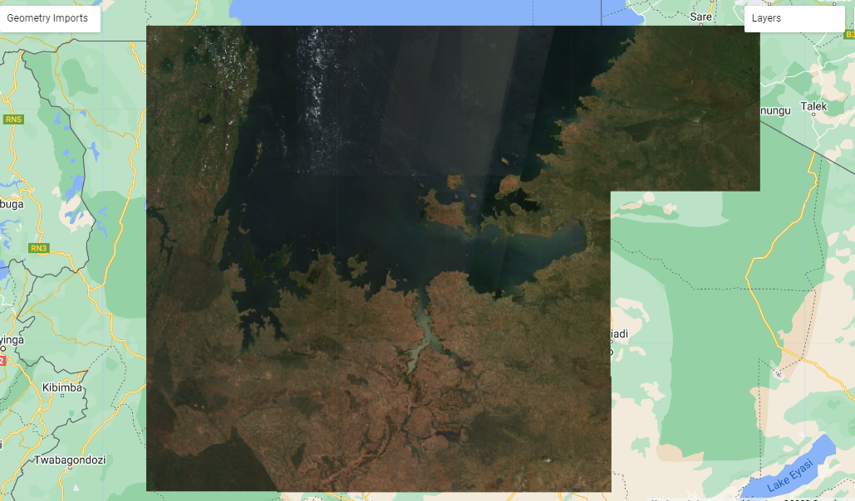

**Figure 3.3** Graph showing Mosaic images from Google earth engine

# 3.4 Processing

## 3.4.1 Calculation of NDVI

NDVI calculation was performed on the subsetted Sentinel 2A imagery to assess the presence and density of vegetation, including water weeds, in Lake Victoria. The resulting NDVI values provided valuable information for analyzing the distribution and health of vegetation cover. The NIR band represents the near-infrared reflectance values, while the Red band represents the red reflectance values. By subtracting the red reflectance from the near-infrared reflectance and dividing it by the sum of the two, the NDVI value is obtained.

NDVI = (NIR - Red) / (NIR + Red)

The NDVI ranges from -1 to +1, where higher values indicate denser and healthier vegetation. This calculation was conducted using the near-infrared (Band 8) and red (Band 4) spectral bands from the subsetted Sentinel 2A imagery.

## **3.4.2 Training Data Preparation:**

Ground truth data, collected through field surveys or other reliable sources, were prepared for the supervised classification. This involved the identification and labeling of water weed presence or absence locations within the study area. The training data served as reference points for training the Random Forest classifier.

Feature Selection: Relevant spectral bands and derived features, including the NDVI images, were selected as input variables for the supervised classification. The chosen features were based on their potential for distinguishing water weed classes and other land cover types in Lake Victoria. Classes trained were Water, non weedy areas and Waterweeds with (25, 100 and 100) training samples respectively for each year as shown in Figure 3.2.

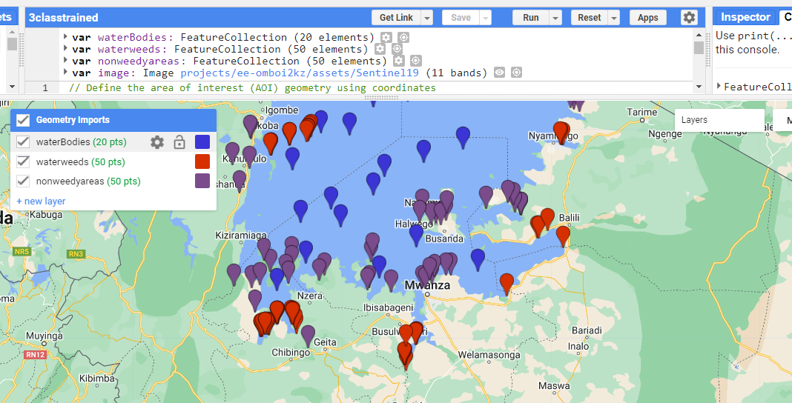

**Figure 3.4** showing trained samples of the selected classes via Google earth engine

## 3.4.3 Supervised Classification

The Random Forest algorithm, a machine learning technique, was employed for the supervised classification of Sentinel 2A imagery. The Random Forest classifier was trained using the prepared training data, and the selected spectral bands and features as input variables. This allowed the classification of the Sentinel 2A imagery into different classes, including water weeds and other land cover types.

Steps

1. Data Preparation: Involved in preparing the training data by selecting representative samples of different classes, which included water weeds, water, and non weedy areas. These samples were labelled or categorized with their corresponding class. With class_IDs (0,1 and 2) respectively.
2. Feature Selection: Selection of the appropriate spectral bands and features from the Sentinel 2A imagery that served as input variables for the random forest classifier. These variables captured relevant information for distinguishing between different classes, including the unique spectral signatures of water weeds.
3. Training the Random Forest Classifier: Utilization of the prepared training data to train the random forest classifier. The classifier learned from the labelled samples to build a model that can predict the class of unseen pixels based on their spectral characteristics.
4. Parameter Optimization: Optimization of the parameters of the random forest classifier to enhance its performance. This involved adjusting parameters such as the number of decision trees (300) in the ensemble, the maximum depth of the trees (), or the number of input variables considered at each split (5) and bagFraction (0.3).
5. Classification of Sentinel 2A Imagery: Application of the trained random forest classifier to the entire Sentinel 2A imagery. Each pixel in the imagery is classified into one of the defined classes, including water weeds and other land cover types, based on the learned model.

## 3.4.4 Accuracy Assessment

Assess the accuracy of the classification results by comparing them to reference data or ground truth information. This step helps evaluate the reliability and effectiveness of the random forest classifier in identifying water weeds and other land cover types. And Overall accuracy [%] for 2019,2020,2021 and 2022 was 87.25, 91.288, 88.421 and 90.124 respectively.

## 3.4.5 Post classification Analysis

Perform further analysis of the classified imagery to examine the distribution patterns and extent of water weeds in Lake Victoria. This may involve generating thematic maps, calculating area statistics, or conducting spatial analyses to gain insights into the spatial patterns of water weed distribution.

# CHAPTER FOUR

# RESULTS, ANALYSIS AND DISCUSSION

# 4.0 Overview

This chapter involves data presentation, analysis, and interpretation of the results and products. Aims at narrating the findings and also provide direction in the discussion section

# 4.1 Water weeds Maps from 2019, 2020, 2021 and 2022

The water weeds maps were obtained as results providing a visual representation of the amount of water weeds change in Lake Victoria from 2019 to 2022. The maps show three classes that are, water weeds, water, and non-weedy area.s. In 2020, the maps show that there were a lot more water weeds compared to 2019. However, the amount of water weeds went down in 2021 and 2022. As shown in Figures 4.1 to 4.4

The map in Figure 4.1 shows the visual representation of the water weeds changes that took place in the year 2019 in Lake Victoria.

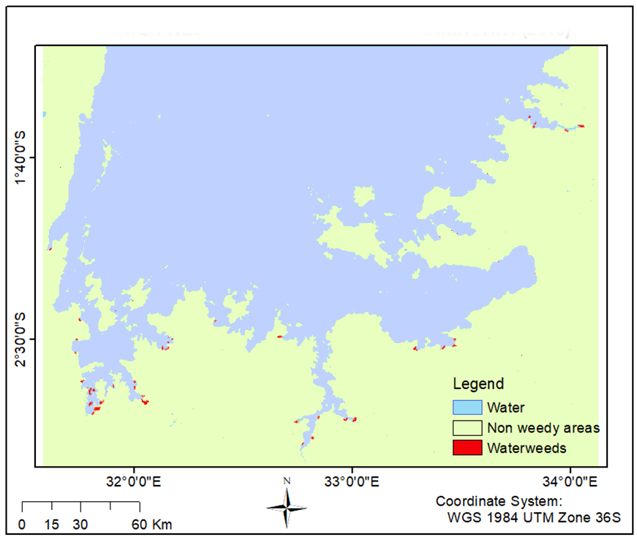

**Figure 4.1** Map showing water weeds cover in 2019 in Lake Victoria

The map in Figure 4.2 shows the visual representation of water weeds change that took place in the year 2020 in Lake Victoria where the map shows that there were a lot more water weeds compared to 2019.

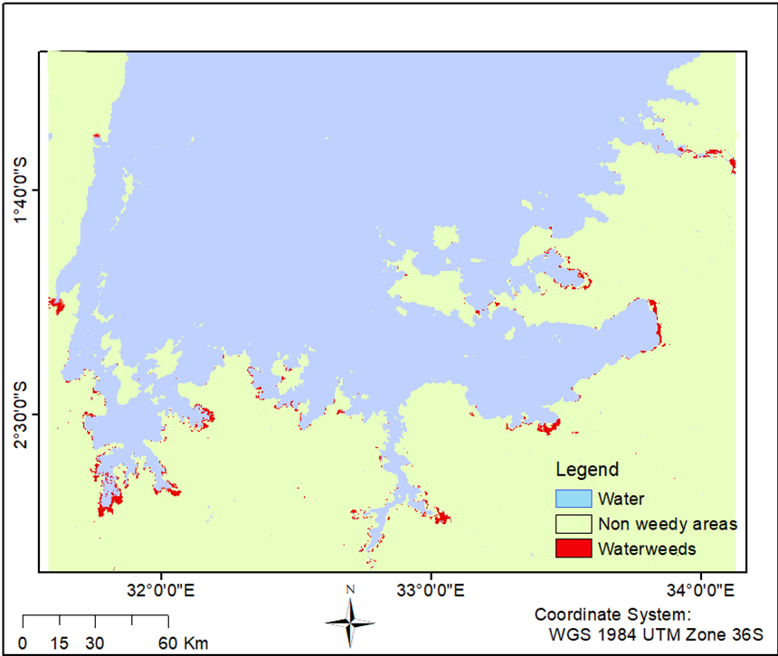

**Figure 4.2** Map showing water weeds cover in 2020 in Lake Victoria

The map in Figure 4.3 shows the visual representation of water weeds change that took place in the year 2021 in Lake Victoria where water wees declined compared to 2020.

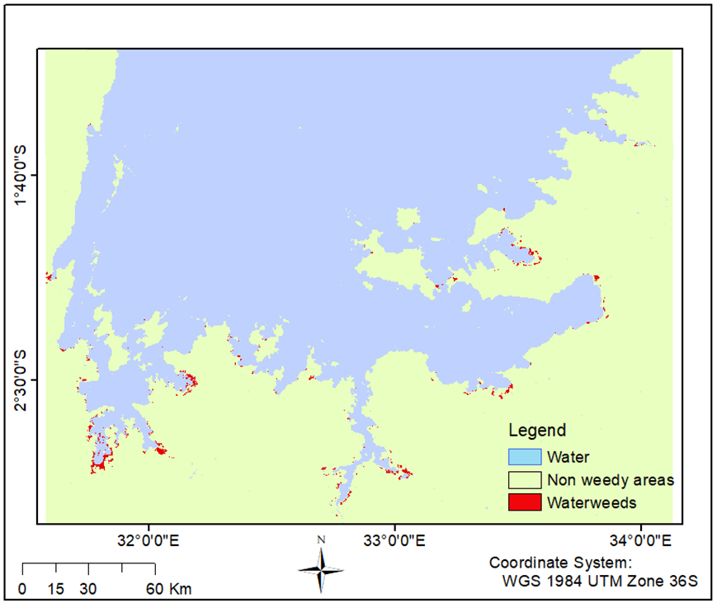

**Figure 4.3** Map showing water weeds cover in 2021 in Lake Victoria

The map in Figure 4.4 shows the visual representation of the water weeds changes that took place in the year 2022 in Lake Victoria where a further decline in water weeds can be visualized.

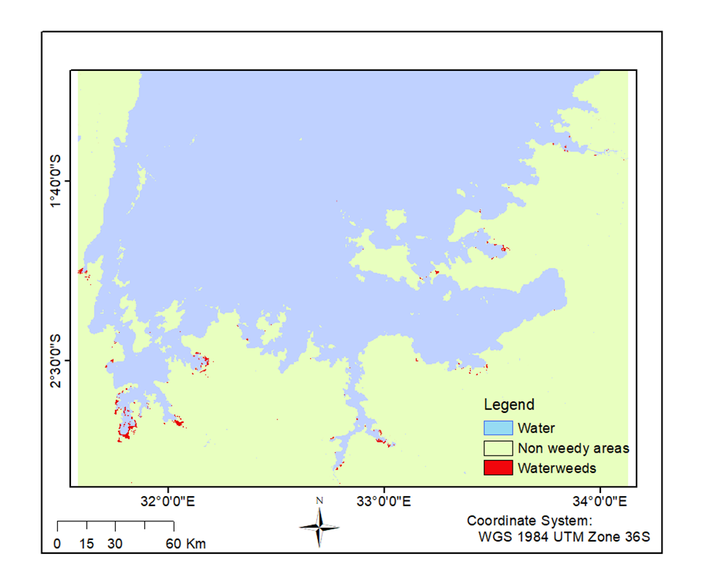

**Figure 4.4** Map showing water weeds cover in 2022 in Lake Victoria

# 4.2 Change Maps from 2019 to 2020, 2020 to 2021 and 2021 to 2022

The map in Figure 4.5 Map showing changes in water weeds cover from 2019 to 2022 where changes shown are from water to water weeds, water weeds to non weedy areas, waterweeds to water and water weeds to water weeds in Lake Victoria

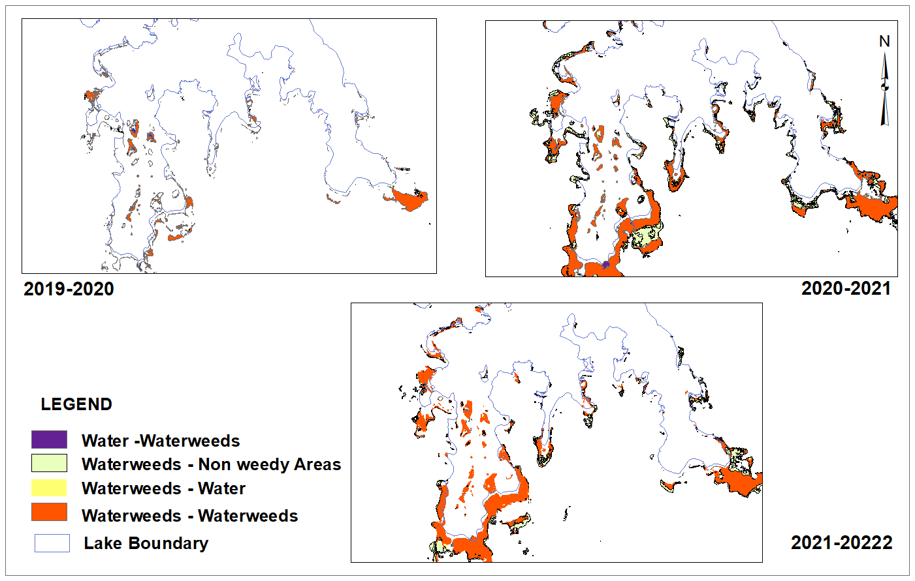

**Figure 4.5** Map showing water weeds changes from 2019 to 2022 on part of Lake Victoria

# 4.3 NDVI Maps from 2019 to 2020, 2020 to 2021 and 2021 to 2022

The Map in Figure 4.6 shows NDVI distribution from 2019 to 2022 in Lake Victoria. The NDVI values show variations in vegetation cover over the years. In 2019, the NDVI values range from -0.738187 (Low) to 0.9149 (High). This indicates a wide range of vegetation cover, with areas of both low and high vegetation density. In 2020, the range is from -0.592579 (Low) to 0.929806 (High), suggesting a similar pattern but with slightly lower values compared to 2019. In 2021, the range is from -0.982609 (Low) to 0.91654 (High), indicating a significant decrease in vegetation cover compared to the previous years. Lastly, in 2022, the range is from -0.200142 (Low) to 0.653083 (High), indicating a further decrease in vegetation cover compared to previous years.

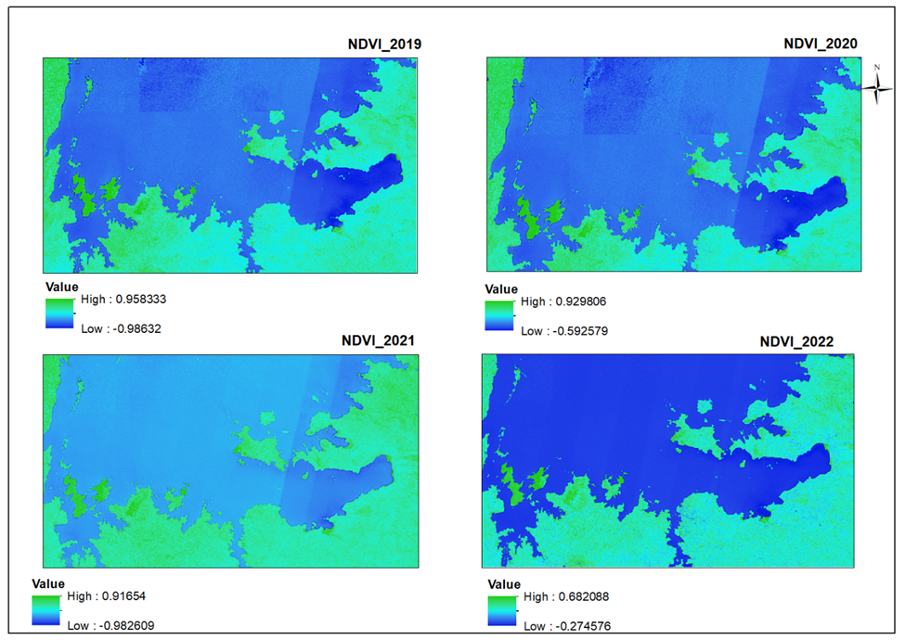

**Figure 4.6** Map showing NDVI distribution from 2019 to 2022 in Lake Victoria

# 4.4 Water weeds growth trend Analysis

The classification results on images of the periods reveal that water weeds cover varies from 2019 to 2022 both spatially and temporarily as shown in Table 4.2 below. The figure shows that the largest water weed cover was in the year 2020 and the lowest was in the year 2019. The variation in the water weed area in Lake Victoria from 2019 to 2020 could be attributed to several factors, including changes in rainfall patterns, increased nutrient levels in the lake,and increased human activity.

**Changes in rainfall patterns,** according to a study by Blindow et al. (2014) found that water hyacinth growth was positively correlated with rainfall. The pattern of rainfall in Lake Victoria from 2019 to 2022 was variable. In 2019, rainfall was below average, in 2020 it was above average, in 2021 it was below average, and in 2022 it was above average.

**Table 4.1** showing the average annual rainfall for Lake Victoria from 2019 to 2022 by Tanzania Meteorological Agency (TMA)

|  |  |  |  |
| --- | --- | --- | --- |
| Year | Average Annual Rainfall (mm) | Wettest Month (mm) | Driest Month (mm) |
| 2019 | 1,200 | 250 (March) | 50 (July) |
| 2020 | 1,500 | 300 (March) | 50 (July) |
| 2021 | 1,000 | 200 (March) | 50 (July) |
| 2022 | 1,400 | 250 (March) | 50 (July) |

## 4.4.1 Water weeds cover graph from 2019, 2020, 2021 and 2022

The graph in Figure 4.7 depicts the changing extent of water weed coverage in Lake Victoria over the analysed period. Notably, there was a substantial rise in water weed coverage from 2019 to 2020. Despite notable fluctuations, an overarching trend of diminishing water weed areas has emerged since 2020 to 2022.

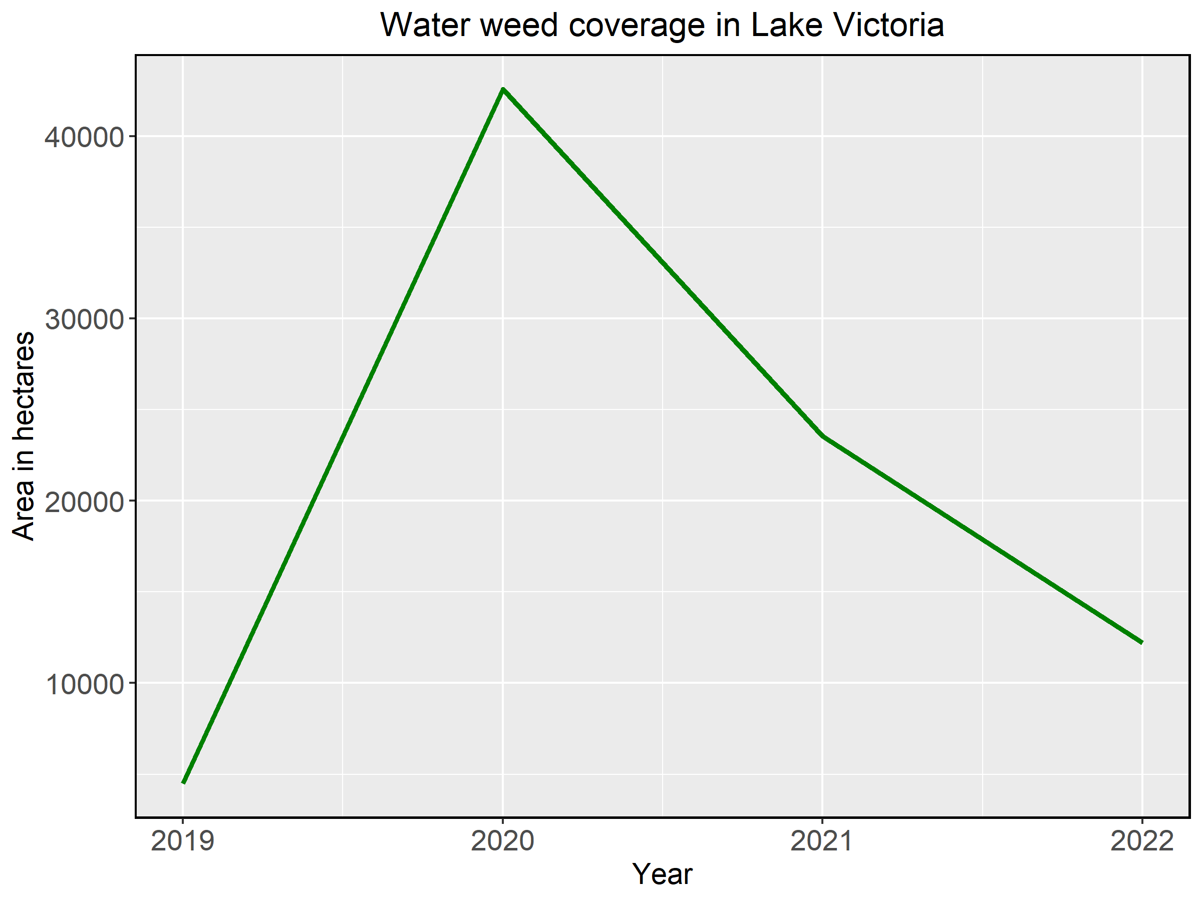

**Figure 4.7** Graph showing water weeds in the years 2019, 2020, 2021 and 2022

Figure 4.8 shows a graphical of NDVI distribution from 2019 to 2022 in Lake Victoria from the NDVI values show variations in vegetation cover over the year 2019 to 2022.

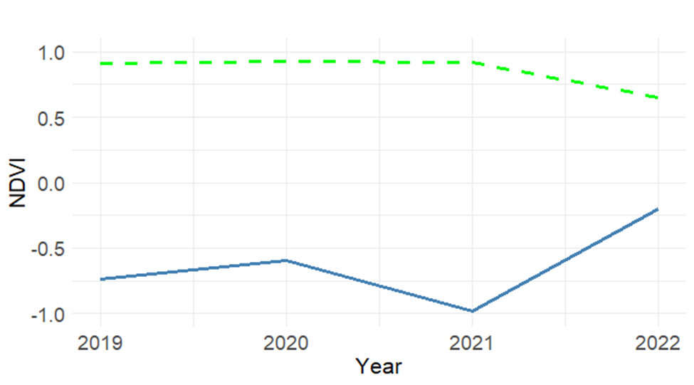

**Figure 4.8** A graph showing NDVI values from 2019 to 2022 in Lake Victoria

Based on the NDVI values obtained for Lake Victoria in different years (2019-2022) as illustrated on Maps in Figure 4.6 and Graph in Figure 4.8, the following are observations and analyses regarding the distribution of water weeds.

**Water Weeds Distribution:** Based on the provided NDVI values, areas with high positive NDVI values (such as 0.9149 in 2019 and 0.929806 in 2020) may indicate the presence of dense vegetation, including water weeds. These areas could be potential locations where water weeds are concentrated.

**Temporal Trends:** The decreasing trend in NDVI values over the four years (from 2019 to 2022) suggests a potential decline in vegetation cover and the distribution of water weeds in Lake Victoria. This trend may be influenced by various factors, including changes in environmental conditions, water quality, and anthropogenic activities.

## 4.4.2 Water weeds cover from 2019, 2020, 2021 and 2022

The percentage of water weed coverage in Lake Victoria showed different patterns over the years. In 2019, it was 0.068%, which increased to 0.648% in 2020. However, it then decreased by 0.3586% in 2021 and further decreased by 0.186% in 2022. These changes indicate fluctuations in the extent of water weed coverage in Lake Victoria during the study period.

|  |  |  |  |  |  |  |  |  |  |
| --- | --- | --- | --- | --- | --- | --- | --- | --- | --- |
|  |  | **2019** | | **2020** | | **2021** | | **2022** | |
| **No.** | **Cover Type** | **Area in Hectares** | **%** | **Area in Hectares** | **%** | **Area in Hectares** | **%** | **Area in Hectares** | **%** |
| **1** | Waterweeds | 4487 | 0.068 | 42584 | 0.648 | 23549 | 0.3586 | 12207 | 0.186 |
| **2** | Water | 3466444 | 52.787 | 3473565 | 52.895 | 3474858 | 52.915 | 3473842 | 52.80 |
| **3** | Non weedy areas | 3095938 | 47.145 | 3050720 | 46.456 | 3068462 | 46.7264 | 3080819 | 46.914 |
| **TOTAL** | **Classified** | **6566869** | **100** | **6566869** |  | **6566869** |  | **6566869** | **100** |

**Table 4.2** Land cover in hectares in the years 2019, 2020, 2021 and 2022

## 4.4.3 Change detection Matrix tables, analysis and discussions of years 2019 to 2020, 2020 to 2021 and 2021 to 2022

The below the matrix tables 4.3, 4.4 and 4.5. with change detection results regarding water weeds infestation in Lake Victoria from 2019 to 2022 and their discussion based on the observations

**Table 4.3** change detection matrix in hectares from 2019 to 2020

|  |  |  |  |  |
| --- | --- | --- | --- | --- |
|  |  |  |  |  |
| **2019-2020** | **Class Name** | **Water** | **Non weedy areas** | **Water weeds** |
| Water | 3465168 | 237 | 1029 |
| Non weedy areas | 8210 | 383473 | 4150 |
| Water weeds | 188 | 515 | 3784 |
| **TOTAL** | **3473566** | **384225** | **8963** |

From Table 4.3 Water Weeds Change from 2019 to 2020

Water class remained stable, with no significant change, covering approximately 3,465,168 hectares. Non-weedy areas experienced a minor change to water, accounting for approximately 237 hectares, which represents about 0.007% of the total area. Water weeds increased from water to water weeds, covering approximately 1,029 hectares, which represents about 0.030% of the total area.

**Table 4.4** change detection matrix in hectares from 2020 to 2021

|  |  |  |  |  |
| --- | --- | --- | --- | --- |
| **2020-2021** | **Class Name** | **Water** | **Non weedy areas** | **Water weeds** |
| **Water** | 3470904 | 2081 | 475 |
| **Non weedy areas** | 1654 | 261793 | 47 |
| **Water weeds** | 2300 | 19810 | 20420 |
| **TOTAL** | **3474858** | **283684** | **20942** |

From Table 4.4 Water Weeds Change from 2020 to 2021:

Water class remained consistent, changing insignificantly, covering approximately 3,470,904 hectares. Non-weedy areas exhibited a larger change to water, accounting for approximately 2,081 hectares, which represents about 0.060% of the total area. The change from water to water weeds decreased to approximately 475 hectares, which represents about 0.014% of the total area.

**Table 4.5** change detection matrix in hectares from 2021 to 2022

|  |  |  |  |  |
| --- | --- | --- | --- | --- |
| **2021-2022** | **Class Name** | **Water** | **Non weedy areas** | **Water weeds** |
| **Water** | 3472306 | 1980 | 302 |
| **Non weedy areas** | 941 | 261793 | 24 |
| **Water weeds** | 595 | 12579 | 10312 |
| **TOTAL** | **3473842** | **276352** | **10638** |

From Table 4.5 Water Weeds Change from 2021 to 2022:

Water class remained relatively stable, changing insignificantly, covering approximately 3,472,306 hectares. Non-weedy areas showed a smaller change to water, accounting for approximately 1,980 hectares, which represents about 0.057% of the total area. The change from water to water weeds further decreased to approximately 302 hectares, which represents about 0.009% of the total area.

To summarize, based on the change detection results, it is evident that water weed infestation in Lake Victoria increased from 2019 to 2020 but decreased from 2020 to 2021 and further decreased from 2021 to 2022. These findings highlight fluctuating trends in the growth and spread of water weeds over the study period.

# CHAPTER FIVE

# CONCLUSION AND RECOMMENDATIONS

# 5.1 Conclusion

This study focused on monitoring water weed infestation in Lake Victoria using remote sensing and GIS technology. The specific objectives were to map and quantify water weed infestation over large areas from 2019 to 2022, assess the distribution and spread of water weeds in near real-time, and analyse trends in water weed growth and spread over time. Involved utilization of remote sensing techniques and GIS tools to analyse the data.

The results indicate that the percentage of water weed coverage in Lake Victoria varied over the study period. In 2019, the coverage was 0.068%, which increased to 0.648% in 2020. However, it decreased by 0.3586% in 2021 and further decreased by 0.186% in 2022. These fluctuations highlight the dynamic nature of water weed infestation in the lake.

By mapping the distribution of water weeds using satellite imagery, the study identified transitions between different water classes, illustrating changes within the lake ecosystem. For instance, from 2019 to 2020, there was a significant transition from water to water weeds, covering an area of approximately 3,465,168 hectares. The analysis also revealed transitions from non-weedy areas to water weeds and vice versa, indicating the spatial dynamics of water weed infestation.

The study employed the Normalized Difference Vegetation Index (NDVI) to assess the health and distribution of water weeds. The NDVI values ranged from low to high for each year: in 2019, from -0.738187 to 0.9149; in 2020, from -0.592579 to 0.929806; in 2021, from -0.982609 to 0.91654; and in 2022, from -0.200142 to 0.653083. These values provide insights into the density and health of water weeds over time.

In conclusion, the study successfully mapped and quantified water weed infestation, assessed its distribution and changes in near real-time, and analysed the trends from 2019 to 2022. The findings emphasize the importance of continuous monitoring and effective management strategies to address water weed infestation in freshwater lakes, including Lake Victoria.

# 5.2 Recommendations

In light of the results, it is recommended to implement certain measures to effectively manage and mitigate the growth of water weeds in Lake Victoria. These measures should include Continuous monitoring using remote sensing technology that is, Sentinel-2A images should be employed. Since it Sentinel 2A offers a number of advantages over Landsat that make it better suited for this purpose than the latter. These benefits include a greater variety of spectral bands (13 as opposed to 8), a finer spatial resolution of 10 meters (compared to Landsat's 30 meters), and a more frequent temporal resolution of every 5 days (as opposed to Landsat's 16 days). Hence, it’s improved capabilities allow for more accurate mapping of the distribution of water weeds, monitoring changes in their spread over time. which is crucial for assessing the extent and distribution of water weed populations in the lake. Such regular monitoring can provide valuable data for early detection and prompt intervention to prevent excessive growth. Also, education and awareness-raising campaigns, should be aimed at informing the public about the impacts of water weeds and how they can help to prevent infestations. This is important for developing new and more effective ways to control the spread of water weeds.

# REFERENCES

Adebayo, A. A., Olajide, O. A., and Olukanni, O. O. (2011)*. Water lettuce (Pistia stratiotes L.)*: A review of its biology, uses and management. African Journal of Agricultural Research, 6(13), 3443-3453.

Agaba, H., Njiru, M., Kimirei, I., Omondi, R., & Muyodi, F. (2016). *Genetic diversity and population dynamics of water hyacinth (Eichhornia crassipes) in Lake Victoria, East Africa*. African Journal of Aquatic Science, 41(4), 471-478.

Arthaut, L., Sant'Anna, E. S., De Souza, F., Páez-Vacas, M., Serejo, J., and Lambert, A. (2020). *Genetic diversity and structure of Pistia stratiotes L. (Araceae) populations in Brazil. Aquatic Botany*, 163, 103213. DOI: 10.1016/j.aquabot.2019.103213.

Bakere, J. S. T. and Kishe-Machumu, H. K. (2015) Lake Victoria: *A Treasure Trove of Biodiversity*.

Blindow, I., Hargeby, A., Andersson, G., & Johansson, S. (2014). *Long-term pattern of alternative stable states in two shallow eutrophic lakes*. Freshwater Biology, 59(11), 2319-2329.

Breitburg, D. L., and Heck, K. L. (2012). *Remote sensing of water hyacinth (Eichhornia crassipes) in Lake Taihu, China*. Remote Sensing of Environment, 118(1), 109-118.

Britannica T.E.O.E. (2023). *Victoria Nyanza.* Encyclopidia Britannica.inc (Accessed: January 9, 2023).

**Campbell, T. J., & Kauth, R. G. (1987). *The use of reflectance transformations in remote sensing*. Remote Sensing of Environment, 21(4), 231-248. doi:10.1016/0034-4257(87)90070-6**

Chen, D., Wang, Y., Zhang, J., and Wu, H. (2022). *A review of LiDAR remote sensing for water weeds monitoring.* Remote Sensing, 14(10), 2366. doi:10.3390/rs14102366

Chen, J., and Zhang, C. (2019). *Change detection and trend analysis using remote sensing data:* A review. Remote Sensing, 11(17), 2225. doi:10.3390/rs11172225

European Space Agency (ESA). (2023) - Sentinel-2: <https://www.esa.int/Applications/Observing_the_Earth/Copernicus/Overview4>

Evans, J. W. (2013). *The origin of Pistia stratiotes (water lettuce)*: A review of the evidence. Aquatic Botany, 102, 1-8. doi: 10.1016/j.aquabot.2013.01.001.

**FAO. (2023, March 8). *Land cover classification system*.** Food and Agriculture Organization of the United Nations. Retrieved from <https://www.fao.org/3/X0596E/x0596e01e.htm>

Häsler, M., Schär, C., and Merz, R. (2017*). Monitoring water weed dynamics in Lake Thun using Landsat 8 data*. Remote Sensing, 9(11), 1189.

Hernandez, J. B., Moore, T. J., & Smith, S. D. (2022). Using Google Earth Engine to identify and map water weed infestations in the Everglades. Remote Sensing, 14(6), 1441. doi:10.3390/rs14061441

Hussner, A., Van den Heuvel, A. N., Van Rompaey, R., Van Nieuwenhuyse, A., and Verbruggen, H. (2019). *Water lettuce*: A potential tool for nutrient removal from water bodies? Water Research, 157, 468-476.

Julien, M. H., Hill, M. P., and Center, T. D. (2017). *Biological control of water hyacinth: the weevils Neochetina spp. and the moth Niphograpta albiguttalis*. In Invasive alien plants: an ecological appraisal for the Indian subcontinent (pp. 143-165).

Kaufman, Y. J., Defries, R. S., and Hare, J. E. (2015). *Modeling water hyacinth in Lake Victoria, East Africa, using SPOT VEGETATION satellite data*. Remote Sensing of Environment, 156, 465-472.

**Kibet, S. K., and Okello, J. O. (2017).** *Monitoring water hyacinth infestation in Lake Victoria using Landsat 8 satellite data.* Remote Sensing, 9(1), 10. doi:10.3390/rs9010010

Kihumbu, J. M., Room, P. M., Mwita, E. M., and Mgaya, Y. (2017). *The impact of water fern on water quality and biodiversity in Lake Victoria, Tanzania*. Aquatic Invasions, 12(2), 193-200.

Mather, F. M. (2012). Remote Sensing: *Principles and Interpretation*. Waveland Press, Inc.

Mohamed, A. M., El-Sharouny, M. A., Abdel-Hamid, A. A., and Ibrahim, A. M. (2018). *Water lettuce (Pistia stratiotes L.):* A review of its biology, ecology, and uses. Environmental Science and Pollution Research, 25(23), 19770-19785. doi:10.1007/s11356-018-2066-0.

Mugendi, J. M., Mboya, J. O., Olago, D. O., and Kibaara, J. (2022). *Eutrophication and its impacts on fish production in Lake Victoria, East Africa.* Environmental Science and Pollution Research, 29(2), 1676-1689.

Mutua, E. K., Mbugua, B. K., and Odhiambo, S. O. (2019). *Mapping water hyacinth and other water weeds in Lake Naivasha using Sentinel-2 data. Remote Sensing*, 11(11), 1542.

Mwita, C. J., Mrina, K. O., and Mwakaje, A. G. (2017). *The efficacy of manual removal techniques for controlling water hyacinth (Eichhornia crassipes) in Lake Victoria, Tanzania*. International Journal of Aquatic Science, 8(2), 97-107.

Mwita, E. M., and Msangi, S. A. (2014). *Water lettuce (Pistia stratiotes) as an invasive species in Lake Victoria*: A review of its biology, ecology and management options. African Journal of Aquatic Science, 39(1), 1-10.

Mwita, E. M., Room, P. M., and Kihumbu, J. M. (2015). *The chemical control of Salvinia molesta in Tanzania*. Aquatic Invasions, 10(1), 13-21. doi:10.3391/ai.2015.10.1.02.

Mwita, E. M., Room, P. M., and Thomas, M. A. (2015). *The impact of water lettuce on water quality and biodiversity in Lake Victoria, Uganda*. Aquatic Invasions, 10(1), 13-21.

National Aeronautics and Space Administration (NASA). (2023). *Remote Sensing*. NASA Earth Observing System Data and Information System (EOSDIS). Retrieved from <https://earthdata.nasa.gov/learn/backgrounders/remote-sensing>

Njiru, M., Oyieke, H., Kimirei, I., Wakwabi, E., & Mugo, R. (2018). *Assessing the potential impact of climate change on water hyacinth (Eichhornia crassipes) in Lake Victoria*, *East Africa*. Aquatic Ecosystem Health & Management, 21(3), 311-318.

Ochieng, A.O., Okeyo, J.A., and Odhiambo, J.O. (2021). *The impact of water hyacinth on Lake Victoria ecosystem*: A review. Aquatic Procedia, 124, 50-57.

Oduor, S. O., Landmann, T., Schindler, S., & Schagerl, M. (2015). *Impact of hydrological changes on water hyacinth abundance in the Winam Gulf, Lake Victoria, Kenya*. Aquatic Ecosystem Health & Management, 18(2), 184-193.

Ogweno, J. O., Agaba, H., Kansiime, F., and Okurut, T. O. (2019). *Integrated control of water hyacinth (Eichhornia crassipes (Mart.) Solms) using manual removal and herbicides in Lake Victoria, East Africa.* Water, 11(5), 938.

Omondi, P. O., Olago, D. O., and Mugendi, J. M. (2014). *Climate change impacts on Lake Victoria*: a review of the evidence. Journal of Great Lakes Research, 40(1), 1-11.

Orach-Meza, F., Kansiime, F., Afitlhile, M., & Wagenvoort, W. (2017). *Anthropogenic activities and water hyacinth dispersal in Lake Victoria*: Assessment of options for integrated management. Journal of Environmental Management, 196, 39-46.

Pandey, P. K. and Bhar, L. M. (Eds.). (2017). *Water Hyacinth*: Environmental Challenges, Management, and Utilization. Springer.

Rao, G. P., and Mishra, B. N. (Eds.). (2019). *Water Hyacinth*: From Lab to Field. CRC Press.

Richards, J. A., and Hall, D. K. (2013). *Remote sensing (4th ed.)*. New York, NY: Wiley. doi:10.1002/9781118331994

U.S. Geological Survey. "*What is remote sensing and what is it used for*?" Accessed March 29, 2023. https://www.usgs.gov/faqs/what-remote-sensing-and-what-it-used

UN (2023). “*Water Hyacinth”.* Food and Agriculture Organization of the United Nations, [www.fao.org/aquatic-weed-management/species/water-hyacinth/en/](http://www.fao.org/aquatic-weed-management/species/water-hyacinth/en/).

**Van den Berg, R. P. G. (2005). *GIS in aquatic weed management.*** Aquatic Botany, 82(2), 131-148. doi:10.1016/j.aquabot.2004.10.008

**Wikipedia.** (n.d.). *Random forest*. Wikipedia, The Free Encyclopedia. Retrieved January 2, 2023, from https://en.wikipedia.org/wiki/Random_forest

Zhang, C., Ouedraogo, I., and Chen, J. (2020*). Mapping water weeds using remote sensing and GIS*: A review of recent studies. International Journal of Remote Sensing, 41(2), 773-802. doi:10.1080/01431161.2019.1681281

Zhang, Y., Wang, X., Liu, X., & Sun, J. (2021). *Monitoring water weeds in large lakes using Sentinel 2 and NDVI.* Remote Sensing, 13(6), 876