PROG2335

CP Capstone Project 2019
(Rapid Grocery)



Designed and Developed by-
Jody Bhamra
Komal Randhawa
Youngsun Chang

School of Engineering and Information Technology

This report is submitted for the completing the course:
PROG2335: System Development - Systems Project
April-2019

Table of Contents

1. Deliverable III: Design 3
1.1. Design Level Class Diagram 4
1.2. Design Level Sequence Diagram 5
1.3. Navigation Diagram 9
1.4. Updated User Interface Prototype (Admin) 4
1.5. Report Design 5
1.6. Entity Relationship Diagram 11
1.7. Data Dictionary 4
1.8. Web Search and Rationale 5

Deliverable 3: Design

Design Level Class Diagram

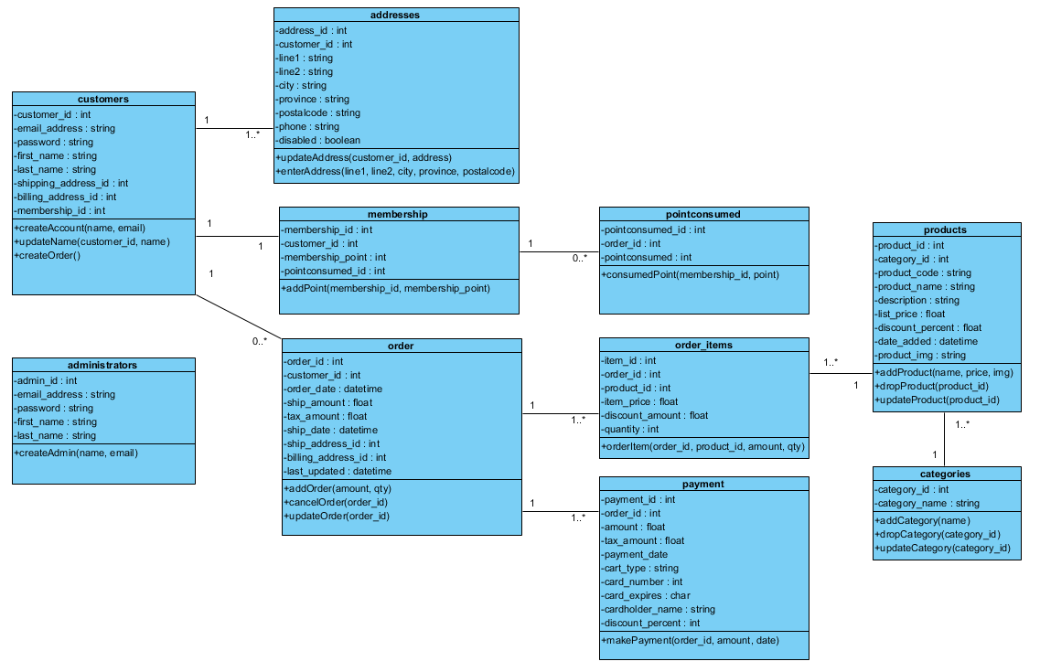

Design Level Sequence Diagram

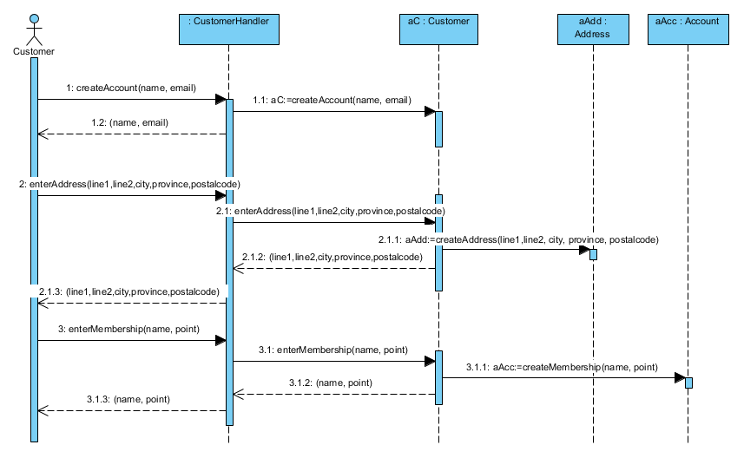
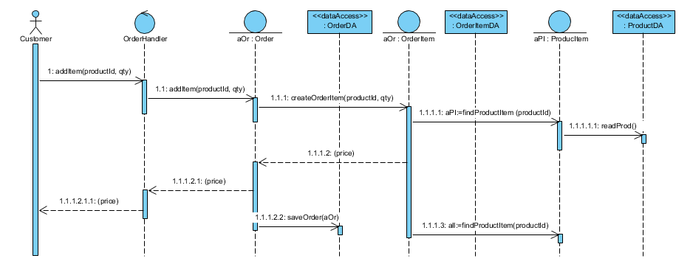
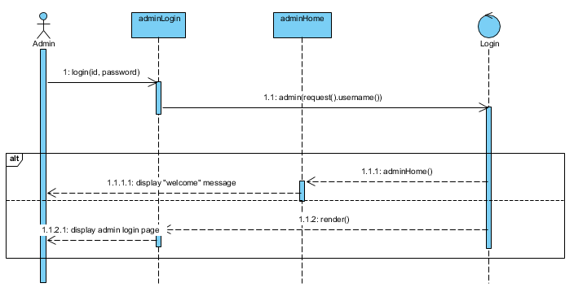
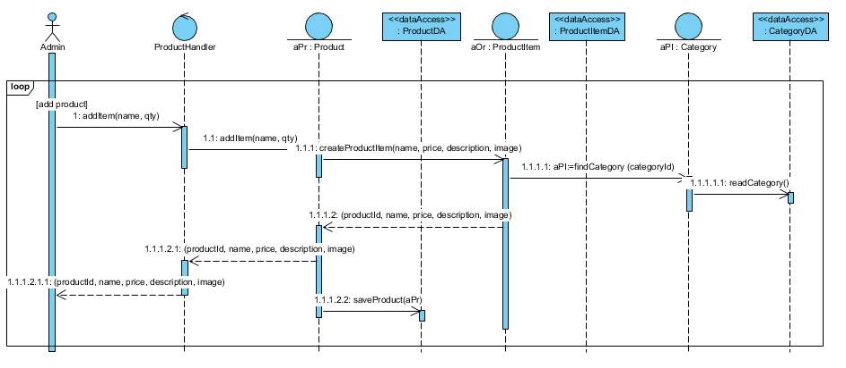

Navigation Diagram
- Customer
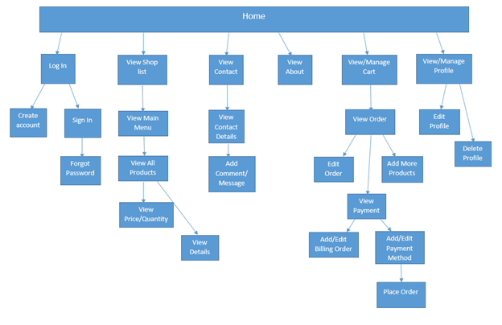
- Admin
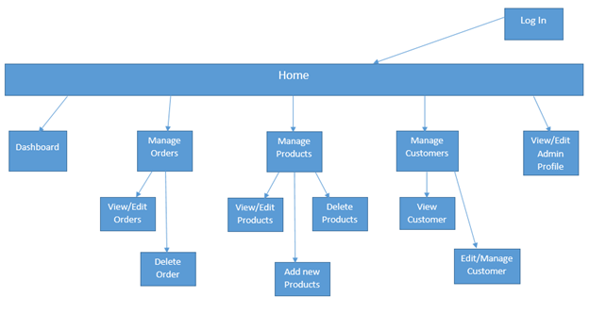

Updated User Interface Prototype (Admin)

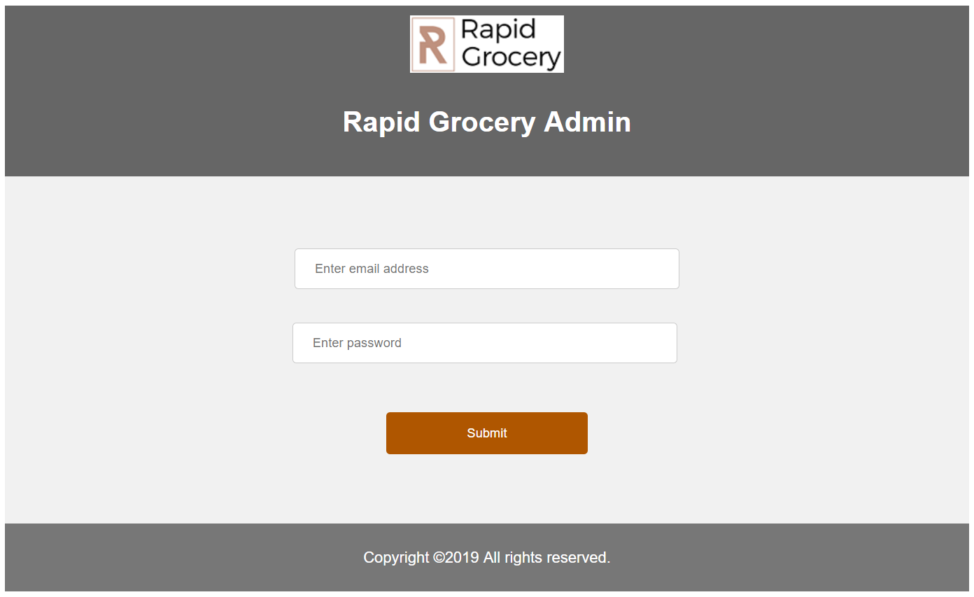
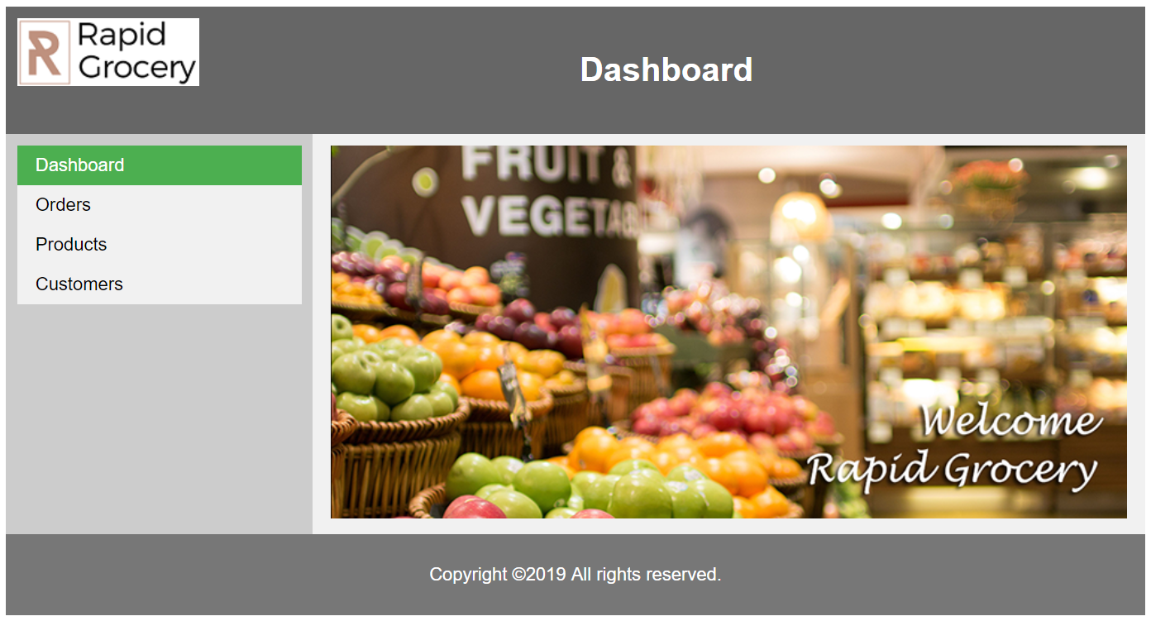

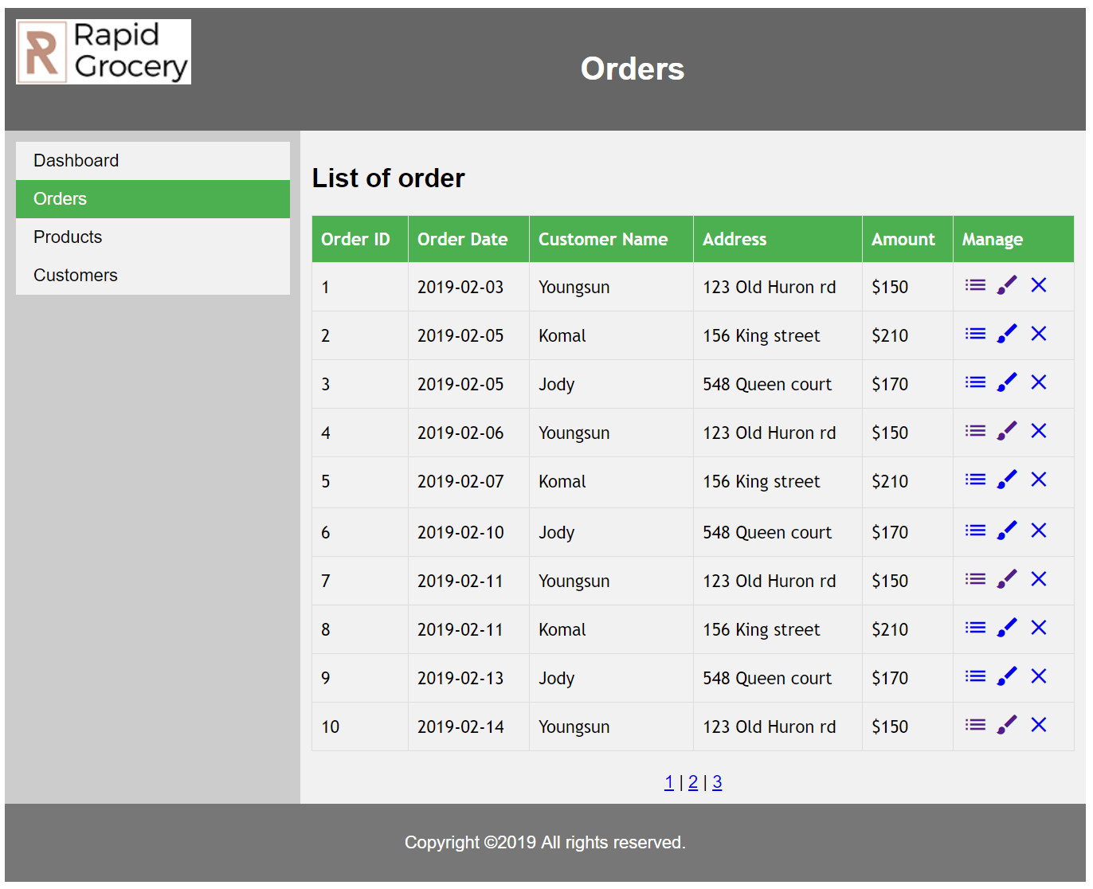

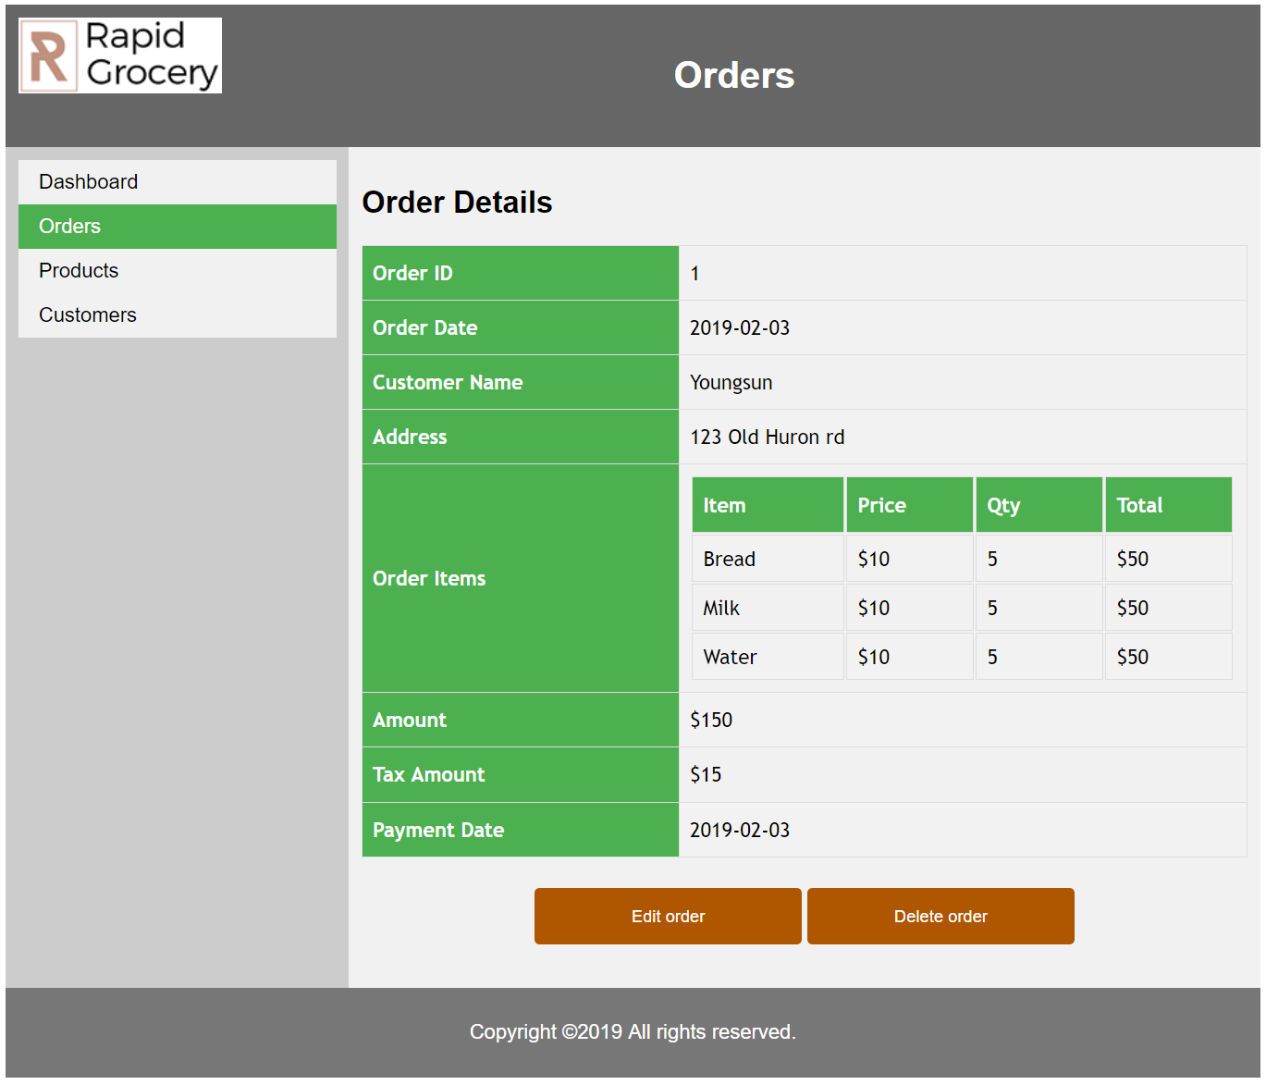

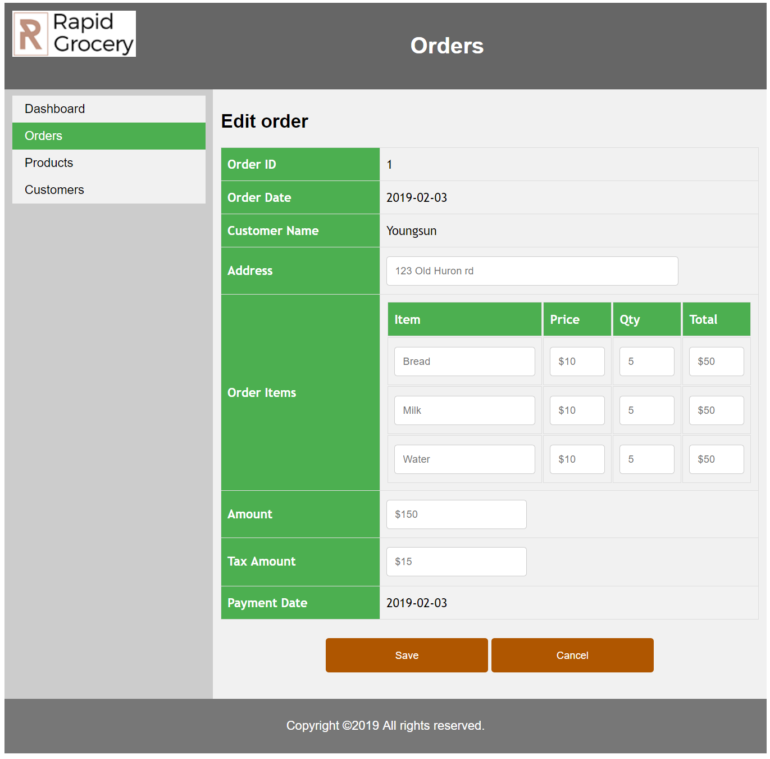

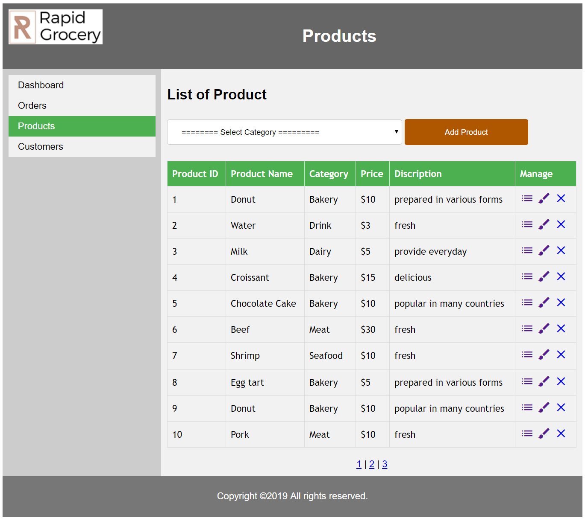

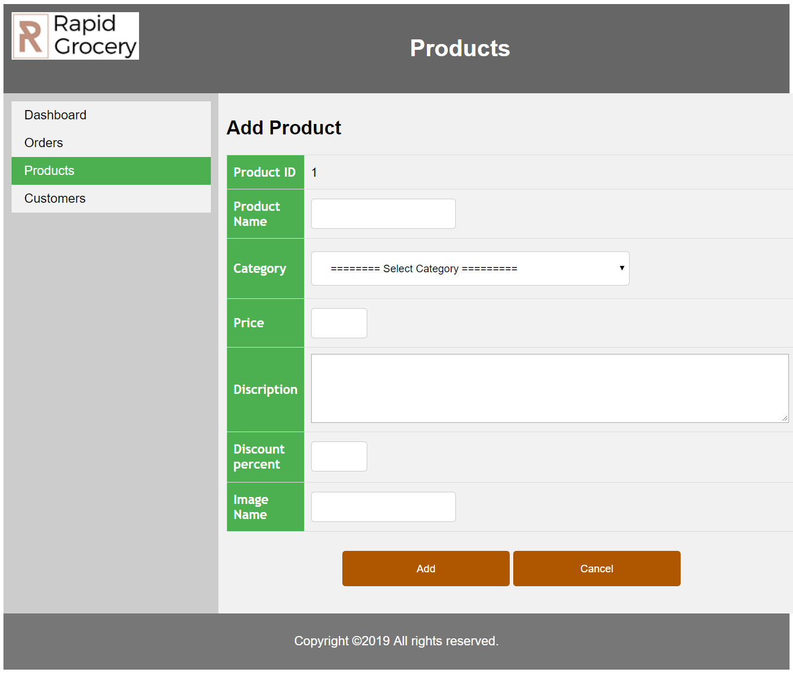

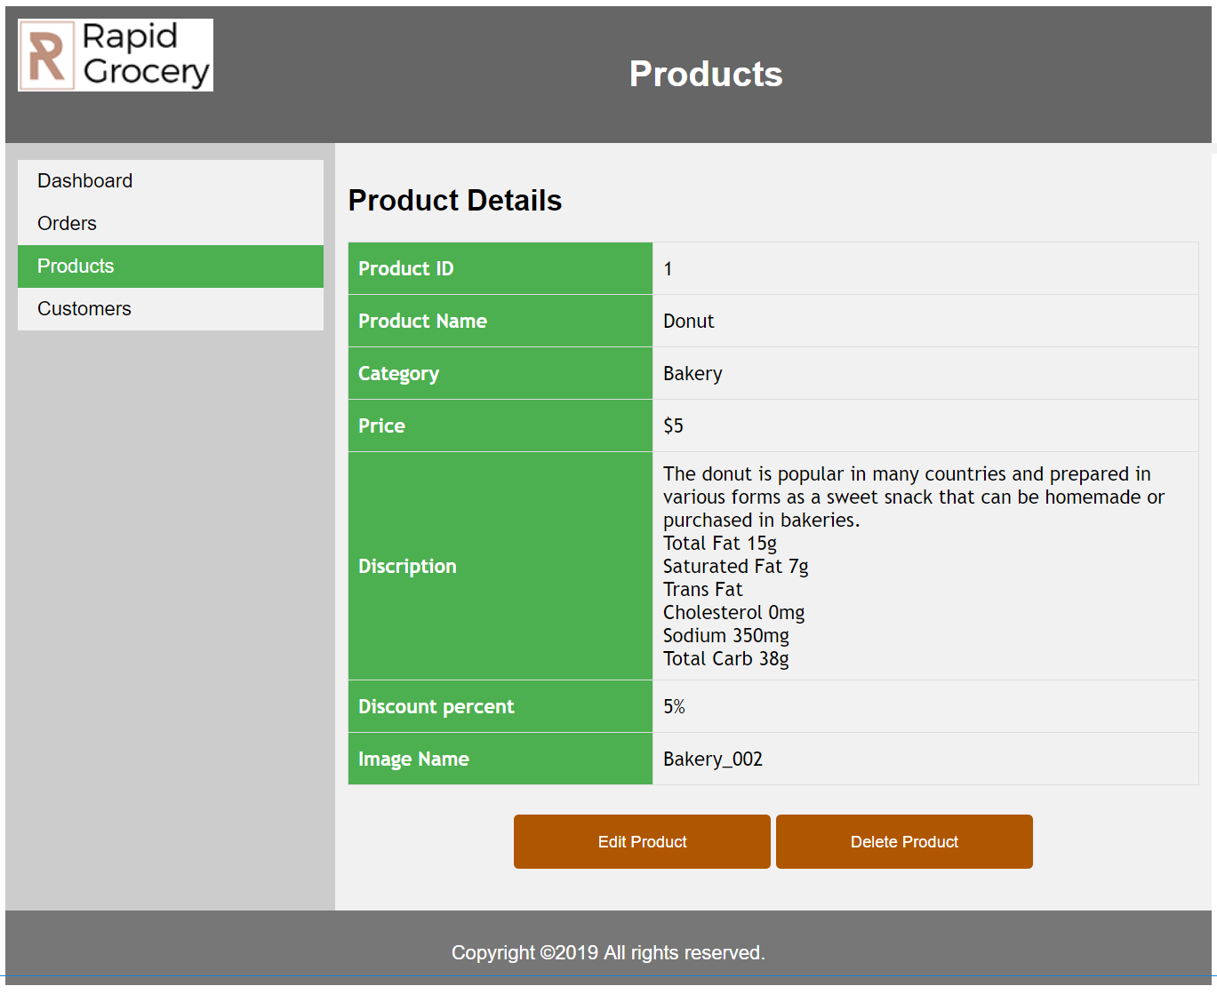

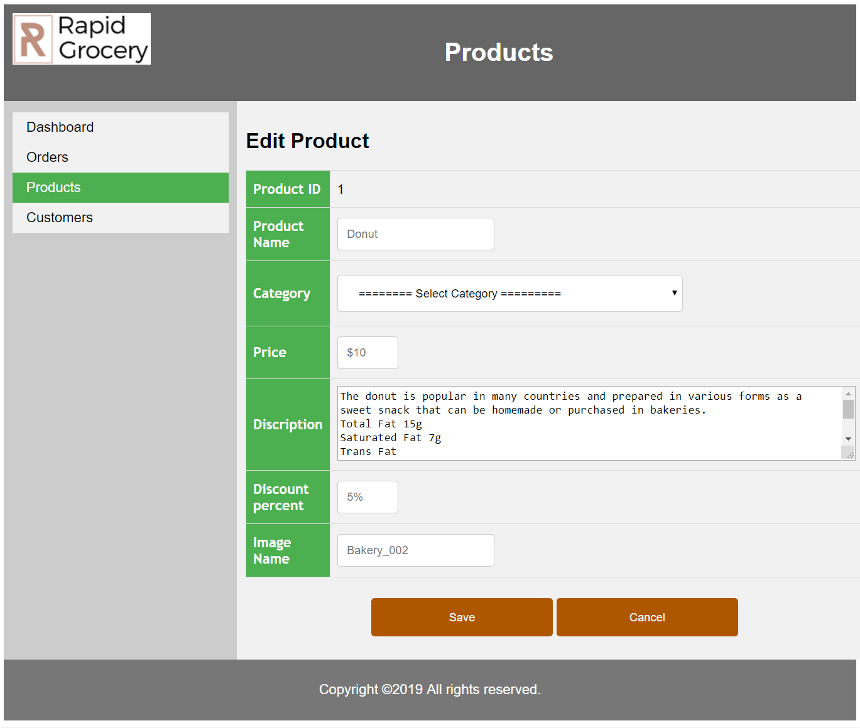

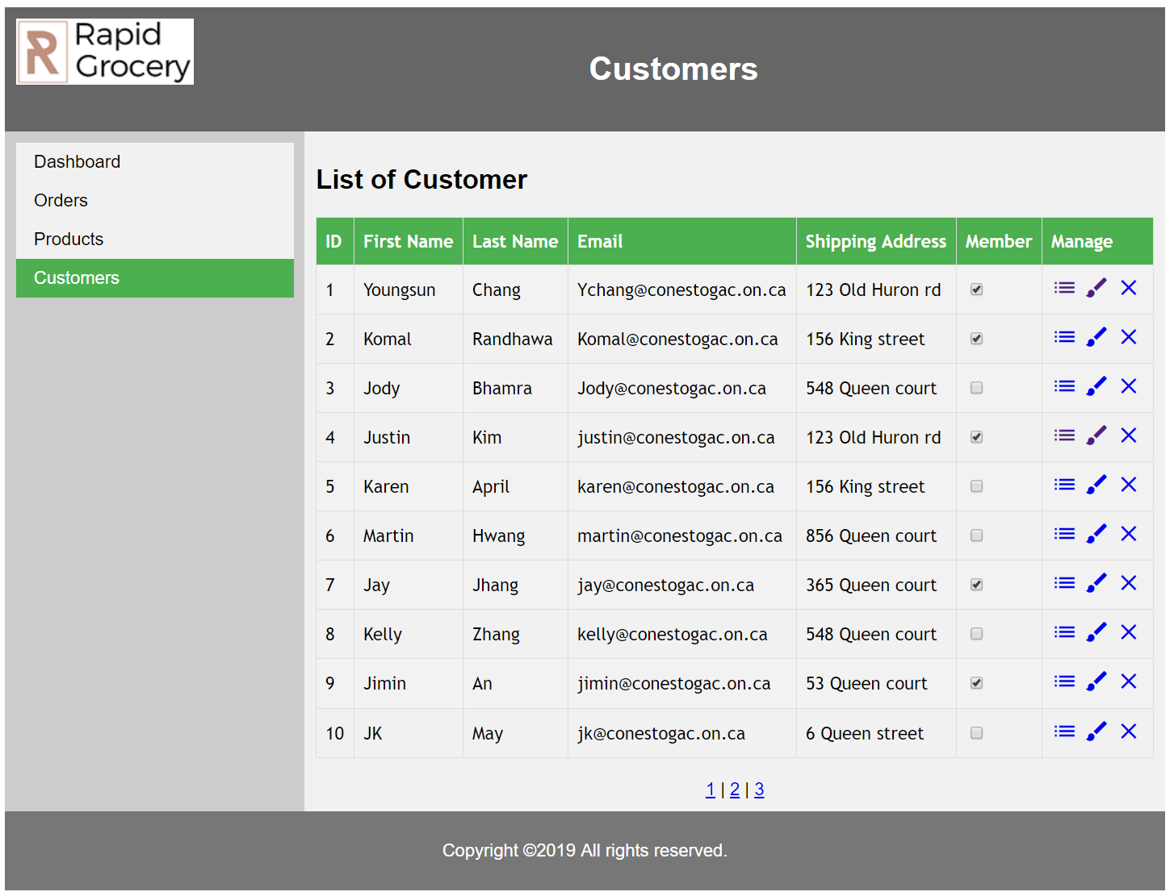

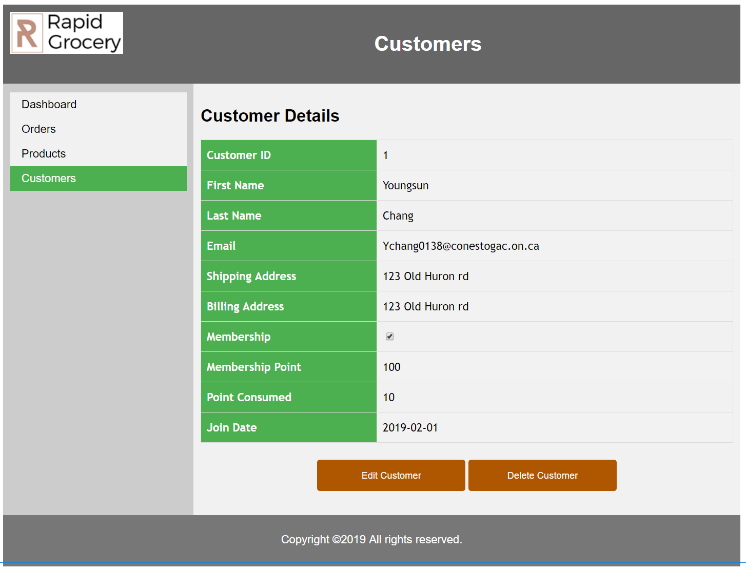

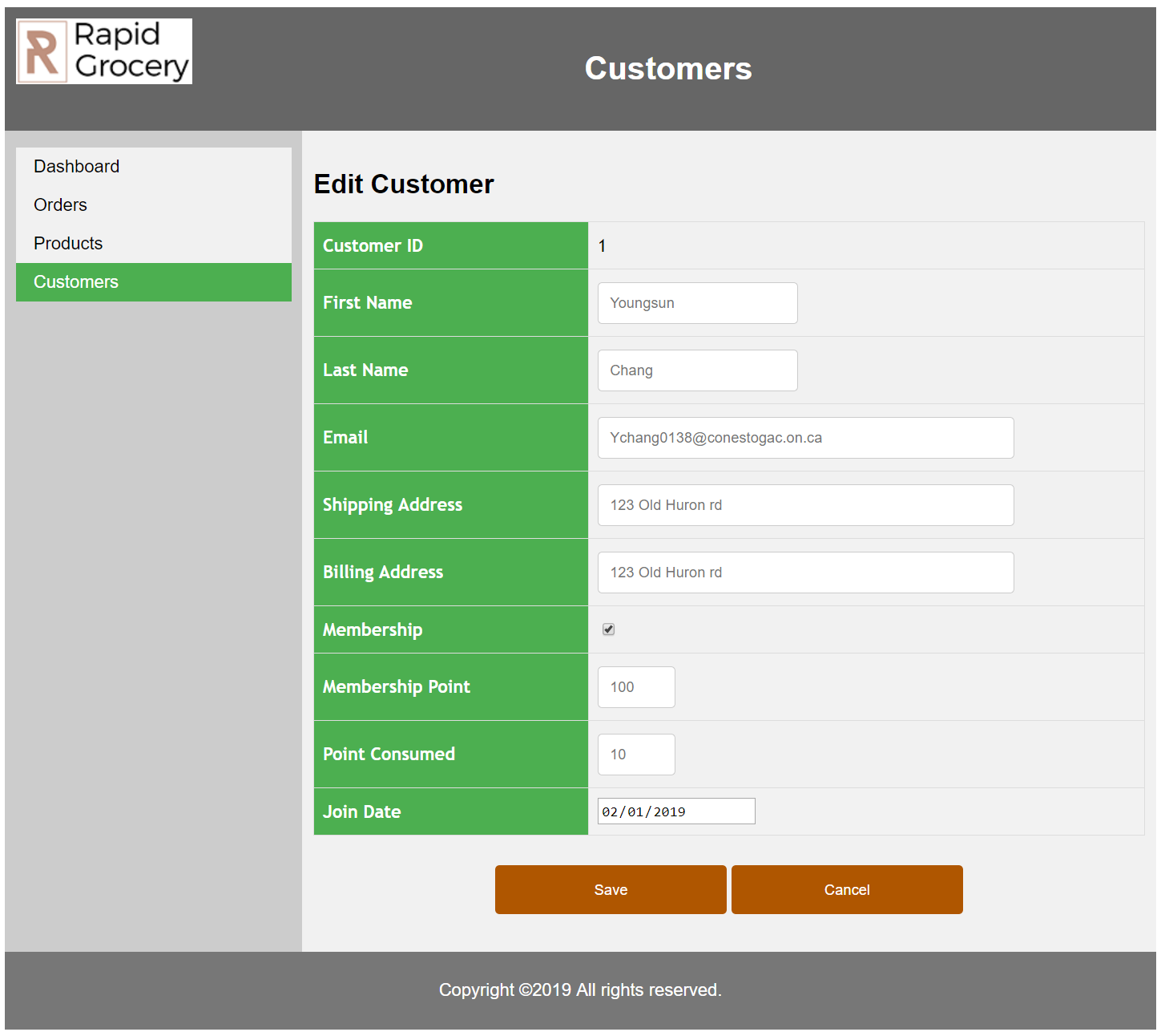

Report Design

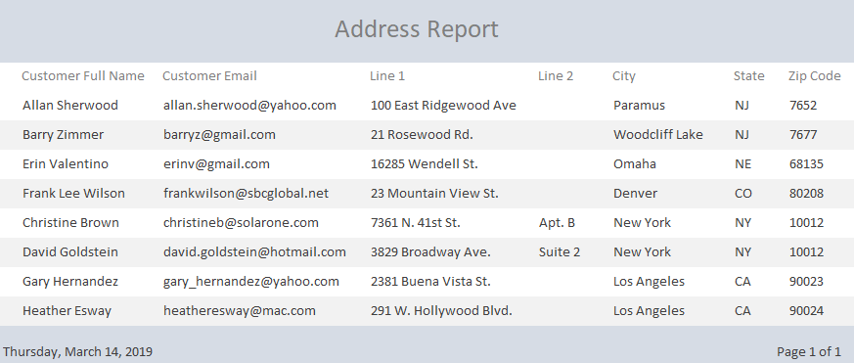

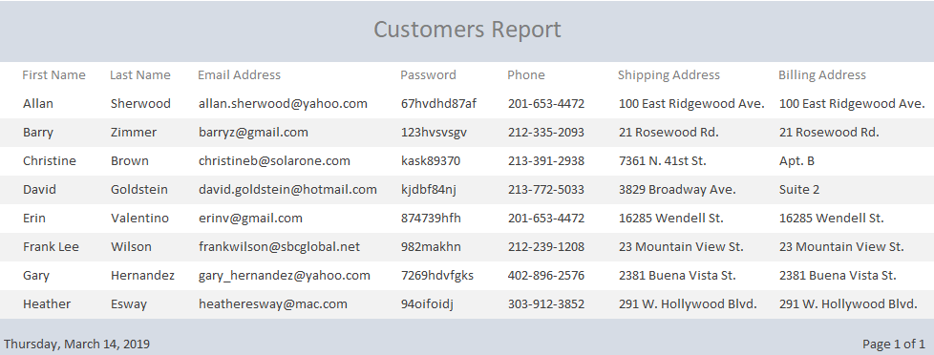

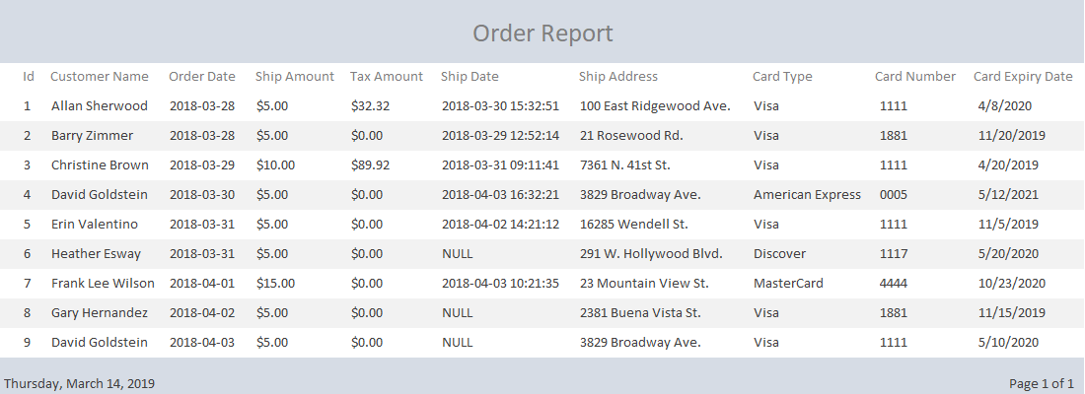
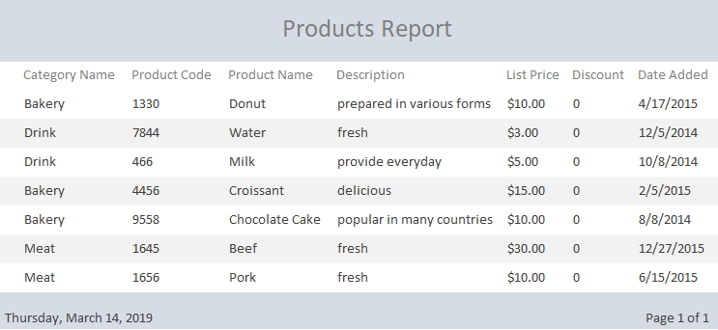
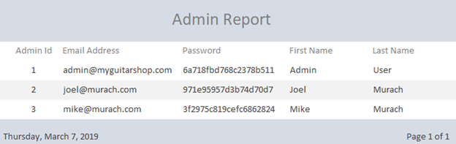

Entity Relationship Diagram
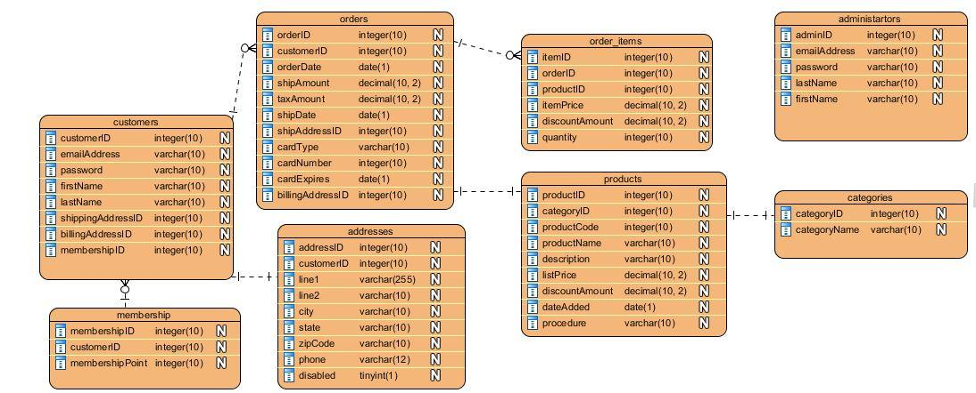
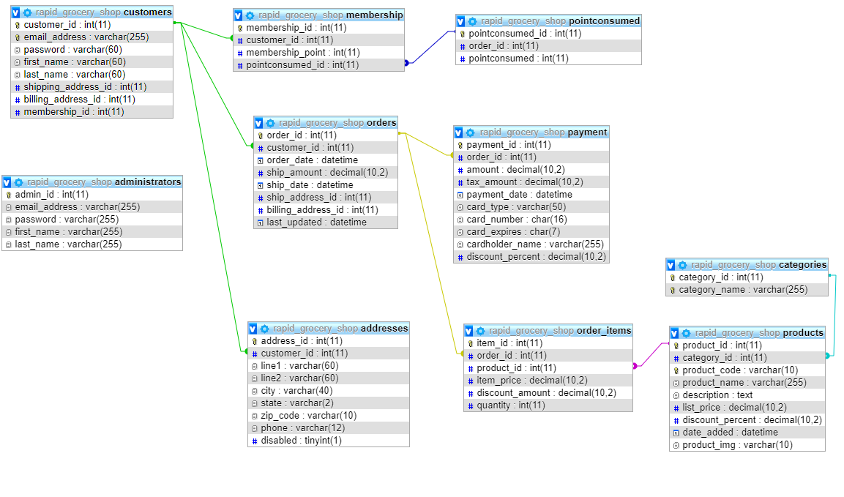

Data Dictionary

Table Name: Customers

PK/FK | Field Name | Description | Caption | Type | Size
PK | customer_id | Unique Identifier for Customer | Customer ID | int | 11
 | email_address | Email address of customer | Email Address | varchar | 225
 | password | Password of customer | Password | varchar | 60
 | first_name | First name of customer | First Name | varchar | 60
 | last_name | Last name of customer | Last Name | varchar | 60
 | shipping_address | Shipping address for delivery | Shipping Address | int | 11
 | billing_address | Billing address for delivery | Billing Address | int | 11
 | membership_id | Customer’s unique Membership Id | Membership ID | int | 11

Table Name: Membership
PK/FK | Field Name | Description | Caption | Type | Size
PK | membership_id | Customer’s unique Membership# | MembershipID | autonum | 11
FK | customer_id | Customer’s unique ID | CustomerID | int | 11
 | membership_point | Number of points for the membership | Membership Point | int | 11

Table Name: administrators
PK/FK | Field Name | Description | Caption | Type | Size
PK | admin_id | Identifier for Admin# | AdminID | autonum | 11
FK | email_address | Customer/Admin email address | Email Address | varchar | 255
 | password | Admin password | Password | varchar | 255
 | first_name | Admin first name | First Name | varchar | 255
 | last_name | Admin last name | Last Name | varchar | 255

Table Name: addresses
PK/FK | Field Name | Description | Caption | Type | Size
PK | address_id | Address Code | AddressID | autonum | 11
FK | customer_id | Customer’s unique ID | CustomerID | int | 11
 | line1 | Customer 1st address | Line1 | varchar | 60
 | line2 | Customer 2nd address | Line2 | varchar | 60
 | city | Customer city | City | varchar | 40
 | state | Customer state/province | Province | varchar | 2
 | zip_code | Customer zipCode/Postal Code | Postal Code | varchar | 10
 | phone | Customer phone | Phone | varchar | 12
 | disabled | Question if the person is disabled | Disabled | tinyint | 1

Table Name: orders
PK/FK | Field Name | Description | Caption | Type | Size
PK | order_id | Order Code | OrderID | autonum | 11
FK | customer_id | Customer’s unique ID | CustomerID | int | 11
 | order_date | Date of the purchase | Order Date | datetime
 | ship_amount | Shipping fee | Ship Amount | decimal | 10,2
 | ship_date | Date of when package is coming | Ship Date | datetime
 | ship_address_id | Shipping number | ShipAddressID | int | 11
 | billing_address_id | Billing Address Code | BillingAddressID | int | 11
 | last_updated | Display last updated | Last Updated | datetime

Table Name: categories
PK/FK | Field Name | Description | Caption | Type | Size
PK | category_id | Category Number | CategoryID | autonum | 11
 | category_name | Type of foods | Category Name | varchar | 255

Table Name: products
PK/FK | Field Name | Description | Caption | Type | Size
PK | product_id | Product Code | ProductID | autonum | 11
FK | category_id | Category Code | CategoryID | int | 11
 | product_code | Code of the product | Product Code | int | 11
 | product_name | Name of the product | Product Name | varchar | 255
 | description | Description of the product | Description | text | 255
 | list_price | Price of the product | List Price | decimal | 10,2
 | discount_percent | Discount for the product | Discount Percent | decimal | 10,2
 | date_added | When did they add the new product | Date Added | datetime
 | product_img | Display image for product | Product Image | varchar | 10

Table Name: orderItems
PK/FK | Field Name | Description | Caption | Type | Size
PK | item_id | Item Code | ItemID | autonum | 11
 | order_id | Order Code | OrderID | int | 11
FK | product_id | Product Code | ProductID | int | 11
 | item_price | Price of the order | Item Price | decimal | 10,2
 | discount_amount | Discount amount for the order | DiscountAmount | decimal | 10,2
 | quantity | How much product | Quantity | int | 11
Table Name: payment
PK/FK | Field Name | Description | Caption | Type | Size
PK | payment_id | Payment Code | PaymentID | autonum | 11
FK | order_id | Order Code | OrderID | number | 11
 | amount | Total amount of the order | Amount | decimal | 10,2
 | tax_amount | Tax amount for the order | Tax amount | decimal | 10,2
 | payment_date | Date when the payment was made | Payment Date | datetime
 | card_type | Card type (Debit/ Credit/ Mastercard) | Card Type | varchar | 50
 | card_number | Card number | Card Number | char | 16
 | card_expires | Date of expiry for card | Card Expiry | char | 7
 | cardholder_name | Card holder name | Cardholder Name | varchar | 255
 | discount_percent | Discount percent for product, if any | Discount Percent | decimal | 10,2

Table Name: pointconsumed
PK/FK | Field Name | Description | Caption | Type | Size
PK | pointconsumed_id | Print consumer documents | PrintconsumedID | int | 11
 | order_id | Order Number | OrderID | int | 11
 | pointconsumed | Points consumed on  groceries | Point Consumed | int | 11

Web search and Rationale

Title: RapidGrocery- New solution to shopping online

Authors: Jody Bhamra
Youngsun Chang
Komal Preet Kaur Randhawa

Faculty Advisor(s): Davneet Chawla

Client/Industry Advisor: N/A

Keywords: Online grocery shopping, HTML5, CSS, JAVASCRIPT, PHP, MYSQL

Abstract
People want an easier way to shop while in the comfort of your house, and do you want local specialty shops that are not in your town, for example, Fergus, a small community of twenty thousand citizens but wish to ship it in a reasonable time frame like a pizza delivery service. Our solution was to make where everyone can order a product from all over and can be shipped via Uber drivers and All-you-can-eat service we can bring you grocery without wasting gas or travel very long distances to give you any food product necessary.

Challenges:
Being a startup business in already raising industry can be hard, especially in the beginning when you are trying to gain with already established, and even more well-known names. We need show the differences and benefits. Also, paying drivers in the future will be hard we need competitive but fair pay to our drivers in the future.

Business/Technological Purpose
The major objective of our project is to sell products and earn highest profits possible. Many online grocery shopping websites face major competition from other retailers like mass merchandisers. You will need an account, but after that, it is simple to use. You need just to pick out your item(s), we will check the store that has your product, pay with PayPal, and bang product will be delivered to a home. This service is used to help people with disabilities, do not have a vehicle due to money issues, and or the poor. To simply give out food access to more people to more rural and or isolated communities like the tribal community of Intuit. We are like your Amazon but for grocery shopping.
Our Contribution:
We are simple and easy to use the site, for now, we are local for “first” stage testing but with community feedbacks and more stores to add we’ll be a force to reckon with. Providing the community with a competitive service at lightning-quick speeds.

Market Analysis
Our service is local, provide many options and will in the future add restaurant as well, and we’ve no delivery fees over $50.
There are numerous grocery businesses across the world that has gained massive success in past couple of years. Furthermore, many big names of ecommerce industry like Amazon, Uber and many more have entered the online grocery shopping arena. The market situation of online grocery shopping business is about 3-5%. But, the numbers of online grocers are increasing with a 3x rate on a year-to-year basis.

Competitors
Zehrs online delivery, Hellofresh, UberEats, NerdyHires, instacarts(any store), Shoppers Online delivery, doordash.

Pricing: Varied By stores

Conclusion
We’re a fast-growing company with loads of potential, grabbing places you can on the fly. With easy access to your favourite stores, and in the future restaurants, you can save money, travel-times, and still able to relax at home, being ready for the super-bowl.

References:
[1] https://www.instacart.ca/zehrs-markets?ko_click_id=ko_9dcc5c776f4b683c3&utm_medium=paid_search&utm_source=instacart_google&utm_campaign=ad_demand_prospecting&utm_term=zehrs%20order%20online&gclid={gclid}
[2] https://www.hellofresh.ca/landing/cookthis-en-v01-1x50-p01/?c=SEMNBB50X1P&msclkid=3938945b58251c9cafc8c82c280daea4&utm_source=bing&utm_medium=cpc&utm_campaign=CA-0-0-S[02-PC-0-GOOG] %20delivery&utm_term=delivery%20food&utm_content=CA-0-0-S[02-PC-0] %20delivery:%20food%20delivery_e
[3] https://www.googleadservices.com/pagead/aclk?sa=L&ai=DChcSEwjV48GK_8DhAhWTwMAKHf44B4cYABAMGgJpbQ&ohost=www.google.ca&cid=CAESEeD2PD6oZBNjVpQBlllT4GJi&sig=AOD64_1oWqdirWXf5gH2J9GkQGiPowxVeA&q=&ved=2ahUKEwiqyLmK_8DhAhVLpIMKHVBqAesQ0Qx6BAgNEAE&adurl=
[4]https://www.googleadservices.com/pagead/aclk?sa=L&ai=DChcSEwjV48GK_8DhAhWTwMAKHf44B4cYABAAGgJpbQ&ohost=www.google.ca&cid=CAESEeD2PD6oZBNjVpQBlllT4GJi&sig=AOD64_05CiMpS1acp2NcstlISMtnkAXobQ&q=&ved=2ahUKEwiqyLmK_8DhAhVLpIMKHVBqAesQ0Qx6BAgPEAE&adurl=
[5]https://www.googleadservices.com/pagead/aclk?sa=L&ai=DChcSEwjV48GK_8DhAhWTwMAKHf44B4cYABADGgJpbQ&ohost=www.google.ca&cid=CAESEeD2PD6oZBNjVpQBlllT4GJi&sig=AOD64_296VYkNW5BY2fynge7JKcui99NNQ&q=&ved=2ahUKEwiqyLmK_8DhAhVLpIMKHVBqAesQ0Qx6BAgOEAE&adurl=
[6] https://www.googleadservices.com/pagead/aclk?sa=L&ai=DChcSEwig2Iymg8HhAhXauMAKHa5NDHoYABAAGgJpbQ&ohost=www.google.ca&cid=CAESEeD2MEf79wHWMfLlE6rRMgNp&sig=AOD64_0bSUN-WcyEvQ9tCoPZMUMhP1KNgQ&q=&ved=2ahUKEwi1m4Gmg8HhAhVL1oMKHWaPDXQQ0Qx6BAgNEAE&adurl=
[7]https://mypharmacy.shoppersdrugmart.ca/en?gclid=Cj0KCQjw4qvlBRDiARIsAHme6otLCqu7dCSpkNZv6zCQ1qXiUfHeb5CBYJEDL5Fo7jQ44yWI5wS24CMaAjnvEALw_wcB&gclsrc=aw.ds

