**Module One: Updated MIS 350 Project**

**MIS 490: Management Information Systems Capstone**

Southern New Hampshire University

Shaival Modi

Prof. Arpit Sharma

**Executive Summary**

**Introduction:**

ABC company is aiming to enhance their customer satisfaction by examining how quickly issues are resolved in their currently functioning Information Technology service desk. In order to aid the company, find an answer to their customer satisfaction rating issue, we must divide analyzation categories into four different segments: time tickets took to close, issue filed against, as well as severity and priority of the tickets. Furthermore, in-depth analysis needs to be undertaken in all categories to help ABC company discover trends and patterns across five years of past historical data, that is from 2013 to 2017. This will let ABC company find out the time tickets are open and their respective type as well as whether staff need to be trained in a specific area to improve customer satisfaction. Finally, Power BI will be utilized to create visualizations in support of the answer to the business question presented.

**Identify the Business Question:**

From the provided list, the IT Help Desk scenario is selected along with its provided data set. To improve ABC company’s customer satisfaction rating, more insight into existing trends and patterns across the years is needed which will be obtained from conducting in-depth analysis of pieces of data such as time tickets are open, issue filed against, severity, and priority of the filed tickets. Once we obtain information into the different categories described above, we can gain more insight into the real issue that is causing the customer satisfaction rate to worsen, such as inadequate employee training or ticket issues.

**Making sense of data:**

To answer the business question in focus, the provided excel spreadsheet is a log of tickets submitted within the IT Service desk of the ABC company. Moreover, there exists a correlation between the data and the business question to be answered. Customer Satisfaction rating is mostly affected by the untimely resolution of the tickets. As a result, severity and priority of tickets play a vital role in the resulting effect followed by ticket type and the duration ticket was opened. Moreover, data is divided by years. This will provide insights into any external factors that are impacting customer satisfaction rates that are outside of company control such as a pandemic and reduced business demand because of it. Areas of data required would be a functional area against which the ticket was filed, severity and priority of tickets, number of days ticket was open, ticket resolution satisfaction, and ticket issue / request to generate visualizations from the given data set.

**Business Intelligence:**

Business Intelligence is often used to address an organization’s business problems. To address the business problem in focus, Power BI will be utilized to import relevant data sources to create a unified view. Moreover, Interactive visualizations will be created that showcase KPIs, highlighting relevant trends and patterns to stakeholders across years. Through the creation of visualizations, I will empower decision making using data by highlighting actionable insights. Lastly, I will make sure visualizations are accessible and shareable to all, promoting a data literate culture across various departments of the organization.

Power BI plays a vital role in influencing stakeholders by showcasing KPIs in a visually appealing manner, allowing them to quickly grasp presented data and make data-driven decisions. For lower-level stakeholders such as employees, it creates an in-depth understanding of the company via consistent error-free reporting of the KPIs, enabling collaboration and contribution that matters. As a result, Power BI allows everyone in the company to identify patterns and trends, ask relevant questions, and contribute their part to a data-driven culture.

**Guiding Questions:**

Based on the initial analysis, the following business questions were developed to guide visualizations:

* What is the average number of days tickets are open for classification of severity, satisfaction rate, issues filed against, and priority?
* How many days is a particular ticket open for each classification of priority?
* How many days is a particular ticket open for each classification of severity?
* What percentage of total tickets does each classification of severity, priority, filed against, and satisfaction rate constitute?
* What percentage of total tickets is a request versus an issue?
* What year were the ratings highest and lowest? Name influences or external factors if any. (formed after incorporation of MIS 490 data)

Once the data is cleaned and compiled, Power BI will be used to create interactive visualizations in a way that directly addresses each business question mentioned above with relevant data and facts. Once the business questions are answered, I will identify trends and patterns from the answers that will uncover where the company is lacking in maintaining satisfactory satisfaction rates. After that, findings will be presented in a clear and concise manner, highlighting actionable insights and other recommendations from the analysis of data obtained from answering each business question.

**Visualizations:**

To answer the first, fourth and fifth business question, pie charts were used. Pie charts were utilized as they are the most convenient way to display data as a percentage of a whole, making it a perfect tool to compare related proportions of different categories within a single set of data. This is an ideal tool to display average days open by severity, priority, satisfaction rate, and issue filed against. With the simplification of proportional data, it makes it simple for teams with different backgrounds to comprehend information quickly. Moreover, it makes it easier to identify keys areas across various target audiences and multi-functional groups. To answer the second and third business question, horizontal stacked bar charts were used. These are used when different categories with hefty amounts of data with long labels are displayed in the form of a bar chart. These were picked as a choice as the horizontal orientation allows more room to showcase different categories in a visually appealing manner, making the information presented easy to read and interpret. These were used to display the number of days a particular ticket was open for each level of priority and severity. As it is used to display categorical data, multi-functional teams can quickly rank performance across various categories and identify differences. Lastly, years of provided data were incorporated into each visualization (MIS 490 provided data), allowing employees and other stakeholders to study data from each year and identify trends and patterns affecting the customer satisfaction rating of the organization.

**Note: Visualizations show breakdown of data by years after incorporation of new data**

The visualizations above showcase the average number of days a ticket remains open based on different factors and across years. The first pie chart shows average days tickets remain open by severity, with the highest average for Major issues. The second pie chart shows the average days tickets remain open by satisfaction rate, with the highest average for unsatisfied rating. The third pie chart shows the average number of days tickets remain open by the issue filed against with the highest number of tickets listed for Hardware. The fourth pie chart shows the average number of days tickets remain open by priority with the highest average for average for low priority tickets. This chart shows numerical values and percentage points for each segment, providing a decent comparison of average ticket solving times sorted by different affecting factors. From the analysis, it is evident that the highest number of unsatisfactory ratings is due to low priority major hardware tickets. The company needs to work on their response time so that low priority tickets are resolved in reasonable time and company operations are not affected by major issues 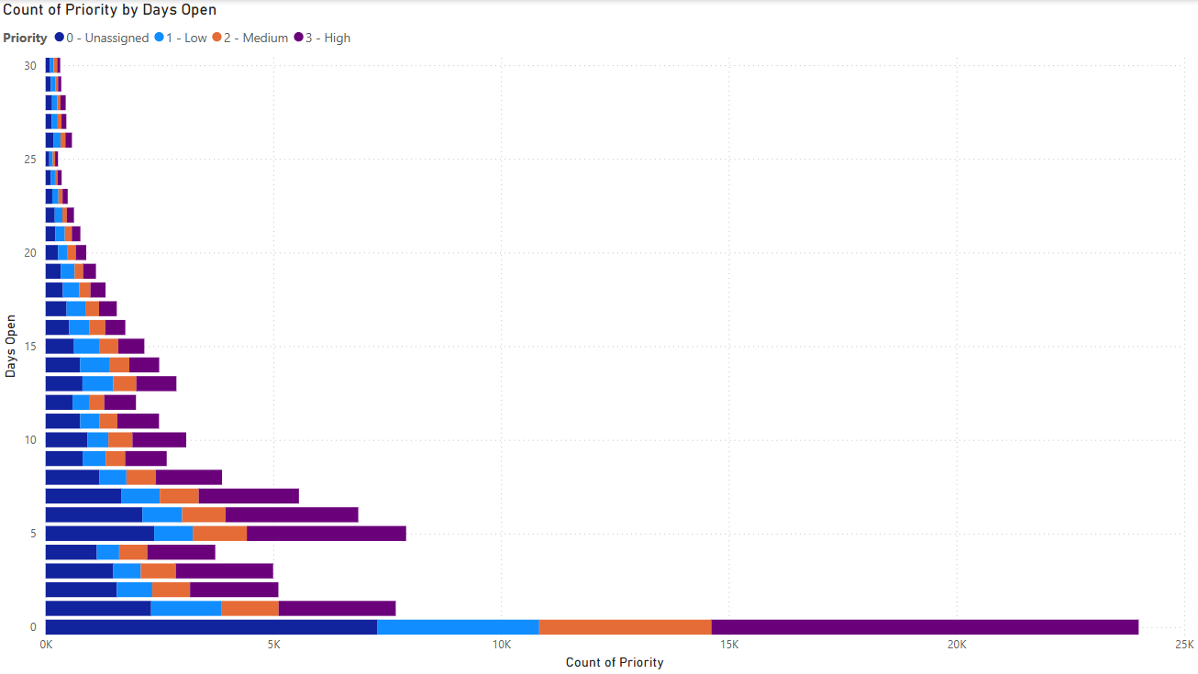coupled with long waiting times.

The horizontally stacked bar chart displays the number of tickets based on different priority levels and the days they have remained open. The horizontal axis represents count for each priority level and the vertical axis represents days tickets remain open. Each bar showcases distribution of priority levels for a particular number of days open. This chart enables quicker understanding of the time tickets remain open for different priority levels and the respective volume for each. From the analysis, it is evident that the highest volume bearing high priority **A screenshot of a computer
**tickets remain open for a long time.

The horizontally stacked bar chart displays the number of tickets based on different severity levels and the days they have remained open. The horizontal axis represents count for each severity level and the vertical axis represents days tickets remain open. Each bar shows distribution of severity levels for a particular number of days open. This chart enables quicker understanding of the time tickets remain open for different severity levels and the respective volume for each. From the analysis, it is evident that the highest volume bearing normal severity remains open for a long time.

**Note: Visualizations show breakdown of data by years after incorporation of new data**

The four donut charts represent distribution of different categories as a percentage of a whole. It shows the breakdown of tickets by variables such as severity, priority, issues filed against, and satisfaction level across years. Each portion of the donut showcases a different category within the variable, with the size of the portion proportional to the percentage of a whole. Moreover, numerical values and percentage points are displayed for each portion. This allows comparison across numerous categories within each donut chart. From the analysis, it is evident that the highest number of high priority tickets have a normal severity and are filed against systems with satisfaction rating of unknown.

**Note: Visualizations show breakdown of data by years after incorporation of new data**

The donut chart represents distribution of ticket type as a percentage of the whole and across years. It effectively shows a clear visual comparison of relative proportions of each ticket type. From the analysis, it is evident that about 75% of tickets are requests while 25% are issues.   
It has been made sure that all visualizations effectively display all the data considered for analysis.

**Actionable Insights:**

From the analysis of the first visualization, the organization needs to investigate why critical issues take the longest to resolve. This could be due to lack of expertise or resource constraints. Moreover, it indicates that complex issues are handled with greater care as customers are highly satisfied with the resolution of tickets. In this case, we need to explore if it is intentional, or improvements can be made without harming quality. Additionally, “Access/Login” take the longest time to get solved. We need to streamline the resolution process by better documentation, automating troubleshooting tools or dedicated support for issues. Lastly, “High Priority” tickets take the longest to get solved. In this case, we can re-evaluate the prioritization process. If they consistently take more time, then we may need to allocate more resources for critical tasks.

From the analysis of the second visualization, high priority tickets remain open for more than 25 days. As a result, the company can implement a system that escalates long open issues, investigate reasons, and introduce service level agreements to make sure tickets get resolved in time. Moreover, a lot of issues are unassigned in the system. The company can ensure a process which assigns tasks to relevant teams in reasonable time.

From the analysis of third visualization, “Normal” tickets make up the largest portion. The company needs to make sure this is not masking underlying systemic problems by reviewing the criteria for the classification of severity. Moreover, “High” and “Medium” tickets make up the largest portion. As a result, the organization needs to make sure that prioritization criteria are effective and accurate. Lastly, a lot of satisfaction ratings are “Unknown”. The company may need to implement a system that captures customer satisfaction feedback accurately.

From the analysis of the fourth visualization, a lot of tickets are “Requests”. As a result, more opportunities for automation and other self-help tools such as self-service portals and support articles need to be examined to reduce the volume of requests. This can result in reallocation of resources for the resolution of complex issues.

Conclusively, if these insights are considered and appropriate actions are taken, ABC company can improve customer satisfaction rating as well as their allocation of resources for other important tasks that might be profitable for the organization.

**Information Security Policies and International and National Regulations:**

When the focus shifts to Information security policies and applicable international and national regulations for an IT help desk of a company, it is a must to recognize the department as a point of frequent contact between internal and external stakeholders including people conducting illegal activity and harming the reputation of the company (Guides at Georgetown Law Library. (n.d.). This makes an IT help desk an exceptional source of performance insights as well as a major security threat. There are many areas of focus concerning security for IT help desk. Authorization and authentication are one of the most important areas. We can enforce industry standard password requirements concerning length, special characters, strength etc., for all kinds of users. Moreover, we can implement multi-factor authentication for all IT systems as well as sensitive data accounts (Guides at Georgetown Law Library. (n.d.). We can also implement role-based access procedures to make sure only necessary information is accessed to perform duties. Lastly, there needs to be established clear procedures for the management of user accounts (Guides at Georgetown Law Library. (n.d.).

Another area is data privacy and handling. The company can enforce policies for handling sensitive data such as personal information and finances. Moreover, encryption can be applied to data in rest and in transit (Guides at Georgetown Law Library. (n.d.). Lastly, external audits need to be conducted to ensure the company is complying with all applicable regulations such as CCPA, GDPR, as well as HIPAA if applicable (California (n.d.). There are many procedures concerning incident response when it comes to handling data. For example, clear procedures need to be defined to report security incidents. Moreover, the company needs to regularly test the incident response plan and rectify any shortcomings (California (n.d.). The staff can also be trained to recognize phishing attacks. The third area of focus is logging and monitoring. The company needs to maintain detailed logs of activity and implement tools to monitor security breaches.   
 There are many general international and national regulations that are applicable to a wide variety of companies such as ISO/IEC 27001/27002 for maintaining information management security systems, NIST framework for cybersecurity as well as PCI DSS if the company handles credit card data and other financial information (NIST (n.d.).

Thus, by implementing these measures, we can ensure that the company’s IT help desk is in compliance with applicable international and national regulations and standards.

**References:**

California, S. of. (n.d.). Security policy. CDT. https://cdt.ca.gov/security/policy/

*Guides: International and foreign cyberspace law research guide: National law*. National Law - International and Foreign Cyberspace Law Research Guide - Guides at Georgetown Law Library. (n.d.). <https://guides.ll.georgetown.edu/cyberspace/data-protection-national-laws>

NIST SP 800-100, information security handbook. (n.d.-d). https://nvlpubs.nist.gov/nistpubs/legacy/sp/nistspecialpublication800-100.pdf