STAT565_Lab

Shen Qu

`Mar 11, 2019

(a).

## Classes 'tbl_df', 'tbl' and 'data.frame': 90 obs. of 6 variables:  
## $ method : chr "a" "a" "a" "a" ...  
## $ variety: num 1 1 1 1 1 1 2 2 2 2 ...  
## $ y : num 221 241 191 221 251 181 271 151 206 286 ...  
## $ m : Factor w/ 3 levels "a","b","c": 1 1 1 1 1 1 1 1 1 1 ...  
## $ v : Factor w/ 5 levels "v1","v2","v3",..: 1 1 1 1 1 1 2 2 2 2 ...  
## $ mv : Factor w/ 15 levels "a.v1","b.v1",..: 1 1 1 1 1 1 4 4 4 4 ...

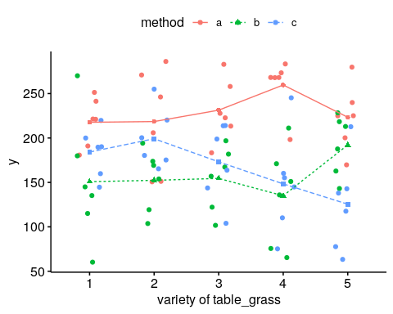

(b).

|  |  |  |  |  |  |  |  |  |  |
| --- | --- | --- | --- | --- | --- | --- | --- | --- | --- |
| method | min | Q1 | median | Q3 | max | mean | sd | n | missing |
| a | 151 | 201.5 | 226.5 | 268 | 286 | 230.1 | 39.86 | 30 | 0 |
| b | 60 | 125.2 | 160 | 186.5 | 270 | 157 | 48.93 | 30 | 0 |
| c | 63 | 143.2 | 164.5 | 200 | 255 | 166.1 | 49.28 | 30 | 0 |

|  |  |  |  |  |  |  |  |  |  |
| --- | --- | --- | --- | --- | --- | --- | --- | --- | --- |
| variety | min | Q1 | median | Q3 | max | mean | sd | n | missing |
| a.1 | 181 | 198.5 | 221 | 236 | 251 | 217.7 | 27.33 | 6 | 0 |
| b.1 | 60 | 120 | 140 | 171.2 | 270 | 150.8 | 70.53 | 6 | 0 |
| c.1 | 145 | 167.5 | 190 | 197.5 | 220 | 184.2 | 27.28 | 6 | 0 |
| a.2 | 151 | 164.8 | 226 | 264.8 | 286 | 218.5 | 58.89 | 6 | 0 |
| b.2 | 104 | 127.8 | 161.5 | 172.8 | 194 | 152.3 | 34.45 | 6 | 0 |
| c.2 | 165 | 176.2 | 190 | 215 | 255 | 199.2 | 33.68 | 6 | 0 |
| a.3 | 183 | 215.5 | 225.5 | 250.5 | 283 | 231.3 | 35.02 | 6 | 0 |
| b.3 | 102 | 130.8 | 162 | 178.2 | 197 | 154.5 | 36.16 | 6 | 0 |
| c.3 | 104 | 149 | 181.5 | 210.2 | 214 | 173.2 | 44.09 | 6 | 0 |
| a.4 | 198 | 268 | 268 | 271.8 | 283 | 259.7 | 30.77 | 6 | 0 |
| b.4 | 65 | 91 | 143.5 | 166 | 211 | 135 | 56.05 | 6 | 0 |
| c.4 | 75 | 118.8 | 150 | 158.8 | 245 | 148.3 | 57.24 | 6 | 0 |
| a.5 | 170 | 206.2 | 225 | 236.2 | 280 | 223.3 | 37.1 | 6 | 0 |
| b.5 | 143 | 169.2 | 200.5 | 216.8 | 228 | 192.2 | 33.68 | 6 | 0 |
| c.5 | 63 | 88 | 128 | 141.8 | 213 | 125.5 | 53.55 | 6 | 0 |
| 1 | 60 | 148.8 | 190 | 220.8 | 270 | 184.2 | 51.86 | 18 | 0 |
| 2 | 104 | 156.8 | 177.5 | 216.5 | 286 | 190 | 50.19 | 18 | 0 |
| 3 | 102 | 158.8 | 190 | 214 | 283 | 186.3 | 49.5 | 18 | 0 |
| 4 | 65 | 138.2 | 165.5 | 262.2 | 283 | 181 | 73.99 | 18 | 0 |
| 5 | 63 | 143 | 194 | 223.2 | 280 | 180.3 | 57.84 | 18 | 0 |

(c).

|  |  |  |  |  |  |
| --- | --- | --- | --- | --- | --- |
|  | Df | Sum Sq | Mean Sq | F value | Pr(>F) |
| **m** | 2 | 95316 | 47658 | 24.25 | 7.525e-09 |
| **v** | 4 | 1138 | 284.5 | 0.1448 | 0.9648 |
| **m:v** | 8 | 37449 | 4681 | 2.382 | 0.02409 |
| **Residuals** | 75 | 147377 | 1965 | NA | NA |
| **Total** | 89 | 281279.2 | 3160.44 | NA | NA |

(d).

The line plot shows that not all lines are parallel. Difference in y between methods is not same for different varieties. There could be an interaction effect.

According to ANOVA table, there is a significant interaction effect from methods and varieties on the y at 5% significance level (P-value=0.02409). That means, effect of method and effect of methods and varieties on y is not independent. Therefore, examie the simple effects.

The table shows the multiple comparisons of levels in varieties and methods.

The difference in y between varieties 2 and 5 is significant when method c is applies (P-value=0.0295).

The difference in y between method a and b are significant when varieties 1 - 4 is applies (P-value=0.0290, 0.0310, 0.0101, <.0001, respectively).

The difference in y between method a and c are significant when varieties 4, 5 is applies (P-value=0.0001, 0.0008, respectively).

The difference in y between method b and c is significant when varieties 5 is applies (P-value=0.0295).

The Tukey test indicates the difference in y between method a and b, a and c are significant when varieties 4 is applies (P-value=0.0002, 0.0015, respectively), the difference in y between method a and c is significant when varieties 5 is applies (P-value=0.0096).

The difference in y between varieties 1-5 applied method a and varieties 5 applied method c are significant (P-value=0.0383, 0.0349, 0.0074, 0.0001, 0.0199, respectively).

The difference in y between varieties 1-4 applied method b and varieties 4 applied method a are significant (P-value=0.0050, 0.0061, 0.0080, 0.0006, respectively).

The difference in y between varieties 4 applied method b and varieties 3 applied method a are significant (P-value=0.0238).

The Scheffe methods indicates the difference in y between varieties 4 applied method a and varieties 5 applied method c are significant (P-value=0.0326).

|  |  |  |  |  |  |  |
| --- | --- | --- | --- | --- | --- | --- |
| contrast | estimate | SE | df | t.ratio | p.value | P.adj |
| c: v2-v5 | 73.667 | 25.6 | 75 | 2.878 | 0.0404 |  |
| v1: a-b | 66.8 | 25.6 | 75 | 2.611 | 0.0290 |  |
| v2: a-b | 66.2 | 25.6 | 75 | 2.585 | 0.0310 |  |
| v3: a-b | 76.8 | 25.6 | 75 | 3.002 | 0.0101 | Tukey |
| v4: a-b | 124.7 | 25.6 | 75 | 4.871 | <.0001 | 0.0002 |
| v4: a-c | 111.3 | 25.6 | 75 | 4.350 | 0.0001 | 0.0016 |
| v5: a-c | 97.8 | 25.6 | 75 | 3.823 | 0.0008 | 0.0096 |
| v5: b-c | 66.7 | 25.6 | 75 | 2.605 | 0.0295 |  |

v1,a-v5,c 92.167 25.6 75 3.601 0.0383

v2,a-v5,c 93.000 25.6 75 3.634 0.0349

v3,a-v4,b 96.333 25.6 75 3.764 0.0238

v3,a-v5,c 105.833 25.6 75 4.135 0.0074

v4,a-v1,b 108.833 25.6 75 4.252 0.0050

v4,a-v2,b 107.333 25.6 75 4.194 0.0061

v4,a-v3,b 105.167 25.6 75 4.109 0.0080

v4,a-v4,b 124.667 25.6 75 4.871 0.0006

v4,a-v4,c 111.333 25.6 75 4.350 0.0036 Scheffe

v4,a-v5,c 134.167 25.6 75 5.242 0.0001 0.0326

v5,a-v5,c 97.833 25.6 75 3.823 0.0199  
————————————————————-

(e).

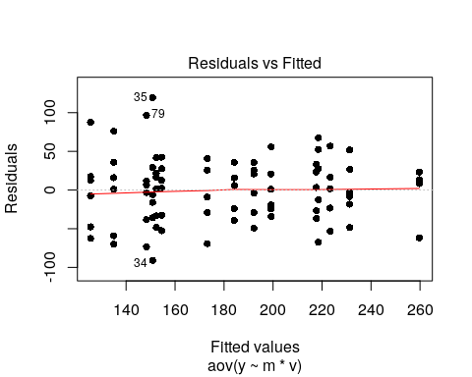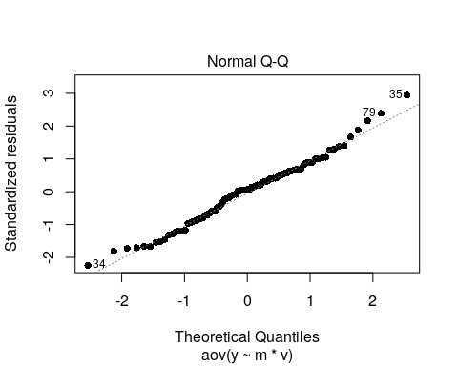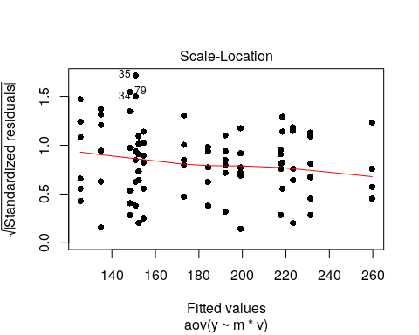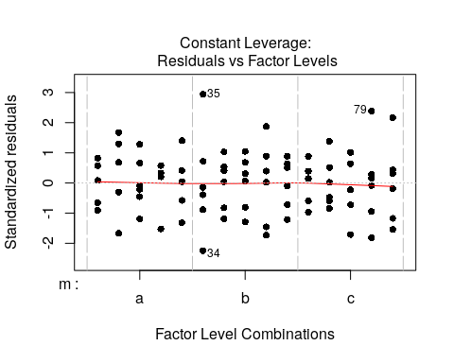

{(f).

The plot of studentized residual versus predicted (fitted) value shows that except few outliers, the residuals are evenly distributed about zero at each prededict value (zero mean) and vertical deviations of residuals from zero are about same for each predicted value (constant variance).

The plots of studentized residual versus factor levels didn’t show obvious violation of zero mean and constant variance.

The QQ plot shows that some data points are not on the line and flattening at the extremes, which is a litte violation of normality.

(g).

c1. Mean yield for variety 1 versus variety 3 at method b

The $H0$ for contrast is $μ_{b1.}−μ_{b3.}=0⟹β_{1}−β_{3}+(τβ)_{b1}−(τβ)_{b3}=0$. The $H1$ is they don’t equal zero.

The P-value of this contrast test is 0.8865, which is large enough. We cannot reject the $H0$ and conclude that the mean yield for variety 1 versus variety 3 at method b may be same at 5% significance level. The contrast tests with Boferroni or tukey’s adjustment have the same results (P-calue=1.0000, 0.9998, respectively).

c2. Mean yield for method a versus average of methods b and c

The $H0$ for contrast is $μ_{a..}−\frac{1}{2}(μ_{b..}+μ_{c..})=0⟹2τ_{a}−τ_{b}−τ_{c}=0$. The $H1$ is they don’t equal zero.

The P-value of this contrast test is 0.0000, which is small enough. We can reject the $H0$ and conclude that the mean yield for method a versus average of methods b and c are significantly different at 5% significance level. The contrast tests with Boferroni or tukey’s adjustment have the same results (P-calue=0.0000, 0.0000, respectively).

c3. Mean yield for method a versus average of methods b and c for variety 1

The $H0$ for contrast is $μ_{a1.}−\frac{1}{2}(μ_{b1.}+μ_{c1.})=0$. The $H1$ is they don’t equal zero.

The P-value of this contrast test is 0.0265, which is small enough. We can reject the $H0$ and conclude that the mean yield for method a versus average of methods b and c for variety 1 are significantly different at 5% significance level. The contrast tests with Boferroni or tukey’s adjustment give the opposite results (P-calue=0.1060, 0.1019, respectively).

c4. Mean yield for method a versus average of methods b and c between variety 1 and variety 2

The $H0$ for contrast is $[μ_{a1.}−\frac{1}{2}(μ_{b1.}+μ_{c1.})]−[μ_{a2.}−\frac{1}{2}(μ_{b2.}+μ_{c2.})]=0$. The $H1$ is they don’t equal zero.

The P-value of this contrast test is 0.5819, which is large enough. We cannot reject the $H0$ and conclude that the mean yield for method a versus average of methods b and c for variety 1 may be same at 5% significance level. The contrast tests with Boferroni or tukey’s adjustment give the same results (P-calue=1.0000, 0.9694, respectively).

(h).

table_grass <- read_excel("Grass.xlsx")  
table_grass$m <- as.factor(table_grass$method)  
table_grass$v <- factor(table_grass$variety, levels = c(1, 2, 3, 4, 5), labels = c("v1",   
 "v2", "v3", "v4", "v5"))  
table_grass$mv <- interaction(table_grass$m, table_grass$v)  
model_grass <- aov(y ~ m * v, data = table_grass)  
model_grass_inter <- aov(y ~ mv, data = table_grass)  
str(table_grass)  
ggline(data = table_grass, x = "variety", y = "y", add = c("mean", "jitter"),   
 shape = "method", color = "method", linetype = "method", ylab = "y", xlab = "variety of table_grass")  
pander(favstats(y ~ method, data = table_grass))  
pander(favstats(y ~ method | variety, data = table_grass))  
summary(model_grass)  
plot(model_grass, pch = 16)  
  
# Test simple effects # Method-1# 1.1 Multiple comparison of levels in  
# variety factor for a given level of method factor #  
v_m <- pairs(lsmeans(object = model_grass, specs = ~v | m))  
# 1.1 Multiple comparison of levels in method factor for a given level of  
# variety factor #  
m_v <- pairs(lsmeans(object = model_grass, specs = ~m | v))  
# 1.1 same with  
lsmeans(model_grass, list(pairwise ~ v | m, pairwise ~ m | v))  
# 1.2 All the above Multiple comparisons with Tukey's adjustment # (strict)  
test(rbind(v_m, m_v), adjust = "tukey")  
  
# Test all the interaction effect# 1.  
pairs(lsmeans(object = model_grass, specs = ~v + m))  
pairs(lsmeans(object = model_grass, specs = ~m * v))  
pairs(lsmeans(model_grass_inter, "mv"))  
lsmeans(model_grass, pairwise ~ v + m)  
TukeyHSD(model_grass, conf.level = 0.95)  
ScheffeTest(model_grass, conf.level = 0.95)  
# 2. another type of interaction effect  
contrast(lsmeans(model_grass, ~v * m), interaction = "pairwise")  
  
# Test specific contrasts# 1. Create a inteaction variable by multiplying  
# the two factors #  
table_grass$mv <- interaction(table_grass$m, table_grass$v)  
# 2. Fit the model again using only that new variable #  
model_grass_inter <- aov(y ~ mv, data = table_grass)  
summary(model_grass_inter) # Check the ANOVA#  
summary.lm(model_grass_inter) # Check the estimated model coefficients. Same with previous#  
  
# 2. Obtain least square estimates for treatment combinations #  
lsmf_grass <- lsmeans(model_grass_inter, "mv")  
  
# 2. Check the order of terms# 3. Write the vectors of contrasts#  
contrast_list_grass <- list(b1_b3 = c(0, 1, rep(0, 5), -1, rep(0, 7)), a_b.c = c(rep(c(1,   
 -0.5, -0.5), 5)/5), a1_b1.c1 = c(1, -0.5, -0.5, rep(0, 12)), a1_b1.c1__a1_b1.c1 = c(1,   
 -0.5, -0.5, 0, 0, 0, -1, 0.5, 0.5, rep(0, 6)))  
# Variety 1 versus Variety 3 at Method b # Method a versus average of  
# Methods b and c averaged across Varieties. # Method a versus average of  
# Methods b and c for Variety 1 # Method a versus average of Methods b and c  
# between Variety 1 and Variety 2 #  
  
contrast(lsmf_grass, contrast_list_grass) # without adjustment #  
summary(contrast(lsmf_grass, contrast_list_grass), adjust = "bonferroni") # Bonferroni#  
summary(contrast(lsmf_grass, contrast_list_grass), adjust = "tukey") #Tukey's#