CS 2402 Data Structures

**Lab 3 - Linked Lists**

Roque, Thomas ID#88732157

horizontal line

# 

# Introduction

Implement the classSortedListthat is identical to theListclass described in class, except that its elements are sorted in ascending order at all times. The class should contain the following functions:

## Implementation

All methods are made within the “List” Class with the exception of the Merge method. The 2 classes used are as follows:

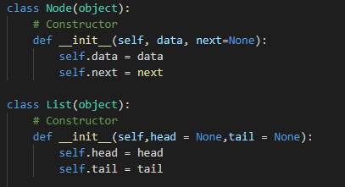

Most of the methods are under the List class as seen above.

To Define a Linked List i also used a few helper methods to make a linked list from 0-9 and 11- 13

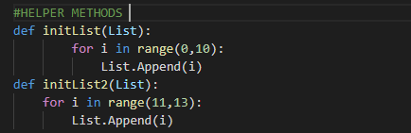

This was so that I did not have to add them by hand.

Lastly the program itself shows that each method works properly by printing out the answers.

### Test cases

1st Elements, Last Elements, and Nones are passed through most.

# Summary:

This Lab makes sure the student has an understanding of objects and how they are referenced, and how to reference them as well as classes.