* Menu open and close

I need to set enable or disable the menu using the same key.

Decide to use Input.getButton() function to manage the event, and set a bool to check if the menu is enable or not, so to make sure the event would be open or close the menu.

Test result 0: cannot find key “Menu”, since input manager does not have it assigned. Checked the key code, and have the value assigned. After fix:

Test result 1: no more alert, but the menu would not show up, how every the debug.log has sign of the event has been triggered for multiple times. Because of this, in void() I start using if else statement instead of only using two different if statement. After fix:

Test result 2: can see the menu by pressing the escape button, however, it flashes, because open or close are trying to active at the same time. The menu can be enable or disable, but it depends by how long to hold the escape button. Input.getButton() function caused the event to be triggered multiple times. Change Input.getButton() to Input.GetKeyUp(). After fix:

Test result 3: Problem solved, since Input.GetKeyUp() will only trigger the event once. But getKeyUp requires hard code for keycode, so player custom setting will not be supported.

* New quest accepts

Can’t accept new quest, since somehow the new reference cannot be set, and always trying to access the old reference, which is trying to accept quest 0 after new conversation, and the reference is already be set to accept new quest 1.

Decide to destroy the old conversation trigger after the old quest finish, didn’t fix the problem. 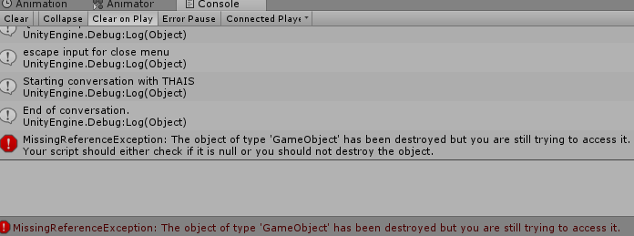

Conversationtrigger2 has been remodified, and still now working.

Therefore, give up on using the conversation trigger to accept new quest, instead, I’m going to use hard code, when quest 1 finish, and done conversation 2, new quest will be accepted. The problem is solved, but the chain system of conversation and quest is proved not working. If future work is needed, new functions needed to load the quest after each conversation.

Solvation: