DOST-FNRI eLibrary
The smart-eLibrary Database
Structure, Schema, Semantics and Integrity
A technical reference and analytical study of the relational data layer

Version: 1.1
Date: 16 October 2026
Prepared by: Joe Cris Viar, Developer
Schema state: 18 migrations, last 2026_10_13; MySQL 8.0.46
Evidence base: 73 database objects (62 tables, 11 views), 763 columns, application source code
Classification: Internal technical documentation. Contains no personal data.

Abstract
This document describes and analyses the relational database behind the smart-eLibrary, the online public access catalogue (OPAC) and library back office of the DOST-PCAARRD eLibrary. It serves two readers at once. For reviewers it frames the database as an object of study: how it was examined, what conceptual model it realises, and how well it satisfies established principles of relational design. For developers and maintainers it provides a complete reference: every table, view, column, index, status code and the application events that create and change data.
The study combines three sources of evidence: introspection of a database built solely from the project's migrations (73 objects, 763 columns), confirmed to be identical to the operational schema; static analysis of the Laravel application code to recover meaning the schema does not express; and aggregate profiling of the operational data, collected without reading any personal records. The schema is organised into eight subject areas centred on two hubs, the bibliographic record (catalogs) and the account (users). Its most distinctive design decision is to store each MARC 21 record as a JSON document inside a relational row and to maintain a separate flattened projection (view_catalogs) as the read model for search and display.
The analysis finds a schema that is functionally coherent and whose current data are clean (no orphaned references), but whose integrity rests almost entirely on application code: only 6 of more than 30 relationships are declared as foreign keys, the same identifier is stored with seven different physical types, monetary amounts and dates are stored as text, several multi-step business operations are not atomic, and 18 objects belong to superseded designs, some of which are still referenced by live views. Twenty findings are reported with their evidence and consequences, and a prioritised programme of sixteen recommendations is proposed.
Keywords: relational database design, entity-relationship modelling, normalisation, referential integrity, MARC 21, library management systems, Laravel, MySQL, data privacy.

Contents
1 Introduction 5
1.1 Purpose and scope 5
1.2 Readers and how to use this document 5
1.3 Conventions 5
2 Methodology 6
2.1 Research questions 6
2.2 Evidence and procedure 6
2.3 Analytical framework 6
2.4 Threats to validity 7
3 Architecture of the data layer 8
3.1 Platform and context 8
3.2 Physical characteristics 8
3.3 Provenance and evolution 9
4 Conceptual and logical model 10
4.1 Subject areas 10
4.2 Bibliographic description and cataloguing 11
4.3 Holdings and circulation 12
4.4 People, organisations and access control 13
4.5 Engagement and discovery 14
4.6 Communication and feedback 15
4.7 Integration and configuration 16
4.8 Legacy structures 17
5 Data semantics: what the schema does not say 18
5.1 The MARC 21 record in catalogs.field_data 18
5.2 The search projection 18
5.3 Status vocabularies and flags 19
5.4 The circulation lifecycle as a state machine 19
5.5 Access-control model 20
6 Event model: how actions become data 21
6.1 Patron engagement 22
6.2 Catalogue propagation 22
7 Analysis 24
7.1 Entity and referential integrity 24
7.2 Domain integrity 25
7.3 Transactional integrity and concurrency 26
7.4 Consistency between schema and code 27
7.5 Physical design and performance 27
7.6 Normalisation 28
7.7 Accountability and maintainability 29
7.8 Security and privacy 29
8 Recommendations 31
9 Conclusion 33
References 34
Appendix A Data dictionary 35
A.1 Bibliographic description and cataloguing 35
A.2 Holdings and digital objects 41
A.3 Circulation 44
A.4 People, organisations and access control 47
A.5 Engagement and discovery 51
A.6 Communication and feedback 54
A.7 Integration, configuration and framework 58
A.8 Legacy (pre-MARC) structures 59
Appendix B Index catalogue 63
Appendix C SQL view definitions 65
Appendix D Migration history 68
Appendix E Reference vocabularies 69
Appendix F Reproducing the evidence 70

1 Introduction

1.1 Purpose and scope
The smart-eLibrary stores its catalogue, holdings, circulation, patron accounts, engagement history and integration state in a single MySQL database. Much of what that database means is not visible in its schema: status codes are bare integers, a complete MARC 21 record lives inside one text column, and most relationships between tables exist only in the application's code. This document makes that meaning explicit and assesses the design against relational-database principles.
The scope is the database elibrarydb as defined by the project's migrations up to 2026_10_13_000000_settings_and_ai_sync_monitor_permissions. It covers all 73 objects (62 base tables and 11 SQL views), their columns, keys, indexes and view definitions, the reference data that gives codes their meaning, and the application events that read and write each table. External stores that hold copies of database content (the Meilisearch index, the LanceDB index of the RAG worker and the file system holding PDFs and covers) are described only at their interface with the database.

1.2 Readers and how to use this document
Part I (chapters 1 to 9) is the study. Chapter 2 explains how the evidence was gathered and analysed. Chapters 3 to 6 describe the database at increasing levels of detail: architecture, conceptual and logical model, data semantics, and the event model. Chapter 7 analyses the design; chapter 8 turns the findings into recommendations; chapter 9 concludes.
Part II (appendices A to F) is the reference: a data dictionary for every object, the index catalogue, the SQL of every view, the migration history, the reference vocabularies, and the queries that reproduce the evidence. A developer looking up a single table can go straight to Appendix A.

1.3 Conventions
- monospace names a table, column, file or code identifier. Table and column names are given exactly as they appear in the schema, including misspellings such as barrowed_books and first_indictors.
- Declared foreign key means a constraint enforced by MySQL. Implicit reference (written FK* in the diagrams) means a column that the application treats as a reference but the database does not enforce.
- Diagrams use crow's-foot notation (Chen 1976; Martin 1990): the crow's foot marks the "many" side; solid lines are enforced by the database, dashed lines only by code, dotted lines are identifiers embedded inside JSON.
- Row counts come from the operational database on 15 October 2026. It is a development snapshot (for example, 34 catalogue records and 5 accounts), so counts illustrate structure rather than production volume.
- Findings are numbered F1 to F20 and recommendations R1 to R16 so they can be cited.

2 Methodology

2.1 Research questions
The study was organised around five questions:
- RQ1. Which entities and relationships does the schema realise, and how are they organised into subject areas?
- RQ2. Which semantics are encoded outside the schema, in status codes, JSON documents and application rules?
- RQ3. How do actions of patrons, staff and integrated services manifest as changes to the data?
- RQ4. To what extent does the design satisfy the principles of relational design (entity, referential and domain integrity; normalisation; atomicity), and where does it deviate?
- RQ5. Which changes would most improve integrity, performance and privacy, at what cost?

2.2 Evidence and procedure
Four complementary sources were used, each chosen to answer a different question and to compensate for the blind spots of the others.
Table 1. Evidence sources and what each contributes.
Source | Procedure | Answers
Schema introspection | A database was built from the migrations alone (elibrarydb_test, as the test suite does) and read through information_schema: tables, columns, indexes, foreign keys, views, triggers, events and routines (Appendix F, Q1). | RQ1, RQ4
Drift check | The same introspection was run against the operational database and compared attribute by attribute: tables, column types, nullability, defaults, keys and indexes. | Validity
Static code analysis | Each of the 61 Eloquent models was resolved to its table by the framework itself (getTable()). Every table name and model was traced through controllers, services, helpers and views to classify reads and writes; key flows were then read in full. | RQ2, RQ3
Aggregate data profiling | Row counts and integrity queries (orphaned references, projection consistency, duplicate keys) were run against the operational data. Only counts were collected; no personal record was read (Appendix F, Q2-Q3). | RQ4

The drift check found no differences between the migrated and the operational schema (0 columns, 0 indexes and 0 tables differ), so every structural statement in this document applies to both.

2.3 Analytical framework
The description follows the classical three-level separation of conceptual, logical and physical models (ANSI/X3/SPARC 1975; Elmasri and Navathe 2016), with entity-relationship modelling for the conceptual level (Chen 1976). The analysis applies Codd's relational model and normal forms (Codd 1970, 1972; Kent 1983); a four-part integrity taxonomy of entity, referential, domain and transactional integrity (Date 2004); an access-path review that compares the predicates used by the application with the indexes available; and the data-privacy principles of the Philippine Data Privacy Act of 2012 (Republic Act No. 10173). MARC structures are interpreted against the MARC 21 Format for Bibliographic Data (Library of Congress).

2.4 Threats to validity
- Volume. The operational database is a development snapshot. Integrity results (for example, zero orphans) show the current state, not a guarantee; performance conclusions are therefore argued from access paths and growth patterns rather than measured.
- Static analysis. Tracing table usage by name can miss dynamically built SQL and can over-count incidental string matches. All findings that matter were confirmed by reading the relevant code in full.
- External consumers. The RAG worker lives in a separate repository; its use of the database was established from the producer side (App\Services\RagSync) and the project documentation only.
- Intent of legacy structures. For empty, unreferenced tables the original purpose is inferred from names and columns, and is labelled as such.

3 Architecture of the data layer

3.1 Platform and context
The database runs on MySQL 8.0.46 and is accessed exclusively by the Laravel 13 application, through Eloquent models and the query builder. Sessions are kept in files, not in the database. Three other systems hold copies of database content: Meilisearch indexes view_catalogs through Laravel Scout; a Python RAG worker (repository hermes-with-rag) reads rag_sync_queue and maintains a LanceDB vector index; and the file system under public/ stores the PDFs and cover images whose paths are recorded in multimedia and frontpages. Figure 1 shows these relationships.
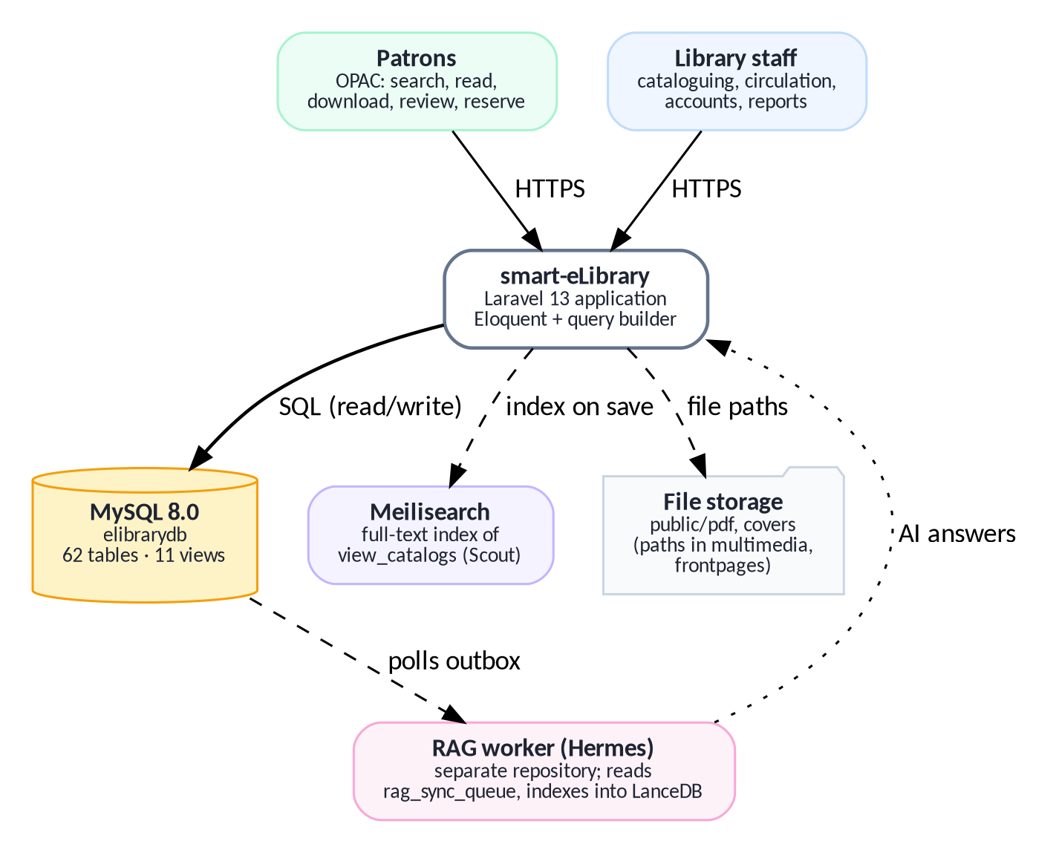
Figure 1. System context: the database, the application that owns it, and the three external stores that hold derived copies of its content.

3.2 Physical characteristics
Table 2 summarises the physical schema. Two figures stand out: the database declares only 6 foreign keys, and it contains no triggers, stored routines or scheduled events, so all behaviour beyond storage lives in the application.
Table 2. Physical summary of the schema.
Measure | Value
Database objects | 73: 62 base tables and 11 SQL views
Columns | 763 in total, 582 in base tables
Primary keys | 59 of 62 base tables (password_resets, view_total_copies, visits have none)
Secondary indexes | 24
Declared foreign keys | 6 (four on the Spatie permission pivots, two on saved_records)
Triggers, routines, events | 0, 0, 0
Objects named view_* | 13: 11 SQL views and 2 base tables (view_catalogs, view_total_copies)

Table 3. Storage engines and collations of the base tables.
Engine / collation | Tables
InnoDB / utf8mb4_unicode_ci | 41
InnoDB / utf8mb4_general_ci | 15
InnoDB / latin1_swedish_ci | 5
MyISAM / utf8mb3_general_ci | 1

3.3 Provenance and evolution
The schema has a dual origin. Migration 2025_09_15_114348_drop_all_tables drops every table, and 2025_09_15_114349_migration then executes a SQL dump (database/sql/elib_new.sql) that creates 56 tables and 11 views: the legacy system's structure carried forward wholesale. Fifteen later migrations, dated July to October 2026, together with Laravel's own 2019 token migration, add six tables (inquiry_seens, rag_sync_queue, material_type_maps, saved_records, plus Laravel's migrations and personal_access_tokens) and alter others (Appendix D).
The dump has itself been refreshed over time: it already contains three tables that later migrations also create (reads, reservation_messages, settings). Those migrations guard with Schema::hasTable, so both paths converge, but the schema now has two sources of truth that must be kept in step, and the baseline begins with an unconditional DROP of every table.

4 Conceptual and logical model

4.1 Subject areas
The 73 objects fall into eight subject areas (Figure 2). Two entities act as hubs: the bibliographic record (catalogs), referenced by at least 12 columns in other tables, and the account (users), referenced by at least 10. Of the 73 objects, 18 belong to superseded designs or are unused; they are shown in grey and discussed in section 4.8.
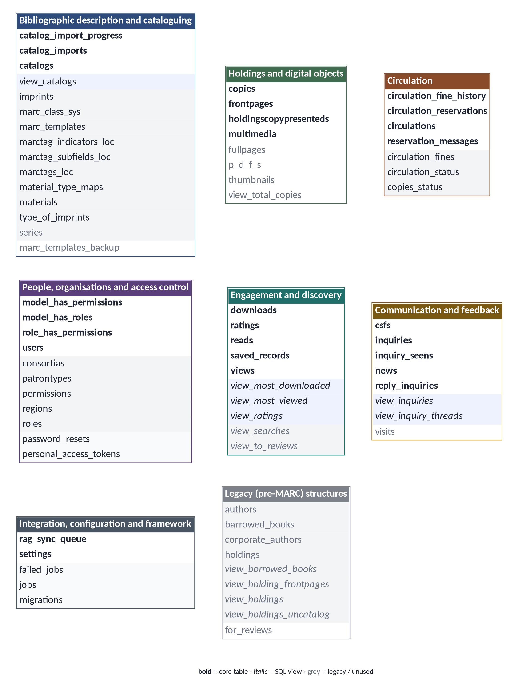
Figure 2. The eight subject areas and their tables. Bold: core tables; italic: SQL views; grey: legacy or unused.

4.2 Bibliographic description and cataloguing
The central entity is the bibliographic record. Each row of catalogs holds one title, and its descriptive content is a complete MARC 21 record serialised as JSON in field_data (section 5.1). The relational columns carry only administration: material type, classification system, the import batch that created the record, whether it is published on the OPAC, the AANR-sector flag and a soft-delete trail.
Because MARC JSON cannot be searched, sorted or displayed efficiently, every record has a one-to-one projection in view_catalogs. Despite its name this is a base table, written by the cataloguing code in the same request as the record: it flattens title, authors, subjects, publisher, year and call number into columns, and it is the model Laravel Scout indexes into Meilisearch. In architectural terms the pair forms a write model and a read model, a pattern known as command-query responsibility segregation (Fowler 2011). The MARC reference tables (marctags_loc with 249 tags, marctag_subfields_loc with 2,606 subfields, marctag_indicators_loc with 312 indicator values) define the vocabulary the editor offers; the JSON records point into them by id (Figure 3).
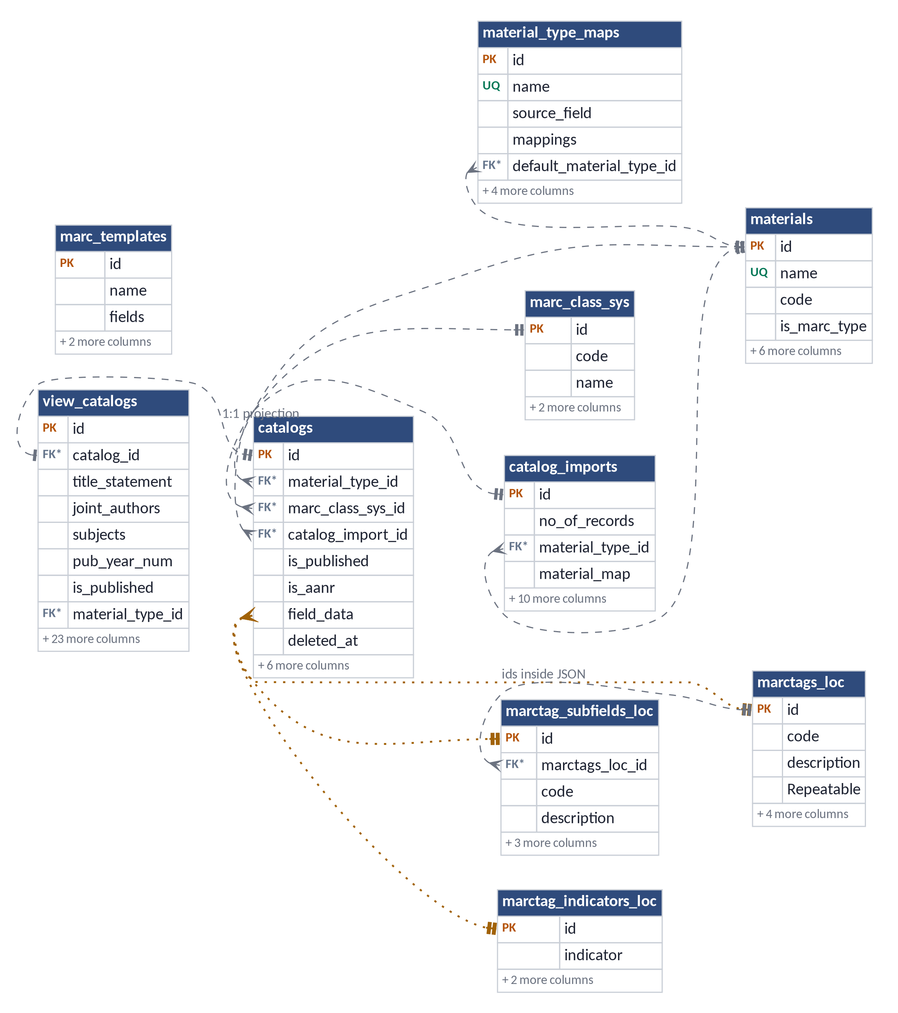
Figure 3. Logical model of bibliographic description and cataloguing.

4.3 Holdings and circulation
A title can have many physical copies, each identified in practice by its circulation_number (barcode) rather than its key. Circulation is modelled as one transaction row in circulations per reservation or loan, keyed for the patron by a reservation_code and linked to its fine assessment by a transaction_code. Three satellite tables share those codes: circulation_reservations (the request details), circulation_fine_history (one fine assessment per transaction) and reservation_messages (the staff-patron chat). Status vocabularies live in circulation_status and copies_status, but rows store the code's order_no, not its key (section 5.3). Digital objects, the full text (multimedia) and the cover (frontpages), hang off the title, and holdingscopypresenteds logs copies confirmed during stock-taking (Figure 4).
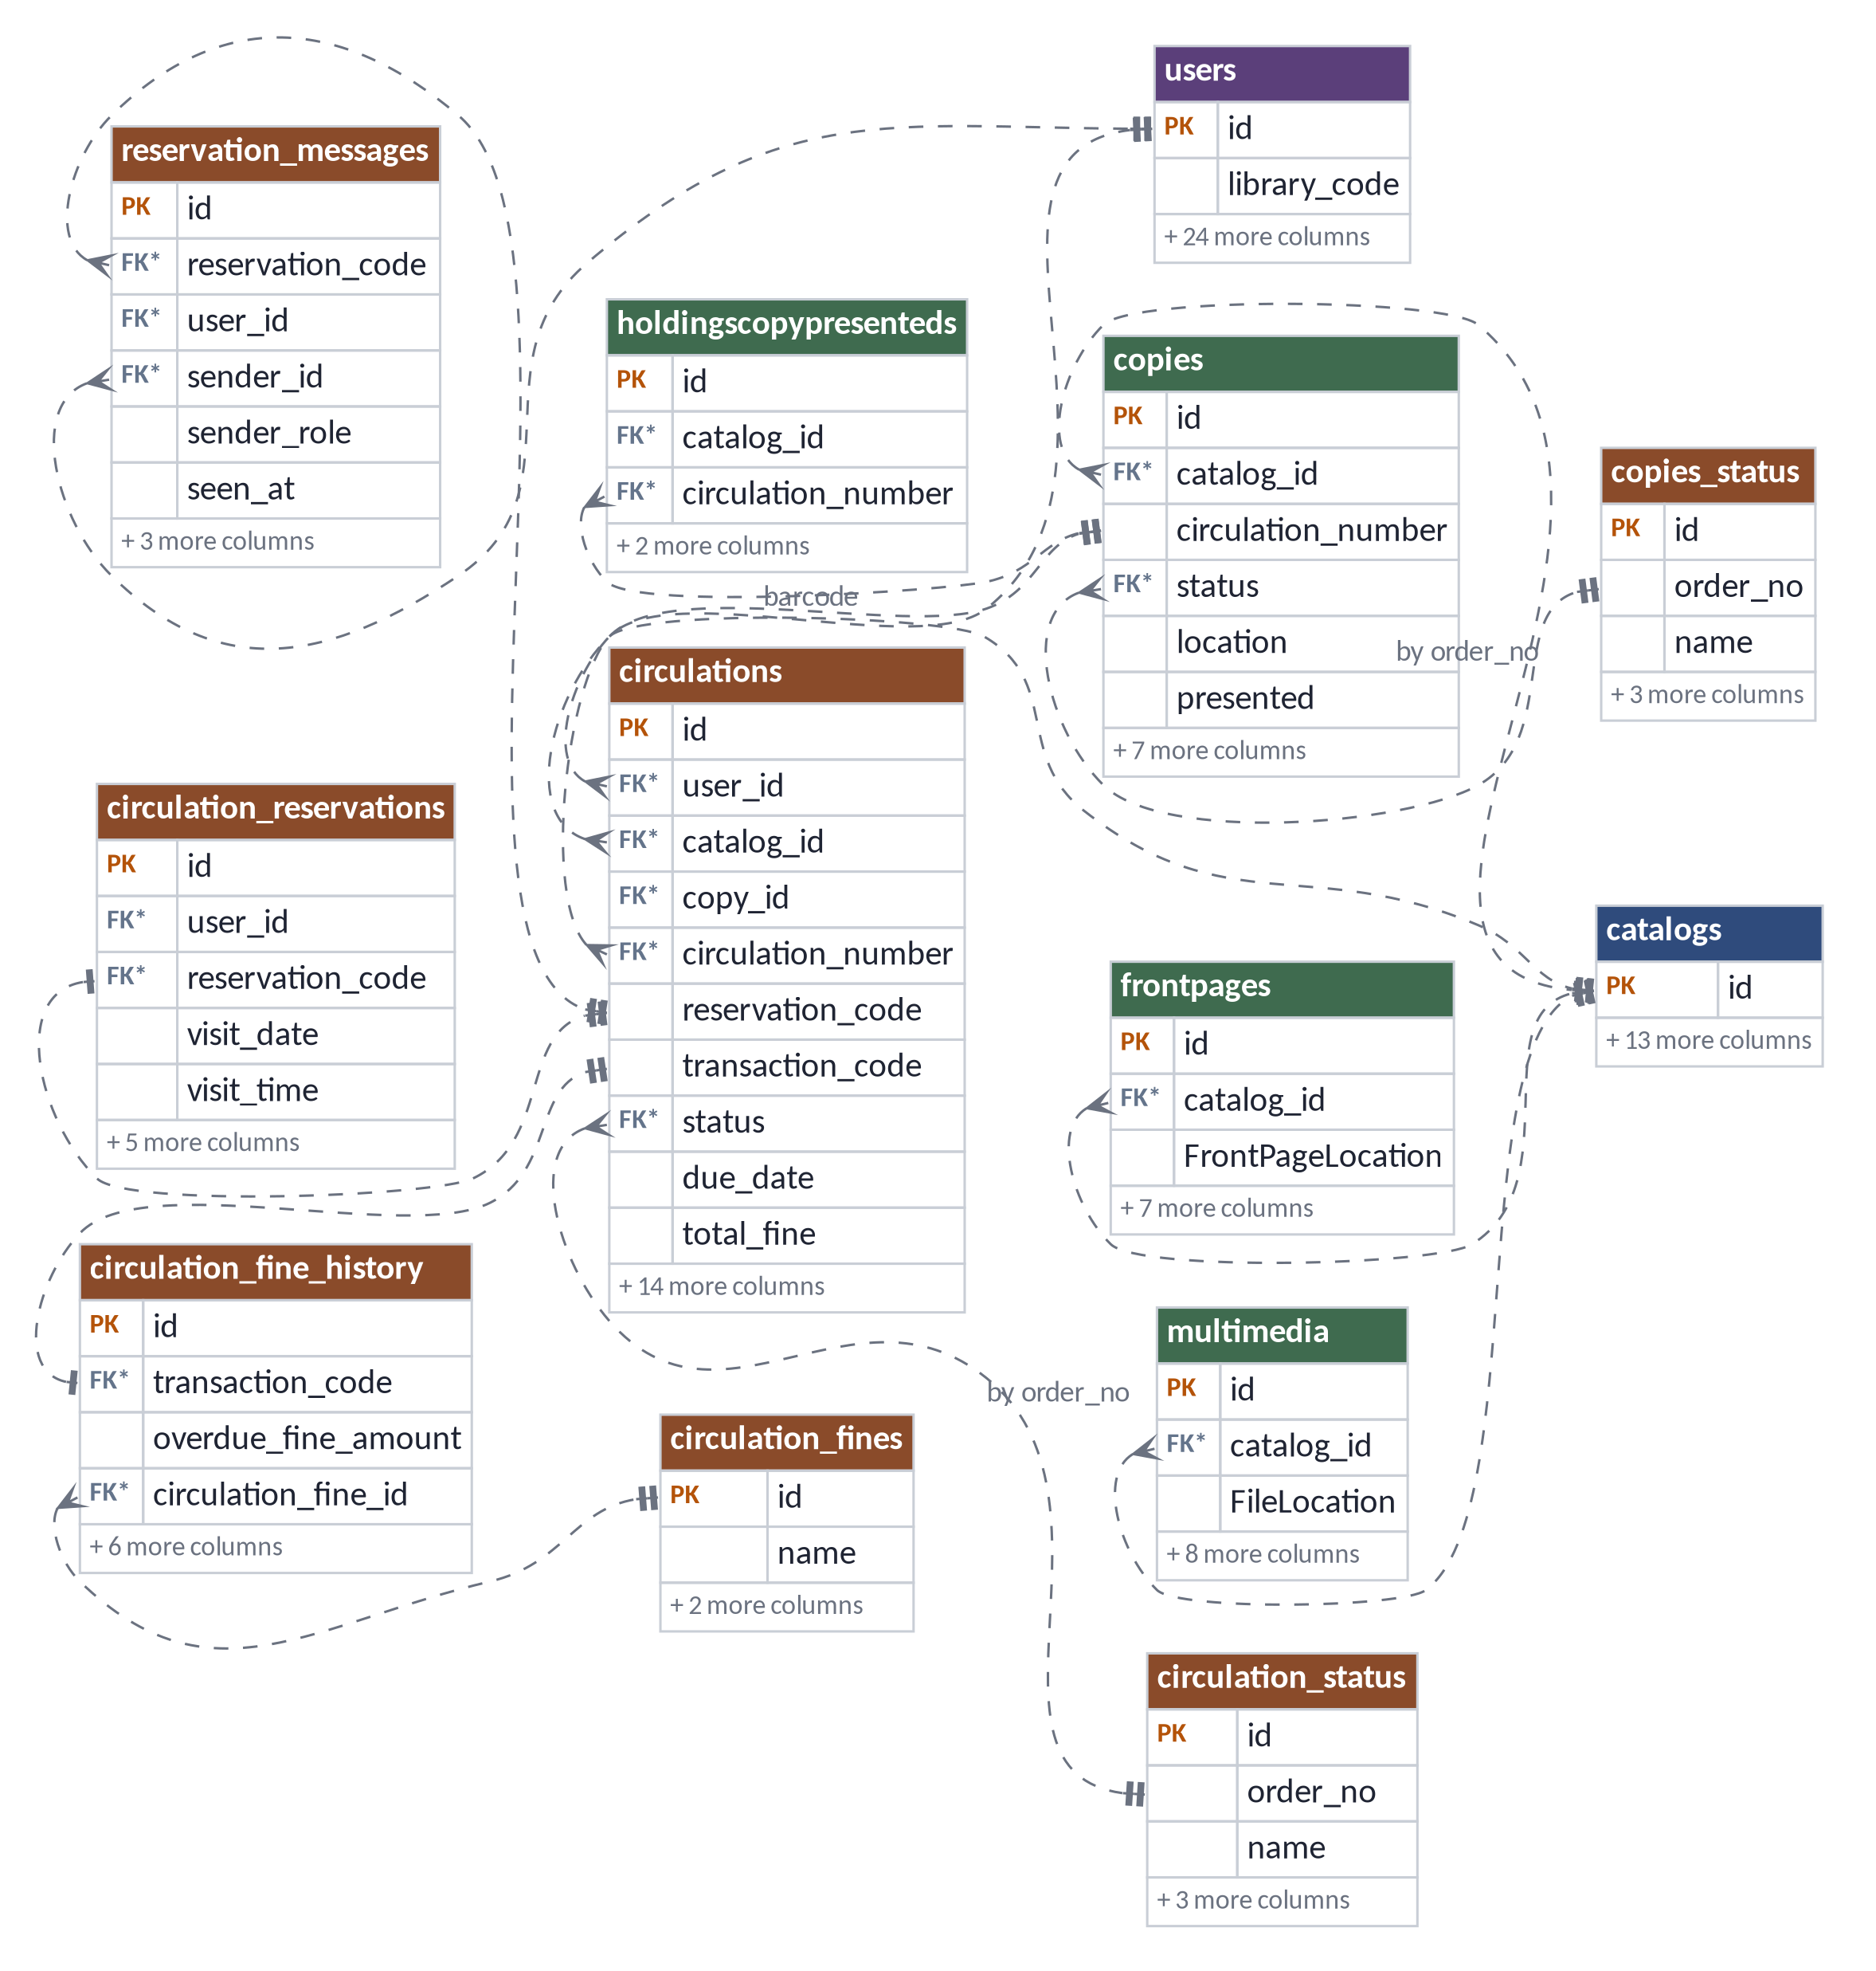
Figure 4. Logical model of holdings, digital objects and circulation. All relationships are implicit; several use natural keys (barcode, reservation and transaction codes).

4.4 People, organisations and access control
One table, users, holds every account. usertype separates patrons from staff, and staff capabilities come from role-based access control implemented with the Spatie laravel-permission package: roles and permissions are linked through role_has_permissions, and accounts receive roles through the polymorphic pivot model_has_roles (Ferraiolo and Kuhn 1992). These pivots carry four of the database's six declared foreign keys. Patron profiling uses patrontypes and regions (Figure 5).
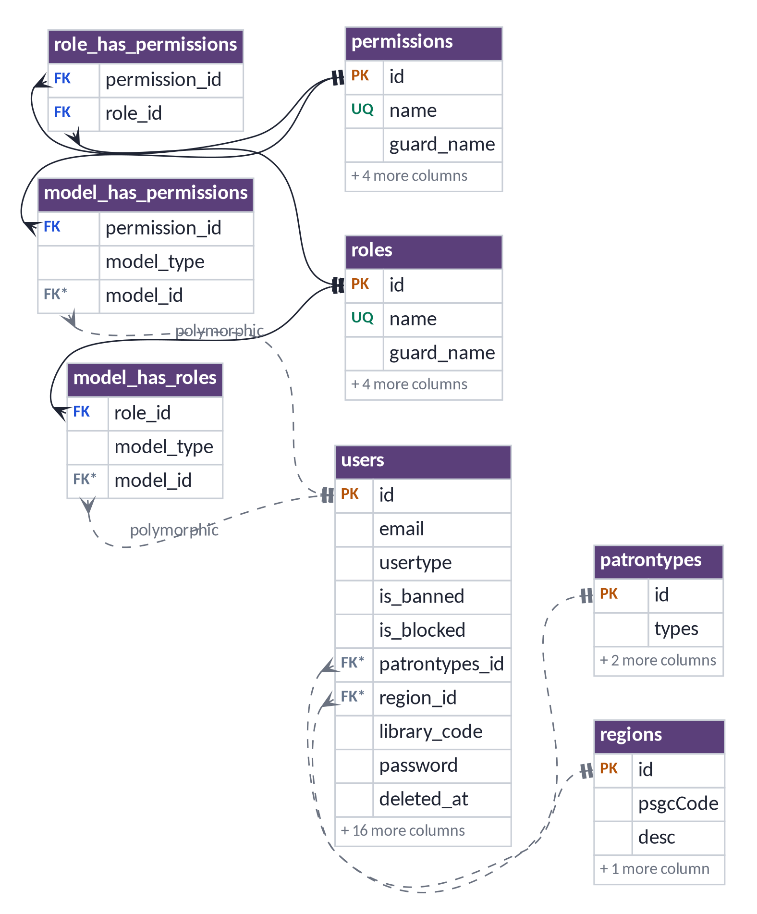
Figure 5. Logical model of accounts and role-based access control. The four solid edges are the only declared foreign keys outside saved_records.

4.5 Engagement and discovery
Four append-only logs record what patrons do with materials: views (opening a record page, including anonymous visitors), reads (the first online read per patron and material), downloads and ratings (reviews). saved_records holds each patron's saved list. Together they feed view and download counts, the staff dashboard, the To Review list and recommendations of popular titles (Figure 6).
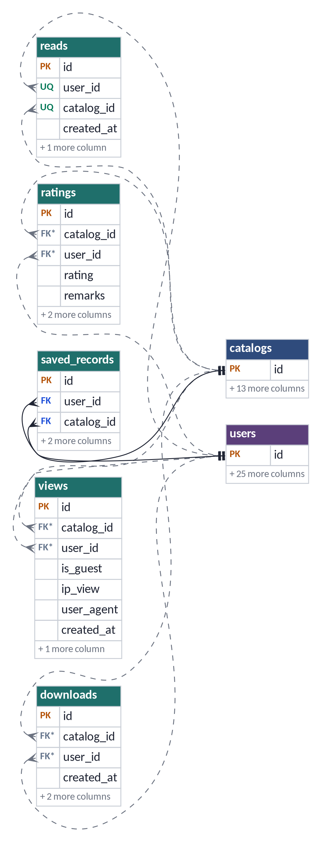
Figure 6. Logical model of engagement. reads and saved_records enforce one row per (user, catalog); the other logs do not.

4.6 Communication and feedback
Registered patrons may send inquiries, which become threads of reply_inquiries; inquiry_seens stores a read receipt per staff member and inquiry and drives the unread badges. news holds OPAC announcements, and csfs the government Client Satisfaction Feedback form with its seven fixed dimensions (Figure 7).
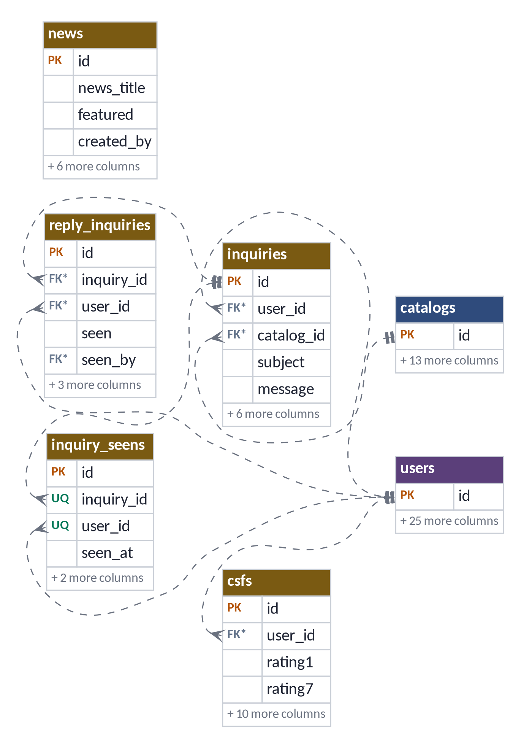
Figure 7. Logical model of inquiries, announcements and satisfaction feedback.

4.7 Integration and configuration
rag_sync_queue implements the transactional outbox pattern (Richardson 2018): whenever a record changes, the application inserts a row naming the record and the action (upsert or delete); a separate worker reads pending rows, updates its index and stamps processed_at. The producer deduplicates to one pending row per record and never lets a failure abort a catalogue save. settings is a key-value store for runtime options. Laravel's own tables (migrations, jobs, failed_jobs, password_resets, personal_access_tokens) complete the area; the queue tables are unused because jobs run synchronously.

4.8 Legacy structures
The baseline dump carried forward the previous system's flat bibliographic model, in which a title was one 89-column row in holdings with satellite authors and corporate_authors, and loans were rows in barrowed_books. These tables are empty and the application no longer writes them, yet seven SQL views still read them (Figure 8 and finding F13). Several other tables (thumbnails, fullpages, p_d_f_s, for_reviews, view_total_copies, visits, marc_templates_backup) are unused.
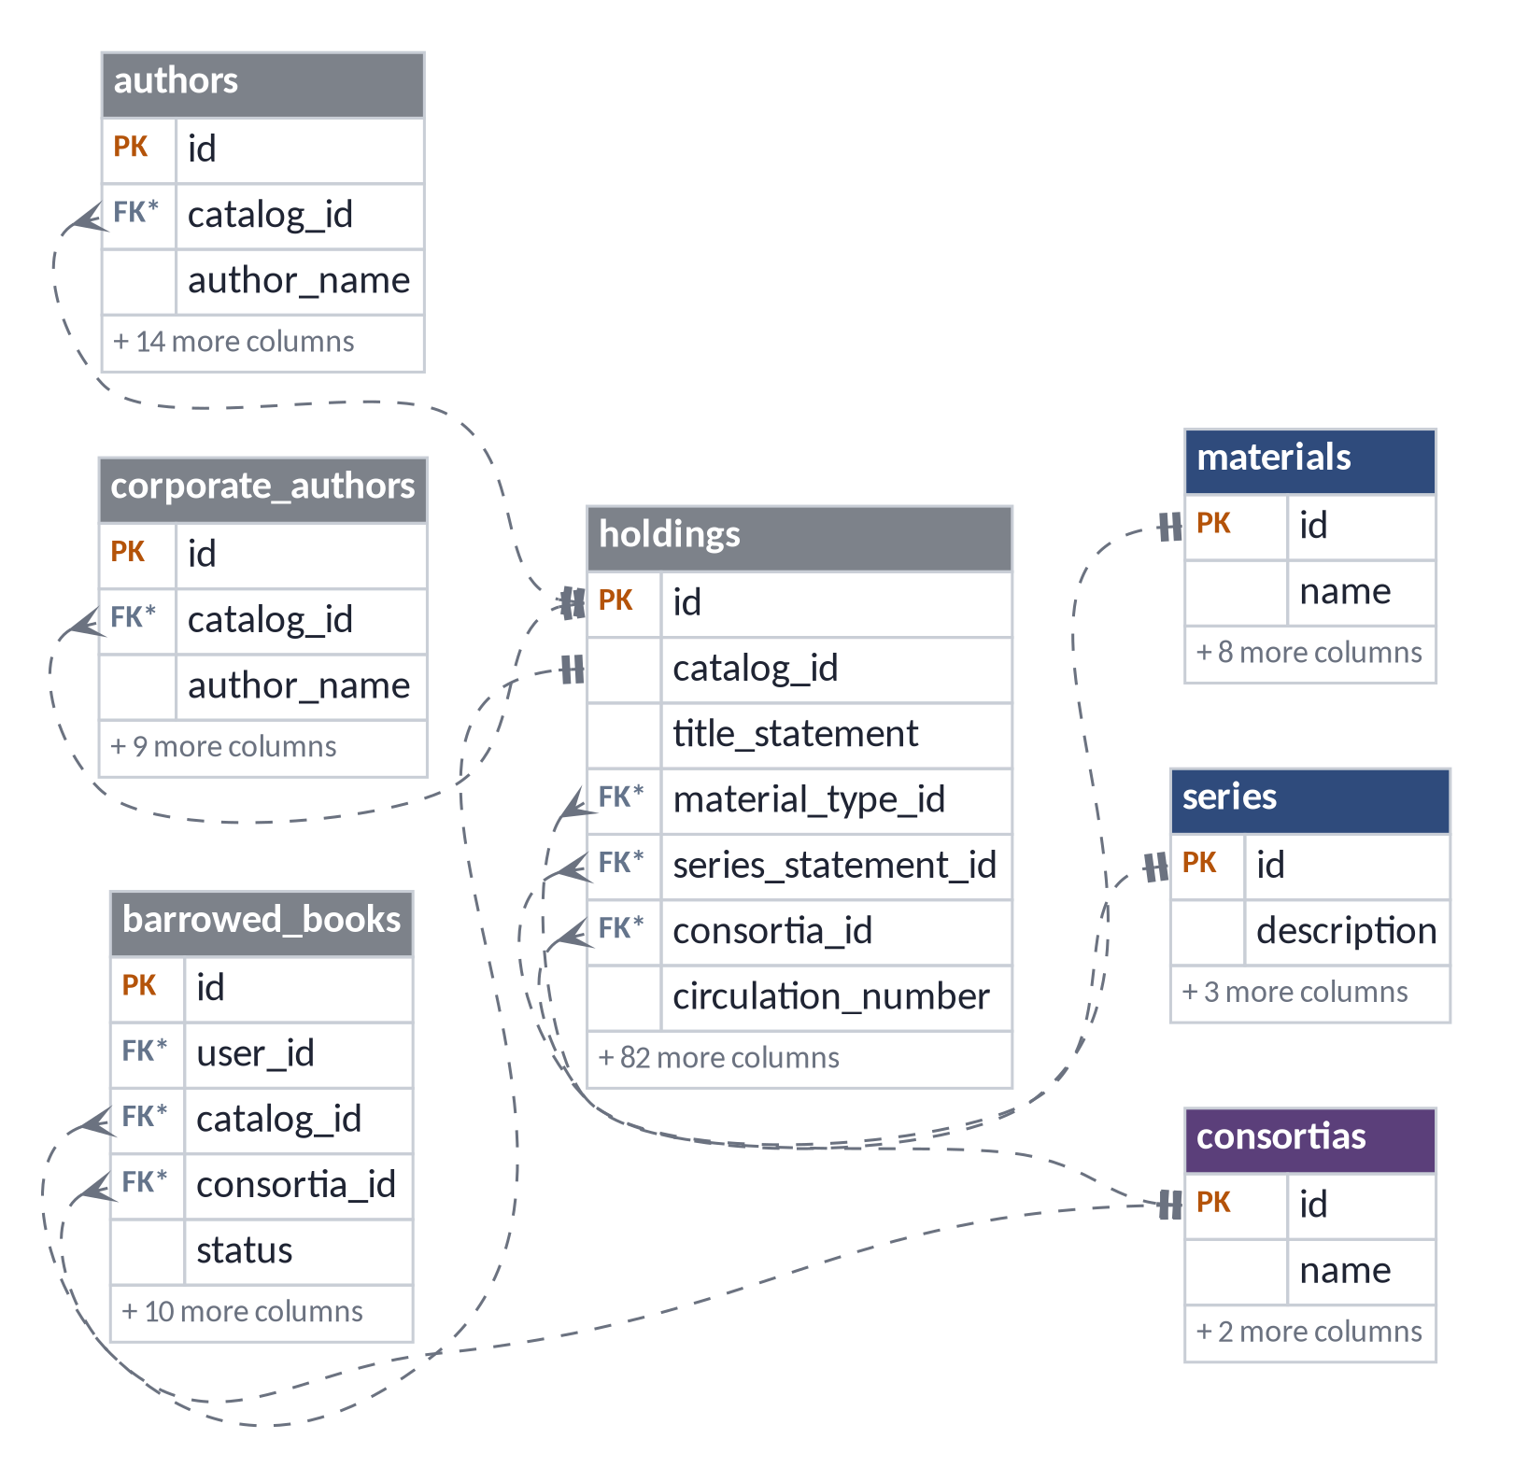
Figure 8. The legacy pre-MARC model, still referenced by seven SQL views.

5 Data semantics: what the schema does not say

5.1 The MARC 21 record in catalogs.field_data
field_data is declared as LONGTEXT, not JSON, so MySQL neither validates nor indexes it. Its content is an ordered array with one element per MARC field. Each element has three parts: marctag (the tag's id in marctags_loc, its code and name), indicator (for data fields, the two indicator values with their ids in marctag_indicators_loc) and subfield (each subfield's id in marctag_subfields_loc, its code such as 245$a, its name and its value). Control fields such as the leader are represented as positional pseudo-subfields (LDR$06, Type of record). Figure 9 shows the structure.
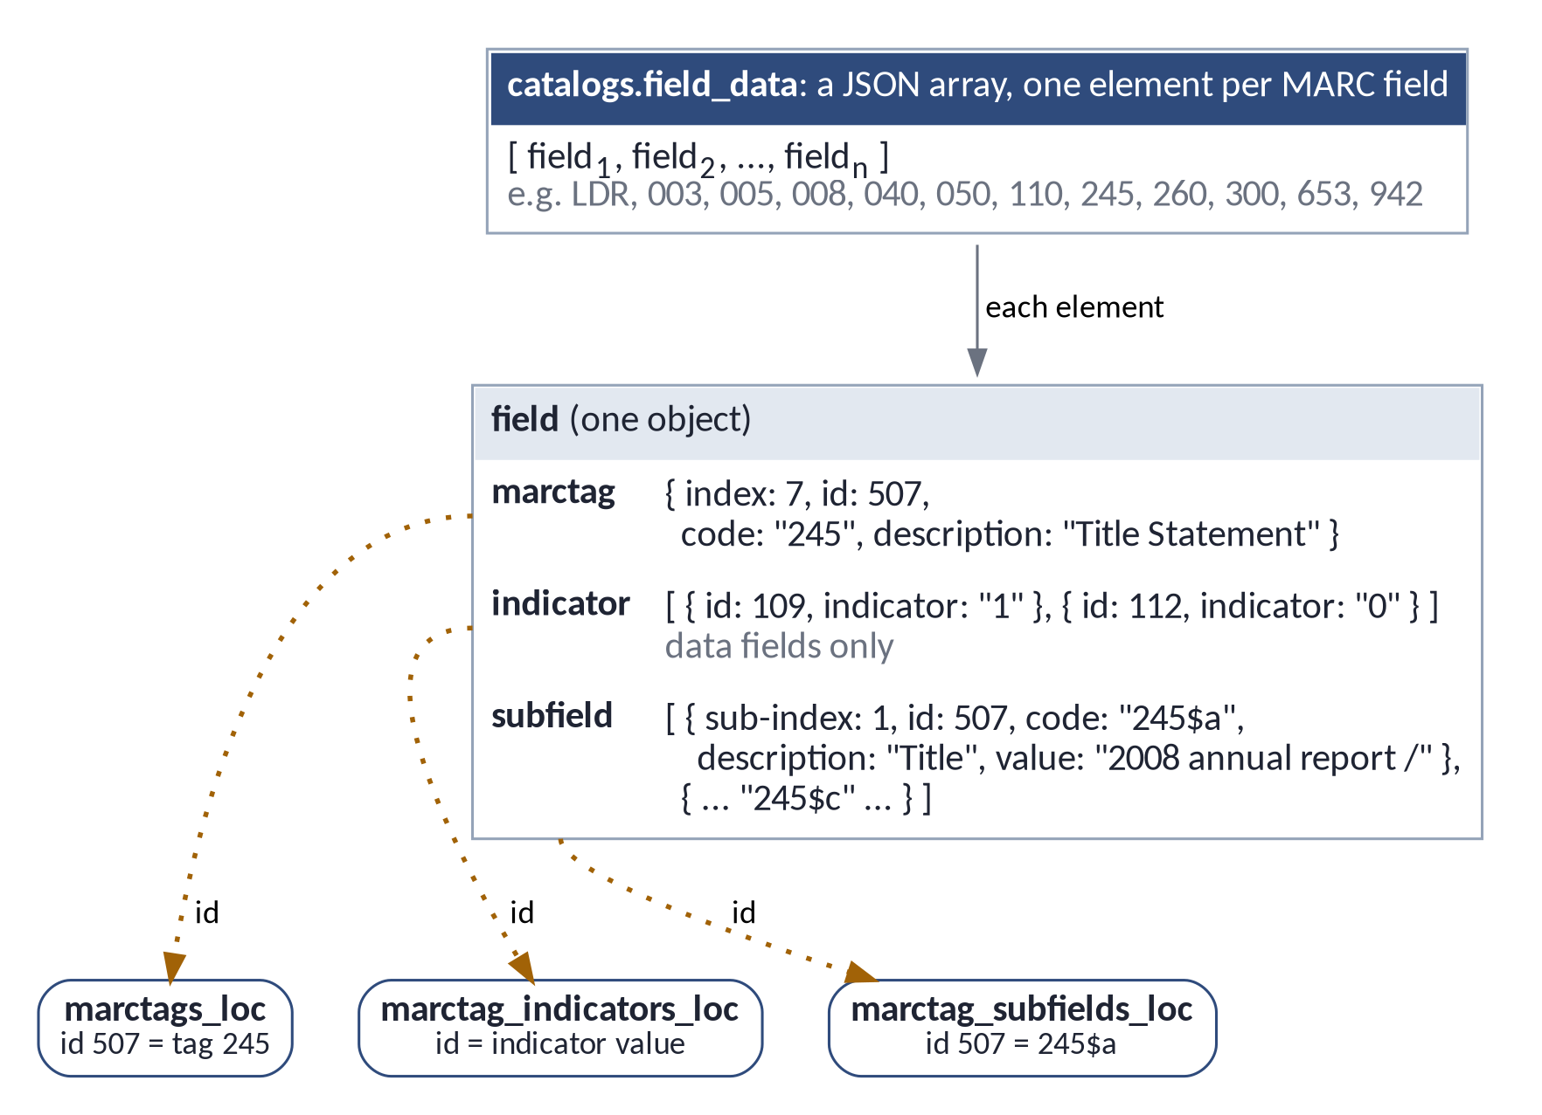
Figure 9. Structure of a MARC record in catalogs.field_data, with the reference tables its ids point to.
The representation is self-describing (names are copied into every record) and preserves field order, repetition and indicators, which a flat relational design could not. The cost is that the references into the MARC vocabulary are invisible to the database, tag and subfield names are copied into every record (records average 6,840 bytes), and any query over bibliographic content must go through the projection.

5.2 The search projection
view_catalogs derives its columns from the MARC record: title_statement from 245, joint_authors from 1XX/7XX joined with " / ", subjects from 6XX as a JSON array, publisher from 260/264, pub_year as transcribed and pub_year_num as a number for sorting and range filters, and so on (Appendix A). It is maintained by application code in the same request as the record, and four Artisan commands (catalog:rebuild-search-fields, catalog:rebuild-titles, catalog:rebuild-authors, catalog:sync-material-types) rebuild it from field_data. Profiling found every catalogue record projected exactly once, with publication and deletion state in agreement.

5.3 Status vocabularies and flags
Several columns hold codes whose meaning is defined elsewhere. Table 4 gathers them.
Table 4. Coded attributes and their vocabularies.
Column | Values and meaning | Defined in
circulations.status (INT) | 1 For Approval; 2 Approved; 3 Open (checked out); 4 Declined; 5 Closed (returned, fines settled) | circulation_status.order_no
copies.status (CHAR(50)) | 1 Available; 2 Reserved; 3 Borrowed; 4 Not Available; 5 Deleted; 6 Lost; 7 For Repair. Default '4'. | copies_status.order_no
catalogs.is_published | 1 visible on the OPAC; 0 on hold (staff only) | Application
users.usertype (ENUM) | Patron, Administrator, Developer; Student is declared but unused | Schema enum
users.is_banned / is_blocked | Banned: cannot log in or read. Blocked: cannot use chat or inquiries | Application
views.is_guest (ENUM) | 'YES' anonymous visitor; 'NO' signed in | Schema enum
rag_sync_queue.action | 'upsert' sync to current state; 'delete' ensure absent | Application
reservation_messages.sender_role | 'admin' or 'patron' | Application

5.4 The circulation lifecycle as a state machine
Reading the circulation controllers reveals a finite-state machine over circulations.status coupled to the status of the copy (Figure 10). A patron's reservation enters state 1. Staff approval moves it to 2 and the copy to Reserved, but only if the copy is Available at that moment. Check-out moves it to 3 and the copy to Borrowed, and sets the due date and an hourly overdue rate. Check-in moves it to 5, returns the copy to Available and records fines (overdue fine = rate × hours overdue, plus any damage fine). Staff can also check out a walk-in loan directly into state 3. Two transitions lead to Declined: a staff decision, and banning the patron, which declines all of their reservations in states 1 and 2.
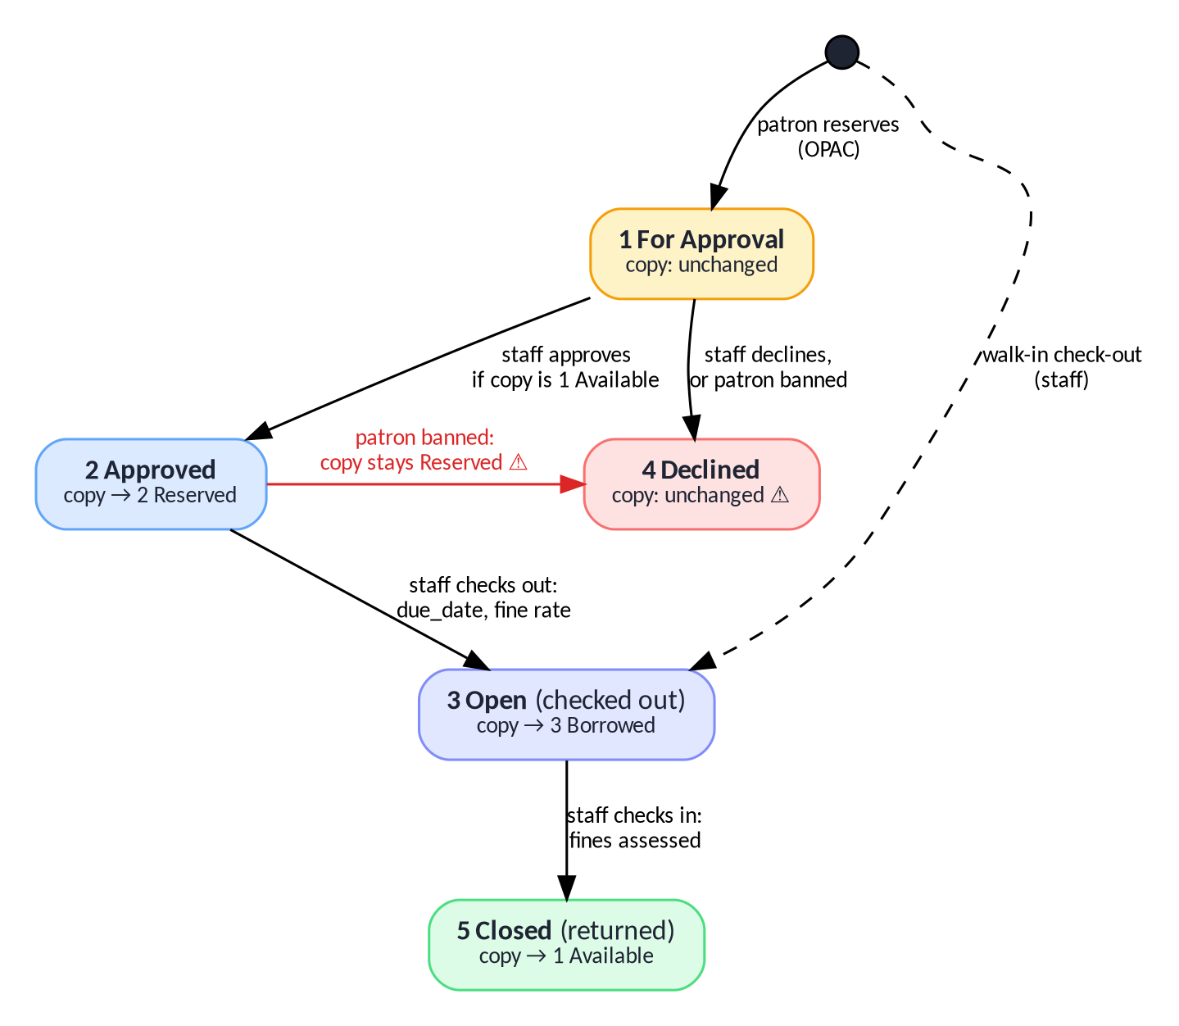
Figure 10. Circulation lifecycle. Each transition also changes the copy's status; the red transition leaves the copy Reserved (finding F11).

5.5 Access-control model
Authorisation is role-based: the application checks 35 permissions (for example access.dashboard, create.catalog, circulation.reservation.view), assigned to 7 roles through 124 grants; super_admin and developer hold all 35, system_admin 29, cataloging_admin 10, circulation_admin 7, faculty 6 and serial_admin 2. Routes check permissions with the can: middleware, and a Gate::before rule lets the developer role pass every check, including permissions added later. Direct grants to individual users (model_has_permissions) are supported but unused.

6 Event model: how actions become data
This chapter answers RQ3. Table 5 lists every application event that writes to the database, the tables it touches and whether the writes are atomic. "No" in the last column means the event issues several statements outside a database transaction, so a failure between them leaves partial state (finding F9).
Table 5. Event catalogue: every write path into the database.
# | Event | Actor | Rows written | Atomic
E1 | Register an account | Visitor | users +1 (type from default Patron; library card code generated) | Yes
E2 | Log in / out | User | None (file sessions). A banned account is signed out at once. | -
E3 | Open a record page | Anyone | views +1 (guest flag, IP, user agent) | Yes
E4 | Read online | Patron | reads +1 on the first read of that material | Yes
E5 | Download full text | Patron | downloads +1 | Yes
E6 | Review (form or quick popup) | Patron | ratings +1 (one per patron per material, checked in code) | Yes
E7 | Save / unsave | Patron | saved_records +1 or -1 | Yes
E8 | Inquire and reply | Patron, staff | inquiries +1; reply_inquiries +1 per message; inquiry_seens upsert when staff open a thread | Per statement
E9 | Reserve a material | Patron | circulations +1 (state 1); circulation_reservations +1; circulation_fine_history +1 (empty) | No
E10 | Approve a reservation | Staff | circulations state 1→2 with copy barcode and approver; copies 1→2 | No
E11 | Decline a reservation | Staff | circulations → 4 with decliner | Yes
E12 | Reservation chat | Staff, patron | reservation_messages +1; seen_at set on reading | Yes
E13 | Check out | Staff | copies → 3; circulations → 3 (or +1 for a walk-in) with due date and rate; circulation_fine_history +1 for walk-ins | No
E14 | Check in | Staff | copies → 1; circulations → 5 with receiver and fines; circulation_fine_history updated | No
E15 | Ban or block a patron | Staff | users flag; on ban, circulations in states 1-2 → 4 | No
E16 | Create or edit a record | Staff | catalogs and view_catalogs written; Meilisearch updated; rag_sync_queue +1 (deduplicated) | No
E17 | Publish, hold or delete | Staff | catalogs and view_catalogs flags or deleted_at; removed from or added to the index; rag_sync_queue +1 | No
E18 | Batch import MARC | Staff | catalog_imports +1; catalog_import_progress updated; per record catalogs and view_catalogs +1; rag_sync_queue +n | No
E19 | Attach full text or cover | Staff | multimedia or frontpages +1/update/soft delete, plus the file on disk | No
E20 | Inventory count | Staff | holdingscopypresenteds +1; copies.presented stamped (Available copies only) | No
E21 | Manage roles, settings, news | Staff | roles, permissions, pivots; settings upsert; news | Per statement
E22 | RAG synchronisation | RAG worker | rag_sync_queue.processed_at, attempts, error | External
E23 | Satisfaction feedback | Patron | csfs +1 | Yes

6.1 Patron engagement
Figure 11 follows a patron from discovery to review. Each step appends one row to its own log, and the To Review list is not stored at all: it is computed on demand as the set of materials the patron downloaded or read, minus those already rated. A review therefore removes a material from the list without any update.
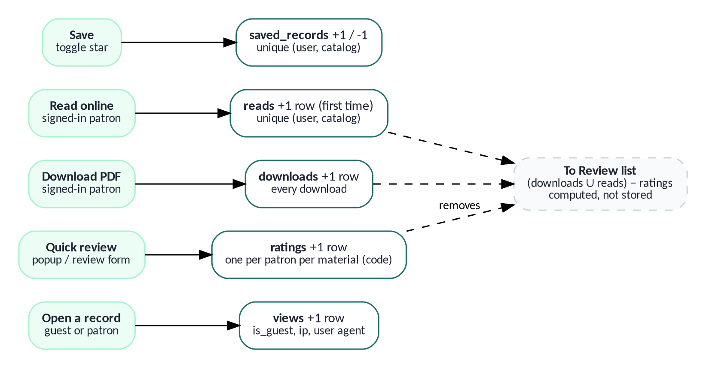
Figure 11. Patron engagement events and the rows they write. The To Review list is derived, not stored.

6.2 Catalogue propagation
A catalogue change fans out to four stores (Figure 12). The record and its projection are written to MySQL in the same request, Scout updates Meilisearch, and a row in the outbox schedules the RAG worker. Only the database writes are under the application's control; the other two are eventually consistent. The outbox makes the RAG side recoverable after a crash, but the database writes are not wrapped in a transaction, so a failure between them would leave the record and its projection out of step until a rebuild command is run.
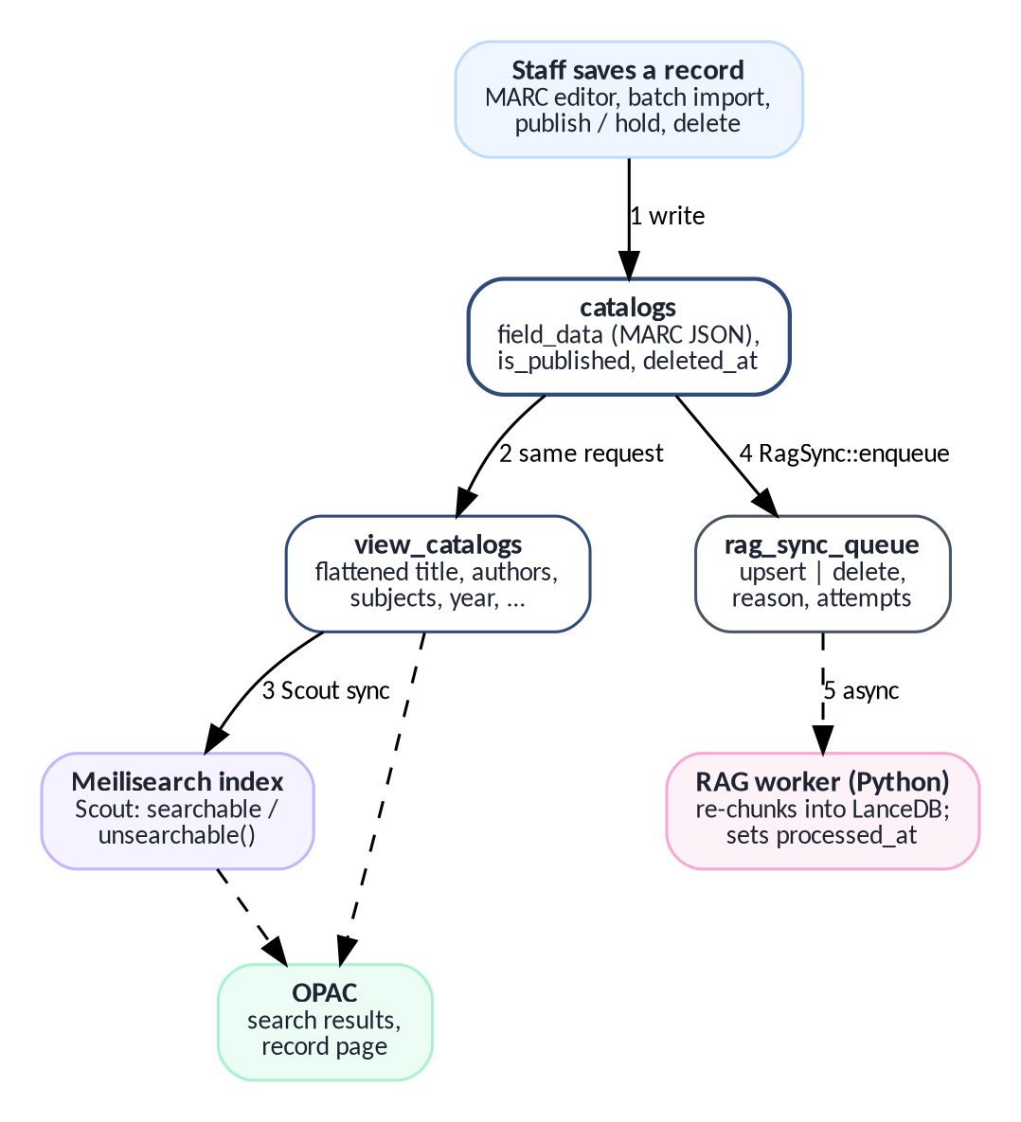
Figure 12. How a catalogue change propagates: one write fans out to the projection, the search index and the RAG outbox.

7 Analysis
This chapter answers RQ4. Each finding states what was observed, the evidence, and why it matters. Table 6 summarises them by severity: high findings can corrupt data or break features now, medium ones weaken integrity or performance as the data grows, and low ones affect maintainability.
Table 6. Summary of findings.
# | Finding | Severity
F1 | Referential integrity is almost entirely implicit | High
F2 | One identifier, seven physical types | High
F3 | Money and dates stored as text | Medium
F4 | Codes without constraints; sentinel value 0 | Medium
F5 | TINYINT import-batch reference caps at 127 | Medium
F6 | Tables without primary keys; redundant indexes | Low
F7 | Natural keys not unique (email, barcode, codes) | High
F8 | Hot predicates without indexes | Medium
F9 | Multi-step operations are not atomic | High
F10 | Check-then-act race on approval | Medium
F11 | Declining an approved reservation leaks the copy | High
F12 | Staff recorded by name, not identity | Low
F13 | Schema-code drift: missing views, views on empty tables | High
F14 | NULL comparison defect in a view | Low
F15 | Mixed character sets, collations and engines | Medium
F16 | Legacy and unused structures | Low
F17 | MARC stored as unvalidated LONGTEXT | Medium
F18 | Projection maintained only by application code | Medium
F19 | Personal data retained without a policy | Medium
F20 | Repeating groups and redundant copies | Low

7.1 Entity and referential integrity

F1. Referential integrity is almost entirely implicit
Of the relationships the application relies on, only 6 are declared: four on the permission pivots and two on saved_records. The profile in Appendix F (Q2) checked 30 references, of which 28 are implicit and not enforced by MySQL. The current data are clean, with no orphaned rows except two accounts whose patrontypes_id is 0 (F4), but nothing prevents a deleted record or account from leaving dangling rows, and the soft-delete convention (rows marked deleted_at rather than removed) hides the problem rather than solving it. Without declared keys, the database cannot protect relationships against bugs, manual edits or future code paths, and tools cannot discover the model.

F6. Tables without primary keys; redundant indexes
password_resets, view_total_copies and visits have no primary key, which violates entity integrity and makes individual rows impossible to address reliably. Conversely, circulations, circulation_fines and circulation_fine_history carry a UNIQUE index on id in addition to the primary key on the same column: redundant indexes that cost space and write time and add nothing.

F7. Natural keys are not unique
Several attributes act as identifiers in the application but are not declared unique: users.email (the login identifier, unique only by form validation, so two concurrent sign-ups can create duplicates), copies.circulation_number (the barcode that circulation joins on), circulations.reservation_code and transaction_code (the keys of three satellite tables) and view_catalogs.catalog_id (a one-to-one link). ratings relies on code for its one-review-per-patron rule, whereas the comparable reads and saved_records enforce theirs with unique indexes.

7.2 Domain integrity

F2. One identifier, seven physical types
The identifier of a catalogue record is stored in 19 columns with 7 different types (Table 7), and user references show the same pattern (users.id is BIGINT UNSIGNED; views.user_id, downloads.user_id, ratings.user_id and circulations.user_id are INT; catalogs.created_by stores user ids as text). Comparing a string column with an integer makes MySQL convert each row's value before comparing, which prevents the use of an index on the string side; equal identifiers can compare unequal as strings ('1147' and '01147'); and a foreign key cannot be declared between columns of different types. This is the single largest obstacle to remedying F1.
Table 7. Physical types of columns that hold a catalogue record id.
Column | Type
catalogs.id (the key) | int unsigned
authors.catalog_id | varchar(24)
barrowed_books.catalog_id | varchar(50)
circulations.catalog_id | int
copies.catalog_id | varchar(50)
corporate_authors.catalog_id | varchar(50)
downloads.catalog_id | varchar(50)
frontpages.catalog_id | varchar(24)
holdings.catalog_id | varchar(24)
holdingscopypresenteds.catalog_id | varchar(100)
inquiries.catalog_id | varchar(50)
multimedia.catalog_id | varchar(24)
p_d_f_s.catalog_id | int
rag_sync_queue.catalog_id | bigint unsigned
ratings.catalog_id | varchar(25)
reads.catalog_id | bigint unsigned
saved_records.catalog_id | int unsigned
view_catalogs.catalog_id | int unsigned
view_total_copies.holdings_id | varchar(24)
views.catalog_id | varchar(50)

F3. Money and dates stored as text
Every monetary amount in circulation is VARCHAR(50): overdue_fine_rate, waived_amount, total_fine and total_fine_paid in circulations, and the fine amounts in circulation_fine_history. So are several dates: users.birthdate, circulation_reservations.visit_date and visit_time, view_catalogs.catalog_date. Text admits values that are not numbers or dates, sorts lexically ('100' before '20'), and pushes validation and arithmetic into application code.

F4. Codes without constraints; sentinel value 0
circulations.status and copies.status are bare codes with no foreign key or CHECK constraint to their vocabularies, and the two are typed differently (INT versus CHAR(50) holding digits). users.patrontypes_id is NOT NULL and staff accounts use 0 to mean "none", a value no patron type has; this sentinel is why two rows appear as orphans in the profile and why a foreign key cannot be added as is.

F5. A TINYINT reference caps import batches at 127
catalogs.catalog_import_id and view_catalogs.catalog_import_id are signed TINYINT columns referencing catalog_imports.id, an INT UNSIGNED key. The 128th batch import will fail to store its batch id (an out-of-range error in strict mode, a silently clipped value otherwise), and every record it creates will point at the wrong batch.

7.3 Transactional integrity and concurrency

F9. Multi-step operations are not atomic
The events marked "No" in Table 5 each issue several dependent statements without DB::transaction. A reservation writes three rows; approval updates the transaction and the copy; check-out and check-in update the copy, the transaction and the fine record; a catalogue save writes the record and its projection. A failure between statements (a validation exception, a timeout, a deadlock) leaves partial state, for example a copy marked Borrowed whose transaction is still Approved. The regions table uses MyISAM, which supports no transactions at all, although as read-only reference data it is not at risk.

F10. Check-then-act race on approval
Approval reads the copy, checks that its status is 1 (Available), then updates the transaction and the copy in separate statements without locking. Two staff approving reservations for the same copy at the same moment can both pass the check, leaving two approved reservations for one copy: a lost-update anomaly (Gray and Reuter 1993). A conditional update (UPDATE copies SET status = 2 WHERE circulation_number = ? AND status = 1, checking the affected-row count) or SELECT ... FOR UPDATE inside a transaction removes the race.

F11. Declining an approved reservation leaks the copy
Approval moves the copy to Reserved, but neither a staff decline nor the automatic decline that follows a ban moves it back. Banning a patron declines all of their reservations in states 1 and 2, so any copy they had approved stays Reserved indefinitely and disappears from availability (red transition in Figure 10). The defect is in the application, but it violates a database-level invariant that the schema could state and enforce: a copy is Reserved only while an approved reservation references it.

7.4 Consistency between schema and code

F13. Missing views, and views over empty legacy tables
Four Eloquent models point at tables or views that do not exist: View_inventory_missing and View_inventory_presented (used by the Inventory "Missing" and "Presented" report pages, which therefore fail with "table not found"), and Result and User_backup (unused). In the other direction, seven of the 11 SQL views read the empty legacy tables holdings or barrowed_books. Only one of them is still read by the application: view_inquiries, whose title column comes from holdings and is therefore always NULL (the inquiry page works around this by looking the title up separately). view_to_reviews has the same defect, and view_searches, the table behind the Search model, returns no rows at all; neither model is used by the current code.

F14. A NULL comparison defect
view_borrowed_books computes the length of a loan with IF(a.returned_at = NULL, ..., ...). Under SQL's three-valued logic a comparison with NULL is never true (Codd 1979), so the expression always takes the second branch and reports the days elapsed until today even for returned loans. The correct test is a.returned_at IS NULL. The view reads a legacy table, so the defect has no current effect, but it would if the view were revived.

F18. The projection is maintained only by application code
The consistency of view_catalogs with catalogs depends on every write path remembering to update both. The profile found them consistent (0 records without a projection, 0 publication or deletion mismatches), and rebuild commands exist as a repair path, but a single missed path, or the absence of a transaction (F9), would let search results diverge from records silently.

7.5 Physical design and performance

F8. Hot predicates without indexes
Comparing the predicates the application uses with the indexes available shows several frequent access paths that must scan whole tables (Table 8). The most important are view_catalogs.catalog_id, looked up on every record page, and the append-only logs views and downloads, filtered by record, user and date for counts and the dashboard. These logs grow without bound, so their cost grows linearly with use. The dashboard's two-minute cache masks the effect today.
Table 8. Frequent predicates without a supporting index.
Table | Predicate used by the application | Used for
view_catalogs | catalog_id = ? | Every record page, citations, admin record view
views | catalog_id = ?; created_at BETWEEN ... | View counts, most viewed, dashboard
downloads | catalog_id = ?; user_id = ?; created_at BETWEEN ... | Counts, To Review, dashboard
ratings | catalog_id = ?; (user_id, catalog_id) | Record page averages, one-review rule
copies | circulation_number = ? | Approval, check-out, check-in, inventory
circulations | reservation_code = ?; transaction_code = ?; status IN (...) | All circulation screens, dashboard
inquiries | user_id = ? | Patron inquiry list, notifications

F15. Mixed character sets, collations and engines
Base tables use four engine and collation combinations (Table 3). Five tables (authors, frontpages, holdings, materials, multimedia) use latin1, which cannot store characters outside the Western European repertoire. The utf8mb4 tables are split between two collations, utf8mb4_general_ci and utf8mb4_unicode_ci, so comparing string columns across them can fail with "Illegal mix of collations" or force a conversion that disables indexes, a risk compounded by F2 because many identifier columns are strings. regions alone uses MyISAM with utf8mb3.

F17. MARC stored as unvalidated LONGTEXT
Declaring field_data as LONGTEXT rather than MySQL's native JSON type means malformed documents are accepted, and the type offers neither path indexing nor generated columns. Embedding the MARC structure as a document is a defensible choice, since MARC's repeatable, ordered and optional fields fit a relational table poorly and the projection handles querying, but the document deserves the validation the JSON type provides.

7.6 Normalisation
Table 9 assesses the core tables against the normal forms. The bibliographic core is deliberately not in first normal form: field_data is a composite document, and view_catalogs is a derived read model in which joint_authors and subjects are multi-valued. Both are justified by their roles. The remaining departures are of two kinds. Historical snapshots, such as the requester's name copied into a reservation at the time of the request, are legitimate, because they record a fact as it was. Redundant copies that should always equal their source are not, because they create update anomalies: copies.title, circulations.user_library_code and the contact details copied into inquiries.
Table 9. Normal-form assessment of the core tables.
Table | Assessment | Departure and its status
catalogs | Below 1NF (by design) | field_data is a composite document; relational columns are in 3NF
view_catalogs | Derived; not normalised | Read model; multi-valued joint_authors, subjects (justified)
copies | 2NF | title depends on catalog_id (redundant copy)
circulations | 2NF | user_library_code depends on user_id (redundant); staff names (F12)
circulation_reservations | 3NF | requested_by, title_statement are snapshots (legitimate)
circulation_fine_history | 3NF | One-to-one with circulations; could be merged
users | 1NF, repeating group | position1-position4 (F20)
inquiries | 2NF | Name, contact and email copied from users (redundant)
csfs | 3NF | rating1-rating7 are a fixed instrument (acceptable)
Logs, pivots, rag_sync_queue | BCNF | None

F20. Repeating groups and redundant copies
users.position1 to position4 is a repeating group: it caps an account at four positions and makes "find everyone holding position X" a four-way disjunction. csfs.rating1 to rating7 look similar but map one-to-one to the seven fixed dimensions of the government form, so they are best read as distinct attributes with poor names.

7.7 Accountability and maintainability

F12. Staff recorded by name, not identity
Circulation records who approved, declined, released and received a transaction by storing the staff member's name (approved_by and similar, VARCHAR). Names are neither unique nor stable, so the trail cannot be joined reliably to accounts and silently changes meaning when an account is renamed. catalogs.created_by does the opposite, storing an id as text.

F16. Legacy and unused structures
18 of the 73 objects are legacy or unused (Appendix A marks each). They enlarge the surface a maintainer must understand, invite accidental reuse, and are the source of F13 and F14. The 89-column holdings table alone accounts for 89 of the schema's 763 columns, and its derived view view_holdings_uncatalog for another 90.

7.8 Security and privacy

F19. Personal data retained without a policy
Table 10 inventories the personal data the database holds. Most of it is necessary for the service, but two practices deserve attention under the principles of proportionality and retention in the Data Privacy Act of 2012 (RA 10173, s. 11). First, views stores the IP address and full user agent of every page view, including anonymous visitors, indefinitely and in clear. Second, contact details are duplicated into inquiries, circulation_reservations and the legacy barrowed_books and visits, multiplying the places where a correction or erasure must be applied. Passwords are stored as bcrypt hashes, and the seed data no longer contains real password hashes (removed in October 2026); real names and contact details of three accounts remain in the seed file in the public repository.
Table 10. Inventory of personal data.
Table | Personal data | Purpose
users | Name, email, contact number, birthdate, sex, location, region, affiliation, positions, patron category | Account, eligibility, statistics
views | IP address, user agent, account id | View counts, abuse detection
inquiries, reply_inquiries | Name, contact number, email (copied); message content | Patron support
circulations, circulation_reservations | Account, card code, requester name, visit schedule; staff names | Lending
reservation_messages | Message content between staff and patron | Lending
ratings, csfs | Opinions linked to an account | Feedback
downloads, reads, saved_records | Reading behaviour linked to an account | Service, To Review
Legacy: barrowed_books, visits | Name, contact number, email | None (unused)

8 Recommendations
Table 11 turns the findings into a programme ordered by priority. Priority 1 items correct defects that can corrupt data or break features now, and each is small. Priority 2 items restore integrity that the database should enforce; they need data-cleaning migrations and should be done in the order given, because type unification (R5) is the prerequisite for declaring foreign keys. Priority 3 items improve hygiene over the longer term. Every schema change should be shipped as a migration and tested against elibrarydb_test before production.
Implementation status (16 October 2026). Recommendations R1 to R15 have been implemented: each schema change is a migration that checks the data first and stops before changing anything a row would block, was tested against a dedicated test database, and was rehearsed on a restored copy of the live database (including its rollback) before being applied. The green line under each recommendation names the commit and migration. R16 remains open; the visits table it mentions was retired under R13. The rest of this document describes the database as it stood before these changes (the schema state on the title page), so findings F1 to F20 are the baseline the recommendations addressed.
Table 11. Prioritised recommendations.
# | Recommendation | Addresses | Effort
Priority 1
R1 | Add UNIQUE(users.email) after checking for duplicates.  Done. 6d3d28e, migration 2026_10_15_000000_unique_user_emails. | F7 | Low
R2 | Repair the inventory reports (create the two views or query copies and holdingscopypresenteds directly); re-point view_inquiries and view_to_reviews at view_catalogs; drop view_searches.  Done. 6d3d28e (inventory reports query copies and the scan list directly) and 3391007 (2026_10_15_600000: view_inquiries reads view_catalogs; view_to_reviews and view_searches dropped). | F13 | Low
R3 | On decline and on ban, return a Reserved copy to Available; approve with a conditional update that checks the affected-row count.  Done. 6d3d28e: decline, revert and ban return a Reserved copy to Available; approval claims the copy with a locked, conditional update. | F10, F11 | Low
R4 | Wrap every multi-statement event (E9, E10, E13-E18) in DB::transaction.  Done. 6d3d28e: reserve, approve, decline, revert, check-out, check-in, ban and every catalogue write run in one transaction each. | F9, F18 | Low
Priority 2
R5 | Unify identifier types: every catalogue reference INT UNSIGNED, every user reference BIGINT UNSIGNED.  Done. 6d3d28e, 2026_10_15_100000_unify_reference_column_types (the corpus-import audit marker it met on real data: 4270b59). | F2 | Medium
R6 | Declare foreign keys for the implicit references (RESTRICT for history tables, CASCADE for dependent logs).  Done. 6d3d28e, 2026_10_15_200000_add_foreign_keys (32 keys; existing orphans handled by their rule: 4270b59); users.region_id -> regions.id in 99268b0 (2026_10_16_400000). | F1 | Medium
R7 | Add the indexes of Table 8, with UNIQUE on copies.circulation_number, circulations.reservation_code and transaction_code, view_catalogs.catalog_id and ratings(user_id, catalog_id); drop the redundant UNIQUE(id) indexes.  Done. 3391007, 2026_10_15_500000_add_indexes_and_unique_codes. | F6, F7, F8 | Low
R8 | Store money as DECIMAL(10,2) and dates as DATE or DATETIME; type status codes as TINYINT UNSIGNED with foreign keys or CHECK constraints.  Done. 6d3d28e (2026_10_15_300000: fines DECIMAL(10,2)) and ebd18c0 (2026_10_15_700000 real dates, 2026_10_15_800000 TINYINT status codes). | F3, F4 | Medium
R9 | Widen catalog_import_id to INT UNSIGNED in both tables.  Done. 6d3d28e, 2026_10_15_100000: catalog_import_id is INT UNSIGNED in both tables. | F5 | Low
R10 | Make users.patrontypes_id nullable and replace the sentinel 0 with NULL.  Done. 6d3d28e, 2026_10_15_100000: users.patrontypes_id is nullable; 0 became NULL. | F4 | Low
R11 | Record staff by id (approved_by_id and so on) alongside or instead of names.  Done. ebd18c0, 2026_10_15_900000_staff_recorded_by_account: the *_by columns hold user ids, shown by name. | F12 | Medium
Priority 3
R12 | Convert latin1 tables to utf8mb4, standardise one collation (e.g. utf8mb4_0900_ai_ci), move regions to InnoDB.  Done. 0faefa0, 2026_10_16_200000_one_collation_and_engine: every table InnoDB utf8mb4_unicode_ci (the collation config/database.php declares), regions included. | F15 | Medium
R13 | Archive and drop the legacy tables and views after a final backup.  Done. 0faefa0, 2026_10_16_100000_retire_legacy_tables: 11 empty tables and 4 views archived and dropped, with the code that still read them. | F13, F14, F16 | Medium
R14 | Change field_data to the JSON type; add generated columns only where a MARC path must be filtered directly.  Done. 0faefa0, 2026_10_16_300000_marc_field_data_as_json; no generated columns were needed. MARC export unchanged for all 8,925 records. | F17 | Low
R15 | Adopt a retention rule for views (e.g. truncate or hash IPs after 90 days); remove copied contact details; replace real personal data in seed files with fictitious data.  Done. 92df5b5: 2026_10_16_500000 (IP address and browser string no longer stored), 2026_10_16_600000 (inquiries read the sender from the account); fictitious seed accounts. | F19 | Low
R16 | Give visits and password_resets primary keys (or adopt Laravel's current password_reset_tokens); replace users.position1-4 with a child table if multiple positions matter. | F6, F20 | Low

9 Conclusion
The smart-eLibrary database is the product of two eras: a flat legacy model imported wholesale, and a modern layer built around MARC records, role-based access and integration with search and AI services. The modern layer is coherent. Its central idea, a MARC document as the write model and a flattened projection as the read model, suits bibliographic data well, and the outbox gives the RAG integration a sound recovery story. Current data are clean.
Its weakness is that integrity is a property of the code rather than of the database. Relationships, types, uniqueness, state transitions and atomicity are all enforced, where they are enforced at all, by application logic that must be right on every path. The defects found here, a broken report, a copy that can be lost to availability, a cap of 127 imports, are typical of that arrangement. The recommendations move those guarantees into the schema in a deliberate order: repair what is broken, make identifiers uniform, declare the constraints, then retire the legacy. Each step can be taken independently and verified against a test database, and together they would turn a database that is correct by convention into one that is correct by construction.

References
ANSI/X3/SPARC Study Group on Data Base Management Systems (1975). Interim report. FDT, Bulletin of ACM SIGMOD, 7(2).
Chen, P. P.-S. (1976). The entity-relationship model: toward a unified view of data. ACM Transactions on Database Systems, 1(1), 9-36.
Codd, E. F. (1970). A relational model of data for large shared data banks. Communications of the ACM, 13(6), 377-387.
Codd, E. F. (1972). Further normalization of the data base relational model. In R. Rustin (Ed.), Data Base Systems (pp. 33-64). Prentice-Hall.
Codd, E. F. (1979). Extending the database relational model to capture more meaning. ACM Transactions on Database Systems, 4(4), 397-434.
Date, C. J. (2004). An Introduction to Database Systems (8th ed.). Addison-Wesley.
Elmasri, R., and Navathe, S. B. (2016). Fundamentals of Database Systems (7th ed.). Pearson.
Ferraiolo, D., and Kuhn, R. (1992). Role-based access controls. In Proceedings of the 15th National Computer Security Conference (pp. 554-563).
Fowler, M. (2011). CQRS. martinfowler.com/bliki/CQRS.html.
Gray, J., and Reuter, A. (1993). Transaction Processing: Concepts and Techniques. Morgan Kaufmann.
Kent, W. (1983). A simple guide to five normal forms in relational database theory. Communications of the ACM, 26(2), 120-125.
Library of Congress, Network Development and MARC Standards Office. MARC 21 Format for Bibliographic Data. loc.gov/marc/bibliographic/.
Martin, J. (1990). Information Engineering, Book II: Planning and Analysis. Prentice-Hall.
Oracle Corporation. MySQL 8.0 Reference Manual. dev.mysql.com/doc/refman/8.0/en/.
Republic of the Philippines (2012). Republic Act No. 10173: Data Privacy Act of 2012.
Richardson, C. (2018). Microservices Patterns. Manning.

Appendix A Data dictionary
Every object is listed below by subject area. For each: its purpose, its status (core, derived, reference, framework, legacy or unused), storage and keys, and its columns. "Key" shows PK (primary key), UQ (unique), IX (indexed) and FK (declared foreign key); implicit references are described in the Description column. Rows are from the 15 October 2026 snapshot. Legacy and unused objects with many columns are listed compactly. A default of now() stands for CURRENT_TIMESTAMP.

A.1 Bibliographic description and cataloguing

catalog_import_progress
Progress counter of a running batch import, polled by the import screen.
Status: Core · Storage: InnoDB, utf8mb4_general_ci · Rows: 0 · Primary key: id · Other indexes: none
Column | Type | Null | Default | Key | Description
id | int unsigned | N |  | PK | Surrogate primary key.
progress | int | Y | 0 |  | Records processed so far.
total_records | int | Y | 0 |  | Records in the batch.
created_at | timestamp | Y |  |  | Row creation time.
updated_at | timestamp | Y |  |  | Last update time.

catalog_imports
One row per batch import of MARC records (e.g. a Koha export): record count, subject, default material type and the material-type mapping used.
Status: Core · Storage: InnoDB, utf8mb4_general_ci · Rows: 1 · Primary key: id · Other indexes: none
Column | Type | Null | Default | Key | Description
id | int unsigned | N |  | PK | Surrogate primary key.
no_of_records | int | Y |  |  | Records in the batch.
subject | varchar(255) | Y |  |  | Batch label.
status | varchar(50) | Y | imported |  | Batch state ('imported', ...).
is_aanr | tinyint | Y | 0 |  | Default AANR flag for the batch.
material_type_id | int | Y | 21 |  | Default material type.
material_map | json | Y |  |  | JSON: the material-type mapping applied.
comment | text | Y |  |  | Free-text note.
created_at | timestamp | Y |  |  | Row creation time.
created_by | varchar(50) | Y |  |  | Staff account that created the row.
updated_at | timestamp | Y |  |  | Last update time.
updated_by | varchar(50) | Y |  |  | Staff account that updated the row.
deleted_at | timestamp | Y |  |  | Soft-delete time; NULL means active.
deleted_by | varchar(50) | Y |  |  | Staff account that deleted the row.

catalogs
The bibliographic record: one row per catalogued title. The full MARC 21 record is stored as JSON in field_data; the remaining columns are administrative (material type, publication state, import batch, audit trail). Source of truth for everything the OPAC and the search index show.
Status: Core · Storage: InnoDB, utf8mb4_general_ci · Rows: 34 · Primary key: id · Other indexes: none
Column | Type | Null | Default | Key | Description
id | int unsigned | N |  | PK | Surrogate primary key.
material_type_id | int unsigned | Y | 1 |  | Material type (materials.id; implicit).
is_aanr | tinyint | N | 0 |  | 1 if the material belongs to the AANR sector (agriculture, aquatic and natural resources).
catalog_import_id | tinyint | Y |  |  | Import batch that created the record (catalog_imports.id; implicit). TINYINT: at most 127 batches can be referenced.
is_published | tinyint | N | 0 |  | 1 = visible on the OPAC; 0 = on hold (staff only).
marc_class_sys_id | int | N | 1 |  | Classification system (marc_class_sys.id; 1 LOC, 2 DDC).
accession_number | varchar(255) | Y |  |  | Library accession number(s) of the title.
field_data | longtext | Y |  |  | The full MARC 21 record as JSON: an ordered array of fields, each with tag, indicators and subfields (see section 5.1).
created_at | timestamp | Y |  |  | Row creation time.
created_by | varchar(100) | Y |  |  | Staff user id, stored as text.
updated_at | timestamp | Y |  |  | Last update time.
updated_by | varchar(100) | Y |  |  | Staff user id, stored as text.
deleted_at | timestamp | Y |  |  | Soft-delete time; NULL means active.
deleted_by | varchar(100) | Y |  |  | Staff user id, stored as text.

imprints
MARC 264 second-indicator vocabulary: sequence of the imprint statement (earliest, intervening, current).
Status: Reference · Storage: InnoDB, utf8mb4_unicode_ci · Rows: 3 · Primary key: id · Other indexes: none
Column | Type | Null | Default | Key | Description
id | bigint unsigned | N |  | PK | Surrogate primary key.
name | varchar(255) | Y
created_at | timestamp | Y |  |  | Row creation time.
updated_at | timestamp | Y |  |  | Last update time.

marc_class_sys
Classification systems a record can use: Library of Congress (LOC) or Dewey Decimal (DDC).
Status: Reference · Storage: InnoDB, utf8mb4_general_ci · Rows: 2 · Primary key: id · Other indexes: none
Column | Type | Null | Default | Key | Description
id | int | N |  | PK | Surrogate primary key.
code | varchar(255) | Y
name | varchar(255) | Y
created_at | timestamp | Y |  |  | Row creation time.
updated_at | timestamp | Y |  |  | Last update time.

marc_templates
Cataloguing templates: the set of MARC fields pre-filled in the record editor for a material type (e.g. BOOKS_LC_PCAARRD).
Status: Reference · Storage: InnoDB, utf8mb4_general_ci · Rows: 7 · Primary key: id · Other indexes: none
Column | Type | Null | Default | Key | Description
id | int | N |  | PK | Surrogate primary key.
name | varchar(255) | Y |  |  | Template name, e.g. BOOKS_LC_PCAARRD.
fields | text | Y |  |  | The template's MARC fields and default values (serialised).
created_at | timestamp | Y |  |  | Row creation time.
updated_at | timestamp | Y |  |  | Last update time.

marc_templates_backup
A copy of marc_templates kept as a backup. Not read or written by the application.
Status: Unused · Storage: InnoDB, utf8mb4_general_ci · Rows: 0 · Primary key: id · Other indexes: none
Column | Type | Null | Default | Key | Description
id | int | N |  | PK | Surrogate primary key.
name | varchar(255) | Y |  |  | Template name.
fields | text | Y |  |  | Serialised fields.
created_at | timestamp | Y |  |  | Row creation time.
updated_at | timestamp | Y |  |  | Last update time.

marctag_indicators_loc
Allowed MARC indicator values. Referenced by id from inside catalogs.field_data.
Status: Reference · Storage: InnoDB, utf8mb4_general_ci · Rows: 312 · Primary key: id · Other indexes: none
Column | Type | Null | Default | Key | Description
id | int | N |  | PK | Surrogate primary key.
indicator | varchar(255) | N | '' |  | Indicator value.
created_at | timestamp | Y |  |  | Row creation time.
updated_at | timestamp | Y |  |  | Last update time.

marctag_subfields_loc
MARC 21 subfields per tag (e.g. 245$a Title). Referenced by id from inside catalogs.field_data.
Status: Reference · Storage: InnoDB, utf8mb4_unicode_ci · Rows: 2,606 · Primary key: id · Other indexes: none
Column | Type | Null | Default | Key | Description
id | bigint unsigned | N |  | PK | Surrogate primary key.
marctags_loc_id | bigint unsigned | Y |  |  | Parent tag (marctags_loc.id; implicit).
code | varchar(255) | N |  |  | Subfield code, e.g. 245$a or LDR$06.
description | varchar(255) | N |  |  | Subfield name.
repeatable | tinyint | N | 0 |  | 1 if the subfield may repeat.
created_at | timestamp | Y |  |  | Row creation time.
updated_at | timestamp | Y |  |  | Last update time.

marctags_loc
The MARC 21 bibliographic tag list (Library of Congress): tag code, name, indicator descriptions and repeatability. Referenced by id from inside catalogs.field_data.
Status: Reference · Storage: InnoDB, utf8mb4_unicode_ci · Rows: 249 · Primary key: id · Other indexes: none
Column | Type | Null | Default | Key | Description
id | bigint unsigned | N |  | PK | Surrogate primary key.
code | varchar(255) | N |  |  | MARC tag (e.g. 245) or LDR.
description | varchar(255) | N |  |  | Tag name.
first_indictors | varchar(255) | Y |  |  | First-indicator definition (column name misspelt in the schema).
second_indicators | varchar(255) | Y |  |  | Second-indicator definition.
Repeatable | tinyint | N | 0 |  | 1 if the tag may repeat.
created_at | timestamp | Y |  |  | Row creation time.
updated_at | timestamp | Y |  |  | Last update time.

material_type_maps
Rules that map a value in an imported record (e.g. Koha item type in 942$c) to a local material type.
Status: Reference · Storage: InnoDB, utf8mb4_unicode_ci · Rows: 1 · Primary key: id · Other indexes: UQ (name)
Column | Type | Null | Default | Key | Description
id | bigint unsigned | N |  | PK | Surrogate primary key.
name | varchar(100) | N |  | UQ | Map name (unique), e.g. 'Koha - FNRI'.
source_field | varchar(20) | N |  |  | MARC field read, e.g. 942$c.
mappings | json | N |  |  | JSON: source value -> materials.id.
default_material_type_id | bigint unsigned | Y |  |  | Fallback material type.
created_by | bigint unsigned | Y |  |  | Staff account that created the row.
updated_by | bigint unsigned | Y |  |  | Staff account that updated the row.
created_at | timestamp | Y |  |  | Row creation time.
updated_at | timestamp | Y |  |  | Last update time.

materials
Material types (Books, Serials, Thesis/Dissertations, ...). is_marc_type marks types that correspond to a MARC record type; is_active hides retired types.
Status: Reference · Storage: InnoDB, latin1_swedish_ci · Rows: 25 · Primary key: id · Other indexes: UQ (name)
Column | Type | Null | Default | Key | Description
id | int | N |  | PK | Surrogate primary key.
name | varchar(100) | N |  | UQ | Display name (unique).
code | varchar(100) | Y |  |  | MARC leader 06 code for MARC types, '#' otherwise.
tooltip | text | Y |  |  | Help text shown in the editor.
is_active | tinyint(1) | N | 1 |  | 0 hides the type from new records.
is_marc_type | tinyint(1) | N | 0 |  | 1 = maps to a MARC record type.
created_by | bigint unsigned | Y |  |  | Staff account that created the row.
updated_by | bigint unsigned | Y |  |  | Staff account that updated the row.
created_at | timestamp | N | now() |  | Row creation time.
updated_at | timestamp | N | now() |  | Last update time.

series
Series statements of the legacy holdings model.
Status: Legacy · Storage: InnoDB, utf8mb4_unicode_ci · Rows: 0 · Primary key: id · Other indexes: none
Column | Type | Null | Default | Key | Description
id | bigint unsigned | N |  | PK | Surrogate primary key.
description | varchar(255) | Y
created_at | timestamp | Y |  |  | Row creation time.
updated_at | timestamp | Y |  |  | Last update time.
deleted_at | timestamp | Y |  |  | Soft-delete time; NULL means active.

type_of_imprints
MARC 264 function vocabulary used by the editor (Production, Publication).
Status: Reference · Storage: InnoDB, utf8mb4_unicode_ci · Rows: 2 · Primary key: id · Other indexes: none
Column | Type | Null | Default | Key | Description
id | bigint unsigned | N |  | PK | Surrogate primary key.
name | varchar(255) | Y
created_at | timestamp | Y |  |  | Row creation time.
updated_at | timestamp | Y |  |  | Last update time.

view_catalogs
A base table (not a SQL view, despite its name) holding a flattened projection of each catalog record: title, authors, subjects, publisher, year, call number and so on, extracted from the MARC JSON. It is written by the cataloguing code whenever a record changes, is the Laravel Scout model indexed into Meilisearch, and is what the OPAC lists, filters and displays.
Status: Derived · Storage: InnoDB, utf8mb4_general_ci · Rows: 34 · Primary key: id · Other indexes: IX (pub_year_num)
Column | Type | Null | Default | Key | Description
id | int unsigned | N |  | PK | Surrogate primary key.
catalog_id | int unsigned | N | 0 |  | The catalog record this row projects (catalogs.id; implicit 1:1). Not indexed.
isbn | varchar(100) | Y |  |  | ISBN (MARC 020$a).
issn | varchar(100) | Y |  |  | ISSN (MARC 022$a).
accession_number | varchar(255) | Y |  |  | Copied from catalogs.
is_published | tinyint | N | 0 |  | Copied from catalogs; filtered on by the OPAC.
catalog_import_id | tinyint | Y |  |  | Copied from catalogs.
material_type_id | int | Y |  |  | Material type id (copied).
material_type | varchar(100) | Y |  |  | Material type name (denormalised).
series_statement_id | int | Y |  |  | Legacy series id.
series_description | varchar(255) | Y |  |  | Series statement (MARC 490/830).
title_statement | text | Y |  |  | Title statement (MARC 245), may contain the statement of responsibility.
summary | text | Y |  |  | Summary/abstract (MARC 520).
general_note | text | Y |  |  | General note (MARC 500).
call_number | varchar(50) | Y |  |  | Call number (MARC 050/082/090).
catalog_date | varchar(50) | Y |  |  | Cataloguing date as text.
catalog_status | varchar(50) | Y |  |  | 'Cataloged' or 'Uncataloged'.
date_acquired | date | Y |  |  | Date the material was acquired.
edition | varchar(100) | Y |  |  | Edition statement (MARC 250).
joint_authors | text | Y |  |  | All authors, ' / '-separated (MARC 1XX/7XX).
subjects | json | Y |  |  | Subject terms as a JSON array (MARC 6XX).
publisher | text | Y |  |  | Publisher (MARC 260/264$b).
pub_url | text | Y |  |  | Electronic location (MARC 856$u).
pub_year | varchar(50) | Y |  |  | Publication year as written (e.g. '[2009]').
pub_year_num | smallint unsigned | Y |  | IX | Numeric publication year for sorting and range filters (indexed).
created_at | timestamp | Y |  |  | Row creation time.
created_by | int | Y |  |  | Staff user id.
updated_at | timestamp | Y |  |  | Last update time.
updated_by | int | Y |  |  | Staff user id.
deleted_at | timestamp | Y |  |  | Soft-delete time; NULL means active.
deleted_by | int | Y |  |  | Staff user id.

A.2 Holdings and digital objects

copies
Physical copies (items) of a title, identified by circulation_number (barcode). Status drives availability for reservation and loan.
Status: Core · Storage: InnoDB, utf8mb4_general_ci · Rows: 0 · Primary key: id · Other indexes: IX (catalog_id)
Column | Type | Null | Default | Key | Description
id | bigint unsigned | N |  | PK | Surrogate primary key.
catalog_id | varchar(50) | Y |  | IX | The title (catalogs.id; implicit; stored as text). Index named holding_id.
title | text | Y |  |  | Copy of the title (denormalised).
circulation_number | varchar(50) | Y |  |  | Copy barcode; used as the natural key by circulation. Not unique, not indexed.
cost | int | N | 0 |  | Acquisition cost (whole units).
acquisition_mode | int | Y |  |  | How it was acquired (code).
source | varchar(50) | Y |  |  | Supplier or donor.
location | char(50) | Y | 1 |  | Shelving location code (default 1).
status | char(50) | Y | 4 |  | copies_status.order_no as text (default '4' Not Available).
series_statement_id | int | Y |  |  | Legacy series id.
presented | timestamp | Y |  |  | When the copy was last confirmed during an inventory count.
created_at | timestamp | Y |  |  | Row creation time.
updated_at | timestamp | Y |  |  | Last update time.

frontpages
The cover image of a record (front and back paths). Generated covers are written here too.
Status: Core · Storage: InnoDB, latin1_swedish_ci · Rows: 34 · Primary key: id · Other indexes: none
Column | Type | Null | Default | Key | Description
id | int | N |  | PK | Surrogate primary key.
catalog_id | varchar(24) | N |  |  | The record (catalogs.id; implicit; text).
AcquisitionID | varchar(24) | N |  |  | Legacy acquisition id.
FrontPageName | varchar(250) | N |  |  | File name.
FrontPageType | varchar(250) | N |  |  | MIME type.
FrontPageLocation | varchar(255) | Y |  |  | Front-cover path under public/.
FrontPageLocation-back | varchar(250) | N |  |  | Back-cover path (hyphenated column name).
created_at | timestamp | Y | now() |  | Row creation time.
updated_at | timestamp | Y |  |  | Last update time.
deleted_at | timestamp | Y |  |  | Soft-delete time; NULL means active.

fullpages
Full-page image file names from an earlier design. Not used by the current code.
Status: Unused · Storage: InnoDB, utf8mb4_unicode_ci · Rows: 0 · Primary key: id · Other indexes: none
Column | Type | Null | Default | Key | Description
id | bigint unsigned | N |  | PK | Surrogate primary key.
filename | varchar(50) | Y
created_at | timestamp | Y |  |  | Row creation time.
updated_at | timestamp | Y |  |  | Last update time.

holdingscopypresenteds
Inventory (physical count) log: copies confirmed present during a stock-taking, by catalog and circulation number.
Status: Core · Storage: InnoDB, utf8mb4_unicode_ci · Rows: 0 · Primary key: id · Other indexes: none
Column | Type | Null | Default | Key | Description
id | bigint unsigned | N |  | PK | Surrogate primary key.
catalog_id | varchar(100) | Y |  |  | The record.
circulation_number | varchar(100) | Y |  |  | The copy confirmed present.
created_at | timestamp | Y |  |  | Row creation time.
updated_at | timestamp | Y |  |  | Last update time.

multimedia
The full-text file attached to a record (normally a PDF): file name, storage path under public/, type and description. Read through the guarded /read route and the download route.
Status: Core · Storage: InnoDB, latin1_swedish_ci · Rows: 4 · Primary key: id · Other indexes: none
Column | Type | Null | Default | Key | Description
id | int | N |  | PK | Surrogate primary key.
catalog_id | varchar(24) | Y |  |  | The record (catalogs.id; implicit; text).
FileName | varchar(255) | Y |  |  | Original file name.
FileLocation | varchar(255) | Y |  |  | Path in private storage, storage/app/private (e.g. pdf/....pdf); never served directly.
FileType | varchar(255) | Y |  |  | MIME type.
Extension | varchar(255) | Y |  |  | File extension.
Permission | varchar(255) | Y |  |  | Access note.
Description | varchar(255) | Y |  |  | Description.
created_at | timestamp | Y | now() |  | Row creation time.
updated_at | timestamp | Y | now() |  | Last update time.
deleted_at | timestamp | Y |  |  | Soft-delete time; NULL means active.

p_d_f_s
PDF file names per catalog from an earlier design (Laravel's table name for the PDF model). Superseded by multimedia.
Status: Unused · Storage: InnoDB, utf8mb4_unicode_ci · Rows: 0 · Primary key: id · Other indexes: none
Column | Type | Null | Default | Key | Description
id | bigint unsigned | N |  | PK | Surrogate primary key.
catalog_id | int | Y |  |  | The record.
filename | varchar(255) | Y |  |  | File name.
created_at | timestamp | Y |  |  | Row creation time.
updated_at | timestamp | Y |  |  | Last update time.

thumbnails
Thumbnail file names from an earlier design. Not used by the current code.
Status: Unused · Storage: InnoDB, utf8mb4_unicode_ci · Rows: 0 · Primary key: id · Other indexes: none
Column | Type | Null | Default | Key | Description
id | bigint unsigned | N |  | PK | Surrogate primary key.
filename | varchar(255) | Y
created_at | timestamp | Y |  |  | Row creation time.
updated_at | timestamp | Y |  |  | Last update time.

view_total_copies
A base table holding copy totals per legacy holdings id. Not read or written by the application.
Status: Unused · Storage: InnoDB, utf8mb4_unicode_ci · Rows: 0 · Primary key: none · Other indexes: none
Column | Type | Null | Default | Key | Description
total | bigint | Y |  |  | Copy count.
holdings_id | varchar(24) | Y |  |  | Legacy holdings id.

A.3 Circulation

circulation_fine_history
Fine assessment for a transaction (one row per transaction_code): overdue amount and hours, damage fine and its type, notes. Created empty with the reservation and filled at check-in.
Status: Core · Storage: InnoDB, utf8mb4_general_ci · Rows: 0 · Primary key: id · Other indexes: UQ (id)
Column | Type | Null | Default | Key | Description
id | int | N |  | PK | Surrogate primary key.
transaction_code | varchar(50) | Y |  |  | Links to circulations.transaction_code.
overdue_fine_amount | varchar(50) | Y |  |  | Overdue fine (text).
overdue_total_hours | varchar(50) | Y |  |  | Hours overdue (text).
other_fine_amount | varchar(50) | Y |  |  | Damage fine (text).
circulation_fine_id | int | Y |  |  | Damage type (circulation_fines.id).
other_fine_description | varchar(255) | Y |  |  | Damage description.
fine_note | varchar(255) | Y |  |  | Staff note.
created_at | timestamp | Y |  |  | Row creation time.
updated_at | timestamp | Y |  |  | Last update time.

circulation_fines
Damage types that can incur a fine (Water Damage, Page Tears, ...).
Status: Reference · Storage: InnoDB, utf8mb4_general_ci · Rows: 10 · Primary key: id · Other indexes: UQ (id)
Column | Type | Null | Default | Key | Description
id | int | N |  | PK | Surrogate primary key.
name | varchar(50) | Y |  |  | Damage type.
created_at | timestamp | Y |  |  | Row creation time.
updated_at | timestamp | Y |  |  | Last update time.

circulation_reservations
The patron's reservation request details (requested visit date and time, title) linked to circulations by reservation_code.
Status: Core · Storage: InnoDB, utf8mb4_general_ci · Rows: 0 · Primary key: id · Other indexes: none
Column | Type | Null | Default | Key | Description
id | int | N |  | PK | Surrogate primary key.
user_id | int | Y |  |  | The patron.
location_id | int | Y |  |  | Pickup location (always 1).
requested_by | varchar(100) | Y |  |  | Patron's name (copied).
title_statement | text | Y |  |  | Title requested (copied).
reservation_code | varchar(50) | Y |  |  | Links to circulations.reservation_code.
visit_date | varchar(50) | Y |  |  | Requested visit date (text).
visit_time | varchar(50) | Y |  |  | Requested visit time (text).
created_at | timestamp | Y |  |  | Row creation time.
updated_at | timestamp | Y |  |  | Last update time.

circulation_status
Circulation lifecycle states. circulations.status stores order_no (not id): 1 For Approval, 2 Approved, 3 Open (checked out), 4 Declined, 5 Closed.
Status: Reference · Storage: InnoDB, utf8mb4_general_ci · Rows: 5 · Primary key: id · Other indexes: IX (order_no)
Column | Type | Null | Default | Key | Description
id | int | N |  | PK | Surrogate primary key.
name | varchar(50) | Y |  |  | State name.
order_no | int | Y |  | IX | The code stored in circulations.status.
description | varchar(255) | Y |  |  | Meaning of the state.
created_at | timestamp | Y |  |  | Row creation time.
updated_at | timestamp | Y |  |  | Last update time.

circulations
One row per circulation transaction: a reservation that may become a loan. Carries the reservation and transaction codes, the copy, the status (see circulation_status.order_no), due date, fines and who approved, declined, released and received it.
Status: Core · Storage: InnoDB, utf8mb4_general_ci · Rows: 0 · Primary key: id · Other indexes: UQ (id)
Column | Type | Null | Default | Key | Description
id | int | N |  | PK | Surrogate primary key.
user_id | int | Y |  |  | The patron (users.id; implicit).
copy_id | int | Y |  |  | The copy (copies.id); set at check-out.
catalog_id | int | Y |  |  | The title (catalogs.id; implicit).
reservation_code | varchar(50) | Y |  |  | Code shown to the patron; links reservation, messages and chat. Not indexed.
transaction_code | varchar(50) | Y |  |  | Links the fine assessment (circulation_fine_history). Not indexed.
status | int | N | 1 |  | Lifecycle state = circulation_status.order_no (1-5).
due_date | datetime | Y |  |  | When the loan is due.
overdue_fine_rate | varchar(50) | Y |  |  | Overdue fine per hour (stored as text).
waived_amount | varchar(50) | Y |  |  | Fine waived at check-in (text).
total_fine | varchar(50) | Y |  |  | Total fine assessed (text).
total_fine_paid | varchar(50) | Y |  |  | Amount paid at check-in (text).
user_library_code | varchar(50) | Y |  |  | Patron card code, copied from users.library_code.
circulation_number | varchar(50) | Y |  |  | The copy's barcode, assigned at approval.
approved_at | datetime | Y |  |  | When staff approved.
approved_by | varchar(50) | Y |  |  | Approving staff member's name (not id).
declined_at | datetime | Y |  |  | When declined.
declined_by | varchar(50) | Y |  |  | Declining staff name.
released_at | datetime | Y |  |  | When checked out.
released_by | varchar(50) | Y |  |  | Staff name.
received_at | datetime | Y |  |  | When returned (checked in).
received_by | varchar(50) | Y |  |  | Staff name.
created_at | timestamp | Y |  |  | Row creation time.
updated_at | timestamp | Y |  |  | Last update time.

copies_status
Copy states. copies.status stores order_no: 1 Available, 2 Reserved, 3 Borrowed, 4 Not Available, 5 Deleted, 6 Lost, 7 For Repair.
Status: Reference · Storage: InnoDB, utf8mb4_general_ci · Rows: 7 · Primary key: id · Other indexes: none
Column | Type | Null | Default | Key | Description
id | int | N |  | PK | Surrogate primary key.
order_no | varchar(50) | Y |  |  | The code stored in copies.status.
name | varchar(50) | Y |  |  | State name.
description | varchar(255) | Y |  |  | Meaning of the state.
created_at | timestamp | Y |  |  | Row creation time.
updated_at | timestamp | Y |  |  | Last update time.

reservation_messages
Chat thread between staff and the patron about one reservation, keyed by reservation_code, with read receipts (seen_at).
Status: Core · Storage: InnoDB, utf8mb4_unicode_ci · Rows: 0 · Primary key: id · Other indexes: IX (reservation_code)
Column | Type | Null | Default | Key | Description
id | bigint unsigned | N |  | PK | Surrogate primary key.
reservation_code | varchar(125) | N |  | IX | The reservation the thread belongs to (indexed).
user_id | bigint unsigned | Y |  |  | The patron who owns the thread.
sender_id | bigint unsigned | Y |  |  | Who wrote the message (users.id).
sender_role | varchar(20) | N | admin |  | 'admin' or 'patron'.
message | text | N |  |  | Message text.
seen_at | timestamp | Y |  |  | When the recipient read it.
created_at | timestamp | Y |  |  | Row creation time.
updated_at | timestamp | Y |  |  | Last update time.

A.4 People, organisations and access control

consortias
The 16 regional R&D consortia of the PCAARRD network (CorCAARRD, MAARRDEC, ...). Referenced only by the legacy borrowing model.
Status: Reference · Storage: InnoDB, utf8mb4_unicode_ci · Rows: 16 · Primary key: id · Other indexes: none
Column | Type | Null | Default | Key | Description
id | bigint unsigned | N |  | PK | Surrogate primary key.
name | varchar(25) | Y |  |  | Consortium acronym.
created_at | timestamp | Y |  |  | Row creation time.
updated_at | timestamp | Y |  |  | Last update time.

model_has_permissions
Permissions granted directly to a user, outside roles (Spatie pivot). Currently empty.
Status: Core · Storage: InnoDB, utf8mb4_unicode_ci · Rows: 0 · Primary key: permission_id, model_id, model_type · Other indexes: IX (model_id, model_type)
Column | Type | Null | Default | Key | Description
permission_id | bigint unsigned | N |  | PK FK | permissions.id (declared FK).
model_type | varchar(125) | N |  | PK | Owning model class.
model_id | bigint unsigned | N |  | PK | users.id (polymorphic).

model_has_roles
Which roles each user has (Spatie polymorphic pivot: model_type = App\Models\User, model_id = users.id).
Status: Core · Storage: InnoDB, utf8mb4_unicode_ci · Rows: 3 · Primary key: role_id, model_id, model_type · Other indexes: IX (model_id, model_type)
Column | Type | Null | Default | Key | Description
role_id | bigint unsigned | N |  | PK FK | roles.id (declared FK).
model_type | varchar(125) | N |  | PK | Owning model class (App\Models\User).
model_id | bigint unsigned | N |  | PK | users.id (polymorphic; no FK).

password_resets
Laravel password-reset tokens (hashed), one per email.
Status: Framework · Storage: InnoDB, utf8mb4_unicode_ci · Rows: 0 · Primary key: none · Other indexes: none
Column | Type | Null | Default | Key | Description
email | varchar(255) | N |  |  | Account email.
token | varchar(255) | N |  |  | Hashed reset token.
created_at | timestamp | Y |  |  | Row creation time.

patrontypes
Patron categories (Student, Researcher, Farmer, ...), used for profiling and reports.
Status: Reference · Storage: InnoDB, utf8mb4_unicode_ci · Rows: 8 · Primary key: id · Other indexes: none
Column | Type | Null | Default | Key | Description
id | bigint unsigned | N |  | PK | Surrogate primary key.
types | varchar(50) | N |  |  | Category name.
created_at | timestamp | Y |  |  | Row creation time.
updated_at | timestamp | Y |  |  | Last update time.

permissions
Permission names checked by the application (access.dashboard, create.catalog, ...).
Status: Reference · Storage: InnoDB, utf8mb4_unicode_ci · Rows: 35 · Primary key: id · Other indexes: UQ (name, guard_name)
Column | Type | Null | Default | Key | Description
id | bigint unsigned | N |  | PK | Surrogate primary key.
name | varchar(125) | N |  | IX | Permission key checked in code (e.g. access.dashboard).
guard_name | varchar(125) | N |  |  | Auth guard ('web').
display_name | varchar(125) | Y |  |  | Label.
description | varchar(125) | Y |  |  | Description.
created_at | timestamp | Y |  |  | Row creation time.
updated_at | timestamp | Y |  |  | Last update time.

personal_access_tokens
Laravel Sanctum API tokens. Present by default; unused.
Status: Framework · Storage: InnoDB, utf8mb4_unicode_ci · Rows: 0 · Primary key: id · Other indexes: UQ (token); IX (tokenable_type, tokenable_id)
Column | Type | Null | Default | Key | Description
id | bigint unsigned | N |  | PK | Surrogate primary key.
tokenable_type | varchar(125) | N |  | IX | Token owner class.
tokenable_id | bigint unsigned | N |  |  | Token owner id.
name | varchar(125) | N |  |  | Token name.
token | varchar(64) | N |  | UQ | Hashed token (unique).
abilities | text | Y |  |  | Scopes.
last_used_at | timestamp | Y |  |  | Last use.
created_at | timestamp | Y |  |  | Row creation time.
updated_at | timestamp | Y |  |  | Last update time.

regions
Philippine regions (PSGC codes) for patron location. The only MyISAM table.
Status: Reference · Storage: MyISAM, utf8mb3_general_ci · Rows: 17 · Primary key: id · Other indexes: none
Column | Type | Null | Default | Key | Description
id | int | N |  | PK | Surrogate primary key.
psgcCode | varchar(255) | Y |  |  | Philippine Standard Geographic Code.
desc | text | Y |  |  | Region name.
regCode | varchar(255) | Y |  |  | Region code.

role_has_permissions
Which permissions each role grants (Spatie pivot; declared foreign keys).
Status: Core · Storage: InnoDB, utf8mb4_unicode_ci · Rows: 124 · Primary key: permission_id, role_id · Other indexes: IX (role_id)
Column | Type | Null | Default | Key | Description
permission_id | bigint unsigned | N |  | PK FK | permissions.id (declared FK).
role_id | bigint unsigned | N |  | PK FK | roles.id (declared FK).

roles
Staff roles (Spatie laravel-permission): super_admin, cataloging_admin, circulation_admin, serial_admin, system_admin, faculty, developer.
Status: Reference · Storage: InnoDB, utf8mb4_unicode_ci · Rows: 7 · Primary key: id · Other indexes: UQ (name, guard_name)
Column | Type | Null | Default | Key | Description
id | bigint unsigned | N |  | PK | Surrogate primary key.
name | varchar(125) | N |  | IX | Role key.
guard_name | varchar(125) | N |  |  | Auth guard ('web').
display_name | varchar(125) | Y |  |  | Label.
description | varchar(125) | Y |  |  | Description.
created_at | timestamp | Y |  |  | Row creation time.
updated_at | timestamp | Y |  |  | Last update time.

users
All accounts: patrons and staff. usertype separates patrons from staff; staff permissions come from Spatie roles. Holds profile data (personal information), the bcrypt password hash, the patron library card code and the ban/block flags.
Status: Core · Storage: InnoDB, utf8mb4_unicode_ci · Rows: 5 · Primary key: id · Other indexes: none
Column | Type | Null | Default | Key | Description
id | bigint unsigned | N |  | PK | Surrogate primary key.
username | varchar(100) | Y |  |  | Optional login name (staff).
name | varchar(255) | N |  |  | Full name.
email | varchar(255) | N |  |  | Login email. Not unique at database level (validated in code).
contactnum | varchar(50) | Y |  |  | Contact number.
usertype | enum('Administrator','Student','Patron','Developer') | Y | Patron |  | Account type: Patron, Administrator, Developer ('Student' unused).
is_banned | tinyint(1) | N | 0 |  | 1 = cannot log in or read (set by staff).
is_blocked | tinyint(1) | N | 0 |  | 1 = cannot use chat/inquiries.
birthdate | varchar(50) | Y |  |  | Date of birth as text.
location | text | Y |  |  | Address/location.
region_id | varchar(10) | Y |  |  | Region (regions.id; implicit; text).
position1 | varchar(100) | Y |  |  | Position/designation (1 of 4 slots).
position2 | varchar(100) | Y |  |  | Position (slot 2).
position3 | varchar(100) | Y |  |  | Position (slot 3).
position4 | varchar(100) | Y |  |  | Position (slot 4).
sex | enum('Female','Male') | Y |  |  | Female/Male.
affiliation | varchar(255) | Y |  |  | Organisation.
email_verified_at | timestamp | Y |  |  | Email verification time.
password | varchar(255) | N |  |  | bcrypt hash.
remember_token | varchar(100) | Y |  |  | 'Remember me' token.
created_at | timestamp | Y |  |  | Row creation time.
updated_at | timestamp | Y |  |  | Last update time.
deleted_at | timestamp | Y |  |  | Soft-delete time; NULL means active.
backup | int | Y |  |  | Legacy migration flag; unused.
patrontypes_id | bigint unsigned | N |  |  | Patron category (patrontypes.id; implicit). Staff accounts use 0.
library_code | varchar(255) | Y |  |  | Patron library card code (generated at registration).

A.5 Engagement and discovery

downloads
Append-only log of full-text downloads by patrons. Also makes the material appear in the patron's To Review list.
Status: Core · Storage: InnoDB, utf8mb4_unicode_ci · Rows: 6 · Primary key: id · Other indexes: none
Column | Type | Null | Default | Key | Description
id | bigint unsigned | N |  | PK | Surrogate primary key.
catalog_id | varchar(50) | Y |  |  | Record (catalogs.id; implicit; text).
user_id | int | Y |  |  | Patron (users.id; implicit).
to_review | date | Y |  |  | Legacy review-due date; unused.
created_at | timestamp | Y |  |  | Row creation time.
updated_at | timestamp | Y |  |  | Last update time.

ratings
Patron reviews: a 1-5 star rating and optional remarks per material. The application allows one review per patron per material.
Status: Core · Storage: InnoDB, utf8mb4_unicode_ci · Rows: 4 · Primary key: id · Other indexes: none
Column | Type | Null | Default | Key | Description
id | bigint unsigned | N |  | PK | Surrogate primary key.
catalog_id | varchar(25) | Y |  |  | Record (catalogs.id; implicit; VARCHAR(25)).
user_id | int | Y |  |  | Reviewer (users.id; implicit).
rating | int | Y |  |  | Stars, 1-5 (enforced in code only).
remarks | text | Y |  |  | Review text (optional).
created_at | timestamp | Y |  |  | Row creation time.
updated_at | timestamp | Y |  |  | Last update time.

reads
First time a patron opens a material in the online reader; unique per (user, catalog). Feeds To Review and the dashboard's Online reads.
Status: Core · Storage: InnoDB, utf8mb4_unicode_ci · Rows: 2 · Primary key: id · Other indexes: UQ (user_id, catalog_id)
Column | Type | Null | Default | Key | Description
id | bigint unsigned | N |  | PK | Surrogate primary key.
user_id | bigint unsigned | N |  | IX | Patron (users.id; implicit).
catalog_id | bigint unsigned | N |  |  | Record (catalogs.id; implicit).
created_at | timestamp | Y |  |  | Row creation time.
updated_at | timestamp | Y |  |  | Last update time.

saved_records
Materials a patron saved to their list; unique per (user, catalog), with declared foreign keys.
Status: Core · Storage: InnoDB, utf8mb4_unicode_ci · Rows: 11 · Primary key: id · Other indexes: IX (catalog_id); UQ (user_id, catalog_id)
Column | Type | Null | Default | Key | Description
id | bigint unsigned | N |  | PK | Surrogate primary key.
user_id | bigint unsigned | N |  | IX FK | Patron (declared FK to users).
catalog_id | int unsigned | N |  | IX FK | Record (declared FK to catalogs).
created_at | timestamp | Y |  |  | Row creation time.
updated_at | timestamp | Y |  |  | Last update time.

view_most_downloaded (SQL view)
SQL view: the 10 most downloaded non-deleted records.
Status: Derived · Columns: 2 · Rows: 4
Column | Type | Null | Default | Key | Description
total | bigint | N | 0 |  | Derived; see the view definition (Appendix C).
catalog_id | varchar(50) | Y |  |  | Derived; see the view definition (Appendix C).

view_most_viewed (SQL view)
SQL view: the 5 most viewed non-deleted records.
Status: Derived · Columns: 2 · Rows: 5
Column | Type | Null | Default | Key | Description
total | bigint | N | 0 |  | Derived; see the view definition (Appendix C).
catalog_id | varchar(50) | Y |  |  | Derived; see the view definition (Appendix C).

view_ratings (SQL view)
SQL view: ratings joined with the reviewer's name; used for record pages and averages.
Status: Derived · Columns: 8 · Rows: 4
Column | Type | Null | Default | Key | Description
id | bigint unsigned | N | 0 |  | Identifier.
catalog_id | varchar(25) | Y |  |  | Derived; see the view definition (Appendix C).
user_id | int | Y |  |  | Derived; see the view definition (Appendix C).
rating | int | Y |  |  | Derived; see the view definition (Appendix C).
remarks | text | Y |  |  | Derived; see the view definition (Appendix C).
created_at | timestamp | Y |  |  | Row creation time.
updated_at | timestamp | Y |  |  | Last update time.
name | varchar(255) | Y |  |  | Derived; see the view definition (Appendix C).

view_searches (SQL view)
SQL view over the legacy holdings table (title + summary per record). Returns no rows because holdings is empty; search now runs on Meilisearch.
Status: Legacy · Columns: 4 · Rows: 0
Column | Type | Null | Default | Key | Description
id | int | N | 0 |  | Identifier.
search | mediumtext | Y |  |  | Derived; see the view definition (Appendix C).
material_type_id | int | Y |  |  | Derived; see the view definition (Appendix C).
material | varchar(100) | Y |  |  | Derived; see the view definition (Appendix C).

view_to_reviews (SQL view)
SQL view: downloads joined with the legacy holdings table for the title; the title is therefore always NULL. Superseded by reviewPendingQuery().
Status: Legacy · Columns: 7 · Rows: 6
Column | Type | Null | Default | Key | Description
id | bigint unsigned | N | 0 |  | Identifier.
catalog_id | varchar(50) | Y |  |  | Derived; see the view definition (Appendix C).
user_id | int | Y |  |  | Derived; see the view definition (Appendix C).
to_review | date | Y |  |  | Derived; see the view definition (Appendix C).
created_at | timestamp | Y |  |  | Row creation time.
updated_at | timestamp | Y |  |  | Last update time.
title_statement | varchar(255) | Y |  |  | Derived; see the view definition (Appendix C).

views
Append-only log of record views (opening a record page): who (or guest), which record, IP address and user agent. Feeds view counts, the dashboard and 'most viewed'.
Status: Core · Storage: InnoDB, utf8mb4_unicode_ci · Rows: 79 · Primary key: id · Other indexes: none
Column | Type | Null | Default | Key | Description
id | bigint unsigned | N |  | PK | Surrogate primary key.
is_guest | enum('YES','NO') | Y |  |  | 'YES' for anonymous visitors, 'NO' when signed in.
user_id | int | Y |  |  | Viewer (users.id; implicit; NULL for guests).
catalog_id | varchar(50) | Y |  |  | Record viewed (catalogs.id; implicit; text).
ip_view | varchar(255) | Y |  |  | Viewer's IP address.
user_agent | varchar(512) | Y |  |  | Browser user agent (first 512 characters).
created_at | timestamp | Y |  |  | Row creation time.
updated_at | timestamp | Y |  |  | Last update time.

A.6 Communication and feedback

csfs
Client Satisfaction Feedback (government CSF form): seven dimension ratings (responsiveness, reliability, access and facilities, communication, integrity, assurance, outcome) and three comments.
Status: Core · Storage: InnoDB, utf8mb4_unicode_ci · Rows: 0 · Primary key: id · Other indexes: none
Column | Type | Null | Default | Key | Description
id | bigint unsigned | N |  | PK | Surrogate primary key.
user_id | bigint unsigned | N |  |  | Respondent.
rating1 | varchar(255) | Y |  |  | Responsiveness.
rating2 | varchar(255) | Y |  |  | Reliability.
rating3 | varchar(255) | Y |  |  | Access and facilities.
rating4 | varchar(255) | Y |  |  | Communication.
rating5 | varchar(255) | Y |  |  | Integrity.
rating6 | varchar(255) | Y |  |  | Assurance.
rating7 | varchar(255) | Y |  |  | Outcome.
comment1 | varchar(50) | Y |  |  | Comment 1.
comment2 | varchar(50) | Y |  |  | Comment 2.
comment3 | varchar(50) | Y |  |  | Comment 3.
created_at | timestamp | Y |  |  | Row creation time.
updated_at | timestamp | Y |  |  | Last update time.

inquiries
Questions a registered patron sends about a material or the library.
Status: Core · Storage: InnoDB, utf8mb4_unicode_ci · Rows: 0 · Primary key: id · Other indexes: none
Column | Type | Null | Default | Key | Description
id | bigint unsigned | N |  | PK | Surrogate primary key.
user_id | int | Y |  |  | Patron (users.id; implicit).
fullname | varchar(255) | Y |  |  | Name (copied).
contactnum | varchar(255) | Y |  |  | Contact number (copied).
email | varchar(255) | Y |  |  | Email (copied).
catalog_id | varchar(50) | Y |  |  | Record asked about (optional).
subject | varchar(125) | Y |  |  | Subject line.
message | text | Y |  |  | First message.
guest_replied_at | timestamp | Y |  |  | Added for guest inquiries; unused since inquiries became registered-only.
created_at | timestamp | Y |  |  | Row creation time.
updated_at | timestamp | Y |  |  | Last update time.

inquiry_seens
Per-staff read receipt for each inquiry (unique per inquiry and user); drives the unread badges.
Status: Core · Storage: InnoDB, utf8mb4_unicode_ci · Rows: 0 · Primary key: id · Other indexes: IX (inquiry_id); UQ (inquiry_id, user_id)
Column | Type | Null | Default | Key | Description
id | bigint unsigned | N |  | PK | Surrogate primary key.
inquiry_id | bigint unsigned | N |  | IX | Inquiry (indexed).
user_id | bigint unsigned | N |  |  | Staff member.
seen_at | timestamp | Y |  |  | When they last opened the thread.
created_at | timestamp | Y |  |  | Row creation time.
updated_at | timestamp | Y |  |  | Last update time.

news
News items and announcements shown on the OPAC (title, body, cover, link, featured flag).
Status: Core · Storage: InnoDB, utf8mb4_unicode_ci · Rows: 0 · Primary key: id · Other indexes: none
Column | Type | Null | Default | Key | Description
id | bigint unsigned | N |  | PK | Surrogate primary key.
news_title | text | Y |  |  | Headline.
redirect_url | text | Y |  |  | Optional external link.
news_body | text | Y |  |  | Body (HTML).
featured | enum('Yes','No') | N | No |  | 'Yes' to feature on the home page.
news_cover | varchar(255) | Y |  |  | Cover image path.
created_by | varchar(50) | Y |  |  | Author (staff name).
created_at | timestamp | Y |  |  | Row creation time.
updated_at | timestamp | Y |  |  | Last update time.
deleted_at | timestamp | Y |  |  | Soft-delete time; NULL means active.

reply_inquiries
Messages in an inquiry thread, from staff or the patron, with when and by whom each was seen.
Status: Core · Storage: InnoDB, utf8mb4_unicode_ci · Rows: 0 · Primary key: id · Other indexes: none
Column | Type | Null | Default | Key | Description
id | bigint unsigned | N |  | PK | Surrogate primary key.
inquiry_id | int | Y |  |  | Thread (inquiries.id; implicit).
user_id | int | Y |  |  | Sender (users.id).
message | text | Y |  |  | Message text.
seen | timestamp | Y |  |  | When the other side read it.
seen_by | int | Y |  |  | Who read it.
created_at | timestamp | Y |  |  | Row creation time.
updated_at | timestamp | Y |  |  | Last update time.

view_inquiries (SQL view)
SQL view: inquiries with message counts and unread-reply counts. Its title column comes from legacy holdings and is always NULL.
Status: Derived · Columns: 14 · Rows: 0
Column | Type | Null | Default | Key | Description
id | bigint unsigned | Y | 0 |  | Identifier.
user_id | int | Y |  |  | Derived; see the view definition (Appendix C).
fullname | varchar(255) | Y |  |  | Derived; see the view definition (Appendix C).
contactnum | varchar(255) | Y |  |  | Derived; see the view definition (Appendix C).
email | varchar(255) | Y |  |  | Derived; see the view definition (Appendix C).
catalog_id | varchar(50) | Y |  |  | Derived; see the view definition (Appendix C).
subject | varchar(125) | Y |  |  | Derived; see the view definition (Appendix C).
message | text | Y |  |  | Derived; see the view definition (Appendix C).
created_at | timestamp | Y |  |  | Row creation time.
updated_at | timestamp | Y |  |  | Last update time.
title_statement | varchar(255) | Y |  |  | Derived; see the view definition (Appendix C).
created_at_string | varchar(82) | Y |  |  | Derived; see the view definition (Appendix C).
total_msg | bigint | Y |  |  | Derived; see the view definition (Appendix C).
new_reply | bigint | Y |  |  | Derived; see the view definition (Appendix C).

view_inquiry_threads (SQL view)
SQL view: each reply with the inquiry owner and the replier's name.
Status: Derived · Columns: 8 · Rows: 0
Column | Type | Null | Default | Key | Description
id | bigint unsigned | Y | 0 |  | Identifier.
user_id | int | Y |  |  | Derived; see the view definition (Appendix C).
replied_by | int | Y |  |  | Derived; see the view definition (Appendix C).
replied_by_name | varchar(255) | Y |  |  | Derived; see the view definition (Appendix C).
replied_msg | text | Y |  |  | Derived; see the view definition (Appendix C).
seen | timestamp | Y |  |  | Derived; see the view definition (Appendix C).
created_at_string | varchar(82) | Y |  |  | Derived; see the view definition (Appendix C).
thread_date | varchar(82) | Y |  |  | Derived; see the view definition (Appendix C).

visits
Library visit schedules from an earlier design. No primary key; not written by the current code.
Status: Unused · Storage: InnoDB, utf8mb4_unicode_ci · Rows: 0 · Primary key: none · Other indexes: none
Column | Type | Null | Default | Key | Description
id | bigint unsigned | N |  |  | Identifier (not a primary key).
user_id | int | Y |  |  | Visitor.
fullname | varchar(100) | Y |  |  | Name.
contactnum | varchar(20) | Y |  |  | Contact number.
email | varchar(100) | Y |  |  | Email.
schedule | datetime | Y |  |  | Scheduled visit.
location | varchar(100) | Y |  |  | Venue.
site_visit | int | Y |  |  | Visit type code.
created_at | timestamp | Y |  |  | Row creation time.
updated_at | timestamp | Y |  |  | Last update time.

A.7 Integration, configuration and framework

failed_jobs
Laravel failed queue jobs. Unused for the same reason.
Status: Framework · Storage: InnoDB, utf8mb4_unicode_ci · Rows: 0 · Primary key: id · Other indexes: none
Column | Type | Null | Default | Key | Description
id | bigint unsigned | N |  | PK | Surrogate primary key.
uuid | varchar(255) | N |  |  | Job id.
connection | text | N |  |  | Connection.
queue | text | N |  |  | Queue.
payload | longtext | N |  |  | Serialised job.
exception | longtext | N |  |  | Error.
failed_at | timestamp | N | now() |  | Failure time.

jobs
Laravel queue (database driver). Unused: the queue runs synchronously.
Status: Framework · Storage: InnoDB, utf8mb4_unicode_ci · Rows: 0 · Primary key: id · Other indexes: none
Column | Type | Null | Default | Key | Description
id | bigint unsigned | N |  | PK | Surrogate primary key.
queue | varchar(255) | N |  |  | Queue name.
payload | longtext | N |  |  | Serialised job.
attempts | tinyint unsigned | N |  |  | Attempts.
reserved_at | int unsigned | Y |  |  | Reserved time (epoch).
available_at | int unsigned | N |  |  | Available time (epoch).
created_at | int unsigned | N |  |  | Created (epoch).

migrations
Laravel's record of which schema migrations have run.
Status: Framework · Storage: InnoDB, utf8mb4_unicode_ci · Rows: 18 · Primary key: id · Other indexes: none
Column | Type | Null | Default | Key | Description
id | int unsigned | N |  | PK | Surrogate primary key.
migration | varchar(125) | N |  |  | Migration file name.
batch | int | N |  |  | Run batch.

rag_sync_queue
Outbox for the AI (RAG) knowledge base: one row per catalog change to push to the Hermes RAG service (upsert or delete), with retry count, last error and processed time.
Status: Core · Storage: InnoDB, utf8mb4_unicode_ci · Rows: 34 · Primary key: id · Other indexes: IX (catalog_id); IX (processed_at)
Column | Type | Null | Default | Key | Description
id | bigint unsigned | N |  | PK | Surrogate primary key.
catalog_id | bigint unsigned | N |  | IX | Record to sync (catalogs.id; indexed).
action | varchar(16) | N |  |  | 'upsert' or 'delete'.
reason | varchar(32) | N |  |  | Why it was queued (created, updated, deleted, manual, ...).
content_hash | varchar(64) | Y |  |  | Hash of the content last sent, to skip unchanged records.
attempts | int unsigned | N | 0 |  | Delivery attempts.
error | text | Y |  |  | Last error.
created_at | timestamp | Y |  |  | Row creation time.
processed_at | timestamp | Y |  | IX | When delivered; NULL = pending (indexed).

settings
Application settings as key/value pairs (AI mode switch, placeholder covers, SEO options).
Status: Core · Storage: InnoDB, utf8mb4_unicode_ci · Rows: 4 · Primary key: id · Other indexes: UQ (key)
Column | Type | Null | Default | Key | Description
id | bigint unsigned | N |  | PK | Surrogate primary key.
key | varchar(191) | N |  | UQ | Setting name (unique).
value | text | Y |  |  | Setting value (text).
created_at | timestamp | Y |  |  | Row creation time.
updated_at | timestamp | Y |  |  | Last update time.

A.8 Legacy (pre-MARC) structures

authors
Personal authors of legacy holdings records (MARC 100/700-like attributes). Empty; authors now live in the MARC JSON.
Status: Legacy · Storage: InnoDB, latin1_swedish_ci · Rows: 0 · Primary key: id · Other indexes: none
Columns (17): id int, catalog_id varchar(24), AuthorTag int, author_name varchar(255), author_name2 varchar(255), numeration varchar(100), title_and_words varchar(255), relator_term varchar(255), date_associated date, fuller_form varchar(255), affiliation text, CreatedBy varchar(255), created_at timestamp, UpdatedBy varchar(255), updated_at timestamp, IsActive tinyint(1), IsDeleted tinyint(1).

barrowed_books
The earlier borrowing model (sic: 'barrowed'), with its own status enum. Empty; superseded by circulations.
Status: Legacy · Storage: InnoDB, utf8mb4_unicode_ci · Rows: 0 · Primary key: id · Other indexes: none
Columns (15): id bigint unsigned, user_id int, fullname varchar(255), contactnum varchar(50), email varchar(100), catalog_id varchar(50), consortia_id int, status enum('For Approval','Borrowed','Returned'), approved_at timestamp, approved_by varchar(100), update_return_by varchar(100), returned_at timestamp, created_at timestamp, updated_at timestamp, deleted_at timestamp.

corporate_authors
Corporate authors of legacy records (MARC 110/710-like). Empty.
Status: Legacy · Storage: InnoDB, utf8mb4_unicode_ci · Rows: 0 · Primary key: id · Other indexes: none
Column | Type | Null | Default | Key | Description
id | bigint unsigned | N |  | PK | Surrogate primary key.
catalog_id | varchar(50) | Y
author_type | int | Y
author_name | varchar(255) | Y
subordinate_unit | varchar(255) | Y
location_meeting | varchar(255) | Y
date_of_meeting | date | Y
number_of_part | varchar(255) | Y
created_at | timestamp | Y |  |  | Row creation time.
updated_at | timestamp | Y |  |  | Last update time.
isActive | tinyint(1) | Y
isDeleted | tinyint(1) | Y

for_reviews
Empty table with only id and timestamps; superseded by reviewPendingQuery().
Status: Unused · Storage: InnoDB, utf8mb4_unicode_ci · Rows: 0 · Primary key: id · Other indexes: none
Column | Type | Null | Default | Key | Description
id | bigint unsigned | N |  | PK | Surrogate primary key.
created_at | timestamp | Y |  |  | Row creation time.
updated_at | timestamp | Y |  |  | Last update time.

holdings
The pre-MARC bibliographic model: 89 flat columns per title (title, edition, physical description, copy data, ...). Empty; superseded by catalogs (MARC JSON) and copies, but still referenced by several SQL views.
Status: Legacy · Storage: InnoDB, latin1_swedish_ci · Rows: 0 · Primary key: id · Other indexes: none
Columns (89): id int, catalog_id varchar(24), call_number varchar(24), catalog_date varchar(50), CatalogSource varchar(50), material_type_id int, ISBN varchar(50), ISSN varchar(50), CallNumber varchar(255), CallNumberFull varchar(255), title_statement varchar(255), edition_statement varchar(255), edition_statement_remainder varchar(255), PhysicalDescriptionEtc varchar(255), MediaTypeCode varchar(50), MediaSource varchar(50), CarrierSource varchar(50), series_statement_id int, series_statement varchar(150), general_note text, bibliography varchar(255), FormattedContents varchar(200), ScopeandContent varchar(150), summary text, AdditionalPhysicalFormAvailableNote varchar(150), PublicationStatus tinyint, IsActive tinyint(1), deleted tinyint(1), deleted_at timestamp, CreatedBy varchar(255), created_at timestamp, UpdatedBy varchar(255), updated_at datetime, LanguageID int, Edition varchar(100), VolumeNo varchar(50), BroadClass varchar(10), ContentTypeID int, ContentTypeSource varchar(50), VolumeSequentialDesignation varchar(150), PhysicalFormAvailableNote varchar(150), AvailabilitySource varchar(150), AvailabilityConditions varchar(150), MediaTypeID int, CarrierTypeID int, CarrierTypeCode int, ContentTypeCode int, DissertationNote varchar(500), AbbreviatedTitle varchar(255), SoundCharacteristics varchar(255), DatesofPublication varchar(255), TimePeriodofCreation varchar(255), CitationReferencesNote varchar(255), SpecialCodedDates varchar(50), ProductionDistributionandYearSubmitted varchar(500), RestrictiononAccessNote varchar(200), TypesofReportandPeriodCoveredNote varchar(200), consortia_id int, accession_number varchar(50), circulation_number varchar(50), cost_price decimal(10,2), acquisition_modes enum('Purchase','Subscription','Donation','Complimentary','Exchange','Download'), copy_number char(10), classifications_system enum('Library of Congress','Dewey Decimal Classification'), date_acquired date, source varchar(50), user_restriction varchar(25), item_status varchar(50), temporary_location text, nonpublic_note varchar(255), frequency enum('Daily','Weekly','Monthly','Quarterly','Yearly','Irregular'), volume varchar(25), issue_date date, issue_number varchar(50), publication_date varchar(20), classification_number varchar(50), author_number varchar(100), copyright_date date, title_remainder varchar(255), statement_responsibility text, extent text, other_physical text, dimension text, imprint enum('Not Applicable/Not Provided/Earliest','Intervening','Current/Last'), type_of_imprint enum('Production','Publication'), publication_place text, publisher text, copies int, pub_url text.

view_borrowed_books (SQL view)
SQL view over barrowed_books with the title from holdings and a 'total days' figure. Contains a NULL-comparison defect (see Analysis).
Status: Legacy · Columns: 19 · Rows: 0
Columns (19): id bigint unsigned, user_id int, fullname varchar(255), contactnum varchar(50), email varchar(100), catalog_id varchar(50), consortia_id int, status enum('For Approval','Borrowed','Returned'), approved_at timestamp, approved_by varchar(100), returned_at timestamp, created_at timestamp, updated_at timestamp, deleted_at timestamp, title_statement varchar(255), request_at_string varchar(82), total_days int, approved_at_string varchar(82), returned_at_string varchar(82).

view_holding_frontpages (SQL view)
SQL view: legacy holdings that have a cover image.
Status: Legacy · Columns: 4 · Rows: 0
Column | Type | Null | Default | Key | Description
id | int | N | 0 |  | Identifier.
catalog_id | varchar(24) | N |  |  | Derived; see the view definition (Appendix C).
material_type_id | int | Y |  |  | Derived; see the view definition (Appendix C).
FrontPageLocation | varchar(255) | Y |  |  | Derived; see the view definition (Appendix C).

view_holdings (SQL view)
SQL view over legacy holdings with joined material, series and author list.
Status: Legacy · Columns: 23 · Rows: 0
Columns (23): id int, catalog_id int, circulation_number varchar(50), accession_number varchar(50), title_statement varchar(255), summary text, material_type_id int, series_statement_id int, catalog_date varchar(50), date_acquired date, edition varchar(100), created_at varchar(82), CreatedBy varchar(255), catalog_status varchar(11), material varchar(100), series_description varchar(255), call_number varchar(24), publisher text, pub_url text, joint_authors text, general_note text, pub_year varchar(20), deleted_at timestamp.

view_holdings_uncatalog (SQL view)
SQL view exposing the 89 legacy holdings columns plus derived values.
Status: Legacy · Columns: 90 · Rows: 0
Columns (90): id int, catalog_id varchar(24), call_number varchar(24), catalog_date varchar(50), CatalogSource varchar(50), material_type_id int, ISBN varchar(50), ISSN varchar(50), CallNumber varchar(255), CallNumberFull varchar(255), title_statement varchar(255), edition_statement varchar(255), edition_statement_remainder varchar(255), PhysicalDescriptionEtc varchar(255), MediaTypeCode varchar(50), MediaSource varchar(50), CarrierSource varchar(50), series_statement_id int, series_statement varchar(150), general_note text, bibliography varchar(255), FormattedContents varchar(200), ScopeandContent varchar(150), Summary text, AdditionalPhysicalFormAvailableNote varchar(150), PublicationStatus tinyint, IsActive tinyint(1), deleted tinyint(1), deleted_at timestamp, CreatedBy varchar(255), created_at timestamp, UpdatedBy varchar(255), updated_at datetime, LanguageID int, Edition varchar(100), VolumeNo varchar(50), BroadClass varchar(10), ContentTypeID int, ContentTypeSource varchar(50), VolumeSequentialDesignation varchar(150), PhysicalFormAvailableNote varchar(150), AvailabilitySource varchar(150), AvailabilityConditions varchar(150), MediaTypeID int, CarrierTypeID int, CarrierTypeCode int, ContentTypeCode int, DissertationNote varchar(500), AbbreviatedTitle varchar(255), SoundCharacteristics varchar(255), DatesofPublication varchar(255), TimePeriodofCreation varchar(255), CitationReferencesNote varchar(255), SpecialCodedDates varchar(50), ProductionDistributionandYearSubmitted varchar(500), RestrictiononAccessNote varchar(200), TypesofReportandPeriodCoveredNote varchar(200), consortia_id int, accession_number varchar(50), circulation_number varchar(50), cost_price decimal(10,2), acquisition_modes enum('Purchase','Subscription','Donation','Complimentary','Exchange','Download'), copy_number char(10), classifications_system enum('Library of Congress','Dewey Decimal Classification'), date_acquired date, source varchar(50), user_restriction varchar(25), item_status varchar(50), temporary_location text, nonpublic_note varchar(255), frequency enum('Daily','Weekly','Monthly','Quarterly','Yearly','Irregular'), volume varchar(25), issue_date date, issue_number varchar(50), publication_date varchar(20), classification_number varchar(50), author_number varchar(100), copyright_date date, title_remainder varchar(255), statement_responsibility text, extent text, other_physical text, dimension text, imprint enum('Not Applicable/Not Provided/Earliest','Intervening','Current/Last'), type_of_imprint enum('Production','Publication'), publication_place text, publisher text, copies int, material_desc varchar(100), joint_authors text.

Appendix B Index catalogue
All 24 secondary indexes (primary keys are listed in Appendix A). Indexes named after a foreign key were created by Laravel when the key was declared.
Table 12. Secondary indexes.
Table | Index | Kind | Columns
circulation_fine_history | id | Unique | id
circulation_fines | id | Unique | id
circulation_status | order_no | Non-unique | order_no
circulations | id | Unique | id
copies | holding_id | Non-unique | catalog_id
inquiry_seens | inquiry_seens_inquiry_id_index | Non-unique | inquiry_id
inquiry_seens | inquiry_seens_inquiry_id_user_id_unique | Unique | inquiry_id, user_id
material_type_maps | material_type_maps_name_unique | Unique | name
materials | materials_name_unique | Unique | name
model_has_permissions | model_has_permissions_model_id_model_type_index | Non-unique | model_id, model_type
model_has_roles | model_has_roles_model_id_model_type_index | Non-unique | model_id, model_type
permissions | permissions_name_guard_name_unique | Unique | name, guard_name
personal_access_tokens | personal_access_tokens_token_unique | Unique | token
personal_access_tokens | personal_access_tokens_tokenable_type_tokenable_id_index | Non-unique | tokenable_type, tokenable_id
rag_sync_queue | rag_sync_queue_catalog_id_index | Non-unique | catalog_id
rag_sync_queue | rag_sync_queue_processed_at_index | Non-unique | processed_at
reads | reads_user_id_catalog_id_unique | Unique | user_id, catalog_id
reservation_messages | reservation_messages_reservation_code_index | Non-unique | reservation_code
role_has_permissions | role_has_permissions_role_id_foreign | Non-unique | role_id
roles | roles_name_guard_name_unique | Unique | name, guard_name
saved_records | saved_records_catalog_id_foreign | Non-unique | catalog_id
saved_records | saved_records_user_id_catalog_id_unique | Unique | user_id, catalog_id
settings | key | Unique | key
view_catalogs | view_catalogs_pub_year_num_index | Non-unique | pub_year_num

Declared foreign keys:
Table 13. Declared foreign keys.
Column | References
model_has_permissions.permission_id | permissions.id
model_has_roles.role_id | roles.id
role_has_permissions.permission_id | permissions.id
role_has_permissions.role_id | roles.id
saved_records.catalog_id | catalogs.id
saved_records.user_id | users.id

Appendix C SQL view definitions
Definitions as stored by MySQL, with schema qualifiers and back-quotes removed for readability.

view_borrowed_books
select a.id AS id,a.user_id AS user_id,a.fullname AS fullname,a.contactnum AS contactnum,a.email AS email,a.catalog_id AS catalog_id,a.consortia_id AS consortia_id,a.status AS status,a.approved_at AS approved_at,a.approved_by AS approved_by,a.returned_at AS returned_at,a.created_at AS created_at,a.updated_at AS updated_at,a.deleted_at AS deleted_at,b.title_statement AS title_statement,date_format(a.created_at,'%M %d, %Y %T') AS request_at_string,if((a.status <> 'For Approval'),if((a.returned_at = NULL),(to_days(cast(a.returned_at as date)) - to_days(cast(a.approved_at as date))),(to_days(now()) - to_days(cast(a.approved_at as date)))),NULL) AS total_days,date_format(a.approved_at,'%M %d, %Y %T') AS approved_at_string,date_format(a.returned_at,'%M %d, %Y %T') AS returned_at_string from (barrowed_books a left join holdings b on((b.catalog_id = a.catalog_id)))

view_holding_frontpages
select a.id AS id,a.catalog_id AS catalog_id,a.material_type_id AS material_type_id,b.FrontPageLocation AS FrontPageLocation from (holdings a left join frontpages b on((a.catalog_id = b.catalog_id))) where (b.FrontPageLocation is not null)

view_holdings
select a.id AS id,a.id AS catalog_id,a.circulation_number AS circulation_number,a.accession_number AS accession_number,a.title_statement AS title_statement,if((a.summary is null),'N/A',a.summary) AS summary,a.material_type_id AS material_type_id,a.series_statement_id AS series_statement_id,a.catalog_date AS catalog_date,a.date_acquired AS date_acquired,a.Edition AS edition,date_format(a.created_at,'%M %d, %Y %T') AS created_at,a.CreatedBy AS CreatedBy,if((a.catalog_date = ''),'Uncataloged','Cataloged') AS catalog_status,b.name AS material,c.description AS series_description,a.call_number AS call_number,a.publisher AS publisher,a.pub_url AS pub_url,(select group_concat(substr(authors.author_name,8) separator ' - ') from authors where (authors.catalog_id = a.id) group by authors.catalog_id) AS joint_authors,a.general_note AS general_note,a.publication_date AS pub_year,a.deleted_at AS deleted_at from ((holdings a left join materials b on((a.material_type_id = b.id))) left join series c on((c.id = a.series_statement_id))) where (a.deleted_at is null)

view_holdings_uncatalog
select a.id AS id,a.catalog_id AS catalog_id,a.call_number AS call_number,a.catalog_date AS catalog_date,a.CatalogSource AS CatalogSource,a.material_type_id AS material_type_id,a.ISBN AS ISBN,a.ISSN AS ISSN,a.CallNumber AS CallNumber,a.CallNumberFull AS CallNumberFull,a.title_statement AS title_statement,a.edition_statement AS edition_statement,a.edition_statement_remainder AS edition_statement_remainder,a.PhysicalDescriptionEtc AS PhysicalDescriptionEtc,a.MediaTypeCode AS MediaTypeCode,a.MediaSource AS MediaSource,a.CarrierSource AS CarrierSource,a.series_statement_id AS series_statement_id,a.series_statement AS series_statement,a.general_note AS general_note,a.bibliography AS bibliography,a.FormattedContents AS FormattedContents,a.ScopeandContent AS ScopeandContent,a.summary AS Summary,a.AdditionalPhysicalFormAvailableNote AS AdditionalPhysicalFormAvailableNote,a.PublicationStatus AS PublicationStatus,a.IsActive AS IsActive,a.deleted AS deleted,a.deleted_at AS deleted_at,a.CreatedBy AS CreatedBy,a.created_at AS created_at,a.UpdatedBy AS UpdatedBy,a.updated_at AS updated_at,a.LanguageID AS LanguageID,a.Edition AS Edition,a.VolumeNo AS VolumeNo,a.BroadClass AS BroadClass,a.ContentTypeID AS ContentTypeID,a.ContentTypeSource AS ContentTypeSource,a.VolumeSequentialDesignation AS VolumeSequentialDesignation,a.PhysicalFormAvailableNote AS PhysicalFormAvailableNote,a.AvailabilitySource AS AvailabilitySource,a.AvailabilityConditions AS AvailabilityConditions,a.MediaTypeID AS MediaTypeID,a.CarrierTypeID AS CarrierTypeID,a.CarrierTypeCode AS CarrierTypeCode,a.ContentTypeCode AS ContentTypeCode,a.DissertationNote AS DissertationNote,a.AbbreviatedTitle AS AbbreviatedTitle,a.SoundCharacteristics AS SoundCharacteristics,a.DatesofPublication AS DatesofPublication,a.TimePeriodofCreation AS TimePeriodofCreation,a.CitationReferencesNote AS CitationReferencesNote,a.SpecialCodedDates AS SpecialCodedDates,a.ProductionDistributionandYearSubmitted AS ProductionDistributionandYearSubmitted,a.RestrictiononAccessNote AS RestrictiononAccessNote,a.TypesofReportandPeriodCoveredNote AS TypesofReportandPeriodCoveredNote,a.consortia_id AS consortia_id,a.accession_number AS accession_number,a.circulation_number AS circulation_number,a.cost_price AS cost_price,a.acquisition_modes AS acquisition_modes,a.copy_number AS copy_number,a.classifications_system AS classifications_system,a.date_acquired AS date_acquired,a.source AS source,a.user_restriction AS user_restriction,a.item_status AS item_status,a.temporary_location AS temporary_location,a.nonpublic_note AS nonpublic_note,a.frequency AS frequency,a.volume AS volume,a.issue_date AS issue_date,a.issue_number AS issue_number,a.publication_date AS publication_date,a.classification_number AS classification_number,a.author_number AS author_number,a.copyright_date AS copyright_date,a.title_remainder AS title_remainder,a.statement_responsibility AS statement_responsibility,a.extent AS extent,a.other_physical AS other_physical,a.dimension AS dimension,a.imprint AS imprint,a.type_of_imprint AS type_of_imprint,a.publication_place AS publication_place,a.publisher AS publisher,a.copies AS copies,b.name AS material_desc,(select group_concat(authors.author_name2 separator ' - ') from authors where (authors.catalog_id = a.catalog_id) group by authors.catalog_id) AS joint_authors from (holdings a left join materials b on((a.material_type_id = b.id))) where ((a.catalog_date is null) and (a.deleted_at is not null))

view_inquiries
select a.id AS id,a.user_id AS user_id,a.fullname AS fullname,a.contactnum AS contactnum,a.email AS email,a.catalog_id AS catalog_id,a.subject AS subject,a.message AS message,a.created_at AS created_at,a.updated_at AS updated_at,b.title_statement AS title_statement,date_format(a.created_at,'%M %d, %Y %T') AS created_at_string,(select count(reply_inquiries.id) from reply_inquiries where (reply_inquiries.inquiry_id = a.id)) AS total_msg,(select count(view_inquiry_threads.id) from view_inquiry_threads where ((view_inquiry_threads.id = a.id) and (view_inquiry_threads.seen is null) and (view_inquiry_threads.replied_by <> a.user_id))) AS new_reply from (inquiries a left join holdings b on((b.catalog_id = a.catalog_id)))

view_inquiry_threads
select b.id AS id,b.user_id AS user_id,a.user_id AS replied_by,c.name AS replied_by_name,a.message AS replied_msg,a.seen AS seen,date_format(b.created_at,'%M %d, %Y %T') AS created_at_string,date_format(a.created_at,'%M %d, %Y %T') AS thread_date from ((reply_inquiries a left join inquiries b on((a.inquiry_id = b.id))) left join users c on((a.user_id = c.id)))

view_most_downloaded
select count(a.id) AS total,a.catalog_id AS catalog_id from (downloads a join catalogs c on((a.catalog_id = c.id))) where (c.deleted_at is null) group by a.catalog_id order by count(a.id) desc limit 0,10

view_most_viewed
select count(a.id) AS total,a.catalog_id AS catalog_id from (views a join catalogs c on((a.catalog_id = c.id))) where (c.deleted_at is null) group by a.catalog_id order by count(a.id) desc limit 0,5

view_ratings
select a.id AS id,a.catalog_id AS catalog_id,a.user_id AS user_id,a.rating AS rating,a.remarks AS remarks,a.created_at AS created_at,a.updated_at AS updated_at,b.name AS name from (ratings a left join users b on((b.id = a.user_id)))

view_searches
select a.id AS id,concat(a.title_statement,a.summary) AS search,a.material_type_id AS material_type_id,b.name AS material from (holdings a left join materials b on((b.id = a.material_type_id)))

view_to_reviews
select a.id AS id,a.catalog_id AS catalog_id,a.user_id AS user_id,a.to_review AS to_review,a.created_at AS created_at,a.updated_at AS updated_at,b.title_statement AS title_statement from (downloads a left join holdings b on((b.catalog_id = a.catalog_id)))

Appendix D Migration history
Table 14. Migrations in order of execution.
Migration | Effect
2019_12_14_000001_create_personal_access_tokens_table | Laravel Sanctum token table (framework default; unused).
2025_09_15_114348_drop_all_tables | Drops every table and view. Destructive; part of the baseline only.
2025_09_15_114349_migration | Baseline: executes database/sql/elib_new.sql (56 tables, 11 views).
2026_07_12_000000_create_settings_table | Key-value settings (guarded; the table is also in the dump).
2026_07_13_000000_add_guest_replied_at_to_inquiries | inquiries.guest_replied_at.
2026_07_13_100000_add_ban_block_and_reservation_messages | users.is_banned, users.is_blocked; reservation_messages.
2026_07_14_000000_create_reads_table | reads with UNIQUE(user_id, catalog_id).
2026_07_14_200000_add_subject_to_inquiries | inquiries.subject; recreates view_inquiries.
2026_07_15_000000_create_inquiry_seens_table | inquiry_seens with UNIQUE(inquiry_id, user_id).
2026_07_18_000000_widen_accession_number | Widens accession_number in catalogs and view_catalogs.
2026_07_19_000000_create_rag_sync_queue_table | The RAG outbox rag_sync_queue.
2026_07_28_000000_add_user_agent_to_views_table | views.user_agent.
2026_10_07_000000_widen_title_columns | Title columns to TEXT in copies, view_catalogs, circulation_reservations.
2026_10_07_100000_create_material_type_maps_table | material_type_maps; catalog_imports.material_map.
2026_10_07_200000_material_types_utility | materials.is_active, is_marc_type, audit columns, UNIQUE(name); permission rows.
2026_10_08_000000_add_subject_to_catalog_imports | catalog_imports.subject.
2026_10_12_000000_add_search_fields_to_view_catalogs | view_catalogs.subjects, pub_year_num (indexed); saved_records with foreign keys.
2026_10_13_000000_settings_and_ai_sync_monitor_permissions | Permission rows for Settings and the AI Sync Monitor.

Appendix E Reference vocabularies
Contents of the lookup tables that give codes their meaning (no personal data).
Table 15. Circulation states (circulation_status).
order_no | Name | Meaning
1 | For Approval | The booking is being reviewed and validated.
2 | Approved | Passed the checks; ready for check-out.
3 | Open | Checked out and received by the patron.
4 | Declined | Reservation request denied.
5 | Closed | Returned and fines settled.

Table 16. Copy states (copies_status).
order_no | Name | Meaning
1 | Available | Ready for reservation or borrowing.
2 | Reserved | On hold for an approved reservation.
3 | Borrowed | Checked out until returned.
4 | Not Available | Marked unusable by staff.
5 | Deleted | Soft-deleted.
6 | Lost | Lost.
7 | For Repair | Damaged; needs repair.

Table 17. Other vocabularies.
Table | Values
patrontypes | Business/Private Sector, Farmer, Government Employee, Policymaker, Professional, Researcher, Student, Others
circulation_fines | Water Damage, Cover Damage, Spine Damage, Page Tears, Highlighting and Underlining, Writing or Annotations, Dog-Eared Pages, Loose Binding, Dust Jacket Damage, Excessive Wear
marc_class_sys | LOC (Library of Congress), DDC (Dewey Decimal Classification)
imprints | Not Applicable/Not Provided/Earliest, Intervening, Current/Last
type_of_imprints | Production, Publication
roles | super_admin, serial_admin, cataloging_admin, circulation_admin, faculty, system_admin, developer
consortias | CorCAARRD, MAARRDEC, WESMAARRDEC, ILAARRDEC, BCAARRD, NOMCAARRD, CVAARRD, WESVAARRDEC, SMAARRDEC, CLAARRDEC, CVAARRDEC, SOXAARRDEC, STAARRDEC, ViCARP, CCAARRD, PCAARRD
settings keys | ai_mode_enabled, enable_placeholder_covers, seo_discourage_indexing, seo_verification_google

Appendix F Reproducing the evidence
The queries below regenerate the evidence. They are read-only and return structure or counts only. Run Q1 against both elibrarydb_test (after vendor/bin/phpunit has built it from the migrations) and elibrarydb, then compare.

Q1 Schema introspection
SELECT TABLE_NAME, TABLE_TYPE, ENGINE, TABLE_COLLATION FROM information_schema.TABLES WHERE TABLE_SCHEMA = DATABASE();
SELECT TABLE_NAME, ORDINAL_POSITION, COLUMN_NAME, COLUMN_TYPE, IS_NULLABLE, COLUMN_DEFAULT, COLUMN_KEY, EXTRA FROM information_schema.COLUMNS WHERE TABLE_SCHEMA = DATABASE();
SELECT TABLE_NAME, INDEX_NAME, NON_UNIQUE, SEQ_IN_INDEX, COLUMN_NAME FROM information_schema.STATISTICS WHERE TABLE_SCHEMA = DATABASE();
SELECT TABLE_NAME, COLUMN_NAME, REFERENCED_TABLE_NAME, REFERENCED_COLUMN_NAME FROM information_schema.KEY_COLUMN_USAGE WHERE TABLE_SCHEMA = DATABASE() AND REFERENCED_TABLE_NAME IS NOT NULL;
SELECT TABLE_NAME, VIEW_DEFINITION FROM information_schema.VIEWS WHERE TABLE_SCHEMA = DATABASE();

Q2 Orphaned implicit references
For each implicit reference child.c → parent.p (30 were checked), count child rows whose value has no parent:
SELECT COUNT(*) FROM child c WHERE c.c IS NOT NULL AND NOT EXISTS (SELECT 1 FROM parent p WHERE p.p = c.c);
Table 18. Results of Q2 on 15 October 2026.
Reference | Rows | Orphans
view_catalogs.catalog_id → catalogs.id | 34 | 0
copies.catalog_id → catalogs.id | 0 | 0
multimedia.catalog_id → catalogs.id | 4 | 0
frontpages.catalog_id → catalogs.id | 34 | 0
views.catalog_id → catalogs.id | 79 | 0
downloads.catalog_id → catalogs.id | 6 | 0
reads.catalog_id → catalogs.id | 2 | 0
ratings.catalog_id → catalogs.id | 4 | 0
inquiries.catalog_id → catalogs.id | 0 | 0
circulations.catalog_id → catalogs.id | 0 | 0
rag_sync_queue.catalog_id → catalogs.id | 34 | 0
saved_records.catalog_id → catalogs.id | 11 | 0
catalogs.material_type_id → materials.id | 34 | 0
catalogs.catalog_import_id → catalog_imports.id | 34 | 0
views.user_id → users.id | 59 | 0
downloads.user_id → users.id | 6 | 0
reads.user_id → users.id | 2 | 0
ratings.user_id → users.id | 4 | 0
circulations.user_id → users.id | 0 | 0
inquiries.user_id → users.id | 0 | 0
reply_inquiries.user_id → users.id | 0 | 0
reply_inquiries.inquiry_id → inquiries.id | 0 | 0
inquiry_seens.inquiry_id → inquiries.id | 0 | 0
saved_records.user_id → users.id | 11 | 0
csfs.user_id → users.id | 0 | 0
model_has_roles.model_id → users.id | 3 | 0
users.patrontypes_id → patrontypes.id | 5 | 2
users.region_id → regions.id | 3 | 0
circulation_fine_history.circulation_fine_id → circulation_fines.id | 0 | 0
marctag_subfields_loc.marctags_loc_id → marctags_loc.id | 2,606 | 0

Q3 Projection consistency
SELECT COUNT(*) FROM catalogs c WHERE NOT EXISTS (SELECT 1 FROM view_catalogs v WHERE v.catalog_id = c.id);
SELECT COUNT(*) FROM catalogs c JOIN view_catalogs v ON v.catalog_id = c.id WHERE v.is_published <> c.is_published OR (c.deleted_at IS NULL) <> (v.deleted_at IS NULL);
Results: 0 records without a projection; 0 publication and 0 deletion mismatches; 0 duplicate reviews; 0 records without MARC data.

