St. Xavier’s College

**Affiliated to Tribhuvan University**

Maitighar, Kathmandu



**Final Year Internship Report**

**On**

**“MediCare: A Desktop Based Solution for Clinics”**

**[CSC-452]**

**At**

**“Arhant Solution”**

For the partial fulfillment of the requirement for the degree of Bachelor of Science in Computer Science and Information Technology awarded by Tribhuvan University

**Under the supervision of**

**Mr. Bal Krishna Subedi**

**Lecturer**

**Submitted by**

**Urendra Khakurel (2712/070)**

**Submitted to**

St. Xavier’s College

**Department of Computer Science**

**Maitighar, Kathmandu, Nepal**

**February 18, 2018**

**“MediCare: A Desktop Based Solution for Clinics”**

**[CSC-452]**

An Internship report submitted for the partial fulfillment of the requirement of the degree of Bachelor of Science in Computer Science and Information Technology awarded by Tribhuvan University

Submitted by

**Urendra Khakurel (TU Exam Roll No. 2712/070)**

Submitted to

ST. XAVIER'S COLLEGE

Department of Computer Science

Affiliated to Tribhuvan University

Maitighar, Kathmandu, Nepal

February 18, 2018



**CERTIFICATE OF APPROVAL**

The undersigned certify that he has read and recommended to the Department of Computer Science for acceptance, an internship report entitled “**Medicare** – **A Desktop Based Solution For Clinic**” submitted by **Urendra Khakurel (T.U Exam Roll No. 2712/070)** in partial fulfillment for the degree of Bachelor of Science in Computer Science and Information Technology.

…………………………..

Mr. Bal Krishna Subedi

Supervisor/Lecturer

Department of Computer Science

St. Xavier’s College

……………………………..

External Examiner

Tribuvan University

……………………………..

Vishnu Kumar Rana

Head of the Department

Department of Computer Science

St. Xavier’s College

# ACKNOWLEDGEMENT

This internship project has provided me with immense opportunity to learn about professionalism, work environment and skill development. The success of this project is an accumulation of many people’s endeavor.

First of all I would like to express my sincere and enormous gratitude to our highly respected Head of Department **Mr. Vishnu Kumar Rana**, Department of Computer Science, for his valuable guidance, encouragement and constant support in the completion of this internship project.

I would like to extend my sincere gratitude to supervisor **Mr. Bal Krishna Subedi** for his whole hearted supervision, direction and constructive criticism which has proved to be invaluable support for completion of this report

.I am also grateful to our teachers **Er. Nitin** **Malla**, **Mr.** **Sansar** **Jung** **Dewan**, **Er. Sanjay** **Kumar** **Yadav**, **Mr.** **Ganesh** **Dhami**, **Mr.** **Ganesh** **Yogi** and **Mr. Ramesh** **Shahi**, Department of Computer Science, St. Xavier’s College for their direct or indirect help and support.

I am thankful to **Mr.** **Bibek** **Konda,** **Mr.** **Om** **Nath** **Shrestha**, **Mr.** **Tej** **Bahadur** **Gurung** and **Mr.** **Sagar** **Rijal,** Lab Assistants, Department of Computer Science, St. Xavier’s College, for their support.

I also want to thank **Mrs Srijana Chitrakar,** CEO, for providing me a golden opportunity for completing my internship at their reputed organization. I would sincerely like to thank **Mr. Harihar Shrestha** and **Mr** **Sundar Shukhala** for their constant support and guidance during my internship. Lastly, I would like to express my deepest gratitude to all my friends and others who helped me directly or indirectly during this project work.

Urendra khakurel (TU ROLL NO: 2712/070)

# ABSTRACT

MediCare is introduced to optimize clinic operations. Due to huge changes in management nowadays, management for clinic is important due to the wide spread of technology. This system is proposed for those clinics which are still using paper-based to record down patient record, disease history, etc. This system is to manage the clinic's operation efficiently. This system will help out the user in the clinic in managing the work.

Gone are the days when keeping patients’ records and maintaining appointment schedules was a herculean task at the clinics involving various administrative and functional inefficiencies. MediCare has revolutionized clinic management systems with tremendous improvements. The advanced software technology has transformed the way the health industry worked in the earlier years. This clinic management system offers innumerable services with its innovative and wide features. Clinic use this software to automate and record the tasks that were otherwise performed manually. The main target for this system is patient and doctor. Patient can easily take appointment with help of receptions.

**Keywords: Appointment, Record, Clinic.**

Table of Contents

ACKNOWLEDGEMENT i

ABSTRACT ii

LIST OF FIGURES vi

LIST OF TABLES vii

ABBREVIATIONS viii

CHAPTER 1: INTRODUCTION 1

1.1 Introduction to Internship 1

1.2 Background 2

1.3 Problem Statement 2

1.4 Objective 3

1.4.1 Internship Objectives 3

1.4.2 Objectives of project 4

1.5 Brief Introduction to Industry 4

1.6 Brief Introduction to Organization 5

1.6.1 About Organization 5

1.6.2 Organization Rationale 6

1.6.3 Organization Hierarchy 7

1.6.4 Contact Details 7

CHAPTER 2: ANALYSIS OF ACTIVITY DONE 9

2.1 Internship Placement Details 9

2.1.1 Organization Selection 9

2.1.2 Placement 9

2.1.3 Duration 10

2.1.4 Roles and Responsibilities 10

2.2 Literature Review 11

2.2.1 Proposed clinic management system 12

2.2.2 Existing Clinic Management system 13

2.3 Specific Problem Analysis 14

2.3.1 Understanding the Existing System 14

2.4 Management Strategy 15

2.4.1 Time Management Strategy 15

2.4.2 Cost Management Strategy 16

2.5 Project Schedule 17

2.5.1 Time Schedule 17

2.5.2 Gantt Chart 19

CHAPTER 3: SOLUTION DESIGN 20

3.1 Project Management Plan 20

3.1.1 System Analysis 20

3.1.2 System Design 22

3.1.3 Alternative Solution 29

3.2 Technical Requirements 29

3.2.1 Hardware Requirements 29

3.2.2 Software Requirements 30

CHAPTER 4: IMPLEMENTATION STRATEGIES 31

4.1 Testing Strategies 31

4.1.1 Unit Testing 31

4.1.2 Integration Testing 36

4.1.3 System Testing 36

4.2 Hardware Implementation 36

4.3 Software Implementation 36

CHAPTER 5: RESULT ANALYSIS 38

5.1 Result 38

5.2 Critical Analysis 41

5.3 Limitations of the System/Organization 44

5.4 Recommendation to the Organization 44

5.5 Recommendation to the Internship Program 45

CHAPTER 6: CONCLUSION 46

CHAPTER 7: REFERENCES 48

# LIST OF FIGURES

Figure 1: Organizational Structure with hierarchy 7

Figure 2: Gantt chart 19

Figure 3: Project Feasibility Analysis 21

Figure 4: Context Diagram 23

Figure 5: DFD Level 0 24

Figure 6: DFD Level 1 24

Figure 7: DFD Level 2 25

Figure 8: DFD Level 3 25

Figure 9: Entity Relationship Diagram 26

Figure 10: Use Case Diagram 27

Figure 11: Data Empty Error 32

Figure 12: Data Entry Successful test Case 33

Figure 13: Search Result 34

Figure 14: Update Data 35

Figure 15: Login Page 39

Figure 16: Doctor Page 40

Figure 17: Reception Page 41

# LIST OF TABLES

Table 1: Contact Details 8

Table 2: Internship Duration 10

Table 3: Time Management Strategy 16

Table 4: Gantt chart 18

# ABBREVIATIONS

|  |  |
| --- | --- |
| BScCSIT | Bachelors of Science in Computer Science and Information Technology |
| CMS | Clinic Management System |
| CEO  DB | Chief Executive Officer  Database |
| DFD | Data Flow Diagram |
| EMR | Electronic Medical Record |
| ICT | Information And Communication Technology |
| IT | Information Technology |
| SSADM | Structured System Analysis & Design Method |
| SQL | Structured Query Language |
|  |  |
|  |  |
|  |  |
|  |  |
|  |  |
|  |  |
|  |  |

# CHAPTER 1: INTRODUCTION

## Introduction to Internship

The internship program is designed to provide students engaged in a field experience with an opportunity to share their insights, to explore the links between students' academic preparation and their field work, and to assist participants in developing and carrying out the major research project which will serve to culminate their internship experience. Internships are individualized and tailored to the needs and interests of each student in the program. As part of the internship experience, students are expected to take an active role in finding an appropriate internship for themselves [1].

The internship is done as a partial fulfillment of requirements of the Bachelor’s degree in Computer Science and Information Technology under Tribhuvan University. The internship is assigned six credit hours (minimum of ten weeks or 180 hours long) as a part of the course requirement. An internship is a great way to develop specific skills and knowledge, as well as make contacts and build confidence. More and more, employers assess the skills and abilities of prospective employees by evaluating their previous experiences [2] [3].

This internship as per the requirement of the TU for the BSc. CSIT not only fulfils that very requirement but has also developed me personally by getting myself acquainted with how the software industry regulates. This program has enhanced the skill and enthusiasms of the students are they get knowledge of the company environments and to learn different aspects of working mechanism that prevail in the organizations. Every subject learned during the BSc.CSIT course including Data Structure and Algorithm, Design Analysis and Algorithm, Database Management System, Data Mining and Data Warehouse, Web Technology, Distributed Database and others have been well implemented during this internship program. During this internship period student were introduced to the organizational structure, professional world, ISO Stands of the organization [4].

## Background

As a part of the course, the author had an opportunity to do internship at Arhant Solution, which is located at Hattisar, Kathamndu. . It is an IT (Information Technology) company expertise in cross-platform skills and quality-integrated methodologies to achieve a competent global delivery model in providing value-based solutions as well as professional services to clients worldwide. As an intern, the author was given the task of developing a Medicare – A desktop based solution for clinic [5].

Clinic management is introduced to optimize clinic's operation. Because of huge changes in management nowadays, management for clinic is important due to the widely spread of technology. Basically there are no such systems in the clinic. The system use before has caused a lot of problems to the user. Due to that, using manual system seems to be the only solutions in managing the daily works. The system will help out the user in the clinic in managing the work [6].

The system aims to help the patients to take appointment with help of receptionist. Clinic has been facing problems due to its paper-based appointment system. With the increase in the number of patients visiting, it has become difficult to manage the appointment system manually. The purpose of this project is to solve these complications by creating custom-built database software to manage the appointment system. For the receptionist it makes easy to set date and time for the appointment of the patient to the relevant doctor. Doctor enters medical prescription and receptionist takes the print. This project helps in maintaining the previous record of the patient [7].

## Problem Statement

Clinical Patient management system is enhanced from the traditional paper-based management system that has been using in the clinic. Based on the previous system, the patient who comes to the clinic for the first time is registered via the system. The assistant assist the patient by write down the personal detail in a form. The patient gets the treatment and information about the treatment is record in a file. The system manages the activities in the clinic but the previous system has cause problems to the user [7].

Problems of using paper to record down the records of patient:

* Only one copy, emergent consult problem
* Waste time to search the record
* Easy to lost record or duplicate record
* Waste money on purchase paper
* Waste space for store record

These problem are so important because they will affect the operation of clinic cause decrease of patient’s visits, inefficiency and increase of cost. Clinical Patient management is developed to overcome the problems. This system has few modules such as patient registration, previous record, reception registration, doctor registration, patient record search, appointment, billing and reporting.

## Objective

The main objective of the internship project is to get practical experience of the theoretical academic knowledge. The internship attachment project is a remarkable opening to experience the real world working environment and culture where the knowledge learned during BScCSIT course might be implemented. As per the three months of internship, one can divide it into two major parts. The first part involved being familiar with the organization, research on various topics, exploration and study. The other part involved design and development of the application.

### Internship Objectives

Some objectives which the internship might fulfill for both the students and the organization (agency, candidate, interest group, etc.) are:

1. Provide students the opportunity to relate theory to practice.
2. Provide students with an opportunity to gain meaningful work experience in a field of interest.
3. Provide students with work experience in a professional setting aimed to expand their academic, professional, and personal learning
4. To prepare the documentation of a real world project being developed in the industry.

### Objectives of project

1. To make clinic management easy to maintain record.
2. To ensure system is useful to user as it help in daily activity in the clinic
3. To overcome the problems exists in the previous system.

## Brief Introduction to Industry

The information and communication technology (ICT) industry has become one of the most robust industries in the world. ICT encompasses all possible aspects of information systems based on computers and telecommunications used often in the context of a business or other enterprise. ICT, more than any other industry or economic facet, has an increased productivity, particularly in the developed world, and therefore is a key driver of global economic growth. Arhant Solutions was established with the objective of introducing Nepal’s highly matured IT execution capability to the world. With more than 100 extremely competent manpower, Arhant is well equipped to guide organization to the forefront of the digital world [8].

The software industry expanded in the early 1960s, almost immediately after computers were first sold in mass-produced quantities. Universities, government, and business customers created a demand for software. Many of these programs were written in-house by full-time staff programmers. Some were distributed freely between users of a particular machine for no charge. Others were done on a commercial basis, and other firms such as Computer Sciences Corporation (founded in 1959) started to grow. The computer/hardware makers started bundling operating systems, systems software and programming environments with their machines [9].

## Brief Introduction to Organization

### About Organization

Arhant Solution is one of the software companies in Nepal. Based at **ICTC, Kamal Pokari, Kathmandu**, it was founded on 2006 AD. The website of company is www.arhant.com. Arhant Solution claims to be a team of software professionals who cumulatively have years of varied industry experience and they strive to translate information technologies into value for our customers through their professional, innovative and cost-effective solutions and services[10].

Services offered by Arhant Solutions are:

* Software Solution:

Their main strengths lies in the area of Application Development with competencies in both ready-to-use application and product development.

* IT Consultation Services

Arhant Solution is highly specialized IT Consulting Division provides IT solutions for government, non-government and business organizations.

* Content Management

Arhant Solutions has a department specializing in content development, designing and management. It has successfully completed a project for a UK based college to deploy the educational content on a digital media.

* Multimedia Solution

Arhant Solutions carries out specialized multimedia works requiring complex animation and sound effects such as web animation, 3D modeling, gaming software and multi-media web site development.

### Organization Rationale

The key rationale that Arhant Solution follows is that the company encourages well-defined project structures and methodologies to design and develop each product and service offering that meets the client's requirements. The company also keeps its team of technical staffs side by side with the latest technology trends. These trends are generally the ones that shape the dynamics of IT and IT enabled solutions market. Arhant Solution also follows another rationale of applying customer centric approach in the products development and service delivery. Arhant Solution struggle to create applications that provide an unforgettable experience throughout the application’s lifetime.

### Organization Hierarchy

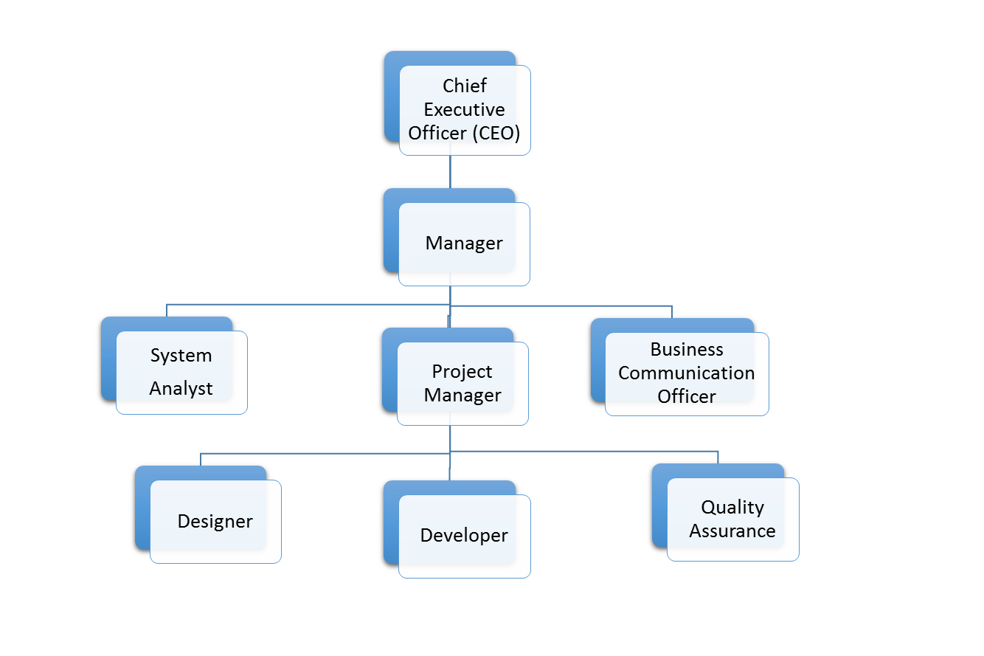

Figure 1:Organizational Structure with hierarchy

The diagram in Figure 3 defines the organizational hierarchy of Arhant Solution. Every organization runs under a system. In order to maintain system, an organization follows certain hierarchy. An organizational hierarchy structure is a blue print of an organization’s employee and job titles. The employees who fall vertically beneath, they have lower ranks and work under the higher level. In addition, employees who hold similar titles are under the same horizontal lines. Therefore, companies can use one or several key organizational hierarchy structures.

### Contact Details

|  |  |
| --- | --- |
| Name of Organization | Arhan Solutions |
| Organization Type | Private |
| Address | Hattisar, Kathmandu |
| Phone No. | +977-1-5528592, 5548923 |
| Email | [info@arhant.com](mailto:info@arhant.com) |
| Website | <http://www.arhant.com> |

Table 1. Contact Details [8]

# CHAPTER 2: ANALYSIS OF ACTIVITY DONE

## 2.1 Internship Placement Details

The internship is done as a partial fulfillment of the requirement for the degree of Bachelor of Science in Computer Science and Information Technology. The internship is assigned six credit hours (minimum of ten weeks or 180 hours long) as a part of the course requirement. A systematic process was followed for the development of the project. The authorities of the organization carried out an interview to provide an internship opportunity to be part of that organization for certain period of time as an internee.

An organization was selected according to the area of interest. Then the placement duration and activities required for the project were finalized and finally project planning and scheduling were carried out according to the given time constraints.

### 2.1.1 Organization Selection

Organization for the internship was selected based on three major criteria:

* Organization should specialize in the field similar or close to final year project of the student
* Intern should be placed in close proximity to the actual development team
* Intern must be allowed regular working hours that should exceed the minimum recommended hours by Tribhuvan University

### 2.1.2 Placement

After about one week of the application for the internship at various organizations, the author was called by Arhant Solution. Then the author was interviewed along with other candidates. The interviewer was the manager of the organization. The questions were related to designing and development in the programming techniques. Along with those questionnaire, there were few questions related to the previous projects done by the author. After the author was selected for the internship, the supervisor described the kind of work the author has to perform in three months of time. The author was appointed as an Internee for web development of in-house project of the organization.

### 2.1.3 Duration

|  |  |
| --- | --- |
| Start Date | 1st September, 2017 |
| End Date | 1st December, 2017 |
| Total Duration | 3 months |
| Position | Internee |
| Supervisor | Mr. Hari Shrestha |
| Office Hour | 10:00 am – 5:00 pm |
| Working Days | 6 days a week |

Table 2: Internship Duration

### 2.1.4 Roles and Responsibilities

The major roles and responsibilities of the intern are enlisted as follows:

* Undertake, manage and complete an individual project
* Complete the tasks assigned by the mentor
* Update the mentor on daily basis and supervisor on weekly basis
* Develop self-learning capabilities and seek help from mentor when needed

## 2.2 Literature Review

Currently, many clinic in our country still stores patients’ record by using paper or card manual system. Receptionist need to manually write down the patients’ information and index the patients’ medial card. Then, these medical cards are kept on the organized racks or in the cabinets. These works are so troublesome and plaguing. Moreover, patients’ information is not secure [10].

Medicare is developed to support and automate the clinic daily operation. Clinic Management System is a system that can help the clinic to manage their daily activity. This system will involve all the clinic operation starting from patient registration until billing the patient. Here the patients can register and get their appointment. This system help reduce the problems occur when using the manual system. The important thing is it will become easier for the data record and retrieval. This software also stores all the patient details, patients lab reports, bill calculation, billing, monthly reports, daily reports. This system enables doctors and clinic assistant to manage patient records, medicine stock, and appointment and produce reports. This system will be able to generate report regarding the clinic operation. User can enter the patient details. Whatever treatment he has taken will also be saved in the database. Other than that, the system is user friendly and it can help the clinic to manage their activity. Overall this system is able to support the daily clinic operation based on evaluation from real user and the system is able to perform the task correctly. The patient gets the treatment and data about the treatment is recorded into the system. The system has few modules such as patient registration, medicine registration, disease registration and treatment history, patient record search, appointment and reporting [11].

Clinic Management system is used to record all the details and the prescription in each patient in the Clinic. This EMR is very important to know the history health of each patient, what types of medicines that he takes what type of sickness and many more. In Nepal this system is still new, but in the overseas this system has been used in some healthy care center. This EMR system can be used to view and to give many functions for those who applied it. The project clinic management is software developed to simplify the communication process between the doctor and the receptionist. The software would be operated by two users one is doctor and the other is receptionist. Receptionist would be responsible for creating appointment to the patient visiting the clinic and save it in the database along with their details. These appointment detail move along with respective patient details are sent to doctor. The doctor can thus view patient details and after checking up the patient, the recommended medicines for the particular patient are fed into the database by the doctor and are sent to receptionist. The receptionist can then generate bill and feed into the database. The system also maintains patient’s history so that doctor or receptionist can view them anytime. The system can thus reduce complexity in maintaining patient’s records [12].

### 2.2.1 Proposed clinic management system

Clinic Management System is used by the doctor and clinic assistant. Clinic Registration System is developed to improve the clinic management and automates the workflow that happens in the clinic. It includes medicine registration, generate report and register new disease and category. When the patient will visit on clinic, they will ask to provide their name, address, sex, age and type or problems. Patient will make registration first. After entering these fields, user will provided with a registration slip including their name, address, sex, age, Appointment date and time. The user will find it useful because the system has benefits that can help the operation of the clinic. If the patient never registered before, patient information collected and stored in the database. However, if it is an existing patient the patient data is search-using IC (identification card) no. Each registration form will have unique registration number, arrival time of patient. This will improve the record of the patient and save the time during the registration. The system makes record keeping more efficient and secure from an unauthorized people. At this time, patient is assign to the doctor once the patient gets the treatment, the doctor will send the prescription including the medicine name. The doctor will prescribe medicines using patient registration number. For taking medicine user have to give their registration number to the clinic reception, where they will get all the medicines and their bill details. Only authorized user has the right to retrieve data of their own. This will secure the patient's information. The staff will view the report and complete the patient record. After that, the staff will prepare the bills for the patient. Besides that, it is easy for the management to maintain record about the patient. The time for retrieving the information needed will be less compare to the manual. When the bill will be provided to the user, it all provides all the details for each medicine which they have purchased. Under this bill they will get info on :- Date of manufacturing, expiry date, number of medicines, price for each item, total number of items and total price. Then the staff will update the medicine stock and the patient record will be kept in database [13].

### 2.2.2 Existing Clinic Management system

The Records maintain in traditional fashion is poorly stored and lack standard structure. So, an alternative digital solution is to be sought. Before this, the management of the clinic is done manually. The system is develop due to the problems that exist when using the manual system. There are some problem arise especially for the data retrieval. There are many systems for clinic management system, but it does not meet the local user requirement come to the clinic before. Data inconsistency, data mix with other data and problem regarding reporting is the main problem that the user is facing. Clinic has a problem of loss of patient data. There is also redundant patient data if the patient not sure whether they have currently, the inventory for the medicine is done manually. The paper-based system currently in use cause many problems to the user. When the patient first visit to the clinic, the nurses is require to fill in a new medical card for the patient. This include some private information that can be obtain from the patient’s identity card such as name, identity card number, date of birth, gender, and mailing address. The nurse will pass this medical card to the doctor .After the patient seed the doctor, some diagnosis information and treatment will be written down in the medical card by the doctor .Once again, this medical card is passing to the dispensatory. After patient getting their medicine, the nurse will keep that medical cards are arranged in alphabetical order according to the patient’s name or based in the reference for each card. The nurse needs to search through the file for the medical cards that match the patients’ name for any subsequences visit of the patient. The medical card is easily exposed to unauthorized user. They can easily get the vital patient information from clinic because the medical card are just kept on the rack without any security lock. By using cards, time are wasted when the medical card need to pass form the nurse to doctor and then dispensatory .Besides that, clinic also needs to spend time to organize medical cards from time to time [12][13].

The system use before has caused a lot of problems to the user. The management of the clinic also has to takes times to check for the medicine inventory Due to that, this system is developed to overcome the problems. Clinic Management System is desktop based project. The main objective is to develop the software that covers all the aspects of management and operations of clinics. The Software Clinic Management System Project keeps all records and transaction details for a particular clinic [14].

## 2.3 Specific Problem Analysis

Problem analysis deals with in-depth and systematic analysis of the domain to fully understand the problem and work towards a real-life solution for the taken problem. It specifies the level of difficulty of the problem and helps to determine if the problem indeed relates to the problem under investigation. Problem analysis refers to understanding the existing system of the company’s work procedure and then matches it to the current project being developed. Problem Analysis assists teams and individuals in their process of gathering assessment data and evaluating that data in comparison to a standard, expectation, norm, or criteria to better understand what variables are causing and maintaining a problem [15].

### 2.3.1 Understanding the Existing System

The current system is based on handwritten prescription given by doctor, Therefore it is paper based. So, it is difficult to understand by patient and staff .This illegible handwriting of doctors is major problem in current system. Doctors' sloppy handwriting kills more than 7,000 people annually. It's a shocking statistic, and, according to a July 2006 report from the National Academies of Science's Institute of Medicine (IOM), preventable medication mistakes also injure more than 1.5 million annually[16]. The Records maintain in this fashion is poorly stored and lack standard structure. So, an alternative digital solution is to be sought.  
Before this, the management of the clinic is done manually the system is develop due to the problems that exist when using the manual system. There are some problem arise especially for the data retrieval. There are many systems for clinic management system, but it does not meet the local user requirement come to the clinic before. Data inconsistency, data mix with other data and problem regarding reporting is the main problem that the user is facing. Clinic has a problem of loss of patient data. There is also redundant patient data if the patient not sure whether they have currently, the inventory for the medicine is done manually. The paper-based system currently in use cause many problems to the user [17] [18].

## 2.4 Management Strategy

A project is all about planning and execution. Management activities are necessarily related with a set of planned steps to control the execution of the project directed towards a specific set of goals. A project also has a set of constraints, a lifetime, and a definitive scope [19]. Each project is unique in itself, and software projects are always unique because of the disparate client dynamics and marketplace fluctuations. Nonetheless, out of many resources required to conduct a successful project, there is an important triad. Time, cost and quality are the three interrelated aspects of every software project. Allocating resources to optimize one needs sacrifice in another. So, we need a good management strategy to mobilize these resources to the maximum, and optimally complete the project [20].

### 2.4.1 Time Management Strategy

Time is one of the most valuable resource in a project. While we can add other resources, adding time is the most challenging thing of all. A time-bound project must be delivered within the specified timeline, and to ensure that, a structured set of reviews need to be performed periodically to check if the project is on track. The three step approach for better productive and effective utilization of time includes: to do list, weekly review, time blocking [21][22].

* To do list: This is simplest tool used for time management strategy. It captures all actions that need to take in the near-to mid-term to meet commitments and goals. This is one of the simplest strategies used in this process [23].
* Weekly Review: The Weekly Review evaluates the actions needed to take when performing the operations in the system. It allows to review all of the actions needed to take and then identify those that are more important and should be prioritized. When one performs weekly review, to do list is compulsory [24].
* Time Blocking: The final step in this system is to use a technique called Time Blocking. Once important and must do task are identified in Weekly Review, block off some time in calendar to focus on each individual task [25].

The necessary software and tools were downloaded to prevent the time consumption and the effort for developing the application.

|  |  |
| --- | --- |
| Study of system and tools | 2 weeks |
| Design and Review | 2 weeks |
| Coding and Development | 6 weeks |
| Testing and Implementation | 2 weeks |

Table 3: Time Management Strategy

### 2.4.2 Cost Management Strategy

Project Cost management deals with the planning and controlling the budget of the project. Cost management is a detailed strategy to compare cost with intended benefits and invest on the project wisely. As an intern, there was no need to worry about the management of the overall budget of the project. Since it was conducted using the existing resources, there no additional cost in terms of adding infrastructure, buying software or external consultation. The development cost, however, was in terms of providing necessary support to the intern throughout the internship period which was taken care by the organization’s administration [26][27].

## 2.5 Project Schedule

The project schedule is the tool that  helps to communicate what work needs to be performed, which resources of the organization will perform the work and the timeframes in which that work needs to be performed. The project was divided into different phases of work depending upon the requirement of the work. The phases were carried on in hierarchy as well as in parallel. The works were divided in groups and integrated later.

### 2.5.1 Time Schedule

|  |  |  |  |
| --- | --- | --- | --- |
| Time Schedule | | | |
|  |  | Actual Date | |
| Task ID | Task Description | Start date | Finished date |
| **1** | **Preliminary work** |  |  |
| 1.1 | Planning for the project | 10/6/2017 | 10/11/2017 |
| 1.2 | Analysis on the topic | 10/11/2017 | 10/12/2017 |
| 1.3 | Discussion with the project supervisor | 10/12/2017 | 10/12/2017 |
| 1.4 | Understanding the project | 10/13/2017 | 10/14/2017 |
| 1.5 | Preparation of project proposal | 10/14/2017 | 10/17/2017 |
| 1.6 | Preparing Gantt chart and Project time schedule | 10/15/2017 | 1/10/2018 |
| 1.8 | Approval from project supervisor | 10/16/2017 | 10/16/2017 |
| 1.9 | First Review | 10/18/2018 | 10/18/2018 |
| **2** | **Research Work** |  |  |
| 2.1 | Research on design and Development | 10/11/2017 | 10/14/2017 |
| 2.2 | Research on latest trends | 10/15/2017 | 10/16/2017 |
| 2.3 | Research on framework | 10/16/2017 | 10/18/2017 |
| 2.4 | Research on database | 10/18/2017 | 10/20/2017 |
| 2.5 | Second Review | 10/21/2017 | 10/21/2017 |
| **3** | **Design** |  |  |
| 3.1 | Website design | 10/20/2017 | 10/25/2017 |
| 3.2 | Website Development | 10/26/2017 | 10/28/2017 |
| 3.2.1 | Database Design | 10/28/2017 | 11/1/2017 |
| 3.2.2 | ER Diagram | 11/1/2017 | 11/4/2017 |
| 3.2.3 | Schema Diagram | 11/4/2017 | 11/4/2017 |
| 3.2.4 | Data flow diagram | 11/5/2017 | 11/7/2017 |
| 3.3 | Milestone 3 | 11/8/2017 | 11/8/2017 |
| **4** | **Implementation** |  |  |
| 4.1 | Coding | 10/10/2017 | 11/9/2017 |
| 4.2 | Designing database | 10/9/2017 | 11/9/2017 |
| 4.3 | Implementing prototype | 10/10/2017 | 11/10/2017 |
| 4.4 | Milestone 4 | 11/11/2017 | 11/11/2017 |
| **5** | **Testing** |  |  |
| 5.1 | Unit testing | 12/12/2017 | 12/12/2017 |
| 5.2 | Remote Usability testing | 12/13/2017 | 12/15/2017 |
| 5.3 | Offline Usability testing | 12/15/2017 | 12/17/2017 |
| 5.4 | A/B testing | 12/18/2017 | 12/20/2017 |
| 5.5 | Milestone 5 | 12/21/2017 | 12/21/2017 |
| **6** | **Analysis** |  |  |
| 6.1 | Critical evaluation | 12/22/2017 | 12/24/2017 |
| 6.2 | Feasibility analysis | 12/24/2017 | 12/25/2017 |
| 6.3 | Performance analysis | 12/25/2017 | 12/26/2017 |
| 6.4 | Milestone 6 | 12/27/2017 | 12/27/2017 |
| **7** | **Dissertation** |  |  |
| 7.1 | Draft report writing | 10/20/2017 | 1/5/2018 |
| 7.2 | Final report writing | 1/5/2018 | 1/7/2018 |
| 7.3 | Report evaluation and conclusion | 1/8/2018 | 1/9/2018 |
| 7.4 | Submission of Final draft copy report | 1/10/2018 | 1/11/2018 |
| 7.5 | Changes made on Final draft copy report | 1/12/2018 | 1/14/2018 |
| **8** | **Final Phase** |  |  |
| 8.1 | Final documentation printing and binding | 1/16/2018 | 1/19/2018 |
| 8.2 | Final report submission to the college | 1/31/2018 | 1/31/2018 |

Table 4 : Gantt chart

### 2.5.2 Gantt Chart

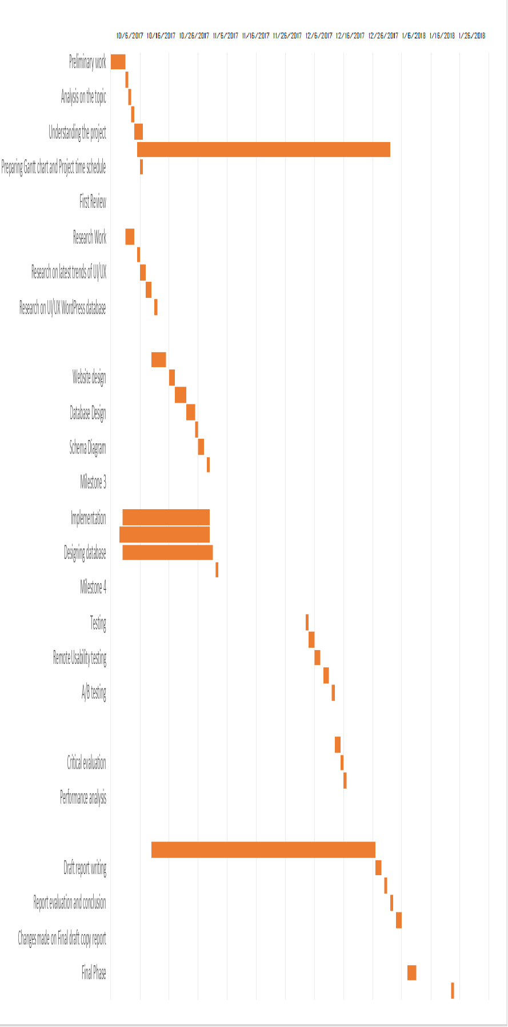

Figure 2. Gantt chart

# CHAPTER 3: SOLUTION DESIGN

## 3.1 Project Management Plan

The chapter Solution design consists of how the project was managed in the aspects of designing and planning. It also explains about the requirements of the project from hardware used to the software used. Also it consists the topics explaining the uses and importance of different tools being used while developing the application [28].

### 3.1.1 System Analysis

Systems analysis is a process of collecting factual data, understand the processes involved, identifying problems and recommending feasible suggestions for improving the system functioning. System Analysis includes subdividing of complex process involving the entire system, identification of data store and manual processes. System analysis is used in every field where there is a work of developing something. Analysis can also be defined as a series of components that perform organic function together [29].

#### 3.1.1.1 Feasibility Study

A feasibility study is an important tool for making the right decisions. The purpose of a feasibility study is to determine if a business opportunity is possible, practical, and viable. A feasibility study enables them to take a realistic look at both the positive and negative aspects of the opportunity. This section includes the result of requirements of the project based on research [30].

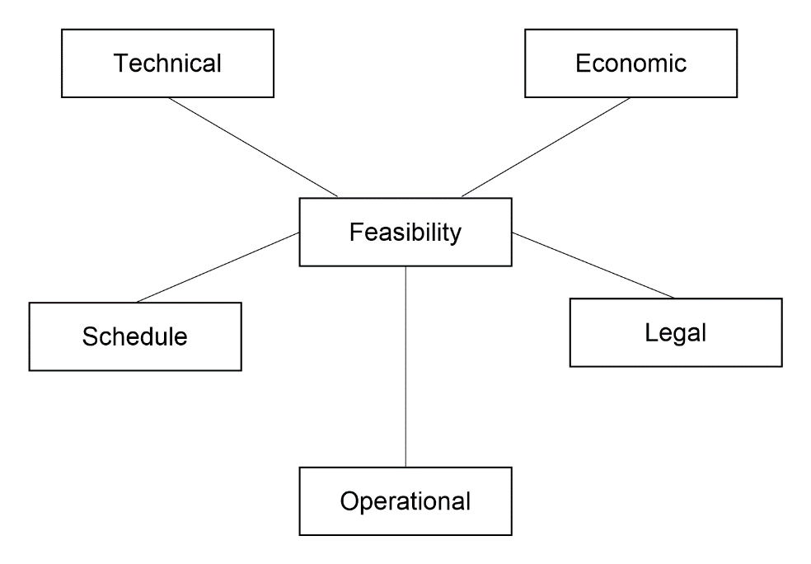

Figure 3: Project Feasibility Analysis

The diagram in Figure 4 shows the various types of feasibility analysis. The various types of project feasibility analysis are technical, economic, legal, and operational feasibilities. The schedule of feasibility test has been performed to ensure that the project is feasible from all aspects [31].

##### 3.1.1.1.1 Technical Feasibility

The technical feasibility assessment is focused on gaining an understanding of the present technical resources of the organization and their applicability to the expected needs of the proposed system. It is an evaluation of the hardware and software and how it meets the need of the proposed system [32].

Based on various research for this project, the technical prospects of this project can be achieved by the current technology available. All the required hardware and software are easily available this project is technically feasible.

##### 3.1.1.1.2 Economic Feasibility

This is a part of client project. This application will be beneficial for the organizations who are interested in implementing desktop application in their Clinic. Hence, the required capital for deployment and maintenance of this system is dependent upon company policy in which as an intern the researcher had no issue [33].

##### 3.1.1.1.3 Legal Feasibility

Legal Feasibility analyzes and deals with various legal issues, contracts, policies, laws and violations that staffs are usually unknown about. It ensures if the application is legal to operate or not. Some systems may require license to operate. In such cases legal feasibility needs to be checked [34].

##### 3.1.1.1.4 Operational Feasibility

In simple words, operational feasibility is a measure of how people feel about the application or project. It is a measure of how well a proposed system solves the problems and how it satisfies the requirements identified in the analysis phase [34].A system can work more effectively when it’s technical and operating characteristics are engineered into the design. It is a critical aspect of systems engineering that needs to be an integral part of the early design phases [35]. Therefore, proposed projects are beneficial only if they can be turned out into real world implementation system that will meet the user’s requirements.

##### 3.1.1.1.5 Schedule Feasibility

The schedule feasibility is defined as the possibility of outsourcing in the allocated time [36]. The tasks, sub-tasks involved in the project were identified prior to project initiation. The schedule was planned at the very beginning of the project and was followed according to it. Therefore, our project has been identified feasible based on schedulability.

### 3.1.2 System Design

#### 3.1.2.1 Context Diagram

The Context Diagram shows the system under consideration as a single high-level process and then shows the relationship that the system has with other external entities. Another name for a Context Diagram is a Context-Level Data-Flow Diagram or a Level-0 Data Flow Diagram.

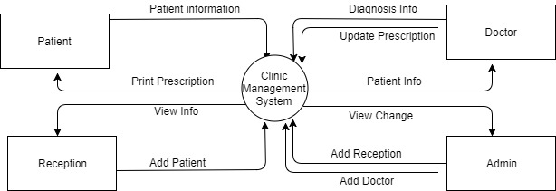

Figure 4: Context Diagram

The diagram in Figure 4: Context Diagram shows the general work flow of the system. The system consists of users who are responsible for performing all the CRUD operations on the information..

#### 3.12.2 DFD

A Data-Flow Diagram (DFD) is a graphical visualization of the movement of data through an information system. DFDs are one of the three essential components of the structured-systems analysis and design method (SSADM). Each DFD may show a number of processes with data flowing into and out of each process. If there is a need to show more detail within a particular process, the process is decomposed into a number of smaller processes in a lower level DFD.

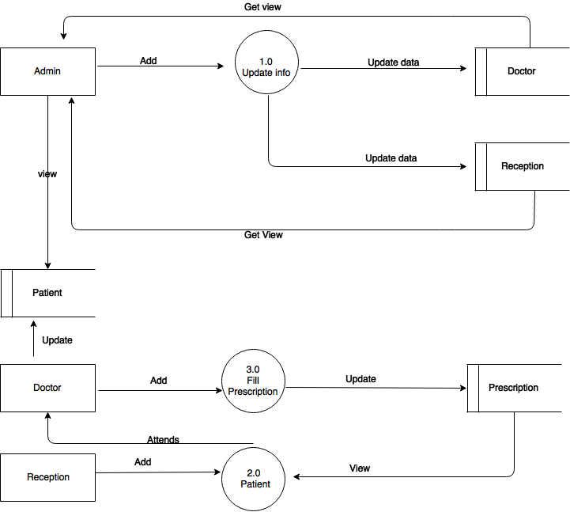

Figure 5: DFD Level 0

Figure 5 DFD Level 0 shows all the user functions from inserting the information to viewing the information which is already stored in the database. Admin has privilege to perform the CRUD operation interacting with the database.

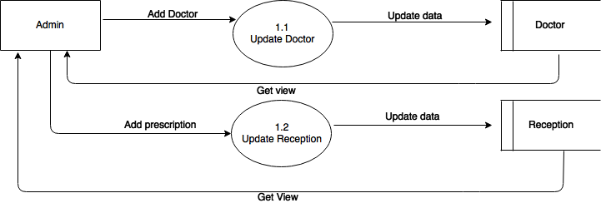

Figure 6 : DFD Level 1

Figure above represents the data creation process. The admin can add new data in the application as per the requirements.

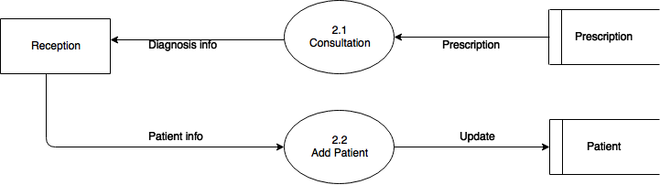

Figure 7: DFD Level 2

Figure 10 above represents receptionist can add new patient info with appointment time and get prescription details from database added by doctor.

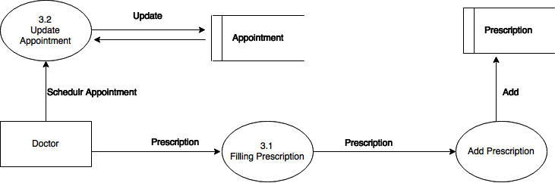

Figure 8 : DFD Level 3

Figure above represents doctor can schedule appointment time and add new prescription.

#### 3.1.2.3 ER Diagram

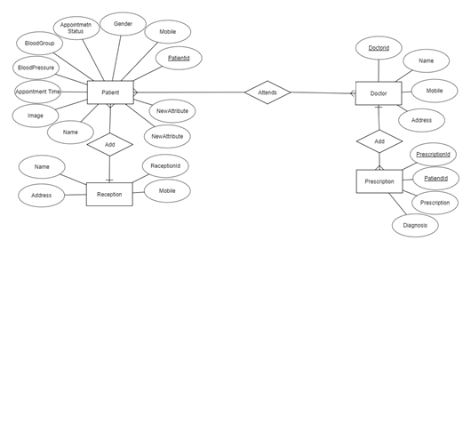

Figure 9:Entity Relationship Diagram

The diagram in Figure 9 shows the overall relation between the entities to build an Clinic management application. The major entities are: patient details, doctor_details, prescription_details, reception_details. All the entities has their own attributes. For example the patient have attribute like name, image, appointment time, blood pressure, blood group, gender, mobile and patient_id. Reception add new patient with their details and Patient attends to doctor by fixing appointment schedule. Doctors gives prescription and medicine to respective patient with their diagnosis report.

#### 3.1.2.4 Use Case Diagram

Use case diagram consists of use cases and actors and shows the interaction between them. The key points are:

* + - * + The main purpose is to show the interaction between the use cases and the actor.
        + To represent the system requirement from user’s perspective.
        + The use cases are the functions that are to be performed in the module.
        + An actor could be the end-user of the system or an external system .

#### C:\Users\Khakurel\Desktop\usecase.png

Figure 10 : Use Case Diagram

Figure 10 Use Case Diagram explains about the use case property of the system where actors like admin are responsible for the management of the system. Use Case shows the interaction of the system and the users.

#### 3.1.2.5 Design and Development Tools

##### 3.1.2.5.1 Net Beans

NetBeans is a software development platform written in Java. The NetBeans Platform allows applications to be developed from a set of modular software components called modules. Applications based on the NetBeans Platform, including the NetBeans integrated development environment (IDE), can be extended by third party developers. The GUI design-tool enables developers to prototype and design Swing GUIs by dragging and positioning GUI components [38].

##### 3.1.2.5.2 MySqli

The MySQLi Extension (MySQL Improved) is a relational database driver used in the java language to provide an interface with MySQL databases [39]. MySQLi has been used in this project for database connection and to perform different SQL queries such as for registering users in the database and logging in.

##### 3.1.2.5.3 Adobe Photoshop

Bootstrap image editing software developed and manufactured by Adobe Systems Inc. Photoshop is considered one of the leaders in photo editing software. The software allows users to manipulate, crop, resize, and correct color on digital photos. The software is particularly popular amongst professional photographers and graphic designers [40]. Its uses range from full featured editing of large batches of photos to creating intricate digital paintings and drawings that mimic those done by hand. it has become the de facto industry standard in raster graphics editing, such that the word "Photoshop" has become a verb as in "to Photoshop an image," "photo shopping," and "Photoshop contest," etc. It can edit and compose raster images in multiple layers and supports masks, alpha compositing and several color models including RGB, CMYK, Lab color space, spot color and duotone [41].

##### 3.1.2.5.4 Draw.io

Draw.io is a basic diagram web application that utilizes a large amount of equally basic images to create a project. With simple drag and drop techniques, it is easy to use this website that provides a method for design that virtually anyone can use. It is based on jGraph technology and is supported in all browsers. On top of all features, it provides the user with an option to save the diagram locally or in cloud [42]. It has been used in this project to draw DFDs efficiently.

### 3.1.3 Alternative Solution

The choice of platform for development of any project depends on the client requirement or convenience of developer. This project is developed as a desktop application as it renders application as platform independent. Java swing is choice for front end tool for desktop application development.

Alternatively, the ASP .NET framework using preferably C# or VBScript could be used to develop the project. The project could also be developed using Android application framework. Even the platform could be shifted to desktop or mobile application while achieving same functionality. Desktop application can be developed using .NET using C# framework.

### 3.2 Technical Requirements

This project is a desktop application built with java swing framework and SQLyog. So the following are requirements to run the application and to host the database.

### 3.2.1 Hardware Requirements

There are no specific hardware requirements for the systems, as the clients can use it from any system which has an operating system. However, from an implementation point of view, the hardware must have the capability to run required backend software [43].

* + - * Platform: Platform Independent
      * Processors: Pentium 4 or any greater processor.
      * Ram: 512 MB minimum
      * Display: Graphical over 64mb
      * Enviroment: Java JDK 8, Java JRE 8

### 3.2.2 Software Requirements

The application runs on a desktop, but at implementation side, there are certain specific requirement which map to the development scenario used to create and maintain the system.

* Operating System: Platform Independent
* Platform: Java swing Framework
* Additional software : JDK, Development IDE,XAMP

# CHAPTER 4: IMPLEMENTATION STRATEGIES

Implementation sees that plans and strategies are turned into action that achieve strategic objective and goals. Implementation is much significant than planning [45]. Strategic implementation is critical to a project’s success, addressing who, where, when, and how of reaching the desired goals and objectives.

## 4.1 Testing Strategies

Testing is the integral part of the software development process. It is the process of verifying and validating that a software meets the requirements based on the design and development proposed. This project is focused on the validation and verification of the user input data from the very beginning. A single module is created for the application part of the project . The project is broken down into several modules and configured as necessary per requirement. Testing is performed after completion of each module and after their integration also.

### 4.1.1 Unit Testing

This type of testing is performed by developers before the setup is handed over to the testing team to formally execute the test cases. Unit testing is performed by the respective developers on the individual units of source code assigned areas. The developers use test data that is different from the test data of the quality assurance team. The goal of unit testing is to isolate each part of the program and show that individual parts are correct in terms of requirements and functionality.

**Test case 1 New Data Creation with Empty field**

**Test Data Case: One** of the data field left empty.

**Expected Outcome:** Data entry is prevented as the data field is set empty by the user. So, an error message is shown requesting to fill the empty field.

**Evidence:**

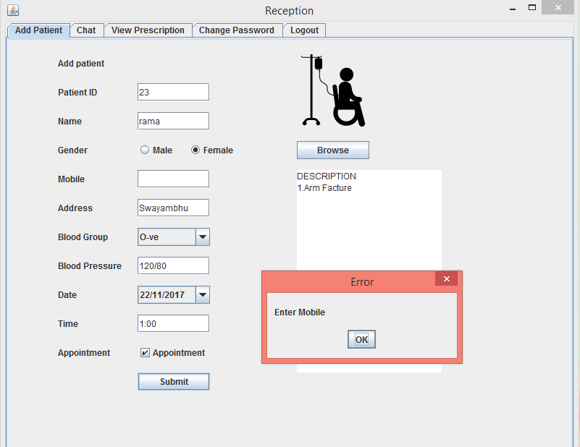

Figure 11: Data Empty Error

The diagram in figure shows if data provided by the user is null or not. If null, then an error message request is shown to the user.

**Test case 2: New data creation valid data entry**

**Test Data Case:** Valid data entry in all fields

**Expected Outcome:** Data entry is successful as the data field is set with valid data’s by the user. So, a success message should pop up

**Evidence:**

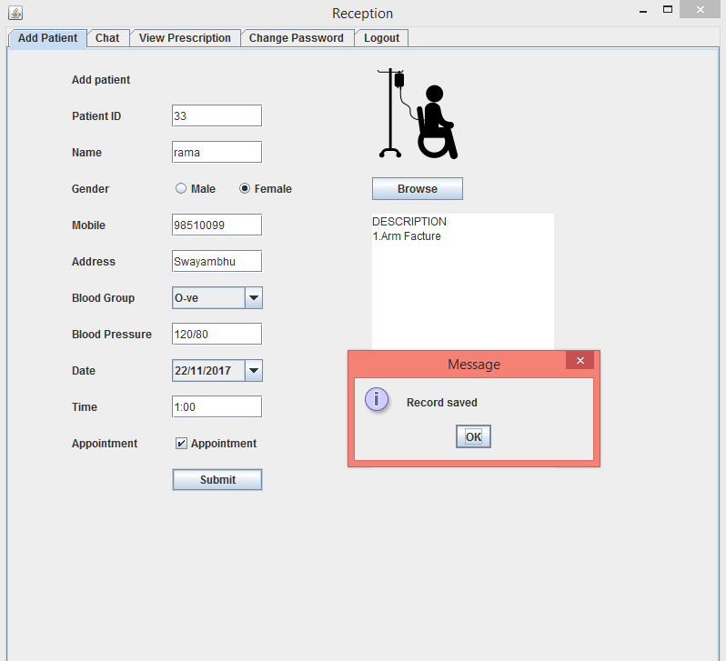

Figure 12: Data Entry Successful test Case

The diagram above shows user data entry gets success upon submission of valid data in the mentioned field.

**Test case 3 Data search success**

**Test Data Case:** Valid data entry in search box

**Expected Outcome:** Valid keyword for search is mentioned so search result is expected in the table.

**Evidence:**

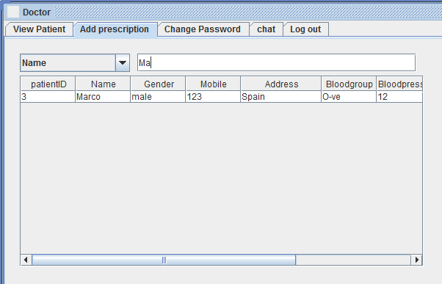

Figure 13: Search Result

The diagram above shows the search result in table as the search keyword match the content in the database list.

**Test case 4 Data update success**

**Test Data Case:** Valid data entry to update

**Expected Outcome: The** data should be successfully updated in the database and success message should pop up.

**Evidence:**

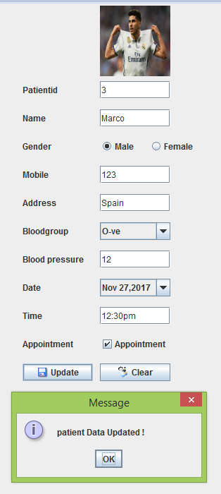

Figure 14: Update Data

The above figure illustrates the message for the successful update of data in the database set.

### 4.1.2 Integration Testing

Integration testing is defined as the testing of combined parts of an application to determine if they function correctly. Integration testing can be done in two ways: Bottom-up integration testing and Top-down integration testing. The different modules were integrated and tested to ensure that they work perfectly and address the objectives set in the initial phase of the system development.

### 4.1.3 System Testing

The system testing is testing of whether all integrated components are working correctly and in coordination to perform functionality of the system as a whole. A product software implementation method is a systematically structured approach to effectively integrate software based service or component into the workflow of an organizational structure or an individual end-user.

## Hardware Implementation

The developed desktop application was first implemented on a Windows based computer while the application was still being developed. Then the web application was installed in various computers with Windows 10 as their main operating system. This was done to check the application’s working with distributed clients, clients who have the authority to access the application from multiple locations. During this process, various problems were found out which were immediately dealt with.

## 4.3 Software Implementation

System For software implementation, various java development tools were required. The coding was done from Netbeans IDE and for the database MySql was used. The developed application was converted into apache maven build which contains a ‘pom.xml’ file. The ‘pom’ file includes all the dependencies required to run the application. When the project is run, all the executable .jar files that the pom generates is stored in the libraries folder of the application. Only after the collection/download of all the dependency jars, the IDE is able to run the application in a distinct server. The server can either be a local server or a generic server too. The client’s browser should be IE7 or higher to run this application

# CHAPTER 5: RESULT ANALYSIS

## 5.1 Result

The application for clinic as a management system was successfully developed. For the purpose of storing the data, My SQL is used so that the data stored is secure and appropriate. The MYSQL handles entire backend; we don't have to worry about databases, performance, or scaling.

1. **Login Page**

public class Clinic extends JFrame implements ActionListener,WindowListener{

public Clinic() {

}

}

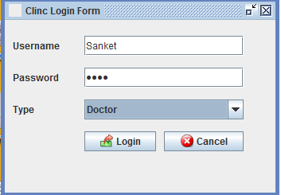

Figure 15: Login Page

The screenshot in Figure 14 shows the login page of Admin, Doctor and Reception. The login page consists of username and password. The password is stored in database in an encrypted form so that even developer cannot see.

1. **Doctor Page**

public class Doctor extends JFrame {

public Doctor(String uname) {

jtb = new JTabbedPane();

jtb.addTab("View Patient", new Viewpatient());

jtb.addTab("Add prescription", new Addprescription());

jtb.addTab("Change Password", new Changepassword());

jtb.addTab("chat", new Chat());

jtb.addTab("Log out", new Logout());

}

}

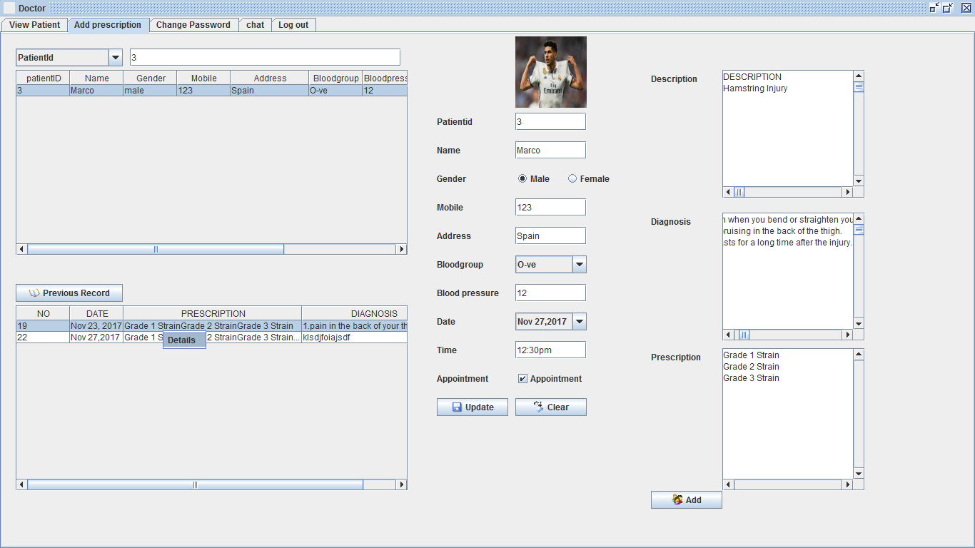

Figure 16: Doctor Page

1. **Reception Page:**

public class Receptionist extends JFrame implements WindowListener {

public Receptionist() {

jtb = new JTabbedPane();

jtb.addTab("Add Patient", new AddPatient());

jtb.addTab("Chat", new Token());

jtb.addTab("View Prescription", new ViewPrescription());

jtb.addTab("Change Password", new ChangePassword());

jtb.addTab("Logout", new LogOut());

}

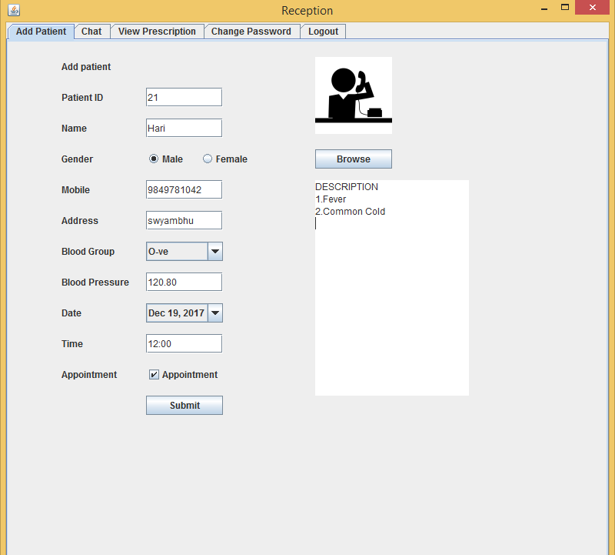

Figure 17: Reception Page

## 5.2 Critical Analysis

This project is developed due to the problems that exist when using the manual system. There are some problem arise especially for the data retrieval. There are many systems for clinic management system, but it does not meet the local user requirement come to the clinic before. Data inconsistency, data mix with other data and problem regarding reporting is the main problem that the user is facing. Clinic has a problem of loss of patient data. There is also redundant patient data if the patient not sure whether they have currently or previously admitted. The paper-based system currently in use cause many problems to the user. When the patient first visit to the clinic, nurses are require to fill in a new medical card for the patient. This include some private information that can be obtain from the patient’s identity card such as name, identity card number, date of birth, gender, and mailing address. Nurse will pass this medical card to the doctor. Doctor will checkup patient by examine patient information in medical card, some diagnosis information and treatment will be written down in the medical card by the doctor .Once again, this medical card is passing to the dispensatory. After patient getting their medicine, the nurse will keep that medical cards are arranged in alphabetical order according to the patient’s name or based in the reference for each card. The nurse needs to search through the file for the medical cards that match the patients’ name for any subsequences visit of the patient. The medical card is easily exposed to unauthorized user. They can easily get the vital patient information from clinic because the medical card are just kept on the rack without any security lock. By using cards, time are wasted when the medical card need to pass form the nurse to doctor and then dispensatory. Besides that, clinic also needs to spend time to organize medical cards from time to time.

The system use before has caused a lot of problems to the user. Due to that, using manual system seems to be the only solutions in managing the daily works. The management of the clinic also has to takes times to check for the medicine inventory Due to that, this system is developed to overcome the problems. The main objective is to develop the software that covers all the aspects of management and operations of clinics. The Software is Clinic Management System Project keeps all records and transaction details for a particular clinic.

To begin with, the electronic health records give the clinics an opportunity to get rid of papers and documents which are not only difficult to store and maintain but also prone to wear and tear. With advanced software, clinics can keep a systematic record of patient’s history with medical prescriptions, previous medical treatment received etc. When needed, the doctor can have a glance at the entire history of the patient at the click of a button. Clinic Management Systems improve the general efficiency of the organization by automating the entire system. The software helps in printing out prescriptions, patient records, and billings. It maintains accounts and inventory. It schedules appointments and sends reminders. As such the operating cost of the clinic is minimized and the productivity of the staff is improved. Clinic management systems save the time of writing prescriptions, calculating and making bills, filing and hunting for patient records and also maintaining appointment schedules. As such, the doctors can pay more attention to the patients and give them speedy and better service. Electronic health records are error free. It does away with the chances of wrong treatment due to the wrong diagnosis. Also, printed prescriptions are easy to read and chances of getting wrong medicines due to the illegible handwriting of the doctors are reduced.

The requirements of the system were extracted, analyzed and finalized on the basis of the various research conducted. The finalized requirements were used to develop desktop application admin panel that follows the information and trending UI. Clinic management system has some good points and some bad points which are analyzed below. The development was carried out systematically through various diagrams and designs. Different development tools were used to develop the application. The existing system uses file system instead of database for storing records. Recording of all information about patients, doctors, receptions manually in various files or registers involves time consuming processes. Time will be saved after this software comes into existence. It has been observed that the patient information management work is a very tedious job to carry and manage. Maintaining patients, receptions and doctor’s records in manual system we can’t quickly search about information in clinic record. Such works needs man-hours to be spent in manual systems, whereas in automated systems, such information are just few clicks away. Even after spending sufficient number of man-hours, it will be difficult to find information. We can’t get updated information as quickly as we get in automated systems.

Taking those points into consideration the system has been developed as conceived by the mentor, who is also the idea executer of the internship project. From the research it is found that Clinic Management system is still new topic in some clinics. In CMS there are three type of user in this application admin, reception and doctor. Admin can add and view doctor and reception information. Admin can also check if there is any change made by any other users.

Reception can add patients including their information and reception can also view prescription prescribed by the doctor. After viewing prescription reception adds medicine one by one and generate bill. Doctor can view all patient information including appointment time. Doctor have authority to approve or refuse appointment and change time it according to his schedule. In this application there is database of previous record also, which make easy for both doctor and patient. If patient come for follow up in clinic than doctor can easily check previous prescription and diagnosis report and evaluate it.

## 5.3 Limitations of the System/Organization

No system is perfect. Despite numerous features, this system too has few limitations that can be addressed in future to make it better. The major limitations of this project are as follows:

* User types such as admin, employees and doctor without update are not dynamically added to system.
* Accuracy and performance of the application could be improved

The system can be further enhanced with following features:

* Upgrading application with new features.
* Upgrading a mobile app for using the application more effectively.
* To develop the web based application to access data from remote location.
* To add features for making online appointment with doctors.

## 5.4 Recommendation to the Organization

* Arhant Solution has provided us with all the necessary guidance and support which is really worth mentioning. But still there are few recommendations to Arhant Solution as follows:
* Information channel: Information related to holidays, changes in work hours and lunch time must be briefed to intern. Similarly, the procedure for requesting leave must be well explained beforehand.
* Workstation: Organization must allow intern to use spare machine. Some of the machines were unused yet; intern was not given accessed to. Intern has to bring his/ her own workstation.
* Orientation program: Intern must be introduced to various departments within the organization so that it is easier to get help form employee of other department.

## 5.5 Recommendation to the Internship Program

The internship program at Arhant Solution can be improved much better. The ways to improve intern program are enlisted below.

* Compensation:It’s not all about the money; and, it’s true, price cannot be given to valuable experience. But the unfortunate reality is that not all students can afford to work for without or low compensation, no matter how much they might be motivated and interested in the industry.
* Meaningful work:Possibly more than anything else, interns are constantly clamoring for “meaningful” work. Interns are interested to learn about the business in general as well as to acquire the specific skills necessary to function effectively in the industry.
* Inclusion:In line with the learning objective is to what extent the organization includes the intern in employee activities. Aside from assigning challenging projects with educational value, inviting interns to meetings and other activities as participants or observers is an enticing attribute.

# CHAPTER 6: CONCLUSION

The project Medicare: A desktop based solution for clinic is for computerizing the working in a Clinic. It is a great improvement over the manual system. The Computerization of the system has speed up the process. In the current system, the front office managing is very slow. The Clinic Management system was thoroughly checked and tested with dummy data and this is found to be very reliable. The Software takes care of all the requirements of an average Clinic and is capable to provide easy and effective storage of information related to patients that come to Clinic.

CMS stores all information of patient including Diagnosis report and prescriptions. Patient can fix their appointment date and time with help of receptionist. If patient come for follow up than doctor can check previous prescription and record history. At last receptions will generates bill for patient.

Although author didn’t master all of these technologies, author got to learn enough to get started. Some of the learnt tools and technologies are Java EE, MySql, Java Swing various design patterns, Restful Web Services. Apart from these, author got opportunity to develop application in real world environment.

To conclude, author found that the internship was very beneficial as a part of development of career and the experience gained through this would be helpful and beneficial for the future opportunities. Besides developing a project other lessons are also learnt and they are as follows:

* + - The importance of communication to coordinate the tasks.
    - The importance of team work and working in a team.
    - How to bring ideas into implementation.
    - How to work within the time constraints.
    - The process of gathering the information that is required to develop a software.

With this internship opportunity, the author has gained much more insight into the professional environment in IT industry and helped to develop vital skills that go beyond what regular classed and courses cover. During these three months of program, the author got chance to work in java development and desktop development. This give author to learn new knowledge and interact and deal with clients. During the development of system, author got the practical view of desktop application development process and learn vital knowledge from it.

This project stands its ground after months of hard work and research. The outcome of all these hard works and patience has now led to a properly functioning system that would be helpful for the Clinic administration as well as the Patient/Doctor. Therefore, this application helps in the digitalization aspect for the clinic.

# CHAPTER 7: REFERENCES

[1] P. S. Verma, "A Test Drive before Joining the Job Market," in Technical Communication for Engineers, New Delhi, Vikas Publishing House Pvt Ltd, 2015, p. 720.

[2] What is an Intership?," [Online]. Available: http://www.graduateadvantage.co.uk/blog/2011/09/what-is-an-internship/.[ 14, Dec 2017]

[3] R. D. Merritt, "Student Internships," [Online]. Available: https://www.ebscohost.com/uploads/imported/thisTopic-dbTopic-1072.pdf. [Accessed 17 /12/ 2017].

[4] "What is an Internship?," [Online]. Available: http://www.allaboutcareers.com/careers-advice/internships/what-is-an-internship. [Accessed 17 /12/ 2016].

[5] "Software Developement – ICTC", Ictc.com.np, 2017. [Online]. Available: http://ictc.com.np/it-communication-software/software-developement/\. [Accessed: 25- Dec- 2017].

[6] "Clinical Patient Management System", UKEssays, 2017. [Online]. Available: https://www.ukessays.com/essays/information-technology/problem-statement-and-motivation-information-technology-essay.php. [Accessed: 25- Dec- 2017].

[7] "Cite a Website - Cite This For Me", Cfps.org.sg, 2017. [Online]. Available: http://www.cfps.org.sg/publications/the-singapore-family-physician/article/147_pdf. [Accessed: 25- Dec- 2017].

[8] 2017. [Online]. Available: http://www.arhant.com. [Accessed: 25- Dec- 2017].

[9] "Clinic Management System Project | NevonProjects", Nevonprojects.com, 2017. [Online]. Available: http://nevonprojects.com/clinic-management-system/. [Accessed: 05- Nov- 2017]

[10] Mahfooz, A. (2017). AUTOMATED CLINIC RECORD MANAGEMENT SYSTEM A CASE STUDY OF AHMADU BELLO UNIVERSITY SICK-BAY. [online] Academia.edu. Available at: https://www.academia.edu/17849565/AUTOMATED_CLINIC_RECORD_MANAGEMENT_SYSTEM_A_CASE_STUDY_OF_AHMADU_BELLO_UNIVERSITY_SICK-BAY [Accessed 5 Nov. 2017].

[11] "Breaking News, Analysis, Politics, Blogs, News Photos, Video, Tech Reviews - TIME.com", TIME.com, 2017. [Online]. Available: http://content.time.com/time/health/article/0,8599,1578074,00.html. [Accessed: 05- Nov- 2017]

[12] "Hospital Management System – For Hospital", Mobilewebs.net, 2017. [Online]. Available: http://www.mobilewebs.net/mojoomla/extend/wordpress/hospital/?dashboard=user&page=prescription&tab=addprescription. [Accessed: 05- Nov- 2017]

[13] (2017). CLINIC MANAGEMENT SYSTEM PROJECT REPORT - BSc IT PROJECTS. [online] Available at: https://sites.google.com/site/ignoubcafinalyearprojects/project-report/clinic-management-system-project-report [Accessed 5 Oct. 2017].

[14] "Clinic Management System, Hospital Management Software India", Esecforte.com, 2017. [Online]. Available: https://www.esecforte.com/clinic-management-system/. [Accessed: 05- Nov- 2017]

[15] "Defining and Analysis the Problem," [Online]. Available: http://ctb.ku.edu/en/table-of-contents/analyze/analyze-community-problems-and-solutions/define-analyze-problem/main. [Accessed 18 /12/ 2016].

[16] S. Alam, "Clinic Management System Project For Final year", Lovelycoding.org, 2017. [Online]. Available: http://www.lovelycoding.org/2015/10/clinic-management-system-project-php-python-ruby-on-rails.html. [Accessed: 05- Nov- 2017]

[17] "Clinic Management System (CMS) | Medical Free/Libre and Open Source Software", Medfloss.org, 2017. [Online]. Available: https://www.medfloss.org/node/425. [Accessed: 06- Nov- 2017].

[18] "OpenELIS |", Openelis.shl.uiowa.edu, 2017. [Online]. Available: http://openelis.shl.uiowa.edu/. [Accessed: 06- Nov- 2017].

[19] J. Moncrieff, "Is Strategy Making a Difference?," [Online]. Available: https://learningleadershipstudy.files.wordpress.com/2012/11/moncrieff-1999.pdf. [Accessed 18 /12/ 2017].

[20] "What is Project Management," Project Management Institute, [Online]. Available: http://www.pmi.org/about/learn-about-pmi/what-is-project-management. [Accessed 18 /12/ 2017].

[21] "Time Management," Genius Academy Nepal, [Online]. Available: http://geniusacademy.com.np/workshops/time-management/. [Accessed 18 /12/ 2016].

[22] "Project Cost Management," InEight HD, [Online]. Available: http://harddollar.com/products/hd-pcm/. [Accessed 18 /12/ 2016].

[23] "Project Management Software," [Online]. Available: https://www.tutorialspoint.com/management_concepts/project_management_softwares.htm. [Accessed 18 /12/ 2016].

[24] "What are the knowledge areas of Project Cost Management?," [Online]. Available: https://www.bayt.com/en/specialties/q/183243/what-are-the-knowledge-areas-of-project-cost-management/. [Accessed 18 /12/ 2017].

[25] "Cite a Website - Cite This For Me", Pragtech.co.in, 2017. [Online]. Available: http://www.pragtech.co.in/products/odoo-verticals/odoo-openerp-clinic-management-system.html. [Accessed: 06- Nov- 2017].

[26] "Cost Management," [Online]. Available: https://msu.edu/course/prr/473/oldstuff/final%20cost%20management.htm. [Accessed 18 /12/ 2016].

[27] "Project Cost Managemenr Strategies," [Online]. Available: https://www.villanovau.com/resources/project-management/project-cost-management-strategies/#.WFcaqPl97cd. [Accessed 18 /12/ 2017].

[28] P. Newton, "Principles of Project Management," [Online]. Available: http://www.free-management-ebooks.com/dldebk-pdf/fme-project-principles.pdf. [Accessed 19 /12/ 2017].

[29] IOWA State University, "What is Feasibility Study?", Internet: https://www.extension.iastate.edu/agdm/wholefarm/html/c5-65.html, [June 14, 2017]

[30] "15 Assessing Legal Feasibility | The APMG Public-Private Partnerships Certification Program", Ppp-certification.com, 2017. [Online]. Available: https://ppp-certification.com/ppp-certification-guide/15-assessing-legal-feasibility. [Accessed: 02- July- 2017]

[31] Z. Siddiqui, "The Feasibility Study," Department of Software Engineering, Kingdom of Saudi Arabia, 2009. [Online]. [Accessed 19 /12/ 2017].

[32] Mohammad Taheri Rouzbahani, Mehrdad Babei, Parsamanesh Mehdi, Behrouz Begdeli Mojarad, Milad Yaghoubi, "The Feasibility Process of Executive Outsourcing with TELOS Technique from Managers and Experts’ Viewpoints," Islamic Azad University, 2013. [Online]. [Accessed 19 /12/ 2016].

[33] Mohammad Taheri Rouzbahani, Mehrdad Babei, Parsamanesh Mehdi, Behrouz Begdeli Mojarad, Milad Yaghoubi, "The Feasibility Process of Executive Outsourcing with TELOS Technique from Managers and Experts’ Viewpoints," p. 206, 2013.

[34] Benjamin S. Blanchard, Wolt Fabrycky, "System Engineering and Analysis," p. 361, 2010.

[35] L. Bently, J. Whitten, "System Analysis and Design," p. 417, 2007.

[36] Mohammad Taheri Rouzbahani, Mehrdad Babei, Parsamanesh Mehdi, Behrouz Begdeli Mojarad, Milad Yaghoubi, "The Feasibility Process of Executive Outsourcing with TELOS Technique from Managers and Experts’ Viewpoints," p. 206, 2013.

[37] "OpenEMR | Open Source Electronic Health System", Open-emr.org, 2017. [Online]. Available: http://www.open-emr.org/. [Accessed: 06- Nov- 2017].

[38] "Welcome to NetBeans", Netbeans.org, 2017. [Online]. Available: https://netbeans.org/. [Accessed: 25- Dec- 2017].

[39] "PHP 5 MySQLi Functions", W3schools.com, 2017. [Online]. Available: https://www.w3schools.com/php/php_ref_mysqli.asp. [Accessed: 25- Dec- 2017].

[40] "Photoshop User Guide", Helpx.adobe.com, 2017. [Online]. Available: https://helpx.adobe.com/photoshop/user-guide.html. [Accessed: 25- Dec- 2017].

[41] "Buy Adobe Photoshop CC | Best photo, image, and design editing software", Adobe.com, 2017. [Online]. Available: http://www.adobe.com/products/photoshop.html. [Accessed: 25- Dec- 2017].

[42] "Draw.io Online User Manual - Draw.io Online Documentation - draw.io Support", Support.draw.io, 2017. [Online]. Available: https://support.draw.io/display/DOD/Draw.io+Online+User+Manual. [Accessed: 25- Dec- 2017].

[43] "Hardware and software requirements for installing Project Archive", Aconex.com, 2017. [Online]. Available: https://www.aconex.com/support/aconex/project-archive/install-troubleshoot-project-archive/hardware-software-requirements-installing-project-archive. [Accessed: 02- July- 2017]