PREDICTING TRANSCRIPTIONAL RESPONSES TO UNSEEN GENETIC PERTURBATIONS USING PERTURB-seq
Application-Oriented Mini-Project Report
PBMG607L — Artificial Intelligence in Healthcare
Fall Semester 2026–27
Student Name: URJASWEE DEY
Registration Number: 25MSG0008
Course Teacher: Dr. Kavitha Thirumurugan
Abstract
Single-cell perturbation experiments measure how gene expression changes after targeted genetic interventions. This project asks whether a simple machine-learning model can predict transcriptional responses to perturbation targets absent from training. A lightweight subset of the Norman et al. (2019) Perturb-seq dataset from K562 cells was analysed. Each response was defined as the mean expression of perturbed cells minus the mean expression of sampled control cells. A mean-response baseline was compared with Ridge regression using target-gene co-expression profiles derived from control cells. Evaluation withheld target identities from training and repeated the comparison across five random seeds. The baseline achieved a mean Pearson correlation of 0.5222 (SD 0.0234), compared with 0.3408 (SD 0.0548) for Ridge; it also had higher Spearman correlation and lower RMSE. The tested co-expression features therefore did not improve unseen-target prediction in this pilot. The model is for research and educational use only, not clinical prediction.
Keywords: Artificial intelligence; Perturb-seq; single-cell RNA sequencing; gene perturbation; Ridge regression; generalization

Problem Statement
The project investigates whether a simple machine-learning model can predict the transcriptional response to a single-gene perturbation when that perturbation target has been completely withheld from model training. Perturb-seq combines pooled genetic perturbations with single-cell RNA sequencing, allowing researchers to measure transcriptional phenotypes associated with genetic interventions [1]. Norman et al. demonstrated the use of rich single-cell phenotypes to analyse genetic interactions and cellular response patterns [2]. This project focuses on a narrower predictive task: generalization to unseen target identities.

1.1 Literature context and research gap
Perturb-seq combines pooled genetic perturbations with single-cell RNA sequencing to connect genetic interventions with their transcriptional consequences. Dixit et al. introduced Perturb-seq as a scalable approach for dissecting molecular circuits from single-cell profiles [1]. Norman et al. subsequently used rich single-cell phenotypes to investigate genetic interaction patterns in K562 cells, demonstrating the value of perturbation-response data for studying cellular systems [2]. These studies provide the experimental foundation for the present project.
The present project addresses a narrower predictive question: whether a model can generalize to a perturbation target whose measured response was excluded from training. This is distinct from describing responses for targets already represented in the training data. A simple mean-response predictor is therefore used as a reference, and Ridge regression is tested to determine whether control-derived co-expression features add predictive value. The aim is not to claim a new biological mechanism, but to evaluate the usefulness of this feature representation under a held-out-target setting. The pilot's limited scale and lack of external validation mean that its findings should be interpreted as exploratory.
The problem is relevant to computational biology because predictive models may eventually help prioritize hypotheses for experimental testing. This project does not predict patient outcomes, diagnose disease, recommend treatment, or establish clinical utility.

2. Objectives
- Process a manageable subset of the Norman et al. (2019) Perturb-seq dataset in a CPU-based Google Colab environment.
- Represent each single-target perturbation by its control-relative mean gene-expression response.
- Compare a mean-response baseline with Ridge regression using co-expression features derived from control cells.
- Evaluate generalization using target-level train/test splits repeated across five random seeds.
- Interpret model performance and document limitations, ethics, and appropriate use.

3. Methodology

3.1 Dataset and preprocessing
The dataset was Norman et al. (2019) Perturb-seq, profiling transcriptional responses to CRISPR-based gene activation in K562 cells [2]. The analysed subset contained 10,600 cells and 582 genes. Single-target perturbations and controls were retained, while combinatorial perturbations were excluded. Up to 100 control cells were sampled to estimate the control reference. A 500-gene panel was used to represent transcriptional responses. Response vectors were constructed for 105 target labels; three targets did not match gene names in the expression matrix and were excluded from the Ridge feature comparison, leaving 102 matched targets.

3.2 Response representation
For target k and response gene g, the response was calculated as:
Δₖ,g = mean(expression in cells perturbed at target k) − mean(expression in control cells)
This produces one 500-dimensional response vector per target. The prediction unit is a perturbation target, not an individual cell or a patient.

3.3 Models
Mean-response baseline: for every held-out target, predict the average response vector across the training targets. This baseline was selected because it is transparent, computationally inexpensive, and provides a necessary reference for deciding whether a more complex model adds predictive value. If Ridge regression cannot outperform this baseline, the added feature complexity is not justified by the current results.
Ridge regression with co-expression features: each target is represented by a co-expression profile computed from sampled control cells. Target-gene expression and the selected expression panel are standardized across control cells; their cross-product forms the target-by-panel feature matrix. Ridge regression learns a regularized mapping from these features to the response vector. Ridge was chosen as an interpretable linear model that can handle correlated predictors by penalizing large coefficients, reducing the risk of overfitting in a relatively small target-level dataset. Cross-validation within the training targets selects the regularization parameter. The biological rationale is that control-state co-expression may encode information about a target's cellular context; however, co-expression is associative and does not itself demonstrate direct regulation or causality. The baseline comparison tests whether these features provide measurable added value.

3.4 Evaluation and metrics
The comparison was repeated using five fixed random seeds (11, 21, 42, 52, and 62), with approximately 80% of matched target identities used for training and 20% held out for testing. Target-level splitting was chosen because the research question concerns generalization to perturbation identities absent from training; a cell-level split could place cells from the same perturbation in both sets and answer a different question. Training and test targets were disjoint within each split, and both models were evaluated on the same valid held-out targets. Pearson correlation measures linear agreement between predicted and observed response profiles; Spearman correlation measures rank agreement; and root mean squared error (RMSE) measures prediction error, for which lower values are preferable. Correlations were calculated per held-out perturbation and averaged; RMSE was calculated across held-out response values for each split.

4. Implementation
The notebook was implemented in Python in Google Colab. AnnData manages single-cell expression data; NumPy and pandas support data manipulation; SciPy computes correlation statistics; scikit-learn provides feature scaling and Ridge regression; and Matplotlib generates figures. The pipeline limits the analysis to a sampled subset and 500 response genes, making it feasible on CPU resources without GPU-dependent deep learning. The notebook saves per-seed metrics, summary metrics, target split assignments, sampled-cell counts, and figures.
Reproducibility note: this report uses the latest five-seed results shared for the notebook. The notebook file contains duplicated or stale outputs from earlier runs; before submission, save a clean top-to-bottom execution so all displayed outputs correspond to one consistent run.

5. Results and Interpretation
The mean-response baseline outperformed Ridge regression on all three reported metrics across the five held-out-target splits.
Model | Pearson  mean | Pearson  SD | Spearman  mean | Spearman  SD | RMSE  mean | RMSE  SD
Mean-response baseline | 0.5222 | 0.0234 | 0.4827 | 0.0163 | 0.0865 | 0.0088
Ridge: co-expression features | 0.3408 | 0.0548 | 0.3396 | 0.0307 | 0.1060 | 0.0095
The baseline achieved a mean Pearson correlation of 0.5222, compared with 0.3408 for Ridge. The mean Spearman correlation was 0.4827 for the baseline and 0.3396 for Ridge. Mean RMSE was lower for the baseline (0.0865 versus 0.1060). The baseline also had lower split-to-split variability in Pearson correlation (SD 0.0234 versus 0.0548). These results do not support the hypothesis that the current co-expression feature representation improves prediction of unseen perturbation responses.
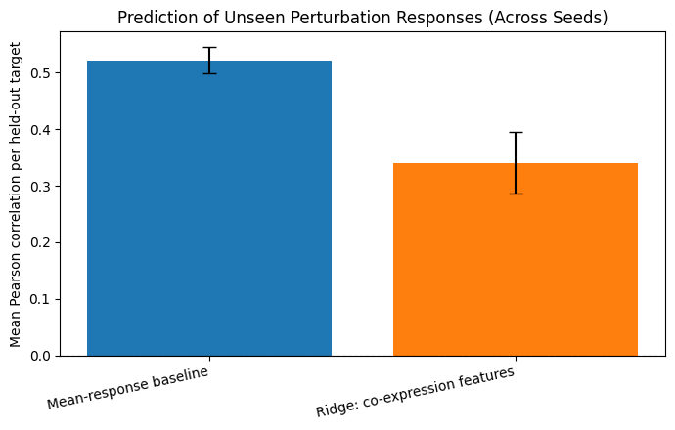
Figure 1. The notebook's model-comparison bar chart shows the higher mean Pearson correlation for the baseline; error bars represent variability across seeds.

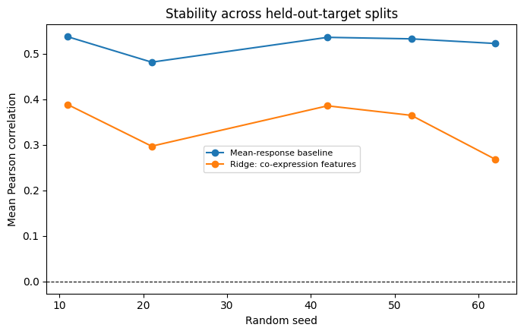
Figure 2. The split-stability plot shows that baseline performance is comparatively stable, while Ridge performance is lower and more variable. Insert the generated model_comparison.png and split_stability.png from the notebook's results folder if figures are required in the submitted document.

6. Limitations
- The analysis is a lightweight subset, with 10,600 cells and 582 genes, rather than a full reanalysis of the dataset.
- Only 102 matched targets were used for the model comparison; three target labels did not match expression gene names.
- Feature selection was fixed globally before the target-level splits rather than repeated within each training split. This limits the strictness of evaluation and should be addressed in future work.
- Co-expression features were estimated from a sample of control cells and may not adequately encode the functional consequences of activating a target gene.
- Only five random splits were evaluated; additional splits and independent external validation would be needed to assess robust generalization.
- The model predicts average transcriptional responses in a cell line and does not represent all cell-to-cell heterogeneity or establish causal mechanisms.
- The Ridge model did not outperform the baseline and must not be presented as an improvement.

7. Ethical, Regulatory, and Real-World Feasibility
The project uses publicly available research data from experimentally perturbed cell-line samples and does not use identifiable patient records. Data source attribution and applicable dataset terms must still be respected. Transparent reporting of sampling, gene-matching exclusions, and evaluation design is important for reproducibility.
The main ethical risk is overinterpretation. K562 cell-line transcriptional responses do not establish how a patient will respond to a drug or treatment. The model has not been clinically validated, assessed for patient-population bias, or evaluated under a medical-device regulatory framework. Do not use it for diagnosis, treatment selection, or patient-care decisions. Any future clinical translation would require independent biological validation, external replication, robustness and bias assessment, expert oversight, and appropriate institutional and regulatory review.
The pipeline is feasible for education and hypothesis generation because it runs on CPU resources and uses interpretable metrics. Its current value is methodological: it demonstrates target-level evaluation and shows why more complex models must be compared with a simple baseline.

8. Conclusion
This project implemented a lightweight pilot to predict transcriptional responses for unseen single-gene perturbations using Norman et al. (2019) Perturb-seq data. Across five held-out-target splits, the mean-response baseline achieved higher Pearson and Spearman correlations and lower RMSE than Ridge regression using co-expression features. Thus, the selected feature representation did not improve unseen-target prediction in this experiment. This result is informative: predictive methods should be evaluated against simple baselines, and biological features should be retained only when they provide reproducible added value. The analysis remains an exploratory cell-line pilot and is not suitable for clinical use.

References
- Dixit, A., Parnas, O., Li, B., Chen, J., Fulco, C. P., Jerby-Arnon, L., et al. (2016). Perturb-Seq: Dissecting molecular circuits with scalable single-cell RNA profiling of pooled genetic screens. Cell, 167(7), 1853–1866.e17. https://doi.org/10.1016/j.cell.2016.11.038
- Norman, T. M., Horlbeck, M. A., Replogle, J. M., Ge, A. Y., Xu, A., Jost, M., Gilbert, L. A., & Weissman, J. S. (2019). Exploring genetic interaction manifolds constructed from rich single-cell phenotypes. Science, 365(6455), 786–793. https://doi.org/10.1126/science.aax4438
- Hoerl, A. E., & Kennard, R. W. (1970). Ridge regression: Biased estimation for nonorthogonal problems. Technometrics, 12(1), 55–67. https://doi.org/10.1080/00401706.1970.10488634

Colab notebook:
https://colab.research.google.com/drive/1wYTp45cyJDuTCAic2G0r7SnP9uizJY5M?usp=sharing

