- www.globalspec.com
  - From the home page, we need to extract the two highlighted links
    - Directory Of Suppliers
    - Product Directory
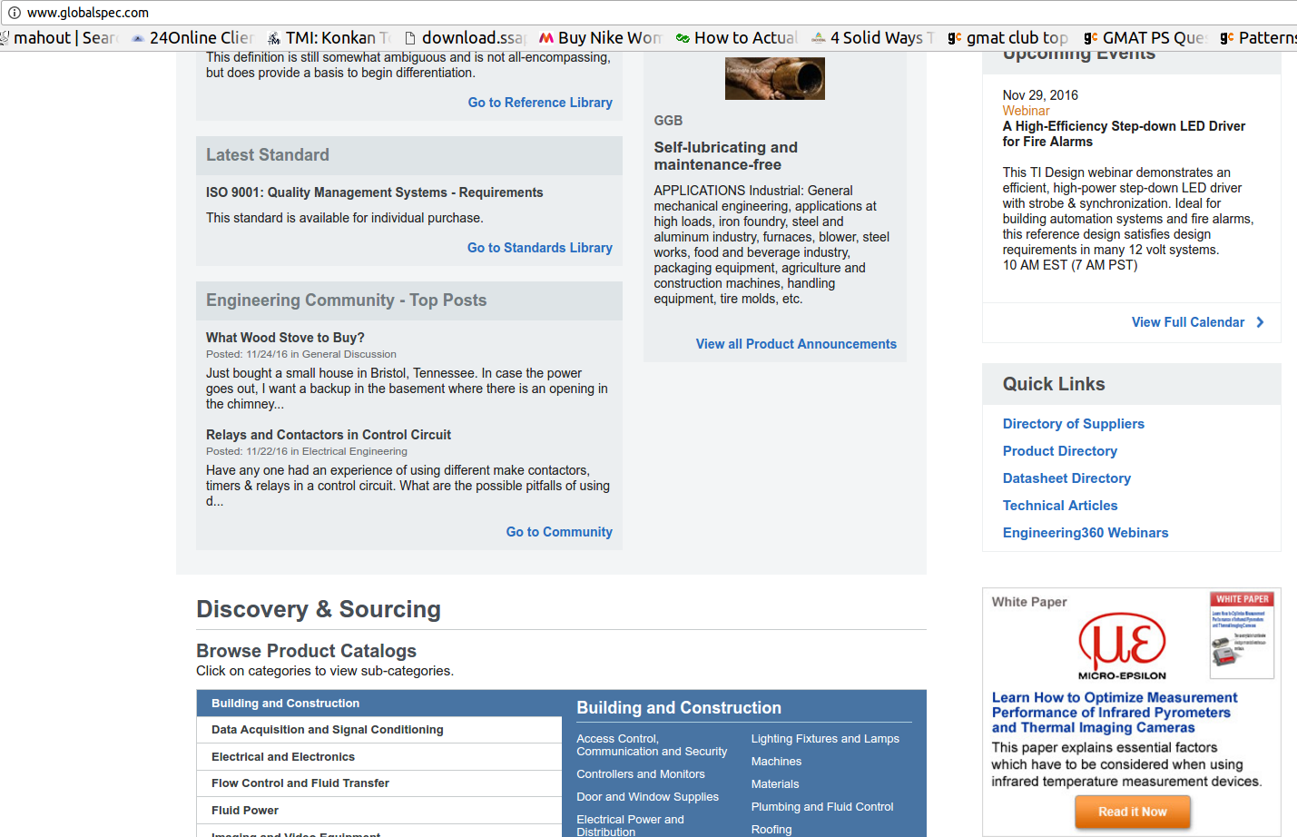

Directory Of Suppliers
- http://www.globalspec.com/SpecSearch/SuppliersByName/AllSuppliers/1/1
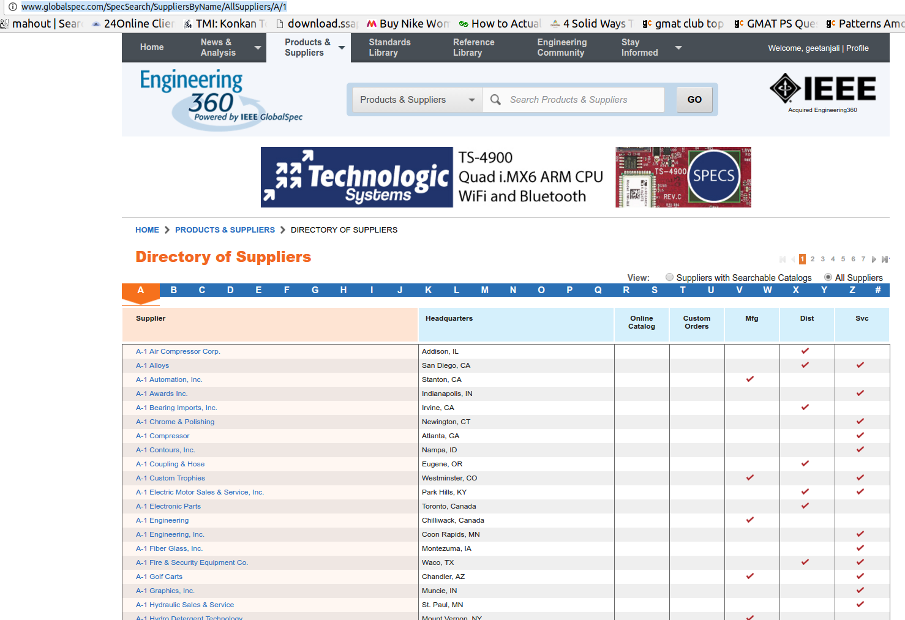
- http://www.globalspec.com/industrial-directory
In the directory of suppliers, all links from A to # have to be scrapped
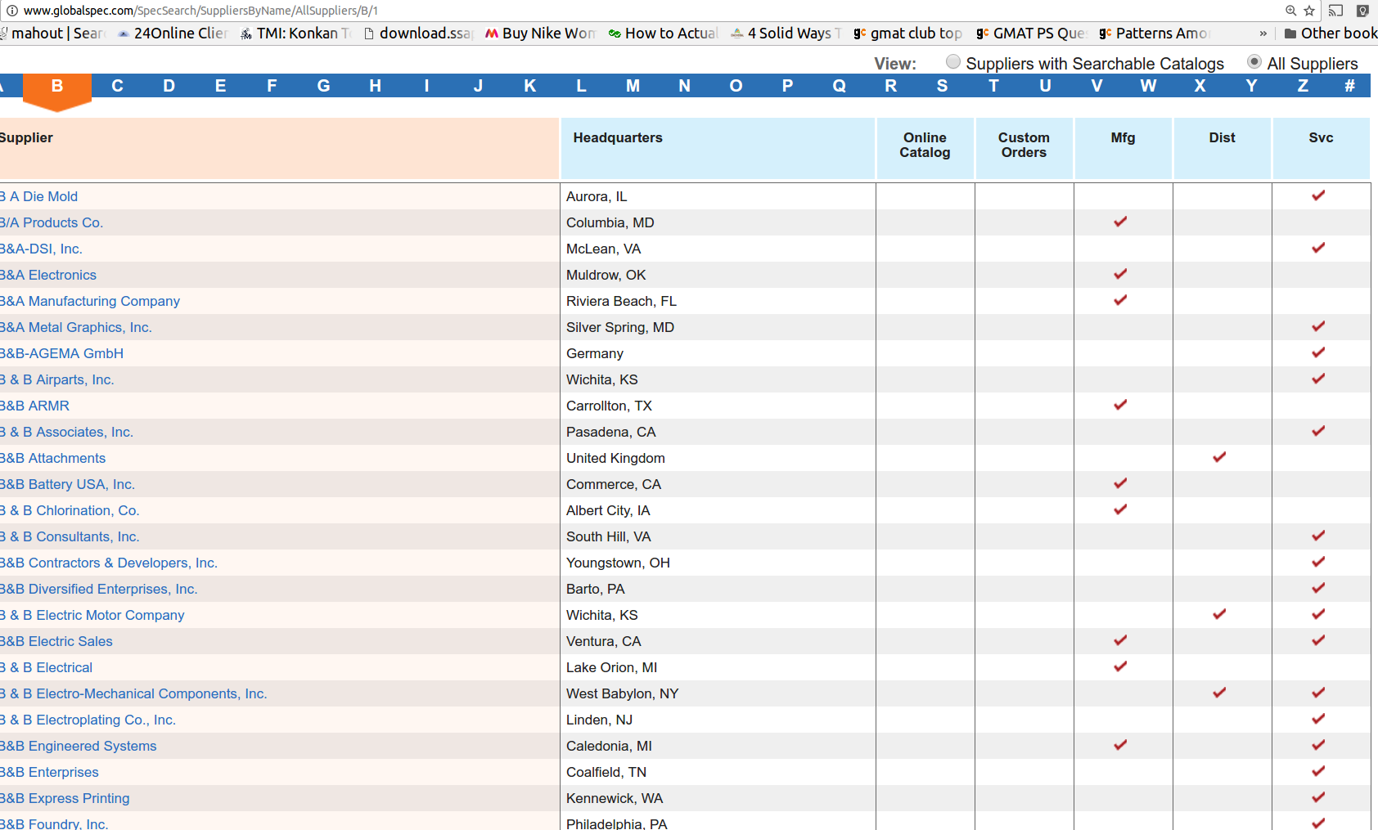

- http://www.globalspec.com/supplier/profile/ABBElectrificationProducts
  - This is the final HTML page to be scrapped for Directory Of Supplier
  - The Link present at “Email Supplier” needs to be extracted, decoded and kept in a seperate text file for further scrapping
Unclear how to proceed, wait for reply
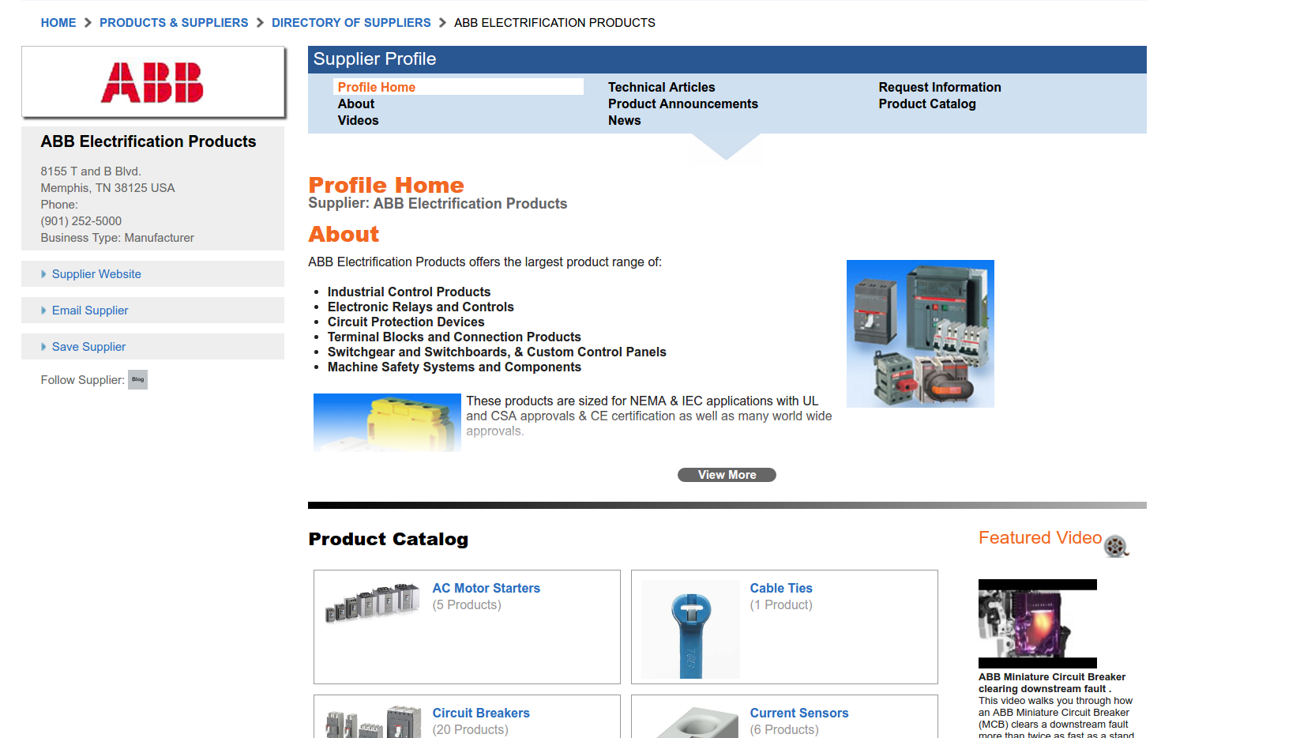
- All the media files (Image, video) and all PDFs have to be extracted and saved locally
- All the tabs under “Supplier Profile” have to be scrapped:
  - Profile Home, Technical Articles, Request Information, Product Catalog
  - About, Product Announcement, Videos, News

Product Directory

- http://www.globalspec.com/industrial-directory98924
  - All the product links need to be scrapped from the directory
  - The final page required is similar to the profile page as indicated above for supplier
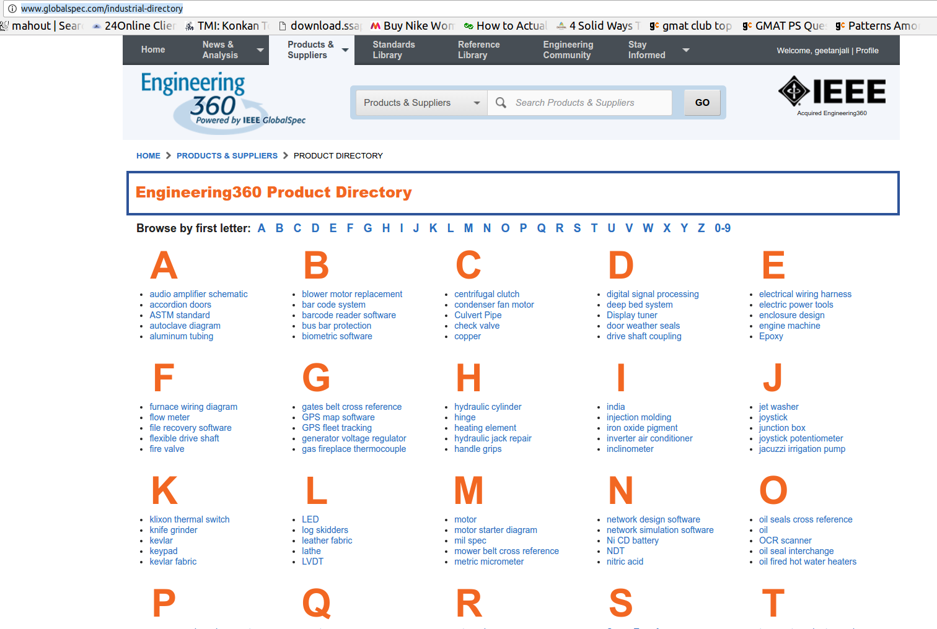
E.g: Link scrapped:
- http://www.globalspec.com/industrial-directory/audio_amplifier_schematic
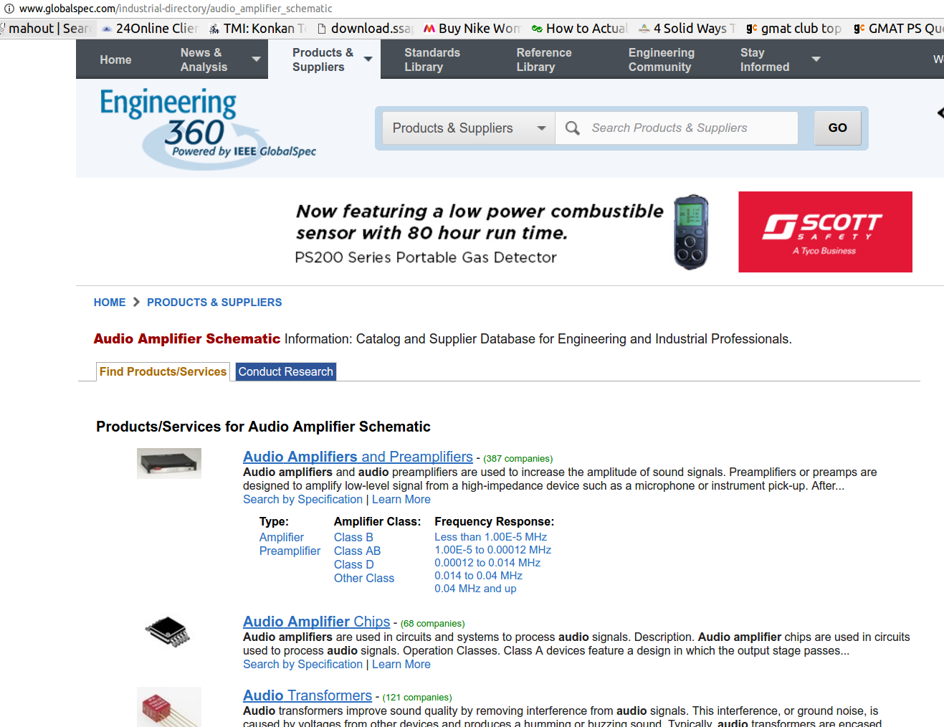
We will scrape all the product links here: Audio Amplifires and Preamplifiers, Audio Amplifier Chips, Audio Transformers, etc..
Inside ‘Audio Amplifires and Preamplifiers’, we get
- http://www.globalspec.com/search/products?page=ms#comp=2940&show=products&sqid=18975208
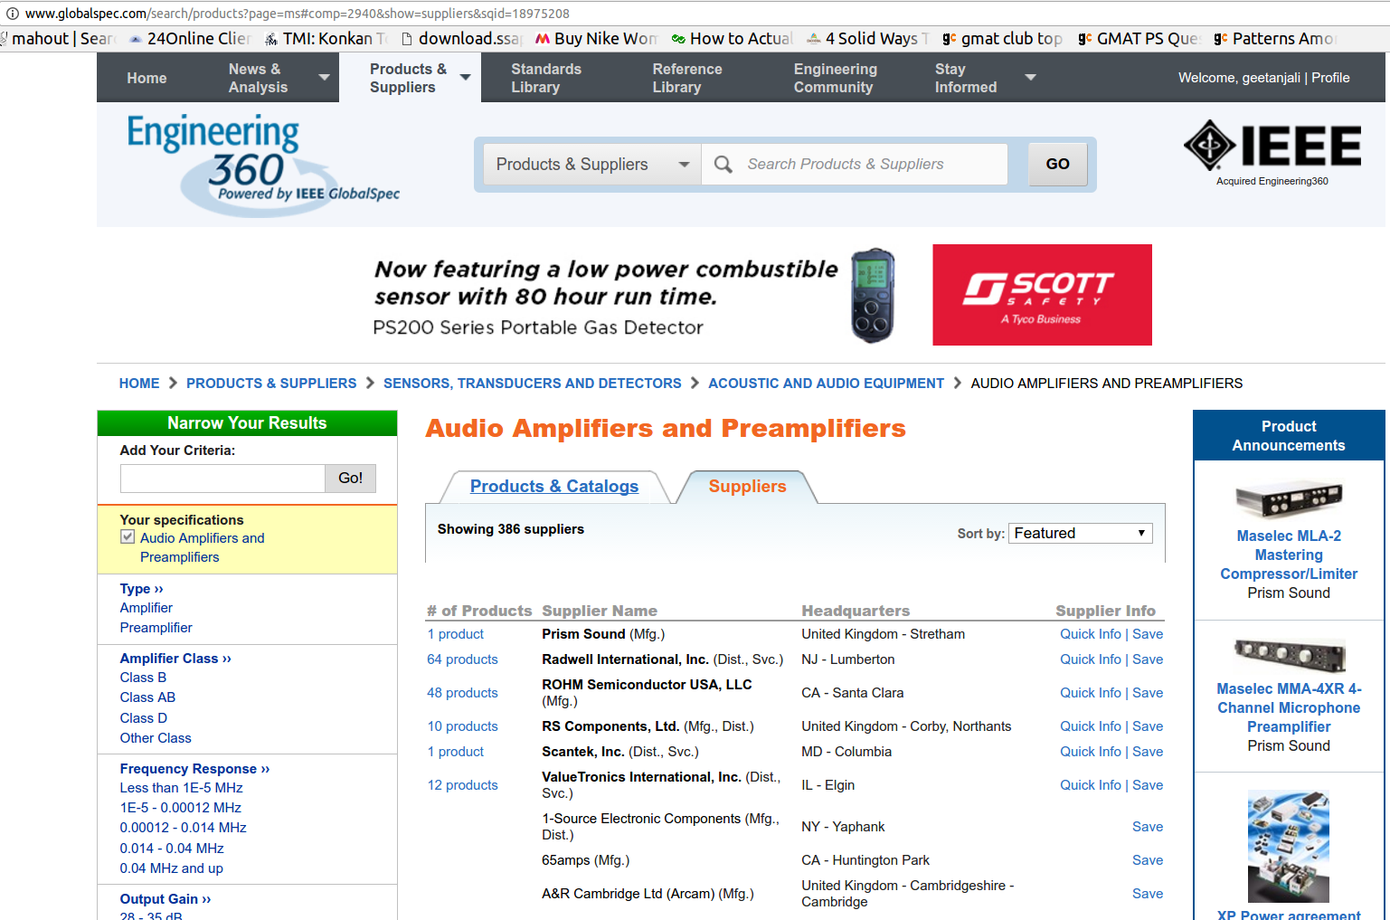
By default, it takes us at the Supplier link. We will need to get the Products & Catalogs link:
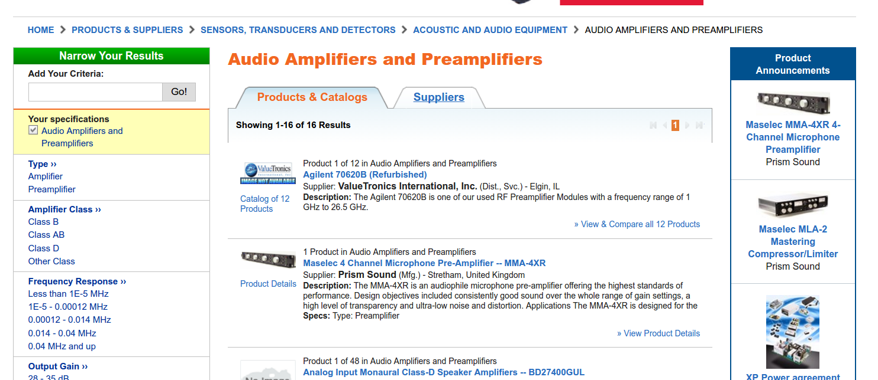
Here, we extract link to all the products links:
- http://www.globalspec.com/search/products?page=ms#comp=2940&show=products&sqid=18982954
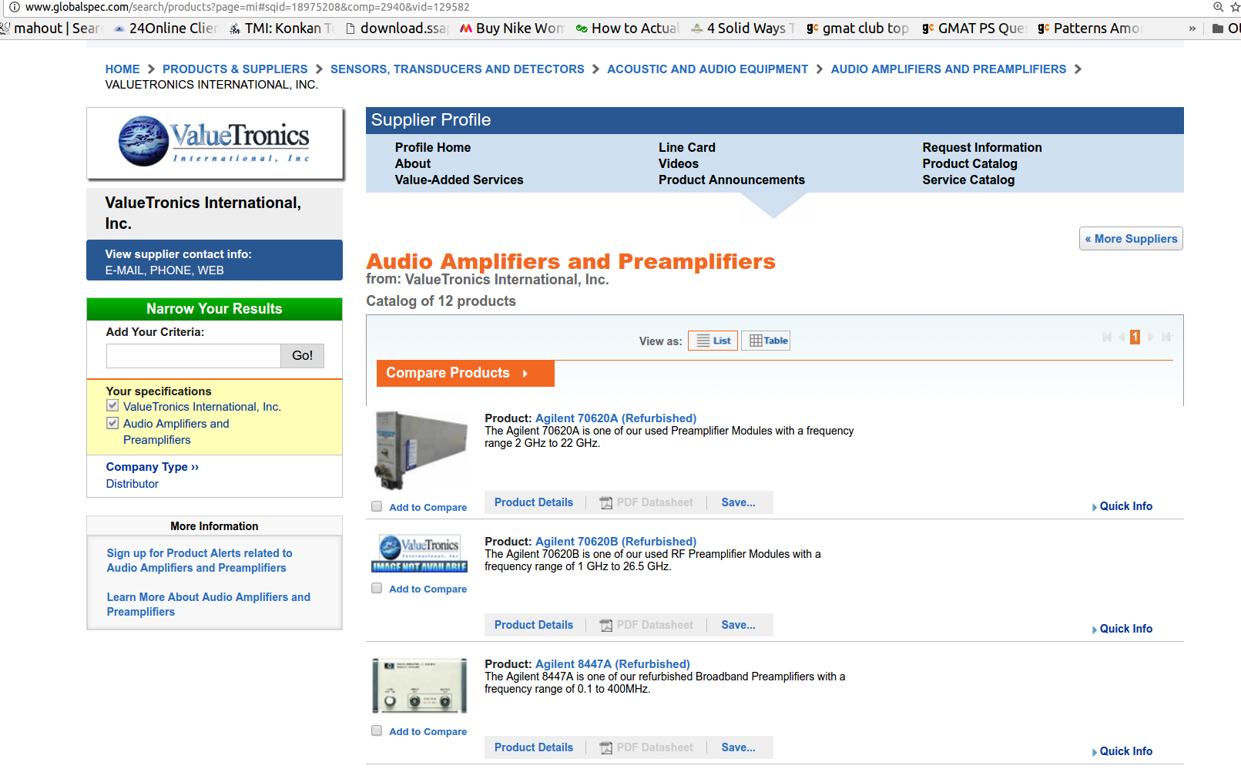
After extracting the link to final product pages, we get:
- http://www.globalspec.com/specsearch/partspecs?partId={7AB52A51-6A2A-4D38-9624-5FDFF94F3F9C}&vid=129582&comp=2940&sqid=18975208
- 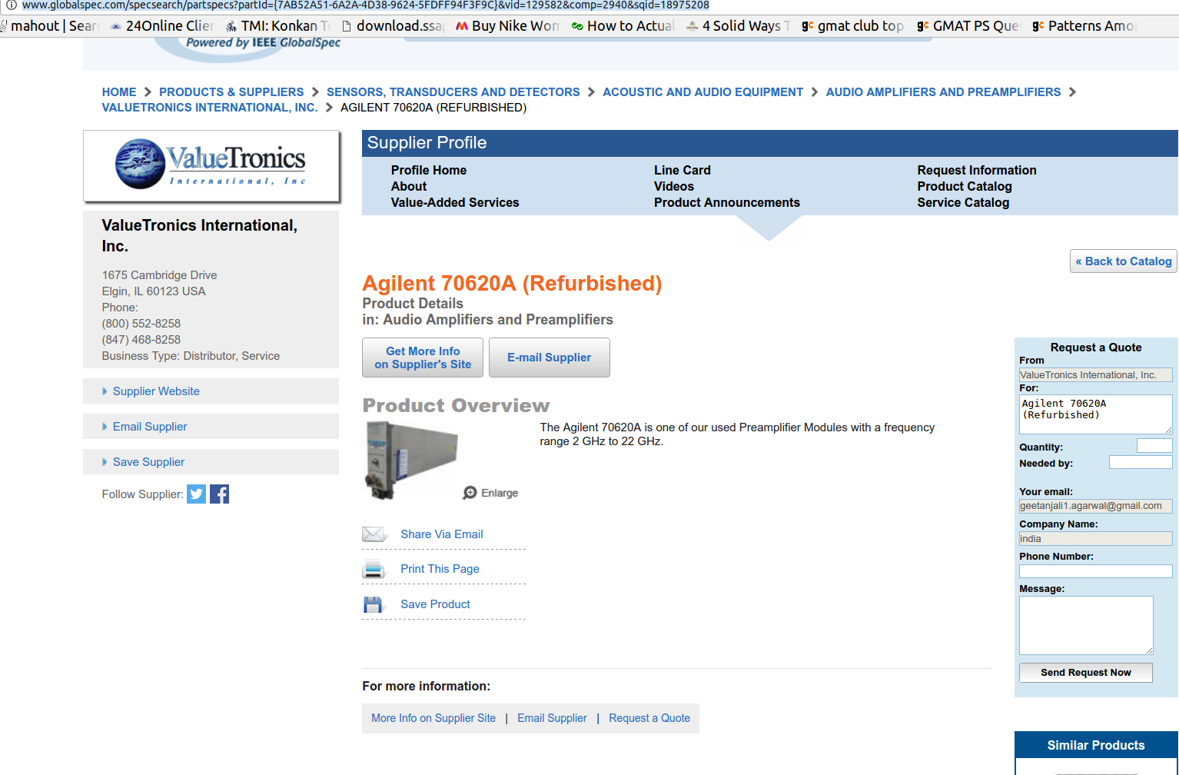
- This is the final page to be extracted as per the product directory
- All the media files, PDF, video, etc has to be extracted.
- The “Supplier website” needs to be extracted, decoded and input in a text file for further extraction.

Where will we save all these HTMLs and media files
- We will use MongoDb to save them
- All media files must be saved by the name = URL of the particular file
- These will be saved in the same collection as their corresponding HTMLs
- The HTML have to be arranged in MongoDB as per their Breadcrumb:

- This type of Breadcrumb is present on every page, and will be useful for us to keep track of every HTML page in MongoDB

