The Knight’s Tour

By Kevin de Leeuw,

500712026

**The code**

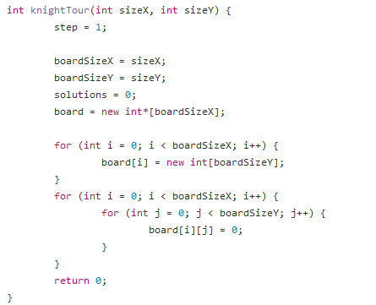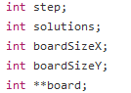In order to make the board any size I want , I declared a pointer to a multidemensional array and let the user fill in the sizeX and sizeY variable to create a board accordingly.

The knights descision to make the next step is done with a simple , but sloppy use of nested if statements. There are a total of 8 tiles a knight can land on. In order to determine where the knight can move I first check the options do not fall outside of the board. Next I check if the Knight can move there. By checking if the value of that “tile” is 0, if that is true it will continue until all tiles are filled after which the solution is shown to the user.

