Student ID: | : | 24CS021 | Student Name: | : | Urja Gajera
Subject code & Name | : | ITUE301 – Advanced Web Development Frameworks | Practical | : | 1 | Academic Year | : | 2026-27

Practical 1: Introduction to React and Component Architecture
Task - 1
Aim
To set up a React development environment using Vite and build a static student portfolio page from independently structured, reusable components.
• Scaffold a React app with Vite.
• Build at least 4 reusable components — Header, About, Skills and Footer — and compose them into one single-page layout in App.
• Avoid duplicating logic or JSX across components.
• Pass data into at least 2 components through props (name to Header, skillList to Skills).
Code
GitHub Repository Link: https://github.com/Urjagajera/AWDF_Practicals/tree/main/practical-1
Main files for this task:
• client/src/App.tsx — composes every component and passes the props
• client/src/components/Header.tsx
• client/src/components/About.tsx
• client/src/components/Skills.tsx — renders the skillList prop as a list
• client/src/components/Footer.tsx
• client/src/components/Section.tsx — shared section heading, so no JSX is duplicated
• client/src/data/profile.ts — portfolio data handed down as props
Output
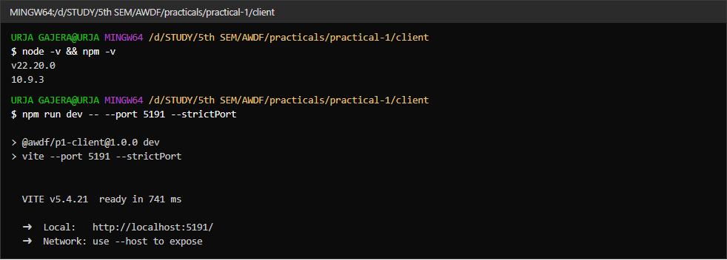
1.1 Node.js and npm versions, and the Vite dev server starting
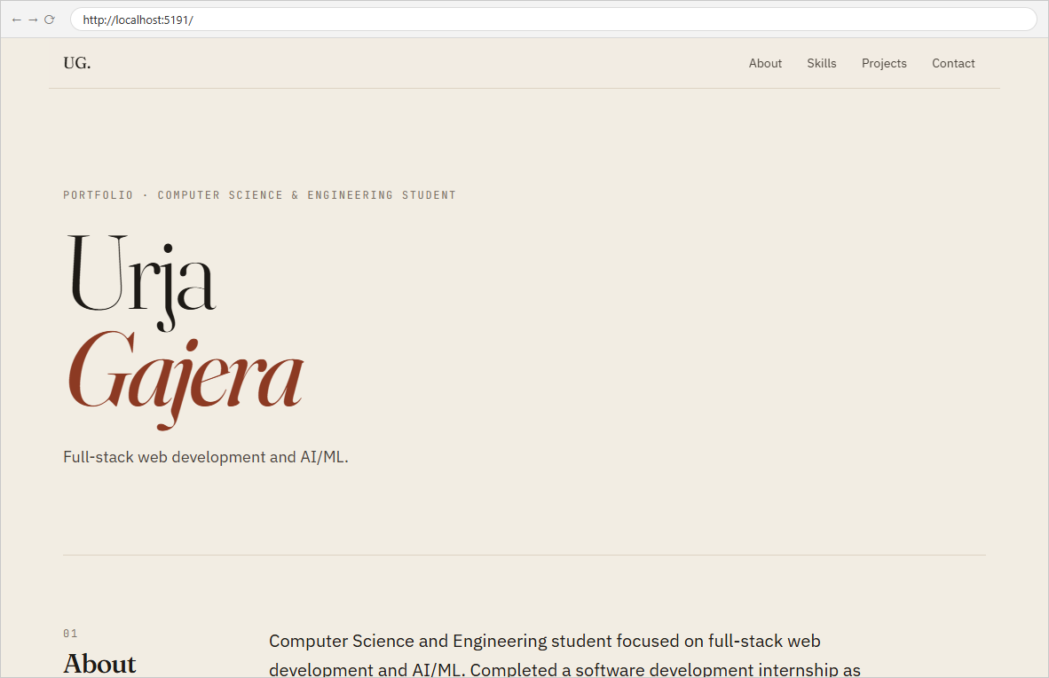
1.2 Header component — name and role passed in as props from App
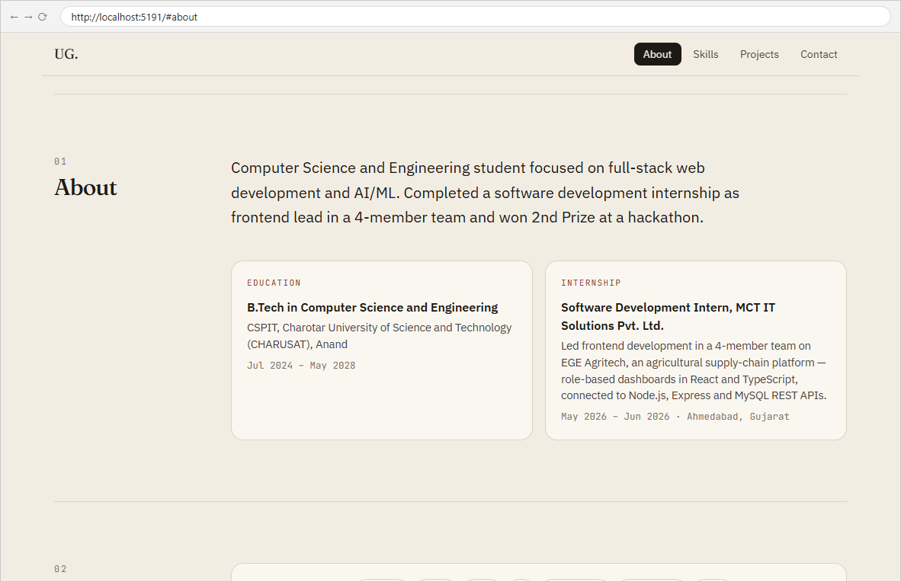
1.3 About component — bio, education and internship received as props
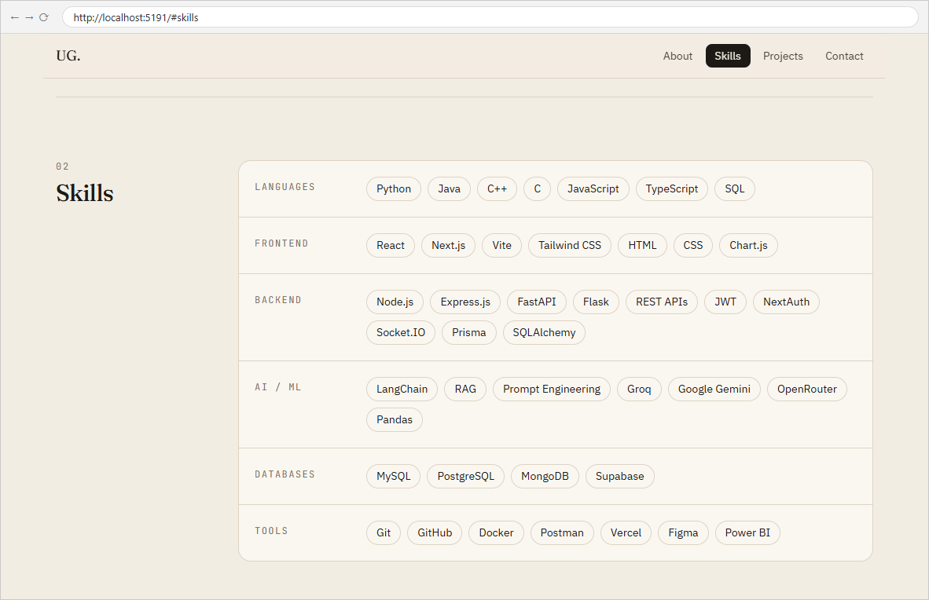
1.4 Skills component — the skillList prop rendered as grouped lists
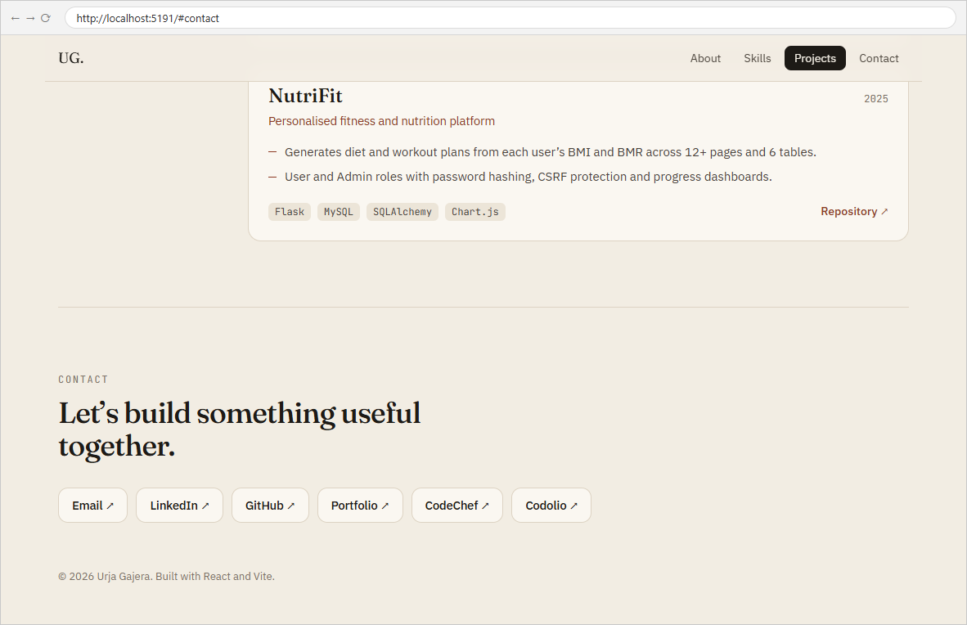
1.5 Footer component — contact links and copyright

Task - 2
Aim
To extend the portfolio with the supplementary problems and post-lab tasks:
• Add a NavBar component that highlights the active section while scrolling.
• Pass an array of skills as a prop to Skills and render it dynamically with map().
• Add a themeColor prop to Header and apply it as an inline style.
• Post-lab: add a Projects component that renders a hardcoded list of 3 projects, and try different prop values to see the UI change.
Code
GitHub Repository Link: https://github.com/Urjagajera/AWDF_Practicals/tree/main/practical-1
Main files for this task:
• client/src/components/NavBar.tsx — IntersectionObserver marks the section in view as active
• client/src/components/Header.tsx — themeColor prop applied with style={{ color: themeColor }}
• client/src/components/Projects.tsx — the 3 projects, received as a prop
Output
2.1 NavBar highlighting “Skills” while the Skills section is in view; the skills array is rendered with map()
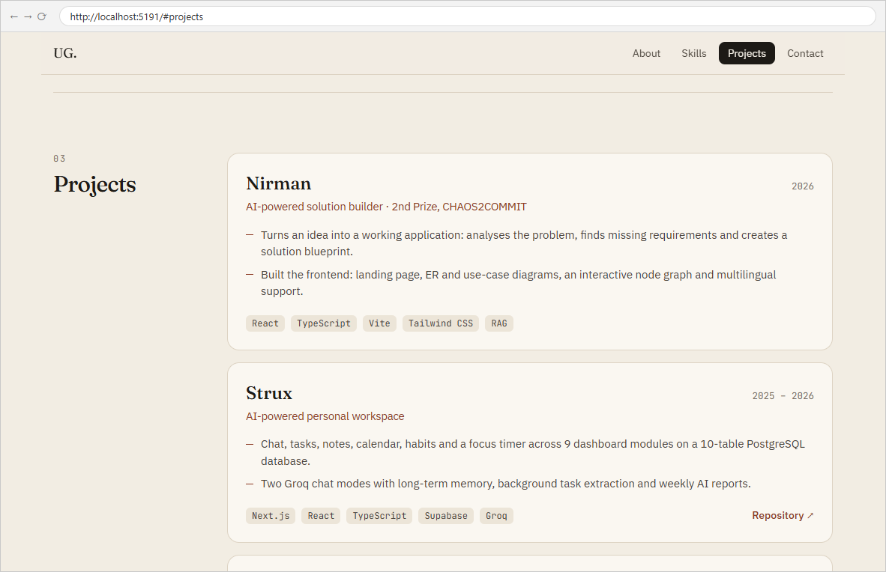
2.2 Projects component rendering 3 projects; NavBar now highlights “Projects”
2.3 Header surname drawn in the colour passed through the themeColor prop (inline style)

Key Questions / Analysis
What is the role of each component? Header introduces the person, About gives the bio with education and internship, Skills lists grouped skills, Projects shows work, Footer holds the contact links, and NavBar moves between them. App only arranges them and hands each one its data.
How does React re-render when props change? When a parent re-renders with new prop values, React calls the child function again with the new props, compares the returned elements with the previous output, and updates only the DOM nodes that changed. Changing skillList in App re-renders Skills and only adds or removes the affected <li> elements (the key lets React match items between renders).
Why does reusability matter in large applications? A component written once and configured through props can be used in many places, so a fix or design change happens in one file. Here Section gives About, Skills and Projects the same heading layout without copying markup, and the portfolio content can be swapped for another student's just by changing profile.ts.
Errors Faced and Fixes
• Port 5173 already in use — another project's dev server was running on 5173. Vite moves to the next free port on its own; for a fixed port, run npm run dev -- --port 5174 (the fix from the troubleshooting guide).

