Student ID: | : | 24CS021 | Student Name: | : | Urja Gajera
Subject code & Name | : | ITUE301 – Advanced Web Development Frameworks | Practical | : | 2 | Academic Year | : | 2026-27

Practical 2: State Management and Routing in React
Task - 1
Aim
To add client-side routing with React Router v6 and manage dynamic UI state with the useState hook in the Practical 1 portfolio.
• Wrap the app in BrowserRouter and add a NavBar with 3 routes — Home, Projects and Contact.
• Render a distinct component for each route without a full page reload (Link/NavLink, never <a href>).
• Use at least 2 meaningful useState variables: one toggling UI visibility (the help tip) and one holding form input on the Contact page.
• The Contact page has a controlled input whose value is shown in real time.
Code
GitHub Repository Link: https://github.com/Urjagajera/AWDF_Practicals/tree/main/practical-2
Main files for this task:
• client/src/main.tsx — <BrowserRouter> wraps <App /> once
• client/src/App.tsx — <Routes> with /, /projects, /contact and *
• client/src/components/NavBar.tsx — NavLink for each route
• client/src/pages/Home.tsx, ProjectsPage.tsx, Contact.tsx
Output
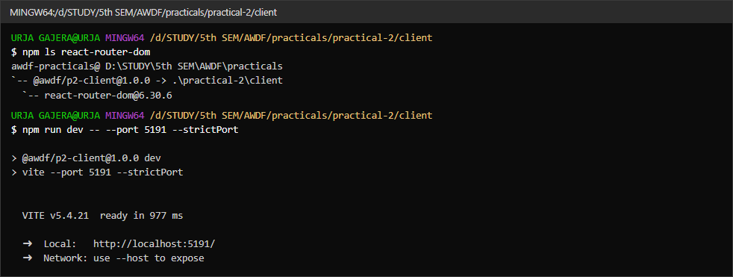
1.1 react-router-dom v6 installed, and the dev server starting
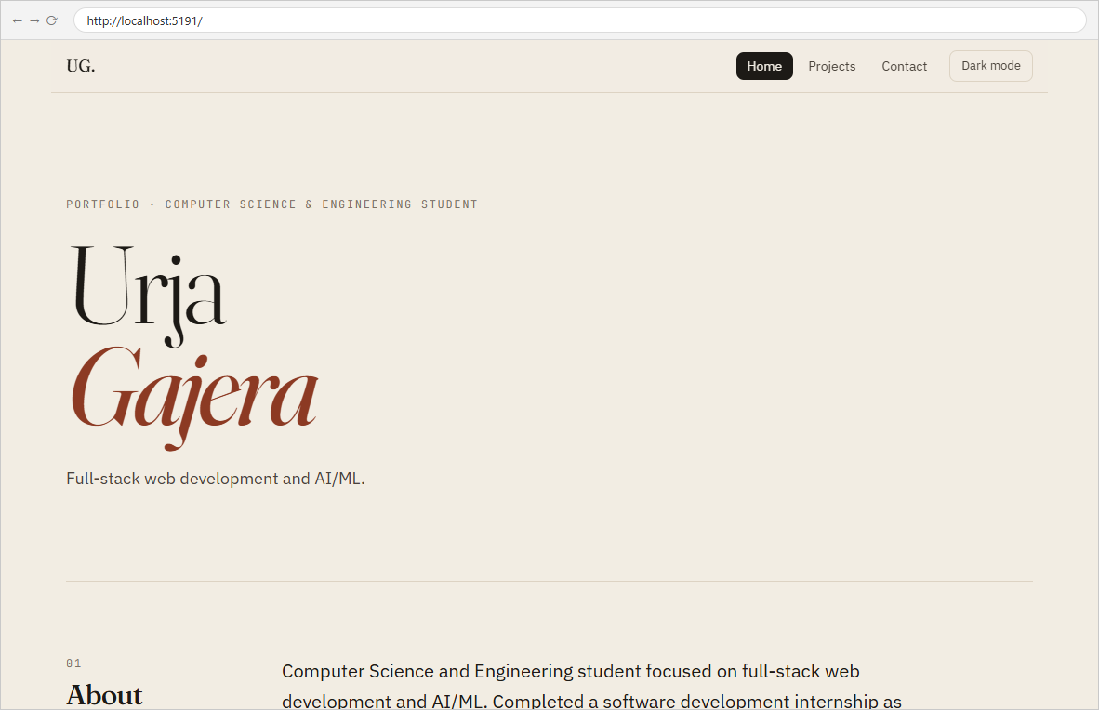
1.2 Route “/” renders the Home page; NavBar marks Home as active
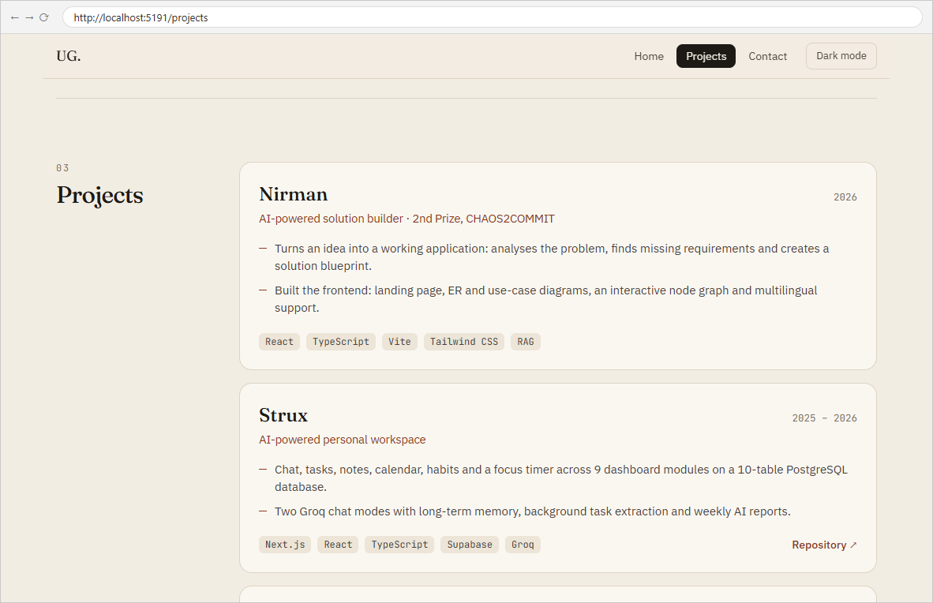
1.3 Route “/projects” renders the Projects page — reached with a NavLink, no reload
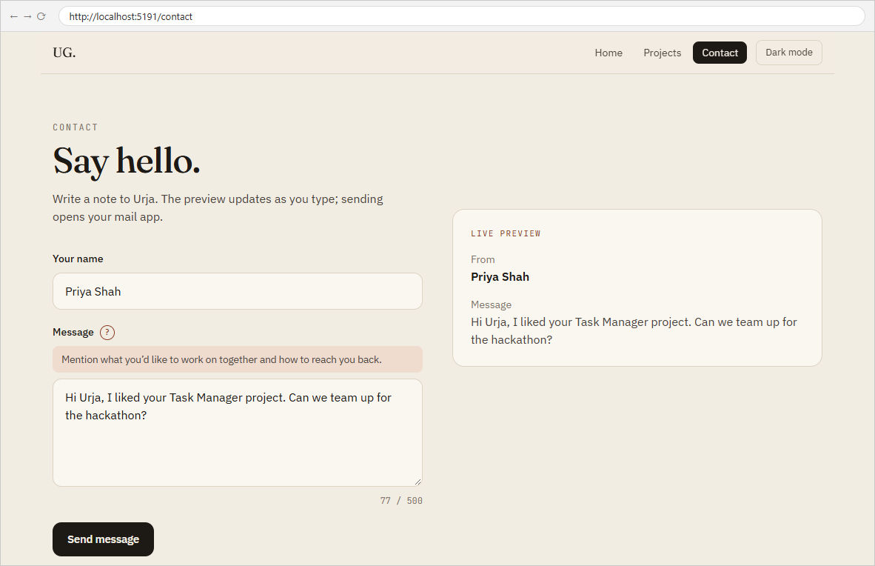
1.4 Route “/contact” — controlled inputs (useState) mirrored live in the preview; the “?” button toggles the help tip (second useState)
Observations
A value stored on window before clicking Projects and then Contact in the NavBar was still present afterwards (“still here”), which shows the page never reloaded — only the routed component changed.

Task - 2
Aim
Supplementary problems and post-lab tasks:
• Add a 404 Not Found route that renders a custom component for unknown paths.
• Implement a dark/light mode toggle with useState that applies a CSS class to the root element.
• Show a live character count below the contact message input.
Code
GitHub Repository Link: https://github.com/Urjagajera/AWDF_Practicals/tree/main/practical-2
Main files for this task:
• client/src/pages/NotFound.tsx — rendered by <Route path="*">
• client/src/components/ThemeToggle.tsx — useState + the dark class on <html>
• client/src/pages/Contact.tsx — {message.length} / 500 under the textarea
Output
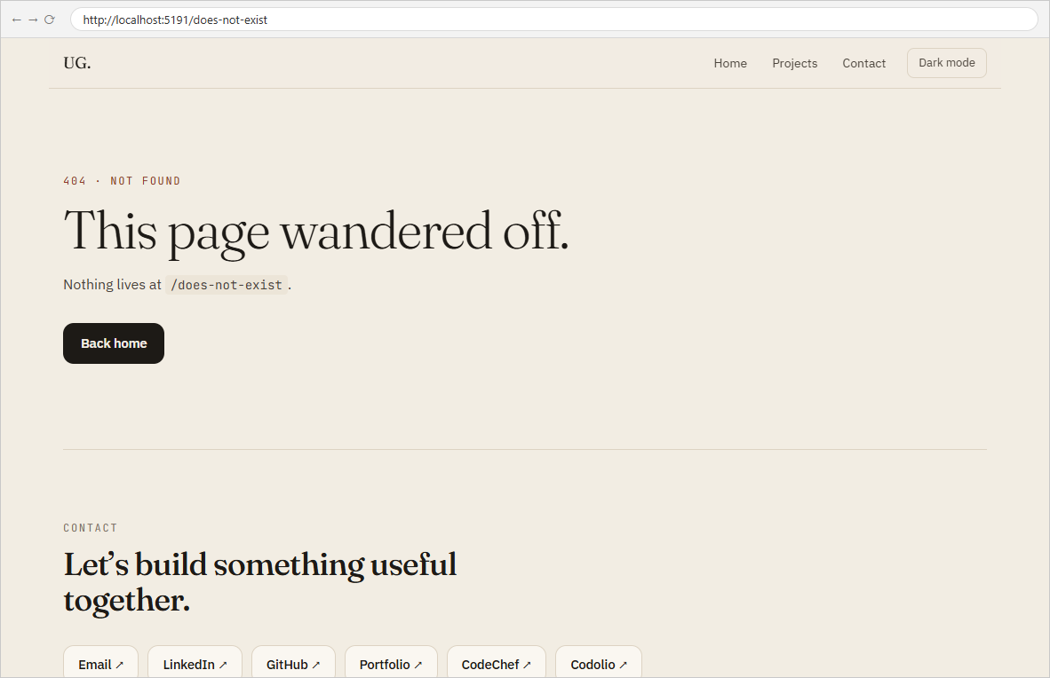
2.1 Unknown path /does-not-exist renders the custom 404 page
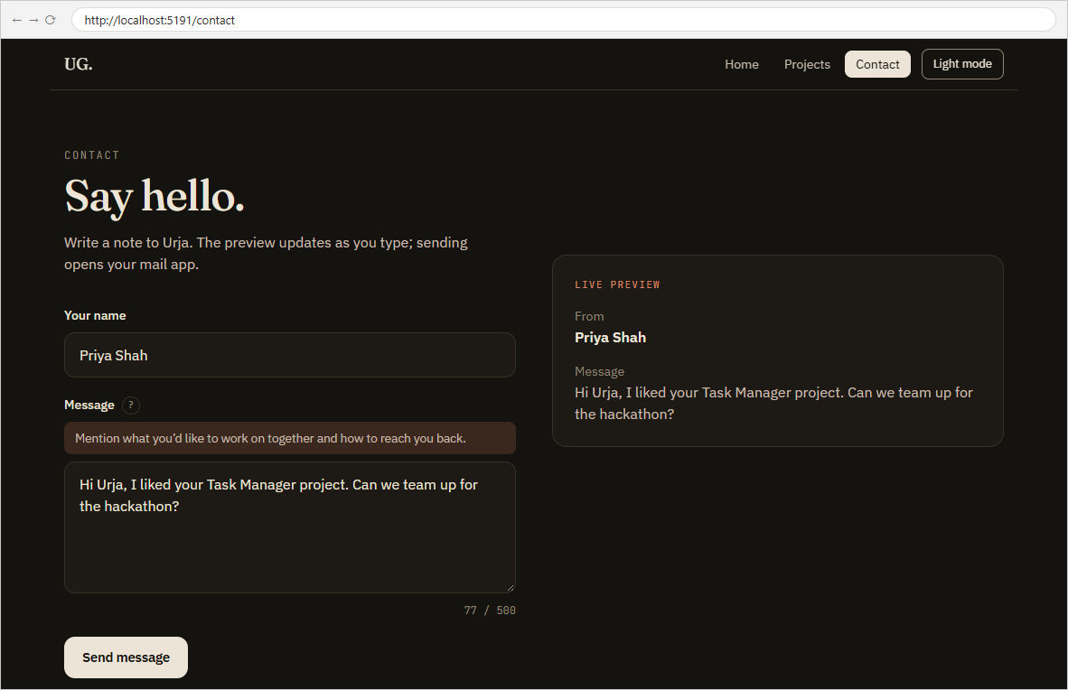
2.2 Dark mode on — the toggle adds the dark class to <html>; the button now offers Light mode
2.3 Live character count “77 / 500” updating on every keystroke

Key Questions / Analysis
What is the role of each component? main.tsx provides the router, App declares which component each path renders, NavBar moves between paths, and each page component owns one screen. Contact is the only page with its own state, because it is the only one whose content changes as the user interacts.
How does React re-render when props or state change? Calling setMessage schedules a re-render of Contact; React runs the function again with the new state and patches only the changed DOM (the textarea value, the preview text and the count). A route change works the same way: the router's location state changes, so <Routes> renders a different element, without the browser fetching a new page.
Why is component reusability important? The Practical 1 components (Header, About, Skills, Projects, Footer) were reused unchanged inside the new pages; only the composition changed. That is what makes it cheap to restructure a growing app.
Errors Faced and Fixes
• npm install react-router-dom -w practical-2/client did not add the dependency the first time, because the new folder was not yet a registered workspace. Adding it to package.json and running npm install from the repo root fixed it.

