Student ID: | : | 24CS021 | Student Name: | : | Urja Gajera
Subject code & Name | : | ITUE301 – Advanced Web Development Frameworks | Practical | : | 3 | Academic Year | : | 2026-27

Practical 3: API Integration and Data Rendering in React
Task - 1
Aim
To consume a public REST API (GitHub) on the Projects page and handle the loading, success and error states of the request.
• Fetch the list of repositories inside useEffect with an empty dependency array (on mount).
• Keep three pieces of state: data, loading and error.
• Show a Spinner while loading and an ErrorMessage if the call fails.
• Render at least the repository name and URL for every item.
Code
GitHub Repository Link: https://github.com/Urjagajera/AWDF_Practicals/tree/main/practical-3
Main files for this task:
• client/src/components/GitHubRepos.tsx — useEffect + fetch, loading/error/data state
• client/src/components/Spinner.tsx
• client/src/components/ErrorMessage.tsx
• client/src/components/RepoList.tsx — name, html_url and stars per repository
• client/src/pages/ProjectsPage.tsx — integration point from Practical 2
Output
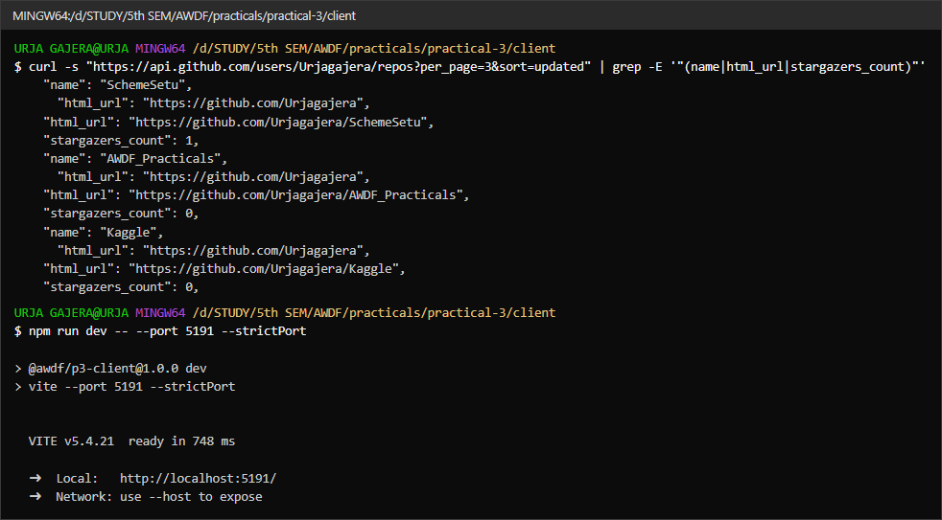
1.1 The GitHub endpoint used (name, html_url, stargazers_count fields), and the dev server
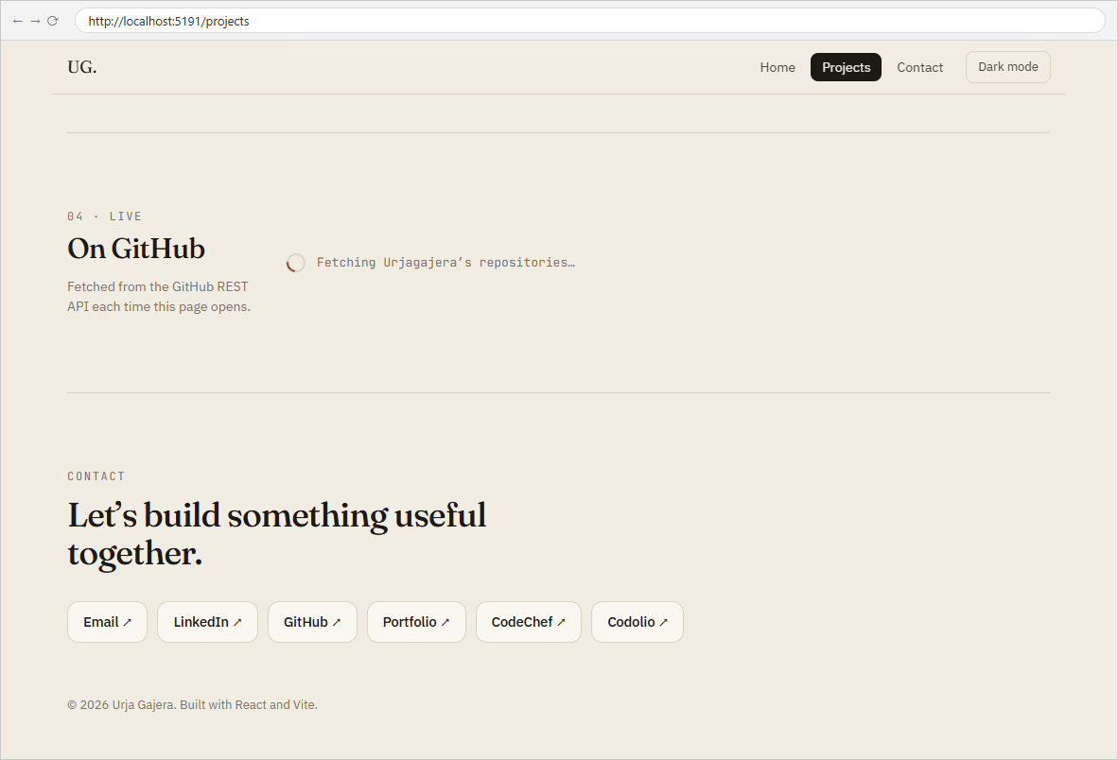
1.2 Loading state — the Spinner is shown while the request is in progress
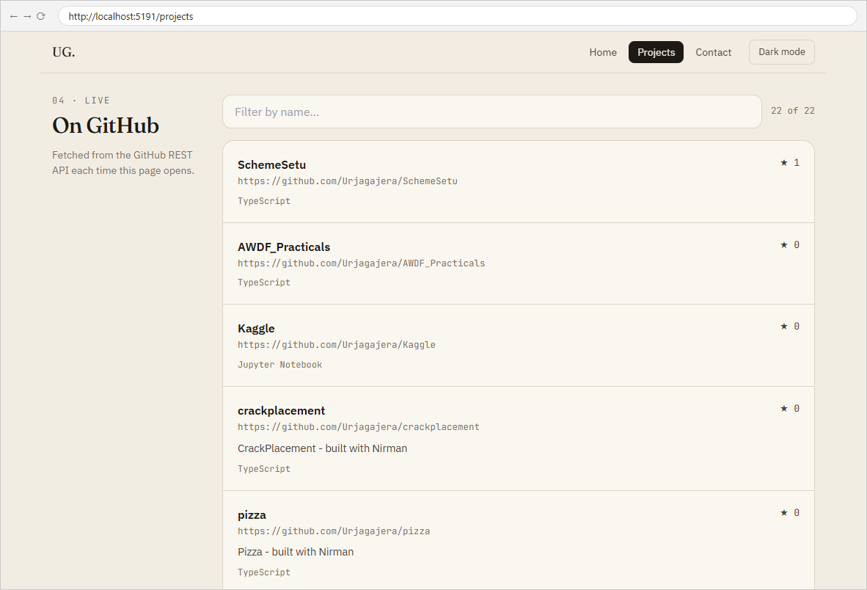
1.3 Success state — every repository rendered with its name and URL
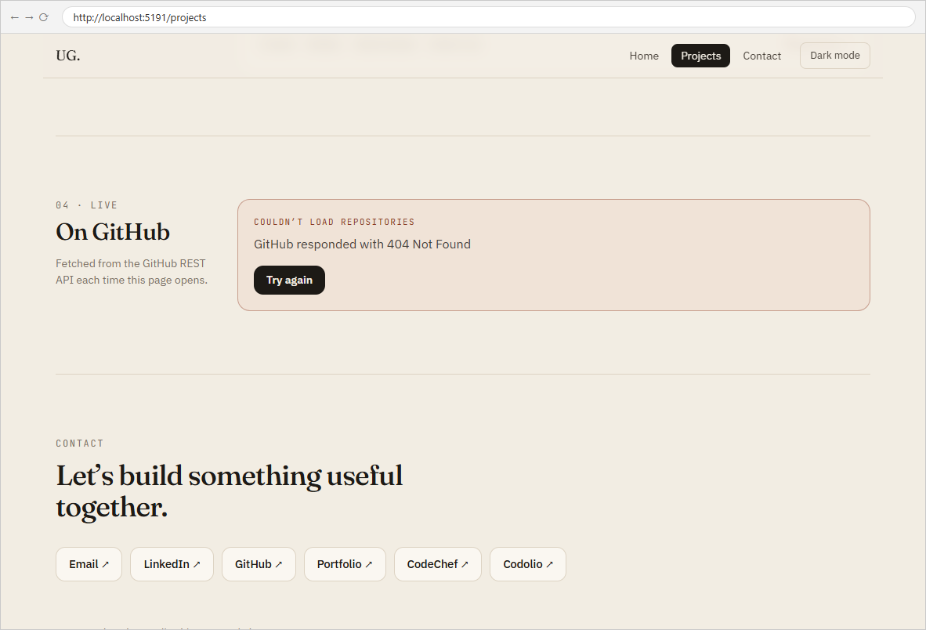
1.4 Error state — the API answered 404 Not Found, so ErrorMessage is shown instead of a blank page

Task - 2
Aim
Supplementary problems and post-lab tasks:
• Add a retry button that re-triggers the fetch when an error occurs.
• Add a search input that filters the rendered repositories by name.
• Display each repository’s star count next to its name.
Code
GitHub Repository Link: https://github.com/Urjagajera/AWDF_Practicals/tree/main/practical-3
Main files for this task:
• client/src/components/ErrorMessage.tsx — “Try again” button (onRetry)
• client/src/components/GitHubRepos.tsx — attempt state re-runs the effect; query state filters
• client/src/components/RepoList.tsx — ★ stargazers_count
Output
2.1 Retry button shown with the error
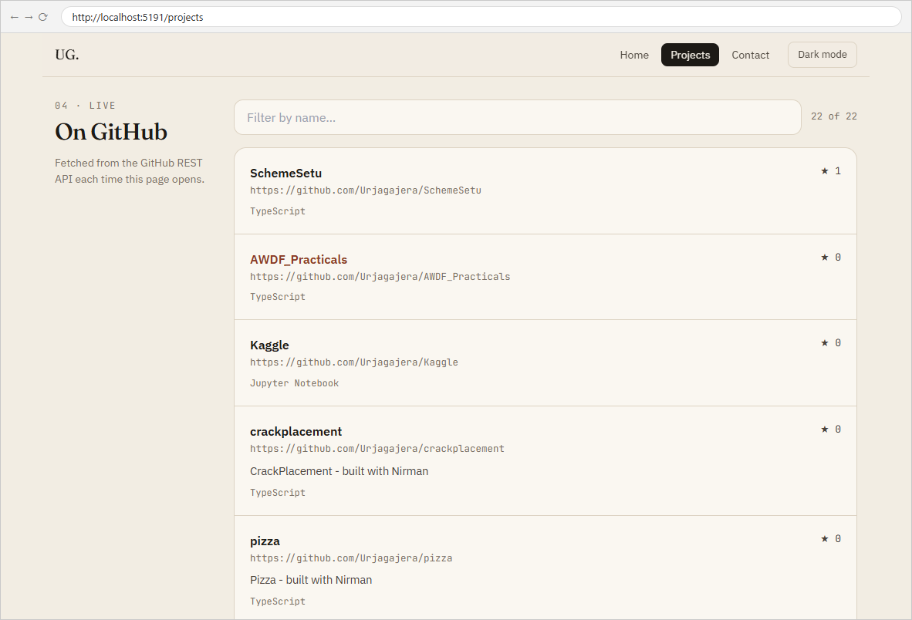
2.2 After pressing “Try again” with the network back, the list loads (22 of 22), with star counts
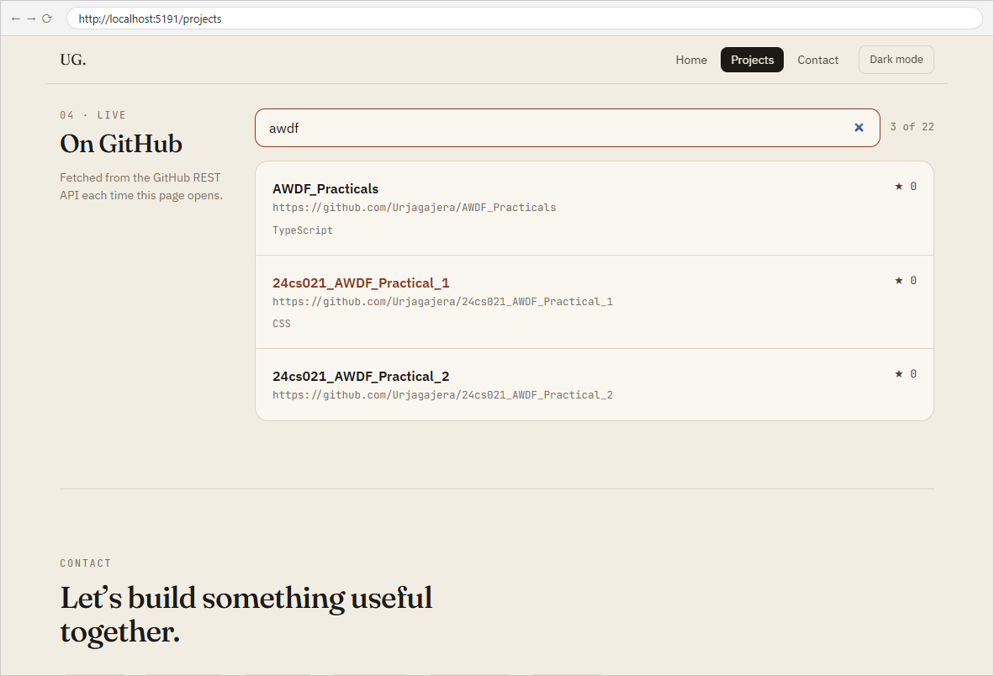
2.3 Search filter — typing “awdf” leaves 3 of 22 repositories

Key Questions / Analysis
Why is useEffect needed instead of calling fetch in the component body? The component body runs on every render. A fetch there would call setRepos, which triggers a render, which fetches again — an infinite loop. useEffect runs after rendering, and its dependency array controls when: [attempt] means "once on mount, and again only when the user retries".
Why handle loading and error separately? They mean different things to the user: loading means "wait, data is coming", error means "it isn't coming — here is why, and here is what you can do". With only one of them, a failure would look like an endless spinner, or a slow request would look like a failure.
How would the UX change without them? Without a loading state the section would be empty (or say "no repositories") until data arrives, which is misleading. Without an error state a failed request leaves a permanent spinner or a blank area with no explanation and no way to retry.
Errors Faced and Fixes
• The first version treated GitHub's HTTP error responses as data, because fetch resolves for any HTTP status. Checking res.ok and throwing fixed it, which made the error path testable.

