Student ID: | : | 24CS021 | Student Name: | : | Urja Gajera
Subject code & Name | : | ITUE301 – Advanced Web Development Frameworks | Practical | : | 4 | Academic Year | : | 2026-27

Practical 4: Building a RESTful API with Node.js and Express
Task - 1
Aim
To design and implement a RESTful Task Management API with Express, including a working middleware pipeline with request logging and centralised error handling.
• REST endpoints to create, read, update and delete tasks, stored in an in-memory array.
• A request-logging middleware that logs method, URL and timestamp for every request.
• A global error-handling middleware registered last in the pipeline.
• Correct HTTP status codes — 200, 201, 404 and 500.
Code
GitHub Repository Link: https://github.com/Urjagajera/AWDF_Practicals/tree/main/practical-4
Main files for this task:
• server/src/app.ts — pipeline: express.json() → logger → routes → 404 → error handler
• server/src/routes/tasks.ts and controllers/taskController.ts — the CRUD routes
• server/src/data/taskStore.ts — the in-memory array
• server/src/middleware/logger.ts
• server/src/middleware/errorHandler.ts — no stack trace sent to the client
Output
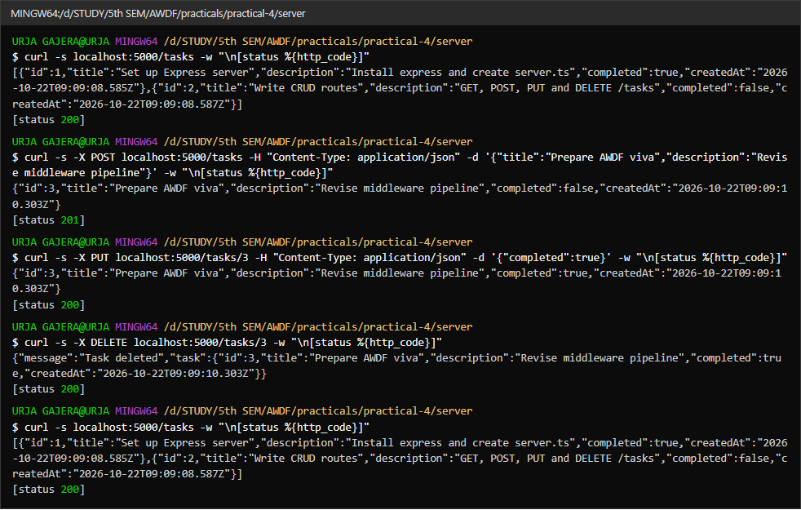
1.1 CRUD with curl — GET 200, POST 201, PUT 200, DELETE 200, then GET shows the task removed
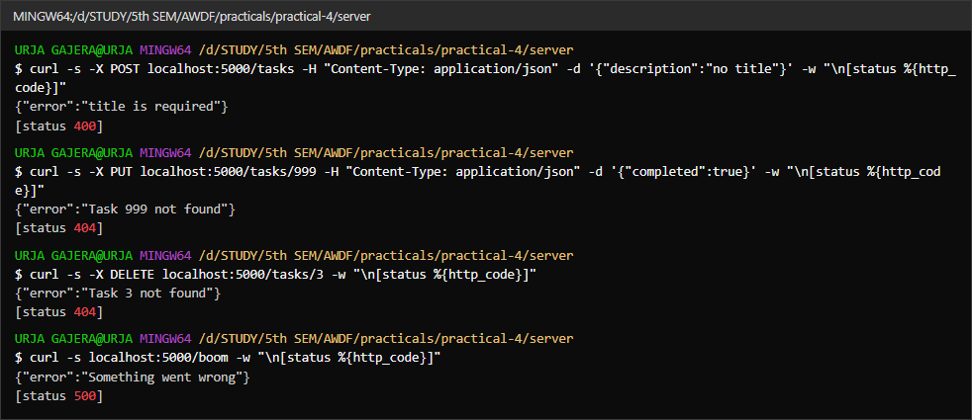
1.2 Error codes — 400 missing title, 404 unknown id, 404 on a second DELETE, 500 from the error handler
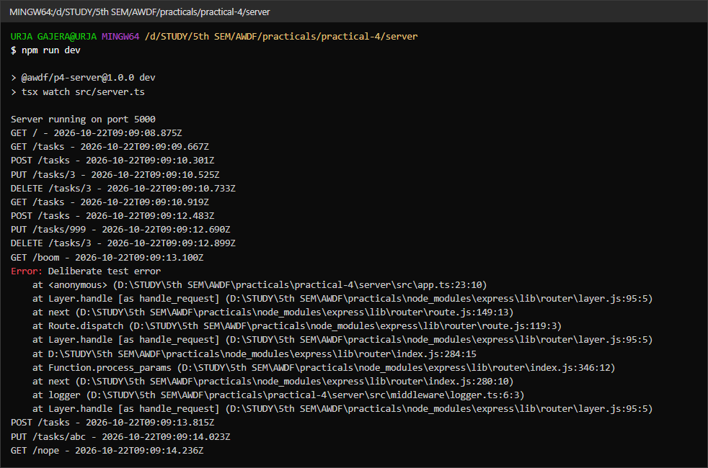
1.3 Server console — the logger prints method, URL and timestamp for every request; the error handler logs the stack on the server only

Task - 2
Aim
Supplementary problems and post-lab tasks:
• A middleware that rejects POST/PUT requests without Content-Type: application/json.
• A route-specific middleware that validates the task id format before the controller.
• A 404 handler for undefined routes that returns a structured JSON response.
Code
GitHub Repository Link: https://github.com/Urjagajera/AWDF_Practicals/tree/main/practical-4
Main files for this task:
• server/src/middleware/requireJson.ts — 415 Unsupported Media Type
• server/src/middleware/validateId.ts — used only on /tasks/:id routes
• server/src/middleware/notFound.ts
Output
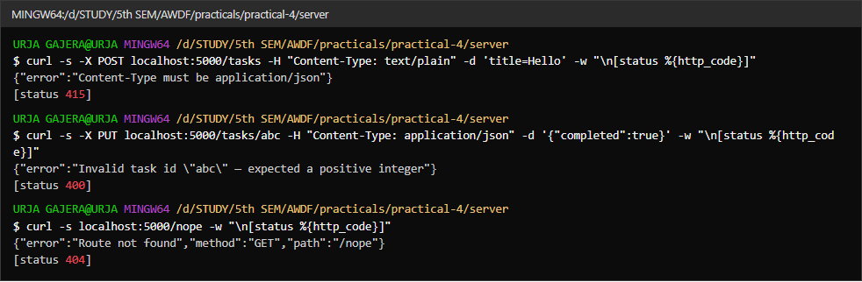
2.1 415 for a text/plain body, 400 for the id “abc” (rejected before the controller), and a structured JSON 404 for an undefined route

Key Questions / Analysis
Why must the error handler be defined last? Express runs middleware in the order it was registered. When something calls next(err), Express skips ordinary middleware and looks for the next one with four arguments (err, req, res, next) after the current point. A handler registered before the routes is never "after" them, so errors raised in routes would fall through to Express's default HTML error page.
app.use() vs route-specific middleware? app.use(fn) runs for every request that reaches it (logger, express.json()). Route-specific middleware is passed in a route definition — router.put('/:id', validateId, requireJson, updateTask) — and runs only for that method and path, so it can rely on things like req.params.id existing.
Why not send stack traces to the client? A stack trace exposes file paths, library versions and internal logic that help an attacker, and it means nothing to a normal user. The handler logs the stack on the server (console.error(err.stack)) and sends a generic message with the right status code.
Errors Faced and Fixes
• Stopping a test server started with npx tsx … & from Git Bash: pkill doesn't exist there and killing the npx wrapper left the Node process listening. The API tests now start the app in-process on a free port instead, using createApp(), which is why app.ts exports the app without calling listen().
• In the combined landing app every request first returned 404: the new .env.development setting the API base URL was not loaded until the Vite dev server restarted.

