Student ID: | : | 24CS021 | Student Name: | : | Urja Gajera
Subject code & Name | : | ITUE301 – Advanced Web Development Frameworks | Practical | : | 5 | Academic Year | : | 2026-27

Practical 5: MongoDB Integration and Schema Design with Mongoose
Task - 1
Aim
To connect the Express API to MongoDB with Mongoose, define a validated Task schema and perform real CRUD operations against a live database.
• Task schema with title (String, required), description (String), completed (Boolean, default false) and createdAt (Date, default Date.now).
• Replace the in-memory array with Task.find(), create(), findByIdAndUpdate() and findByIdAndDelete().
• Connection string read from .env (MONGO_URI); .env.example committed instead.
• Validation errors returned as structured JSON, not raw Mongoose errors.
Code
GitHub Repository Link: https://github.com/Urjagajera/AWDF_Practicals/tree/main/practical-5
Main files for this task:
• server/src/db.ts — Mongoose connection from MONGO_URI
• server/src/models/Task.ts — schema, defaults and validation
• server/src/controllers/taskController.ts — model operations, errors passed with next(err)
• server/src/middleware/errorHandler.ts — ValidationError → {"error","fields"}
• server/.env.example
Output
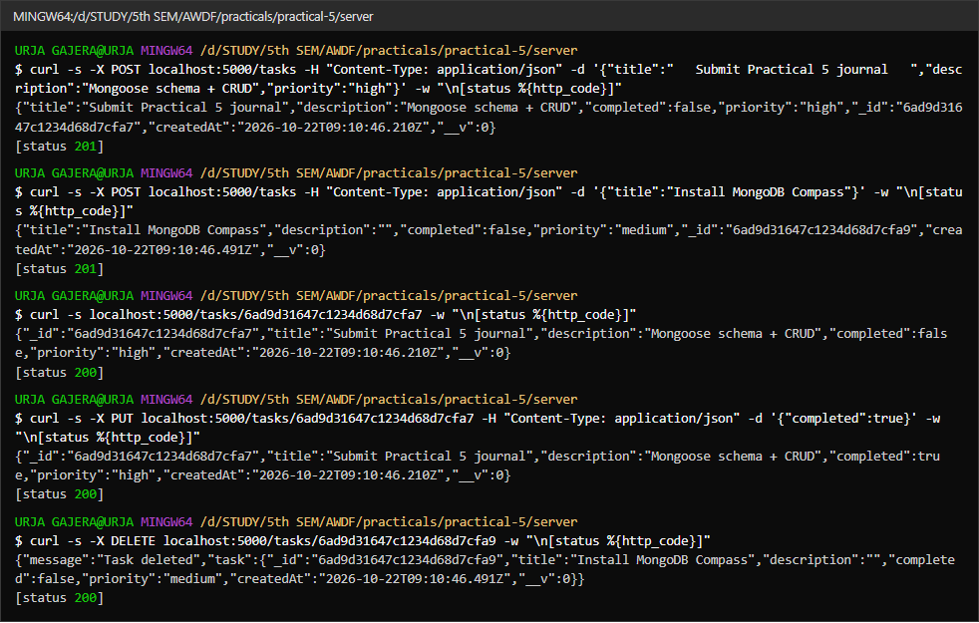
1.1 CRUD against MongoDB — defaults (completed: false, createdAt) filled in by the schema
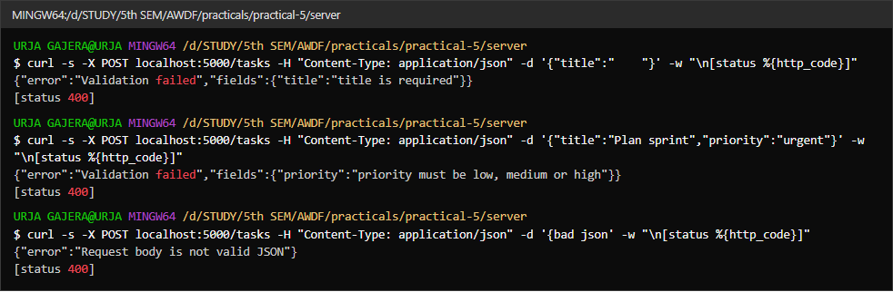
1.2 Validation errors as structured JSON — blank title, invalid priority, malformed JSON
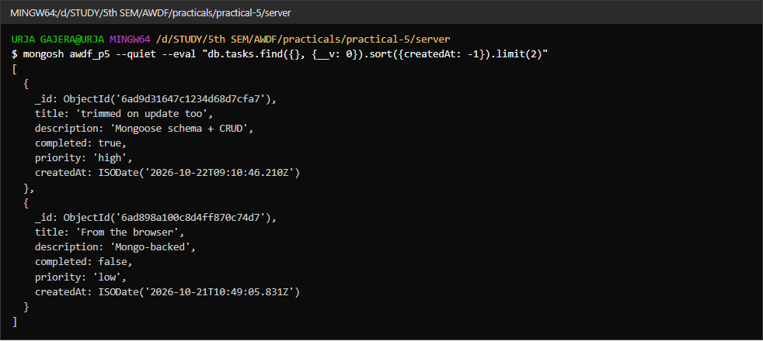
1.3 The same documents seen in MongoDB with mongosh
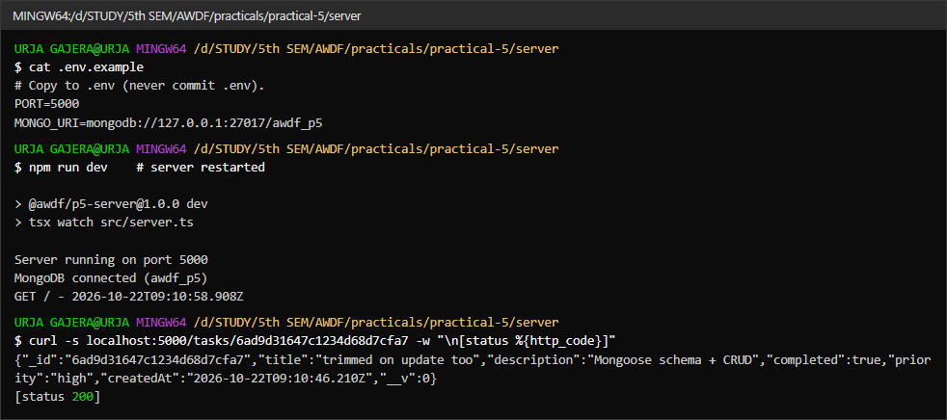
1.4 Persistence — after restarting the server, the task created earlier is still returned
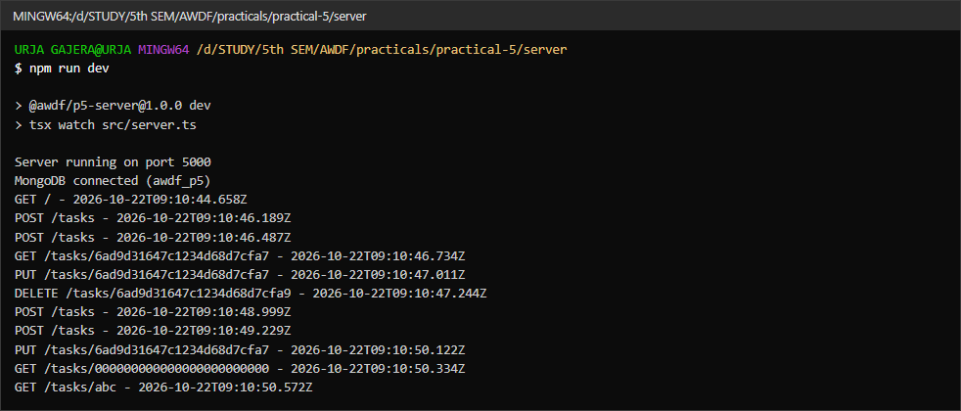
1.5 Server console — “MongoDB connected (awdf_p5)” and the request log

Task - 2
Aim
Supplementary problems and post-lab tasks:
• A priority field restricted to the enum low / medium / high.
• A pre-save hook that trims whitespace from the title.
• A GET /tasks/:id endpoint that returns a 404 JSON response for an id that does not exist.
Code
GitHub Repository Link: https://github.com/Urjagajera/AWDF_Practicals/tree/main/practical-5
Main files for this task:
• server/src/models/Task.ts — priority enum; pre("validate") and pre("findOneAndUpdate") trimming hooks
• server/src/controllers/taskController.ts — getTask with 404
• server/src/middleware/validateId.ts — isValidObjectId check
Output
2.1 “ Submit Practical 5 journal ” saved as “Submit Practical 5 journal” (trim hook); priority “high” accepted
2.2 priority “urgent” rejected by the enum
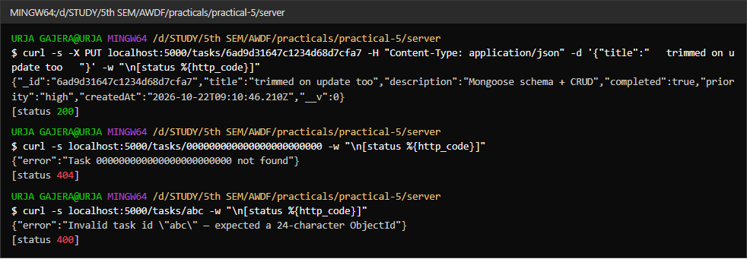
2.3 Trim on update, 404 JSON for a valid but unknown id, 400 for a malformed id

Key Questions / Analysis
What is a schema for, if MongoDB is schema-less? MongoDB accepts any document shape in a collection, which is flexible but means nothing stops a typo'd field or a task without a title. The Mongoose schema is an application-level contract: it casts types, applies defaults and rejects invalid documents, so every task in the collection has the same, predictable shape.
Why define required fields and defaults in the schema, not only in the frontend? Frontend checks can be skipped — anyone can send a request with Postman or curl. The server is the last line of defence, and the schema is the one place every write passes through, whether it comes from the React app, a script or a future mobile client.
What happens when a document fails validation? Task.create() (or the update with runValidators: true) rejects with a ValidationError before any write is sent to MongoDB. The catch in the controller forwards it with next(err), Express skips the remaining middleware and runs the error handler, which turns it into 400 {"error":"Validation failed","fields":{…}}. The database never sees the invalid document.
Errors Faced and Fixes
• A plain pre('save') trim hook let a title of " " through: Mongoose validates before save hooks run, so required saw a non-empty string. Moving the trim to pre('validate') fixed it.
• Update queries skip document hooks entirely, so the trim also needed a pre('findOneAndUpdate') hook.

