Student ID: | : | 24CS021 | Student Name: | : | Urja Gajera
Subject code & Name | : | ITUE301 – Advanced Web Development Frameworks | Practical | : | 6 | Academic Year | : | 2026-27

Practical 6: Full Stack Integration: React + Node + MongoDB
Task - 1
Aim
To integrate the React frontend with the Node/Express/MongoDB backend into a working full-stack application.
• Enable CORS on Express so the React dev server can call the API.
• Replace the GitHub data from Practical 3 with task data from our own backend.
• Create, view, update and delete tasks from the React UI through API calls.
• Data persists in MongoDB — confirmed by refreshing the browser.
• Loading and error states for every API interaction, not only the first fetch.
Code
GitHub Repository Link: https://github.com/Urjagajera/AWDF_Practicals/tree/main/practical-6
Main files for this task:
• server/src/app.ts — app.use(cors()) before the routes
• client/src/api.ts — one BASE_URL shared by every request
• client/src/pages/Tasks.tsx — list state, re-synced after each write
• client/src/components/tasks/TaskForm.tsx and TaskItem.tsx
Output
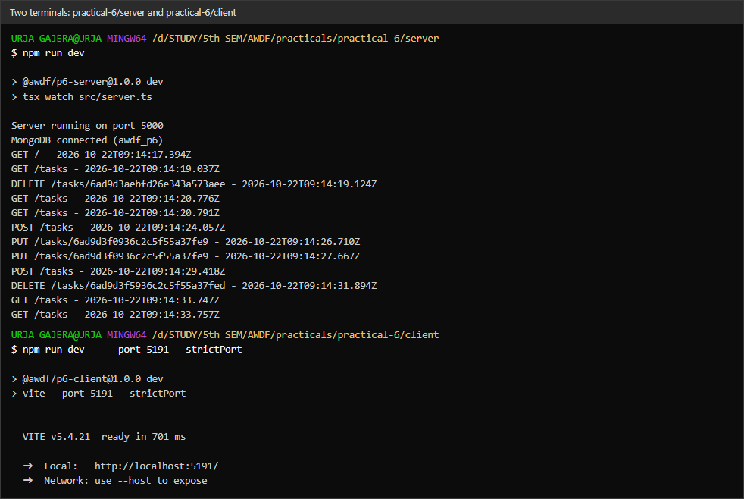
1.1 Both dev servers running — Express on 5000 and React on 5191
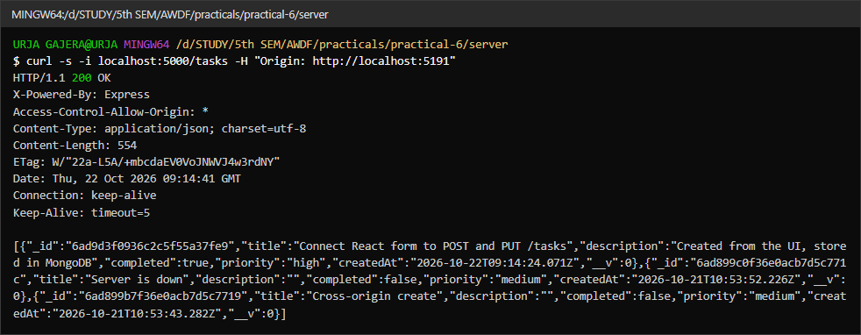
1.2 CORS — the API answers with Access-Control-Allow-Origin
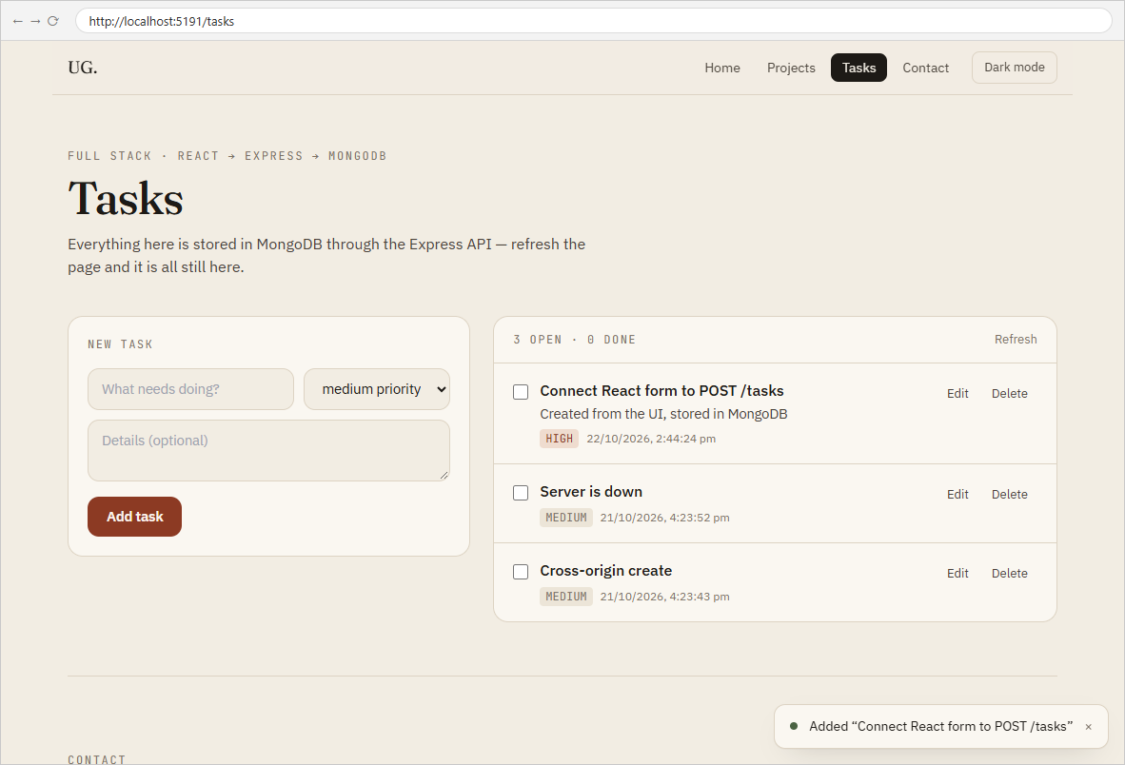
1.3 Create — the task posted from the form appears in the list
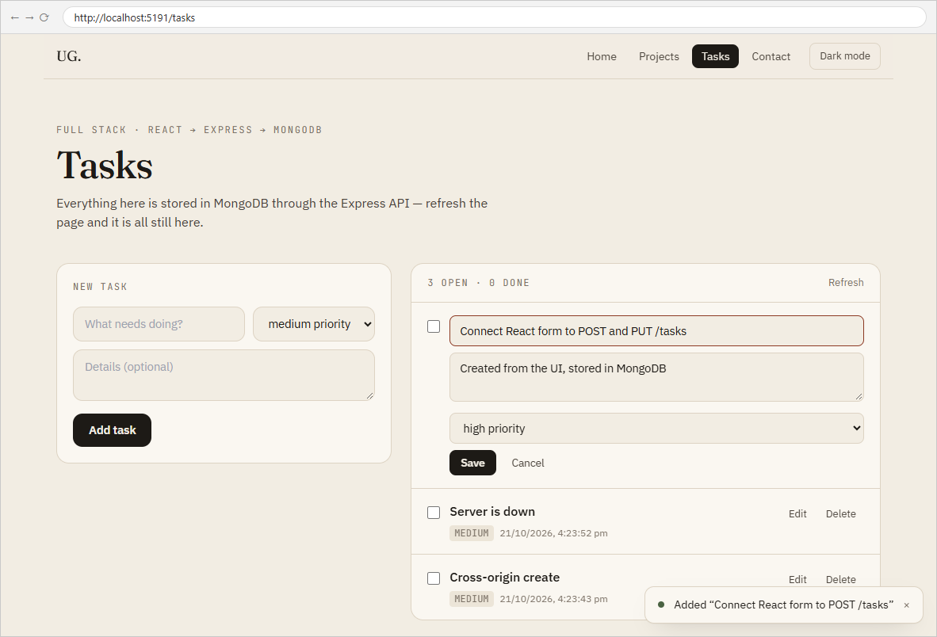
1.4 Update — editing a task in place
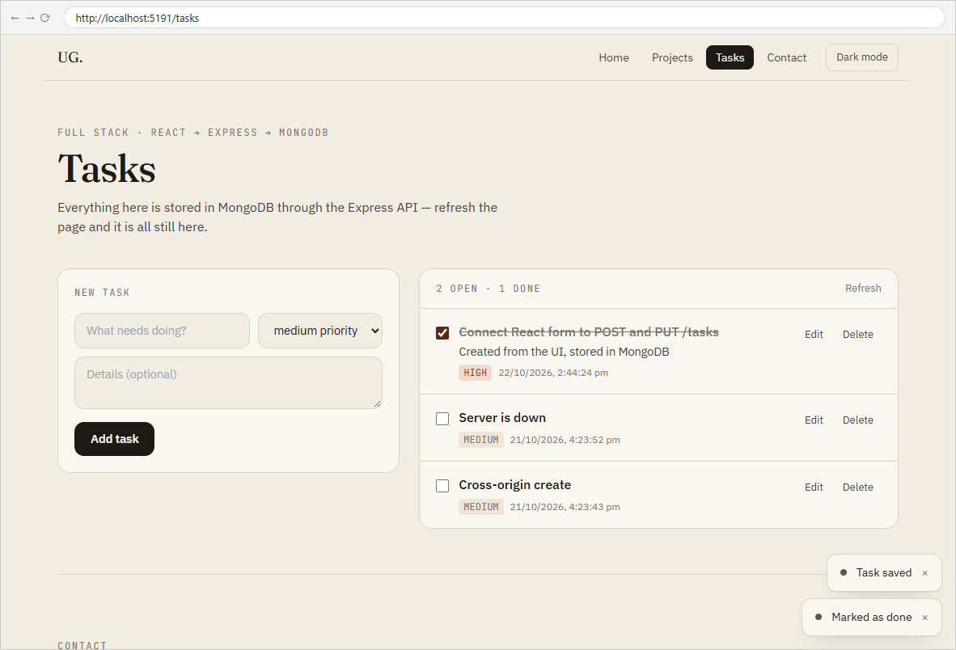
1.5 Saved and marked done (PUT) — the list reflects the server response
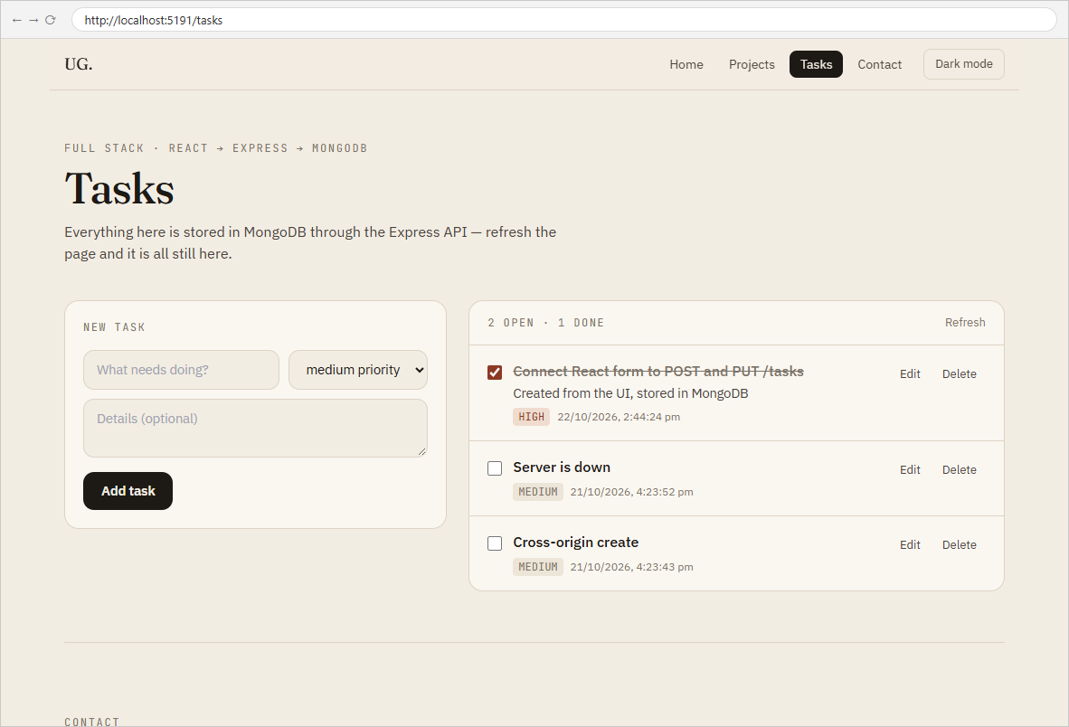
1.6 Persistence — after a browser refresh the tasks are loaded again from MongoDB
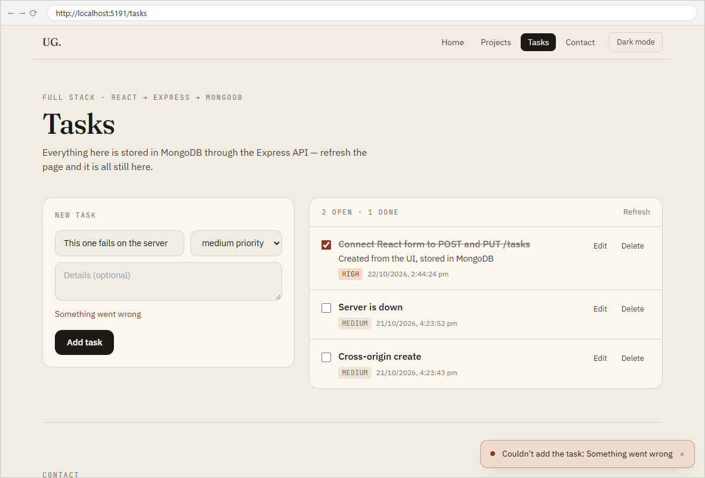
1.7 Error state on a write — the server rejected the POST and the form shows the message
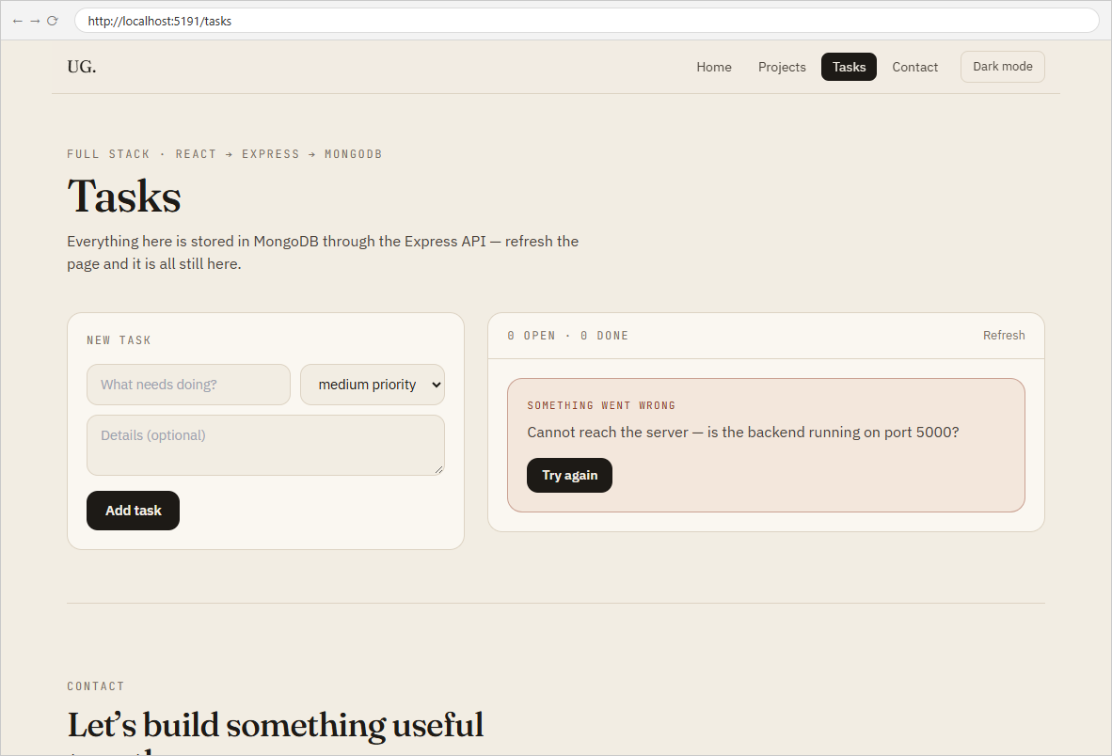
1.8 Error state on the initial load — backend unreachable, with a retry button

Task - 2
Aim
Supplementary problems and post-lab tasks:
• Optimistic UI for task creation — show the new task immediately, before the server confirms.
• A confirmation dialog before deleting a task.
• A toast notification for the success or failure of each operation.
Code
GitHub Repository Link: https://github.com/Urjagajera/AWDF_Practicals/tree/main/practical-6
Main files for this task:
• client/src/pages/Tasks.tsx — optimistic insert, replaced or rolled back on the server reply
• client/src/components/ConfirmDialog.tsx — native <dialog>
• client/src/components/Toast.tsx
Output
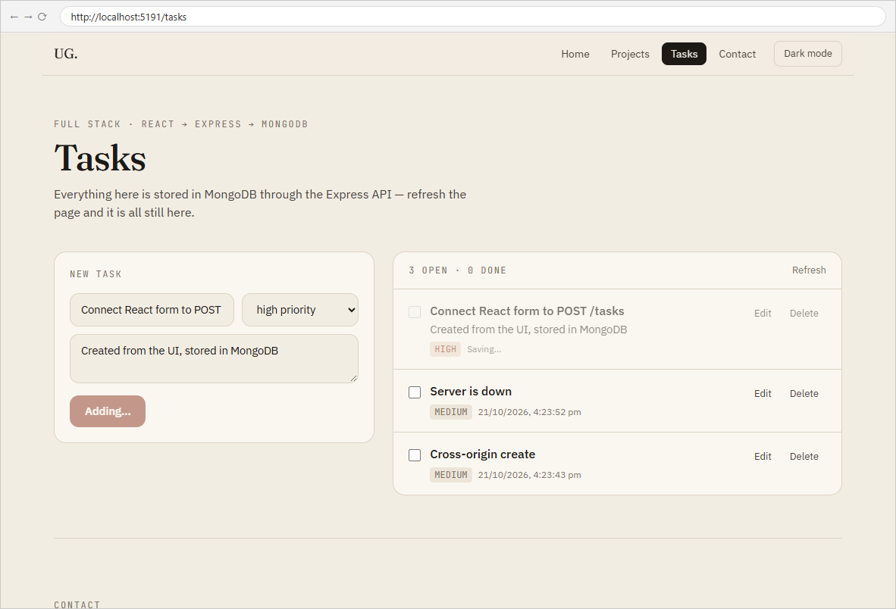
2.1 Optimistic create — the task is listed at once, marked “Saving…”, while the POST is still pending
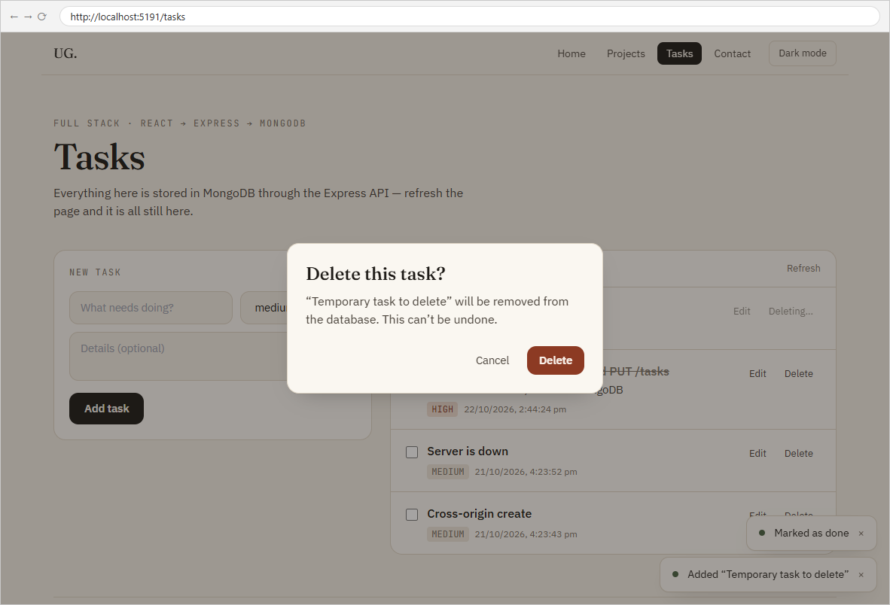
2.2 Confirmation dialog before deleting
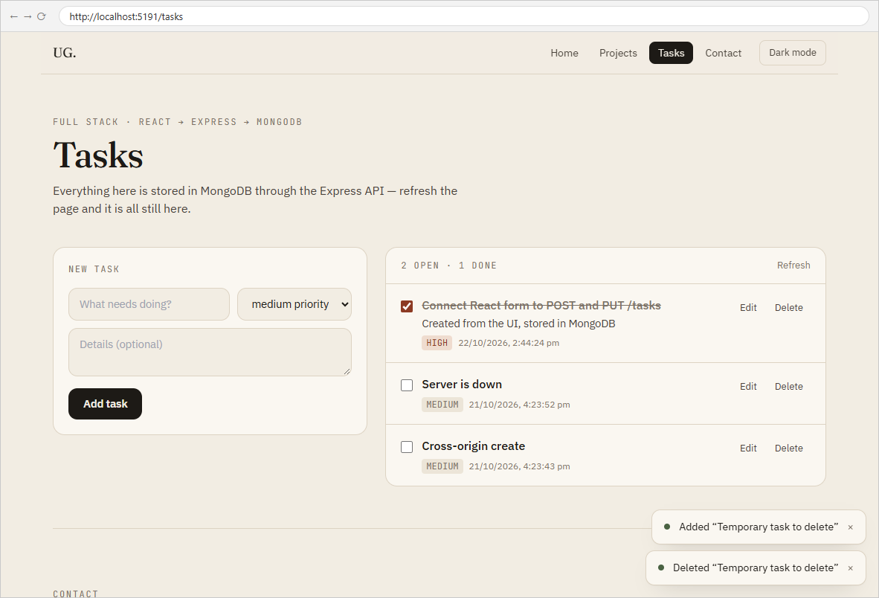
2.3 Toasts after create and delete
2.4 Failure toast — “Couldn’t add the task: Something went wrong”

Key Questions / Analysis
What backend change lets the React dev server call the API? The browser's same-origin policy blocks JavaScript on localhost:5173 from reading responses from localhost:5000 unless the server says it is allowed. The cors middleware adds Access-Control-Allow-Origin (and answers the OPTIONS preflight that browsers send before a JSON POST/PUT), so it must run before the routes.
Why update the UI from the server's response instead of assuming success? The server is the source of truth: it trims the title, fills _id, createdAt and default priority, and may reject the write altogether. Using the returned document keeps the screen identical to what is actually stored; assuming success shows data that may not exist after a refresh.
What is the risk of not handling errors on writes? A failed POST/PUT/DELETE would look like it worked — the task seems saved or deleted, the user moves on, and the change silently disappears on the next load. Reads that fail are visible (nothing shows); writes that fail are invisible unless handled, which is why each form and row reports its own errors here.
Errors Faced and Fixes
• Testing the "backend down" case: the first create after stopping the dev server still succeeded, because the server process had not finished shutting down. Repeating the request once port 5000 was free showed the expected error.

