Student ID: | : | 24CS021 | Student Name: | : | Urja Gajera
Subject code & Name | : | ITUE301 – Advanced Web Development Frameworks | Practical | : | 7 | Academic Year | : | 2026-27

Practical 7: Authentication and Middleware Pipeline
Task - 1
Aim
To add registration and login to the Task Management app, protect the task routes with JWT middleware and validate input on the server.
• Hash passwords with bcrypt before saving the User document.
• Issue a JWT on successful login with a 1 hour expiry; JWT_SECRET read from .env.
• Protect all task routes with an authentication middleware that verifies the token.
• Server-side validation that rejects malformed requests before they reach the database.
Code
GitHub Repository Link: https://github.com/Urjagajera/AWDF_Practicals/tree/main/practical-7
Main files for this task:
• server/src/models/User.ts
• server/src/controllers/authController.ts — bcrypt.hash / bcrypt.compare, jwt.sign
• server/src/middleware/auth.ts — verifies Authorization: Bearer <token>, sets req.user
• server/src/middleware/validate.ts — register, login and task rules
• server/src/routes/tasks.ts — router.use(auth)
• client/src/pages/Login.tsx — login and register in the UI
Output
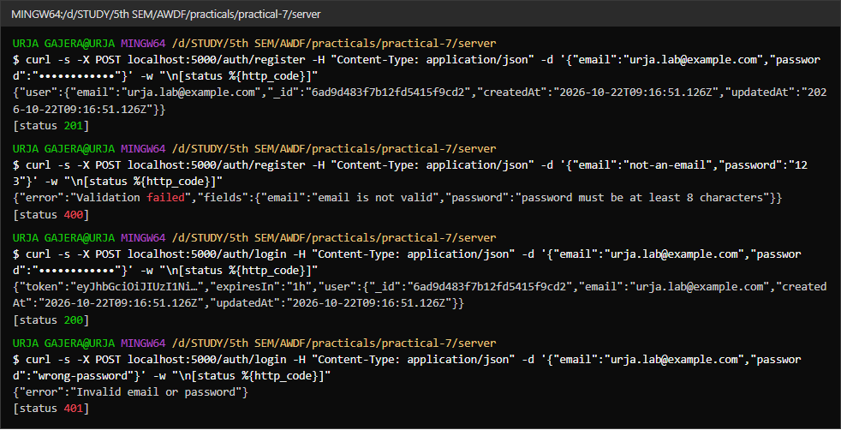
1.1 Register (201), validation errors (400), login returns a 1 h JWT (200), wrong password (401)
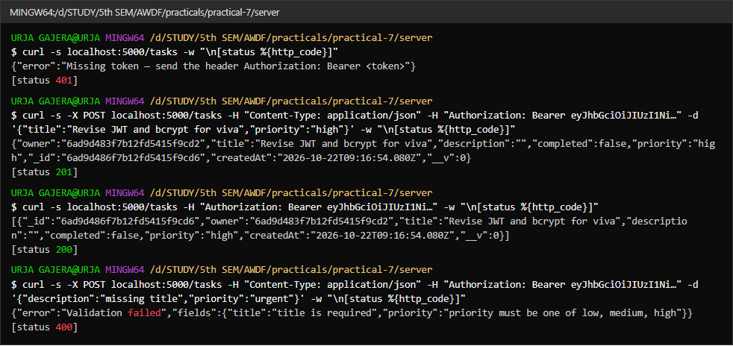
1.2 Task routes — 401 without a token; with the token they work; invalid input rejected (400)
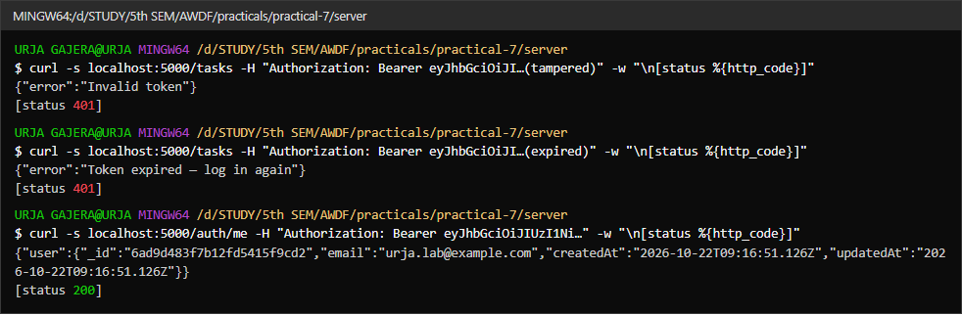
1.3 Tampered and expired tokens both rejected with 401
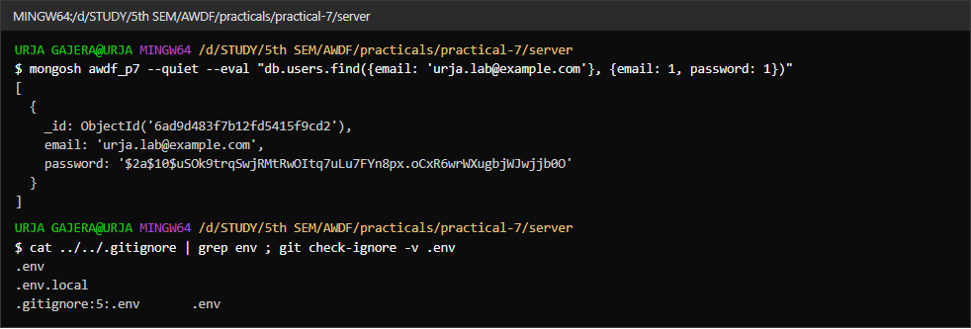
1.4 The password stored as a bcrypt hash ($2a$10$…); .env is git-ignored
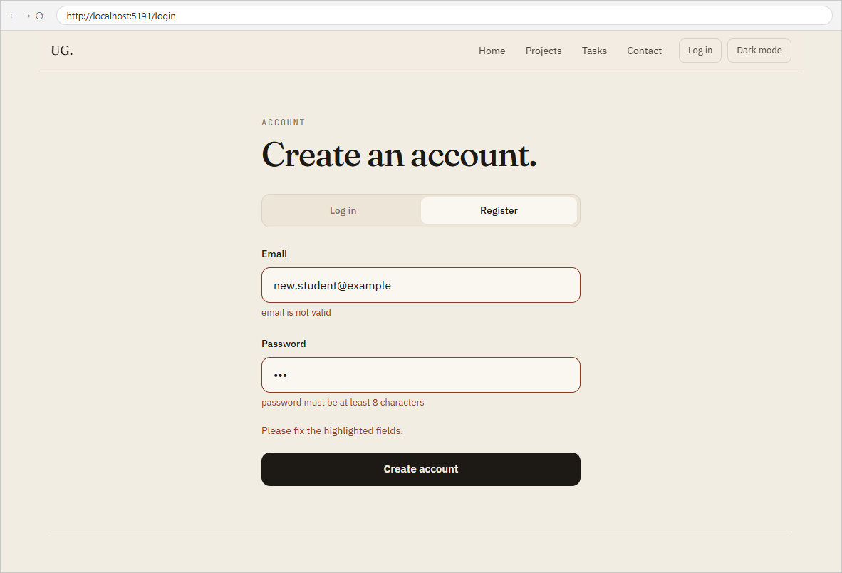
1.5 Register form showing the server’s field errors
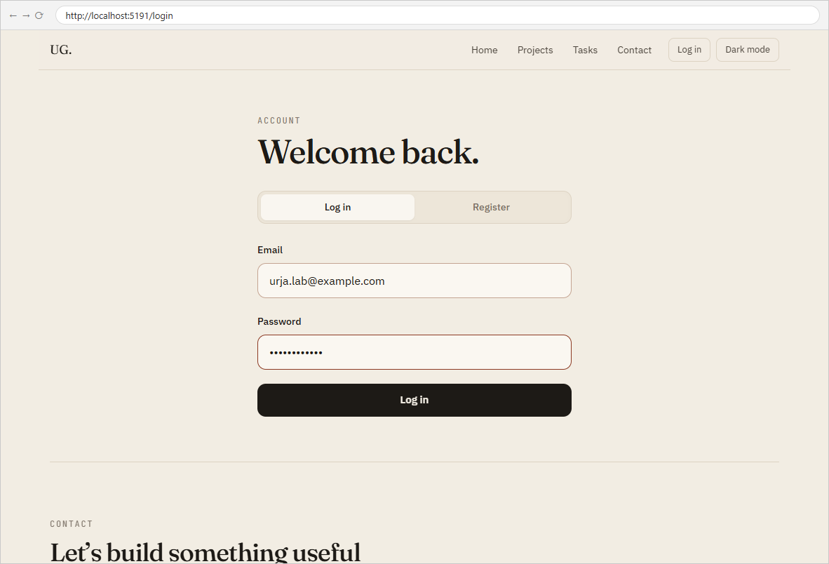
1.6 Log in page
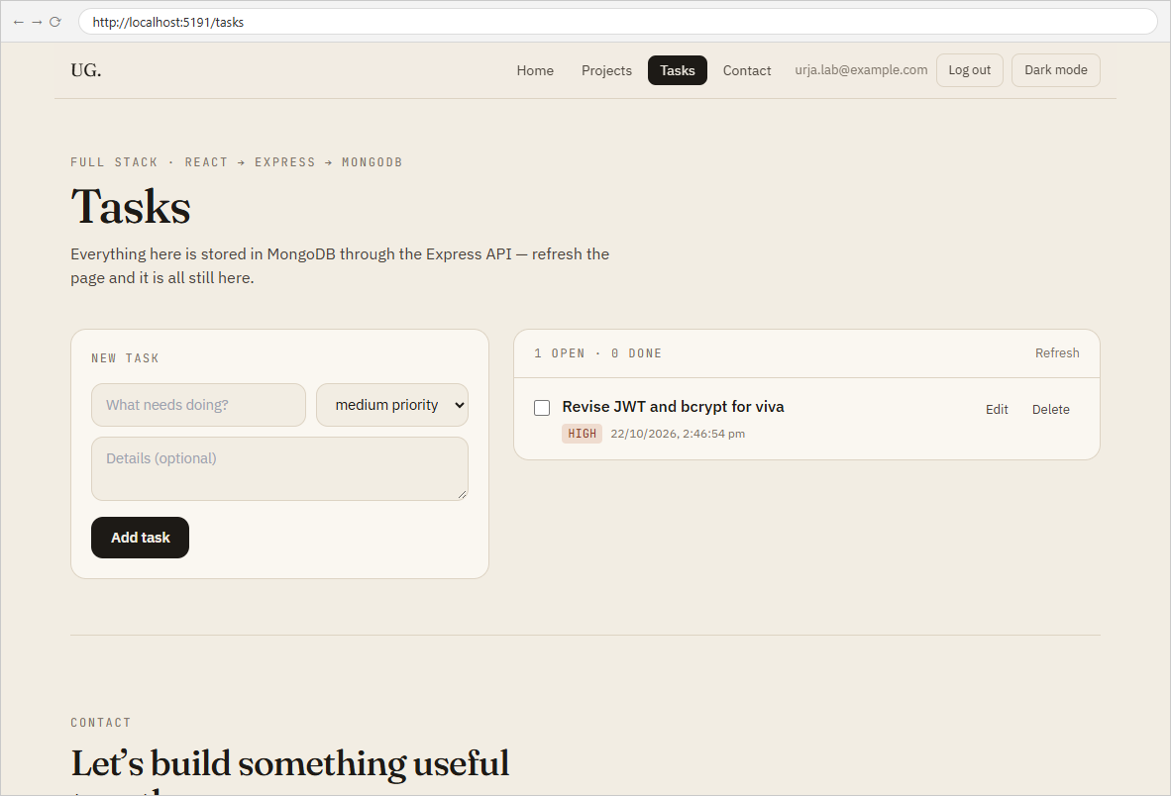
1.7 After login — only this user’s tasks, loaded with the token
Observations
Passwords in the curl commands are masked in the captures; the requests used a local test account.

Task - 2
Aim
Supplementary problems and post-lab tasks:
• A /auth/me endpoint that returns the logged-in user from the decoded JWT.
• Frontend handling of 401 — redirect to the login page when a protected request is rejected.
• A logout that clears the token from the client.
Code
GitHub Repository Link: https://github.com/Urjagajera/AWDF_Practicals/tree/main/practical-7
Main files for this task:
• server/src/routes/auth.ts — GET /auth/me behind auth
• client/src/api.ts — 401 handler clears the token and redirects
• client/src/components/AccountMenu.tsx — Log out
Output
2.1 GET /auth/me returns the user decoded from the token
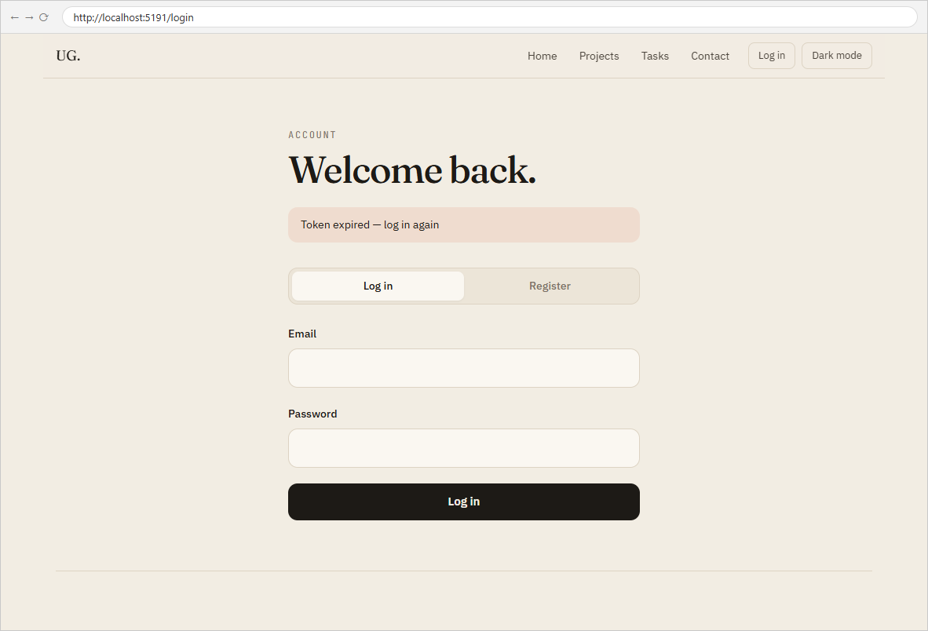
2.2 Expired token — the app returns to Log in with “Token expired — log in again”
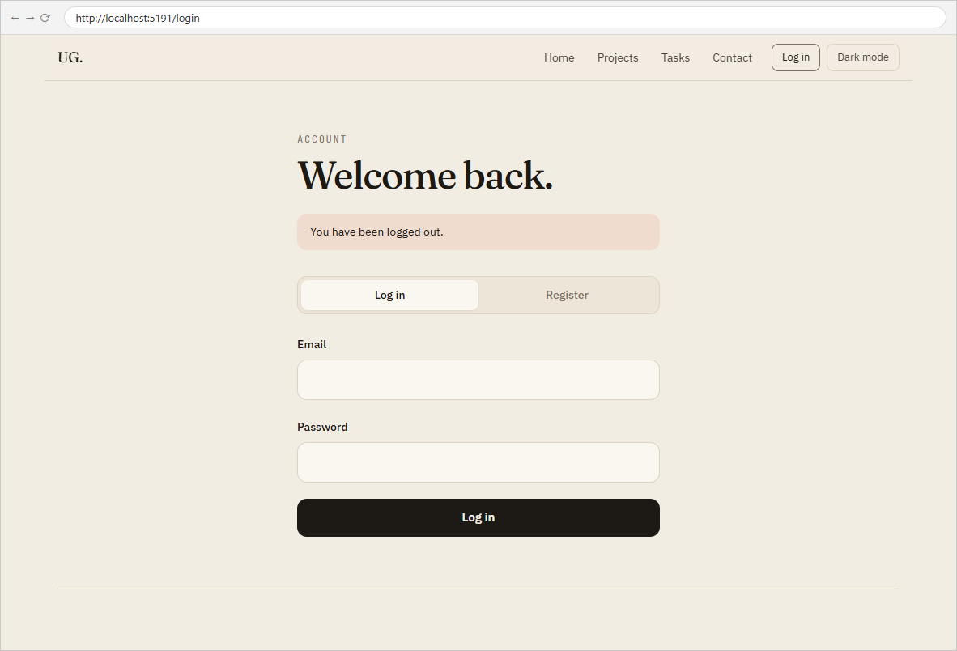
2.3 Log out — token removed from localStorage; “You have been logged out.”

Key Questions / Analysis
Why hash passwords even in a demo project? A database leak, a shared lab machine or a committed backup would expose every password in plain text, and people reuse passwords across sites. bcrypt is one-way, salts each password automatically (so equal passwords get different hashes) and is deliberately slow, which makes guessing passwords from stolen hashes expensive. Fast hashes like plain SHA-256 can be brute-forced at billions per second.
What does the auth middleware verify, and what if the token is missing or expired? jwt.verify checks that the signature was made with our JWT_SECRET (so the payload hasn't been altered) and that exp is in the future. If the header is missing, the signature doesn't match, or the token has expired, it responds 401 with the reason and the controller never runs. verify throws on failure, so it sits in try/catch — an uncaught throw would otherwise turn a bad token into a 500.
Why validate on the server when the frontend already does? The frontend is only a convenience: requests can be sent with Postman, curl or a modified page, skipping all of its checks. The server is the only place that sees every request, so it must enforce the rules. Here it also sanitises — dropping unknown fields like owner and rejecting objects where strings are expected.
Token storage note: the client keeps the JWT in localStorage, which is simple and works across reloads, but is readable by any script on the page (an XSS risk). Production apps often prefer an httpOnly cookie; for this lab the short 1 hour expiry limits the damage.
Errors Faced and Fixes
• The first test run stopped after one request: my test script sent a null body on GET requests that only had headers, and fetch refuses a body on GET. Treating null as "no body" fixed it.
• In the combined app the API server had been started before server/.env existed, so JWT_SECRET was undefined until the server was restarted — exactly the "JWT_SECRET is undefined" case from the troubleshooting guide. config.ts now fails with a clear message instead of signing with undefined.

