Student ID: | : | 24CS021 | Student Name: | : | Urja Gajera
Subject code & Name | : | ITUE301 – Advanced Web Development Frameworks | Practical | : | 8 | Academic Year | : | 2026-27

Practical 8: Performance Optimization and Lazy Loading in React
Task - 1
Aim
To reduce the initial bundle of the Task Management frontend with route-based code splitting, and to measure and document the result.
• Apply React.lazy() and Suspense to route components — at least Projects and Contact.
• Show a meaningful fallback UI while a lazy chunk is loading.
• Measure bundle size and load behaviour before and after the change.
• Document the before/after comparison with recorded values.
Code
GitHub Repository Link: https://github.com/Urjagajera/AWDF_Practicals/tree/main/practical-8
Main files for this task:
• client/src/App.tsx — lazy(() => import(...)) for Projects, Tasks, Login, Contact, NotFound
• client/src/components/PageFallback.tsx — page-shaped skeleton
• docs/performance.md — all measurements
Output
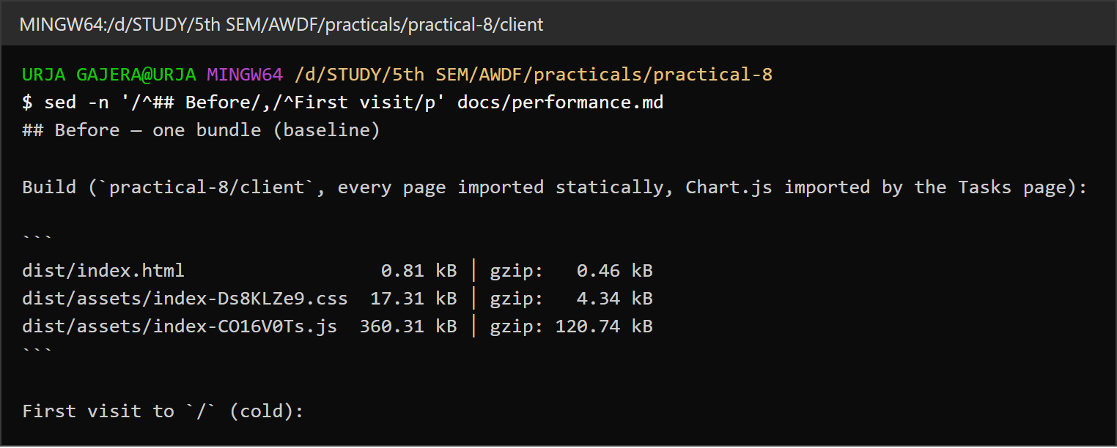
1.1 Before — one 360 kB bundle (recorded baseline in docs/performance.md)
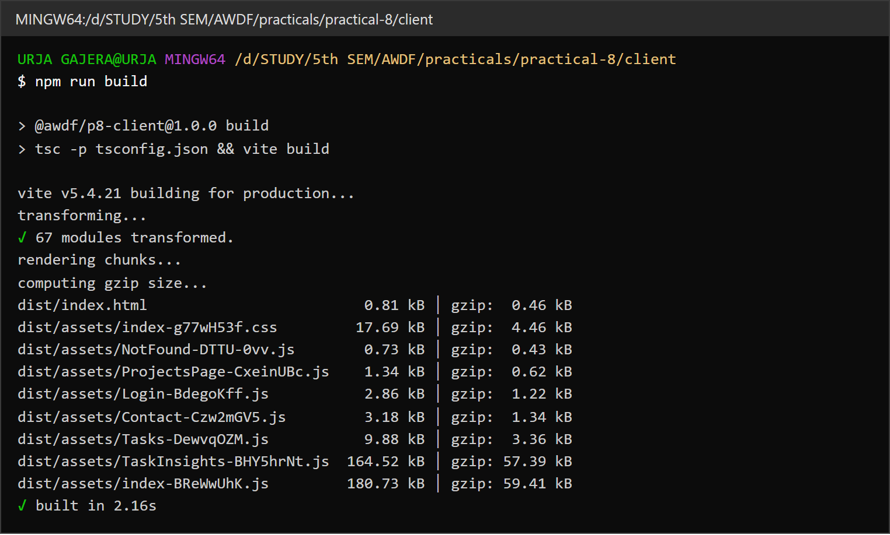
1.2 After — npm run build splits each route into its own chunk; main bundle 180 kB
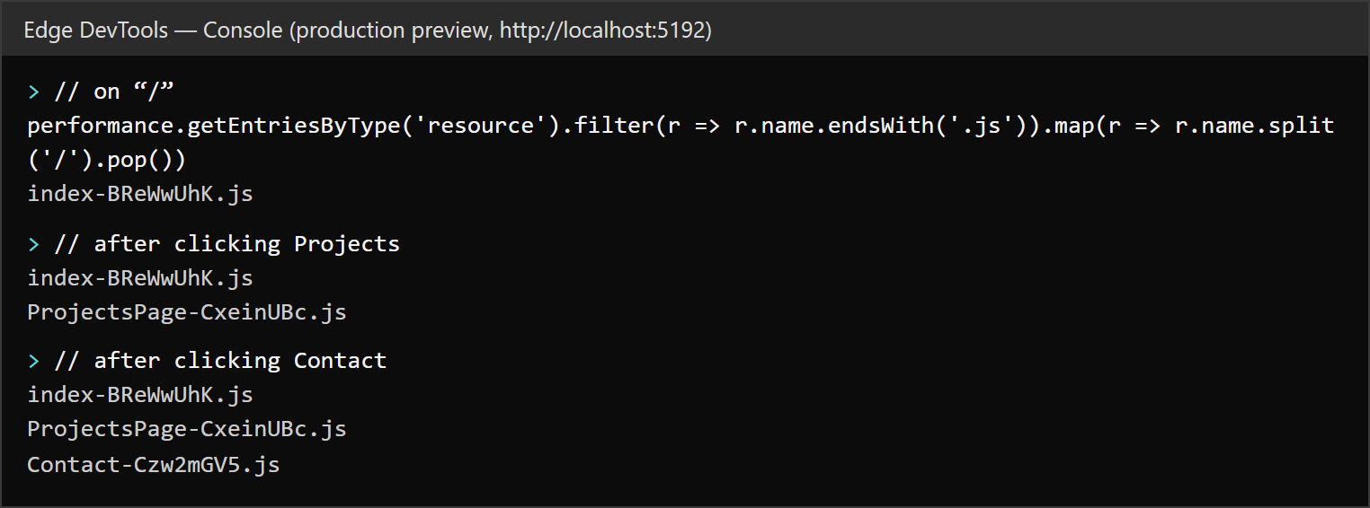
1.3 Chunks are downloaded only when their route is opened (resource timing in the production preview)

1.4 Suspense fallback — the skeleton shown while the Projects chunk is still loading

Task - 2
Aim
Supplementary problems and post-lab tasks:
• Lazy load a heavy third-party component (Chart.js) only when the page needs it.
• Add a minimum-delay (300 ms) fallback to avoid a flickering loading state.
• Use the React DevTools Profiler to find and document one unnecessary re-render.
Code
GitHub Repository Link: https://github.com/Urjagajera/AWDF_Practicals/tree/main/practical-8
Main files for this task:
• client/src/pages/Tasks.tsx — TaskInsights = lazy(...), loaded on “Show charts”
• client/src/components/tasks/TaskInsights.tsx — Chart.js charts
• client/src/components/Delayed.tsx — renders the fallback only after 300 ms
• client/src/components/tasks/TaskItem.tsx — React.memo; useCallback in Tasks.tsx
Output
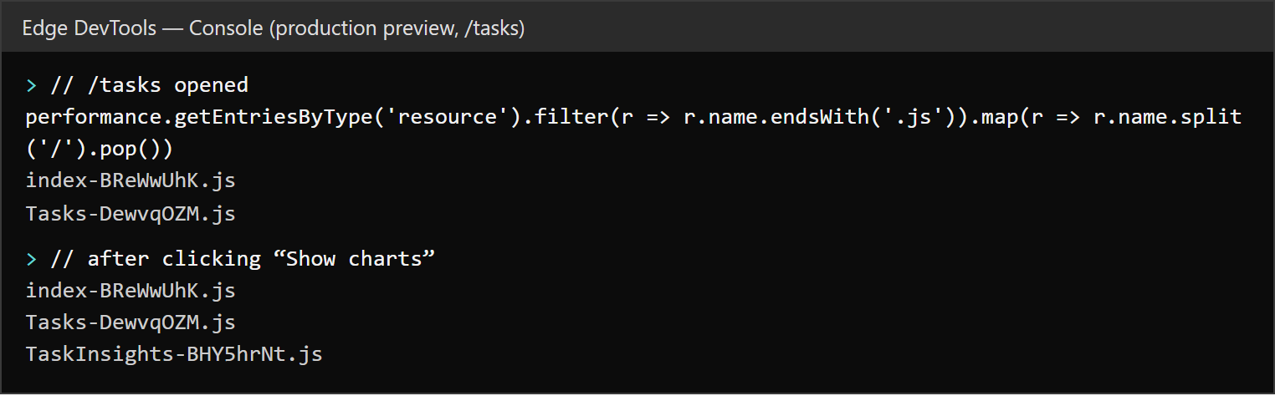
2.1 TaskInsights (Chart.js, 164 kB) is fetched only after clicking “Show charts”
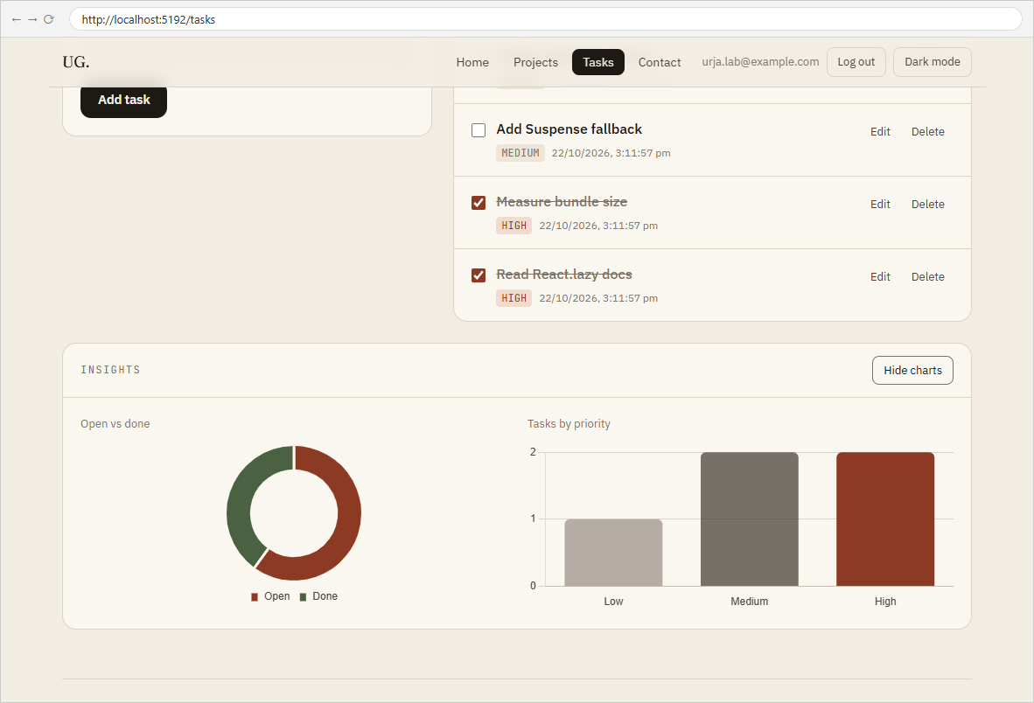
2.2 The lazily loaded charts rendered on the Tasks page
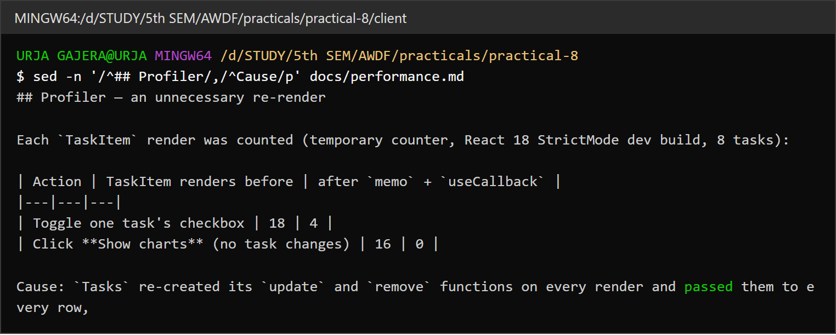
2.3 Re-render measurement — TaskItem renders 18 → 4 and 16 → 0 after memo + useCallback
Observation: With <Delayed ms={300}> around the fallbacks, chunks that arrive in under 300 ms show no loading state at all; the skeleton in output 1.4 appears only because that chunk was held back for longer.

Key Questions / Analysis
Initial bundle vs lazy-loaded chunk — when is each downloaded? The initial bundle is referenced by index.html and downloaded before the app can render anything. A lazy chunk is fetched by a dynamic import() the first time React renders the lazy component — here, the first time its route (or the charts panel) is opened. After that it is cached and reused.
Why does lazy loading improve perceived performance if the total code stays the same? The user only waits for the code needed for the screen in front of them. The first page becomes interactive after 181 kB instead of 360 kB, and the rest arrives in small pieces when needed — often never (most visitors never open the charts or the 404 page). The total over a full session is similar, but it is spread out and mostly hidden behind user actions.
When is lazy loading not worth it? For a very small app (Practical 1's whole bundle is 143 kB with nothing heavy), splitting adds extra requests and a loading state for a saving of a few kilobytes. It is also a poor fit for components needed immediately on the first screen — lazy loading those only adds a round trip. It pays off when a route or component is large and not needed by everyone.
Errors Faced and Fixes
• Reloading to take repeated timing samples gave a JS size of 0 KB on the third reload — the script came from the browser cache. Only cold first loads are used in the comparison, and byte counts from the build are treated as the reliable figure.
• Opening the charts re-rendered every task row although none had changed — traced to new function identities on each render (see the Profiler section).

