Student ID: | : | 24CS021 | Student Name: | : | Urja Gajera
Subject code & Name | : | ITUE301 – Advanced Web Development Frameworks | Practical | : | 9 | Academic Year | : | 2026-27

Practical 9: In-Memory Caching and Query Optimization
Task - 1
Aim
To add in-memory caching to the Task Management API with node-cache, keep it correct through invalidation, and measure its effect on response times.
• Cache the response of GET /tasks with a 60 second TTL.
• Invalidate the cache on every POST, PUT and DELETE so stale data is never served.
• Record response times with and without caching — at least 3 readings each.
Code
GitHub Repository Link: https://github.com/Urjagajera/AWDF_Practicals/tree/main/practical-9
Main files for this task:
• server/src/cache.ts — NodeCache (stdTTL 60), keys, hit/miss stats, on/off switch
• server/src/controllers/taskController.ts — cached(...) reads, invalidateTasks() after writes
• server/scripts/benchmark.ts — npm run benchmark
• docs/response-times.md — recorded readings
Output
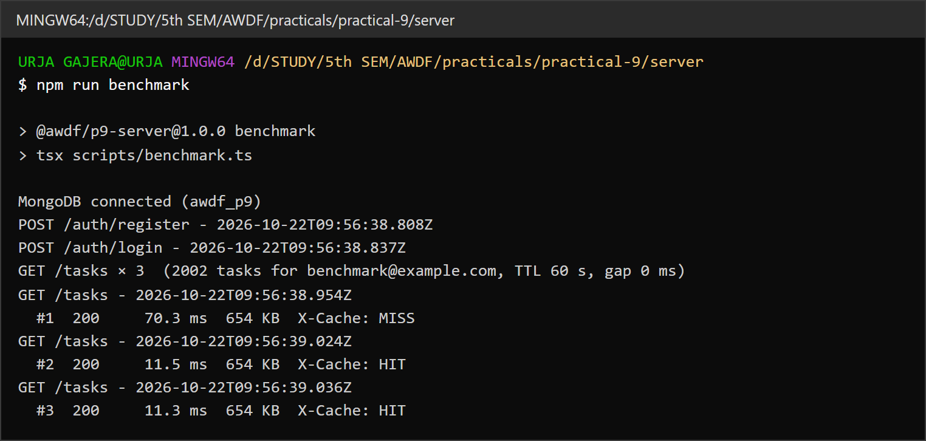
1.1 Benchmark with 2,000 tasks (654 KB) — first request MISS, then HIT, HIT
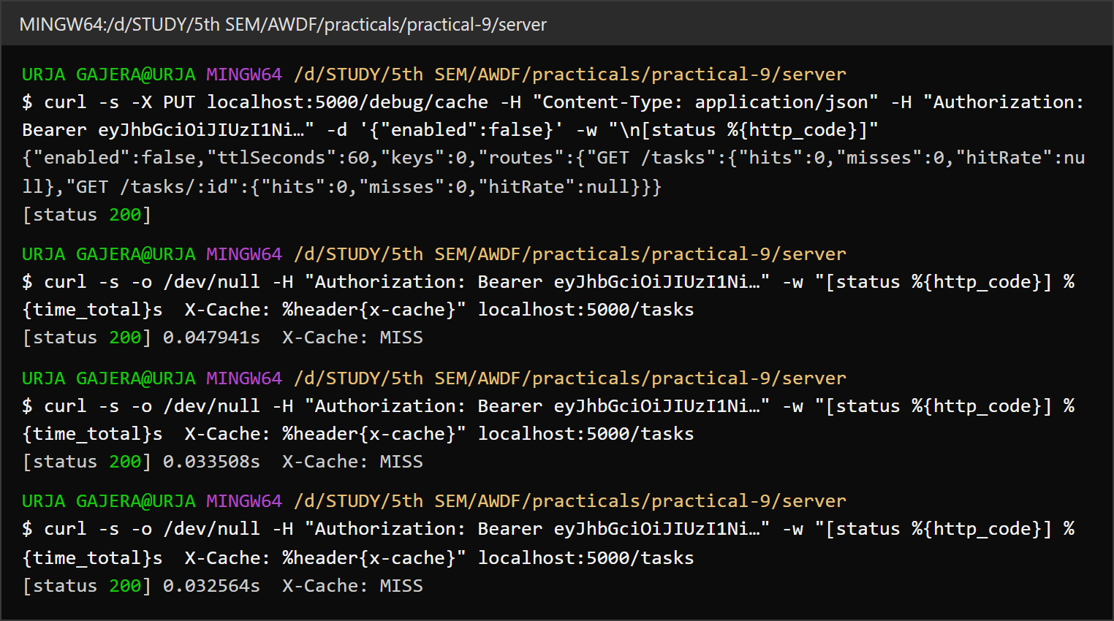
1.2 Uncached — caching switched off: every GET /tasks queries MongoDB (MISS)
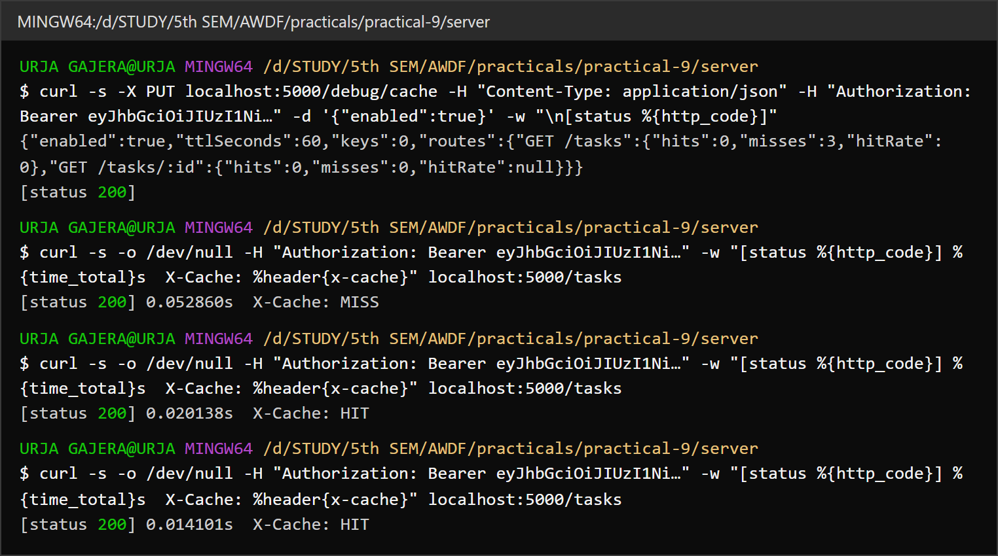
1.3 Cached — first request MISS, the next ones are served from memory (HIT)
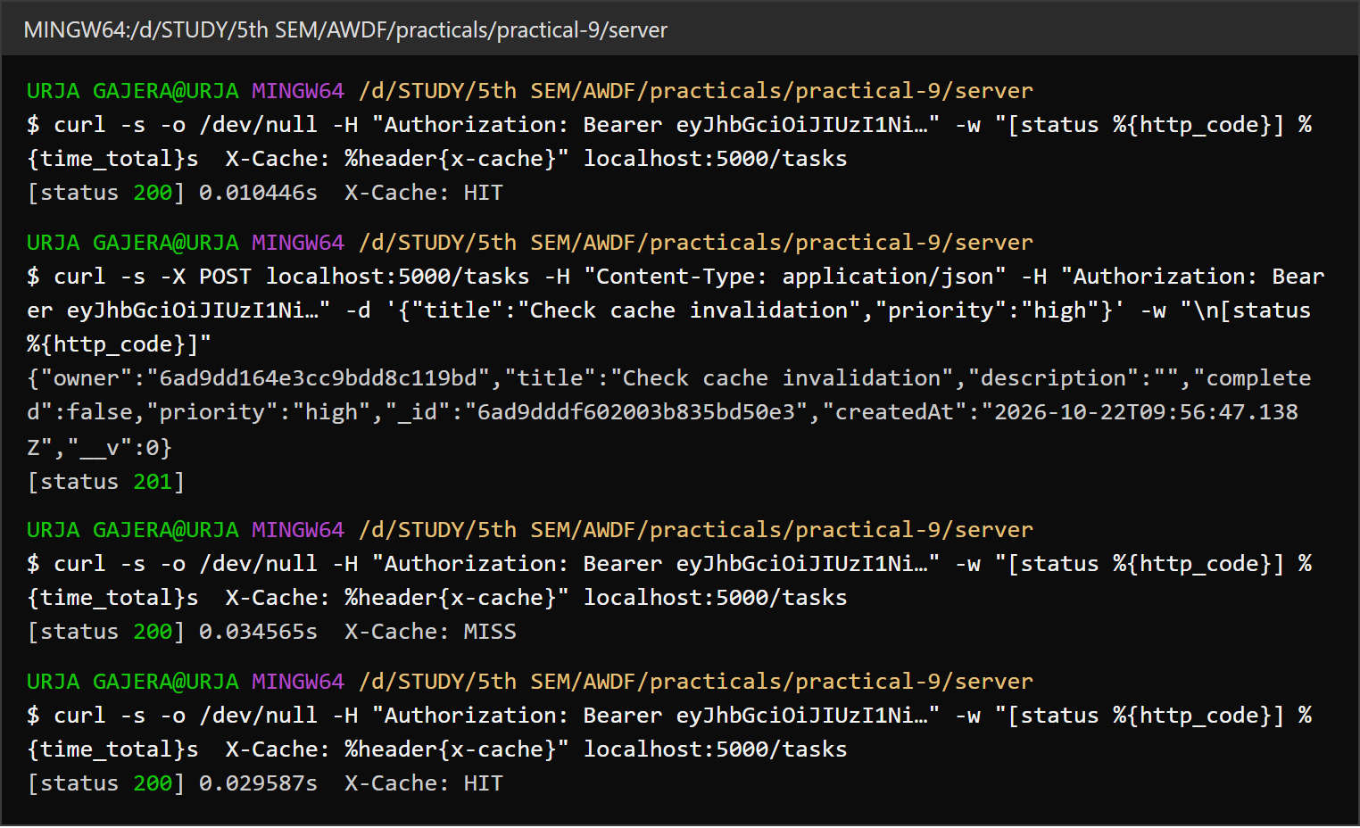
1.4 Invalidation — after POST /tasks the next GET is a MISS, so the new task is never hidden

Task - 2
Aim
Supplementary problems and post-lab tasks:
• Cache GET /tasks/:id separately from the all-tasks endpoint.
• Add a cache-hit / cache-miss counter exposed through a debug endpoint.
• Experiment with different TTL values and note staleness versus performance.
Code
GitHub Repository Link: https://github.com/Urjagajera/AWDF_Practicals/tree/main/practical-9
Main files for this task:
• server/src/cache.ts — keys.task(userId, taskId)
• server/src/routes/debug.ts — GET / PUT / DELETE /debug/cache
• client/src/components/CacheLab.tsx — browser page for the same measurements
Output
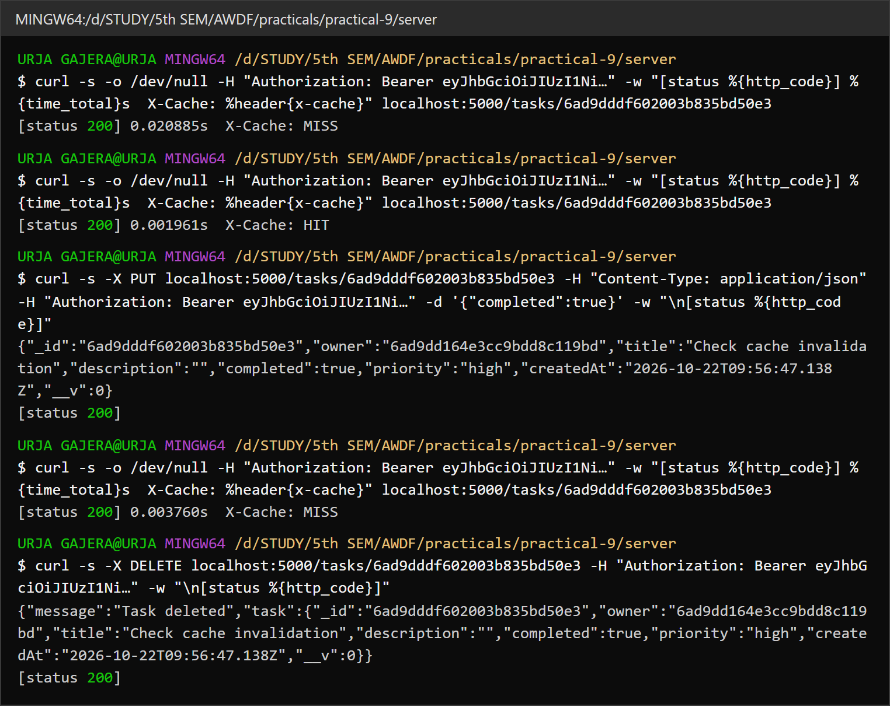
2.1 Single-task cache — MISS then HIT; a PUT on that task invalidates it (MISS again)
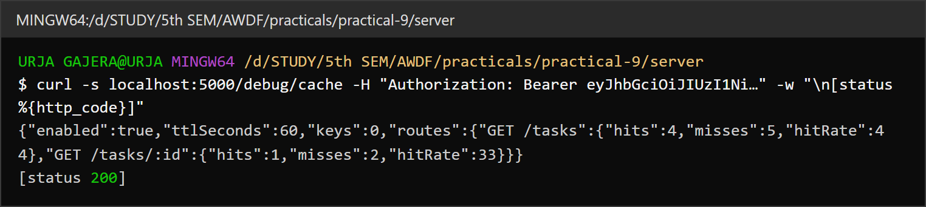
2.2 GET /debug/cache — hits, misses and hit rate per route, TTL and key count
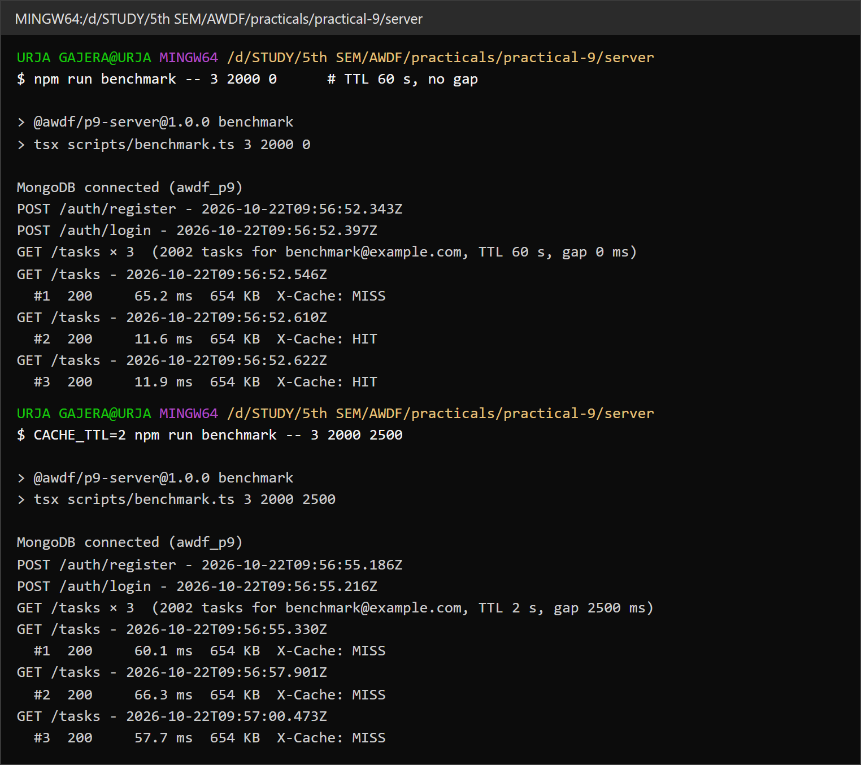
2.3 TTL experiment — 60 s TTL gives HIT, HIT; a 2 s TTL with 2.5 s gaps misses every time
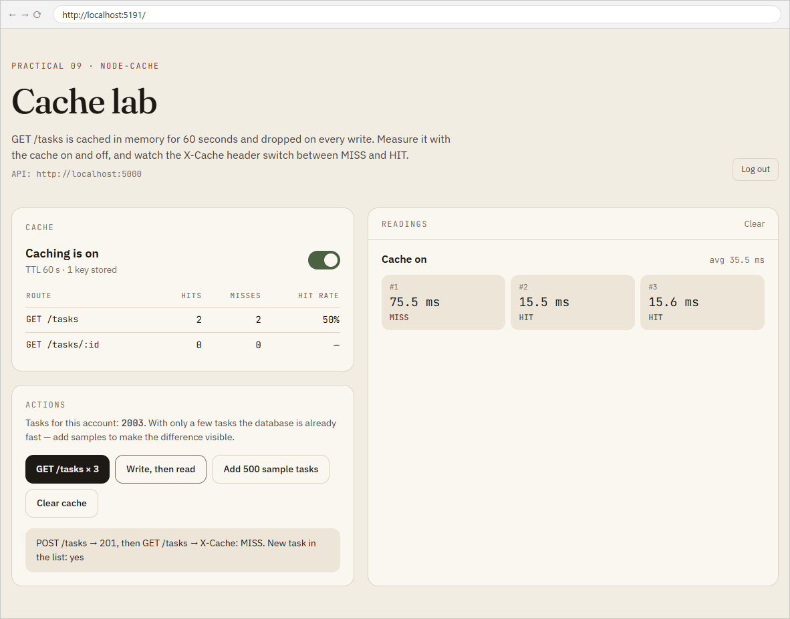
2.4 Cache lab page — readings with the X-Cache header, and the write-then-read check

Key Questions / Analysis
Why invalidate on every write, and what if we didn't? The cache holds a copy of the list as it was when it was stored. Without invalidation, a task created, edited or deleted after that would not appear in GET /tasks until the TTL ran out — up to 60 s of the UI showing deleted tasks or missing new ones, and a user who just saved something would think it failed. Deleting the key after each write means the next read always rebuilds the list from the database.
What is a reasonable TTL here, and what trade-off does it represent? With invalidation on every write, the TTL is mainly a safety net (for changes made outside this API) and a memory limit, so 60 s is reasonable for a task list. Longer TTLs give more hits but risk staler data if something bypasses the invalidation; shorter TTLs keep data fresher but hit the cache less — the experiment with a 2 s TTL and requests 2.5 s apart got no hits at all.
Why is node-cache unsuitable for several server instances? It lives in one Node process's memory. With two instances behind a load balancer, a write handled by instance A clears only A's cache; instance B keeps serving its stale copy. Each instance also builds its own copy (more database load and memory), and everything is lost on restart. A shared cache such as Redis solves this, because every instance reads and invalidates the same store.
Errors Faced and Fixes
• The lab sheet's single all_tasks key would have mixed users' lists once Practical 7 made tasks per-user; the key includes the user id for that reason. For the same kind of reason "not found" results for GET /tasks/:id are never cached, so a lookup can't hide a task for the length of the TTL.
• With only a handful of tasks, cached and uncached times were both 3–8 ms and the comparison showed nothing. Seeding 2,000 tasks (as the troubleshooting guide suggests) made the database read measurable.

