Student ID: | : | 24CS021 | Student Name: | : | Urja Gajera
Subject code & Name | : | ITUE301 – Advanced Web Development Frameworks | Practical | : | 10 | Academic Year | : | 2026-27

Practical 10: Asynchronous Processing with Event-Driven Architecture
Task - 1
Aim
To add a background notification system with Node.js’s built-in EventEmitter, so side effects run after the API has already responded.
• Emit a task-created event when a task is created through the API.
• The listener logs a notification (task title, timestamp, assigned user) without blocking the response.
• The API response returns immediately, before the handler finishes.
• Log timestamps at the response point and in the handler to show the order.
Code
GitHub Repository Link: https://github.com/Urjagajera/AWDF_Practicals/tree/main/practical-10
Main files for this task:
• server/src/events/events.ts — the shared EventEmitter
• server/src/events/listeners.ts — task-created / task-deleted / error listeners, registered at startup
• server/src/controllers/taskController.ts — res.status(201).json(...) then taskEvents.emit(...)
Output
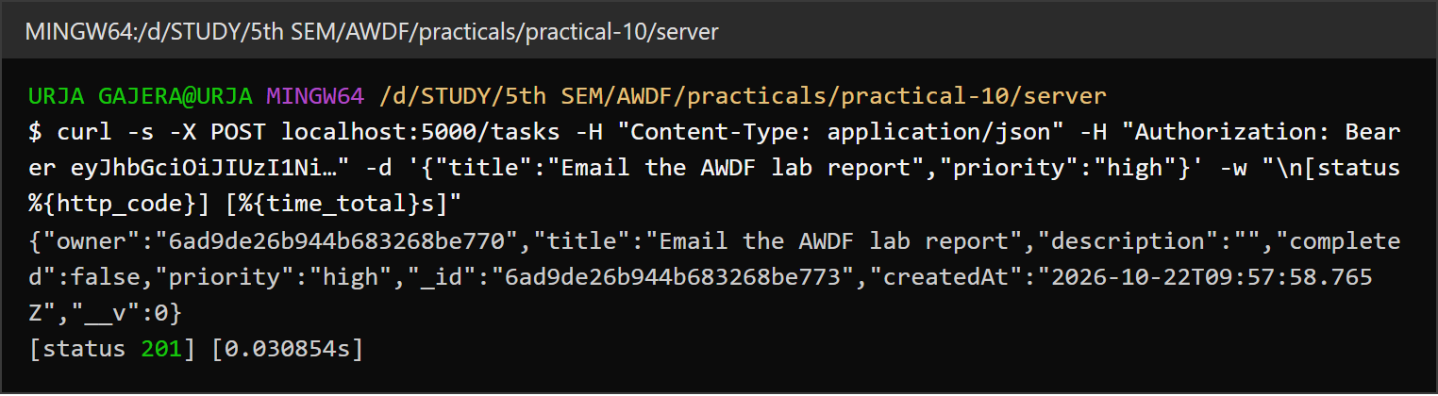
1.1 POST /tasks answers 201 in about 30 ms
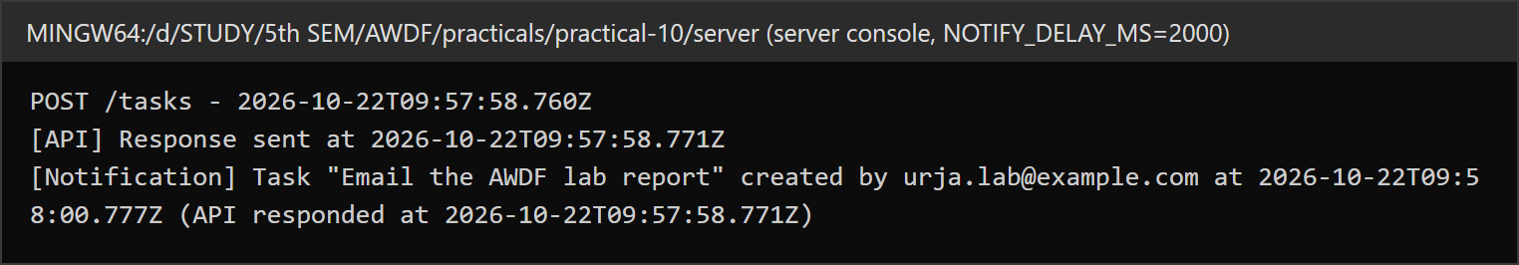
1.2 Server console — “[API] Response sent” first; the notification is logged 2 s later
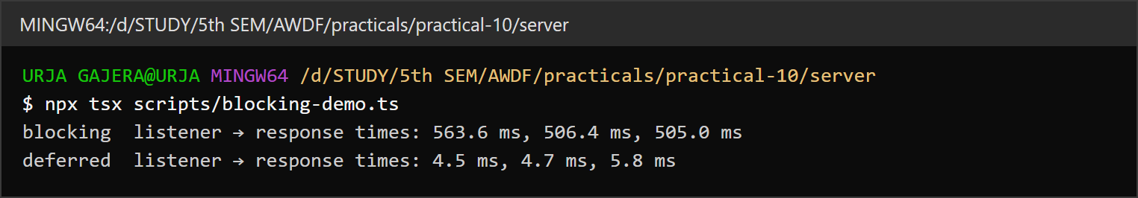
1.3 Synchronous vs asynchronous listener — 500 ms of work blocks the response only when done synchronously
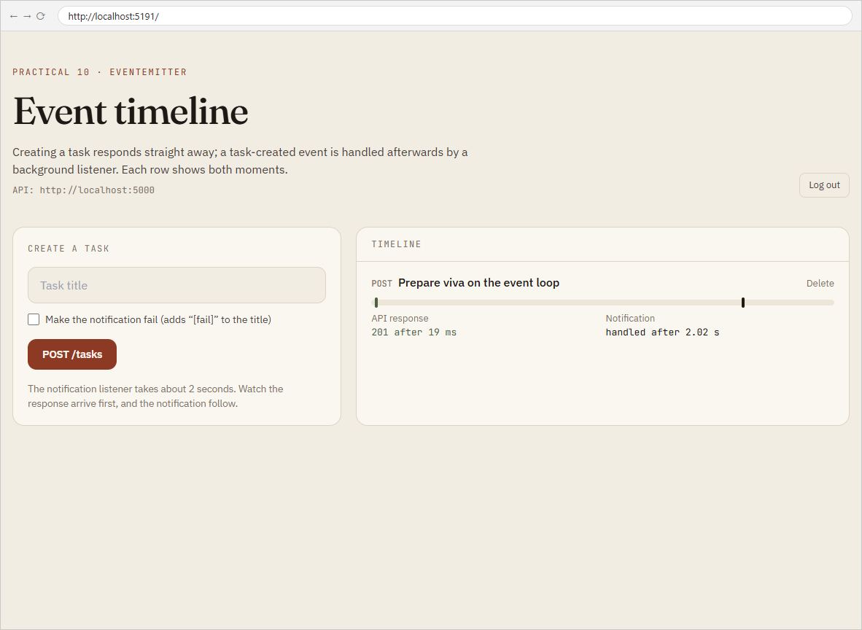
1.4 Event timeline page — API response after a few ms, notification handled after about 2 s

Task - 2
Aim
Supplementary problems and post-lab tasks:
• A second event, task-deleted, with its own listener and message.
• An error listener that catches errors thrown inside the task-created handler.
• A slow handler (2 s delay) — the API must still respond instantly.
Code
GitHub Repository Link: https://github.com/Urjagajera/AWDF_Practicals/tree/main/practical-10
Main files for this task:
• server/src/events/listeners.ts
• server/src/routes/events.ts — GET /events (recent events for the timeline)
• client/src/components/EventTimeline.tsx
Output
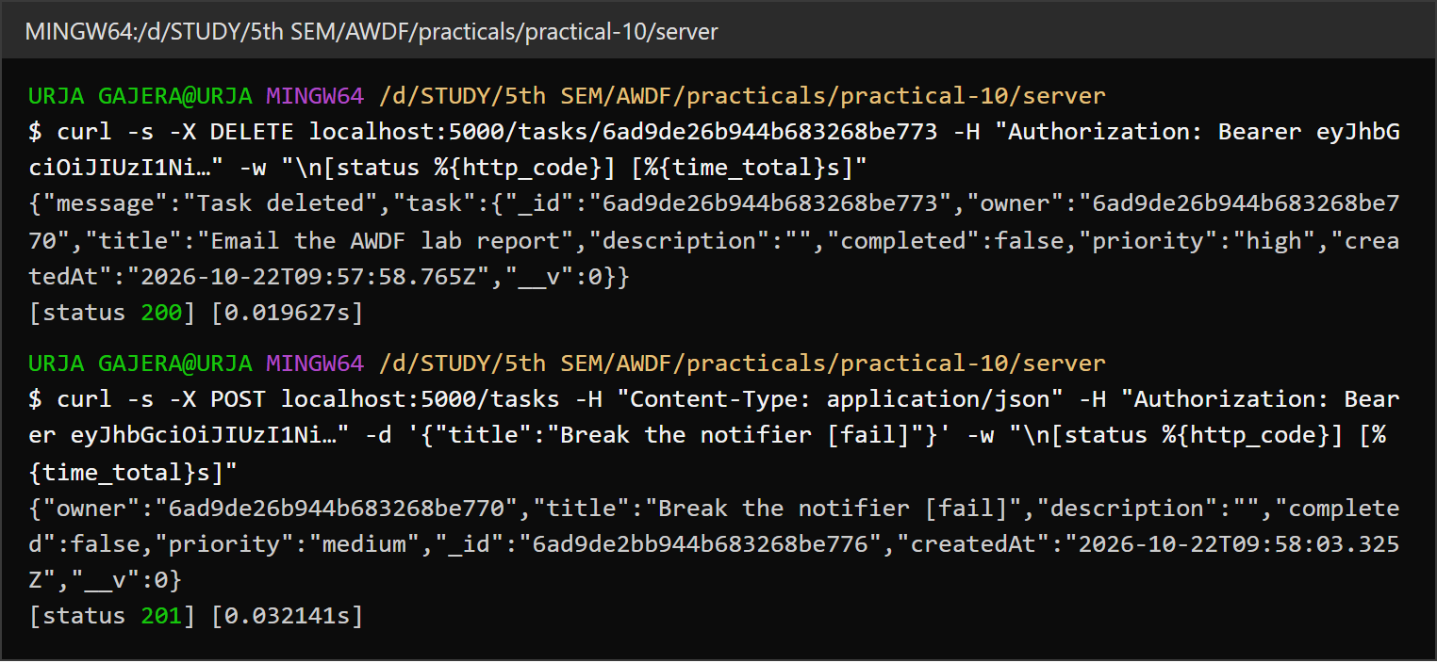
2.1 DELETE emits task-deleted; a title with “[fail]” makes the notification fail — both requests still answer at once
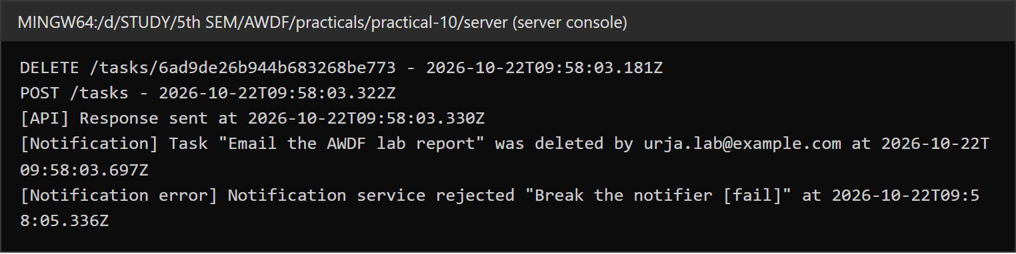
2.2 Server console — the task-deleted message and the error caught by the error listener (the server keeps running)
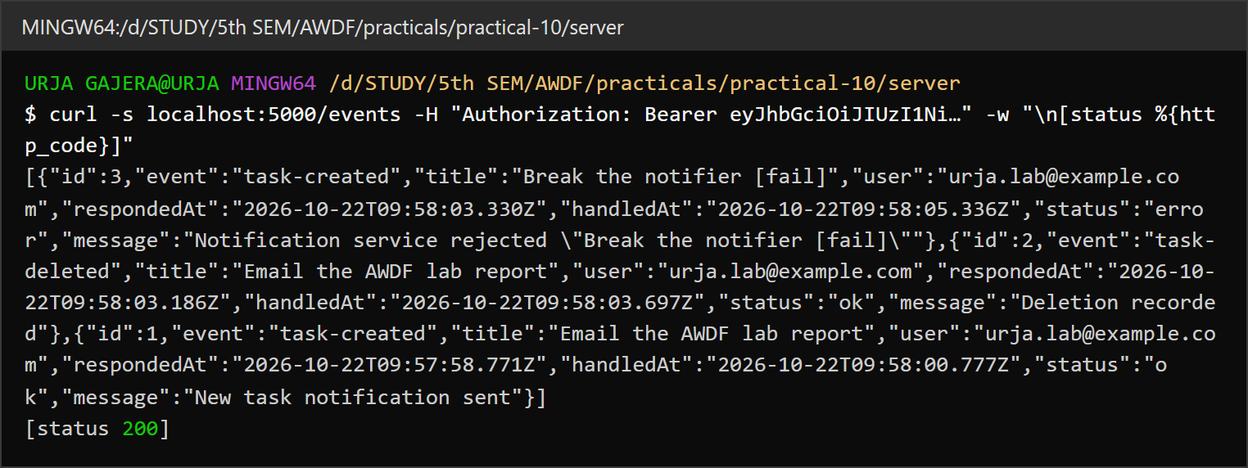
2.3 Recorded events — the failed notification is stored with status “error”
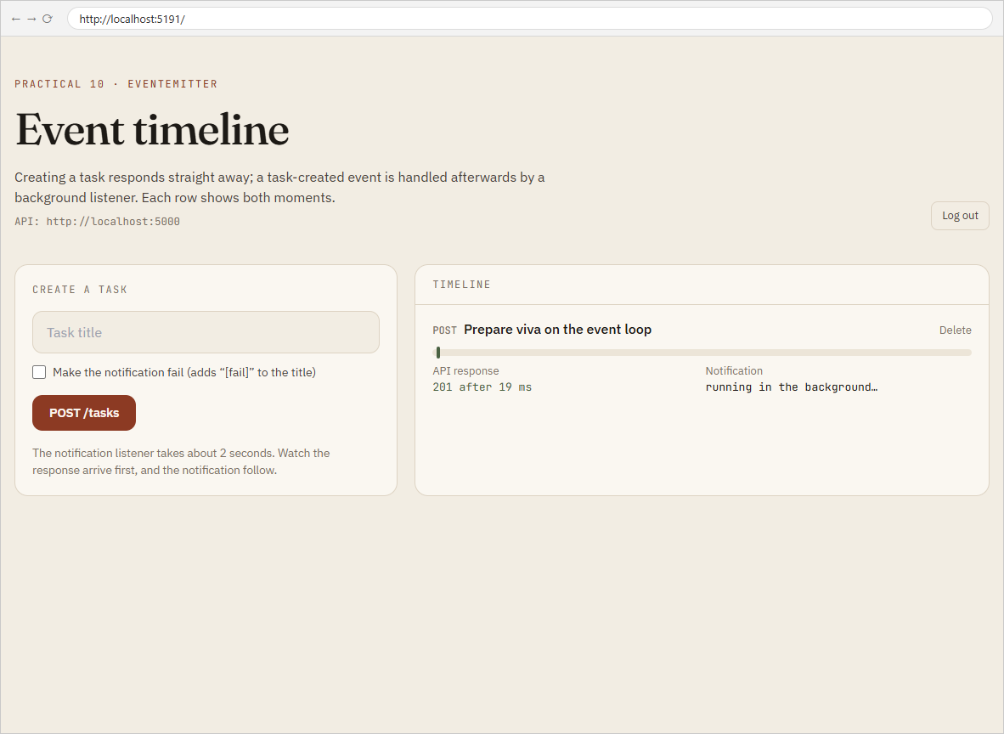
2.4 Slow handler — the task is saved and shown while the notification is still running

Key Questions / Analysis
Why doesn't emitting block the response, when both run in the same process? Strictly, emit() does run listeners synchronously — it is a plain function call. What keeps the response fast is that the route calls res.json() first and the listener immediately awaits (a timer here; an email or HTTP call in real life). That hands the single JavaScript thread back to the event loop, which flushes the response to the socket; the rest of the listener runs later, when its timer fires. The experiment in the docs shows the difference: a listener that busy-waits 500 ms delays the response to ~505 ms even though emit comes after res.json; the same 500 ms as an awaited timer gives 3–5 ms responses.
What if the notification logic were inside the POST route? The route would have to finish the notification before it could respond, so every task creation would take as long as the slowest step — about 2 s here instead of under 50 ms — and a failure in the notification would turn a successful save into an error response. Moving it to a listener decouples the user's request from side effects.
Why is EventEmitter fine here but not for millions of events a day? Everything lives in one process's memory: if the server crashes or restarts, pending events are lost; there are no retries, no persistence, and no way to spread the work across machines or to let another service consume the events. At scale you need a durable message queue (RabbitMQ, Redis/BullMQ, Kafka) with acknowledgements, retries and multiple workers. For a single-server lab app, the built-in emitter gives the same decoupling with zero setup.
Errors Faced and Fixes
• I expected emitting after res.json() to be enough on its own. Measuring it showed otherwise: with synchronous work in the listener, the response still waited (~505 ms). All listeners now start with an await so the response is flushed first.

