Student ID: | : | 24CS021 | Student Name: | : | Urja Gajera
Subject code & Name | : | ITUE301 – Advanced Web Development Frameworks | Practical | : | 11 | Academic Year | : | 2026-27

Practical 11: Containerization with Docker and Docker Compose
Task - 1
Aim
To containerise the full Task Management stack and run frontend, backend and MongoDB together with one Docker Compose command.
• A Dockerfile for the React frontend and one for the Node/Express backend.
• A docker-compose.yml that orchestrates frontend, backend and MongoDB.
• Port mappings and an internal Docker network so the services can talk to each other.
• The whole application starts with a single docker-compose up, with no manual steps.
Code
GitHub Repository Link: https://github.com/Urjagajera/AWDF_Practicals/tree/main/practical-11
Main files for this task:
• practical-11/client/Dockerfile — build with Node, serve dist/ with nginx
• practical-11/client/nginx.conf
• practical-11/server/Dockerfile
• practical-11/docker-compose.yml — mongodb, backend, frontend on app-network
Output
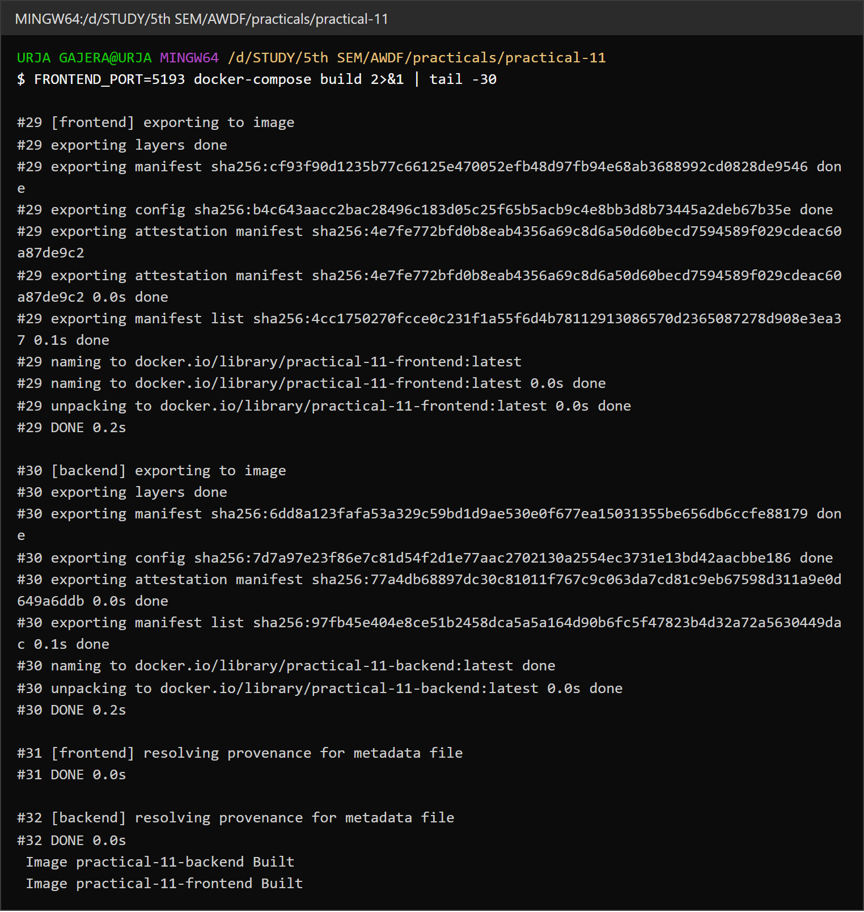
1.1 docker-compose build — both images built (last lines of the build output)
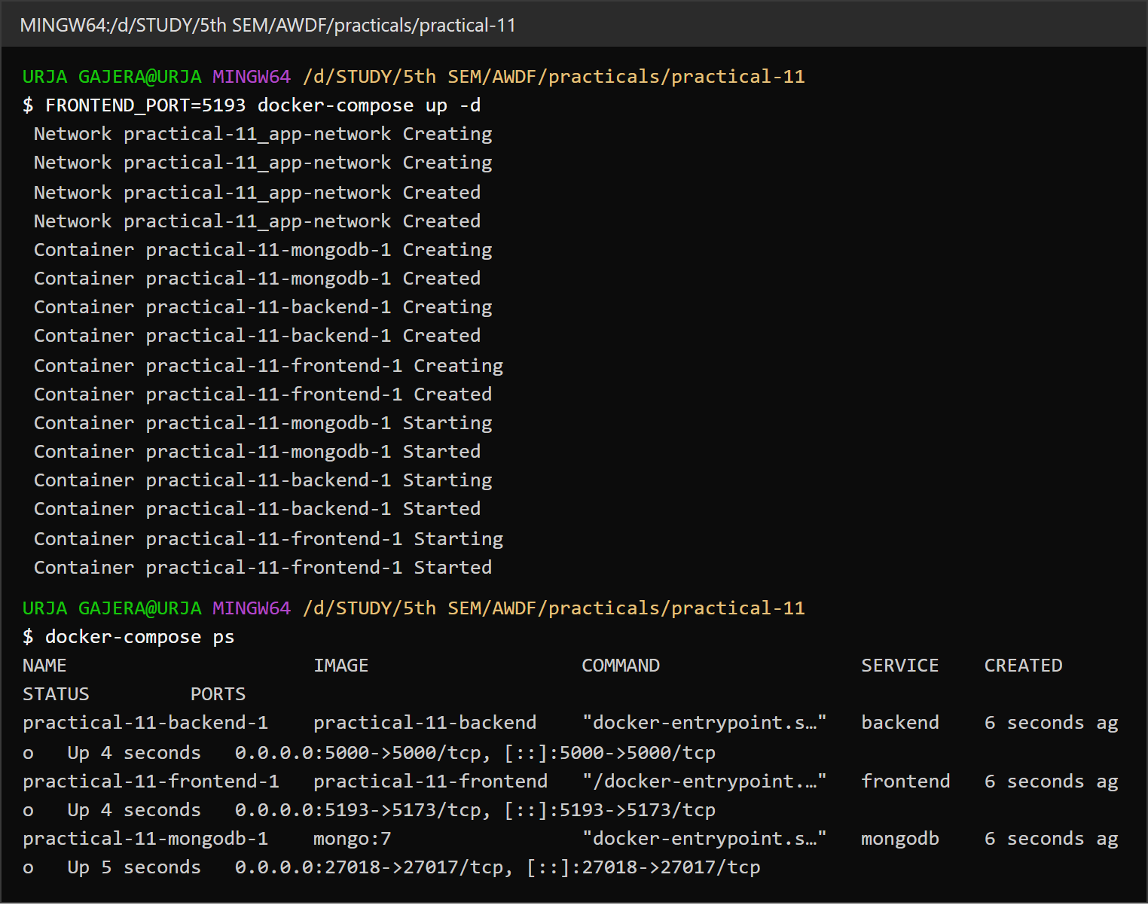
1.2 docker-compose up -d — network and 3 containers created and started; docker-compose ps shows the port mappings
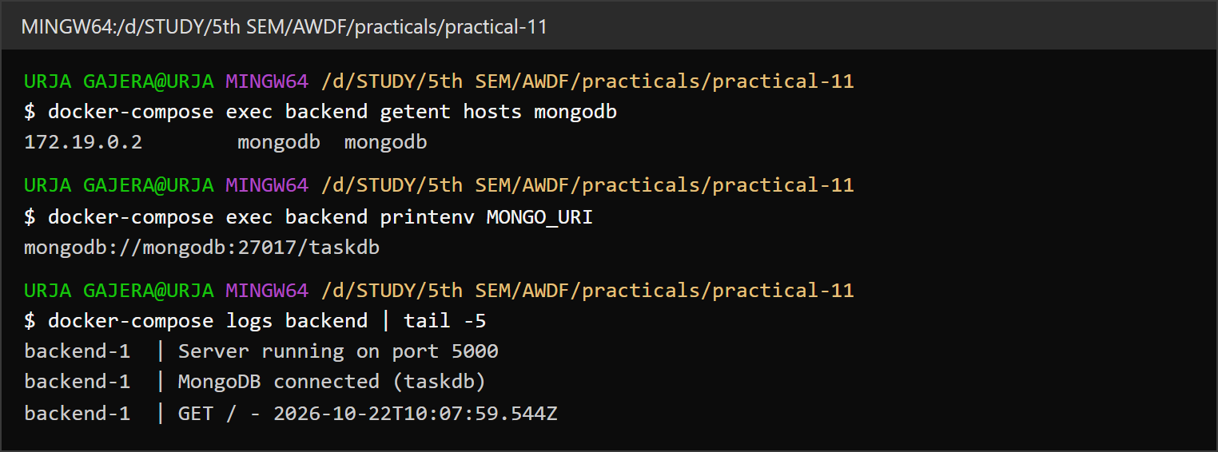
1.3 The backend reaches MongoDB by its service name “mongodb” on the internal network
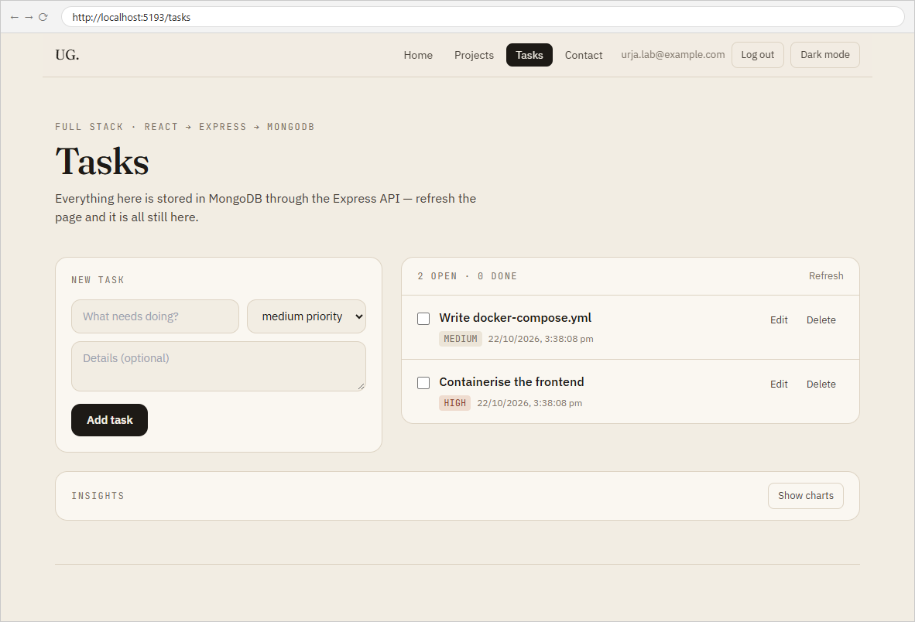
1.4 The app served by the frontend container (port 5193 → 5173), logged in, with tasks from the backend container
Observation: The frontend is published on host port 5193 (FRONTEND_PORT=5193) because port 5173 is used by another project on this machine; inside the container it still listens on 5173.

Task - 2
Aim
Supplementary problems and post-lab tasks:
• A .dockerignore that keeps node_modules and .env out of the build context.
• A multi-stage build for the React frontend to reduce the final image size.
• A named volume for MongoDB so data persists across container restarts.
Code
GitHub Repository Link: https://github.com/Urjagajera/AWDF_Practicals/tree/main/practical-11
Main files for this task:
• practical-11/client/.dockerignore and practical-11/server/.dockerignore
• practical-11/client/Dockerfile — stage 1 node:18 build, stage 2 nginx:1.27-alpine
• practical-11/docker-compose.yml — volumes: mongo-data:/data/db
Output
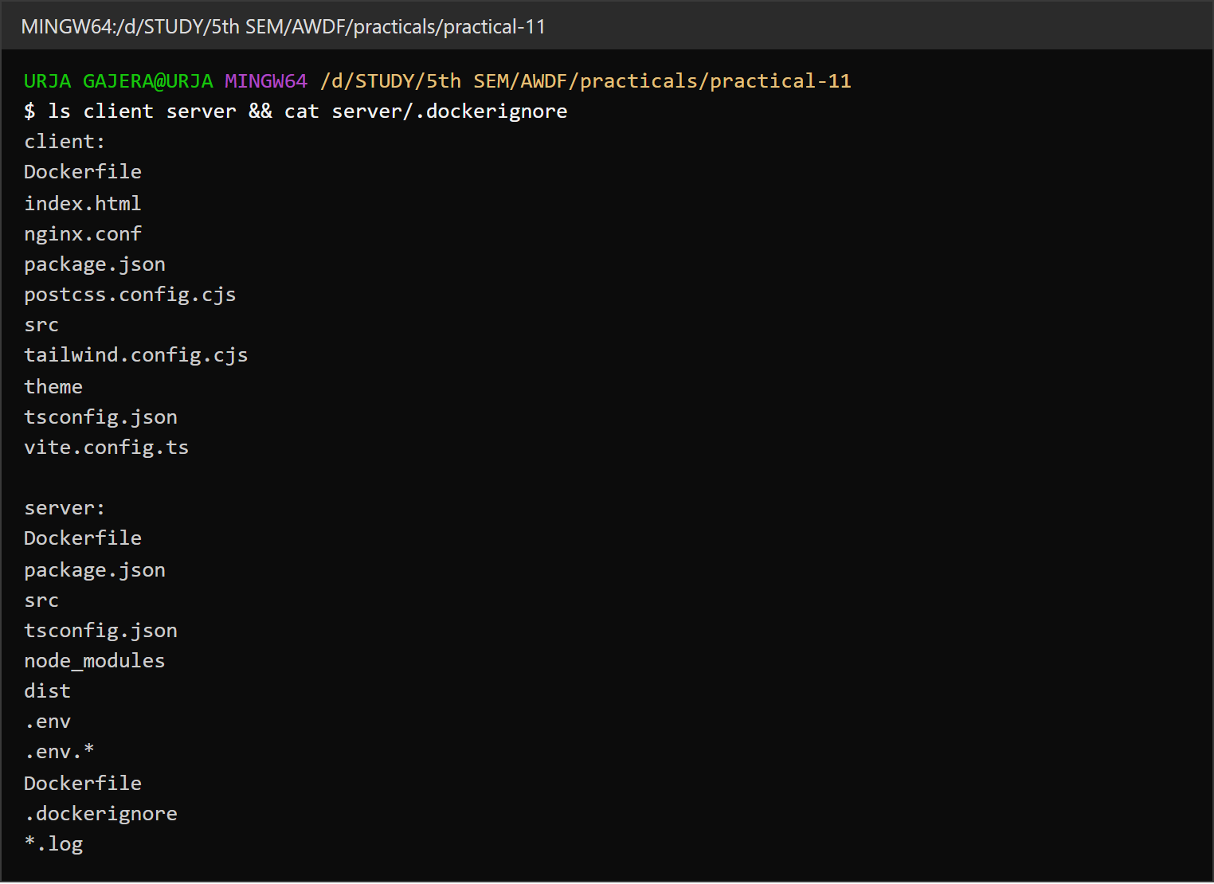
2.1 Project files and server/.dockerignore (node_modules, dist, .env excluded)
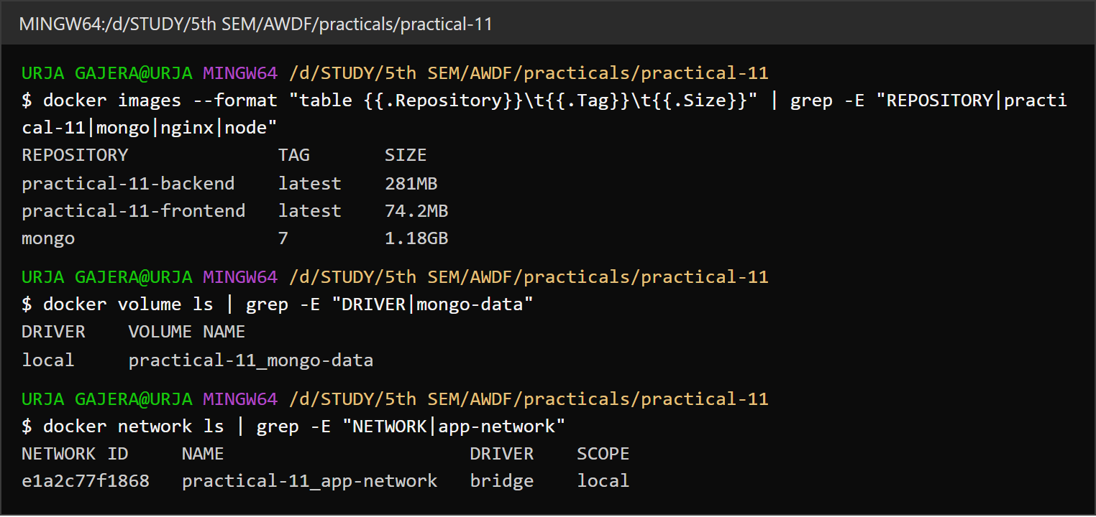
2.2 Multi-stage results — frontend image 74 MB, backend 281 MB; the named volume and the bridge network
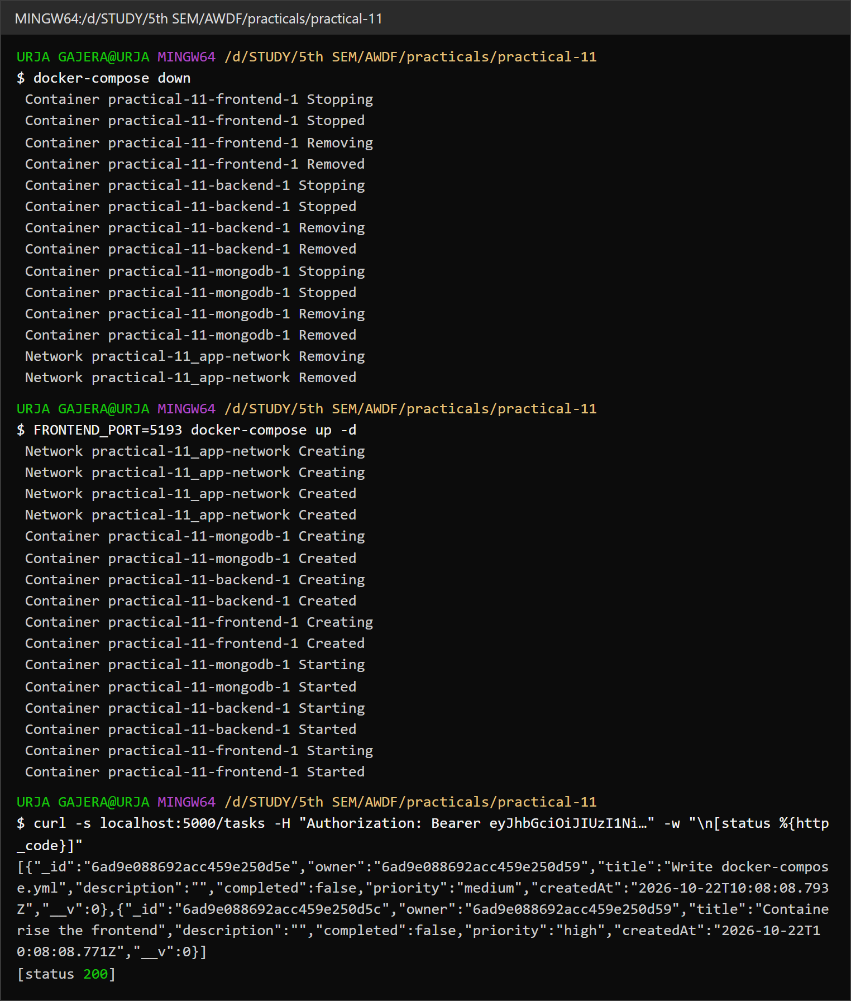
2.3 docker-compose down removes the containers; after up -d the tasks are still returned (named volume)
2.4 The same tasks in the browser after the containers were re-created

Key Questions / Analysis
Why mongodb and not localhost in the backend's connection string? Each container has its own network namespace, so localhost inside the backend container is the backend container itself — nothing listens on 27017 there. Compose puts the services on one network and registers each service name in Docker's internal DNS, so mongodb resolves to the database container's address.
EXPOSE vs ports:? EXPOSE 5000 in a Dockerfile is documentation: it records which port the app listens on and publishes nothing. ports: "5000:5000" in Compose actually maps a host port to a container port so something outside Docker (your browser) can connect. Containers on the same network can reach each other's ports without either.
Why not copy node_modules into the image? Packages installed on Windows can contain platform-specific binaries that don't run on the Linux image, and the folder is huge, which makes every build slow (it is all sent as build context) and bloats the image. Running npm install inside the Dockerfile builds the dependencies for the image's own OS and Node version, and caches them in a layer that only rebuilds when package.json changes. .dockerignore keeps the local folder out of the context entirely.
Errors Faced and Fixes
• Docker Desktop's engine was not running at first (failed to connect to the docker API at npipe:////./pipe/dockerDesktopLinuxEngine); it had to be started before anything could build.
• Host ports 5173 and 27017 were already in use on this machine (another dev server and the local MongoDB service). The compose file publishes MongoDB on 27018 by default and lets every host port be overridden.
• The first images could not be built from inside the repo layout as-is: the client imported ../../shared/theme.css and both tsconfig.json files extended ../../tsconfig.base.json, all outside the build context. Copying the theme into the folder and inlining the TypeScript options fixed it.
• Without a volume, docker-compose down threw away every user and task — see Persistence above.

