Student ID: | : | 24CS021 | Student Name: | : | Urja Gajera
Subject code & Name | : | ITUE301 – Advanced Web Development Frameworks | Practical | : | 12 | Academic Year | : | 2026-27

Practical 12: CI/CD Pipeline with GitHub Actions
Task - 1
Aim
To set up a GitHub Actions pipeline that installs dependencies and runs automated tests on every push to main, and to read its pass/fail result.
• Workflow triggered on every push to main.
• Install dependencies (npm install) as a defined step.
• Run at least one automated test with a clear pass/fail status.
• Show a failed run caused by a deliberately broken test, then a passing run after the fix.
Code
GitHub Repository Link: https://github.com/Urjagajera/AWDF_Practicals/tree/main/practical-12
Main files for this task:
• .github/workflows/ci.yml — lint job, then build-and-test with a MongoDB service
• practical-12/server/tests/tasks.test.ts — Jest + Supertest API tests
• practical-12/server/jest.config.js
Output
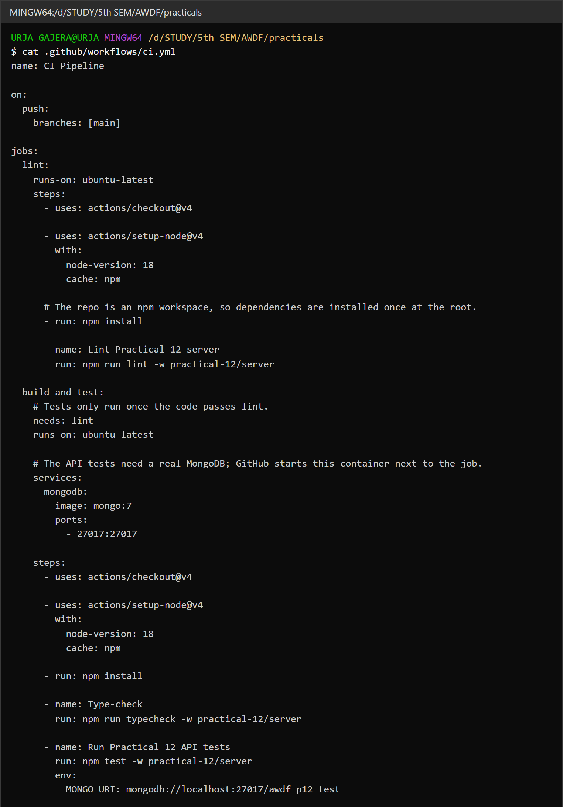
1.1 The workflow file — trigger, npm install, type-check and test steps
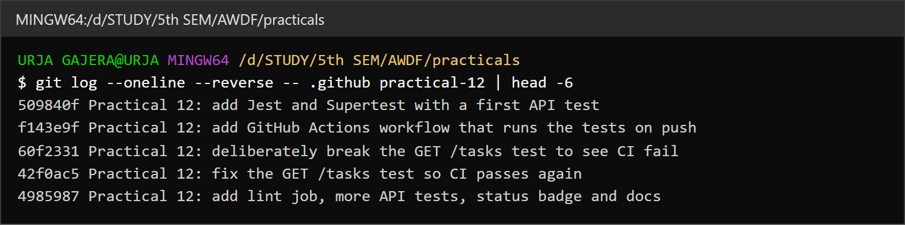
1.2 Commits for this practical — workflow added, test broken on purpose, then fixed
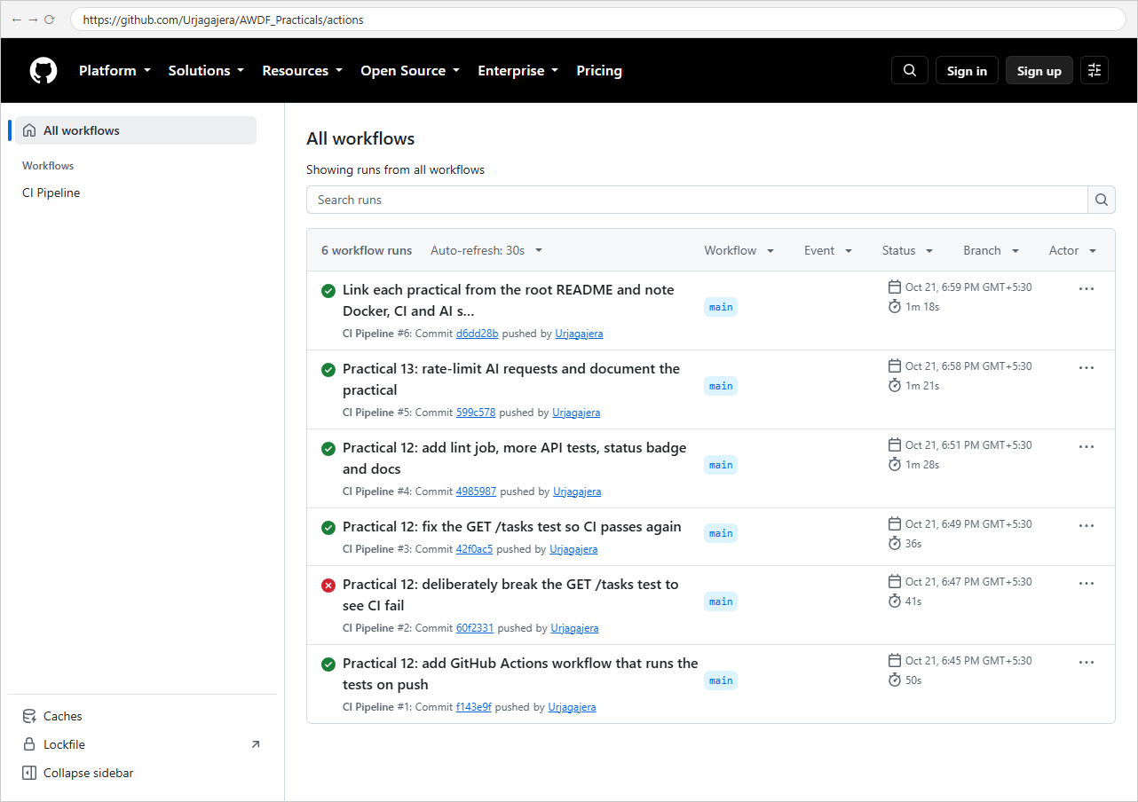
1.3 Actions tab — every push to main has a run; run #2 failed, the rest passed
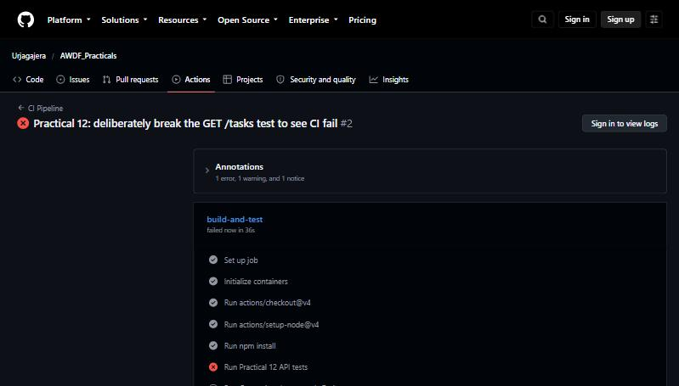
1.4 Run #2 failed at “Run Practical 12 API tests” (expected 201, received 200)
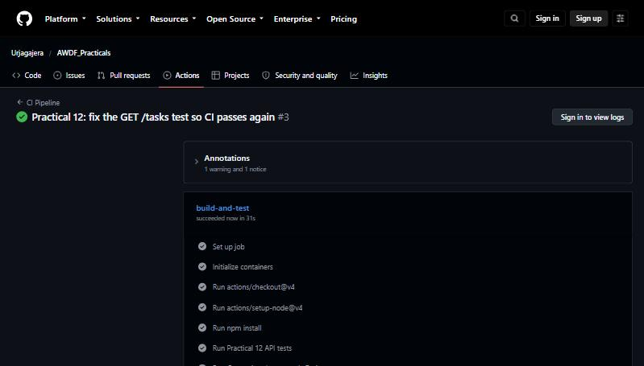
1.5 Run #3 passed after the test was corrected

Task - 2
Aim
Supplementary problems and post-lab tasks:
• Add a second job that runs a linter (ESLint) before the test job.
• Add a status badge to the README that shows the current pipeline status.
• Add a second automated test covering a different endpoint.
• Run only on pull requests targeting main — shown in the README but not switched on, because the main requirement is a run on every push.
Code
GitHub Repository Link: https://github.com/Urjagajera/AWDF_Practicals/tree/main/practical-12
Main files for this task:
• .github/workflows/ci.yml — lint job; build-and-test has needs: lint
• practical-12/server/eslint.config.mjs
• README.md and practical-12/README.md — status badge
Output
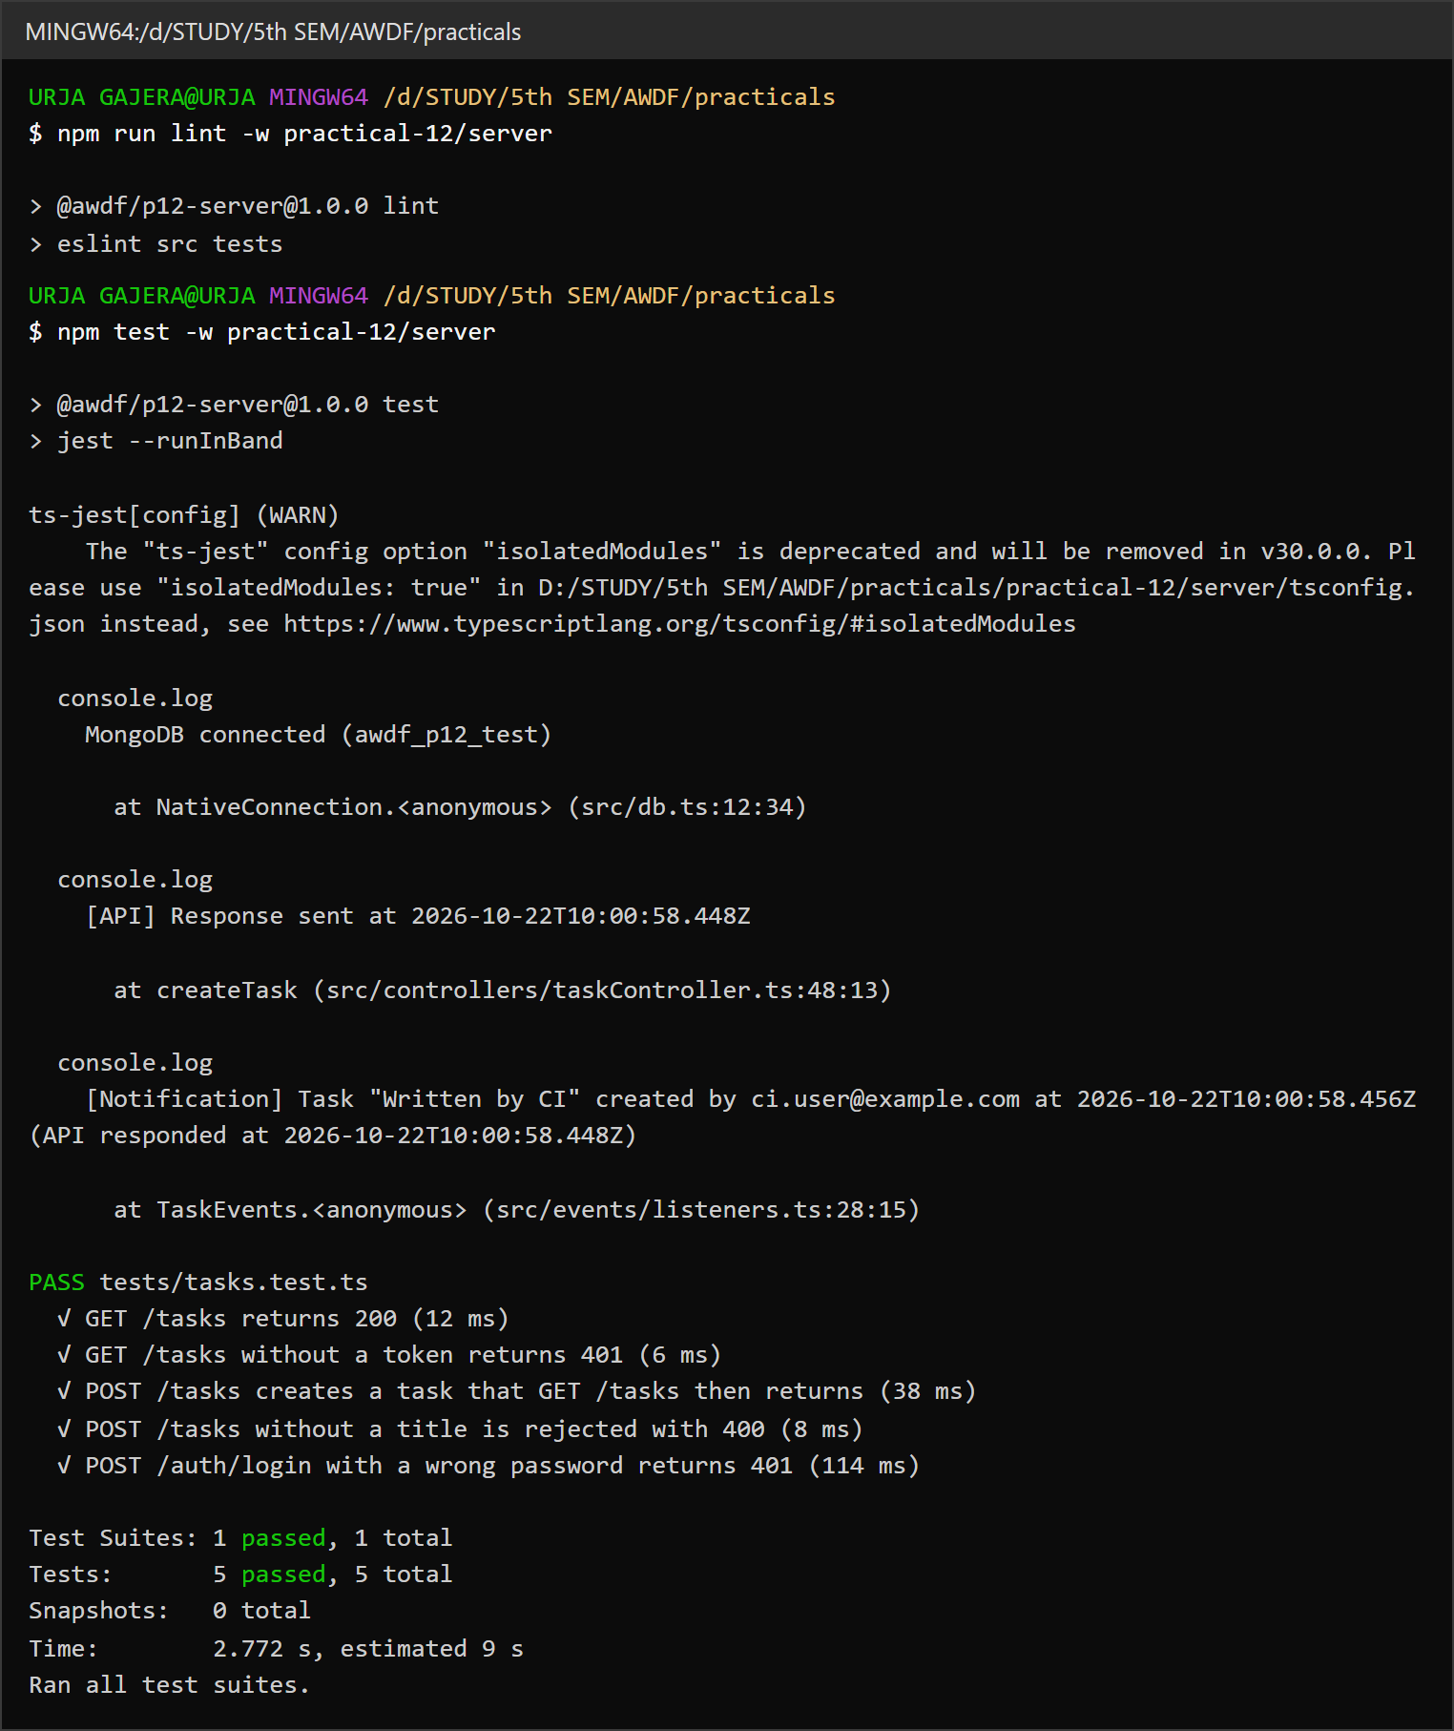
2.1 Locally: ESLint passes and 5 tests pass across GET, POST and /auth/login
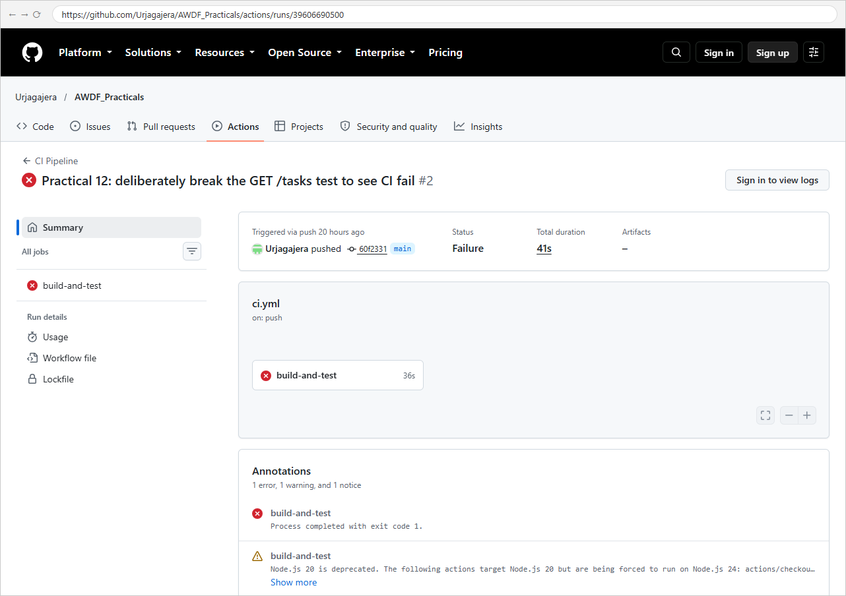
2.2 The failed run’s summary on GitHub
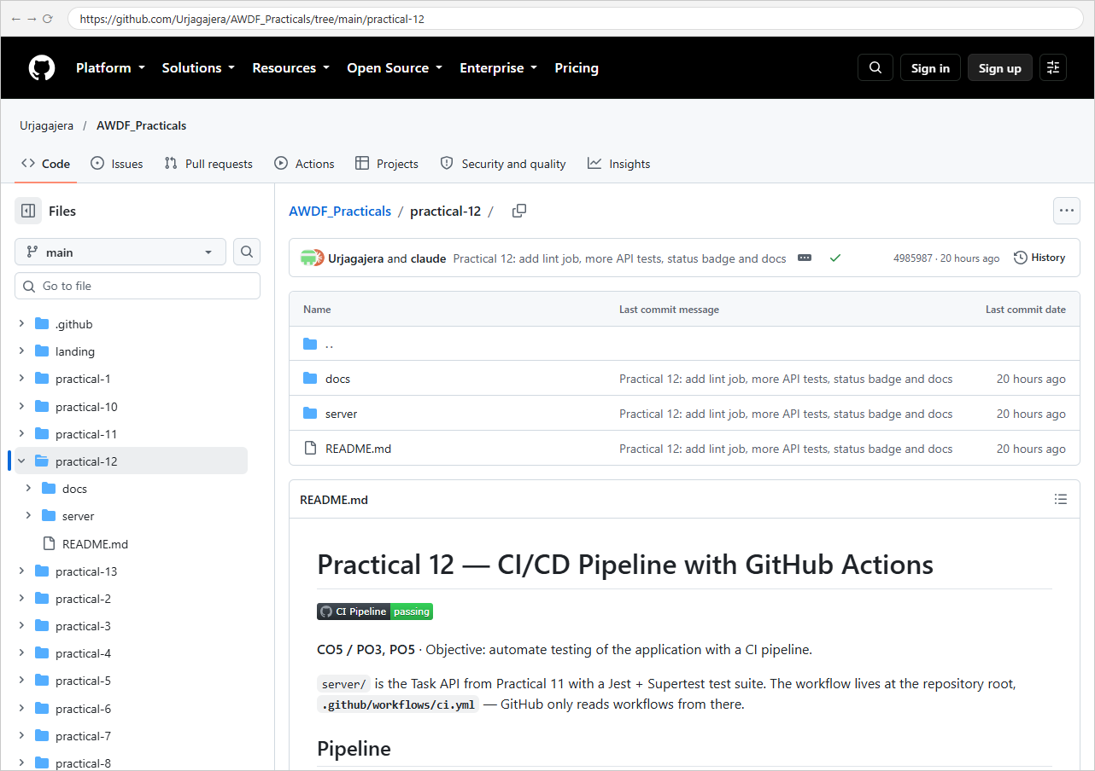
2.3 The “CI Pipeline — passing” badge in the README

Key Questions / Analysis
CI vs CD — which does this practical show? Continuous Integration: every push is automatically installed, linted, type-checked and tested, so broken code is caught as soon as it lands. Continuous Deployment would go further and, when the pipeline passes, automatically release the build (for example, push the Practical 11 images and update a server). This pipeline stops at the green check — it is CI.
Why does running tests on every push catch problems earlier? Each run checks one small change, so a failure points straight at the commit that caused it (here, run #2 failed on exactly the commit that changed the test). Manual testing before a release checks weeks of changes at once — failures are harder to trace, and things people forget to test slip through.
What if the test file path were wrong — same failure step? The job would still fail in the Run … tests step, but for a different reason: Jest prints No tests found, exiting with code 1 instead of an assertion diff. The red X looks the same, which is why the logs matter — the cause is in the step's output, not the icon.
Errors Faced and Fixes
• npm install failed locally with EJSONPARSE after I edited package.json with sed: it had left a stray backslash before the em dash in the description. Rewriting the file properly fixed it.
• Once a second test file was planned, both files would drop the same test database in parallel; the tests were kept in one file and jest --runInBand makes Jest run files one after another.
• Every run shows a warning that actions/checkout@v4 and actions/setup-node@v4 target the deprecated Node.js 20 runtime. They still work (GitHub forces them onto Node 24); @v4 is kept because it matches the lab sheet.

