Student ID: | : | 24CS021 | Student Name: | : | Urja Gajera
Subject code & Name | : | ITUE301 – Advanced Web Development Frameworks | Practical | : | 13 | Academic Year | : | 2026-27

Practical 13: AI API Integration into a Web Application
Task - 1
Aim
To add a meaningful AI feature — generating a task description from its title with the Gemini API — called only from the backend and degrading gracefully when the AI is unavailable.
• The API key is stored and used only on the backend (.env), never sent to the frontend.
• If the AI call fails or times out, the rest of the application keeps working.
• The AI response is shown in the React UI as editable text, not raw JSON.
Code
GitHub Repository Link: https://github.com/Urjagajera/AWDF_Practicals/tree/main/practical-13
Main files for this task:
• server/src/ai/gemini.ts — calls Gemini with the key from process.env, 10 s timeout
• server/src/routes/ai.ts — POST /api/ai/generate-description, fallback on any error
• client/src/components/tasks/TaskForm.tsx — “Generate description” button
• client/src/components/tasks/AiSuggestion.tsx — editable suggestion with Use this / Dismiss
Output
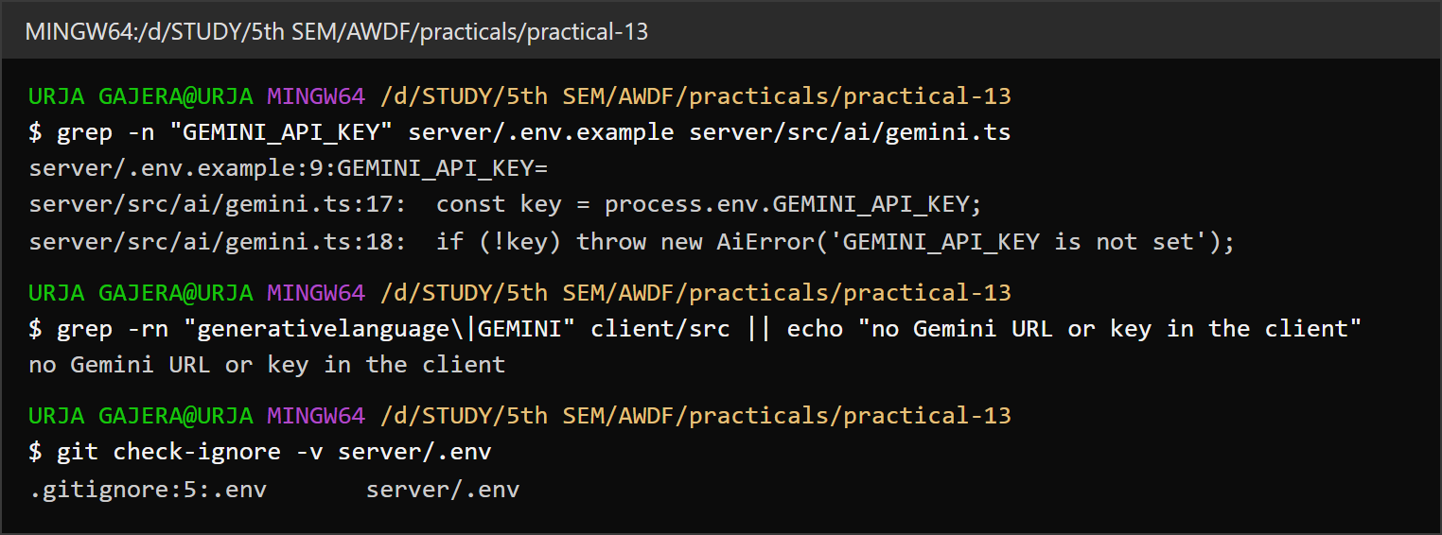
1.1 The key is read only by the server; the client has no Gemini URL or key; server/.env is git-ignored
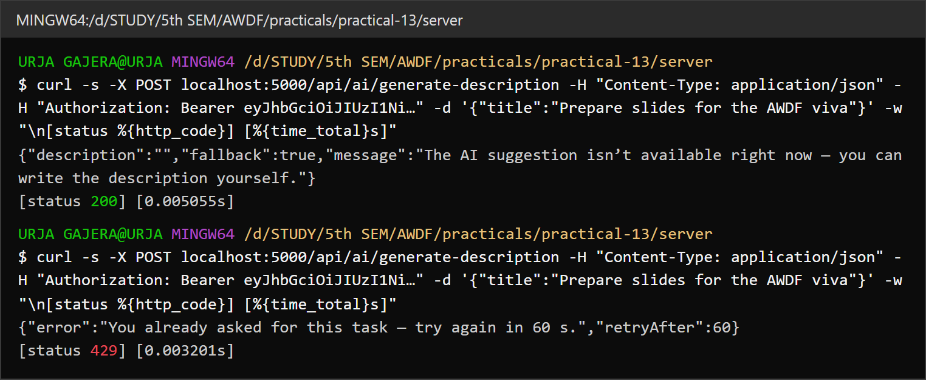
1.2 Graceful degradation — with no key the endpoint answers 200 with fallback: true and a message
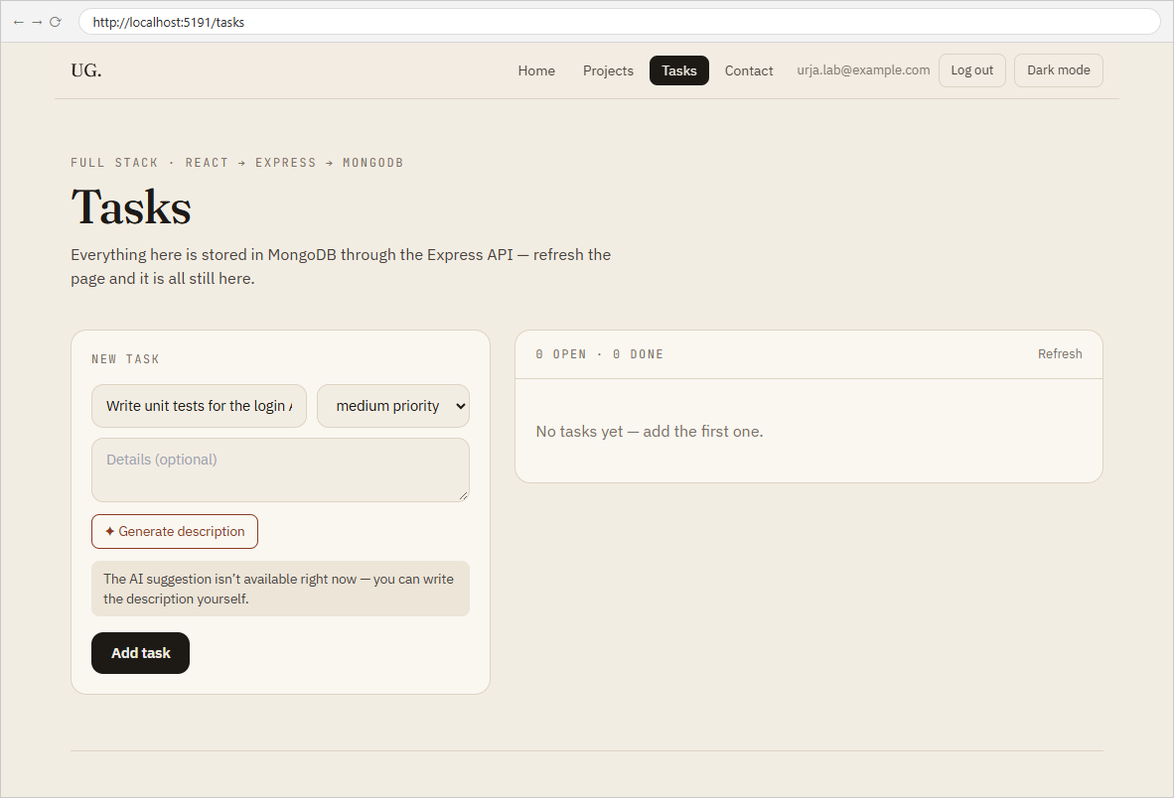
1.3 The UI shows the fallback message and the form stays usable
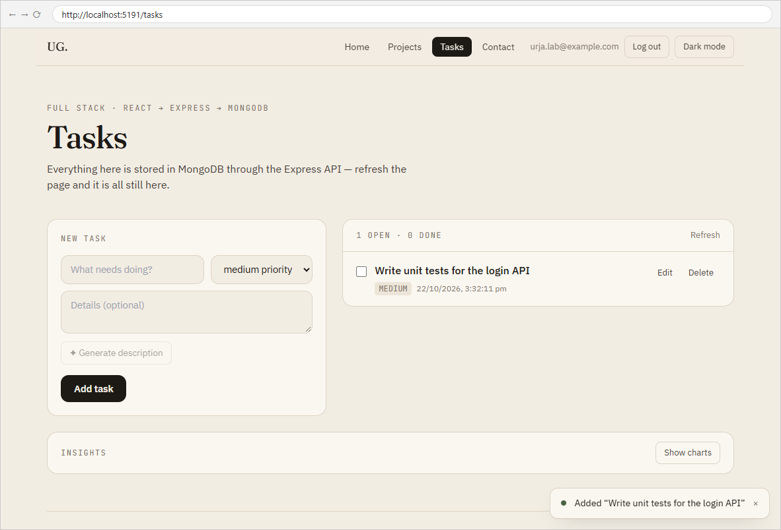
1.4 The task is still created normally without an AI description
Observation: These captures were taken without a GEMINI_API_KEY in server/.env, so they show the failure path.

Task - 2
Aim
Supplementary problems and post-lab tasks:
• A loading state on the frontend while waiting for the AI response.
• A simple rate limit — at most 1 AI request per task per minute.
• A visible disclaimer that the suggestion is AI-generated and should be reviewed.
Code
GitHub Repository Link: https://github.com/Urjagajera/AWDF_Practicals/tree/main/practical-13
Main files for this task:
• server/src/middleware/aiRateLimit.ts — 429 with Retry-After
• client/src/components/tasks/TaskForm.tsx — “Generating…” spinner
• client/src/components/tasks/AiSuggestion.tsx — disclaimer text
Output
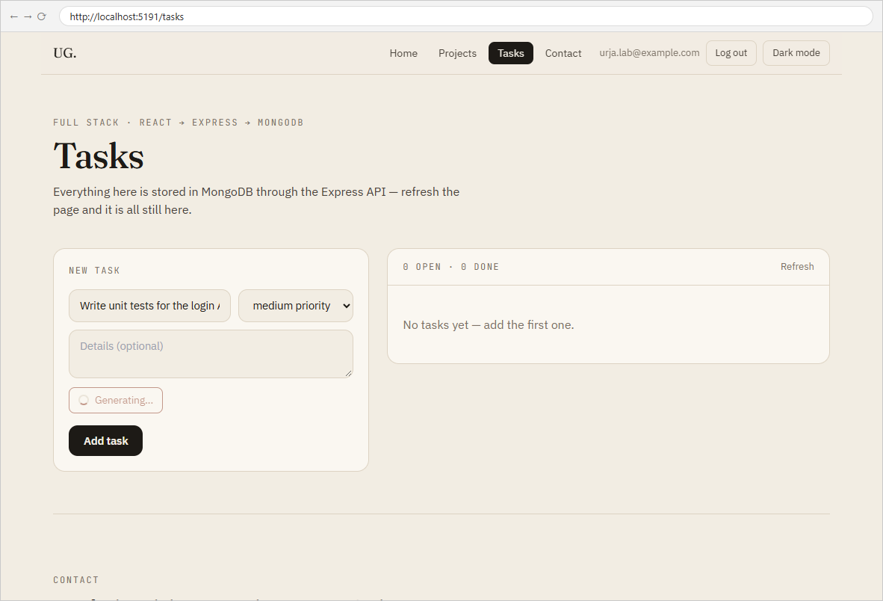
2.1 Loading state — “Generating…” while the request is in progress
2.2 Rate limit — the same title asked again within a minute gets 429 “try again in 60 s”

Key Questions / Analysis
Why call the AI API from the backend, not from React? Everything sent to the browser is public: a key in frontend code or in a request from the page can be read in DevTools and used by anyone, on your quota and billing. The backend keeps the key secret, and is also where you can enforce login, rate limits, input validation and timeouts — none of which can be trusted if the browser talks to the AI provider directly.
What does graceful degradation mean here? The AI is an optional helper on top of a working app. When the third-party service is down, slow, out of quota or misconfigured, the feature quietly steps back — a short notice instead of a suggestion — and the core job, creating and managing tasks, is unaffected. The route returns a normal 200 with fallback: true rather than an error, and never blocks the form for more than 10 s.
Privacy and governance — what should never be sent? Anything sent to an external AI provider leaves your control: it may be logged, retained or used under that provider's terms (free tiers in particular may use inputs to improve models). So send the minimum — here only the task title, never the user's email, ids or other tasks — and never send passwords, tokens, API keys, personal data (phone numbers, addresses, government ids), health or financial details, or confidential company information. Users should know when content is AI-generated (the disclaimer) and stay in control of it (the suggestion is editable and only used when they choose Use this).
Errors Faced and Fixes
• A test script selected the Generate button by its label, and the label changes to "Generating…" while loading — the selector found nothing mid-request. (The UI itself was fine; the check now reads the state after the request.)
• To keep a short reply, the request disables Gemini 2.5's "thinking" step (thinkingBudget: 0); with thinking on, part of a small maxOutputTokens budget can be spent before any visible text. This comes from the API documentation, not something I could observe without a real key.

