
PROJECT-I (CEUP 301)
SCHEMESETU
SMART GOVERNMENT SCHEME FINDER
Group Id- CS26015
Search 4,722 Indian government schemes and see, in English or Hindi, which ones you are eligible for.
Sr. | Student Name | Roll No. | Mentor / Guide
1 | Urja Gajera | 24CS021 | Dr. Jigar Sarda  CSE Dept., CSPIT
SYSTEM FLOW / ARCHITECTURE

User  React web app (English, हिन्दी) | → | Express API  Google sign-in, validation, rate limits | → | Eligibility Engine  Rule checks; unknown never excludes | → | PostgreSQL  4,722 schemes, 2,987 rule sets (Prisma) | → | Ranked Results  Match %, 100% matches first
Data pipeline: myScheme.gov.in dataset → parser (cleans text, extracts eligibility rules) → PostgreSQL.
Hindi text is made once by an AI model (Groq) with automatic quality checks, then stored.
TECHNOLOGY STACK | KEY FEATURES | APPLICATIONS
- Frontend: React 19, TypeScript, Vite, Tailwind CSS  - Backend / DB: Node.js, Express, Prisma, PostgreSQL  - Tools: Google OAuth, Zod, Groq AI (Hindi), Vitest (1,035 tests), GitHub Actions CI | - Eligibility check with match % and reasons, 100% matches first  - Search by 16 topics, state, age, income and occupation  - English and Hindi (Hindi labelled as machine-translated)  - Profile suggestions, bookmarks, compare up to 3 schemes | - Citizens finding the schemes they qualify for  - Students and farmers looking for scholarships, subsidies and loans  - NGOs and CSC operators helping people apply
APPLICATION SCREENSHOTS
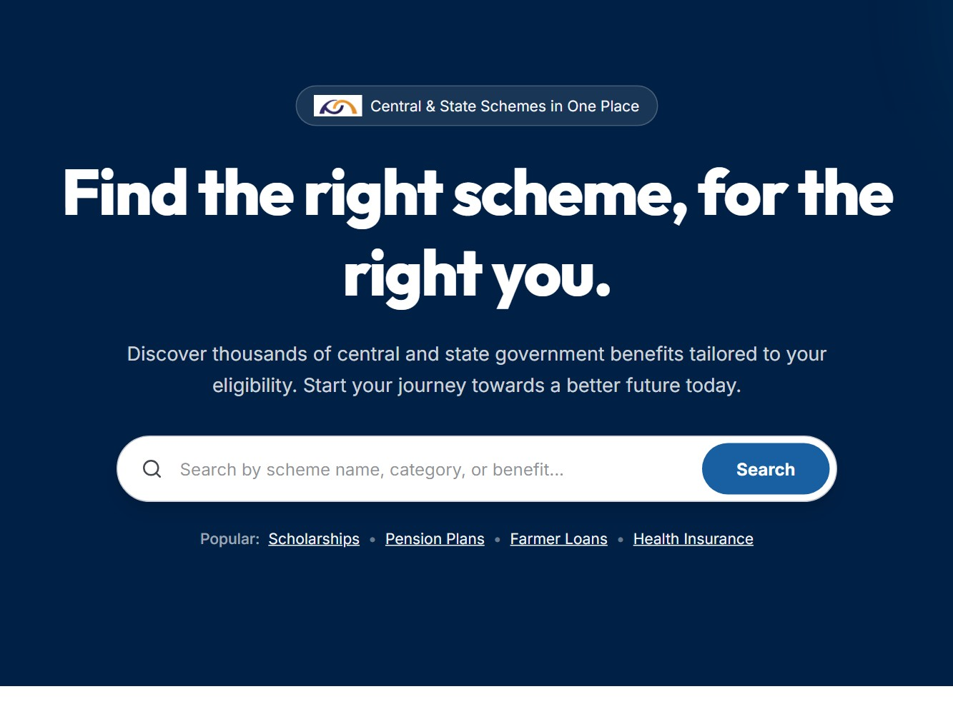  Home - search 4,722 schemes | 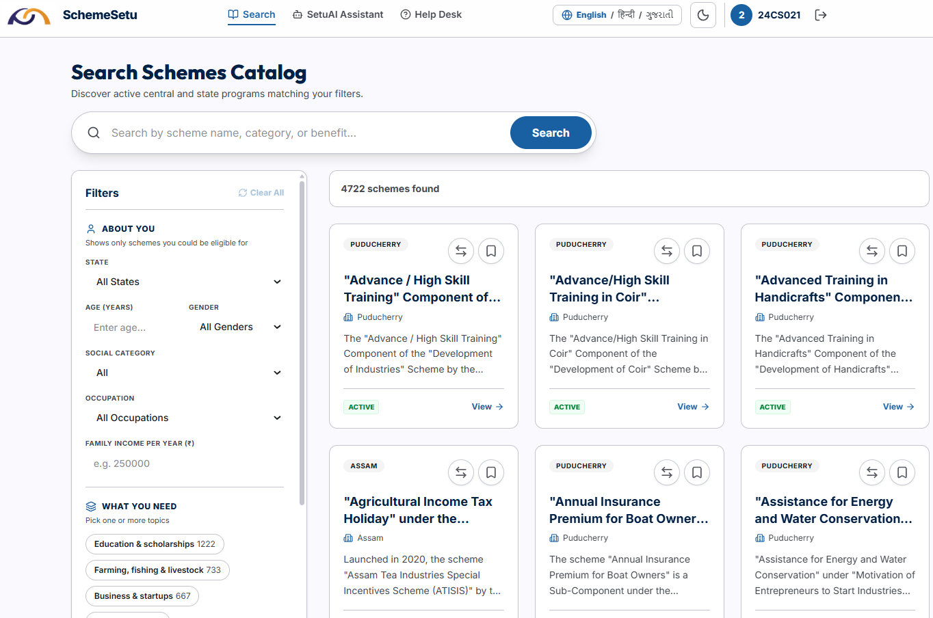  Eligibility check - 100% matches first | 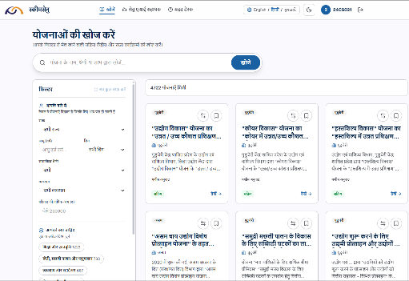  Hindi interface (हिन्दी)

TARGET INDUSTRY / SECTOR : E-Governance / Social Welfare (GovTech)

DEPARTMENT OF COMPUTER SCIENCE & ENGINEERING | CSPIT, CHARUSAT

