

Acme Shop User Manual
Version 1.4.0 · September 24, 2026
Acme Ltd

Contents
Right-click and choose Update Field to show the table of contents.

Getting Started
Acme Shop is where you manage your products, customers and orders. This manual shows you how to do everyday jobs step by step, and explains every screen.

Before you begin
- A computer with an up-to-date web browser (Microsoft Edge, Google Chrome, Firefox or Safari).
- The Acme Shop web address and the email and password your administrator gave you.

Starting the application
Open your web browser and go to the Acme Shop address. The Sign in to Acme Shop page appears.

Signing in
Type your Email and Password, then click Sign in. If you see Invalid email or password, check both and try again.

A quick tour
After you sign in you see the Dashboard. The menu on the left takes you to Products, Orders, Customers and Settings. Click Sign out at the bottom of the menu when you are finished.
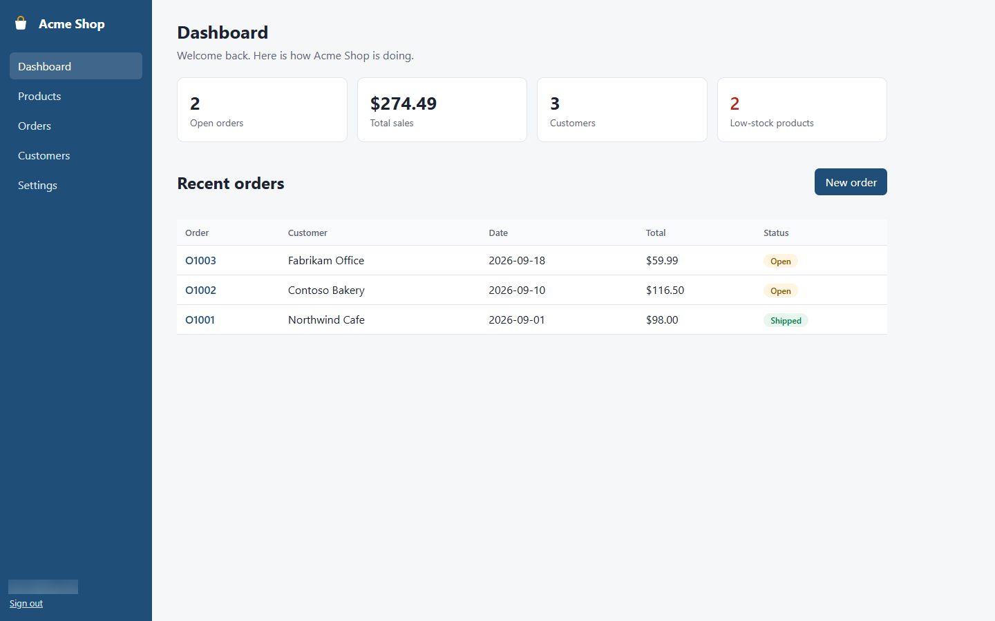
Figure 1: The Dashboard screen

How-To Tasks

Sign in to Acme Shop
Get into Acme Shop with your email and password.
Step 1. Open Acme Shop in your web browser. The Sign in to Acme Shop page appears.
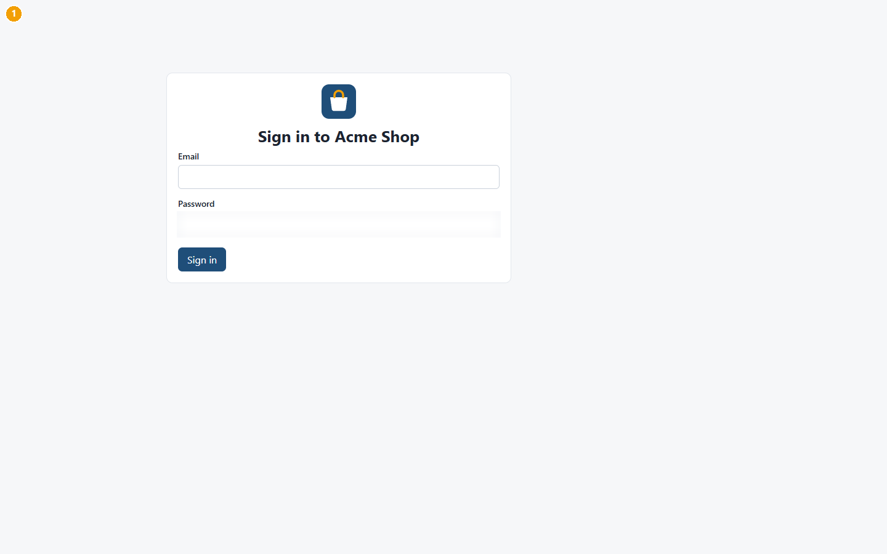
Figure 2: Step 1: Open Acme Shop in your web browser. The Sign in to Acme Shop page appears.
Step 2. In Email, type your email address.
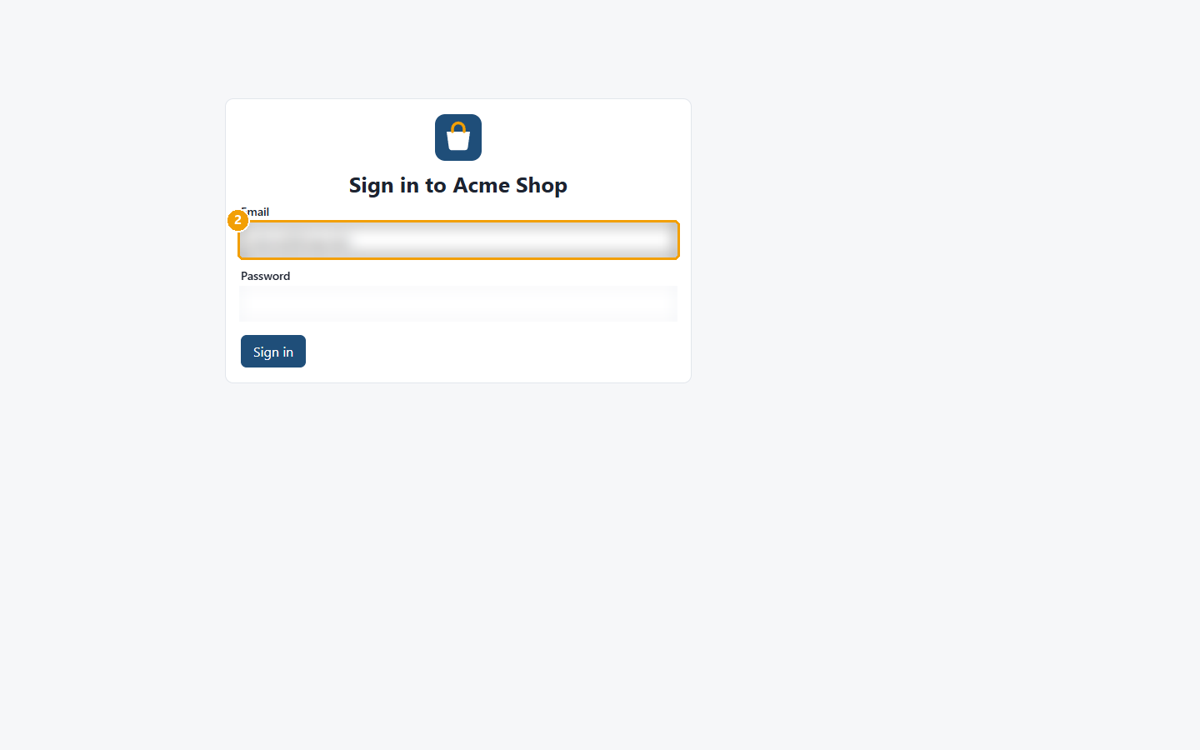
Figure 3: Step 2: In Email, type your email address.
Step 3. In Password, type your password.
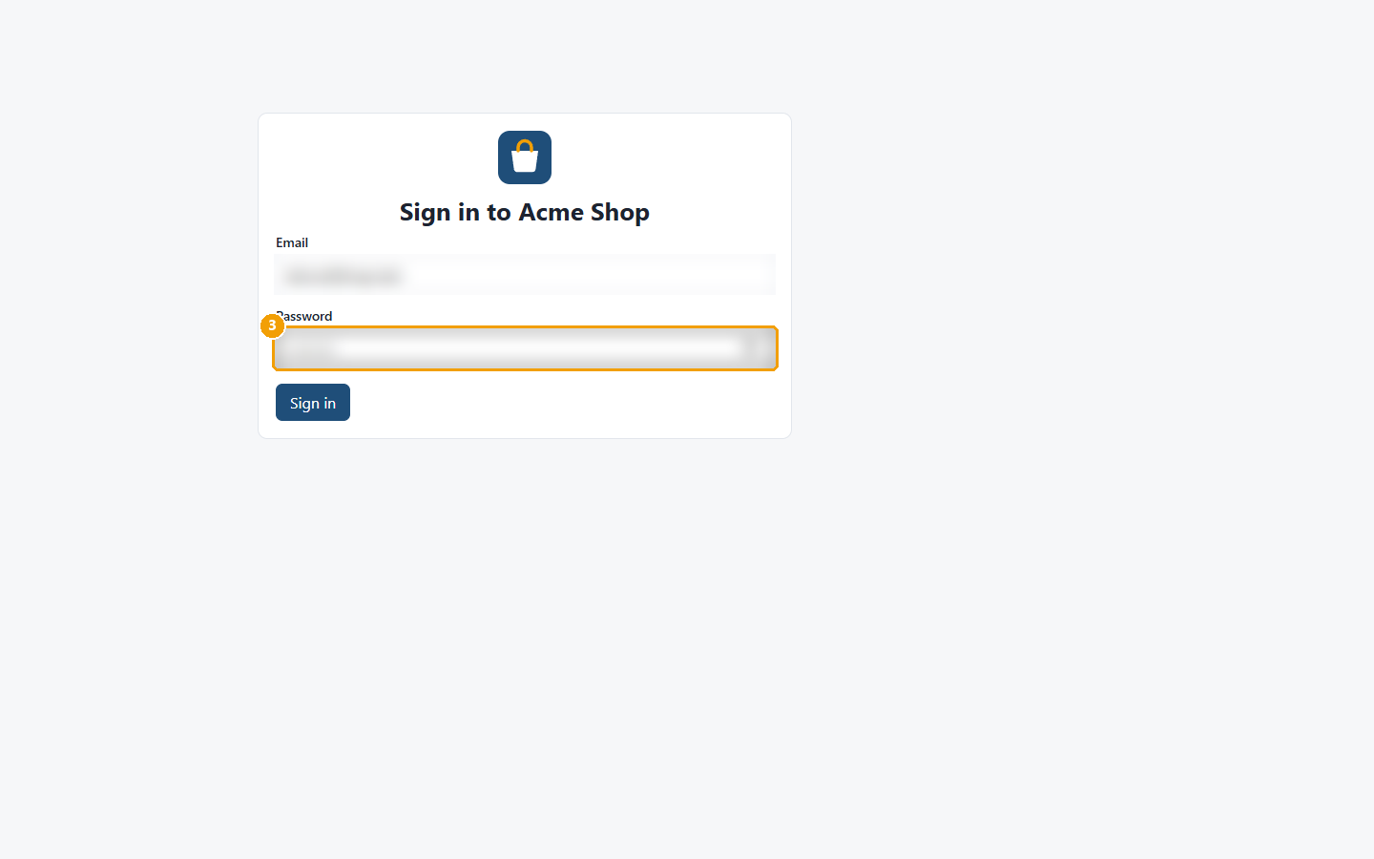
Figure 4: Step 3: In Password, type your password.
Step 4. Click Sign in. The Dashboard opens.
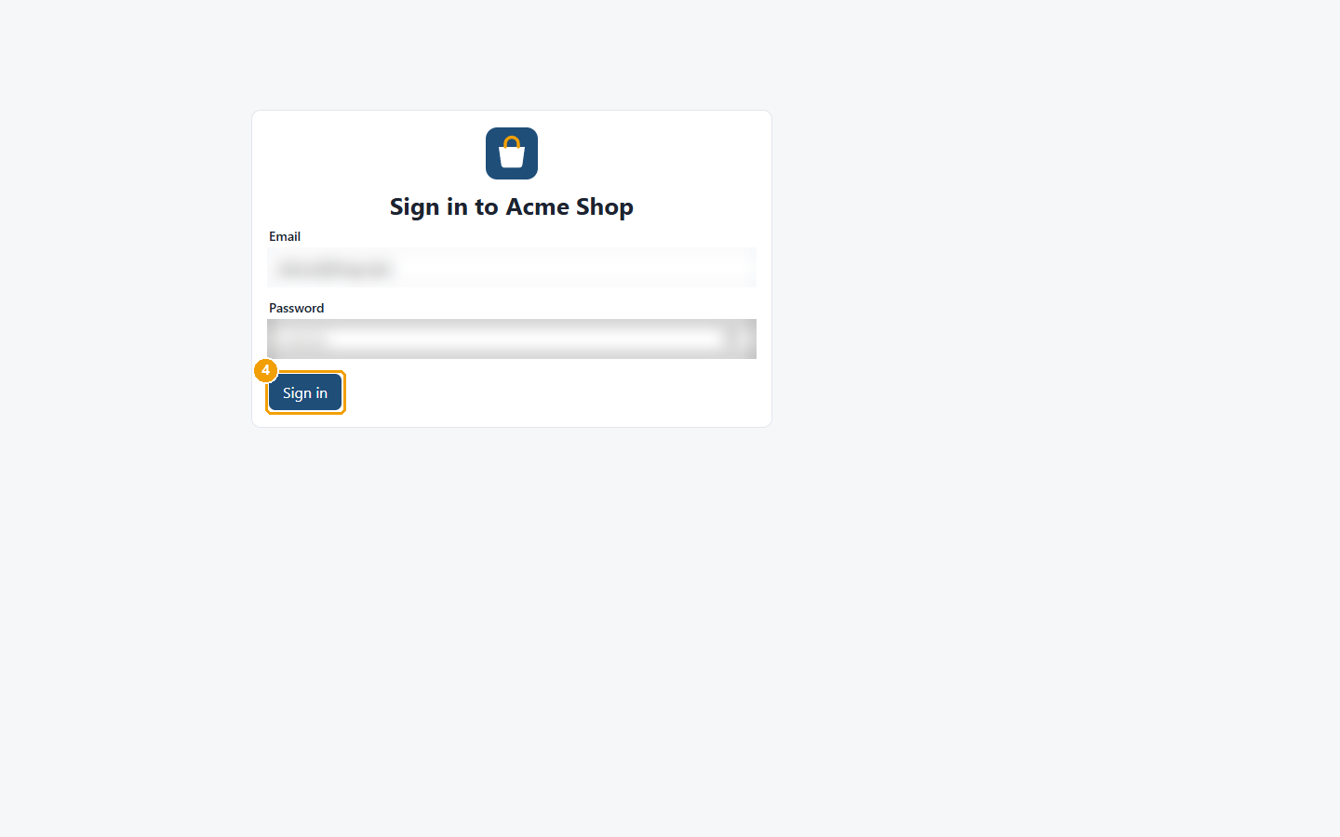
Figure 5: Step 4: Click Sign in. The Dashboard opens.
Screens used: Sign in, Dashboard

Create an order
Record an order for a customer and take the items out of stock.
Step 1. In the menu, click Orders.
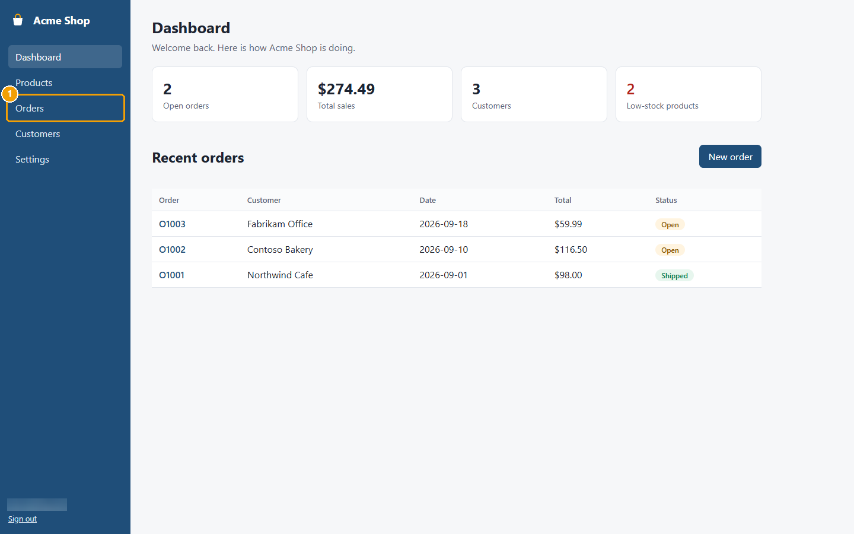
Figure 6: Step 1: In the menu, click Orders.
Step 2. Click New order.
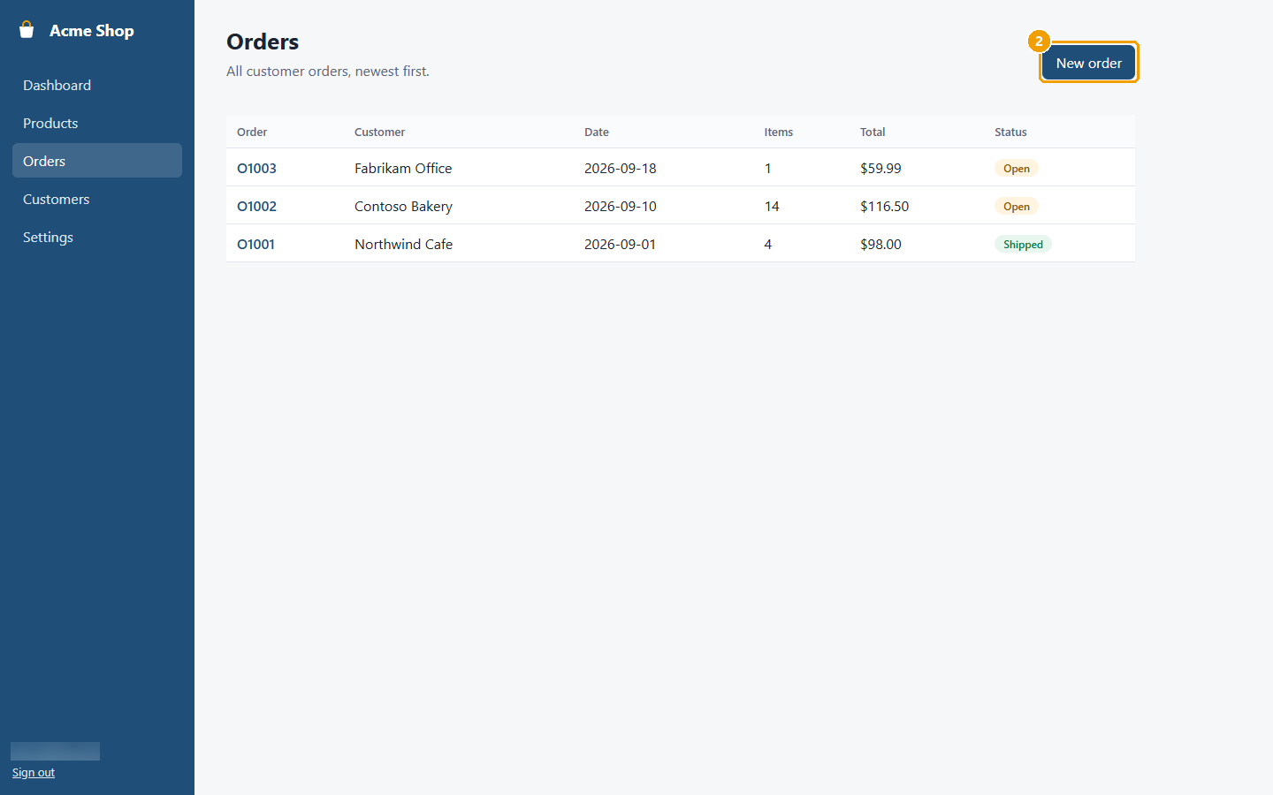
Figure 7: Step 2: Click New order.
Step 3. In Customer, choose who the order is for.
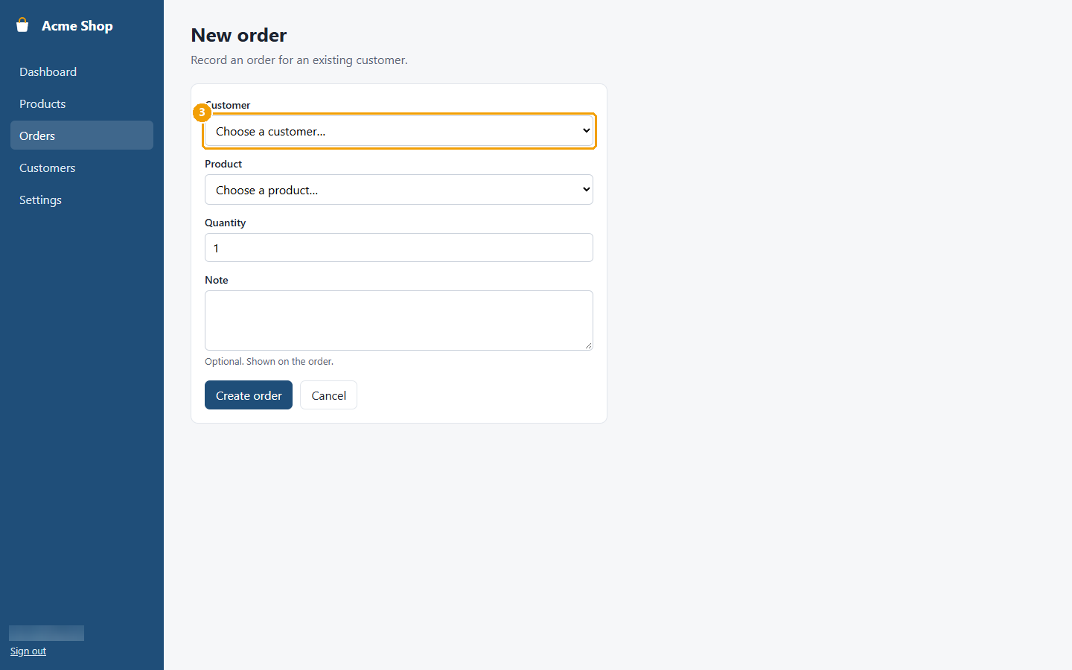
Figure 8: Step 3: In Customer, choose who the order is for.
Step 4. In Product, choose what they are buying.
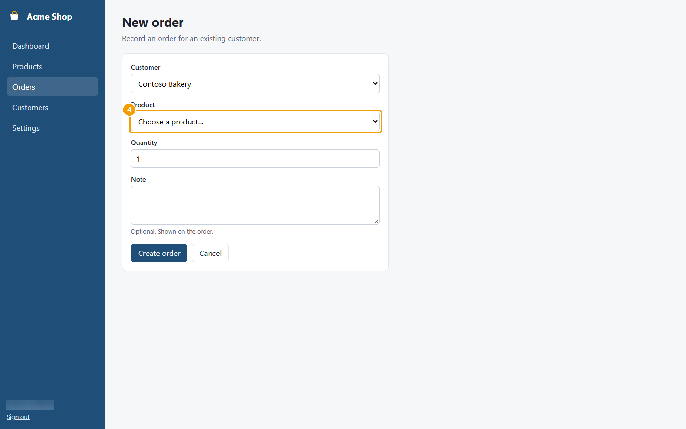
Figure 9: Step 4: In Product, choose what they are buying.
Step 5. In Quantity, type how many.
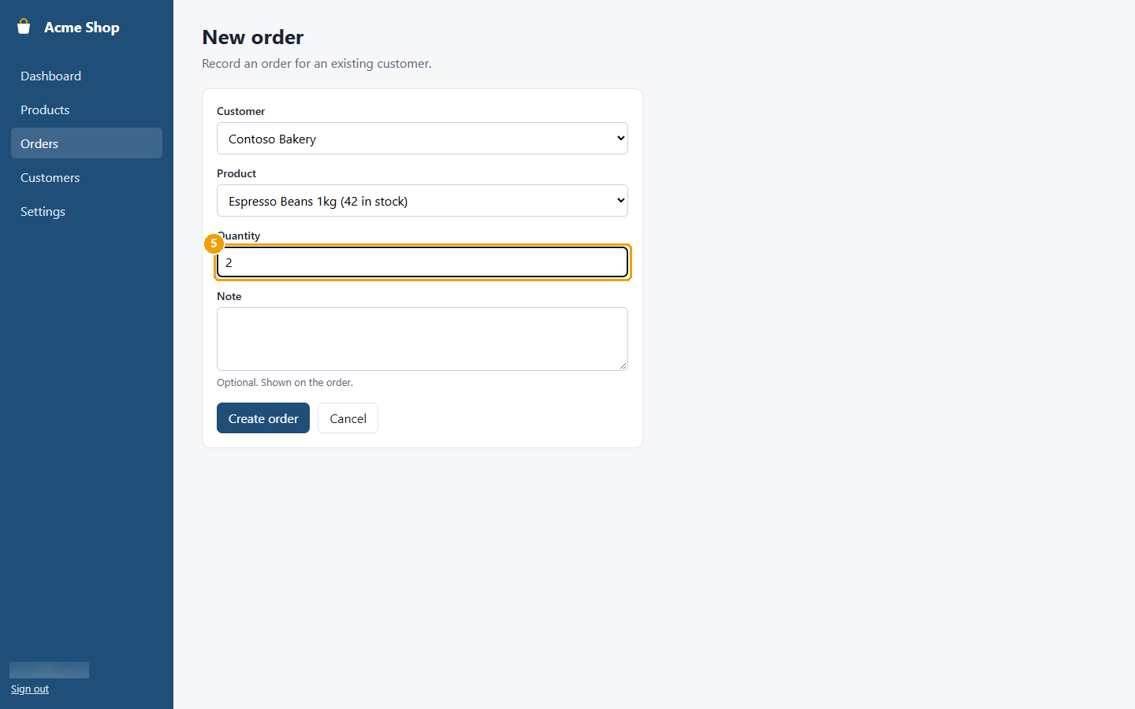
Figure 10: Step 5: In Quantity, type how many.
Step 6. Click Create order. The new order opens with the status Open.
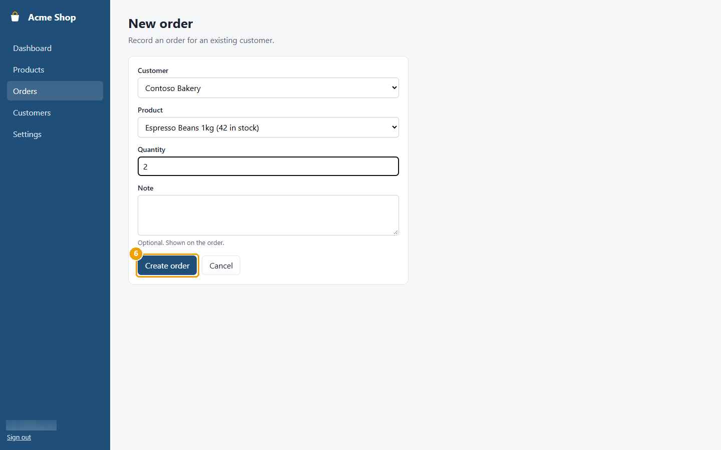
Figure 11: Step 6: Click Create order. The new order opens with the status Open.
Screens used: Dashboard, Orders, New order, Order details

Add a customer
Add a person or business so you can create orders for them.
Step 1. In the menu, click Customers.
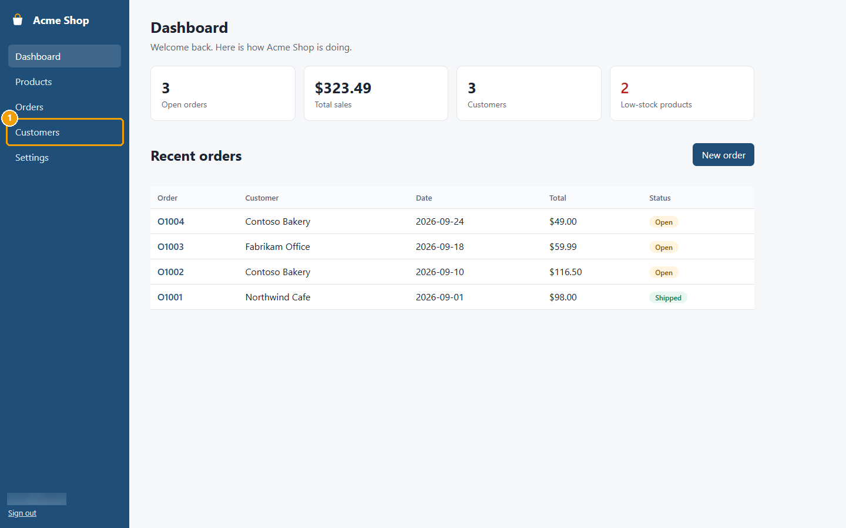
Figure 12: Step 1: In the menu, click Customers.
Step 2. Click New customer.
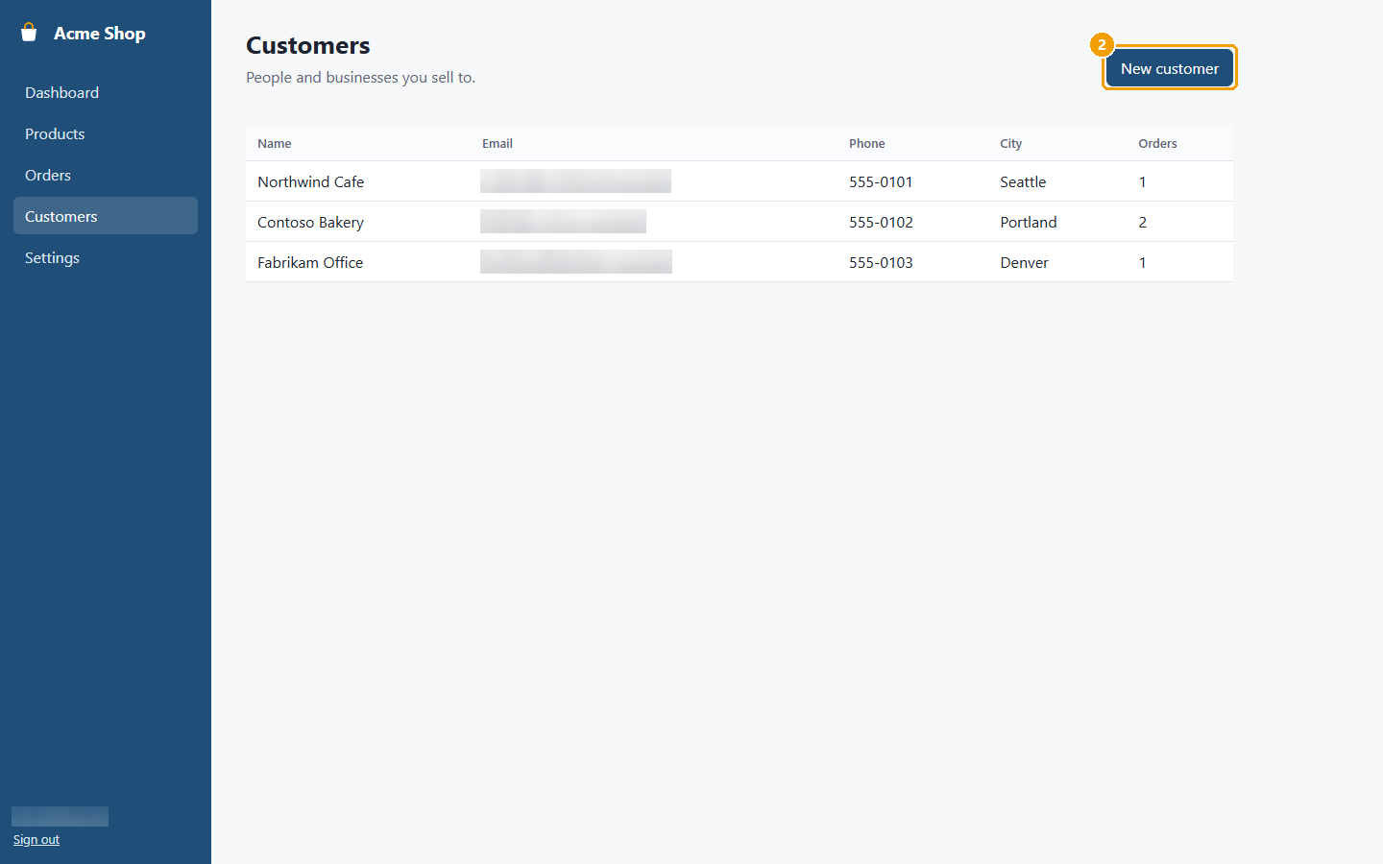
Figure 13: Step 2: Click New customer.
Step 3. In Name, type the customer's name.
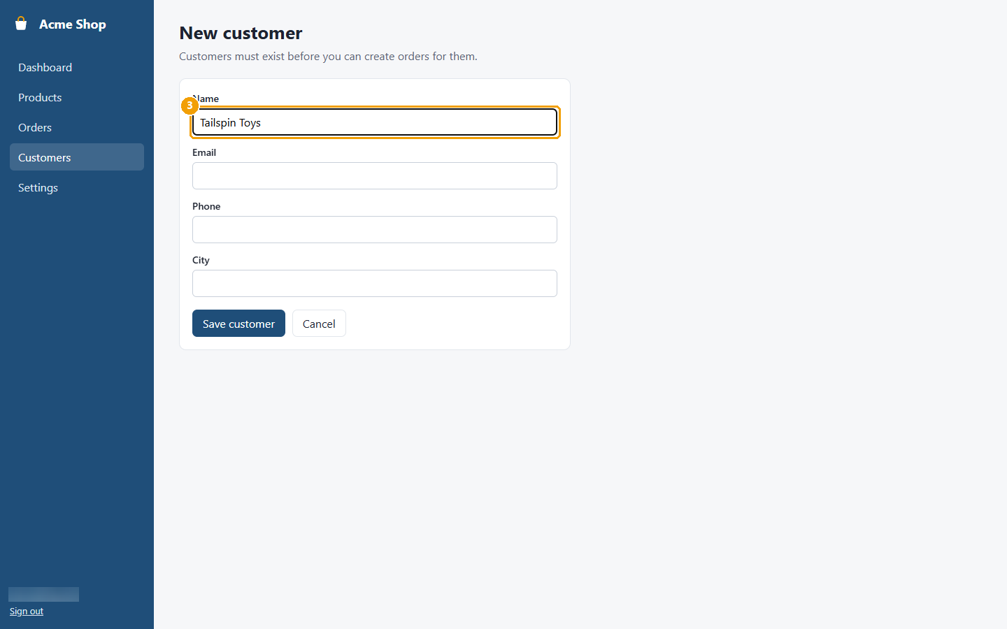
Figure 14: Step 3: In Name, type the customer's name.
Step 4. In Email, type the address where invoices should go.
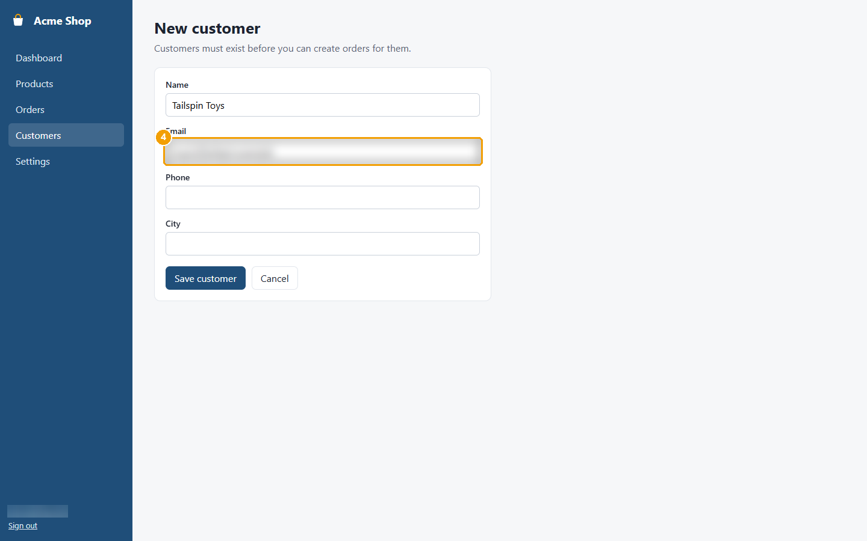
Figure 15: Step 4: In Email, type the address where invoices should go.
Step 5. Click Save customer. The customer now appears in the Customers list.
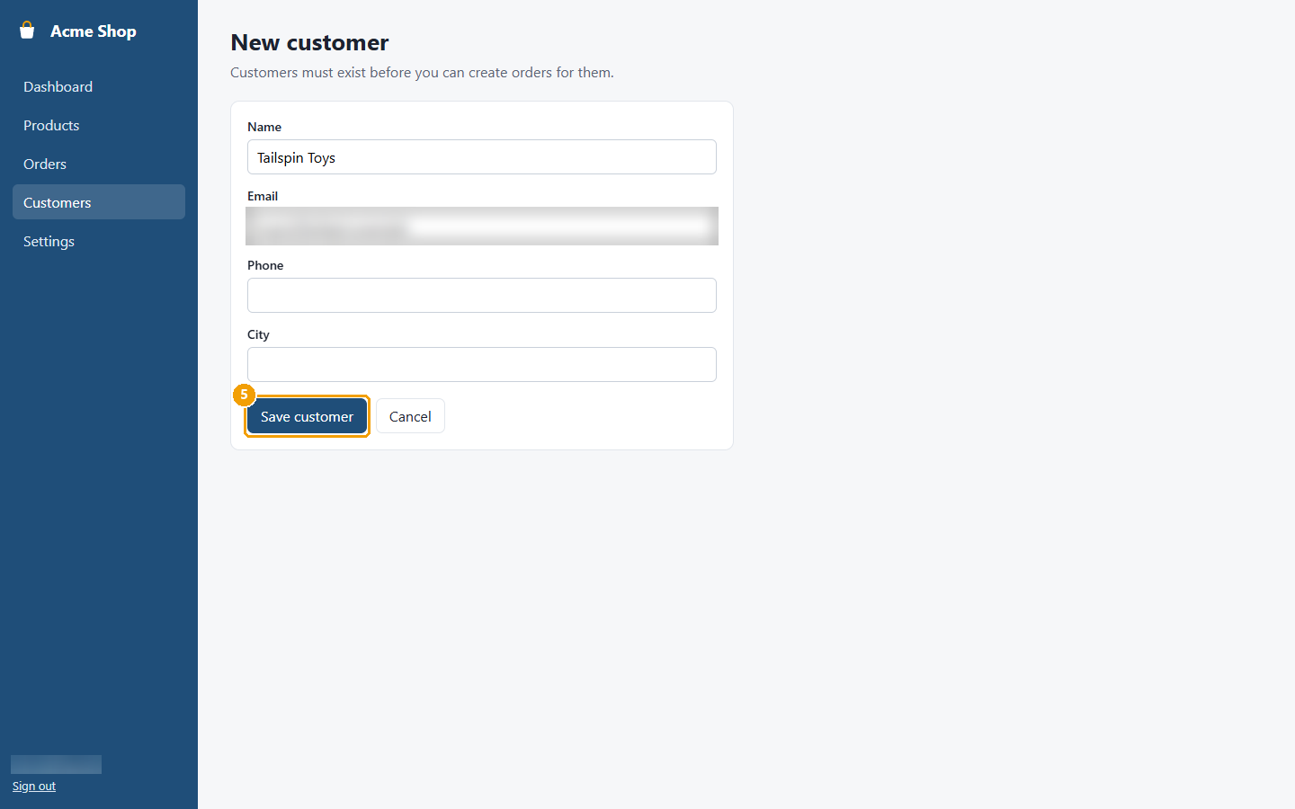
Figure 16: Step 5: Click Save customer. The customer now appears in the Customers list.
Screens used: Dashboard, Customers, New customer

Add a product
Add a new product to your catalogue.
Step 1. In the menu, click Products.
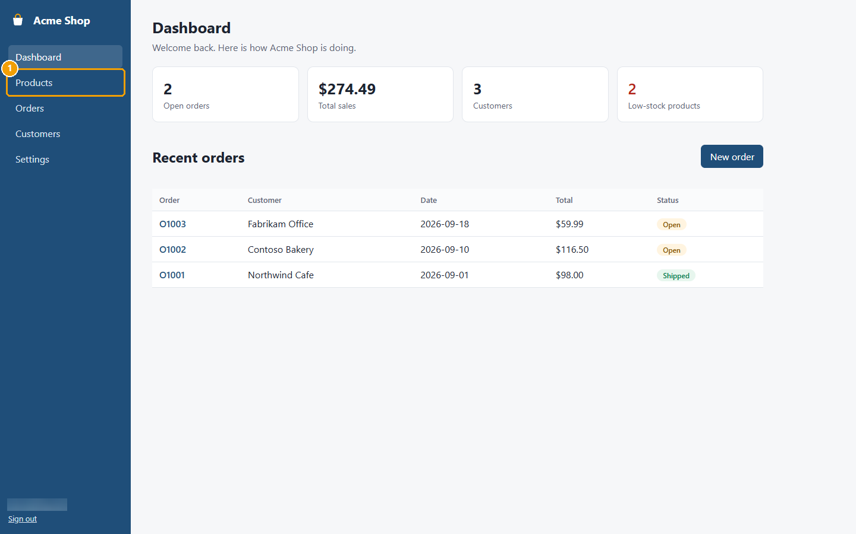
Figure 17: Step 1: In the menu, click Products.
Step 2. Click New product.
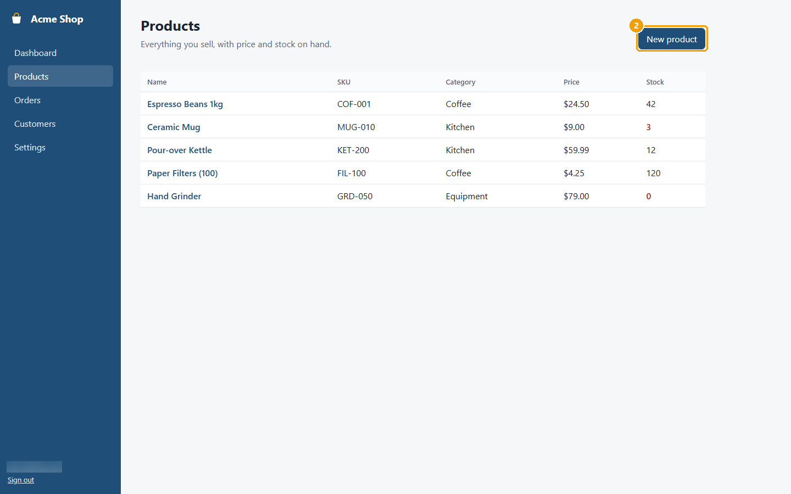
Figure 18: Step 2: Click New product.
Step 3. Type the product Name.
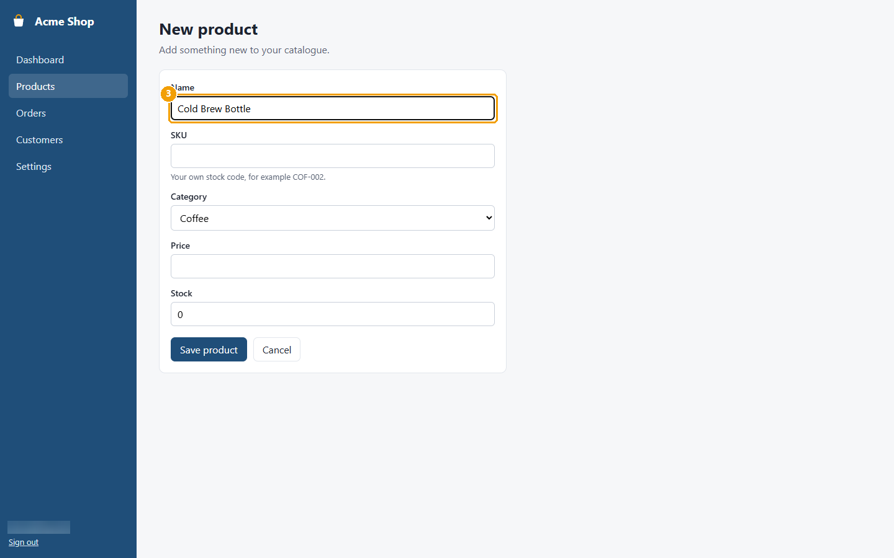
Figure 19: Step 3: Type the product Name.
Step 4. Type your stock code in SKU.
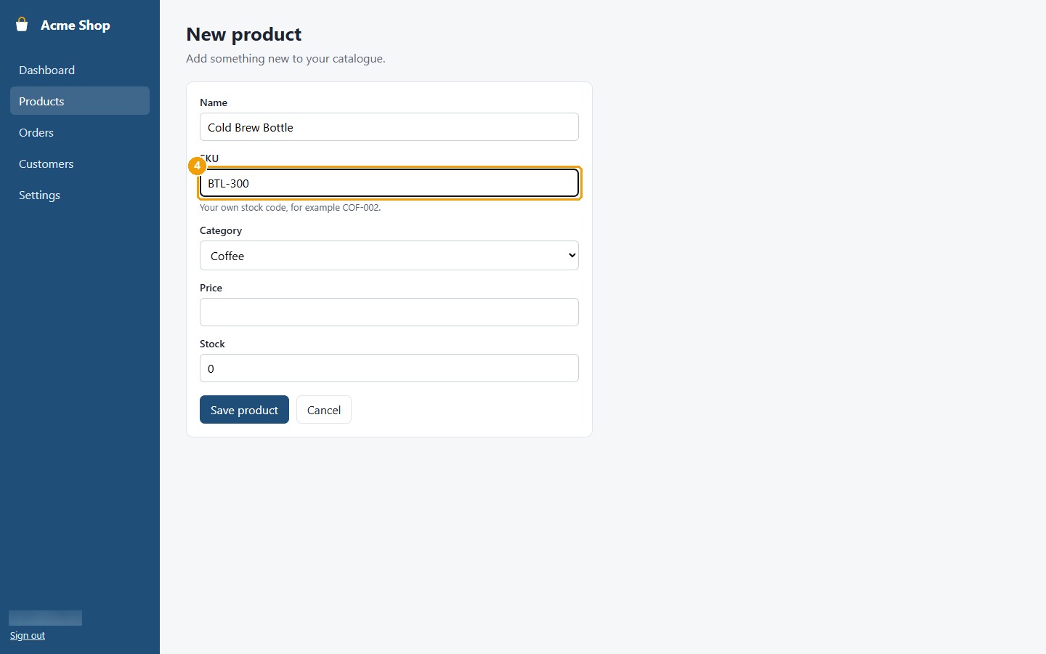
Figure 20: Step 4: Type your stock code in SKU.
Step 5. Choose a Category.
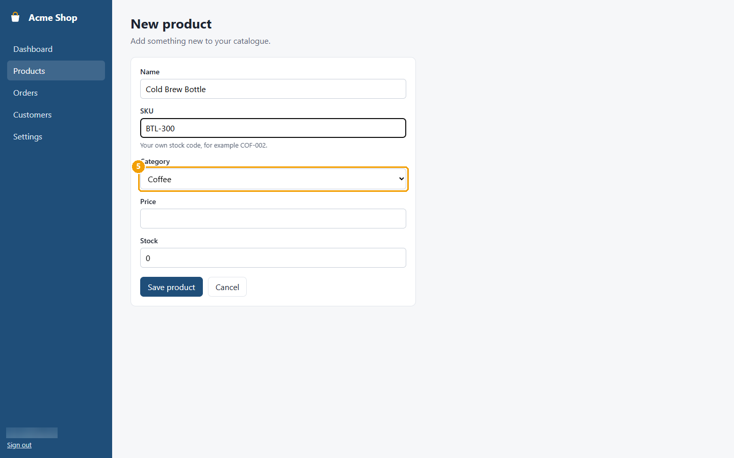
Figure 21: Step 5: Choose a Category.
Step 6. Type the Price.
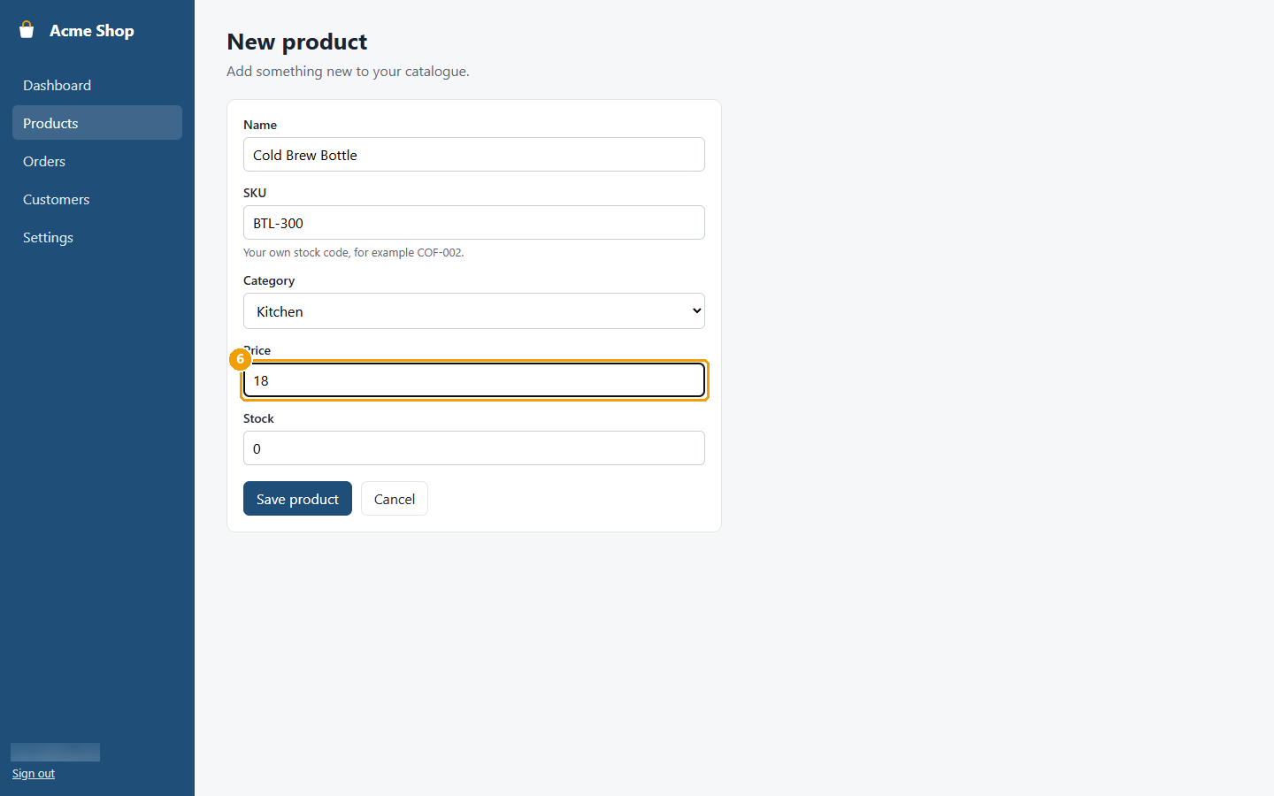
Figure 22: Step 6: Type the Price.
Step 7. Type how many you have in Stock.
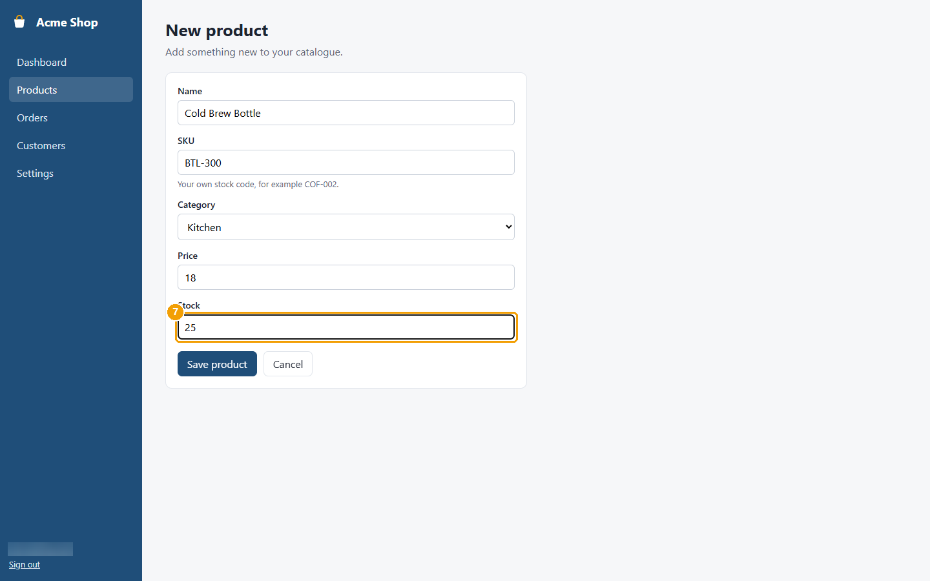
Figure 23: Step 7: Type how many you have in Stock.
Step 8. Click Save product. The product's page opens.
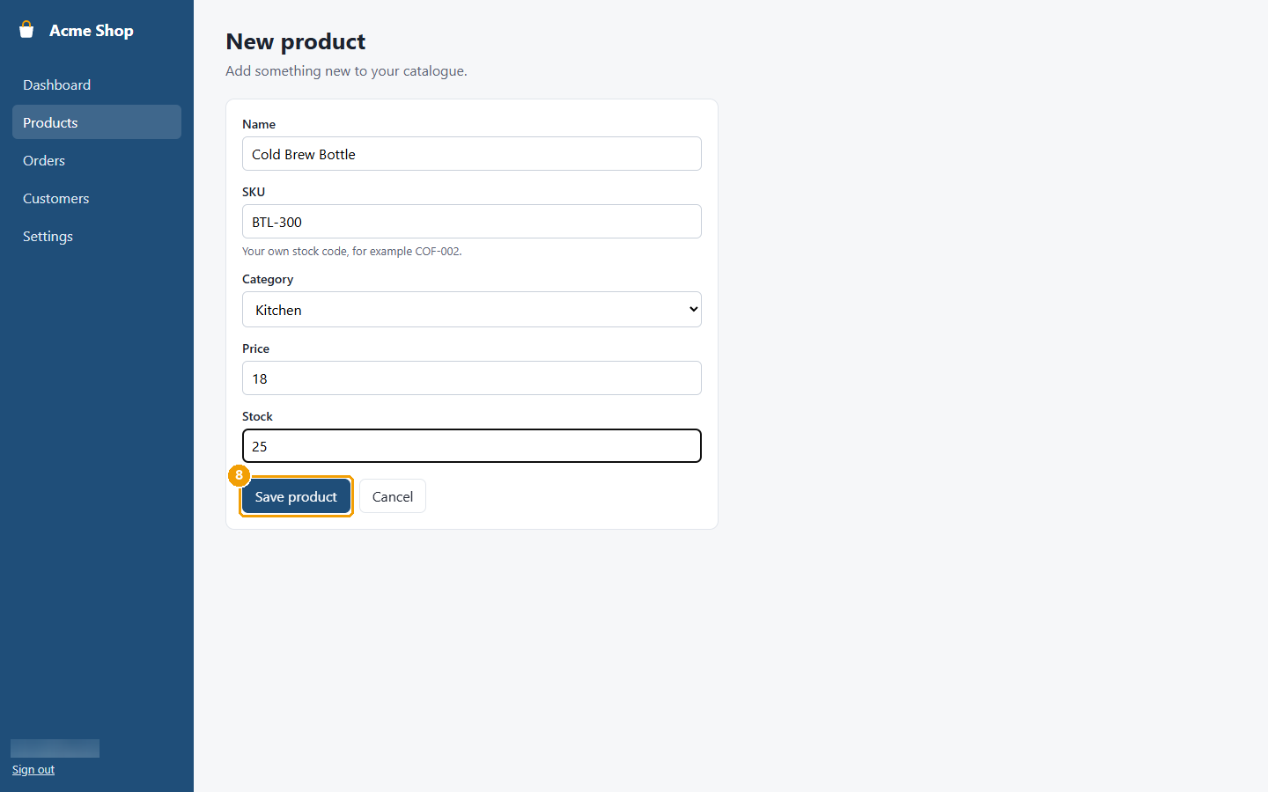
Figure 24: Step 8: Click Save product. The product's page opens.
Screens used: Dashboard, Products, New product, Product details

Correct the stock count
Update how many of a product you have, for example after a stock take.
Step 1. In the menu, click Products.
Figure 25: Step 1: In the menu, click Products.
Step 2. Click the product's name.
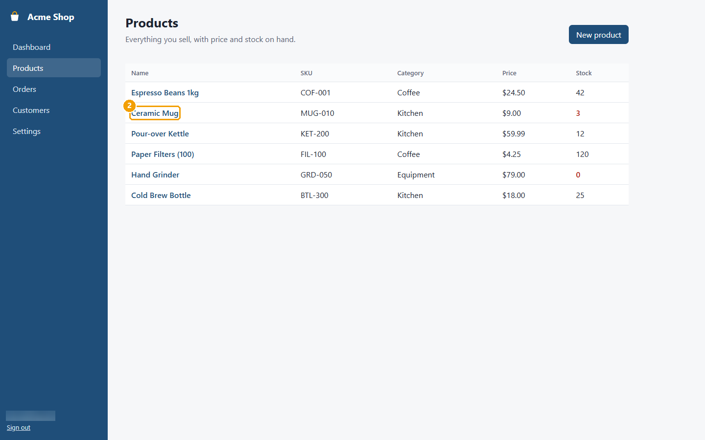
Figure 26: Step 2: Click the product's name.
Step 3. In Adjust stock, type the new count.
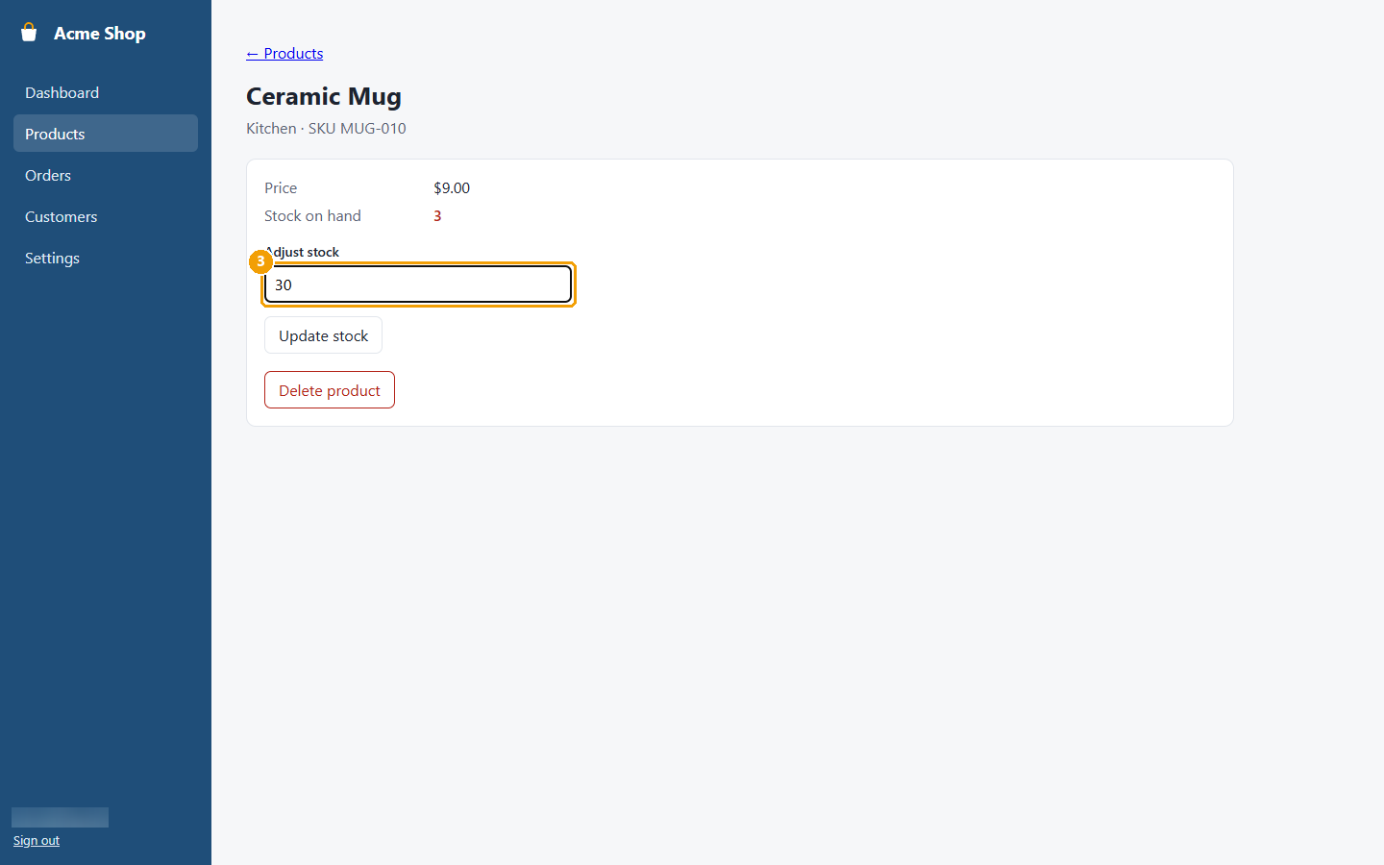
Figure 27: Step 3: In Adjust stock, type the new count.
Step 4. Click Update stock.
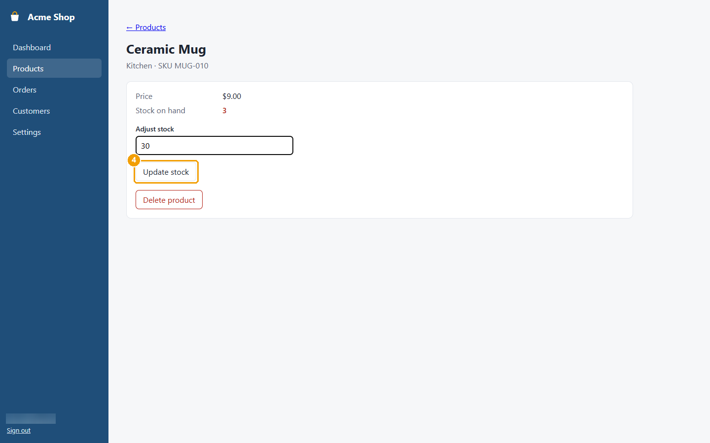
Figure 28: Step 4: Click Update stock.
Screens used: Dashboard, Products, Product details

Mark an order as shipped
Record that an order has left the building.
Step 1. In the menu, click Orders.
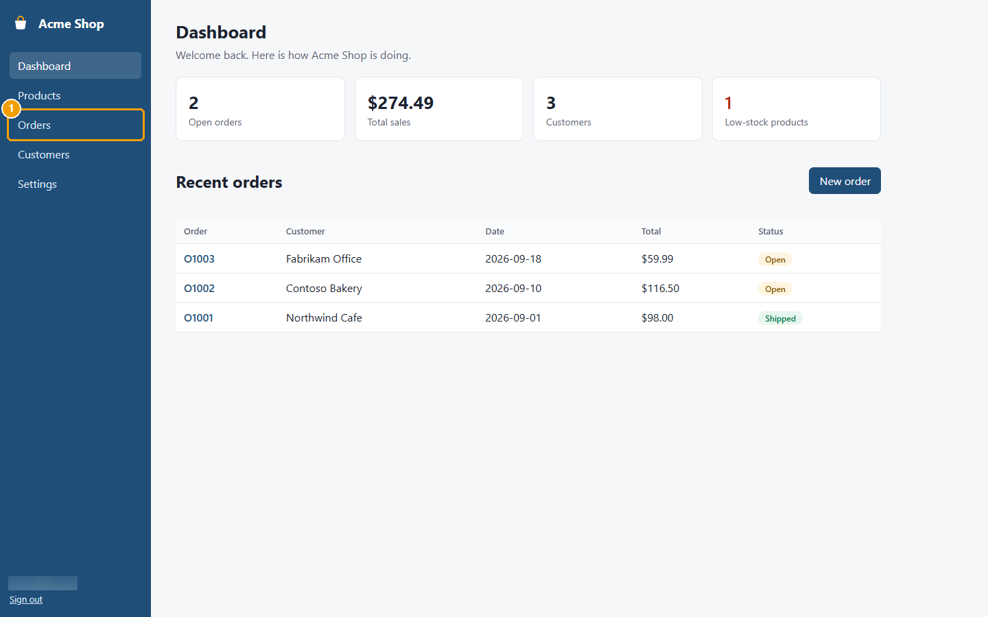
Figure 29: Step 1: In the menu, click Orders.
Step 2. Click the order number.
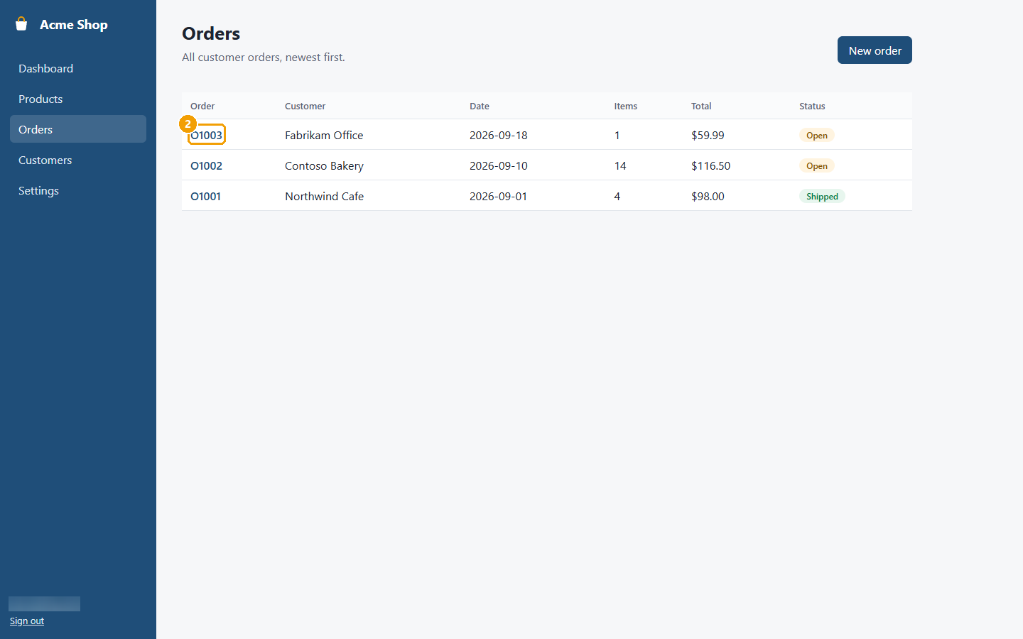
Figure 30: Step 2: Click the order number.
Step 3. Click Mark as shipped. The status changes to Shipped.
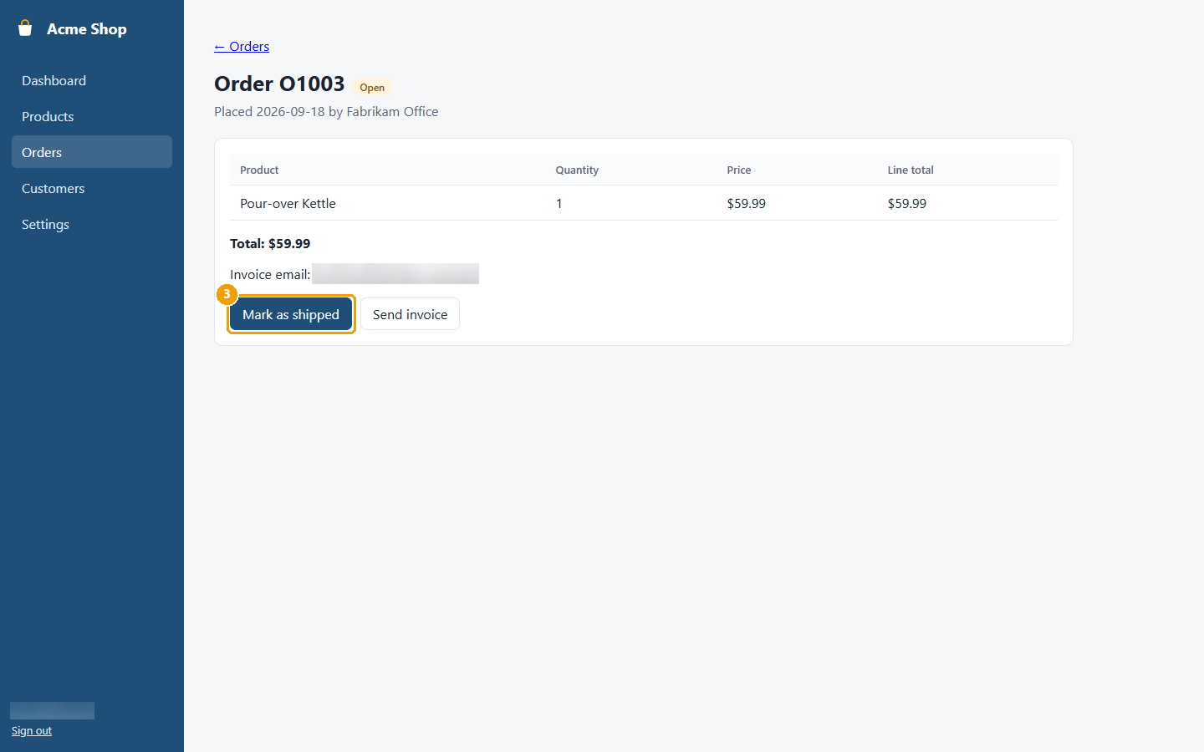
Figure 31: Step 3: Click Mark as shipped. The status changes to Shipped.
Screens used: Dashboard, Orders, Order details

Send an invoice
Email an invoice for an order to the customer.
Step 1. In the menu, click Orders.
Figure 32: Step 1: In the menu, click Orders.
Step 2. Click the order number.
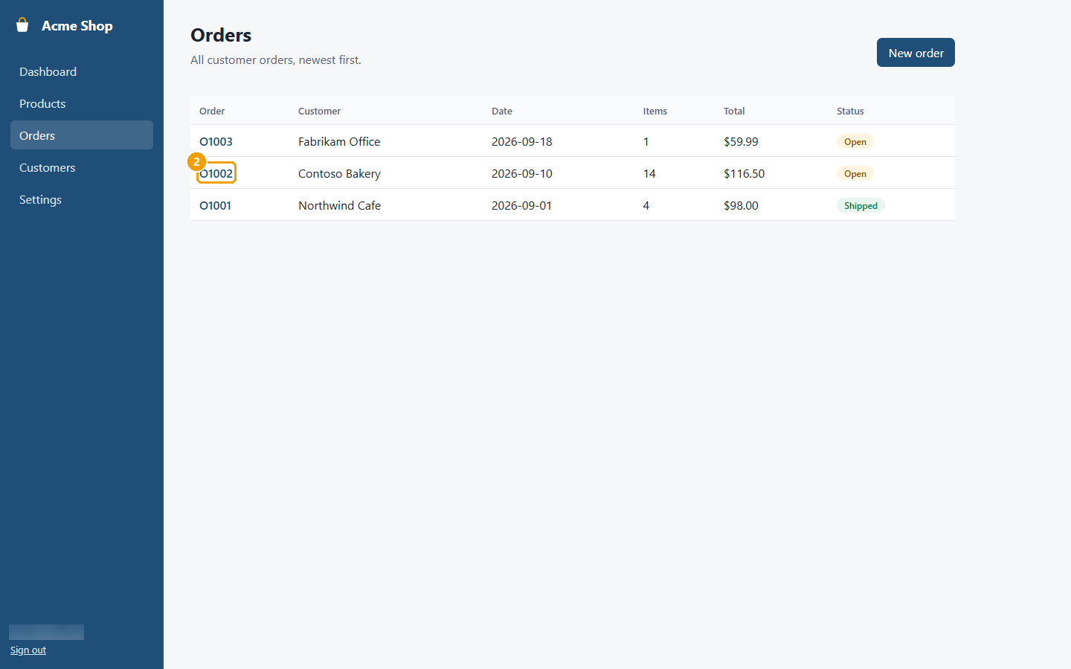
Figure 33: Step 2: Click the order number.
Step 3. Check the invoice email address, then click Send invoice. The invoice is emailed to the customer.
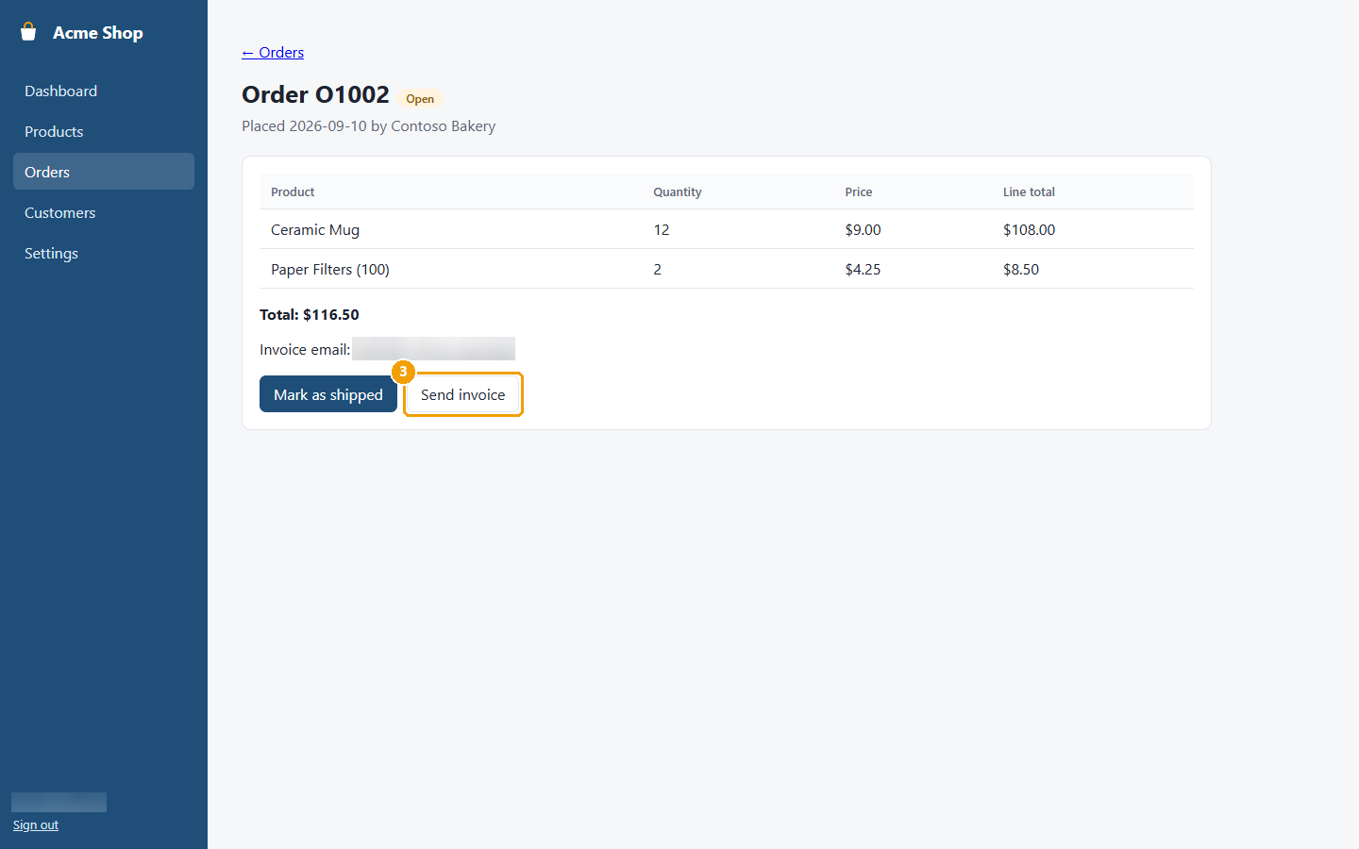
Figure 34: Step 3: Check the invoice email address, then click Send invoice. The invoice is emailed to the customer.
Screens used: Dashboard, Orders, Order details

Change store settings
Change your store name, currency or low-stock level.
Step 1. In the menu, click Settings.
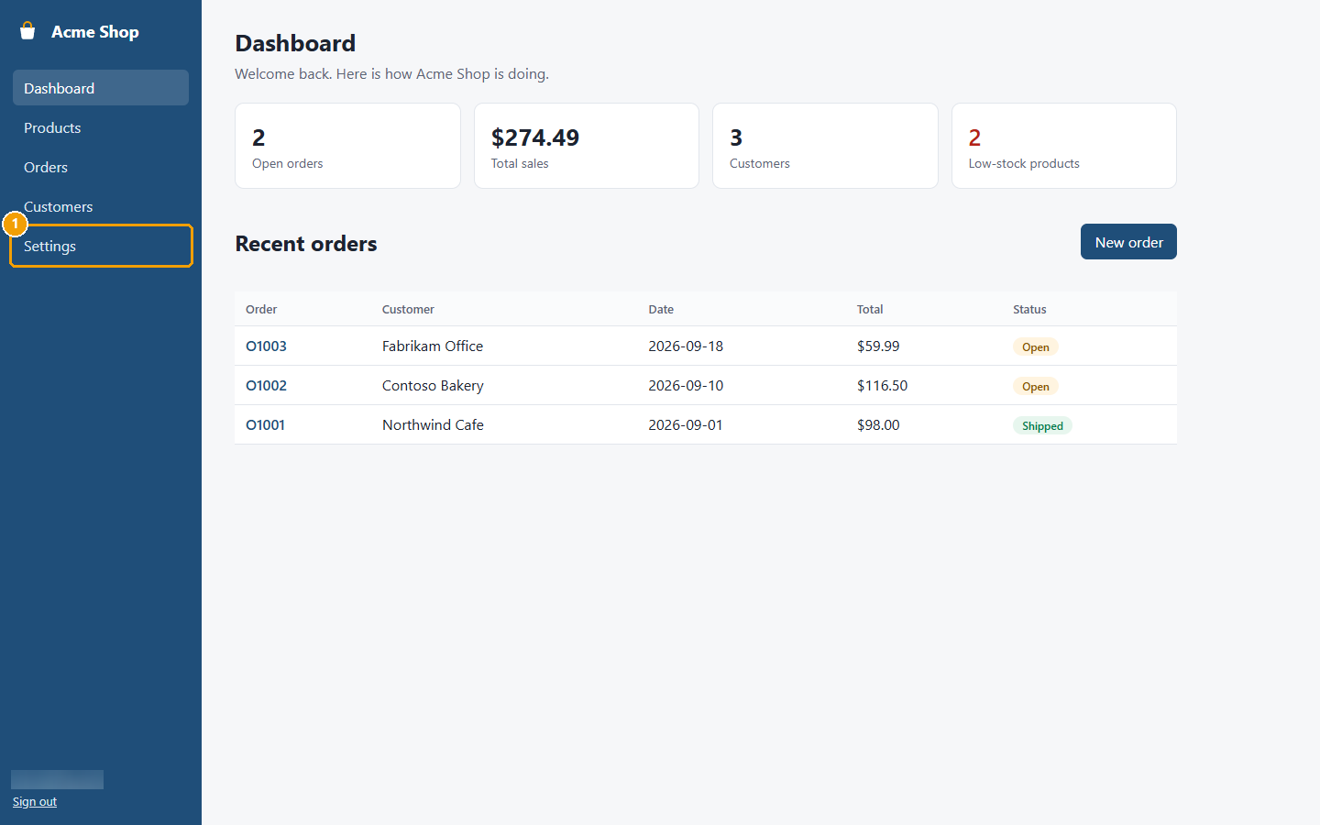
Figure 35: Step 1: In the menu, click Settings.
Step 2. Change Low-stock threshold to the level you want warnings at.
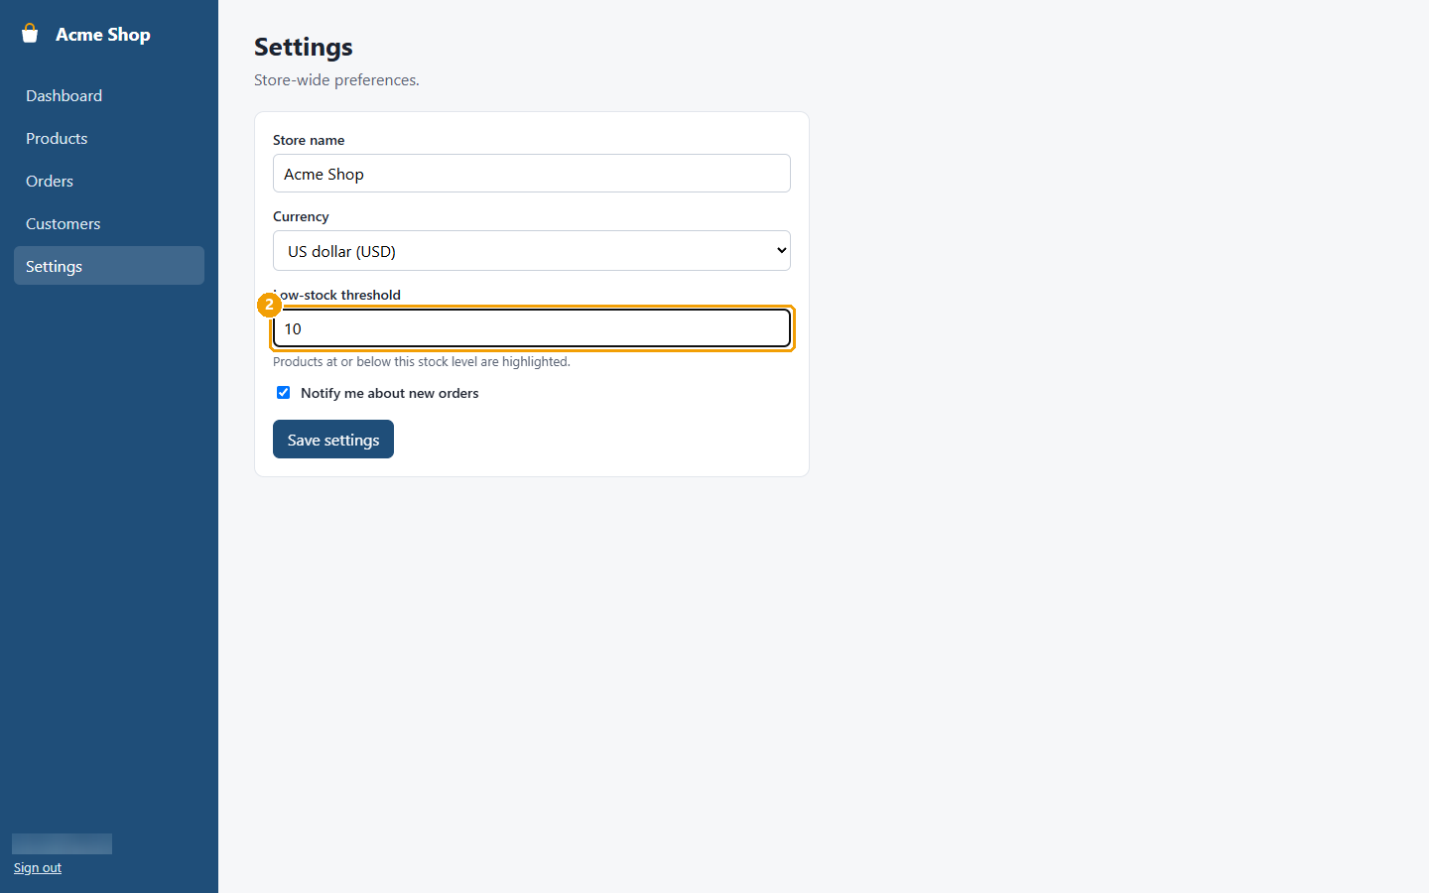
Figure 36: Step 2: Change Low-stock threshold to the level you want warnings at.
Step 3. Choose a Currency if you need to.
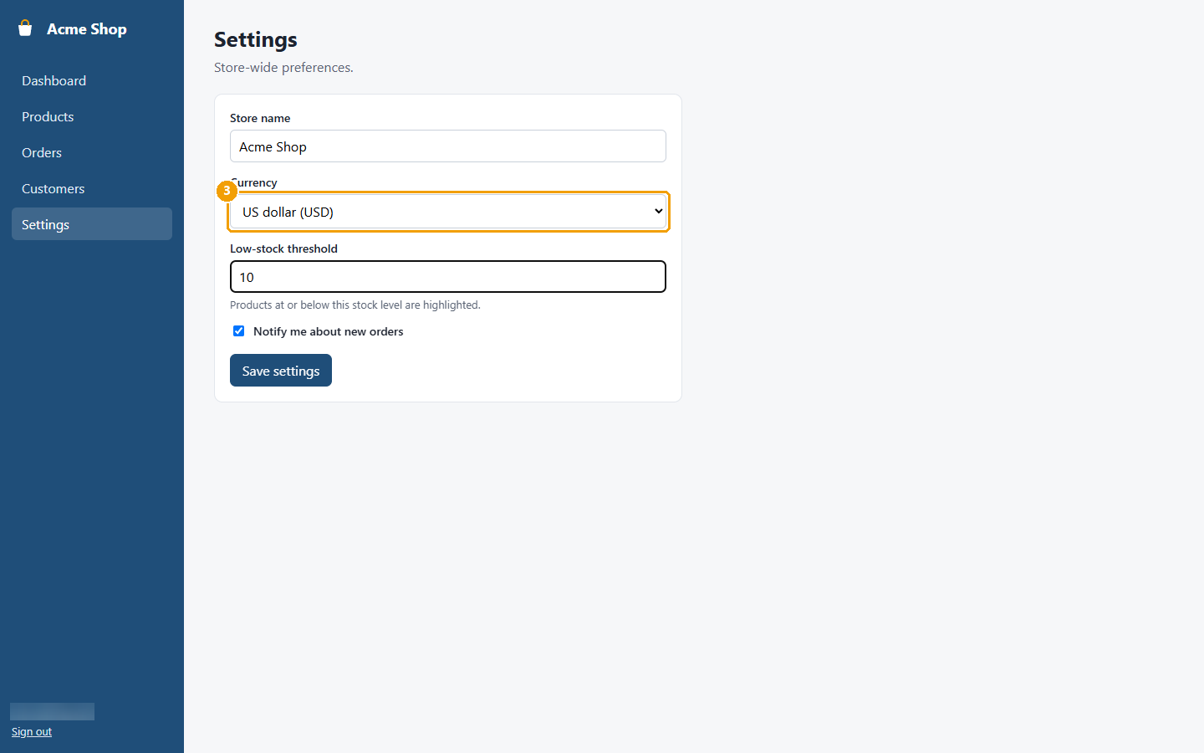
Figure 37: Step 3: Choose a Currency if you need to.
Step 4. Click Save settings. Settings saved. appears.
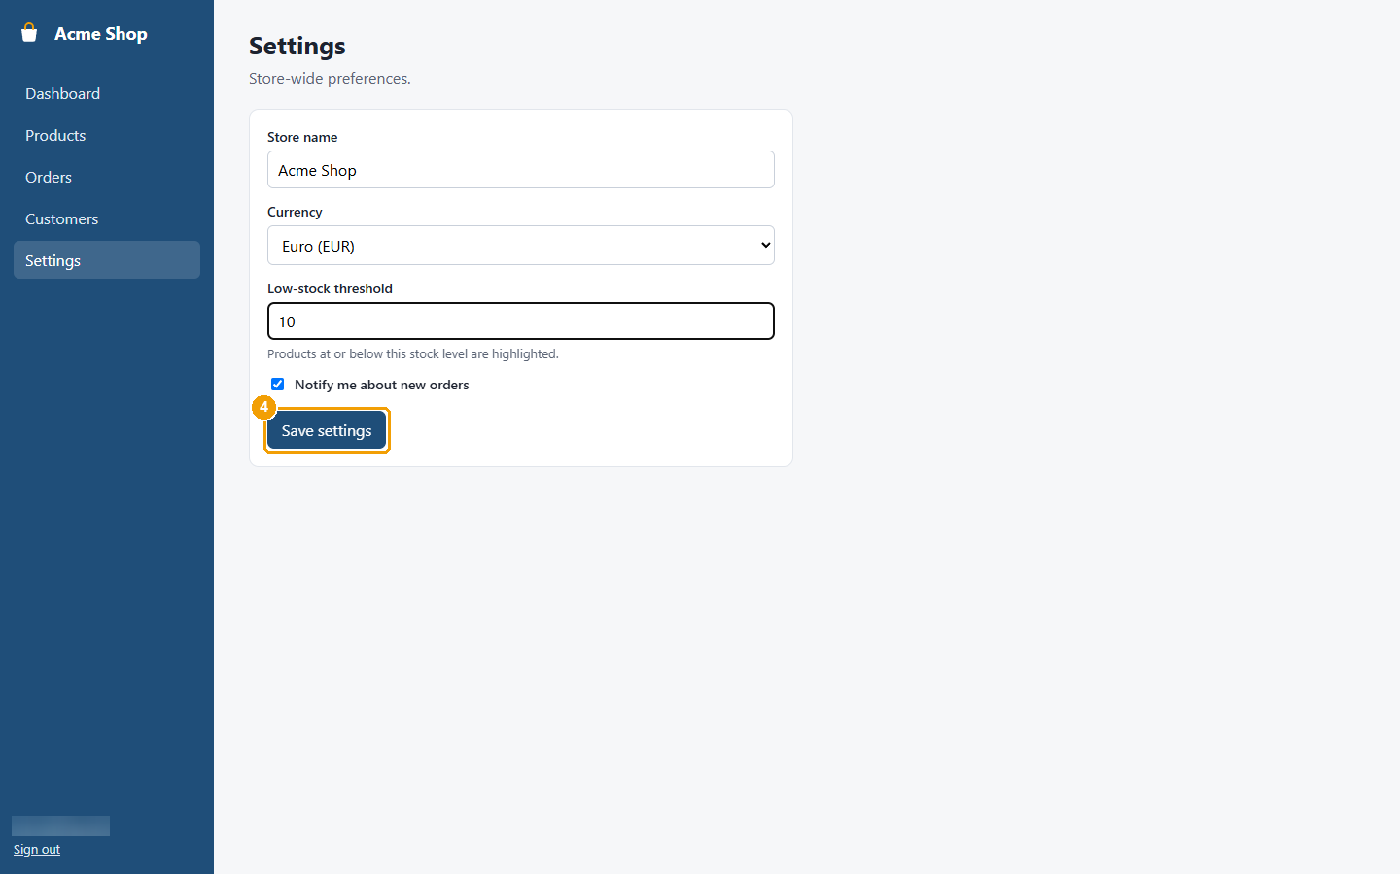
Figure 38: Step 4: Click Save settings. Settings saved. appears.
Screens used: Dashboard, Settings

Find products that are running low
See which products need restocking.
Step 1. In the menu, click Dashboard and look at Low-stock products.
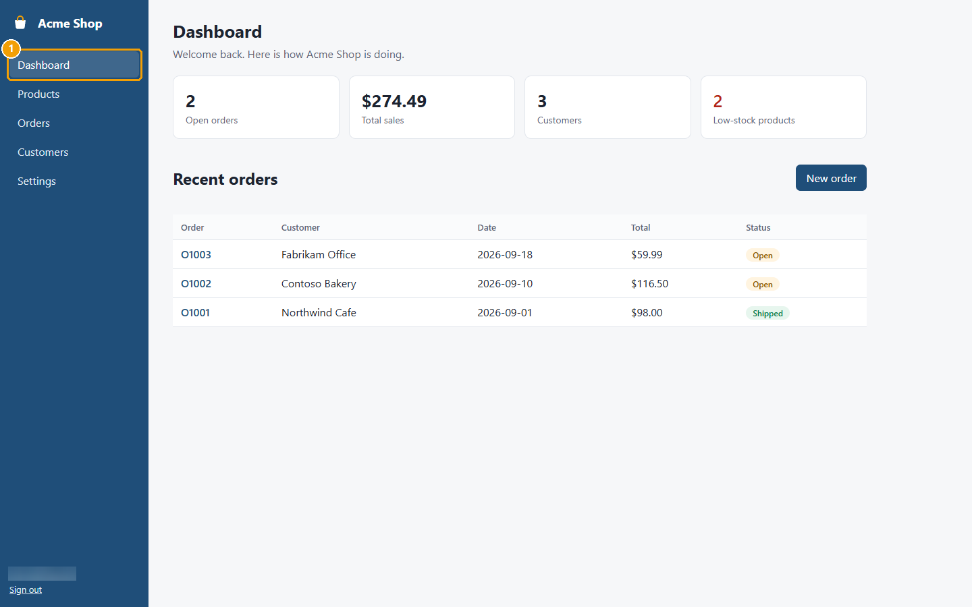
Figure 39: Step 1: In the menu, click Dashboard and look at Low-stock products.
Step 2. Click Products. Stock counts shown in red are at or below your low-stock level.
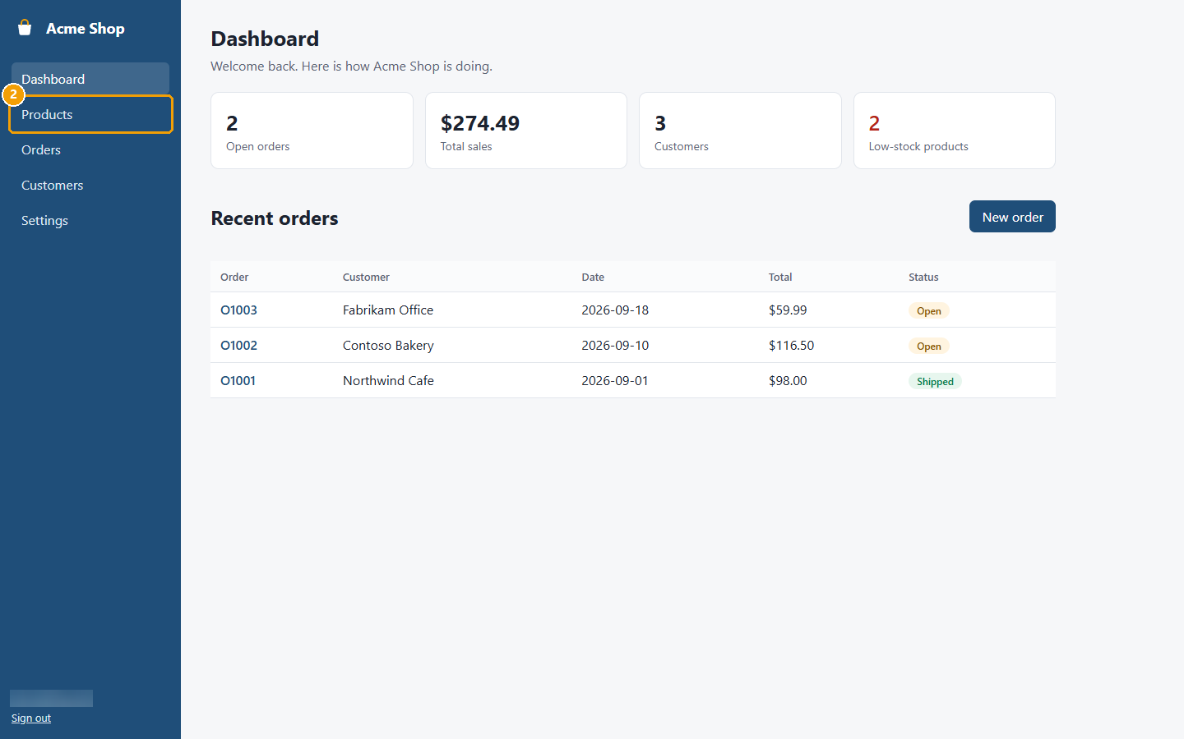
Figure 40: Step 2: Click Products. Stock counts shown in red are at or below your low-stock level.
Screens used: Dashboard, Products

Sign out
Leave Acme Shop safely, for example on a shared computer.
Step 1. At the bottom of the menu, click Sign out. The sign-in page appears.
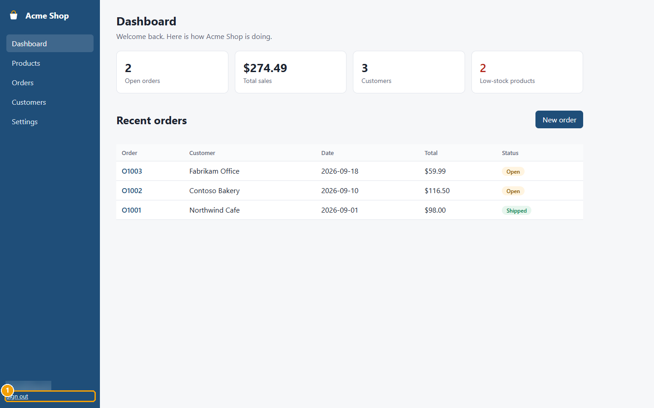
Figure 41: Step 1: At the bottom of the menu, click Sign out. The sign-in page appears.
Screens used: Dashboard

Screen Reference

Sign in
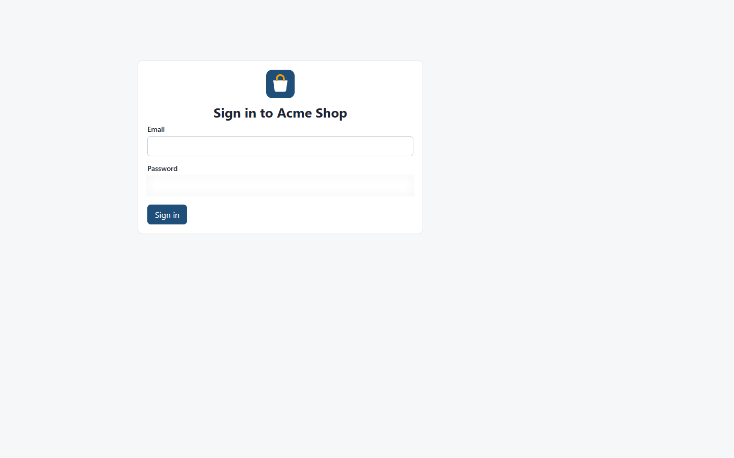
Figure 42: Sign in
The first page you see. Enter your email and password to get into Acme Shop.
Name | Type | What it does
Email | text box | The email address of your Acme Shop account.
Password | text box | Your password. It is hidden as you type.
Sign in | button | Signs you in and opens the **Dashboard**.

Used in: Sign in to Acme Shop

Dashboard
Figure 43: Dashboard
Your home page. It sums up how the shop is doing and lists the most recent orders.
Name | Type | What it does
Open orders | summary tile | How many orders have not been shipped yet.
Total sales | summary tile | The value of all orders.
Customers | summary tile | How many customers you have.
Low-stock products | summary tile | Products at or below the low-stock level set in **Settings**. Shown in red when there are any.
New order | button | Opens the **New order** page.
Recent orders | table | The five newest orders. Click an order number to open it.

Used in: Sign in to Acme Shop, Create an order, Add a customer, Add a product, Correct the stock count, Mark an order as shipped, Send an invoice, Change store settings, Find products that are running low, Sign out

Products
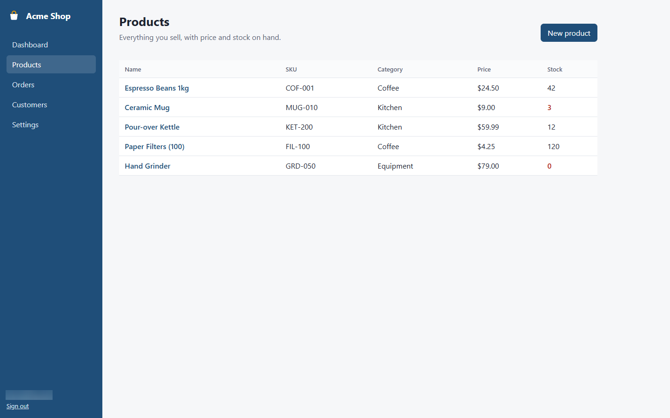
Figure 44: Products
Lists everything you sell, with its stock code (SKU), category, price and stock on hand.
Name | Type | What it does
New product | button | Opens the **New product** page.
Name | link | Opens the product's page.
Stock | column | How many you have. Shown in red when stock is low.

Used in: Add a product, Correct the stock count, Find products that are running low

New product
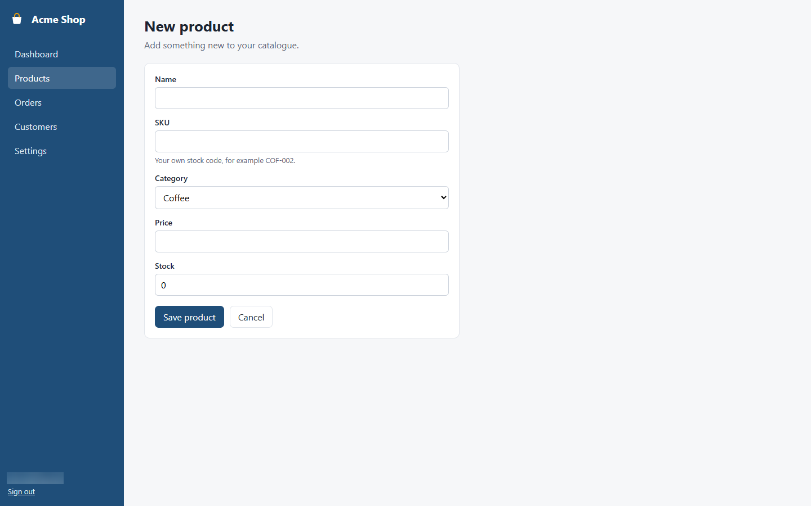
Figure 45: New product
Use this page to add a product to your catalogue.
Name | Type | What it does
Name | text box | The product name customers see. Required.
SKU | text box | Your own stock code, for example COF-002. Required.
Category | list | Coffee, Kitchen, Equipment or Other.
Price | text box | Price per item. Must be greater than 0.
Stock | text box | How many you have now. Cannot be negative.
Save product | button | Saves the product and opens its page.
Cancel | button | Goes back to **Products** without saving.

Used in: Add a product

Product details
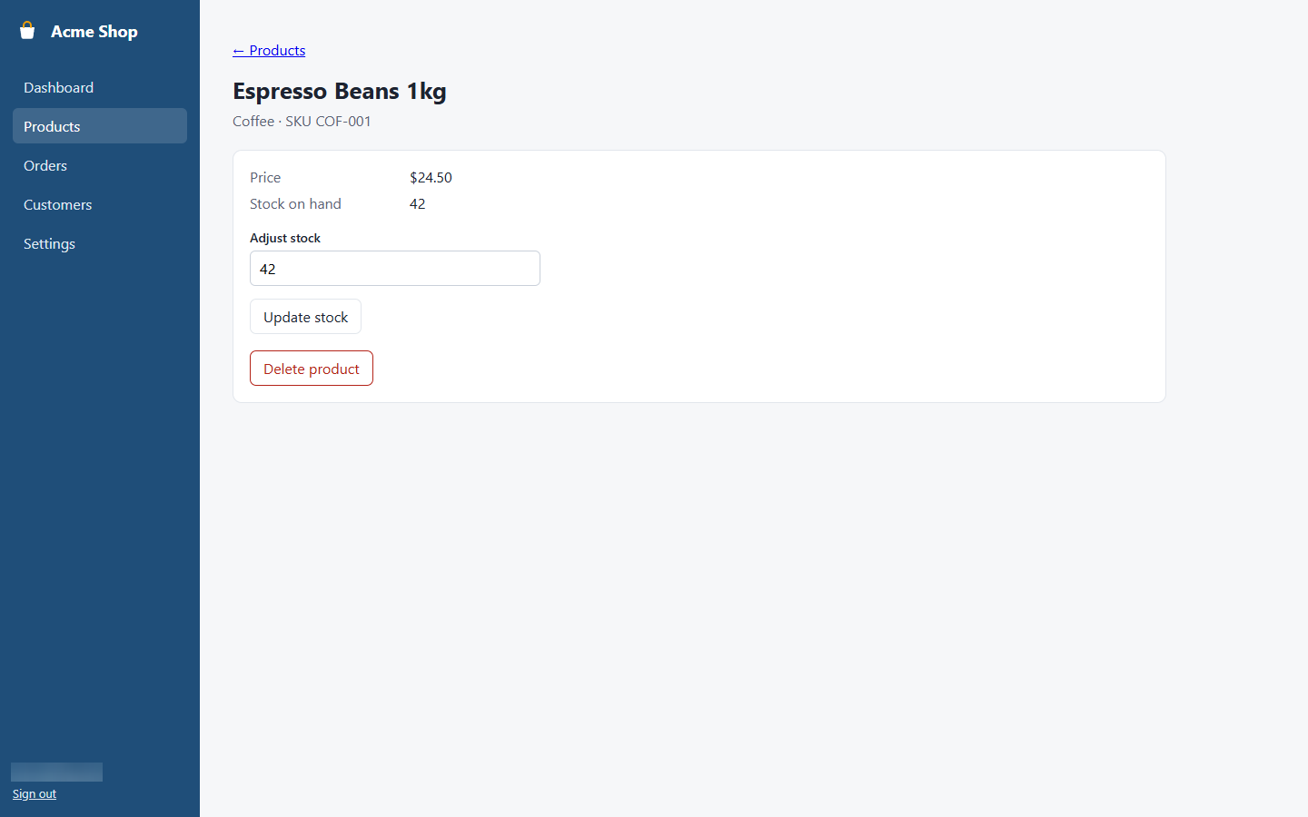
Figure 46: Product details
Shows one product's price and stock. You can correct the stock count or delete the product here.
Name | Type | What it does
Adjust stock | text box | Type the new stock count.
Update stock | button | Saves the new stock count.
Delete product | button | Removes the product after you confirm. This cannot be undone.

Used in: Add a product, Correct the stock count

Orders
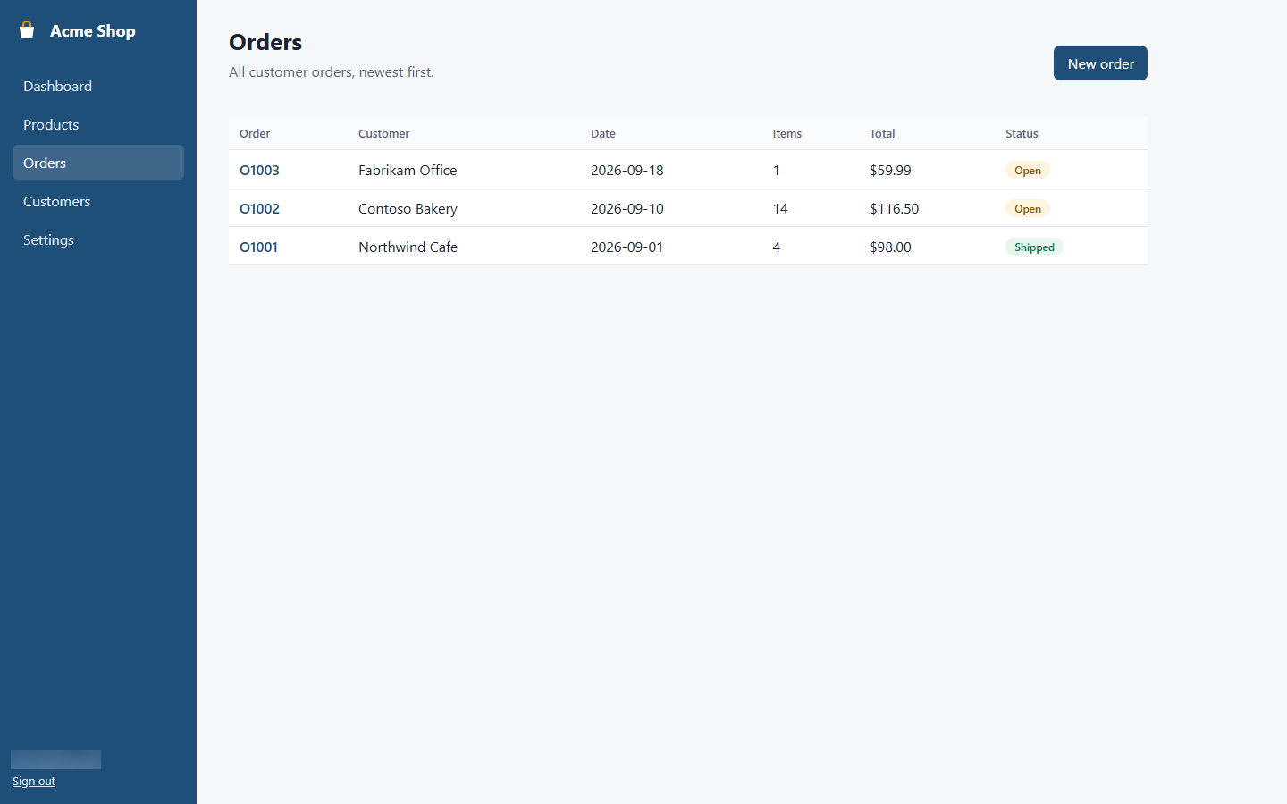
Figure 47: Orders
Lists all orders, newest first, with the customer, date, number of items, total and status.
Name | Type | What it does
New order | button | Opens the **New order** page.
Order | link | Opens the order.
Status | column | **Open** until you mark the order as shipped, then **Shipped**.

Used in: Create an order, Mark an order as shipped, Send an invoice

New order
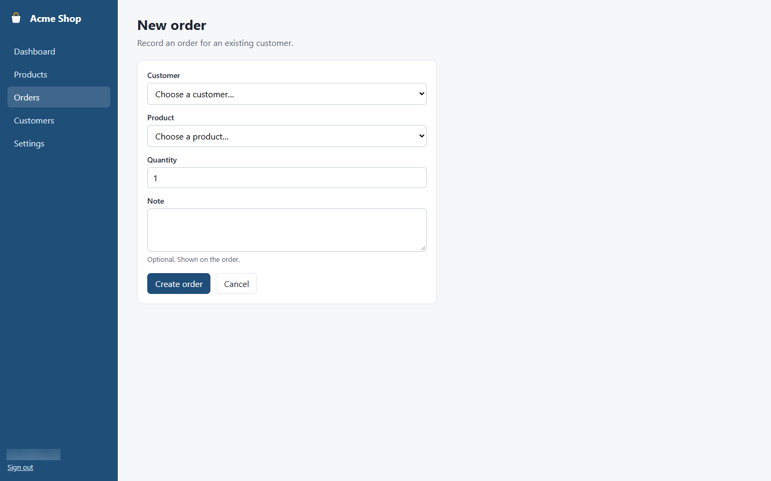
Figure 48: New order
Use this page to record a new order for an existing customer.
Name | Type | What it does
Customer | list | Who the order is for. The customer must already exist - add new customers on the **Customers** page first.
Product | list | What they are buying. The list shows how many are in stock.
Quantity | text box | How many. Must be greater than 0 and not more than the stock.
Note | text box | Optional note shown on the order.
Create order | button | Saves the order and takes the items out of stock.

Used in: Create an order

Order details
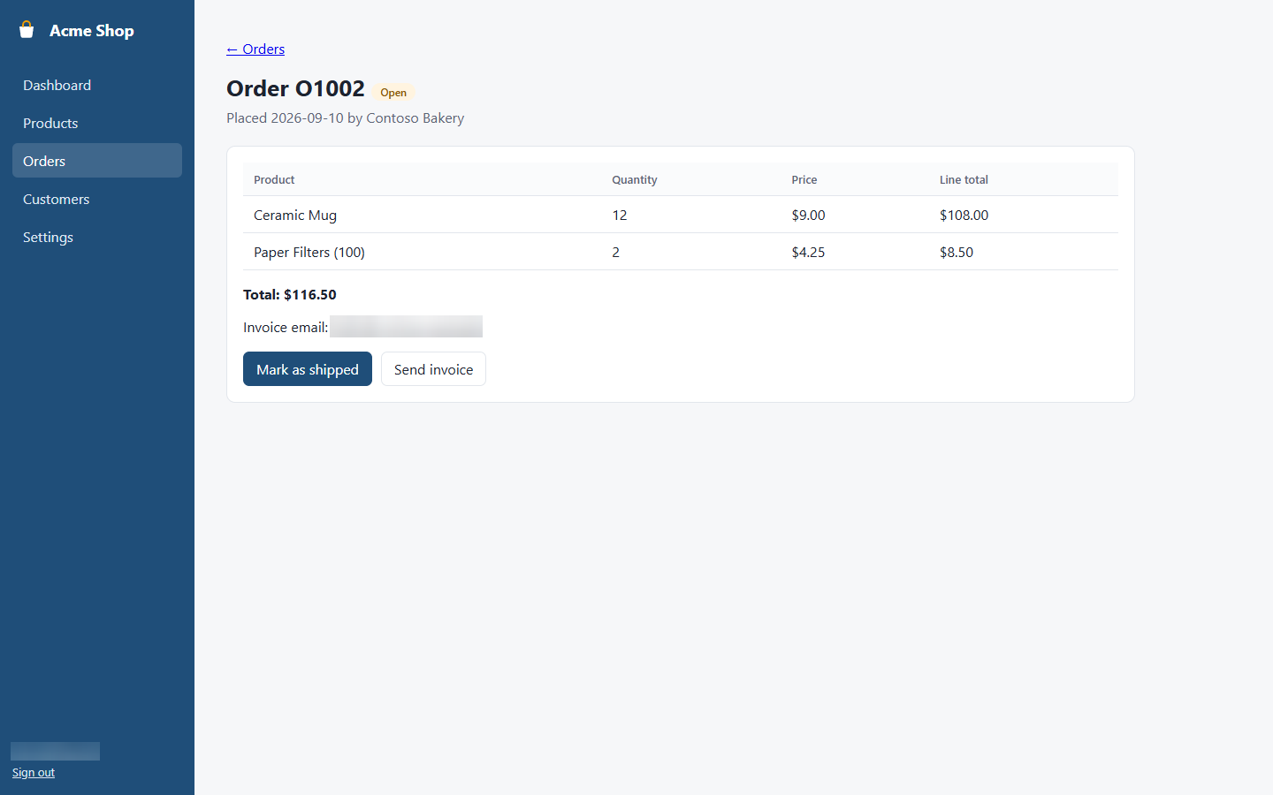
Figure 49: Order details
Shows the items, quantities and total of one order, and who it was for.
Name | Type | What it does
Mark as shipped | button | Changes the status to **Shipped**. Only shown for open orders.
Send invoice | button | Emails an invoice to the customer's invoice email address.

Used in: Create an order, Mark an order as shipped, Send an invoice

Customers
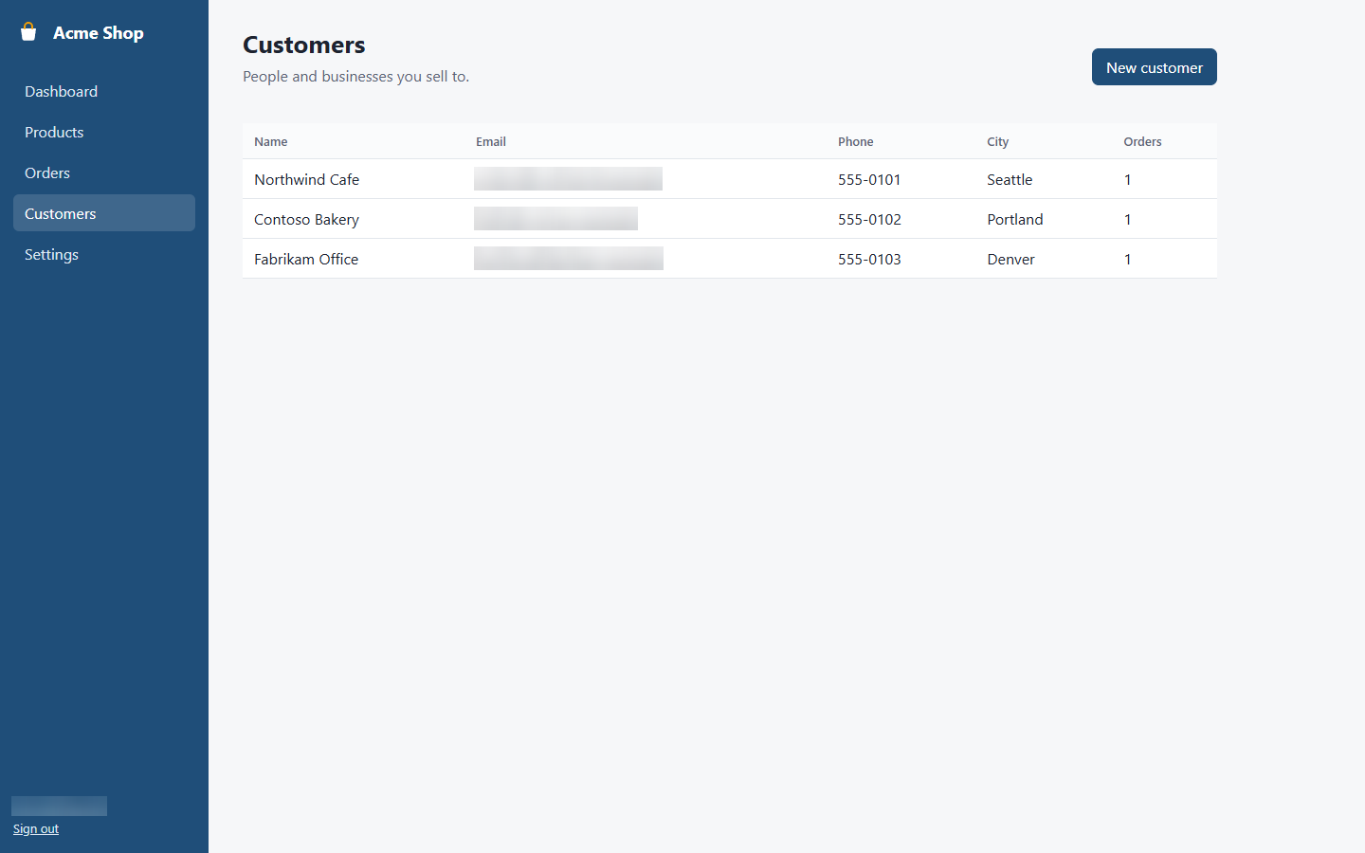
Figure 50: Customers
Lists the people and businesses you sell to, with their contact details.
Name | Type | What it does
New customer | button | Opens the **New customer** page.
Orders | column | How many orders the customer has placed.

Used in: Add a customer

New customer
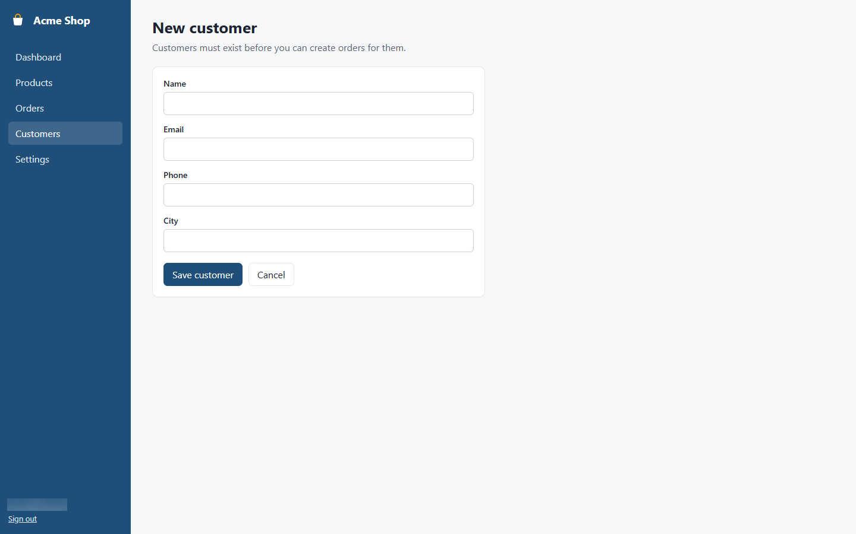
Figure 51: New customer
Use this page to add a customer. You need a customer before you can create an order for them.
Name | Type | What it does
Name | text box | Person or business name. Required.
Email | text box | Where invoices are sent. Must be a valid email address.
Phone | text box | Optional.
City | text box | Optional.
Save customer | button | Saves the customer and returns to **Customers**.

Used in: Add a customer

Settings
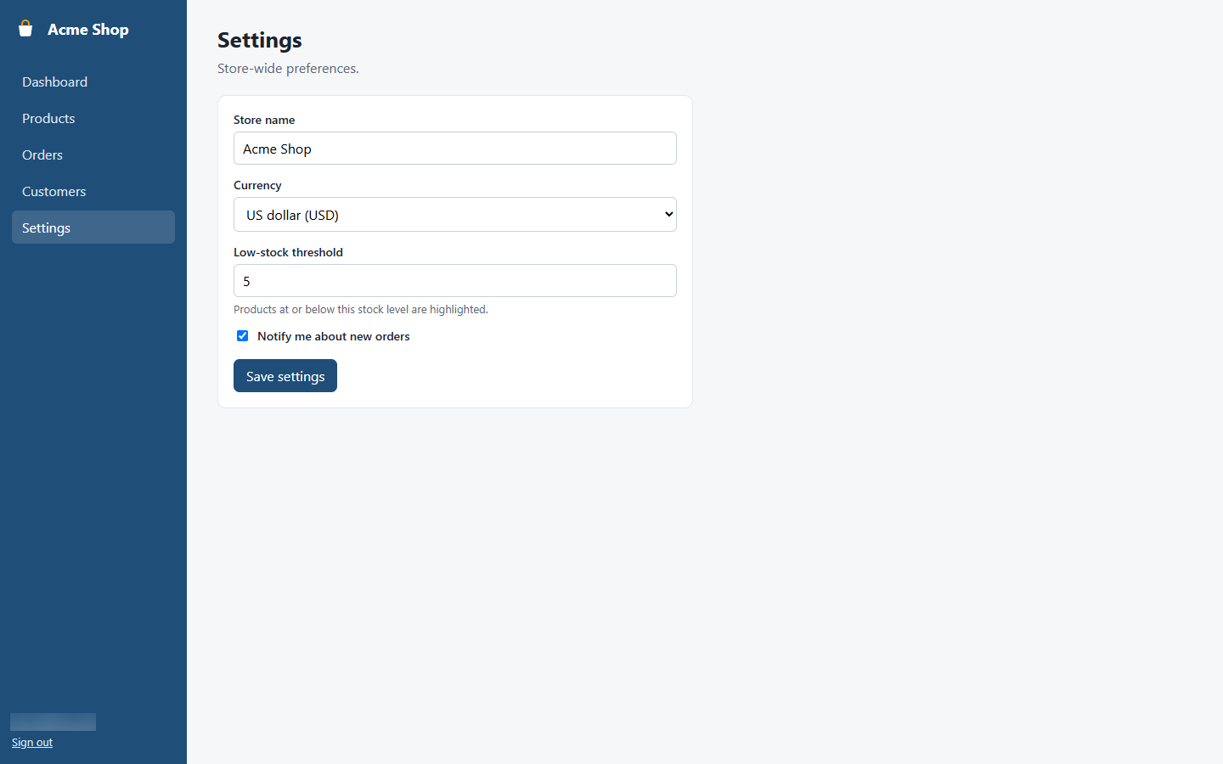
Figure 52: Settings
Store-wide preferences that affect every user.
Name | Type | What it does
Store name | text box | Shown on the **Dashboard**.
Currency | list | Currency used for all prices and totals.
Low-stock threshold | text box | Products at or below this level are highlighted. Between 0 and 1000.
Notify me about new orders | check box | Turn email notifications for new orders on or off.
Save settings | button | Saves your changes.

Used in: Change store settings

Troubleshooting
Message | Cause | How to fix it
Invalid email or password | The email or password does not match your account. | Check for typing mistakes and that Caps Lock is off, then try again. Ask your administrator if you have forgotten your password.
Price must be greater than 0 | The **Price** box is empty, 0 or not a number. | Type a price such as 9.99.
Stock cannot be negative | The stock count is below zero or not a number. | Type 0 or a positive whole number.
Select a customer | No customer was chosen in **Customer**. | Choose a customer. If they are not in the list, add them on the Customers page first.
Quantity must be greater than 0 | The **Quantity** is 0, empty or not a number. | Type 1 or more.
Not enough stock for this quantity | You asked for more items than are in stock. | Lower the quantity, or correct the stock count on the product's page first.
Email is not valid | The email address is missing a part such as @ or the domain. | Type a full address, for example name@company.com.
Low-stock threshold must be between 0 and 1000 | The number is outside the allowed range. | Type a whole number from 0 to 1000.

