

ClientDesk CRM User Manual
Version 1.8.2 · September 24, 2026
Fabrikam Software

Contents
Right-click and choose Update Field to show the table of contents.

Getting Started
ClientDesk keeps your customer contacts, calls, emails and meetings in one place, and shows the value of your sales pipeline at a glance.

Before you begin
- A Windows 10 or Windows 11 PC with ClientDesk installed.
- Your ClientDesk user name and password.

Starting the application
Open the Start menu and click ClientDesk. The Sign in to ClientDesk window appears.

Signing in
Type your User name and Password, then click Sign in.

A quick tour
The main window has three tabs. Customers lists your contacts, Activities shows your calls, emails and meetings, and Dashboard shows your pipeline. The File, Customers and Help menus are at the top.
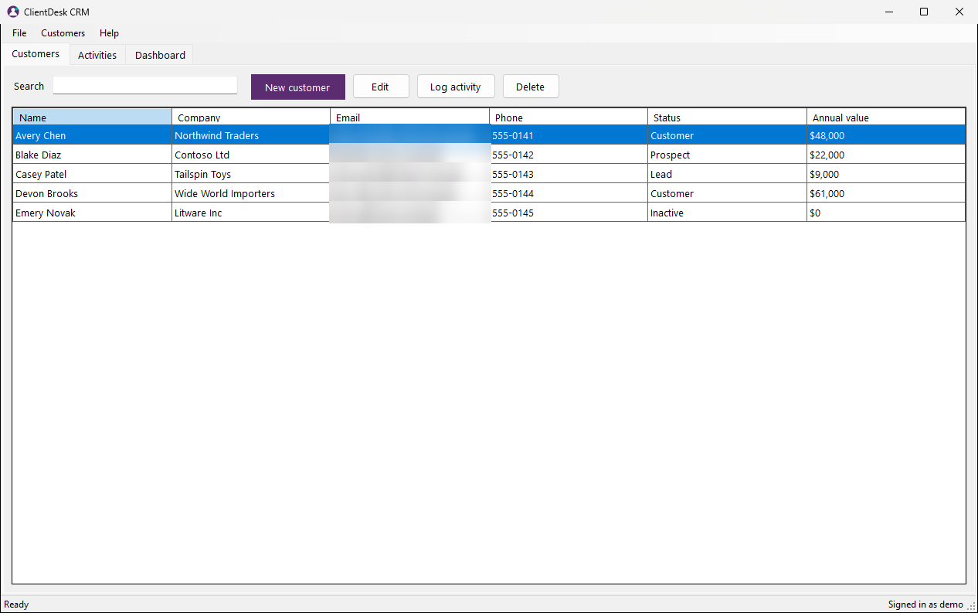
Figure 1: The Customers tab screen

How-To Tasks

Sign in
Open ClientDesk with your user name and password.
Step 1. In User name, type your user name.
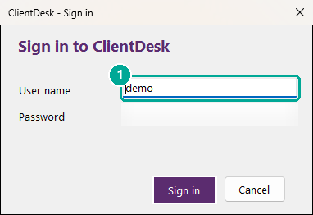
Figure 2: Step 1: In User name, type your user name.
Step 2. In Password, type your password.
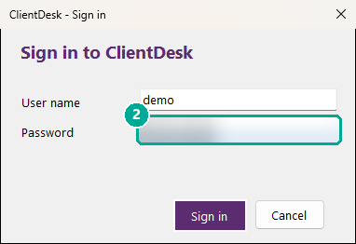
Figure 3: Step 2: In Password, type your password.
Step 3. Click Sign in.
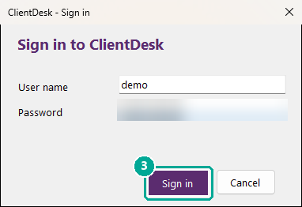
Figure 4: Step 3: Click Sign in.
Screens used: Sign in, Customers tab

Add a customer
Start tracking a new contact.
Step 1. On the Customers tab, click New customer.
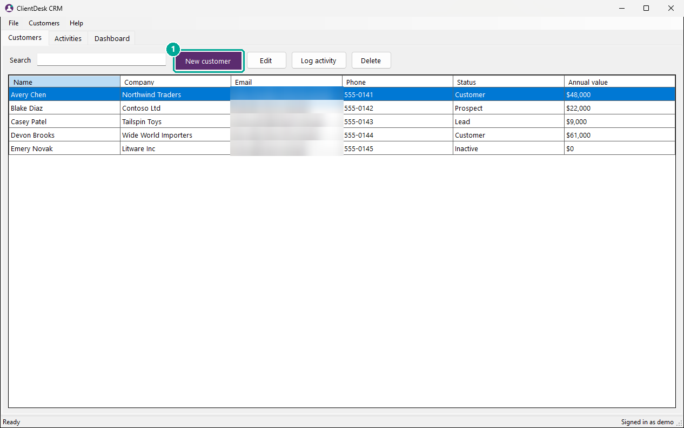
Figure 5: Step 1: On the Customers tab, click New customer.
Step 2. Type the contact's Name.
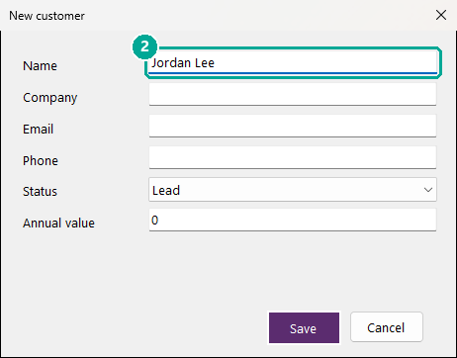
Figure 6: Step 2: Type the contact's Name.
Step 3. Type their Company.
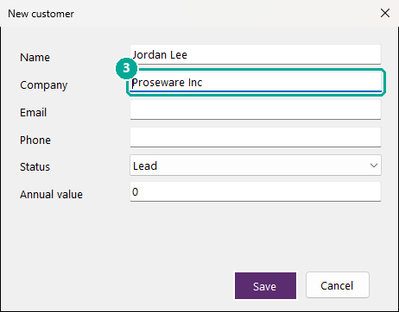
Figure 7: Step 3: Type their Company.
Step 4. Type their Email address.
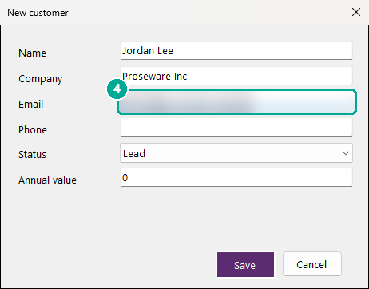
Figure 8: Step 4: Type their Email address.
Step 5. Choose a Status.
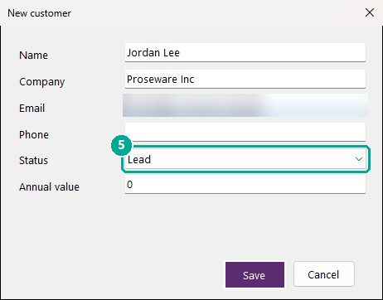
Figure 9: Step 5: Choose a Status.
Step 6. Type the expected Annual value.
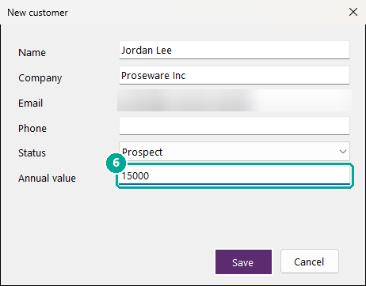
Figure 10: Step 6: Type the expected Annual value.
Step 7. Click Save. The customer appears in the list.
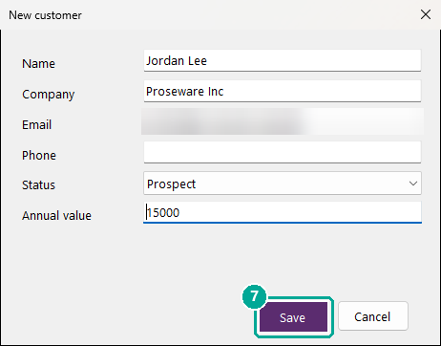
Figure 11: Step 7: Click Save. The customer appears in the list.
Screens used: Customers tab, New customer window

Log a call or meeting
Keep a record of what you discussed with a customer.
Step 1. On the Customers tab, click the customer.
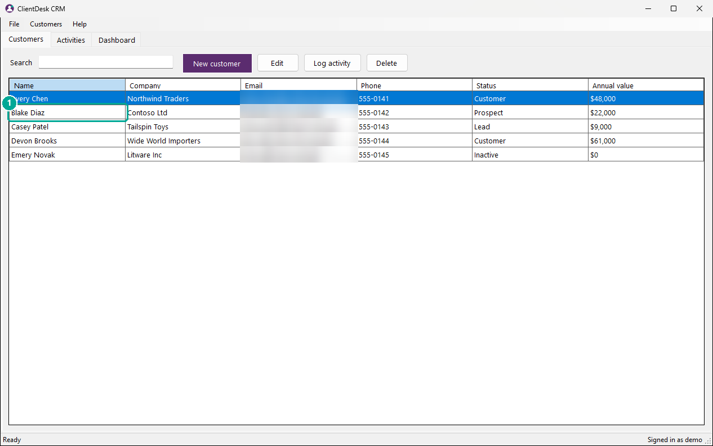
Figure 12: Step 1: On the Customers tab, click the customer.
Step 2. Click Log activity.
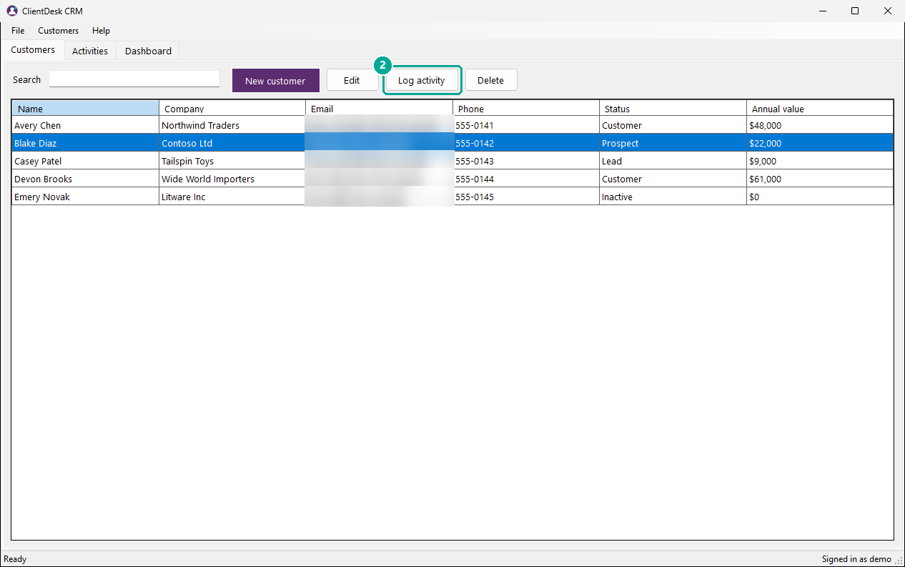
Figure 13: Step 2: Click Log activity.
Step 3. Choose the Type of activity.
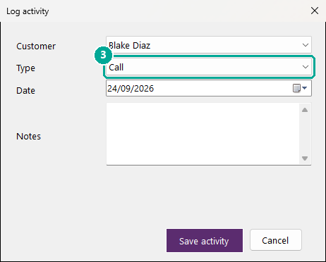
Figure 14: Step 3: Choose the Type of activity.
Step 4. Type what you discussed in Notes.
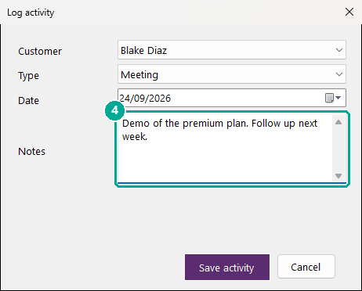
Figure 15: Step 4: Type what you discussed in Notes.
Step 5. Click Save activity. It appears on the Activities tab.
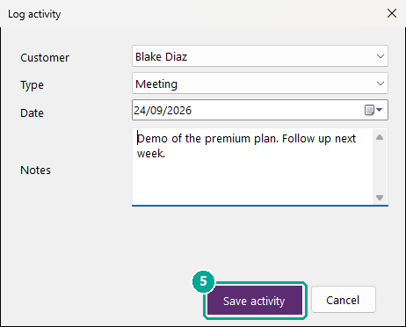
Figure 16: Step 5: Click Save activity. It appears on the Activities tab.
Screens used: Customers tab, Log activity window, Activities tab

Update a customer's details
Change a contact's status, phone number or other details.
Step 1. On the Customers tab, click the customer.
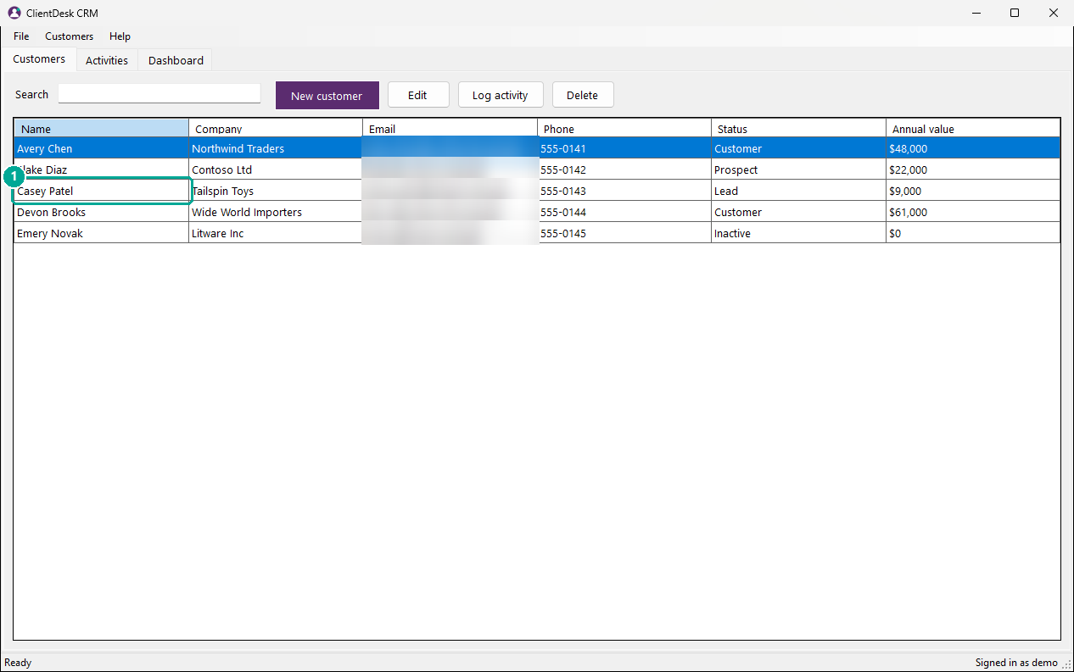
Figure 17: Step 1: On the Customers tab, click the customer.
Step 2. Click Edit, or double-click the row.
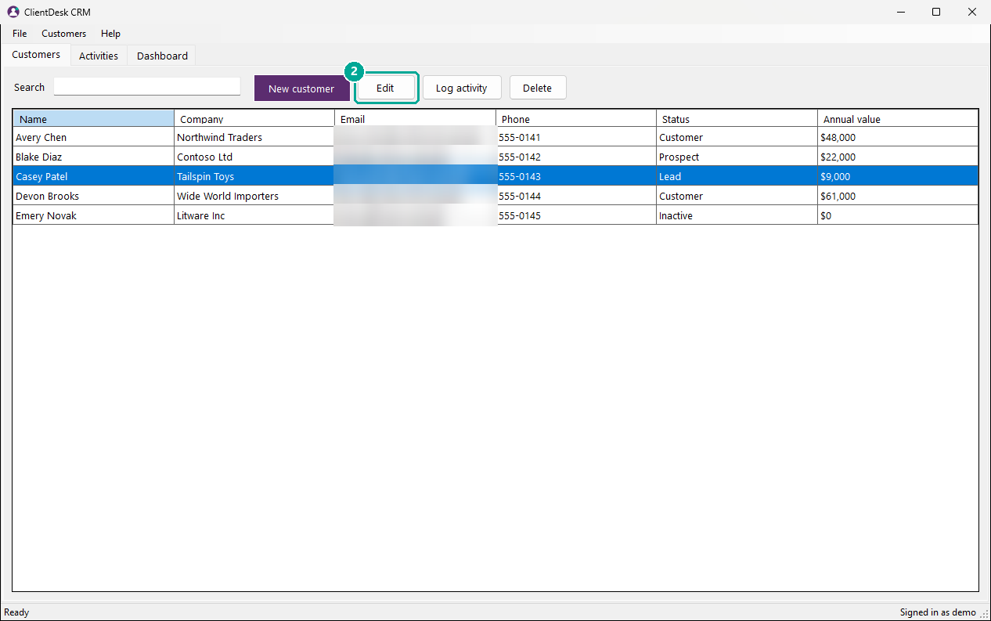
Figure 18: Step 2: Click Edit, or double-click the row.
Step 3. Change the details, for example the Status.
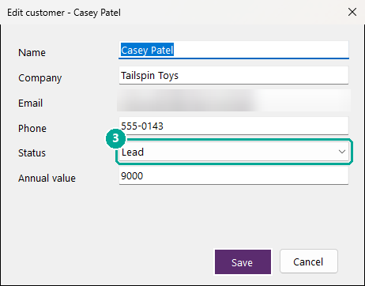
Figure 19: Step 3: Change the details, for example the Status.
Step 4. Click Save.
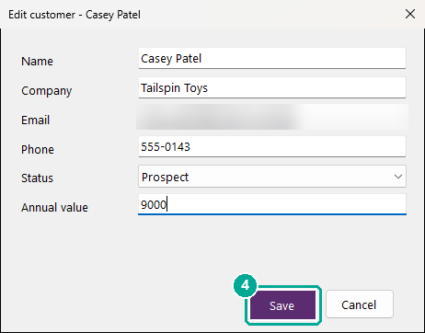
Figure 20: Step 4: Click Save.
Screens used: Customers tab, New customer window

Find a customer
Quickly find a contact by name or company.
Step 1. On the Customers tab, type part of a name or company in Search.
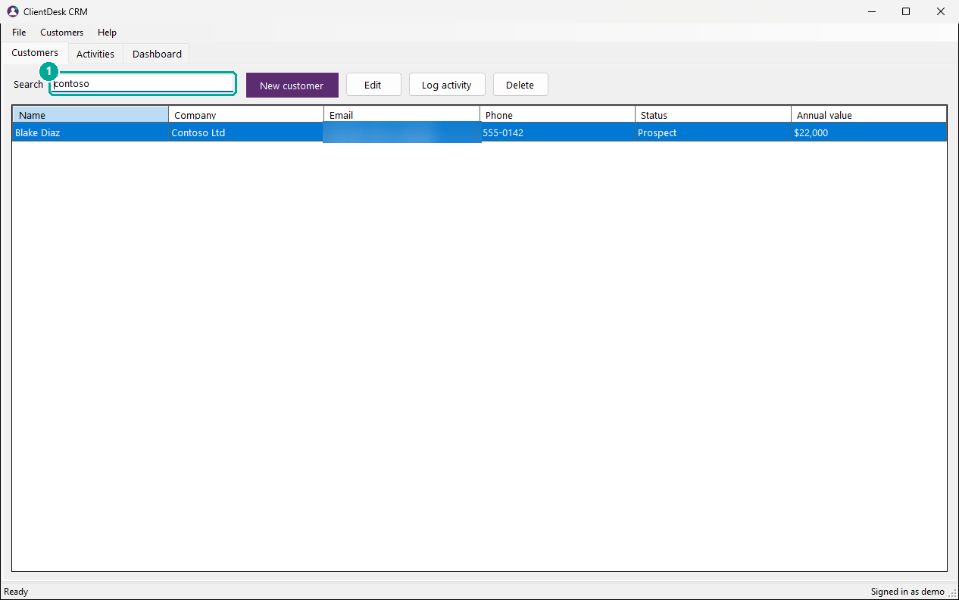
Figure 21: Step 1: On the Customers tab, type part of a name or company in Search.
Screens used: Customers tab

Check your sales pipeline
See the value of your contacts by status.
Step 1. Click the Dashboard tab. The chart shows the total annual value for each status.
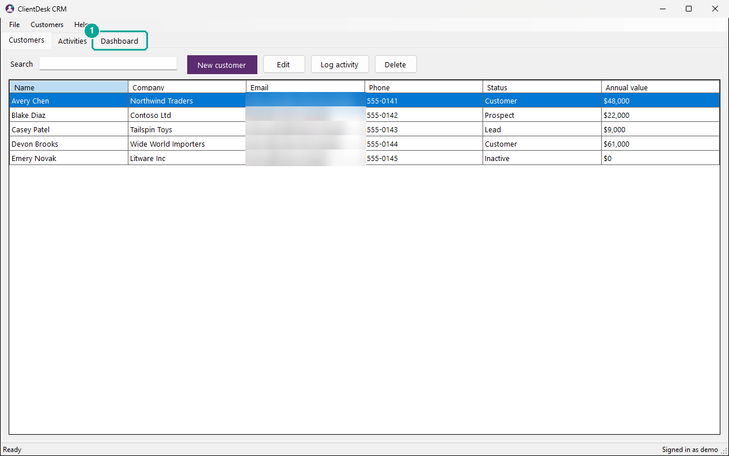
Figure 22: Step 1: Click the Dashboard tab. The chart shows the total annual value for each status.
Screens used: Dashboard tab

Review recent activities
See what has happened with your customers lately.
Step 1. Click the Activities tab.
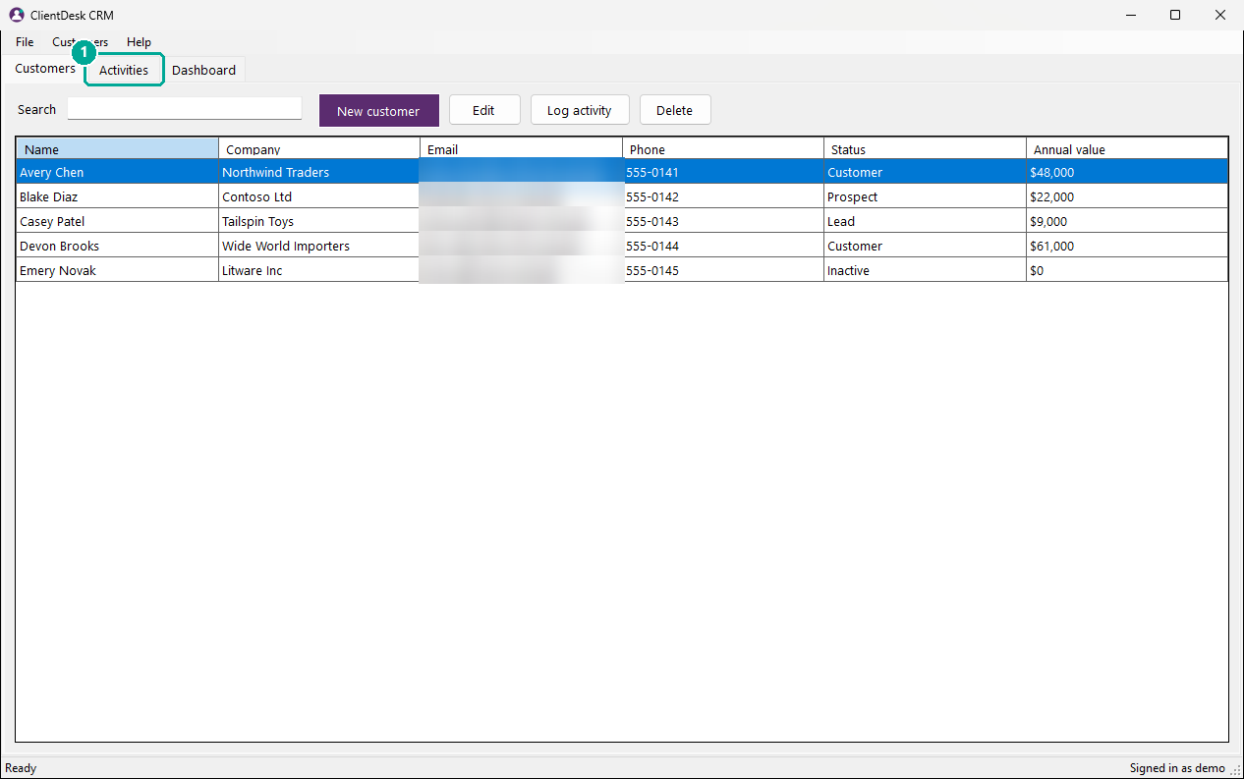
Figure 23: Step 1: Click the Activities tab.
Screens used: Activities tab

Change the default status for new customers
Save time when most new contacts start at the same stage.
Step 1. Click the File menu.
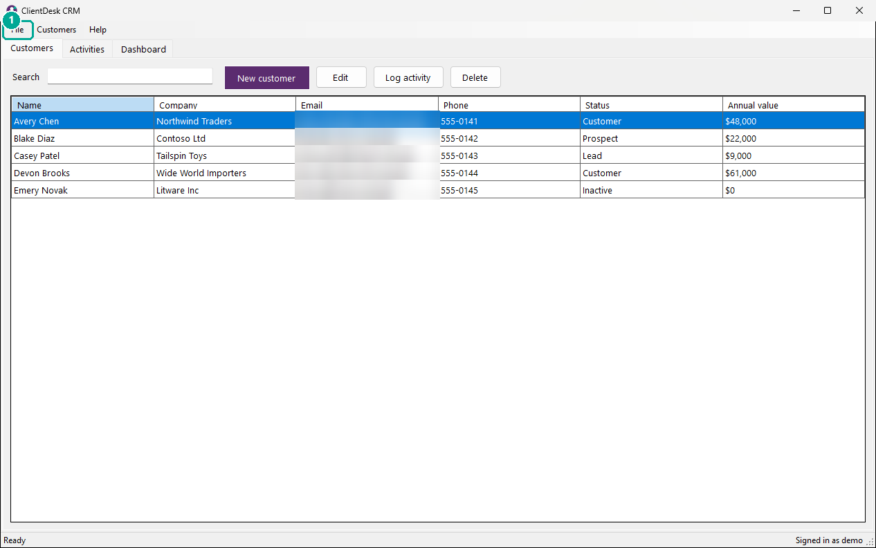
Figure 24: Step 1: Click the File menu.
Step 2. Click Options....
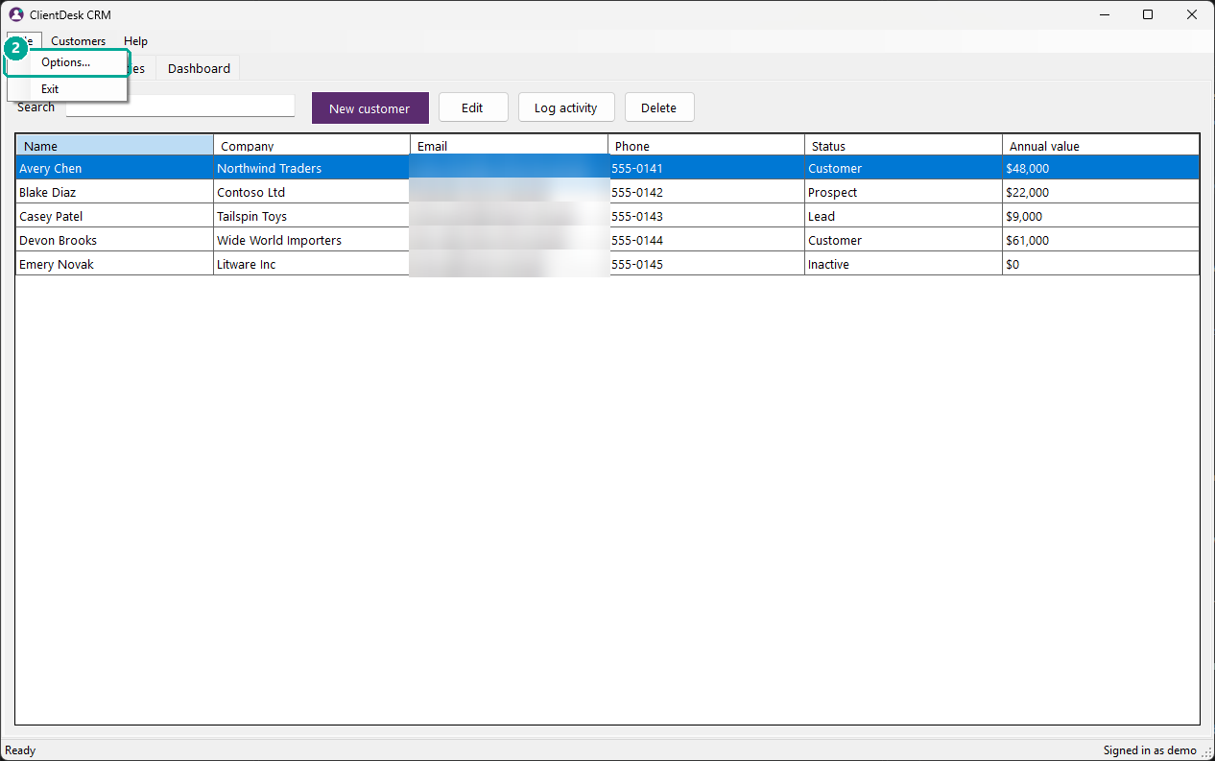
Figure 25: Step 2: Click Options....
Step 3. Choose a Default status.
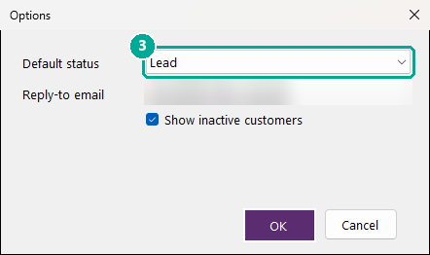
Figure 26: Step 3: Choose a Default status.
Step 4. Click OK.
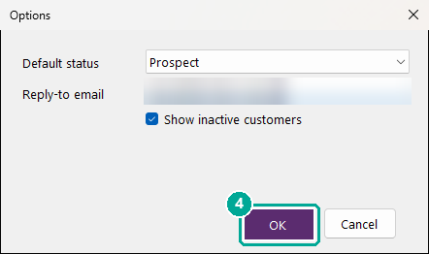
Figure 27: Step 4: Click OK.
Screens used: Customers tab, Options window

Delete a customer
Remove a contact you no longer need.
Step 1. On the Customers tab, click the customer.
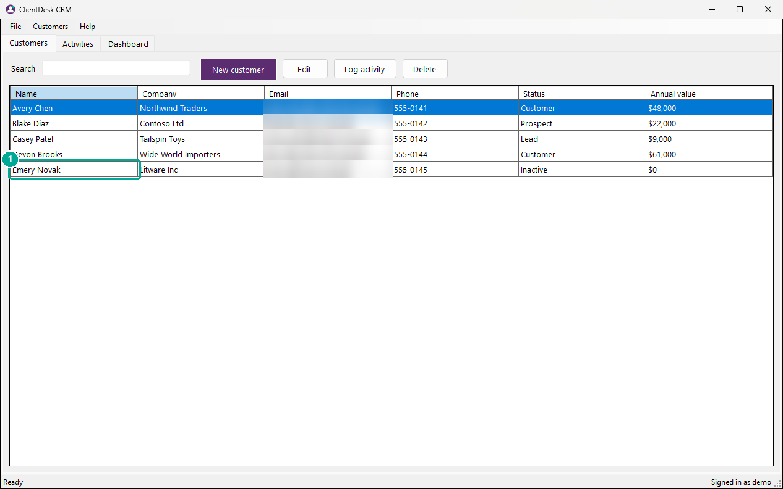
Figure 28: Step 1: On the Customers tab, click the customer.
Step 2. Click Delete, then click Yes. Their logged activities are kept.
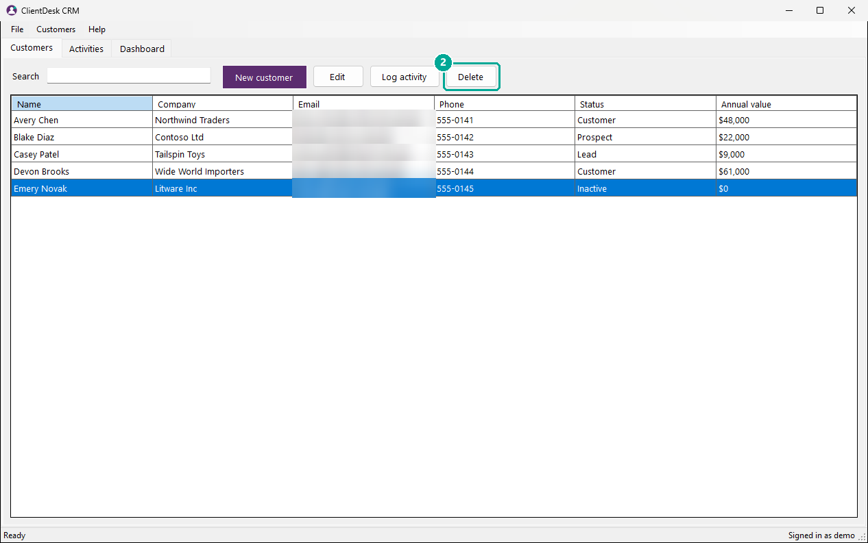
Figure 29: Step 2: Click Delete, then click Yes. Their logged activities are kept.
Screens used: Customers tab

Screen Reference

Sign in
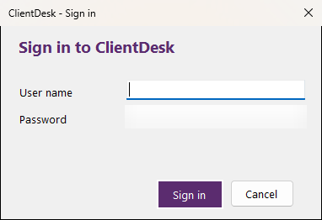
Figure 30: Sign in
Appears when you start ClientDesk.
Name | Type | What it does
User name | text box | Your ClientDesk user name.
Password | text box | Your password. It is hidden as you type.
Sign in | button | Opens the main window.

Used in: Sign in

Customers tab
Figure 31: Customers tab
Your list of contacts. The main window opens on this tab.
Name | Type | What it does
Search | text box | Type part of a name or company to filter the list.
New customer | button | Opens the **New customer** window.
Edit | button | Opens the selected customer. You can also double-click a row.
Log activity | button | Records a call, email or meeting for the selected customer.
Delete | button | Removes the selected customer after you confirm.
Status | column | **Lead**, **Prospect**, **Customer** or **Inactive**.
Annual value | column | Expected yearly sales from this customer.

Used in: Sign in, Add a customer, Log a call or meeting, Update a customer's details, Find a customer, Change the default status for new customers, Delete a customer

Activities tab
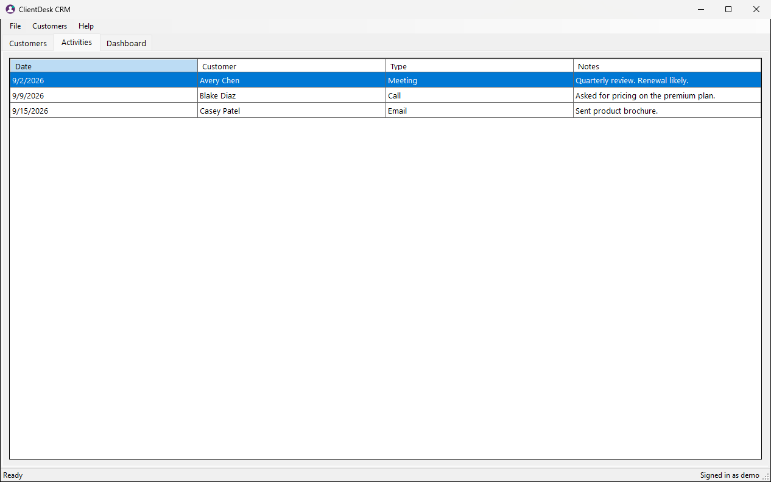
Figure 32: Activities tab
Every call, email, meeting and note you have logged, with the date and customer.
Used in: Log a call or meeting, Review recent activities

Dashboard tab
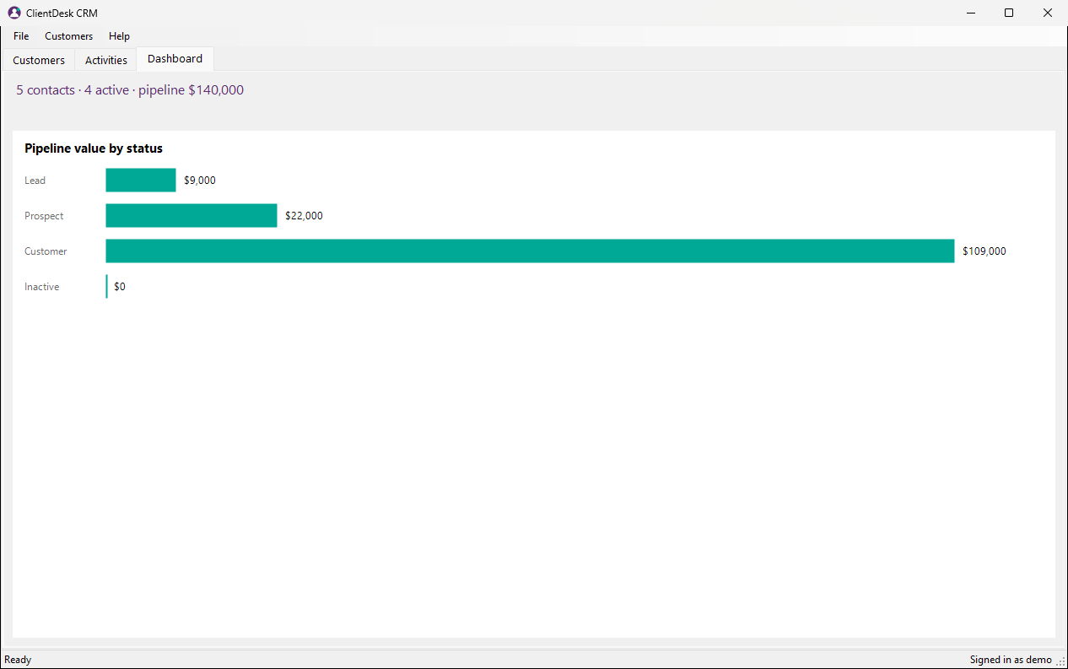
Figure 33: Dashboard tab
Shows how many contacts you have, how many are active, and a chart of pipeline value by status.
Used in: Check your sales pipeline

New customer window
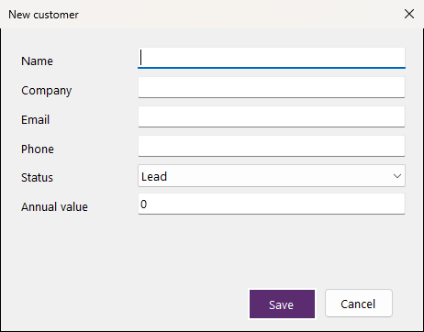
Figure 34: New customer window
Used to add a customer. The same window, titled Edit customer, opens when you edit one.
Name | Type | What it does
Name | text box | The contact's full name. Required.
Company | text box | Where they work.
Email | text box | Must be a valid address and not used by another customer.
Phone | text box | Optional.
Status | list | Where they are in your pipeline. The default is set in **Options**.
Annual value | text box | Expected yearly sales. 0 or more.
Save | button | Saves the customer. Problems are shown in red above the buttons.

Used in: Add a customer, Update a customer's details

Log activity window
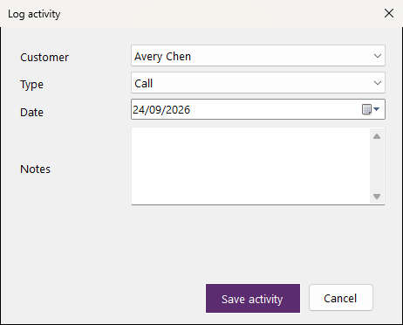
Figure 35: Log activity window
Used to record a call, email, meeting or note.
Name | Type | What it does
Customer | list | Who the activity was with.
Type | list | **Call**, **Email**, **Meeting** or **Note**.
Date | date picker | When it happened.
Notes | text box | What was discussed. Up to 500 characters.
Save activity | button | Adds the activity to the **Activities** tab.

Used in: Log a call or meeting

Options window
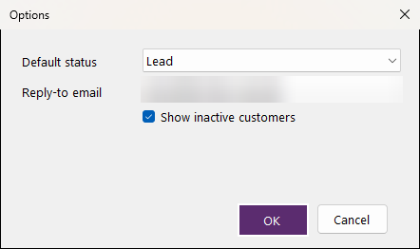
Figure 36: Options window
Preferences for how ClientDesk works.
Name | Type | What it does
Default status | list | Status pre-selected for new customers.
Reply-to email | text box | Address customers reply to.
Show inactive customers | check box | Include inactive customers in the list.

Used in: Change the default status for new customers

About window
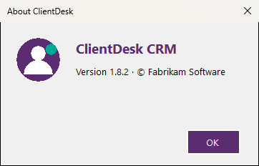
Figure 37: About window
Shows the version number, useful when you contact support.

Troubleshooting
Message | Cause | How to fix it
The user name or password is incorrect. | The sign-in details do not match an account. | Check both and that Caps Lock is off.
Enter the customer's name. | The **Name** box is empty. | Type the contact's name.
Enter a valid email address. | The email address is incomplete. | Type a full address such as name@company.com.
A customer with this email address already exists. | Two customers cannot share an email address. | Search for the existing customer and edit them instead.
Annual value must be a number of 0 or more. | The value has letters or is negative. | Type a number such as 15000, without currency symbols.
Select a customer first. | You clicked **Edit** or **Delete** without choosing a customer. | Click a customer in the list first.
Choose a customer for this activity. | No customer was chosen in **Customer**. | Choose who the activity was with.
Notes cannot be longer than 500 characters. | The notes are too long. | Shorten the notes or split them into two activities.

