

Stockroom Inventory User Manual
Version 2.3.0 · September 24, 2026
Acme Ltd

Contents
Right-click and choose Update Field to show the table of contents.

Getting Started
Stockroom Inventory keeps track of what is on your shelves - items, quantities, prices and suppliers. This manual walks you through everyday jobs and explains every window.

Before you begin
- A Windows 10 or Windows 11 PC with Stockroom Inventory installed.
- The user name and password your administrator gave you.

Starting the application
Open the Start menu and click Stockroom Inventory. The Sign in window appears.

Signing in
Type your User name and Password, then click Sign in.

A quick tour
The main window has three tabs. Items lists everything in stock, Suppliers lists who you buy from and Reports sums up your stock. Use the File, Items and Help menus at the top for everything else.
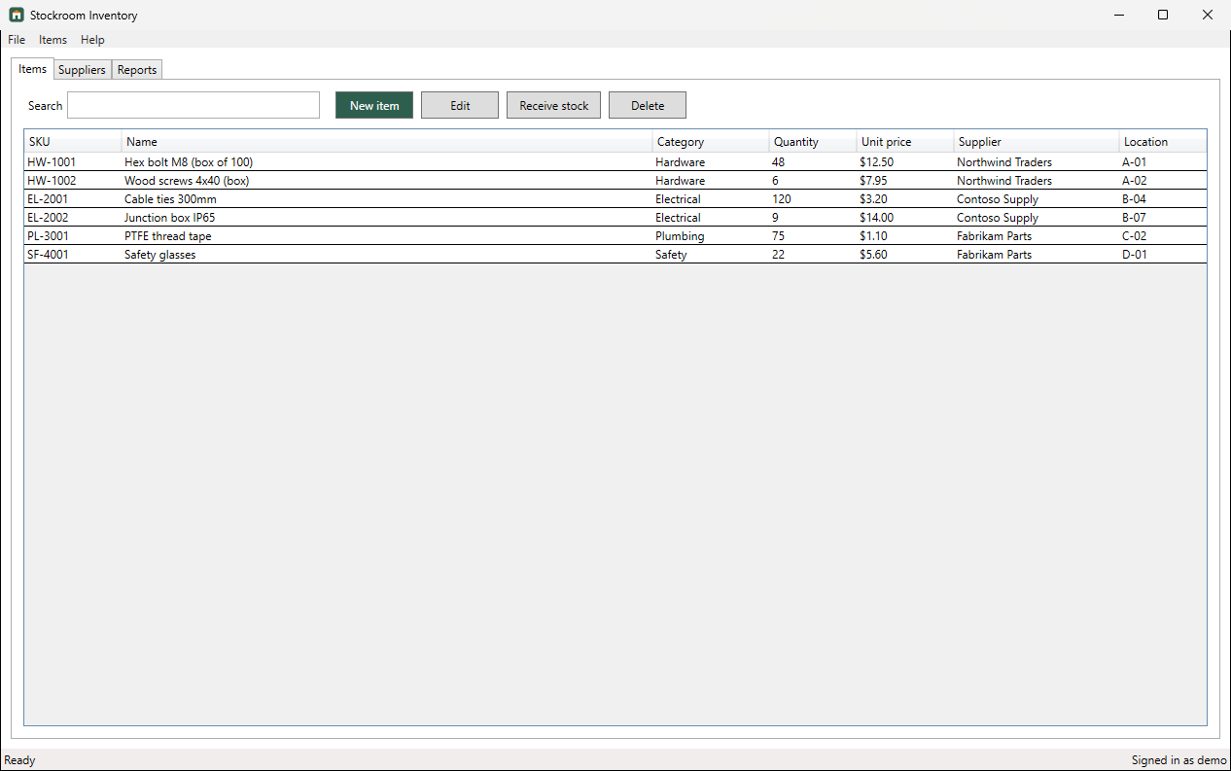
Figure 1: The Items tab screen

How-To Tasks

Sign in
Open Stockroom Inventory with your user name and password.
Step 1. In User name, type your user name.
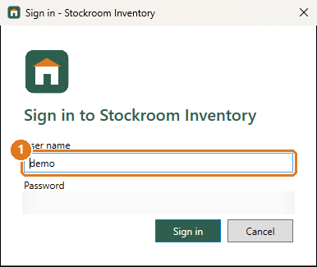
Figure 2: Step 1: In User name, type your user name.
Step 2. In Password, type your password.
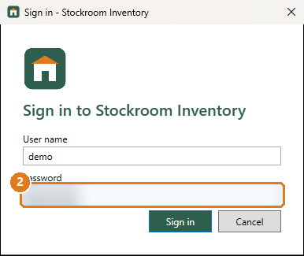
Figure 3: Step 2: In Password, type your password.
Step 3. Click Sign in. The main window opens.
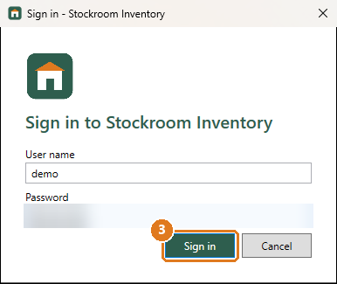
Figure 4: Step 3: Click Sign in. The main window opens.
Screens used: Sign in, Items tab

Add a new item
Start tracking something new in the stockroom.
Step 1. On the Items tab, click New item.
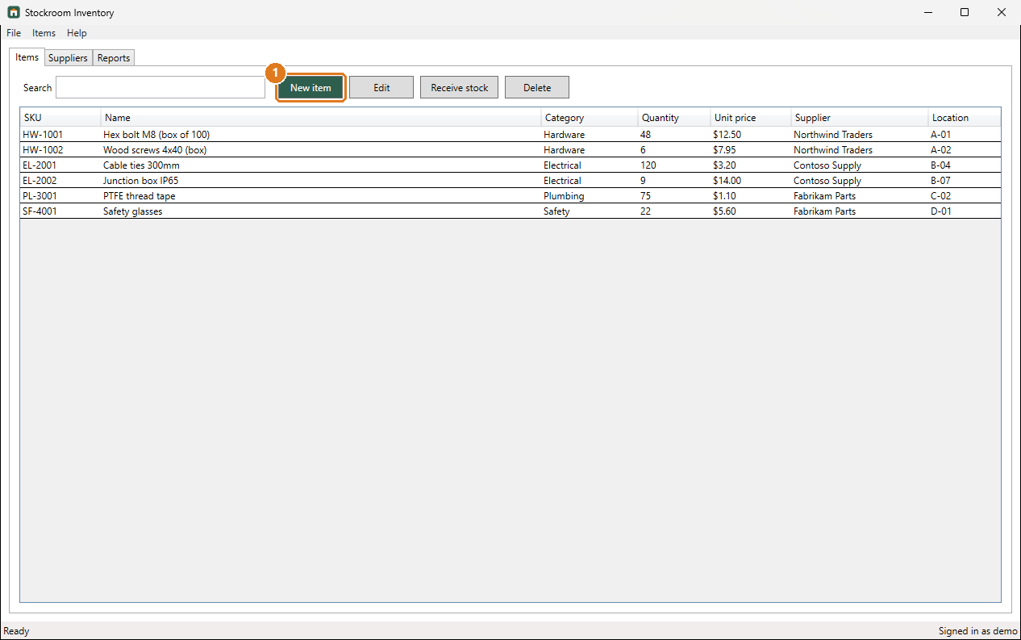
Figure 5: Step 1: On the Items tab, click New item.
Step 2. Type a unique SKU.
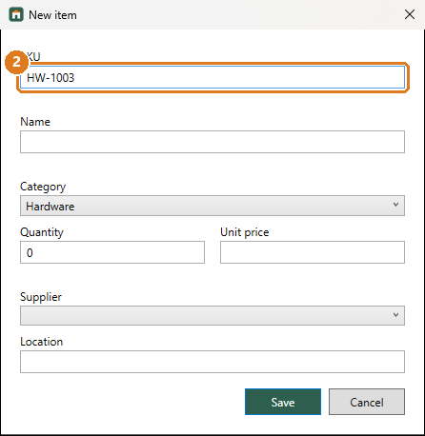
Figure 6: Step 2: Type a unique SKU.
Step 3. Type the item Name.
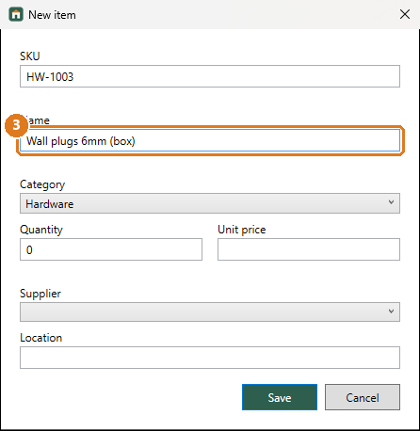
Figure 7: Step 3: Type the item Name.
Step 4. Type the Quantity you have.
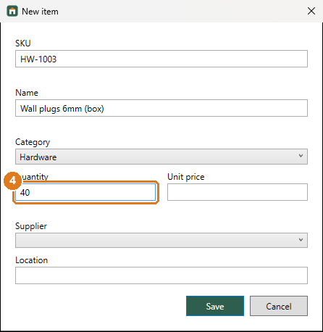
Figure 8: Step 4: Type the Quantity you have.
Step 5. Type the Unit price.
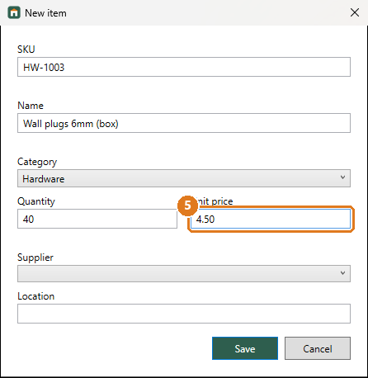
Figure 9: Step 5: Type the Unit price.
Step 6. Type the shelf Location.
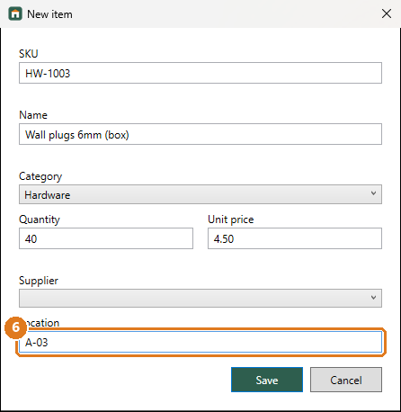
Figure 10: Step 6: Type the shelf Location.
Step 7. Click Save. The item appears in the list.
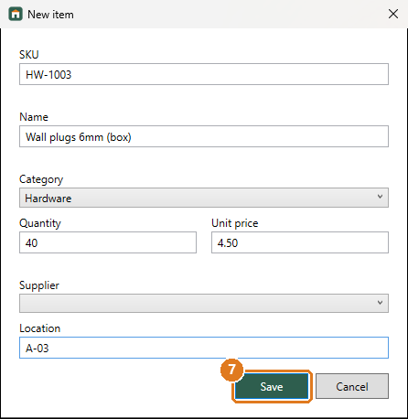
Figure 11: Step 7: Click Save. The item appears in the list.
Screens used: Items tab, New item window

Record a delivery
Add newly delivered stock to an item's quantity.
Step 1. On the Items tab, click the item that was delivered.
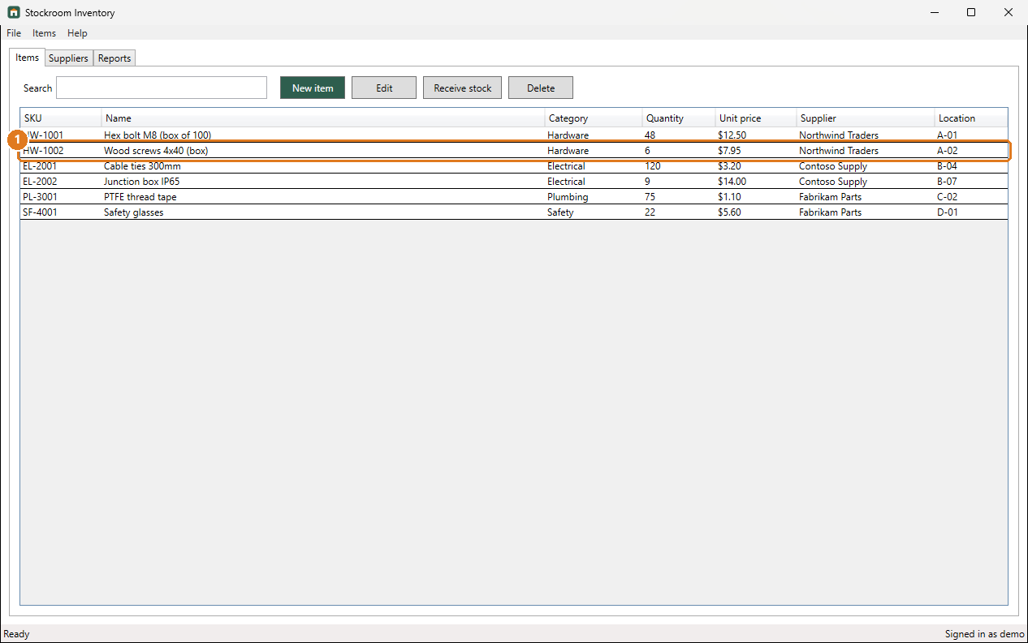
Figure 12: Step 1: On the Items tab, click the item that was delivered.
Step 2. Click Receive stock.
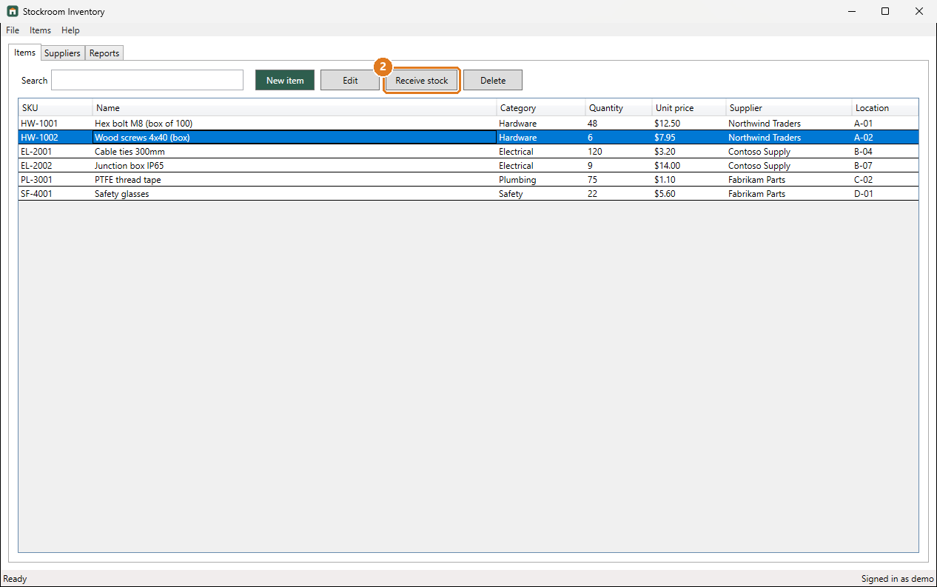
Figure 13: Step 2: Click Receive stock.
Step 3. In Quantity received, type how many arrived.
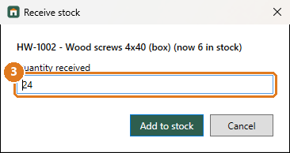
Figure 14: Step 3: In Quantity received, type how many arrived.
Step 4. Click Add to stock. The new quantity shows in the list.
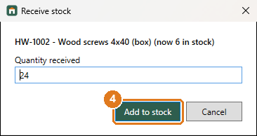
Figure 15: Step 4: Click Add to stock. The new quantity shows in the list.
Screens used: Items tab, Receive stock window

Change an item's details
Correct a price, name or location.
Step 1. Click the item in the list.
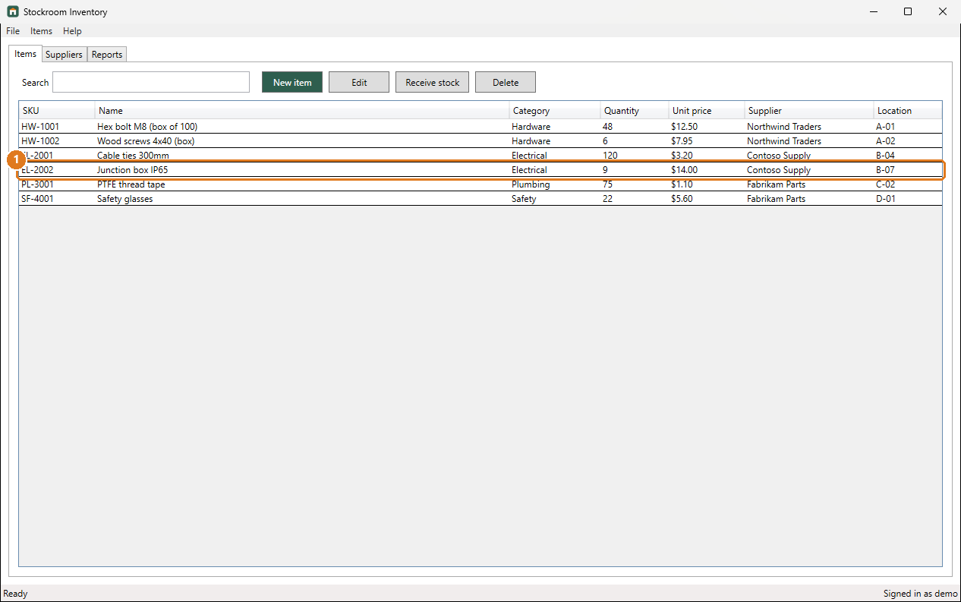
Figure 16: Step 1: Click the item in the list.
Step 2. Click Edit.
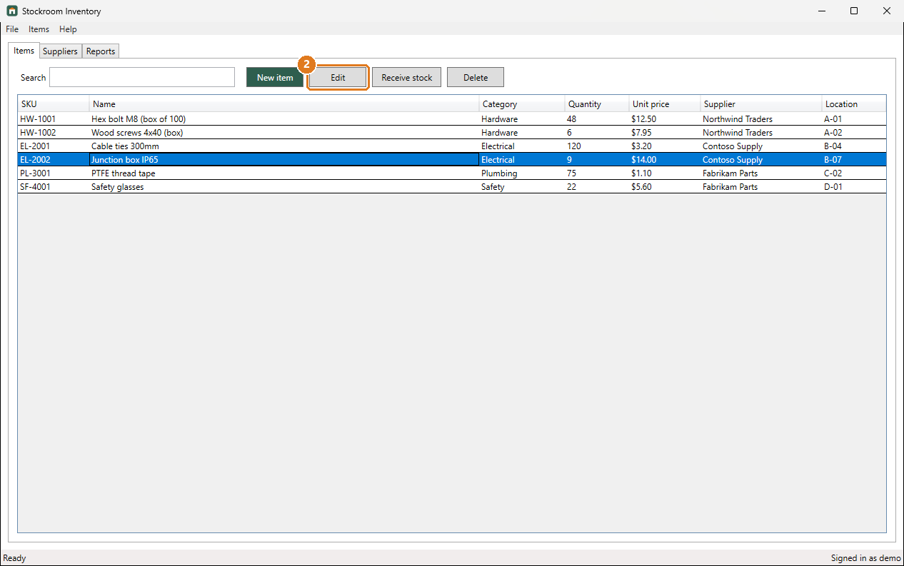
Figure 17: Step 2: Click Edit.
Step 3. Change the details, for example the Unit price.
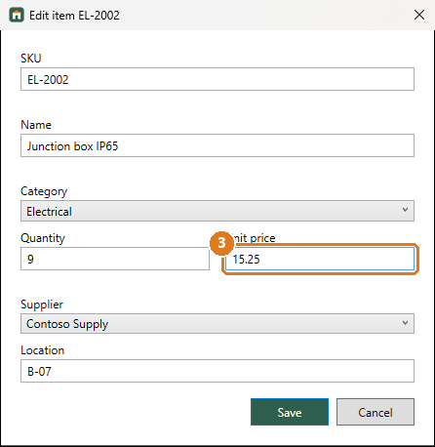
Figure 18: Step 3: Change the details, for example the Unit price.
Step 4. Click Save.
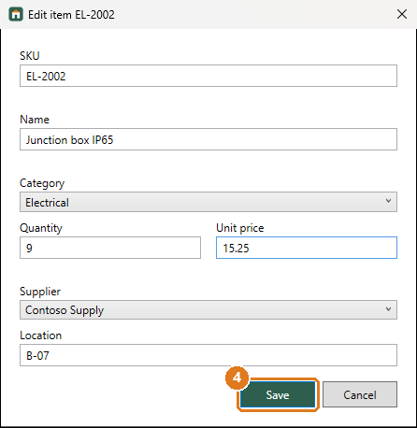
Figure 19: Step 4: Click Save.
Screens used: Items tab, New item window

Find an item
Quickly find an item by name or SKU.
Step 1. On the Items tab, type part of the name or SKU in Search. The list shows only matching items.
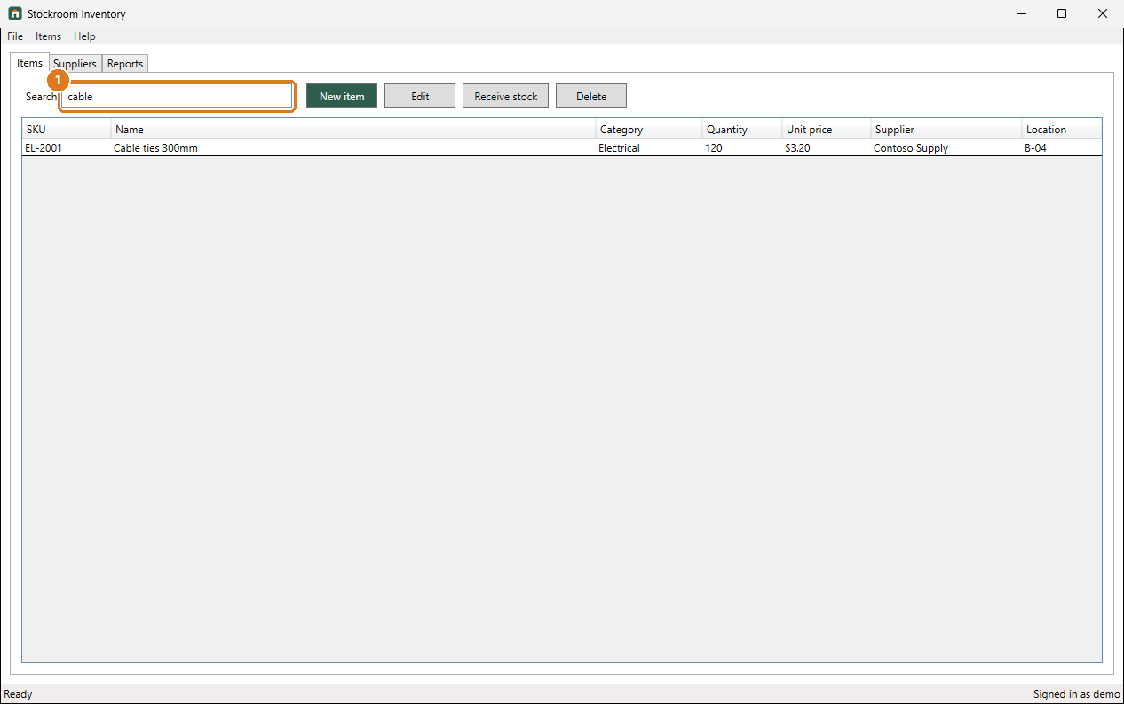
Figure 20: Step 1: On the Items tab, type part of the name or SKU in Search. The list shows only matching items.
Screens used: Items tab

See what needs reordering
Find items that are running low.
Step 1. Click the Reports tab. Items that need reordering are listed under Low stock.
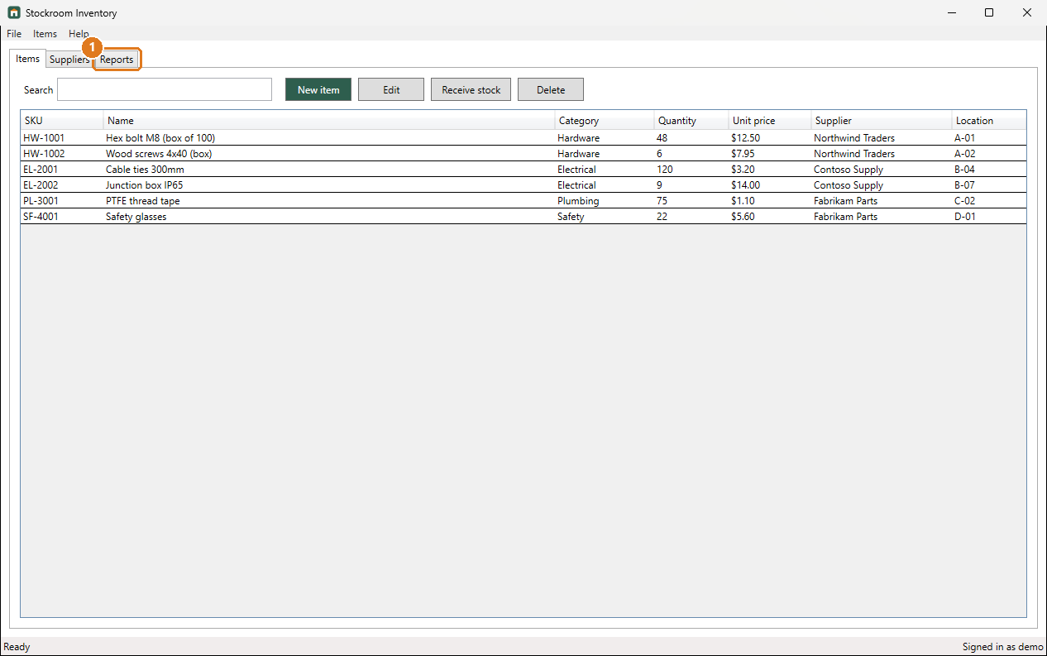
Figure 21: Step 1: Click the Reports tab. Items that need reordering are listed under Low stock.
Screens used: Reports tab

Change the low-stock level
Decide at what quantity an item counts as low.
Step 1. Click the File menu.
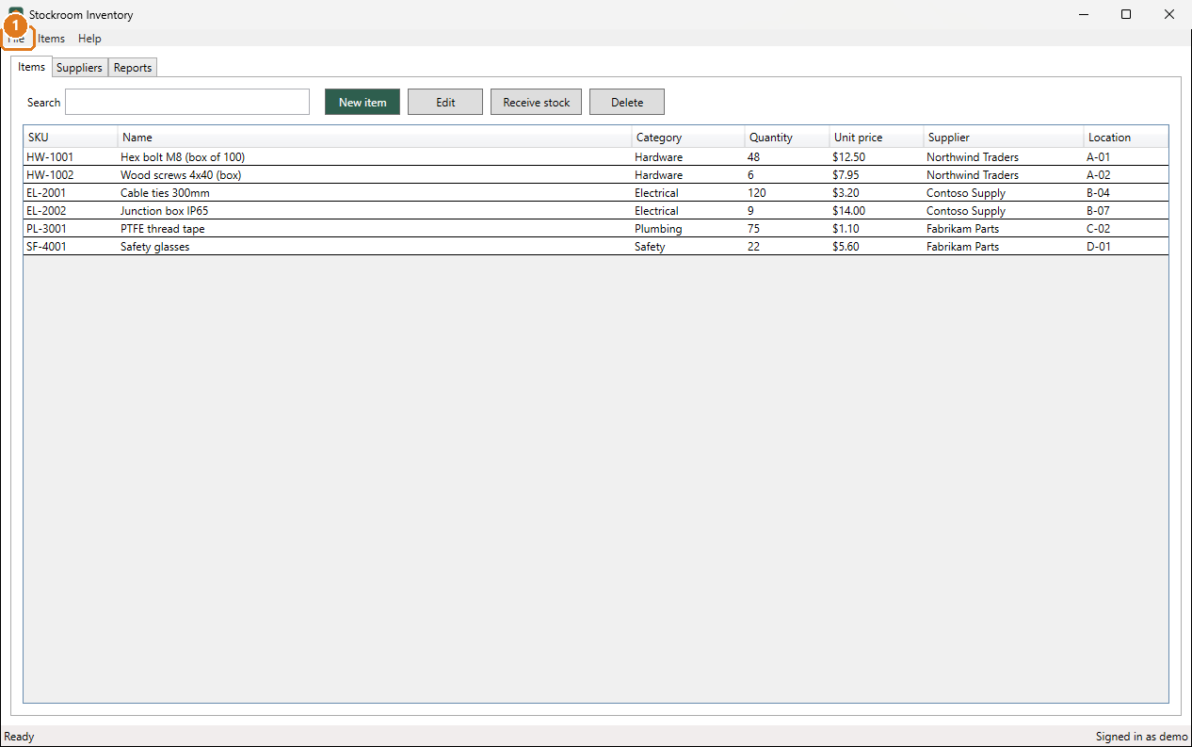
Figure 22: Step 1: Click the File menu.
Step 2. Click Settings....
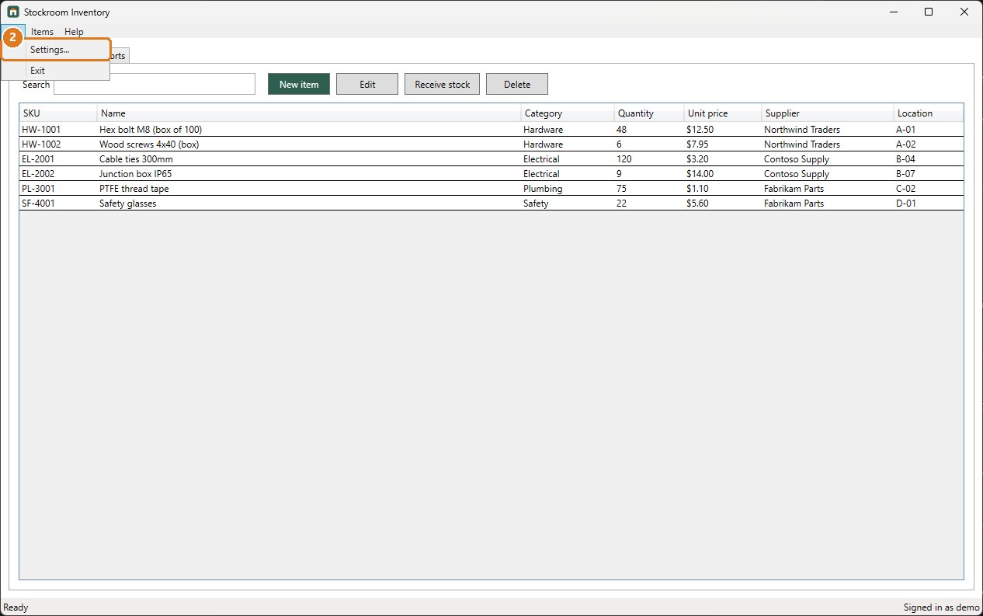
Figure 23: Step 2: Click Settings....
Step 3. In Low-stock threshold, type the new level.
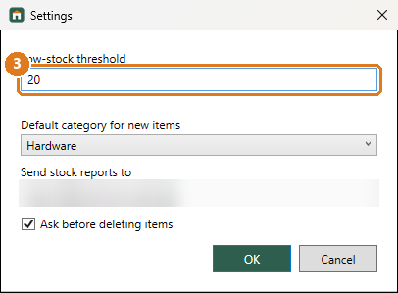
Figure 24: Step 3: In Low-stock threshold, type the new level.
Step 4. Click OK.
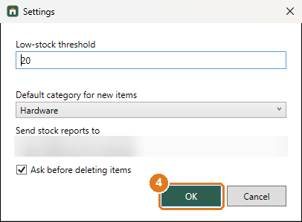
Figure 25: Step 4: Click OK.
Screens used: Items tab, Settings window

Add a category
Create a new category to group items.
Step 1. Click the Items menu.
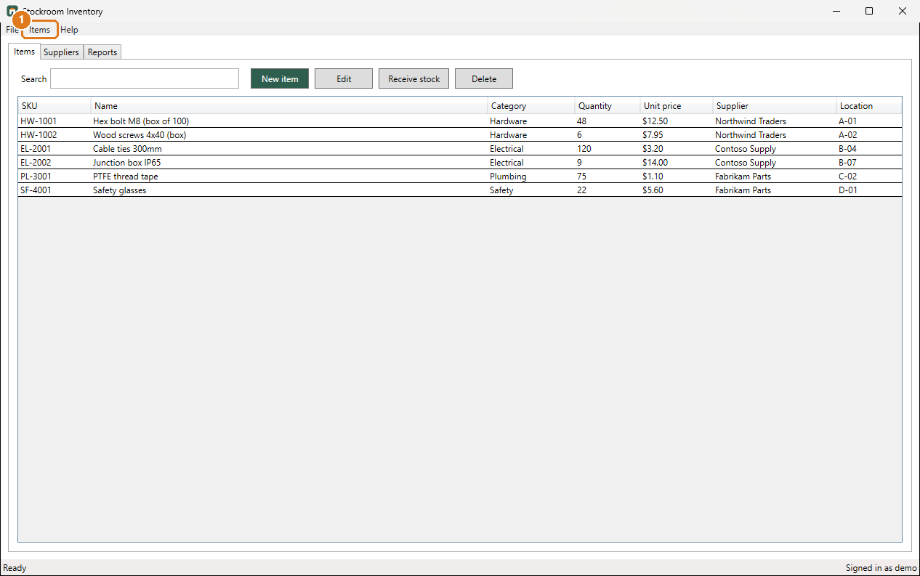
Figure 26: Step 1: Click the Items menu.
Step 2. Click Categories....
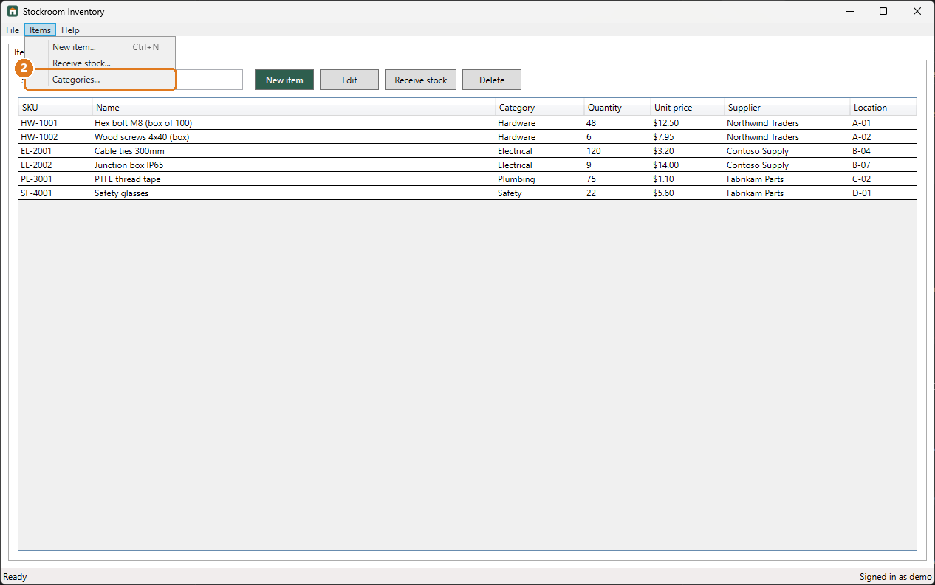
Figure 27: Step 2: Click Categories....
Step 3. In New category, type the name.
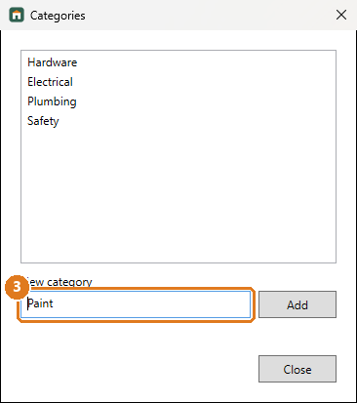
Figure 28: Step 3: In New category, type the name.
Step 4. Click Add. The category appears in the list.
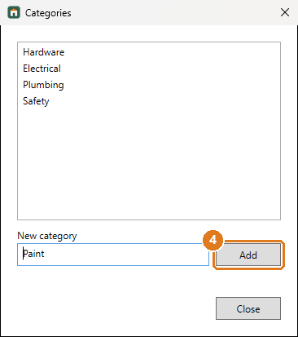
Figure 29: Step 4: Click Add. The category appears in the list.
Step 5. Click Close.
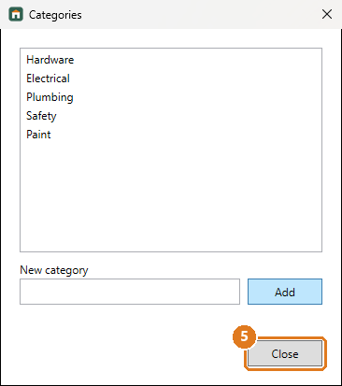
Figure 30: Step 5: Click Close.
Screens used: Items tab, Categories window

Look up a supplier
Find a supplier's contact details and delivery time.
Step 1. Click the Suppliers tab.
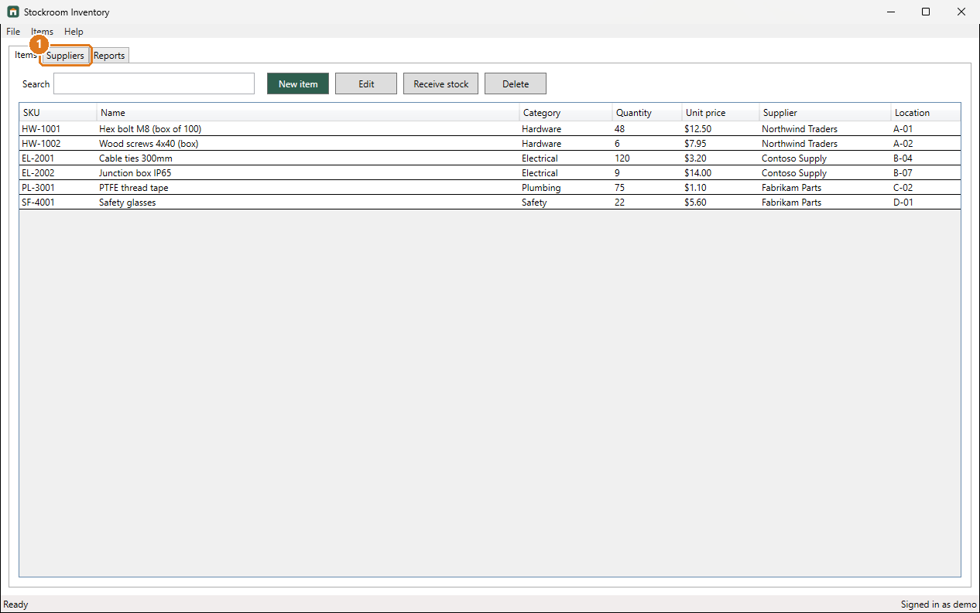
Figure 31: Step 1: Click the Suppliers tab.
Screens used: Suppliers tab

Delete an item
Remove an item you no longer stock.
Step 1. Click the item in the list.
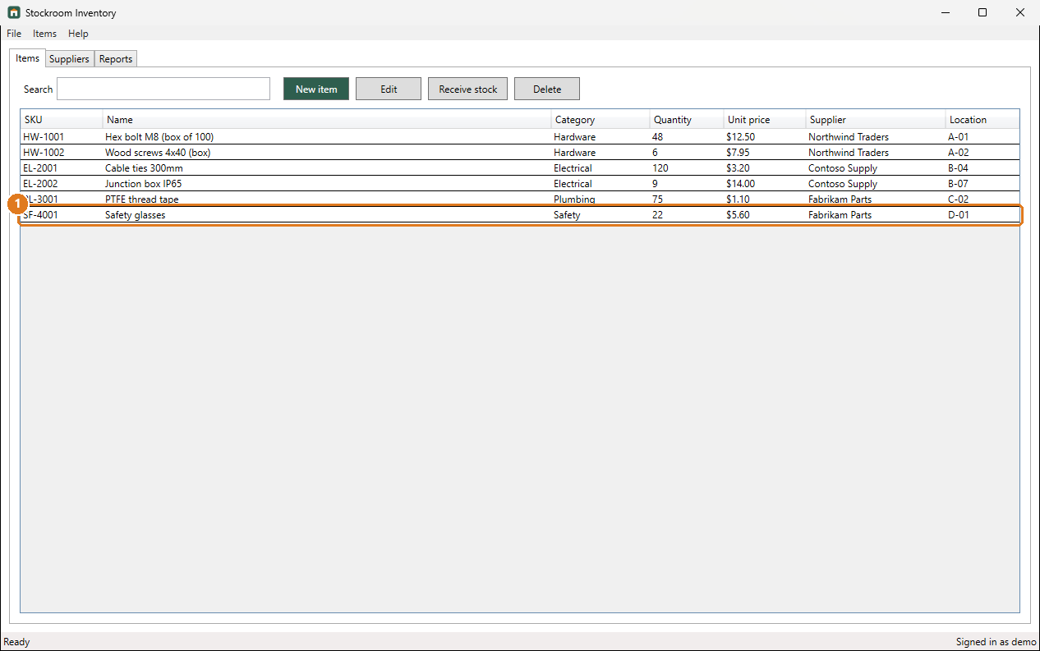
Figure 32: Step 1: Click the item in the list.
Step 2. Click Delete, then click Yes to confirm. This cannot be undone.
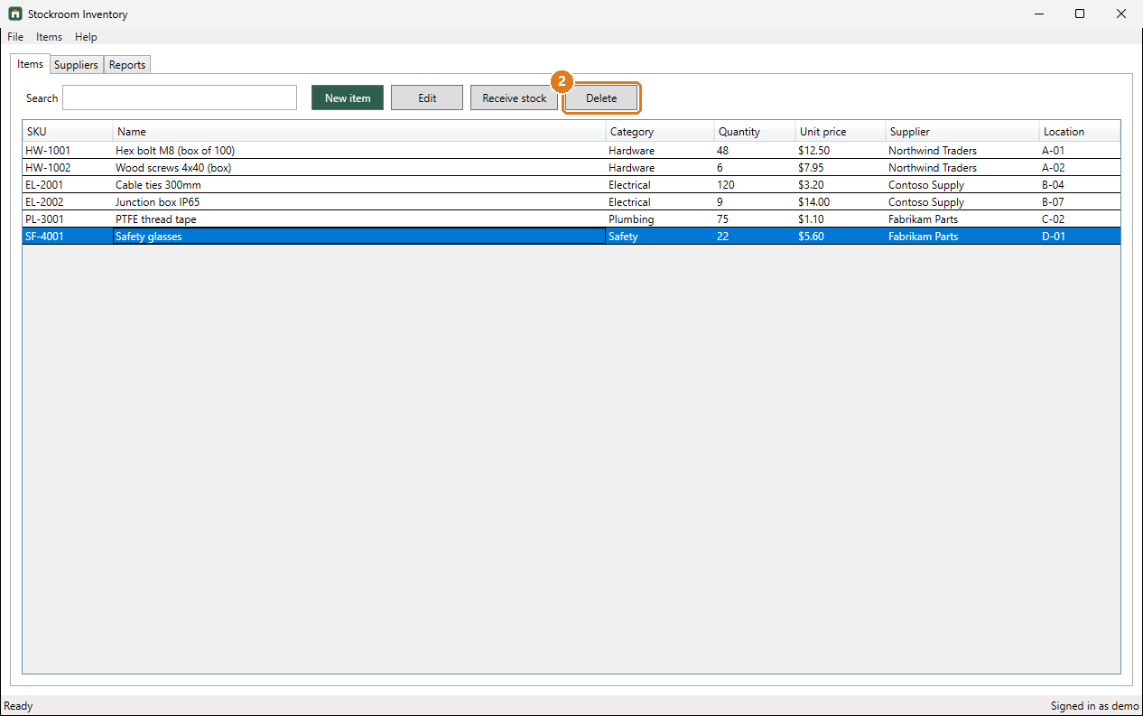
Figure 33: Step 2: Click Delete, then click Yes to confirm. This cannot be undone.
Screens used: Items tab

Screen Reference

Sign in
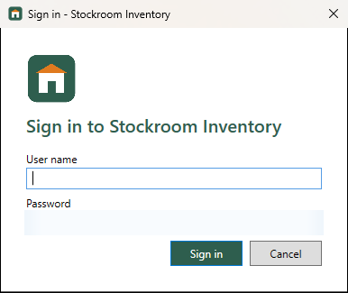
Figure 34: Sign in
Appears when you start Stockroom Inventory.
Name | Type | What it does
User name | text box | Your Stockroom Inventory user name.
Password | text box | Your password. It is hidden as you type.
Sign in | button | Opens the main window.
Cancel | button | Closes Stockroom Inventory.

Used in: Sign in

Items tab
Figure 35: Items tab
The main window opens on this tab. It lists everything you keep in stock.
Name | Type | What it does
Search | text box | Type part of a name or SKU to filter the list.
New item | button | Opens the **New item** window.
Edit | button | Opens the selected item for editing.
Receive stock | button | Adds a delivery to the selected item's quantity.
Delete | button | Removes the selected item after you confirm.
Items | table | Every item with its SKU, category, quantity, price, supplier and shelf location.

Used in: Sign in, Add a new item, Record a delivery, Change an item's details, Find an item, Change the low-stock level, Add a category, Delete an item

Suppliers tab
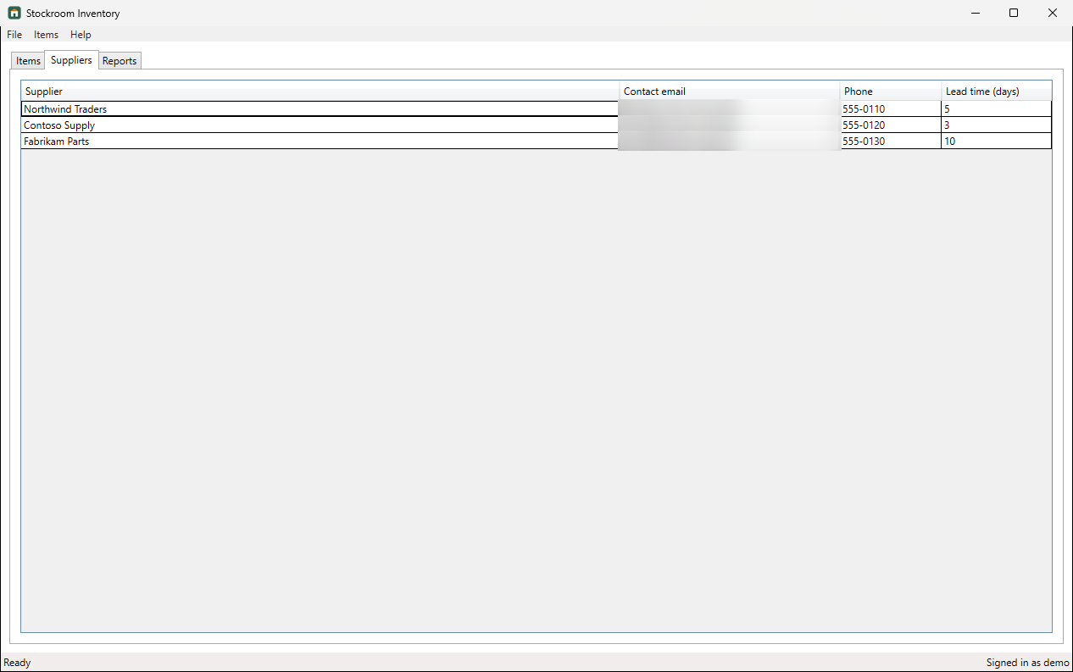
Figure 36: Suppliers tab
Lists your suppliers and how to reach them.
Name | Type | What it does
Supplier | column | The company you buy from.
Contact email | column | Where to send orders.
Lead time (days) | column | How long deliveries usually take.

Used in: Look up a supplier

Reports tab
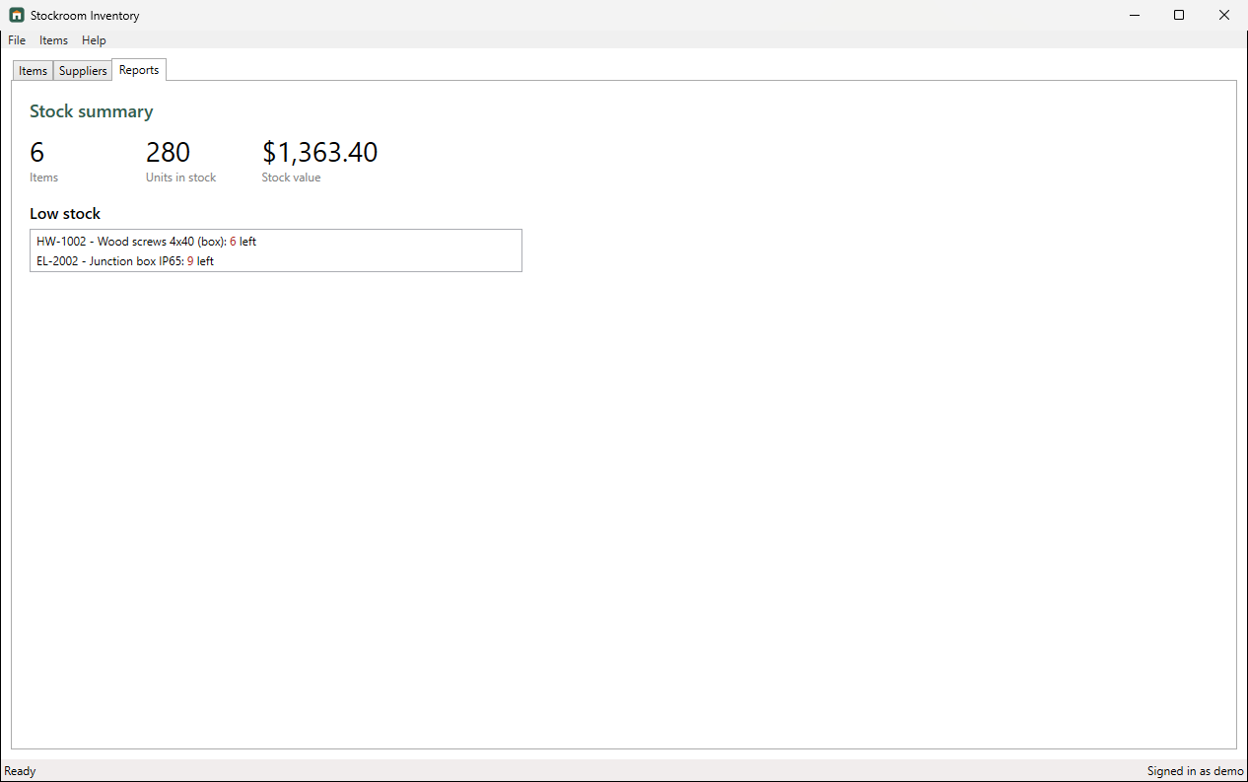
Figure 37: Reports tab
A summary of your stock and a list of items that need reordering.
Name | Type | What it does
Items | figure | How many different items you stock.
Units in stock | figure | The total count of everything on your shelves.
Stock value | figure | Quantity times unit price for all items.
Low stock | list | Items at or below the low-stock threshold set in **Settings**.

Used in: See what needs reordering

New item window
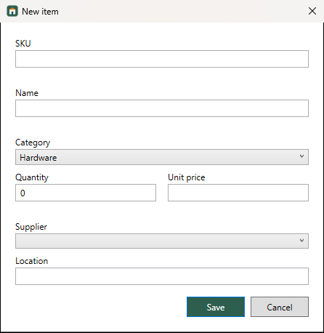
Figure 38: New item window
Used to add a new item. The same window, titled Edit item, opens when you edit an item.
Name | Type | What it does
SKU | text box | Your stock code, for example HW-1003. Must be unique.
Name | text box | What the item is called.
Category | list | Pick a category. Add new ones under **Items > Categories**.
Quantity | text box | How many you have. Cannot be negative.
Unit price | text box | Price of one unit. Must be greater than 0.
Supplier | list | Who you buy it from.
Location | text box | Shelf or bin, for example A-03.
Save | button | Saves the item. If something is wrong, a red message appears under the field.

Used in: Add a new item, Change an item's details

Receive stock window
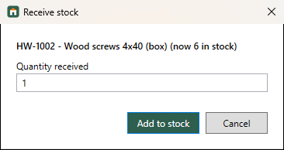
Figure 39: Receive stock window
Used when a delivery arrives. Shows the item and how many you have now.
Name | Type | What it does
Quantity received | text box | How many arrived in the delivery.
Add to stock | button | Adds the quantity to the item.

Used in: Record a delivery

Categories window
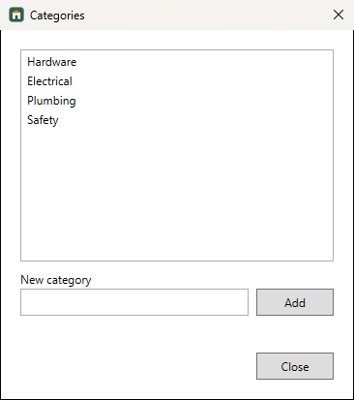
Figure 40: Categories window
Manage the categories used to group items.
Name | Type | What it does
Categories | list | The categories you can choose for items.
New category | text box | Name of a category to add.
Add | button | Adds the category to the list.

Used in: Add a category

Settings window
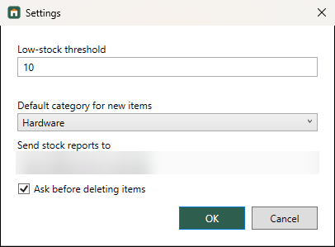
Figure 41: Settings window
Preferences that apply to the whole application.
Name | Type | What it does
Low-stock threshold | text box | Items at or below this quantity appear under **Low stock**. From 0 to 1000.
Default category for new items | list | Pre-selected in the **New item** window.
Send stock reports to | text box | Email address for stock reports.
Ask before deleting items | check box | Asks you to confirm every delete.

Used in: Change the low-stock level

About window
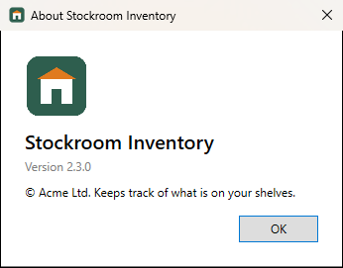
Figure 42: About window
Shows the version number, useful when you contact support.

Troubleshooting
Message | Cause | How to fix it
Invalid user name or password. | The user name or password is wrong. | Check both and that Caps Lock is off. Ask your administrator to reset your password if needed.
SKU is required. | The **SKU** box is empty. | Type a stock code, for example HW-1003.
Another item already uses this SKU. | SKUs must be unique. | Use a different SKU, or edit the existing item instead.
Name is required. | The name box is empty. | Type a name.
Quantity cannot be negative. | The quantity is below zero. | Type 0 or more.
Quantity must be a whole number. | The quantity has letters or decimals. | Type a whole number such as 12.
Unit price must be greater than 0. | The price is empty or zero. | Type a price such as 4.50.
Select an item in the list first. | You clicked **Edit**, **Receive stock** or **Delete** without choosing an item. | Click an item in the list first.
That category already exists. | A category with the same name is already in the list. | Choose a different name.
Low-stock threshold must be between 0 and 1000. | The number is outside the allowed range. | Type a whole number from 0 to 1000.

