Ex. No. 07 | APPLICATION STATE MANAGEMENT AND SERIALIZATION
Date of Exercise
Git Hub Host Link

Aim
To manage application state and serialize/deserialize data using JSON in a Flutter application.

Description
This experiment demonstrates application state management using setState() and JSON serialization/deserialization using a Student model. Student data is converted from a Dart object into JSON format using toJson() and converted back into a Dart object using fromJson(). A list of students is displayed dynamically using ListView.builder().

Procedure:
- A new Flutter project named state_app was created using the Flutter command.
- A Dart file named student.dart was created inside the lib folder to define the Student model.
- The Student class was created with the properties id, name, and course.
- The toJson() method was implemented to convert the Student object into a JSON-compatible Map.
- The fromJson() factory constructor was implemented to convert JSON data back into a Student object.
- A Student object was created with the values 1, Ragu, and CSE.
- The toJson() method was used to serialize the Student object into JSON data.
- The fromJson() method was used to deserialize the JSON data back into a Student object.
- A List<String> was created to maintain the student names as application state.
- The setState() method was used to add a student to the list whenever the Add Student button was pressed.
- ListView.builder() was used to dynamically display the student names.
- The application was executed and tested in the Chrome browser.

Program student.dart
class Student

{ final int id; final String name;
final String course; Student({
required this.id, required this.name, required this.course,
});

Map<String, dynamic> toJson()

{ return { 'id': id,
'name': name, 'course': course,
};

}

factory Student.fromJson(Map<String, dynamic> json)

{ return Student( id: json['id'],
name: json['name'], course: json['course'],

);

}

}

main.dart
import 'package:flutter/material.dart'; import 'student.dart';

void main() { runApp(const StateApp());
}

class StateApp extends StatelessWidget

{ const StateApp({super.key});

@override

Widget build(BuildContext context)

{ return

MaterialApp( debugShowCheckedMode Banner: false, title: 'State Management', home: const StudentPage(),
);

}

}

class StudentPage extends StatefulWidget

{ const StudentPage({super.key}); @override
State<StudentPage> createState() => _StudentPageState();

}

class _StudentPageState extends State<StudentPage>

{ List<String> students = []; Student student =
Student( id: 1, name: 'Raj',
course: 'CSE',

);

@override void initState()
{ super.initState();

Map<String, dynamic> data = student.toJson(); print(data);
Student newStudent = Student.fromJson(data); print(newStudent.name);
}

void addStudent()

{ setState(()

{ students.add('Raj');

});

}

@override

Widget build(BuildContext context)

{ return Scaffold( appBar: AppBar(
title: const Text('Student State'),

),

body:

Column( chil dren: [
const SizedBox(height: 20), ElevatedButton( onPressed: addStudent,
child: const Text('Add Student'),

),

Expanded( child:
ListView.builder( itemCount: students.length, itemBuilder: (context, index) { return ListTile(
title: Text(students[index]),

);

},

),

),

],

),

Output
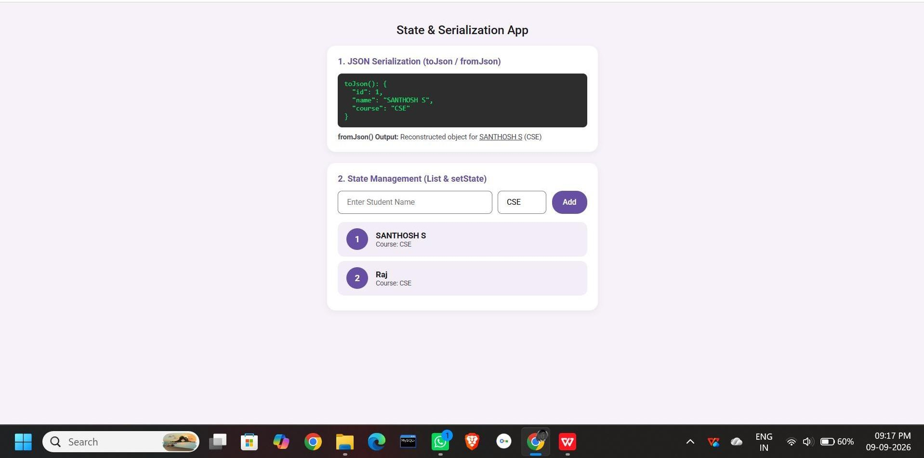

Result
Thus, the Flutter application was successfully developed to manage changing student data using setState(). The Student object was successfully serialized into JSON and deserialized back into a Dart object. The student data was also dynamically displayed using ListView.builder().

Ex. 7| Title of exercise
1

