ECE421S – Introduction to Machine Learning

Assignment 1

Linear and Logistic Regression

Hard Copy Due: February 6, 2019 @ BA3014, 4:00-5:00 PM EST

Code Submission: ece421ta2019@gmail.com

February 6, 2019 @ 5:00 PM EST

General Notes:

* For assignment related questions, please contact Matthew Wong (matthewck.wong@mail.utoronto.ca)
* For general questions regarding Python or Tensorflow, please contact Tianrui Xiao (tianrui.xiao@mail.utoronto.ca) or see him in person in his office hours, Tuesdays, 4:00-6:00 PM in BA-3128 (Robotics Lab)

Please circle section to which you would like the assignment returned

Tutorial Section

|  |  |  |  |
| --- | --- | --- | --- |
| 001 | 002 | 003 | 004 |
| 005 | 006 | 007 | Graduate |

Group Members

|  |  |
| --- | --- |
| Student Name | Student ID |
| Oishi Bandyopadhyay |  |
| Urmi Joshi |  |

**Linear Regression**

Starting with first step of algorithm, MSE (Total loss) for every iteration is calculated. Gradient helps to find the trained weights and trained bias of every iteration. Significant changes in bias and weights are observed.

Gradient Descent is calculates for linear regression which provides validation and test loss accuracies using Loss functions.

* **Linear Regression without Regularization**

1. When iterations are 5000, alpha is 0.001 and Regularization factor is 0.0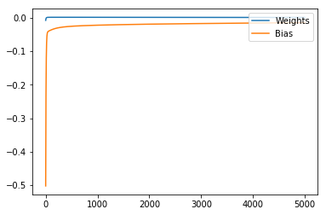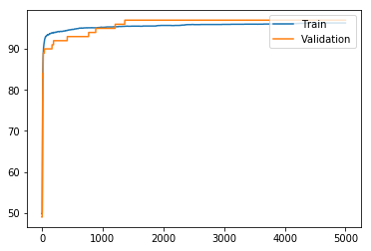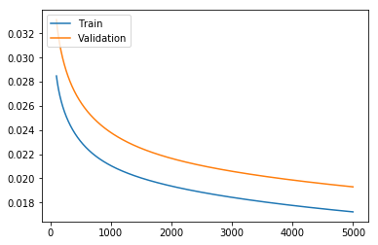

Figure 1(Gradient Graph) Figure 2(Accuracy Graph) Figure 3(Loss Graph)

In figure 1 Gradient Graph denotes that weights remain constant but bias at the end tends to become very small. While in figure2 Blue line indicates Training set and the green line indicates Validation set .Test Accuracy observed is 95.86. We can see that Validation accuracy is more than Training accuracy. Whereas, the below graph defines the Loss taking place in training and validation. Training loss is less as compared to Validation Loss.

1. When iterations are 5000 and alpha is 0.005

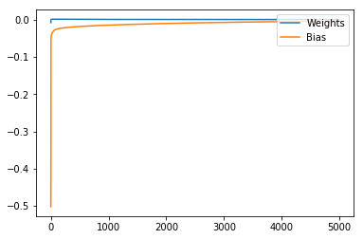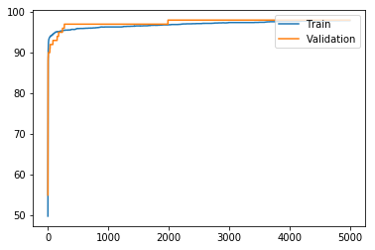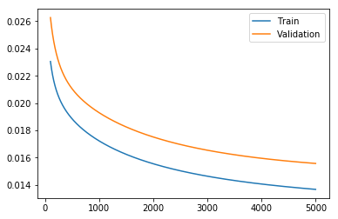

Figure 1 Gradient Graph Figure 2 Accuracy Graph Figure 3 Loss Graph

In figure 1 bias values at the end are quite similar to the weights, almost near to 0.0. In figure 2 it is observed initially, training accuracy was more than validation. Whereas, training gives an incremental graph and validation gives a bumpy graph. At last, both give about same accuracy. In figure 3, training decreases its loss gradually with increasing iterations and at end becomes less than 0.014, while validation shows same pattern as of training but still gives a high loss.

1. When iterations are 5000 and alpha is 0.0

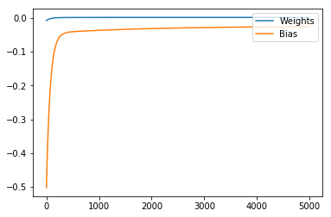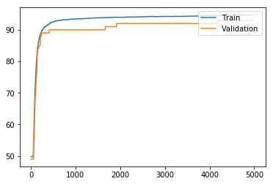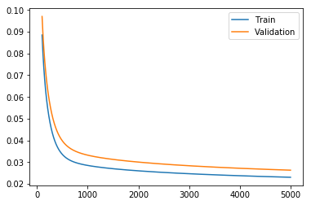

Figure 1 (Gradient Graph) Figure 2 (Accuracy Graph) Figure 3 (Loss Graph)

In figure 1 bias values don’t tend to zero like weights and pervious graph. In figure 2 it is observed training accuracy is more than validation. Whereas, training gives an incremental graph and validation gives a bumpy graph. In figure 3, initially, train and validation had almost same loss, but gradually training decreases its loss with increasing iterations and at end becomes less than 0.002, while validation shows same pattern as of training but still gives a high loss.

Therefore, we can say that as alpha comes near to 0.0, Training data gives more accuracy than validation and with that shows less test loss. When alpha tends to 0.0, Loss Graph shows very small amount of train loss.

* **Linear Regression with Regularization**

1. Regularization = 0.001

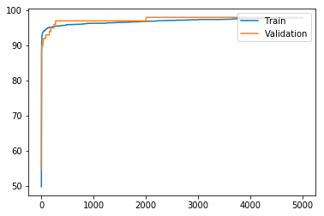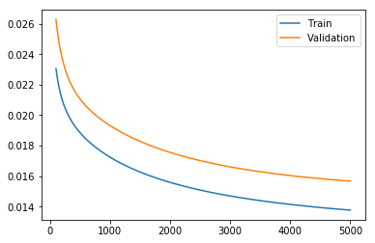

Figure 1 (Accuracy Graph) Figure 2(Loss Graph)

In figure 1, validation is more accurate than train. But validation line is found to be a bit bumpy, whereas train line goes smooth enough. In figure 2, we can see a high difference between train loss and validation loss.

1. Regularization = 0.1

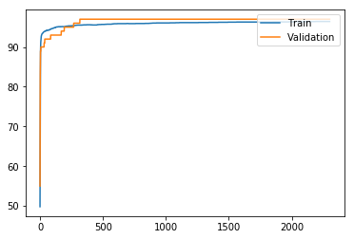 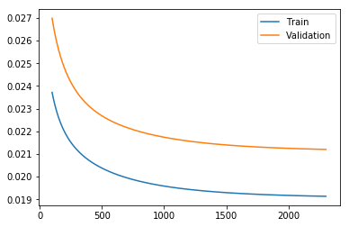

Figure 1 (Accuracy Graph) Figure 2 (Loss Graph)

Figure 1, is same as that of pervious one with regularization 0.001. But in figure 2, Loss has increased as compared to about loss graph. It shows with an increase of 4% comparative to above loss graph.

1. Regularization = 0 .5

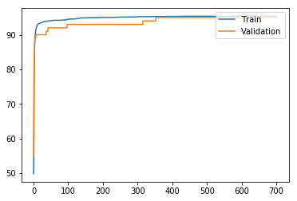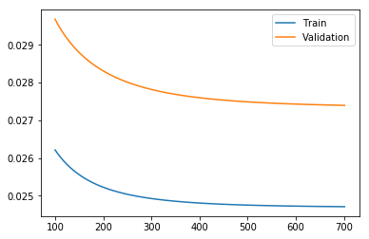

Figure 1 (Accuracy Graph) Figure 2(Loss Graph)

Figure 1, shows initially train accuracy is high comparative to validation accuracy for iterations from 0 to 400. But later on, both accuracies become close to each other. Loss graph shows a huge difference between train loss and validation loss.

Therefore, as regularization increases, it can be stated that loss increases between train and validation, whereas difference in accuracy between those two decreases. It can also be seen, as Regularization increases, the train loss and validation loss also increases.

**Logistic Regression**

In logistic regression, gradient descent is implemented which provides cross entropy loss and its gradient (weights and bias) for every iteration.

1. Alpha = 0.005 and regularization = 0.1

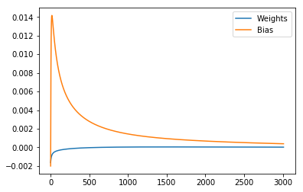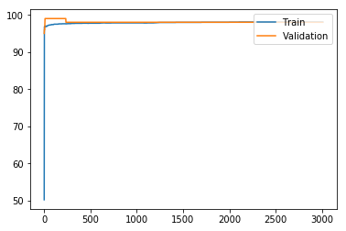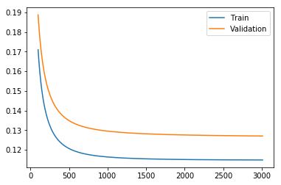

Figure 1(Gradient Graph) Figure 2(Accuracy Graph) Figure 3(Loss Graph)

Figure 1, weights are increasing gradually form negative to 0.0 and bias show a tremendous increase from negative to 0.014 initially. Later on, bias gradually decrease to approximate 0.0. In Figure 2, at initial stage validation shows increase in accuracy than train but later on, both come at same pace. Figure 3, shows that train loss is less but comparing train and validation loss initially it was less but increasing number of iteration it increased.

1. Alpha = 0.005 and regularization = 0.0

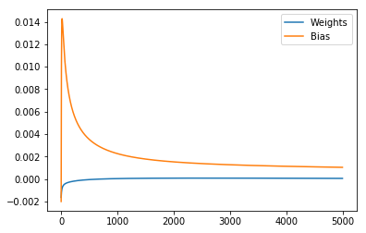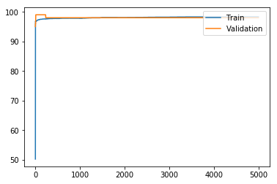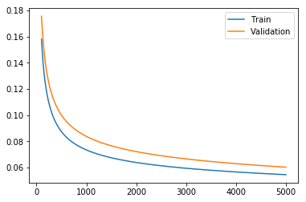

Figure 1(Gradient Graph) Figure 2(Accuracy Graph) Figure 3(Loss Graph)

Figure 1 and Figure 2, behaves similar to that of previous gradient graph and accuracy graph. Therefore, we can say that change in regularization would not affect gradient graph and accuracy graph. But in figure 3, it shows as regularization increases difference between train and validation loss decreases. Validation Loss is also seemed to be decreased in model.

Therefore, comparing with linear regression, it is seen that logistic regression gives a good accuracy but has a higher loss rate. Secondly, Logistic shows similar train and validation accuracy. Therefore, Logistic Regression is better than Linear Regression.

**Batch Gradient vs SGD and Adam**