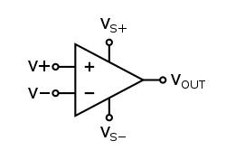**Op-AMP**

Operational Amplifier, also called as an Op-Amp, is an integrated circuit, which can be used to perform various linear, non-linear, and mathematical operations. An op-amp is a direct coupled high gain amplifier. You can operate op-amp both with AC and DC signals. This chapter discusses the characteristics and types of op-amps.

An op-amp consists of differential amplifier(s), a level translator and an output stage. A differential amplifier is present at the input stage of an op-amp and hence an op-amp consists of two input terminals. One of those terminals is called as the inverting terminal and the other one is called as the non-inverting terminal. The terminals are named based on the phase relationship between their respective inputs and outputs.

**Symbol of OP-AMP**

The symbol of an operational amplifier has been demonstrated in figure 8.25. An operational amplifier has at least 5 terminals, out of which two are input terminals, one output terminal and two power supply bias terminals. Names of these terminals have also been written on the symbol as illustrated in the figure.

1). Inverting input terminal

2). Non-inverting input terminal

3). Output terminal (single-ended)

4). Positive bias supply terminal

5). Negative bias supply terminal

In some symbols, positive and negative bias terminals seem juxtaposed whereas in others they seem on one side, as is evident from the triangular type symbol illustrated in the figure. These are usually standard symbols of an operational amplifier, wherein no change is possible except that negative and positive inputs are sometimes reversed (that’s negative input is made upper while positive input lower occasionally). Sometimes, positive terminal is not revealed at all and it is assumed that it is connected with the ground.

Figure– op-amp symbol showing the most important terminals

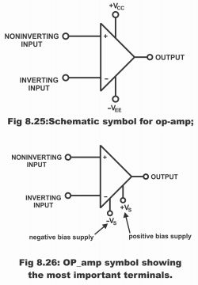

**Working of Op-AMP**

There are several things that are basic to understanding op amps and their operation. The circuit in Figure 0 shows the symbol for the op-amp, U1, and a simplified schematic of the insides of an op-amp. The Op amp has a positive and negative power connection. This provides power from a power source to operate this device.

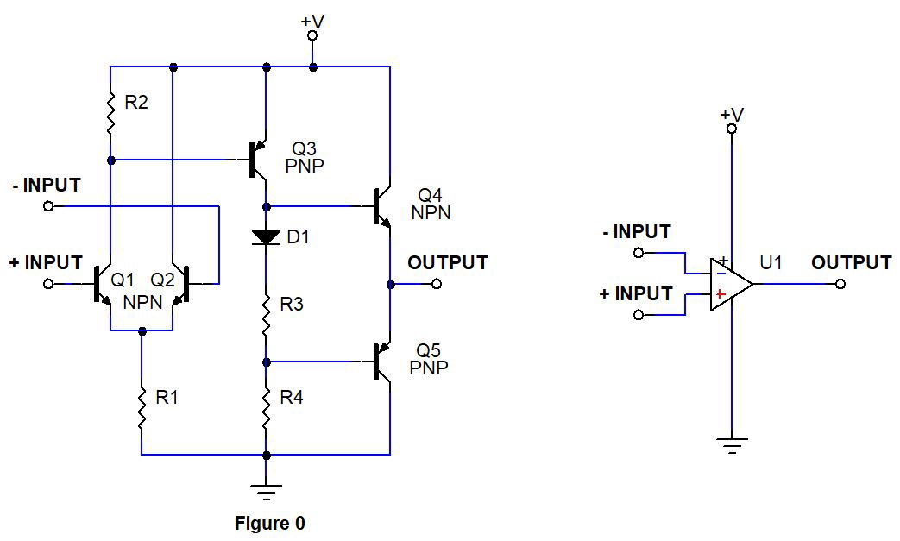

Single or split power supplies can be used depending upon the application. The Op amp has three signal terminals, a positive signal input, a negative signal input, and the op-amp signal output. An op-amp consists of a differential input stage made out of transistors(Q1, Q2), a level shifter stage Q3, and an output stage (Q4, Q5), as shown in Figure 0.

When positive voltage is applied to + Input that is Q1 base and – Input tied to ground, Q3 will be activated ( read about working of transistors to understand this better ). This allows current flow from emitter to collector terminal of Q3. As a result positive voltage will be developed across R3 and R4. This voltage activates Q4 and output will exhibit +V voltage level.

On the other hand when positive voltage is applied to – Input and + Input tied to ground. Q3 will not be activated, hence Q4 will be in off state, however Q5 will turn ON since it is a PNP transistor and low logic at its base activates them. Now Output pin will exhibit low state and Q5 provides a current sinking path through its Emitter to collector terminal.

**Types of Operational Amplifiers**

An op-amp is represented with a triangle symbol having two inputs

and one output.

Op-amps are of two types: Ideal Op-Amp and Practical Op-Amp.

They are discussed in detail as given below −

Ideal Op-Amp

An ideal op-amp exists only in theory, and does not exist practically. The **equivalent circuit** of an ideal op-amp is shown in the figure given below –

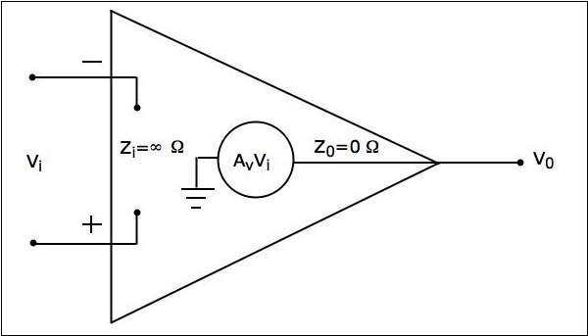

An ideal op-amp exhibits the following characteristics –

* Input impedance Zi=∞Ω
* Output impedance Z0=0Ω
* Open loop voltage gaine Av=∞
* If (the differential) input voltage Vi=0V, then the output voltage will be V0=0V
* Bandwidth is infinity. It means, an ideal op-amp will amplify the signals of any frequency without any attenuation.
* Common Mode Rejection Ratio (CMRR) is infinity.
* Slew Rate (SR) is infinity. It means, the ideal op-amp will produce a change in the output instantly in response to an input step voltage.

Practical Op-Amp

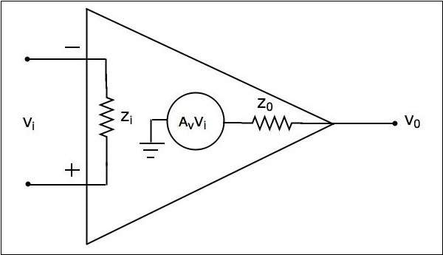Practically, op-amps are not ideal and deviate from their ideal characteristics because of some imperfections during manufacturing. The **equivalent circuit** of a practical op-amp is shown in the following figure −

A practical op-amp exhibits the following characteristics –

* Input impedance, Zi in the order of Mega ohms.
* Output impedance, Z0 in the order of few ohms..
* Open loop voltage gain, Av will be high.

When you choose a practical op-amp, you should check whether it satisfies the following conditions –

* Input impedance, Zi should be as high as possible.
* Output impedance, Z0 should be as low as possible.
* Open loop voltage gain, Av should be as high as possible.
* Output offset voltage should be as low as possible.
* The operating Bandwidth should be as high as possible.
* CMRR should be as high as possible.
* Slew rate should be as high as possible.

**Applications of Operational Amplifier**

Operational Amplifiers have a large no. of applications and some of them are given below as:

* Operational amplifiers are widely used in designing of basic and also advanced electronic projects. The use of operational amplifier as a building block in various projects allows us to get our output much pure and cleaner. The word cleaner emphasis on the part that the other circuit elements like resistance, capacitance, inductance etc, effects the output of the circuit and they also distort it.
* The biggest application of the operational amplifier is ‘voltage comparator’. In order to use op-amp as a comparator, we design a circuit without any feedback. To use op-amp as a comparator gives us the opportunity to get wider range of output voltages and also state switching is done in a faster way, which means it can go from ON to OFF state within no time.
* Op-amp can also be used to design a level detection circuit in terms of voltages. For example if you connect the input or the reference voltages of the circuit to one of the input of the op-amp then, it will start behaving as an voltage level detection circuit.
* Op-amp are commonly used in radio transmission circuits. They are able to amplify the output many times, that’s why they are preferred for signal transmission.
* Op-amp have wide applications in digital electronics and are commonly used to design filter circuits, differential amplifiers and some integration based circuits.
* Op-amp are also commonly use to design ADC (analog to digital converters) and also DAC (digital to analog converters).
* Op-amp are used as a major element in designing voltage clamping circuits and oscillators.
* An interesting application of op-amp is that they are also used to design analogue calculators and some similar electronic products.

**PLAGIARISM REPORT**

**Viva-Voce**

**Q1 What are the properties of an Ideal op-amp?**

**Answer:**

* Infinite input impedance
* Zero output impedance
* Infinite open loop voltage gain
* Infinite Bandwidth
* Zero input offset voltage
* Infinite output voltage
* Zero noise
* Infinite common-mode rejection ratio (CMRR)
* Infinite power supply rejection ratio (PSRR)
* No temperature drift

**Q2: What is the Formula for Non Inverting Amplifier?**

**Answer:** The formula for non inverting amplifier is given as 1+Rf/R1.